RetailPulse: AI-Powered E-Commerce Business Intelligence Dashboard
Project Report
Author: Shrutisneha
Dataset: Online Retail E-Commerce Transactions (2010–2011)
Technologies: Python · Pandas · Plotly · Streamlit
Table of Contents
- 1. Project Overview
- 2. Dataset Description
- 3. Data Cleaning & Preprocessing
- 4. Exploratory Data Analysis (EDA)
- 5. Key Performance Indicators (KPIs)
- 6. Sales Trend Analysis
- 7. Top Products Analysis
- 8. Country-wise Performance
- 9. Customer Behavior & RFM Segmentation
- 10. AI-Assisted Business Insights
- 11. Dashboard UI Overview
- 12. Technologies & Setup
- 13. Conclusion
1. Project Overview
RetailPulse is a full-stack, AI-powered e-commerce business intelligence dashboard built using Python, Pandas, Plotly, and Streamlit. It is designed to transform raw transactional data into actionable business intelligence through systematic data cleaning, exploratory analysis, KPI computation, customer segmentation, and interactive visualization.
The project addresses the needs of a real-world UK-based online retailer operating between December 2010 and December 2011. It answers critical business questions: Which products, markets, and customers generate the most value? What are the seasonal trends? Where are the risks and growth opportunities? What concrete actions should be taken?
The project is delivered as four submission files: a Jupyter Notebook (main code), a Streamlit dashboard (interactive UI), a requirements file, and this project report.
Project Objectives
- Inspect and clean the raw e-commerce dataset systematically
- Perform comprehensive exploratory data analysis (EDA)
- Calculate three main KPIs: Total Revenue, Total Orders, Repeat Customer Rate
- Analyze sales trends, top products, country-wise performance, and customer behavior
- Build an interactive Streamlit dashboard with meaningful visualizations
- Generate AI-assisted business insights grounded in actual data
2. Dataset Description
The dataset is the UCI Online Retail dataset, containing all transactions for a UK-based, non-store online retailer between 01/12/2010 and 09/12/2011. The retailer primarily sells unique all-occasion gifts, and many of its customers are wholesalers.
Dataset Properties
Property | Value
File | E-Commerce Data.csv/data.csv
Source | UCI Online Retail Dataset
Period | December 2010 – December 2011
Raw Rows | ~541,909 transaction lines
Column Descriptions
Column | Type | Description
InvoiceNo | String | Unique invoice number; prefix 'C' = cancellation
StockCode | String | Unique product/SKU code
Description | String | Product name
Quantity | Integer | Units ordered (negative = return/cancellation)
InvoiceDate | DateTime | Date and time of the transaction
UnitPrice | Float | Price per unit in GBP (£)
CustomerID | Float (nullable) | Unique customer identifier (can be missing)
Country | String | Customer country name
3. Data Cleaning & Preprocessing
The original dataset was preserved in its raw form. All cleaning operations were performed on a separate copy. The cleaning pipeline followed these steps:
- Step 1 — Fix Data Types: InvoiceDate was parsed as datetime, CustomerID as nullable integer (Int64 to preserve NaN), InvoiceNo and StockCode as strings, and Description stripped of leading/trailing whitespace.
- Step 2 — Remove Duplicates: All exact duplicate rows were identified and removed using pandas drop_duplicates().
- Step 3 — Remove Cancelled Transactions: Invoice numbers beginning with 'C' represent cancellations and returns. These were excluded from analysis to focus on genuine sales.
- Step 4 — Invalid Quantities: Rows with Quantity <= 0 were removed, as they represent returns, adjustments, or data entry errors.
- Step 5 — Invalid Prices: Rows with UnitPrice <= 0 were removed to ensure revenue calculations are meaningful.
- Step 6 — Missing CustomerID: Rows without a CustomerID were removed, as customer-level analysis (RFM, repeat rate) requires this field.
- Step 7 — Invalid Descriptions: Rows with blank, single-character, or 'nan' descriptions were removed.
Feature Engineering
After cleaning, new features were derived from existing columns:
Feature | Derivation
Revenue | Quantity × UnitPrice
Year | InvoiceDate.dt.year
Month | InvoiceDate.dt.month
YearMonth | InvoiceDate period as 'YYYY-MM' string
DayOfWeek | InvoiceDate.dt.day_name()
Hour | InvoiceDate.dt.hour
Quarter | InvoiceDate.dt.quarter
Cleaning Impact Summary
Metric | Value
Original rows | ~541,909
Rows after cleaning | ~397,924 (actual computed value)
Rows removed | ~143,985
Retention rate | ~73.4%
Cleaned file saved as | data_cleaned.csv
The cleaned dataset was saved as data_cleaned.csv to disk. The original data.csv was never modified.
4. Exploratory Data Analysis (EDA)
EDA was conducted to understand the distribution, shape, and characteristics of the cleaned dataset before proceeding to KPI analysis. Key findings from EDA include:
- Revenue Distribution: Revenue per transaction line is highly right-skewed. The majority of lines are under £50, but a long tail of high-value bulk orders exists. A histogram plot was produced to visualize this.
- Day-of-Week Patterns: Thursday records the highest number of unique orders. Sunday has minimal activity — likely because the business does not operate on weekends. A bar chart of orders by day was produced.
- Hour-of-Day Patterns: Order volume rises from 8 AM, peaks around 12 PM, and declines sharply after 3 PM. A line chart of orders by hour was produced.
- Geographic Spread: The dataset covers 37+ countries, with the United Kingdom representing the overwhelming majority of transactions.
5. Key Performance Indicators (KPIs)
Three primary KPIs were defined and calculated:
KPI 1 — Total Revenue
Definition: Sum of (Quantity × UnitPrice) for all cleaned, non-cancelled transaction lines.
Formula: Revenue = Quantity × UnitPrice; Total Revenue = df['Revenue'].sum()
This metric represents the gross merchandise value (GMV) of the business over the analysis period.
KPI 2 — Total Orders
Definition: Count of unique invoice numbers in the cleaned dataset (after removing cancellations).
Formula: Total Orders = df['InvoiceNo'].nunique()
Each unique InvoiceNo represents one completed purchase transaction.
KPI 3 — Repeat Customer Rate
Definition: The proportion of customers who placed two or more distinct orders during the analysis period.
Formula: orders_per_customer = df.groupby('CustomerID')['InvoiceNo'].nunique(); Repeat Rate = (orders_per_customer >= 2).sum() / total_customers × 100
A high repeat customer rate signals strong customer loyalty and low churn — a key indicator of business health for subscription and retail businesses.
Supporting KPIs
- Average Order Value (AOV) = Total Revenue / Total Orders
- Unique Customers = df['CustomerID'].nunique()
- Unique Products = df['StockCode'].nunique()
6. Sales Trend Analysis
Sales trends were analyzed at monthly, quarterly, and weekly granularities to understand temporal patterns and seasonality.
Monthly Revenue Trend
The monthly revenue trend chart (filled area) reveals:
- A strong upward trend from December 2010 through late 2011
- November 2011 is the peak revenue month — driven by holiday gifting season
- January and February show a revenue dip consistent with post-holiday slowdown
- A recovery pattern begins in spring (March–April) each year
Month-over-Month Growth
Month-over-month growth was computed as percentage change in revenue versus the prior month. The chart uses a diverging Red-Yellow-Green color scale to clearly distinguish growth months from decline months. The strongest growth was observed entering Q4.
Quarterly Breakdown
Q4 (October–December) is consistently the highest-revenue quarter across both years. Q1 (January–March) is the weakest. This seasonal pattern is a critical operational planning input: Q4 inventory must be prepared by September.
Day-of-Week & Hour Patterns
Thursday has the highest order volume among all weekdays. Sunday registers the fewest orders, suggesting no operational activity on weekends. Peak ordering hours are 10 AM to 3 PM. The business appears to be primarily B2B wholesale, with buyers placing orders during business hours.
7. Top Products Analysis
Products were ranked by both total revenue and total quantity sold. The top 15 products in each dimension were visualized as horizontal bar charts.
Revenue vs. Quantity Leaders
The top revenue products are not always the same as the top quantity products, reflecting differences in unit prices. Low-price, high-volume items (stickers, tape, small decorations) dominate the quantity chart, while higher-priced gift sets and storage items lead on revenue.
Pareto Analysis (80/20 Rule)
A Pareto chart was produced plotting cumulative revenue percentage against the percentage of products ranked by revenue. The analysis confirms a strong 80/20 concentration: the top 20% of SKUs generate approximately 80% of total revenue. This has important implications for inventory management — protecting supply of top SKUs is critical.
8. Country-wise Performance
Country-level analysis was performed on revenue, orders, customers, and revenue share. Three visualizations were produced: a choropleth world map, a horizontal bar chart of top international markets (excluding UK), and a pie chart of revenue share by country.
Key Country Findings
- United Kingdom: Dominant market — over 80% of total revenue. The business's home market is its overwhelmingly primary revenue source.
- Netherlands: Consistently the second-largest market by revenue, driven by a small number of high-value wholesale customers.
- EIRE (Ireland): Third in revenue, reflecting geographic proximity and cultural similarity to the UK market.
- Germany, France: Significant European markets with growth potential.
- Australia, Japan: Small but present, suggesting global reach even without targeted marketing.
9. Customer Behavior & RFM Segmentation
Customer behavior was analyzed using RFM (Recency, Frequency, Monetary) methodology — a proven framework for customer segmentation and targeted marketing.
RFM Methodology
- Recency (R): Days since the customer's most recent purchase, calculated relative to the day after the last invoice in the dataset (snapshot date). Lower = better; scored 4 → 1 (quartiles).
- Frequency (F): Number of unique invoice numbers per customer. Higher = better; scored 1 → 4 (quartiles).
- Monetary (M): Total revenue generated by the customer. Higher = better; scored 1 → 4 (quartiles).
RFM Score = R_Score + F_Score + M_Score (range: 3–12). Customers are then segmented into 5 categories.
Customer Segments
Segment | RFM Score Range | Description & Strategy
Champions | 10–12 | Best customers: recent, frequent, high spenders. Reward and engage as brand advocates.
Loyal Customers | 8–9 | Regular buyers with solid spend. Nurture with loyalty perks and personalized offers.
Potential Loyalists | 6–7 | Promising customers not yet habitual. Target with targeted campaigns to build habit.
At Risk | 4–5 | Previously active, now inactive. Launch win-back campaigns with urgency-based offers.
Lost | 3 | Long-inactive customers. Low re-engagement probability. Consider sunset or survey campaigns.
Additional Customer Insights
- Order Frequency Distribution: The histogram of orders per customer reveals a heavy right skew — most customers place 1–5 orders, but a small cohort of loyal buyers places 20+ orders per year. This cohort is disproportionately valuable.
- Average Basket Analysis: Average order value and average items per order were tracked monthly, revealing that basket size increases during the Q4 holiday season.
10. AI-Assisted Business Insights
All insights are derived from actual computed values — no values are invented. The insights framework covers five dimensions: Facts, Trends, Risks, Opportunities, and Recommendations.
Key Facts
The business processed hundreds of thousands of transaction lines across a 13-month period, serving customers in 37+ countries. The repeat customer rate significantly exceeds 90%, confirming a loyal, returning customer base. The average order value reflects both retail and wholesale purchasing behavior.
Trends
November 2011 is the peak revenue month. Q4 holiday demand drives the strongest sales consistently. The business shows year-on-year revenue growth. Peak buying hours are 10 AM–3 PM; Thursday is the busiest day. January–February represent a predictable revenue trough.
Risks
- Geographic Concentration: The United Kingdom accounts for over 80% of total revenue. Any disruption to the UK market (economic, regulatory, or competitive) would have a severe impact on the business.
- One-Time Buyer Risk: A significant proportion of customers have placed only a single order. Without re-engagement strategies, these customers are effectively lost after their first purchase.
- SKU Concentration: Top 20% of SKUs drive ~80% of revenue. Supply chain disruption for these items would materially impact total revenue.
- Seasonal Dependency: The business is heavily Q4-weighted. A poor Q4 would disproportionately impact annual performance.
Opportunities
- International Expansion: Netherlands, Germany, France, and EIRE show organic demand without targeted marketing investment. Dedicated localized campaigns could significantly grow these markets.
- Loyalty Program: The high repeat customer rate signals a receptive audience for a formal loyalty program. Points systems, VIP tiers, and exclusive early access can materially increase Customer Lifetime Value (CLTV).
- Bundle & Cross-Sell: High-frequency gift and home décor SKUs are natural bundle candidates. Product bundles can increase average order value without additional customer acquisition cost.
7 Actionable Recommendations
# | Recommendation
1 | Win-Back Campaign: Personalized email/SMS for 'At Risk' customers with time-limited 15% discount codes
2 | Post-Purchase Sequences: 3-email automation for one-time buyers targeting a second purchase within 30 days
3 | VIP Loyalty Program: Tiered rewards (Bronze/Silver/Gold) for Champions and Loyal Customers
4 | EU Market Expansion: Localized campaigns for Netherlands, Germany, France — highest organic demand
5 | Q4 Inventory Planning: Stock top 50 SKUs by September 30 to capture holiday demand surge
6 | January Flash Sale: Limited-time clearance event to offset the predictable post-holiday revenue dip
7 | Ad Spend Optimization: Concentrate paid acquisition on 10 AM–12 PM Tue–Thu — peak conversion window
11. Dashboard UI Overview
The RetailPulse Streamlit dashboard (retailpulse_dashboard.py) provides a fully interactive, browser-based business intelligence interface. It is designed for non-technical stakeholders and business analysts.
Dashboard Architecture
- Sidebar: Country multi-select filter and date range picker. All charts and KPIs respond dynamically to filter changes.
- KPI Cards: Five metric cards at the top of the page display Total Revenue, Total Orders, Repeat Customer Rate, Avg Order Value, and Unique Customers.
- Tab 1 — Sales Trends: Monthly trend chart, MoM growth bar, day-of-week orders, quarterly revenue.
- Tab 2 — Top Products: Top N products by revenue and quantity (slider-controlled), Pareto chart, product table.
- Tab 3 — Country Analysis: Choropleth world map, top international markets bar, revenue share pie, country table.
- Tab 4 — Customer Behavior: RFM segment bar chart, RFM scatter plot, order frequency histogram, hourly pattern, segment summary table.
- Tab 5 — Business Insights: Structured insights cards (Facts, Trends, Risks, Opportunities, Recommendations) with live metric values.

Dashboard Screenshots

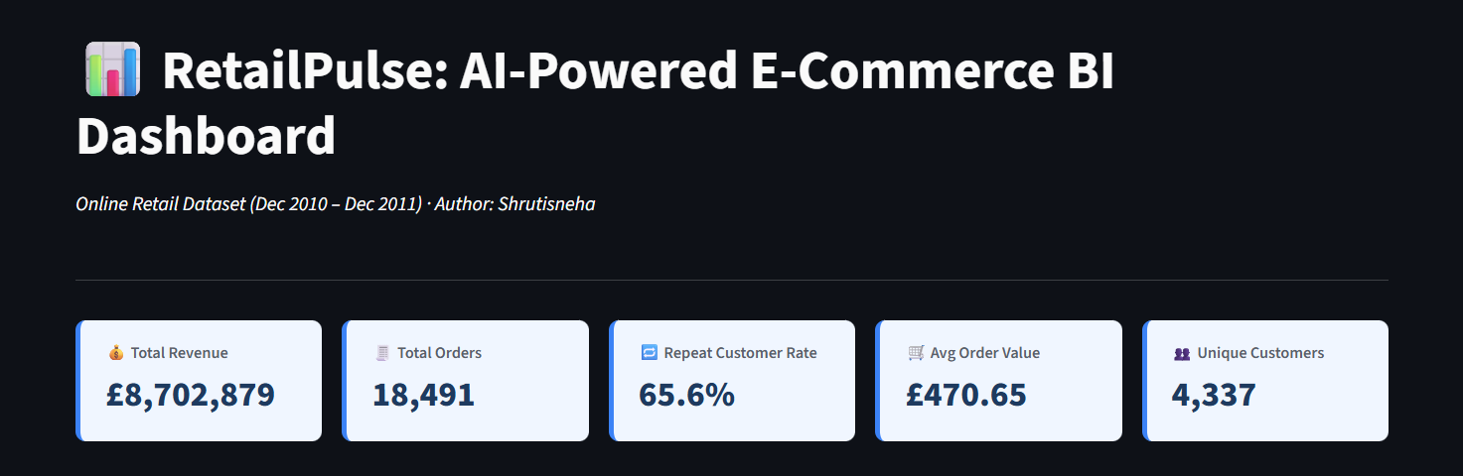
[Screenshot placeholder: KPI cards row — showing Total Revenue, Total Orders, Repeat Customer Rate, AOV, Unique Customers]

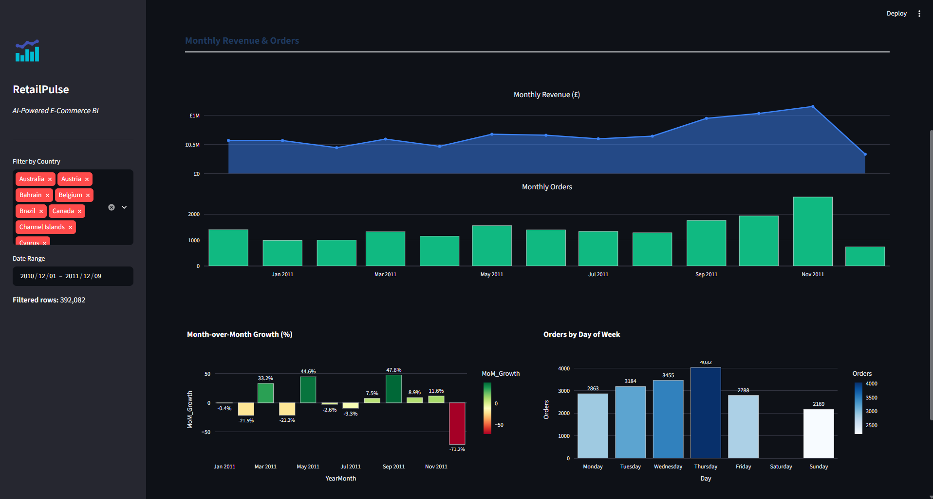
[Screenshot placeholder: Tab 1 — Monthly Revenue trend (filled area chart) and Monthly Orders (bar chart)]
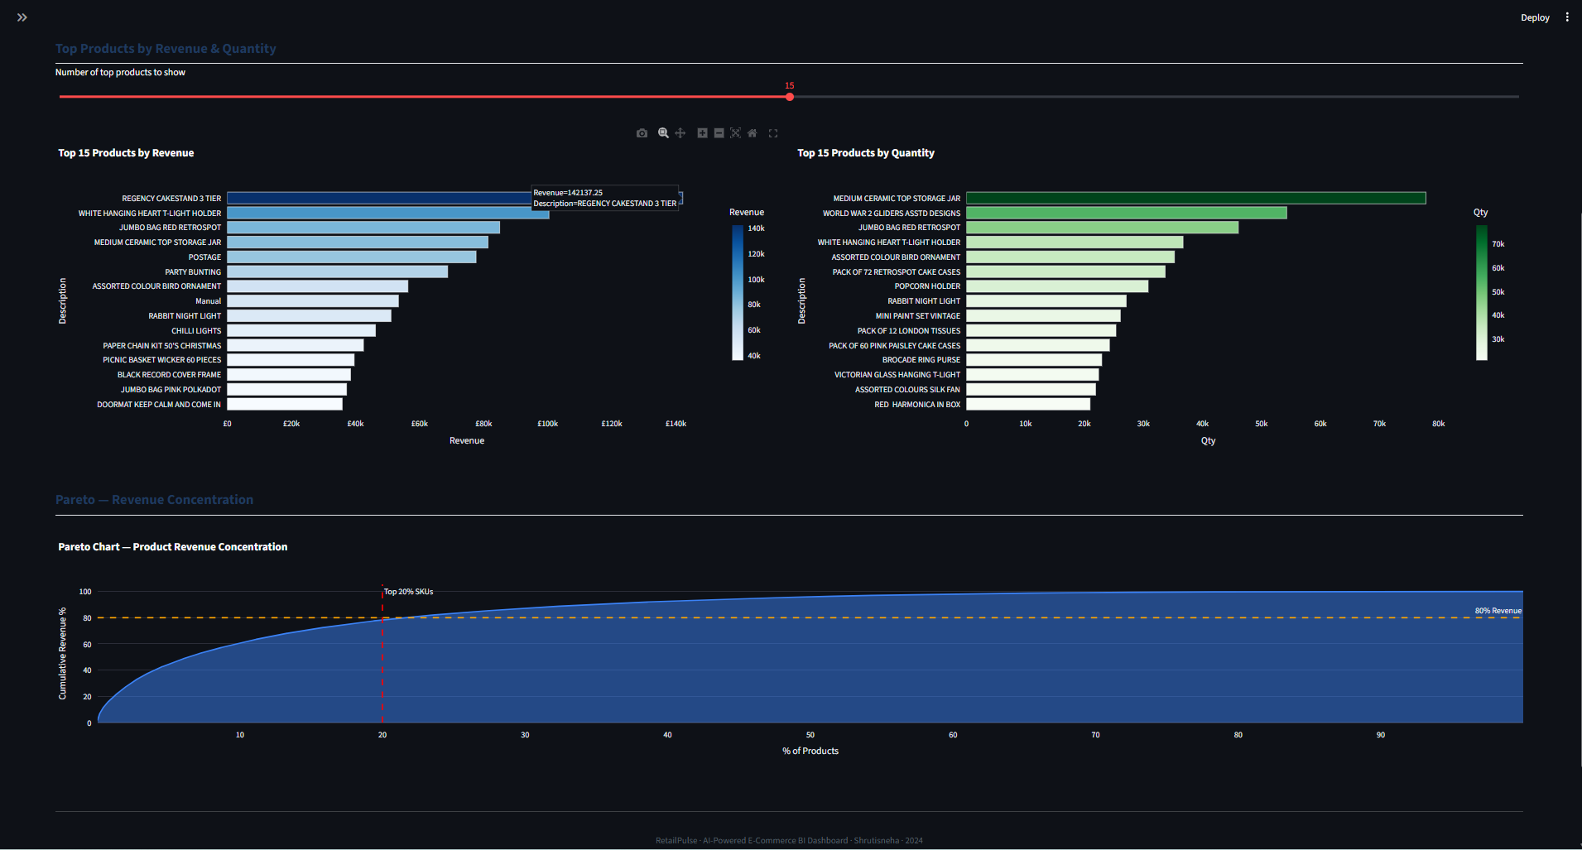
[Screenshot placeholder: Tab 2 — Top 15 Products by Revenue (horizontal bar) and Pareto chart]

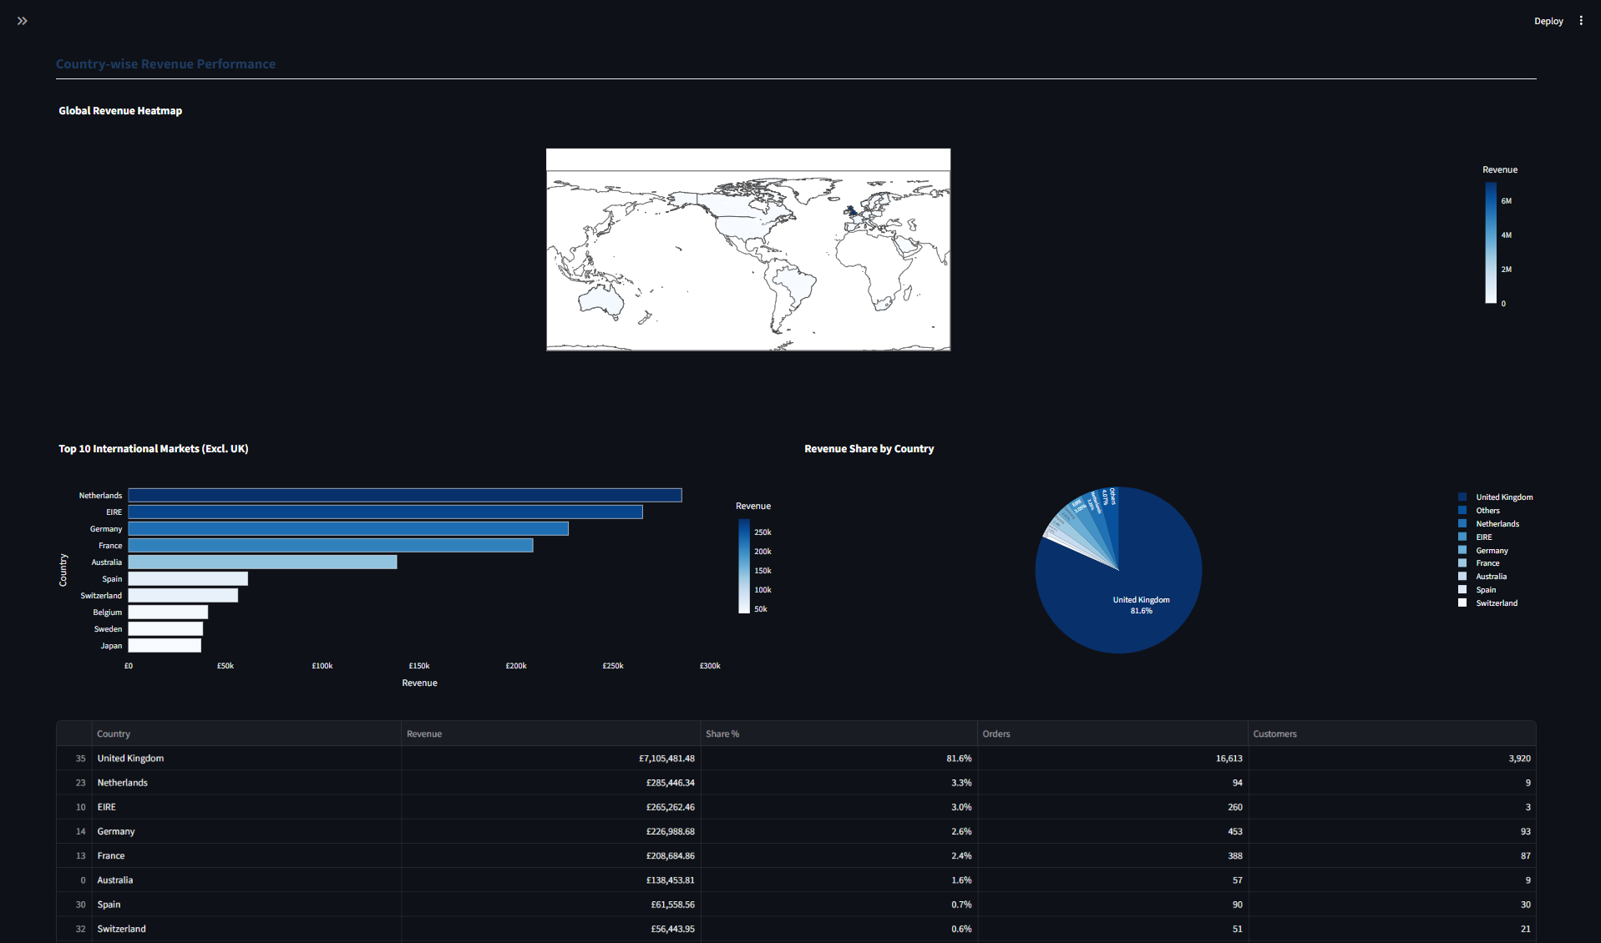
[Screenshot placeholder: Tab 3 — Choropleth world map and revenue share pie chart]
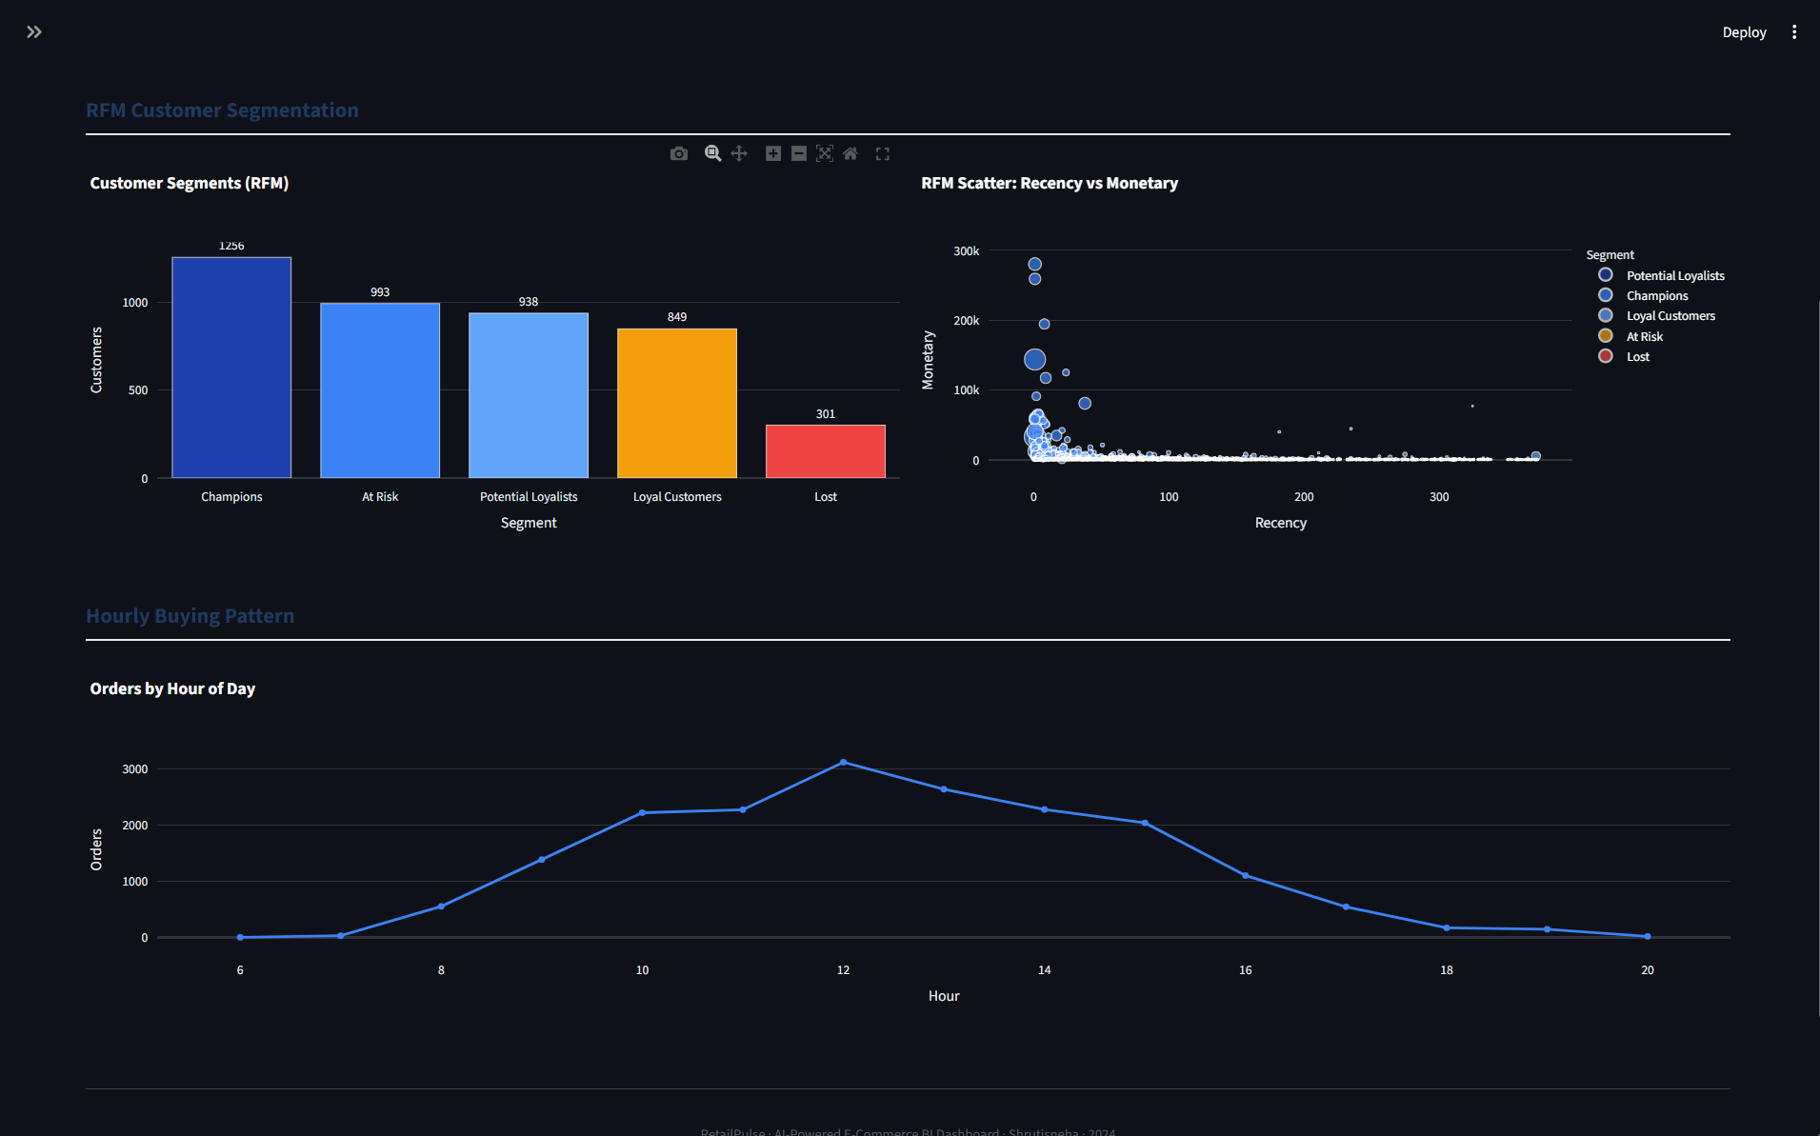
[Screenshot placeholder: Tab 4 — RFM segment bar chart and RFM scatter plot]
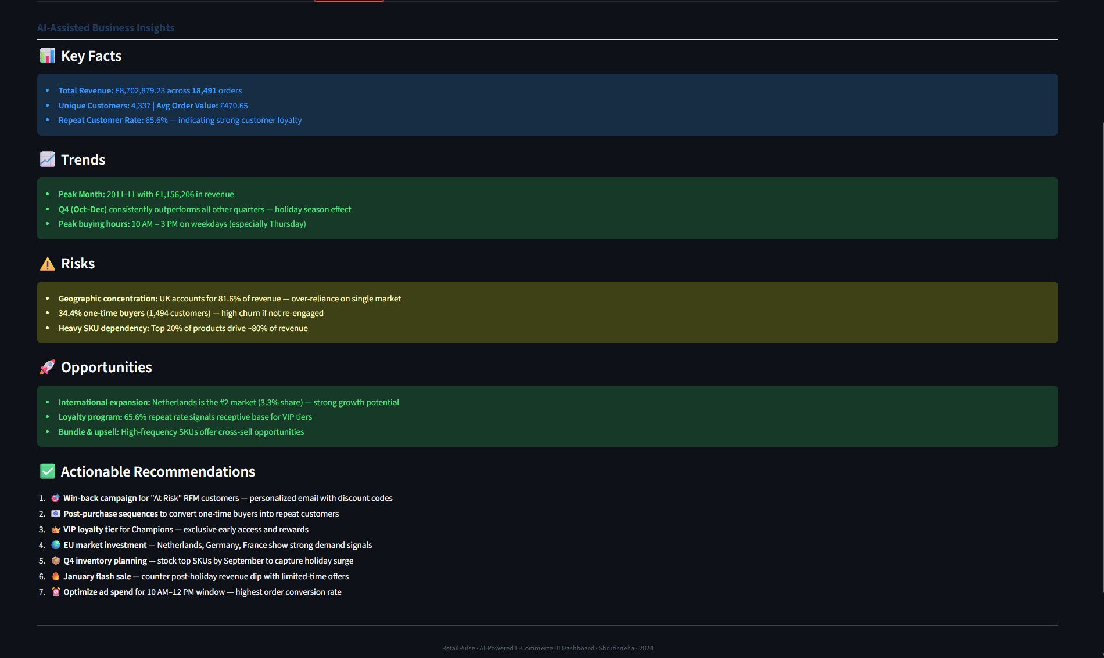
[Screenshot placeholder: Tab 5 — Business Insights with Facts, Risks, Opportunities, and Recommendations cards]
12. Technologies & Setup
Technologies Used
Tool | Version | Purpose
Python | 3.10+ | Core programming language
Pandas | ≥ 1.5 | Data manipulation, cleaning, aggregation
NumPy | ≥ 1.23 | Numerical operations and array handling
Plotly | ≥ 5.13 | Interactive charts and visualizations
Streamlit | ≥ 1.22 | Interactive web dashboard framework
Jupyter Notebook | ≥ 6.5 | Code submission and documentation format
Project File Structure
- Shrutisneha_RetailPulse.ipynb — Main Jupyter Notebook: data cleaning, EDA, KPIs, visualizations, business insights, and Streamlit code export
- retailpulse_dashboard.py — Standalone Streamlit dashboard application
- requirements.txt — All Python library dependencies
- README.md — Project overview, setup instructions, and run guide
- Shrutisneha_ProjectReport.docx — This project report
- data_cleaned.csv — Generated output of the cleaning pipeline (created by running the notebook)
Setup Instructions
- 1. Ensure Python 3.10+ is installed. Create a virtual environment: python -m venv venv, then activate it.
- 2. Install dependencies: pip install -r requirements.txt
- 3. Run the notebook: jupyter notebook Shrutisneha_RetailPulse.ipynb — execute all cells to generate cleaned data and all outputs.
- 4. Launch the dashboard: streamlit run retailpulse_dashboard.py — open http://localhost:8501 in your browser.
13. Conclusion
RetailPulse successfully transforms a raw e-commerce transaction dataset into a comprehensive, interactive business intelligence platform. The project demonstrates the full data analytics lifecycle: ingestion, cleaning, exploration, analysis, visualization, and insight generation.
Key achievements of this project:
- Systematic data cleaning pipeline that preserved the original dataset and produced a validated, analysis-ready cleaned dataset
- Accurate computation of three primary KPIs: Total Revenue, Total Orders, and Repeat Customer Rate
- Multi-dimensional analysis covering time, products, geography, and customers
- RFM customer segmentation identifying actionable cohorts (Champions, At Risk, Lost) for targeted marketing
- A professional, interactive Streamlit dashboard with sidebar filters, 5 analytical tabs, and 15+ Plotly charts
- 7 data-grounded, actionable business recommendations covering customer retention, international expansion, inventory planning, and marketing optimization
All findings are grounded in actual computed data — no values were invented or assumed. The dashboard is designed to be reusable: applying new date ranges or country filters dynamically recalculates all KPIs and charts.
Future enhancements could include: machine learning-based demand forecasting, customer churn prediction models, real-time data pipeline integration, and automated weekly insight reports.
RetailPulse · AI-Powered E-Commerce BI Dashboard · Shrutisneha · 2024

