Machine Learning Lab program 5



**Name – Shruti Gupta**

**Class – CSE – 3**

**Enroll – 41476802717**

**AIM : Use any machine learning method to classify the email dataset**

**GithubLink:-** <https://github.com/Shrutiiig/ML-Assignmnets-Gtbit/tree/master/Lab-5>

**Program Snippets :-**

1. **Importing Modules**

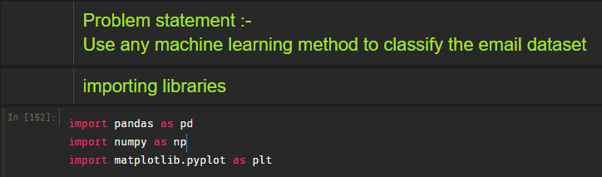

1. **Loading dataset :-**

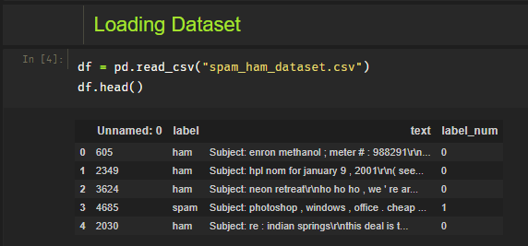

1. **Data Cleaning/ Preprocessing**

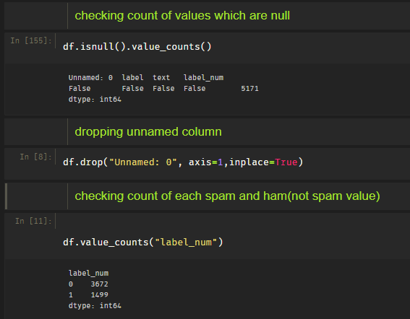

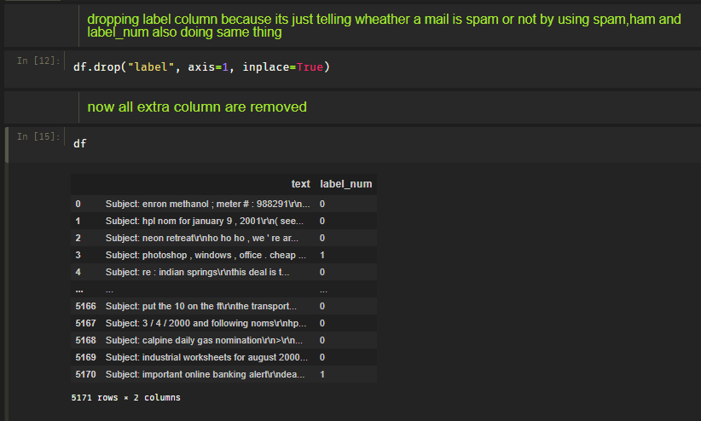

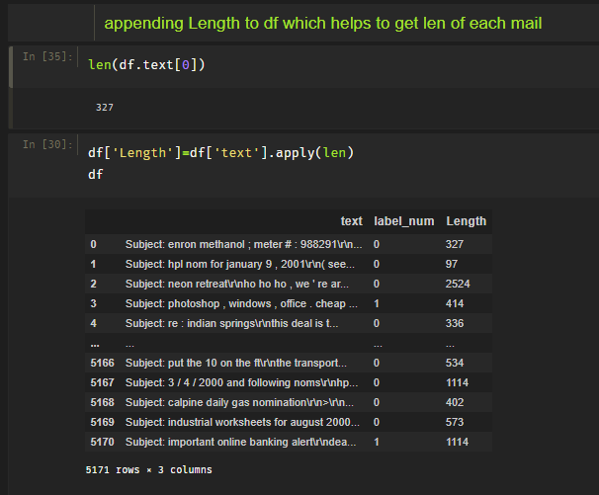

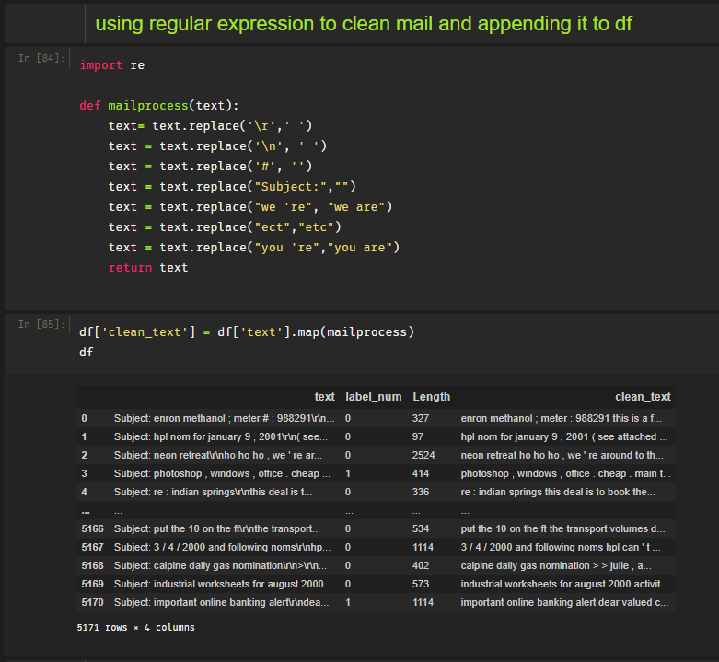

1. **Data Visualization**

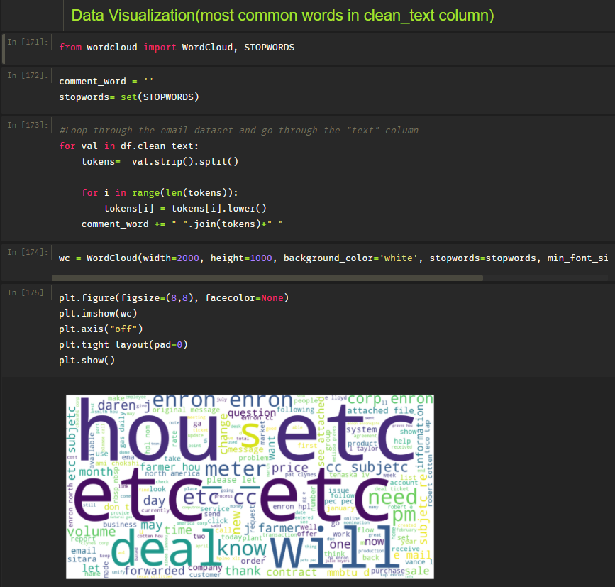

1. **Converting data into X and Y**

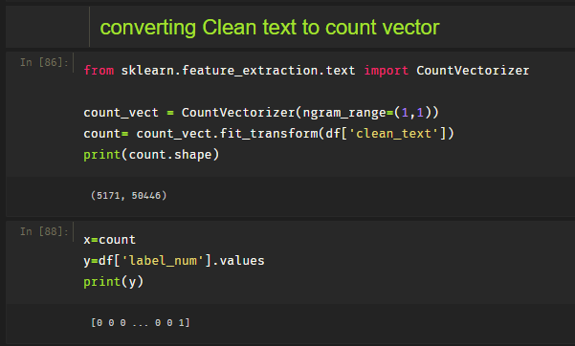

1. **Dividing data into train/test splits**

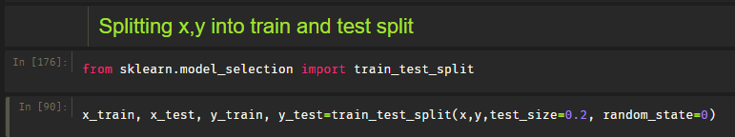

1. **Using Naïve Bayes classifying X_test**

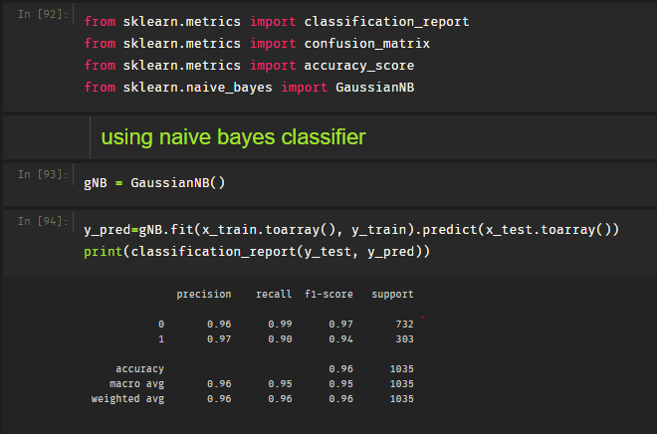

1. **Accuracy Score:-**

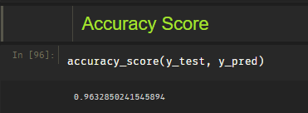

1. **Confusion matrix :-**

