DESIGN AND ANALYSIS OF ALGORITHMS LAB III SEMESTER

Practical No. : 05
Name : Shrutik Bhawsar
Section : A8_B4
Roll Num : 54

Aim: Implement a dynamic algorithm for Longest Common Subsequence (LCS) to find the length and LCS for DNA sequences.
TASK 1: Find the similarity between the given X and Y sequence.
X=AGCCCTAAGGGCTACCTAGCTT
Y= GACAGCCTACAAGCGTTAGCTTG
CODE :

#include <stdio.h>
#include <string.h>

void printlcs(int i, int j, char b[][j], char *text)
{ if (i == 0 || j == 0)
{
return;
} if (b[i - 1][j - 1] == 'D')
{ printlcs(i - 1, j - 1, b, text); printf("%c", text[i - 1]);
} else if (b[i - 1][j - 1] == 'U')
{

printlcs(i - 1, j, b, text);
} else { printlcs(i, j - 1, b, text);
}
} int LCS(char *text1, char *text2)
{ int m = strlen(text1); int n = strlen(text2);
int c[m + 1][n + 1]; char b[m][n];
for (int i = 0; i <= m; i++) c[i][0] = 0;
for (int j = 0; j <= n; j++) c[0][j] = 0;
for (int i = 1; i <= m; i++)
{ for (int j = 1; j <= n; j++)
{ if (text1[i - 1] == text2[j - 1])
{ c[i][j] = c[i - 1][j - 1] + 1; b[i - 1][j - 1] = 'D';
} else if (c[i - 1][j] >= c[i][j - 1])
{ c[i][j] = c[i - 1][j]; b[i - 1][j - 1] = 'U';
} else { c[i][j] = c[i][j - 1]; b[i - 1][j - 1] = 'L';
}
}
}
printf("The LCS is: "); printlcs(m, n, b, text1); printf("\n"); return c[m][n];
}
int main()
{ char str1[100], str2[100];

printf("Enter The 1st String: "); scanf("%s", str1);
printf("Enter The 2nd String: "); scanf("%s", str2);
printf("The Length Of Longest Common Subsequence is : %d\n", LCS(str1, str2));
return 0;
}

OUTPUT :
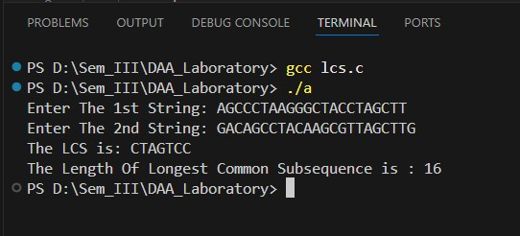

TASK 2 : Find the longest repeating subsequence (LRS). Consider it as a variation of the longest common subsequence (LCS) problem.
CODE :
#include <stdio.h>
#include <string.h>
int main() { char str[100];
printf("Enter The String: "); scanf("%1000s", str);

int m = strlen(str);
int c[m+1][m+1];
for (int i = 0; i <= m; i++) { for (int j = 0; j <= m; j++) { if (i == 0 || j == 0)
c[i][j] = 0; else if (str[i-1] == str[j-1] && i != j) c[i][j] = c[i-1][j-1] + 1; else c[i][j] = (c[i-1][j] > c[i][j-1]) ? c[i-1][j] : c[i][j-1];
}
} int len = c[m][m];
char res[len+1]; res[len] = '\0';
int i = m, j = m, idx = len - 1; while (i > 0 && j > 0) { if (str[i-1] == str[j-1] && i != j) { res[idx--] = str[i-1]; i--; j--;
} else if (c[i-1][j] > c[i][j-1]) { i--; } else { j--;
}
} printf("The LRS is: %s\n", res); printf("The Length Of Longest Repeated Subsequence is : %d\n", len);
return 0;
}

RESULT :
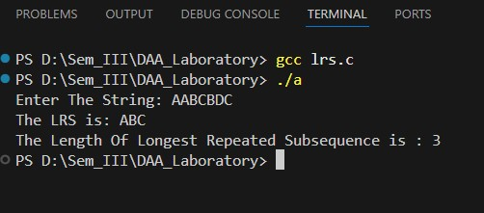

TASK 3 : 1143. Longest Common Subsequence
Given two strings text1 and text2, return the length of their longest common subsequence. If there is no common subsequence, return 0.
A subsequence of a string is a new string generated from the original string with some characters (can be none) deleted without changing the relative order of the remaining characters.

CODE :
int longestCommonSubsequence(char* text1, char* text2)
{ int m = strlen(text1); int n = strlen(text2);
int c[m+1][n+1];
for(int i = 0; i < m+1 ; i++)
{ c[i][0] = 0;
} for(int j = 0; j < n+1 ; j++)
{ c[0][j] = 0;
} for(int i = 1; i <= m; i++)
{ for(int j = 1; j <= n ; j++)
{ if(text1[i - 1] == text2[j - 1])
{ c[i][j] = c[i - 1][j - 1] + 1;
}
else if(c[i - 1][j] >= c[i][j - 1])
{ c[i][j] = c[i - 1][j];
} else { c[i][j] = c[i][j - 1];
}
}
} return c[m][n];
}

RESULT :
LINK:
https://leetcode.com/problems/longest-commonsubsequence/submissions/1825484577/

