**Product analysis**

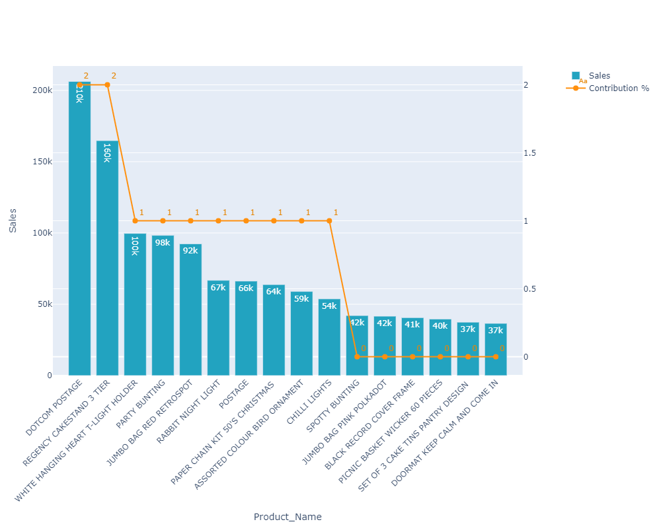

* **Recommendation:**
* Business can focus on these top 5 products and plan to design similar products in their portfolio
* Business can do personalized targeting & offer high sales products. We can also track their media interactions on which media platform are they more active & target them.
* Relook into benefits offered by Products that are generating no sales.

# Country analysis

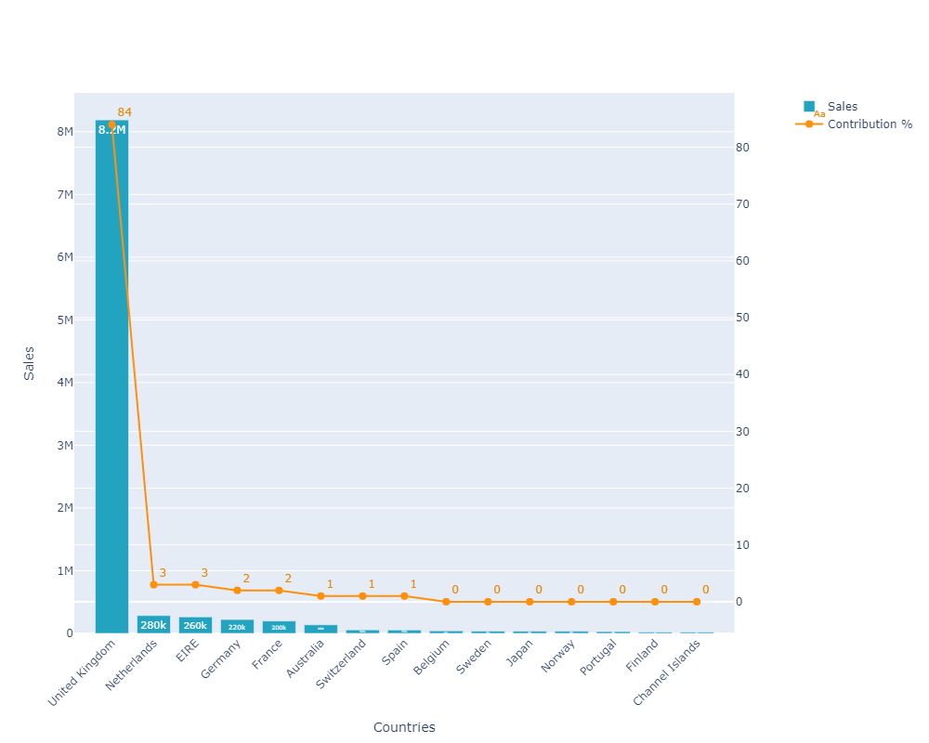

* **Recommendation:**
* United Kingdom contributes highest in Sales.
* Business can focus on these top 5 countries and promote their services.
* Social media platforms can help the business target countries contributing less to the customer base.

# Unique Customers across the country

# 

# To expedite the business growth, the business should try to engage the priority 1 customers

# Initiate promotions/campaigns to target the customers for increasing revenue