#### DECLARATION

We undersigned students of T. Y. B. Tech (Computer Science and Engineering) declare that the project work report entitled ‘Online Attendance Marking System’ written and submitted by us, under the guidance of Mr. S. B. Bhagate is our original work. The empirical findings in this report are based on the data collected by us. The matter assimilated in this report is not the reproduction of any readymade report. We have not violated any of the provisions under Copyright and Piracy / Cyber / IPR Act amended from time to time.

Date:

Place: Ichalkaranji.

**Sr. PRN Name of Student Signature**

1. 17UIT11045CS Shrutika Patil.

2. 18UCS71002XX Priyanka Girmal.

3. 18UCS71010XX Swati Sabane.

4. 18UCS71011XX Priya Sawant.

5. 16UCS 11033XX Ankita Mane.

**INDEX**

**CONTENTS PAGE NO.**

1. Introduction 4
2. Problem Statement 5
3. Problem Description 6
4. Objectives 7
5. Requirement specification 8
6. System Design 9
7. Methodology 13
8. Testing 14
9. Result and Result Analysis 15
10. Conclusion 18
11. References 19

#### INTRODUCTION

As a fast growing organization, the biggest challenge is to manage employees effectively. This is made more complicated with a shift based system and a multi-location campus. In such a scenario, manager is expected to ensure that field employees are reporting to office on time and meeting clients on schedule.

Online attendance marking system using geolocation is a web application that allows an employee to mark his\her attendance of the working in an organization in different districts and states across the country.

#### PROBLEM STATEMENT

Online attendance marking system for employee using geolocation.

#### PROBLEM DESCRIPTION

Creating a web application which store the location of the employee when the employee marks the attendance. Attendance should be marked in the time interval given by the company else employee’s attendance will be marked as absent. Login Id and password will be used to login the application and mark the attendance. Session management is also required in the application. Employee can see its attendance report through the application. Updating employee information in database facility should be provided on the server side.

#### OBJECTIVES

The purpose of this project is to design a web system which marks the attendance of the employee based upon the location.

There is no doubt that this system will help to save time and money by eliminating a great deal of manual processes involved in marking and keeping track of the attendance of the employees or workers.

Some objectives of this application/system are:

1. To mark the attendance of the employees based on their location and in the particular time interval given by the Company.
2. To reduce the paper-work and the manual and hectic processes required to keep track of the activities performed by the employees throughout their working hours.
3. To deal with the shift-based and multi-location company fields.
4. To help the administrator to manage the record of employee efficiently and to help the employees to keep track of their attendance.
5. To generate a monthly report of attendance of employees.

#### REQUIREMENT SPECIFICATION

This system will be dependent on the data of the employee/officer provided by the administrator. (i.e. name of employee, designation of employee, shift in which he/she is working, the site/office location allocated for him/her, etc.) It is necessary that the employee/officer should grant the location access permission of the device. Above all this high speed internet connection is required on client side.

#### SYSTEM DESIGN

**DATA FLOW DIAGRAM**

1. DFD:

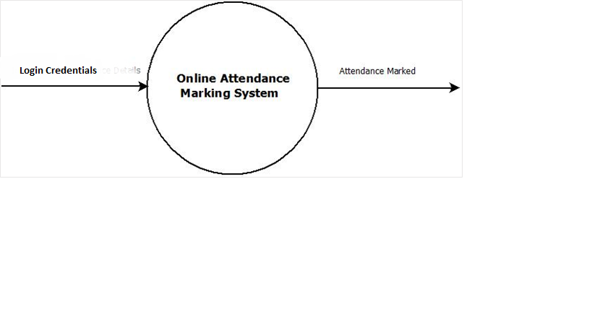

Fig1: Level 0 DFD.

1 DFD:

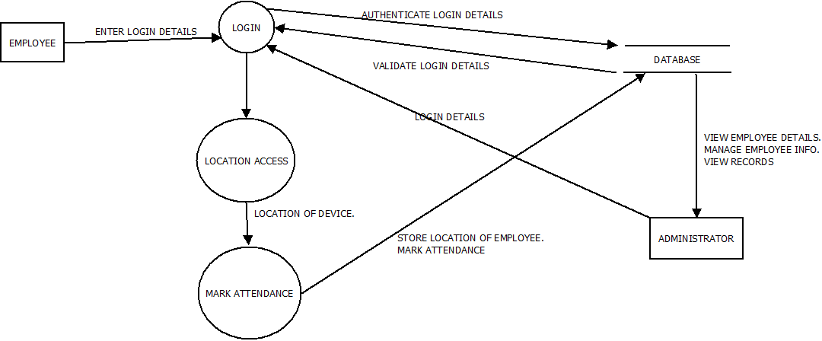

Fig 2.Level 1 DFD.

**Flowchart**

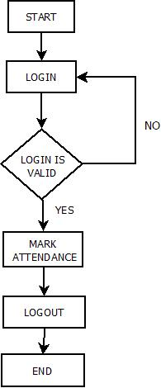

Fig 3: Flowchart

**Use Case Diagram**

User:

1. Employee Logs in to the system using login credentials.

2. Employee then marks attendance.

3. Employee logs out of the system.

Admin:

1. Administration logs in to the system using login credentials.
2. Administrator can update the information of employee.
3. Administrator can add the employee details.
4. Administrator can generate the monthly report of each employee.

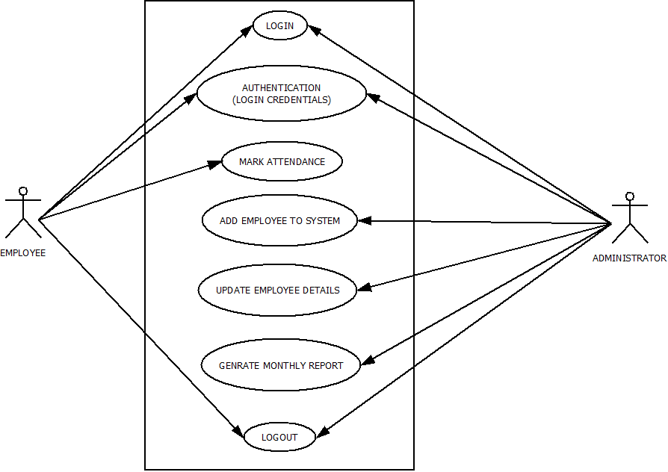

Fig 4: Use case Diagram.

**Sequence Diagram:**

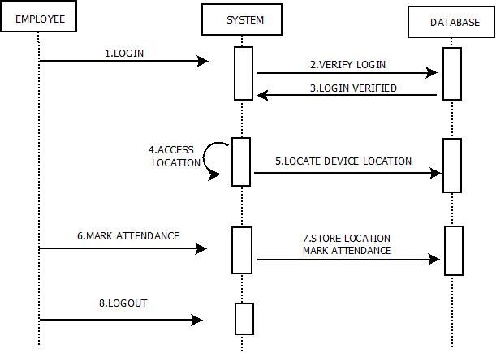

Fig 5: Sequence Diagram.

#### METHODOLOGY

This system will be a web-based application which will be used for taking attendance of an employee working in different shifts and on different locations.

This application will use Geolocation API provided by HTML5 and Google Maps JavaScript API.

So Geolocation API will satisfy the requirement of location recognition of the employee/officer during marking the attendance.

The technology stack used by this system will be:

* Front End: HTML5, JavaScript, Bootstrap.
* Back End: PHP, MySql.

Abbreviations:

API: Application Program Interface.

GPS: Global Positioning System.

GUI: Graphical User Interface.

HTML5: Hyper Text Markup Language 5.

PHP: Hypertext Preprocess

#### TESTING

Using this system the employee will login using given login credential. Employee will have to grant the location access of the device. After attendance is marked device’s location and attendance will be marked in the database. Further employee can logout from the system. Administrator can view the attendance from the database of every employee.

#### RESULT AND RESULT ANALYSIS

This system will help the employee to mark their attendance. As soon as the employee will login into the system and clicks the button to mark attendance, the location of that employee and the time interval conditions will be checked by the system at backend. If both the conditions are valid then the attendance status of that employee will be saved to present, otherwise absent.

Login-Page: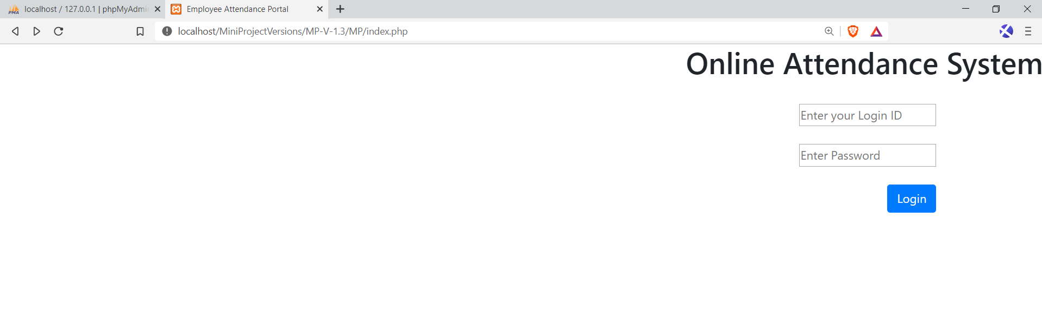

Here employee have to provide the valid credentials and then need to login into system.

After clicking on Login button, the following page will be displayed:

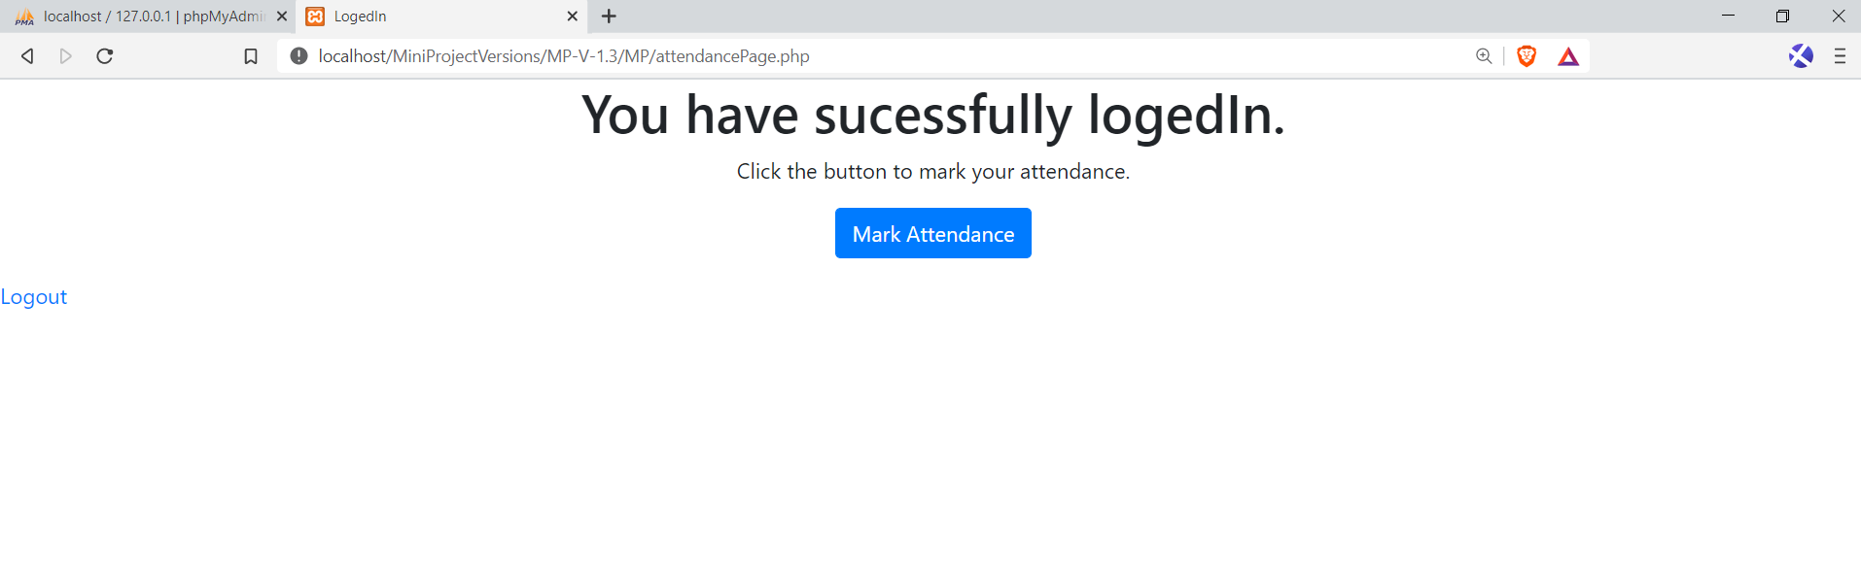

Clicking the Mark Attendance button will generate one pop-up by page to ask for the permission to access location. This will look like:

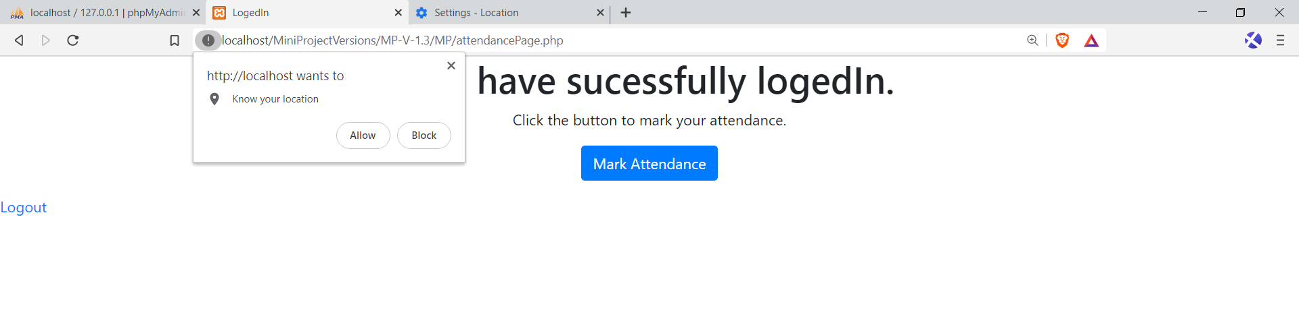

If we click on allow, the location will be tracked, otherwise one message will be displayed as ‘User denied the request for location.’

After allowing following page is displayed:

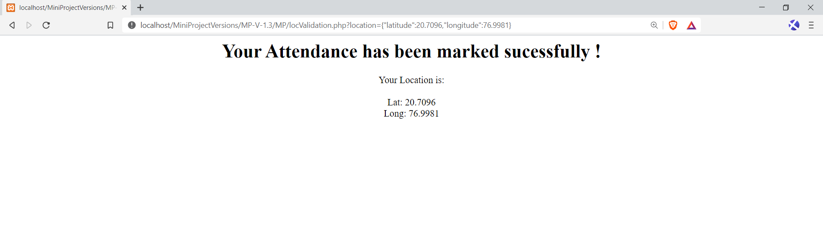

At the backend the table in the database will have fields like:

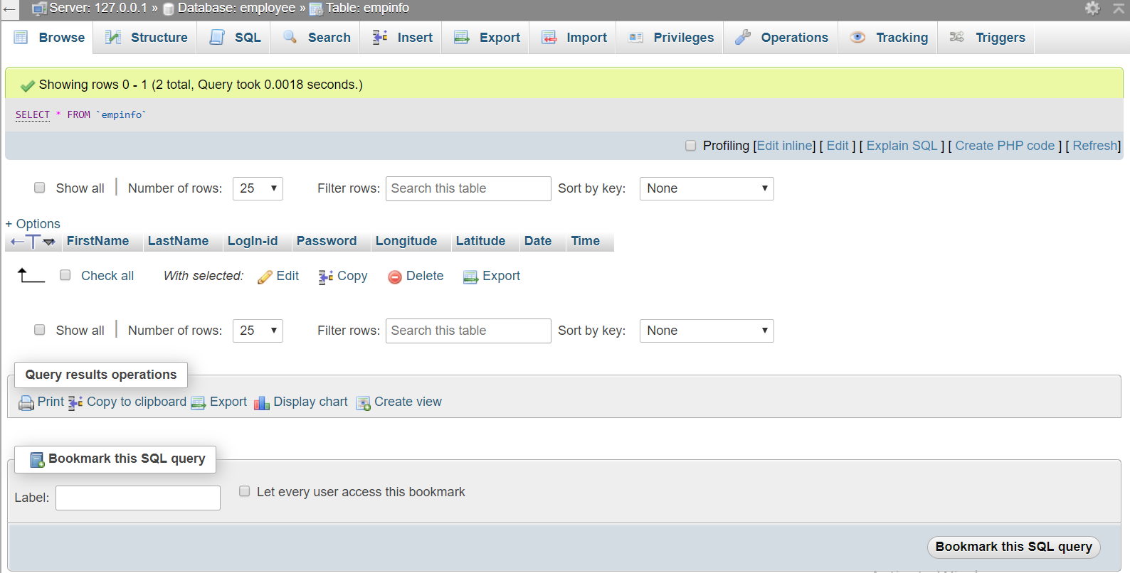

#### CONCLUSION

Online Attendance Marking System has brought a positive impact in the lives of working professionals. It fully meets the objectives of the system.

This system reduces the amount of manual work that is data entry of each and every employee, marking attendance in the registers etc. and provides great efficiency.

It reduces the Human Efforts required for the paper work and manual hectic processes that help in keeping the employee information up to date.

It also reduces the time taken to write the details and other modules of the employees.

#### REFERENCES

[www.google.com](http://www.google.com)

[www.wikipedia.com](http://www.wikipedia.com/)

<https://developer.mozilla.org/en-US/docs/Web/API/Geolocation_API>

<https://www.tutorialspoint.com/html5/html5_geolocation.htm>