Data Visualization with R final project

**R code**

africa <- read.csv("african_crises.csv")

> View(africa)

> dim(africa)

[1] 1059 14

> str(africa)

'data.frame': 1059 obs. of 14 variables:

$ case : int 1 1 1 1 1 1 1 1 1 1 ...

$ cc3 : chr "DZA" "DZA" "DZA" "DZA" ...

$ country : chr "Algeria" "Algeria" "Algeria" "Algeria" ...

$ year : int 1870 1871 1872 1873 1874 1875 1876 1877 1878 1879 ...

$ systemic_crisis : int 1 0 0 0 0 0 0 0 0 0 ...

$ exch_usd : num 0.0523 0.0528 0.0523 0.0517 0.0513 ...

$ domestic_debt_in_default : int 0 0 0 0 0 0 0 0 0 0 ...

$ sovereign_external_debt_default: int 0 0 0 0 0 0 0 0 0 0 ...

$ gdp_weighted_default : num 0 0 0 0 0 0 0 0 0 0 ...

$ inflation_annual_cpi : num 3.44 14.15 -3.72 11.2 -3.85 ...

$ independence : int 0 0 0 0 0 0 0 0 0 0 ...

$ currency_crises : int 0 0 0 0 0 0 0 0 0 0 ...

$ inflation_crises : int 0 0 0 0 0 0 0 1 0 0 ...

$ banking_crisis : chr "crisis" "no_crisis" "no_crisis" "no_crisis" ...

> colnames(africa)

[1] "case" "cc3" "country"

[4] "year" "systemic_crisis" "exch_usd"

[7] "domestic_debt_in_default" "sovereign_external_debt_default" "gdp_weighted_default"

[10] "inflation_annual_cpi" "independence" "currency_crises"

[13] "inflation_crises" "banking_crisis"

nrow(africa)

[1] 1059

> ncol(africa)

[1] 14

> attach(africa)

library(dplyr)

> Africa <- africa %>% select(country,year,exch_usd,domestic_debt_in_default,inflation_annual_cpi,banking_crisis) %>%

+ filter(country %in% c("Egypt","South Africa","Zimbabwe","Algeria","Angola"))

> Africa <- filter(Africa, year > 1880)

> View(Africa)

> str(Africa)

'data.frame': 489 obs. of 6 variables:

$ country : chr "Algeria" "Algeria" "Algeria" "Algeria" ...

$ year : int 1881 1882 1883 1884 1939 1940 1941 1942 1943 1944 ...

$ exch_usd : num 0.052 0.0508 0.052 0.0522 0.449 ...

$ domestic_debt_in_default: int 0 0 0 0 0 0 0 0 0 0 ...

$ inflation_annual_cpi : num 12.62 -12.36 -1.39 -15.94 9.76 ...

$ banking_crisis : chr "no_crisis" "no_crisis" "no_crisis" "no_crisis" ...

detach(africa)

> sort(table(Africa$country),decreasing=TRUE)

Egypt South Africa Zimbabwe Angola Algeria

134 114 90 77 74

> Africa$country <- droplevels(Africa$country)

anyNA(Africa)

[1] FALSE

> table(Africa$year)

1881 1882 1883 1884 1885 1886 1887 1888 1889 1890 1891 1892 1893 1894 1895 1896 1897 1898 1899 1900 1901 1902

2 2 2 2 1 1 1 1 1 1 1 1 1 1 1 1 1 1 1 2 2 2

1903 1904 1905 1906 1907 1908 1909 1910 1911 1912 1913 1914 1915 1916 1917 1918 1919 1920 1921 1922 1923 1924

2 2 2 2 2 2 2 2 2 2 2 2 2 2 2 2 2 2 4 4 4 3

1925 1926 1927 1928 1929 1930 1931 1932 1933 1934 1935 1936 1937 1938 1939 1940 1941 1942 1943 1944 1945 1946

3 3 4 4 4 4 4 4 4 4 4 4 4 4 5 5 5 5 5 5 5 5

1947 1948 1949 1950 1951 1952 1953 1954 1955 1956 1957 1958 1959 1960 1961 1962 1963 1964 1965 1966 1967 1968

5 5 5 5 5 5 5 5 5 5 5 5 5 5 5 4 3 3 3 3 3 4

1969 1970 1971 1972 1973 1974 1975 1976 1977 1978 1979 1980 1981 1982 1983 1984 1985 1986 1987 1988 1989 1990

4 5 5 5 5 5 5 5 5 5 5 5 4 4 4 4 4 4 4 4 4 4

1991 1992 1993 1994 1995 1996 1997 1998 1999 2000 2001 2002 2003 2004 2005 2006 2007 2008 2009 2010 2011 2012

5 5 5 5 5 5 5 5 5 5 5 5 5 5 5 5 5 5 5 5 5 5

2013 2014

5 3

Africa$exch_usd <- round(Africa$exch_usd,2)

> Africa$inflation_annual_cpi <- round(Africa$inflation_annual_cpi,2)

> summary(Africa$exch_usd)

Min. 1st Qu. Median Mean 3rd Qu. Max.

0.00 0.00 0.24 10.31 3.39 378.20

> boxplot(Africa$exch_usd, main = "exch_usd")

> summary(Africa$inflation_annual_cpi)

Min. 1st Qu. Median Mean 3rd Qu. Max.

-28 1 6 45140 12 21989695

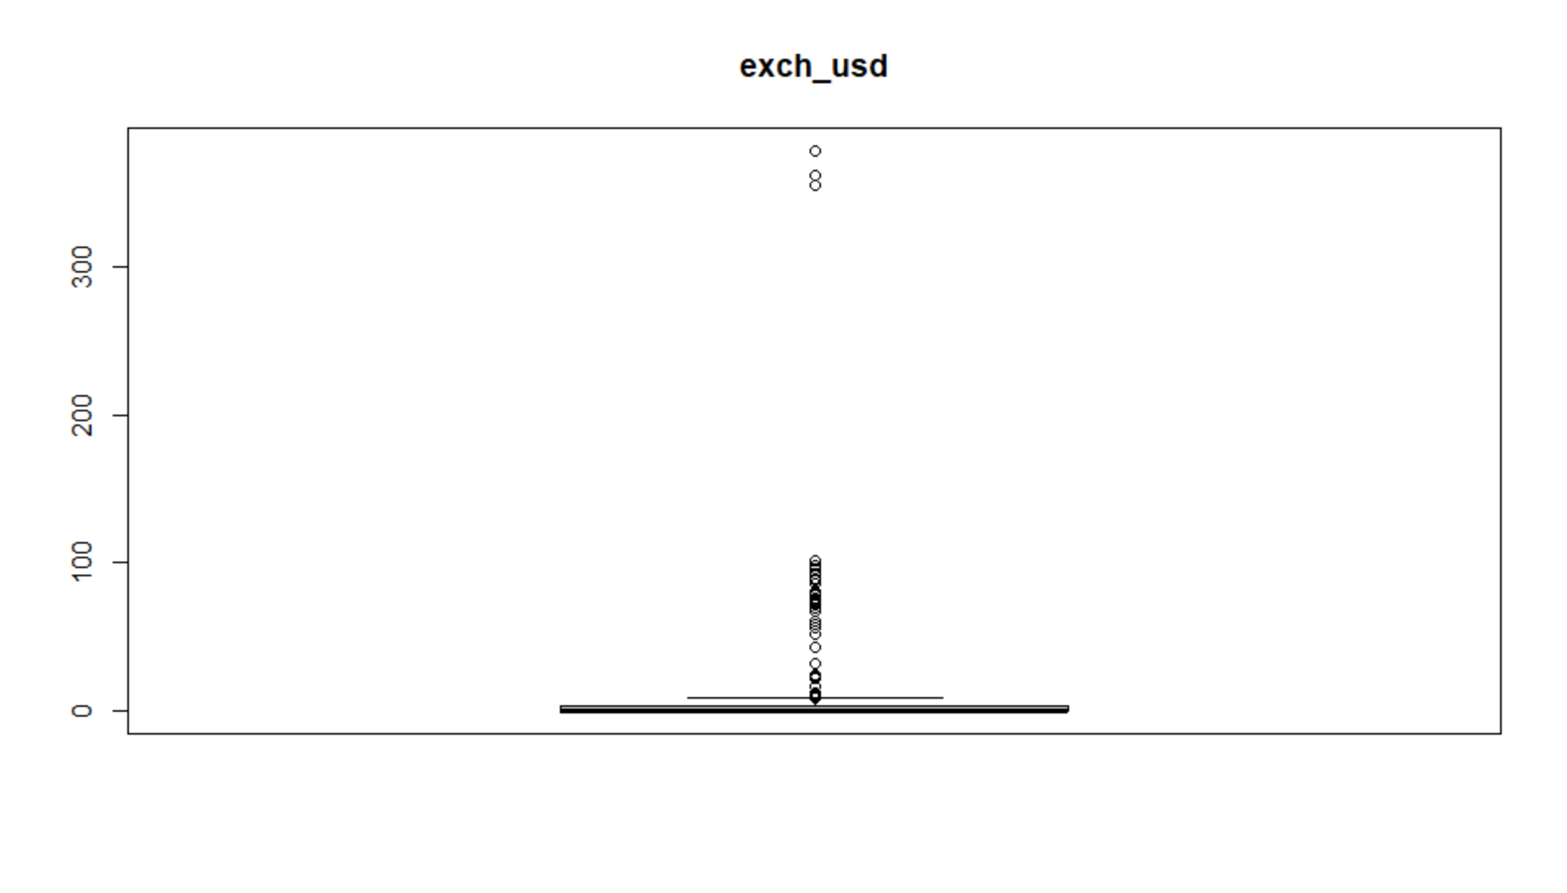

boxplot(Africa$inflation_annual_cpi, main = "inflation_annual_cpi")

> outlier_iqr <- function(x){

+ iqr <- IQR(x,na.rm = T,type = 7)

+ q <- quantile(x)

+ upper_bound = q[4]+(iqr*1.5)

+ lower_bound = q[2]-(iqr*1.5)

+ outliers <- which ((x > upper_bound) | (x < lower_bound))

+ return(outliers)

+ }

> print(outlier_iqr(Africa$inflation_annual_cpi))

[1] 4 9 10 11 13 14 52 55 75 76 77 78 79 81 102 123 124 125 126 127 128 129 130 131 132 133

[27] 134 135 136 137 138 139 140 141 186 188 192 213 306 307 400 468 474 475 476 477 478 479 480 481 482 483

[53] 484

> print(outlier_iqr(Africa$exch_usd))

[1] 50 51 52 53 54 55 56 57 58 59 60 61 62 63 64 65 66 67 68 69 70 71 72 73 74 137

[27] 138 139 140 141 142 143 144 145 146 147 148 149 150 151 387 388 394 398 399 485 486 487 488 489

|  |
| --- |
| Africa_data <- Africa[-c(129,130,131,132,133,137,151,479,481,482,483,484,484,485,486,487,488,489),]  > View(Africa_data)  > str(Africa_data)  'data.frame': 472 obs. of 6 variables:  $ country : chr "Algeria" "Algeria" "Algeria" "Algeria" ...  $ year : int 1881 1882 1883 1884 1939 1940 1941 1942 1943 1944 ...  $ exch_usd : num 0.05 0.05 0.05 0.05 0.45 0.49 0.45 0.75 0.5 0.5 ...  $ domestic_debt_in_default: int 0 0 0 0 0 0 0 0 0 0 ...  $ inflation_annual_cpi : num 12.62 -12.36 -1.39 -15.94 9.76 ...  $ banking_crisis : chr "no_crisis" "no_crisis" "no_crisis" "no_crisis" ... |
|  |
| |  | | --- | | > | |

summary(Africa_data)

country year exch_usd domestic_debt_in_default inflation_annual_cpi

Length:472 Min. :1881 Min. : 0.000 Min. :0.00000 Min. :-28.500

Class :character 1st Qu.:1935 1st Qu.: 0.000 1st Qu.:0.00000 1st Qu.: 1.155

Mode :character Median :1959 Median : 0.240 Median :0.00000 Median : 5.515

Mean :1958 Mean : 6.581 Mean :0.05508 Mean : 10.767

3rd Qu.:1986 3rd Qu.: 3.333 3rd Qu.:0.00000 3rd Qu.: 12.102

Max. :2014 Max. :97.560 Max. :1.00000 Max. :248.250

banking_crisis

Length:472

Class :character

Mode :character

> boxplot(Africa_data$inflation_annual_cpi)

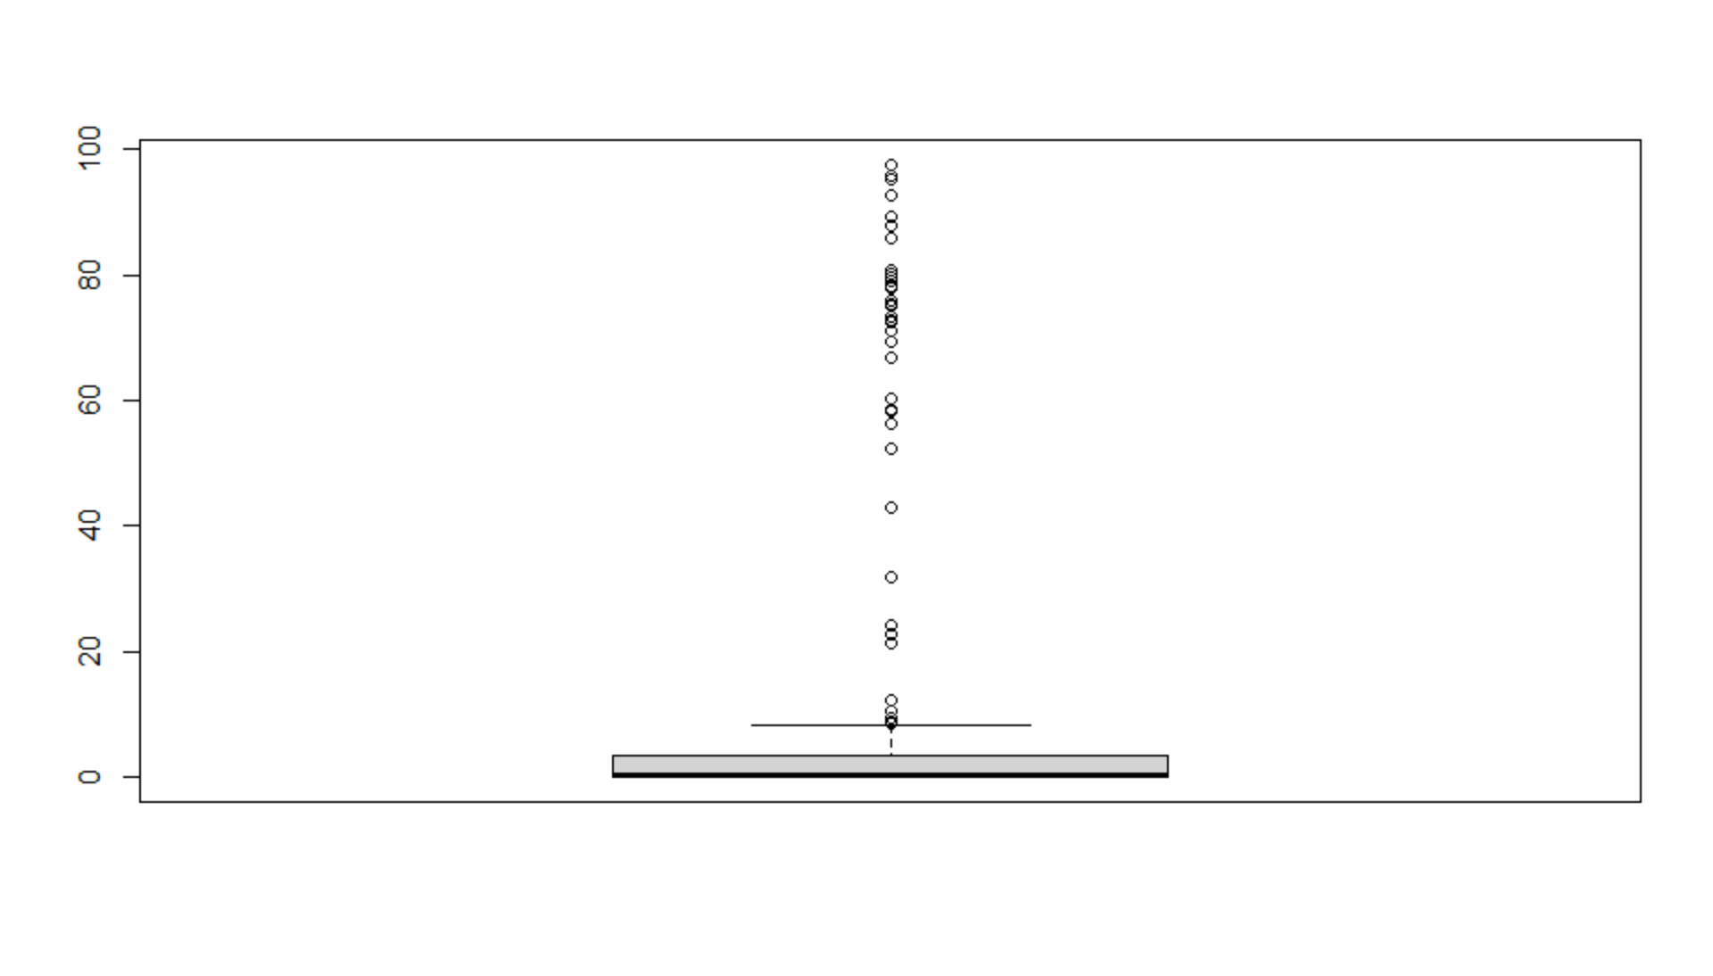 boxplot(Africa_data$exch_usd)

attach(Africa_data)

> colnames(Africa_data)

[1] "country" "year" "exch_usd"

[4] "domestic_debt_in_default" "inflation_annual_cpi" "banking_crisis"

attach(Africa_data)

> colnames(Africa_data)

[1] "country" "year" "exch_usd"

[4] "domestic_debt_in_default" "inflation_annual_cpi" "banking_crisis"

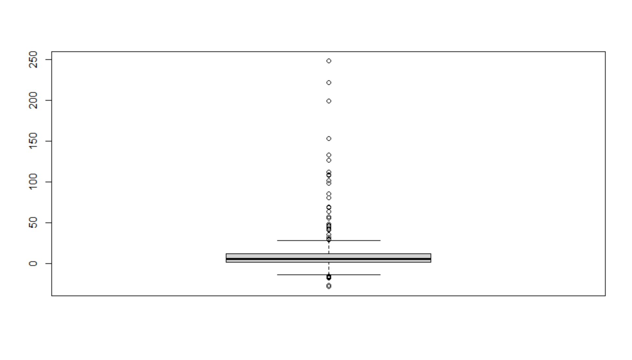

attach(Africa_data)

> colnames(Africa_data)

[1] "country" "year" "exch_usd"

[4] "domestic_debt_in_default" "inflation_annual_cpi" "banking_crisis"

getwd()

[1] "C:/Users/shrut/Desktop/Fall 2020/MET CS 555/project"

> write.csv(Africa_data,'Africa_dateset.csv')

> library(aod)

library(stats)

> library(pROC)

tt<-table(banking=Africa_data$banking_crisis, debt=Africa_data$domestic_debt_in_default)

> prop.test(c(22,6),c(446,26),conf.level = 0.95,correct = FALSE)

prop.debt.banking<-tt[1,1]/colSums(tt)[1]

> prop.nodebt.banking<-tt[1,2]/colSums(tt)[2]

risk_diff <- abs(prop.debt.banking-prop.nodebt.banking)*100

> model<-glm(as.factor(banking_crisis)~domestic_debt_in_default, family = binomial)

> summary(model)

Call:

glm(formula = as.factor(banking_crisis) ~ domestic_debt_in_default,

family = binomial)

Deviance Residuals:

Min 1Q Median 3Q Max

-2.4533 0.3181 0.3181 0.3181 0.7244

Coefficients:

Estimate Std. Error z value Pr(>|z|)

(Intercept) 2.9587 0.2186 13.532 < 2e-16 ***

domestic_debt_in_default -1.7547 0.5143 -3.412 0.000645 ***

---

Signif. codes: 0 ‘***’ 0.001 ‘**’ 0.01 ‘*’ 0.05 ‘.’ 0.1 ‘ ’ 1

(Dispersion parameter for binomial family taken to be 1)

Null deviance: 212.49 on 471 degrees of freedom

Residual deviance: 203.40 on 470 degrees of freedom

AIC: 207.4

Number of Fisher Scoring iterations: 5

|  |
| --- |
| > exp (cbind (OR = coef (model), confint.default (model)))  OR 2.5 % 97.5 %  (Intercept) 19.272727 12.55534089 29.5840642  domestic_debt_in_default 0.172956 0.06312301 0.4738965 |
|  |
| |  | | --- | | > | |

> Africa_data$prob.model<-predict(model, type=c("response"))

> (g <-roc(Africa_data$banking_crisis ~ Africa_data$prob.model))

> roc(Africa_data$banking_crisis ~ Africa_data$prob.model, plot=TRUE, legacy.axes=T, percent=T,

+ xlab="False Positive (%)", ylab="True Positive (%)", col="blue", lwd=4, print.auc=T, print.auc.x=45, main = "ROC curve for model")

|  |
| --- |
| Call:  roc.formula(formula = Africa_data$banking_crisis ~ Africa_data$prob.model, plot = TRUE, legacy.axes = T, percent = T, xlab = "False Positive (%)", ylab = "True Positive (%)", col = "blue", lwd = 4, print.auc = T, print.auc.x = 45, main = "ROC curve for model")  Data: Africa_data$prob.model in 28 controls (Africa_data$banking_crisis crisis) < 444 cases (Africa_data$banking_crisis no_crisis).  Area under the curve: 58.46% |
|  |
| |  | | --- | | > | |

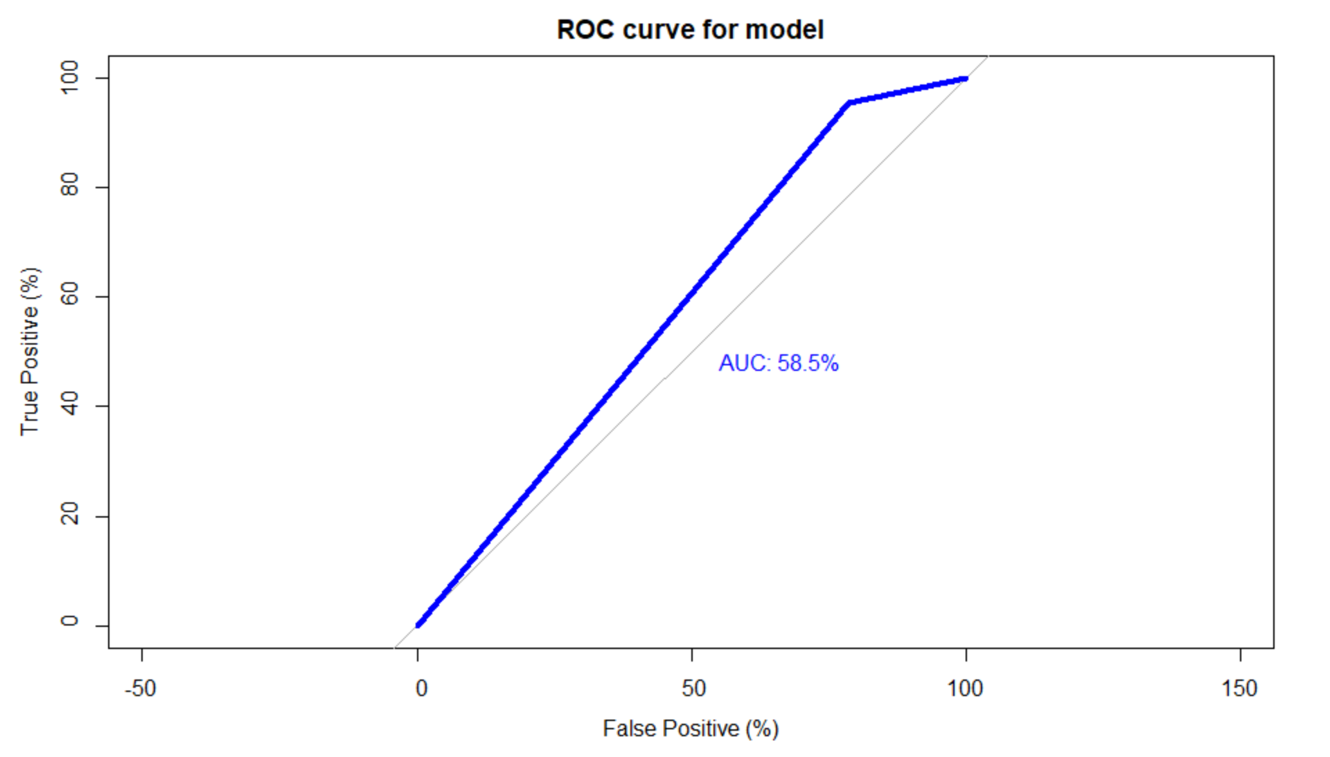

> model2<-glm(as.factor(banking_crisis)~Africa_data$domestic_debt_in_default+Africa_data$inflation_annual_cpi+Africa_data$exch_usd,family = binomial)

> summary(model2)

Call:

glm(formula = as.factor(banking_crisis) ~ Africa_data$domestic_debt_in_default +

Africa_data$inflation_annual_cpi + Africa_data$exch_usd,

family = binomial)

Deviance Residuals:

Min 1Q Median 3Q Max

-2.5541 0.2859 0.3036 0.3281 2.3172

Coefficients:

Estimate Std. Error z value Pr(>|z|)

(Intercept) 3.10222 0.24149 12.846 < 2e-16 ***

Africa_data$domestic_debt_in_default -0.23811 0.80458 -0.296 0.767270

Africa_data$inflation_annual_cpi -0.02260 0.00647 -3.493 0.000477 ***

Africa_data$exch_usd 0.02384 0.01986 1.200 0.229979

---

Signif. codes: 0 ‘***’ 0.001 ‘**’ 0.01 ‘*’ 0.05 ‘.’ 0.1 ‘ ’ 1

(Dispersion parameter for binomial family taken to be 1)

Null deviance: 212.49 on 471 degrees of freedom

Residual deviance: 186.88 on 468 degrees of freedom

AIC: 194.88

Number of Fisher Scoring iterations: 6

exp (cbind (OR = coef (model2), confint.default (model2)))

OR 2.5 % 97.5 %

(Intercept) 22.2473683 13.8587740 35.7135050

Africa_data$domestic_debt_in_default 0.7881124 0.1628264 3.8146227

Africa_data$inflation_annual_cpi 0.9776509 0.9653314 0.9901276

Africa_data$exch_usd 1.0241264 0.9850287 1.0647760

Call:

roc.formula(formula = Africa_data$banking_crisis ~ Africa_data$prob.model2, plot = TRUE, legacy.axes = T, percent = T, xlab = "False Positive (%)", ylab = "True Positive (%)", col = "blue", lwd = 2, print.auc = T, print.auc.x = 40, main = "ROC curve for model")

Data: Africa_data$prob.model2 in 28 controls (Africa_data$banking_crisis crisis) < 444 cases (Africa_data$banking_crisis no_crisis).

Area under the curve: 78.66%

> Africa_data$prob.model2<-predict(model2, type=c("response"))

> (g <-roc(Africa_data$banking_crisis ~ Africa_data$prob.model2))

Call:

roc.formula(formula = Africa_data$banking_crisis ~ Africa_data$prob.model2)

Data: Africa_data$prob.model2 in 28 controls (Africa_data$banking_crisis crisis) < 444 cases (Africa_data$banking_crisis no_crisis).

Area under the curve: 0.7866

> roc(Africa_data$banking_crisis ~ Africa_data$prob.model2, plot=TRUE, legacy.axes=T, percent=T,

+ xlab="False Positive (%)", ylab="True Positive (%)", col="blue", lwd=2, print.auc=T, print.auc.x=40, main = "ROC curve for model")

