MET CS 555 Term Project
10 points

1. Assignment Description
Select a small data set from the available public data sets (you can find a list of public data sets here http://www.teymourian.de/public-data-sets-for-data-analytic-projects/ ).

Describe a research scenario and specify a research question based on data analytic methods that we learned in our class, for example methods like, one and two sample means, t-test, correlation tests, simple and multiple linear regression, ANOVA and ANCOVA, one and two-Sample Tests for Proportions and logistic regression.

Clean up your data and reduce it to no more than 500 observations if your data set is large.

2. Research Scenario Description (no more than 200 words)
Describe your research scenario in no more than 200 words. This is a general description of the use case. Similar to our class examples, we first describe the overall scenario and then we specify a specific research question based on it.
We are interested in African countries’ financial stability and behavioral from 1860 to 2014 among the thirteen African countries and to see what the influences of the financial crisis over the years are. Since we limited the data set to 500 observations, we will only review the top five African counties which have the highest number of observed cases from 1880 to 2014, so we left to have 489 observations from 1,059 observations. Egypt, South Africa, Zimbabwe, Algeria, and Angola are countries that will be focused on for this project, with 155, 114, 90, 85, and 77 observations, respectively. Firstly, we want to understand if the exchange rate (compared to USD), domestic debt, or/and inflation annual CPT causing banking crisis, currency crisis, and inflation crisis or not. Then, we will draw a conclusion based on the analysis results. From those 489 observations, there are only 39 crises were happened for almost the past two centuries. The data set is published by Harvard Business School: https://www.hbs.edu/behavioral-finance-and-financial-stability/data/Pages/global.aspx.

3. Describe the data set (no more than 200 words)
Describe briefly the data set. Describe each columns of the data set if you use the column in your analysis. Clean up your data before usage, for example you can remove the outliers. Remove unused columns. If possible provide a Link to the main data set source.

This dataset is about thirteen African countries’ financial stability and behavioral. The original dataset has total 1059 rows and 14 columns. To clean up the data and reduce the size to meet the limitation of this project, I extracted only the 5 countries that have the highest number of cases which are Egypt, South Africa, Zimbabwe, Algeria, and Angola and analyze from 1880 to 2014. There are 18 outliers that need to be removed. I will focus on predicting the banking crisis since it is the consequence of currency and inflation crisis and it has a potential in indicating an overall financial behavioral of the country (Racickas&Vasiliauskaite,2012). We left with 472 observations of 6 variables. The first variable contains country name. Second, column year shows year from 1880 to 2014. Third, exch_usd variable is indicated the exchange rate of the country compare to USD. The fourth variable shows that whether the domestic debt default occurred in the year with “0” = no and “1” = yes. The annual CPI inflation rate is the fifth variable, with the range of -28.5 to 248.25. Lastly, banking crisis contains information of the event that was there a crisis happen on the year.

By reading the dataset into R
africa <- read.csv("african_crises.csv")

Dataset: Chiri. (2019, July 21). Africa Economic, Banking and Systemic Crisis Data. Retrieved from https://www.kaggle.com/chirin/africa-economic-banking-and-systemic-crisis-data/data#.

Reference: Racickas E. & Vasiliauskaite A. (2012). Classification of Financial Crises and their occurrence Frequency in Global Financial Markets. Retrieved from http://www.su.lt/bylos/mokslo_leidiniai/soc_tyrimai/2012_29/rakickas_vasiliauskaite.pdf

3. Research Question (no more than 100 words)
Describe briefly in one or two sentences the main research question. This is similar to the last sentence of our class examples.

There are some research questions that I am interested in. Is “domestic_debt_in_default” a good predictor on causing a baking crisis? If yes, what is the c-statistic? What is the risk difference between the domestic debt occurred and did not for having the banking crisis? What is the 95% confident interval of the odds of having a banking crisis based on the variable? Another research question is that are the variables inflation_annual_cpi, exch_usd, domestic_debt_in_default and together good predictor for banking crisis? If yes, what is the c-statistic?

4. Your solution R code
Copy your R code here. Start from read the data from a data file. Keep the following data read line.
This is similar to one of our R code examples.

#CS555 Final Project – Shrutika Singodia

#Data Preperation
africa <- read.csv("african_crises.csv")
View(africa)
dim(africa)
str(africa)
colnames(africa)
nrow(africa)
ncol(africa)
attach(africa)

#filter the top 5 countries in Africa where they have the highest number of cases
sort(table(africa$country), decreasing = TRUE)[1:5] #Egypt, South Africa, Zimbabwe, Algeria, and Angola
library(dplyr)
Africa <- africa %>% select(country,year,exch_usd,domestic_debt_in_default,inflation_annual_cpi,banking_crisis) %>%
filter(country %in% c("Egypt","South Africa","Zimbabwe","Algeria","Angola"))
Africa <- filter(Africa, year > 1880)
View(Africa)
str(Africa)
detach(africa)

sort(table(Africa$country),decreasing=TRUE)
Africa$country <- droplevels(Africa$country)
anyNA(Africa)
table(Africa$year)

#install.packages("GGally")
Africa$exch_usd <- round(Africa$exch_usd,2)
Africa$inflation_annual_cpi <- round(Africa$inflation_annual_cpi,2)
summary(Africa$exch_usd)
boxplot(Africa$exch_usd, main = "exch_usd")
summary(Africa$inflation_annual_cpi)
boxplot(Africa$inflation_annual_cpi, main = "inflation_annual_cpi")

#outliers
outlier_iqr <- function(x){
iqr <- IQR(x,na.rm = T,type = 7)
q <- quantile(x)
upper_bound = q[4]+(iqr*1.5)
lower_bound = q[2]-(iqr*1.5)
outliers <- which ((x > upper_bound) | (x < lower_bound))
return(outliers)
}
print(outlier_iqr(Africa$inflation_annual_cpi))
print(outlier_iqr(Africa$exch_usd))

#remove significant outliers

Africa_data <- Africa[-c(129,130,131,132,133,137,151,479,481,482,483,484,484,485,486,487,488,489),]
View(Africa_data)
str(Africa_data)
summary(Africa_data)
boxplot(Africa_data$inflation_annual_cpi)
boxplot(Africa_data$exch_usd)
detach(Africa)
attach(Africa_data)
colnames(Africa_data)

#save Africa_data
getwd()
write.csv(Africa_data,'Africa_dateset.csv')

library(aod)
library(stats)
library(pROC)

#Banking crisis VS Domestic Debt

tt<-table(banking=Africa_data$banking_crisis, debt=Africa_data$domestic_debt_in_default)
prop.test(c(22,6),c(446,26),conf.level = 0.95,correct = FALSE)
prop.debt.banking<-tt[1,1]/colSums(tt)[1]
prop.nodebt.banking<-tt[1,2]/colSums(tt)[2]

#Risk difference
risk_diff <- abs(prop.debt.banking-prop.nodebt.banking)*100
#The risk of having a banking crisis is 18.14% higher among no domestic debt as among domestic debt
#Is “domestic_debt_in_default” a good predictor on causing a baking crisis?

model<-glm(as.factor(banking_crisis)~domestic_debt_in_default, family = binomial)
summary(model)

#Domestic_debt_in_default is a significant value since its p-value(0.000645) less than 0.05.

#Odds ratio and 95% confident interval
exp (cbind (OR = coef (model), confint.default (model)))

#C-statistic
Africa_data$prob.model<-predict(model, type=c("response"))
(g <-roc(Africa_data$banking_crisis ~ Africa_data$prob.model))
roc(Africa_data$banking_crisis ~ Africa_data$prob.model, plot=TRUE, legacy.axes=T, percent=T,
xlab="False Positive (%)", ylab="True Positive (%)", col="blue", lwd=4, print.auc=T, print.auc.x=45, main = "ROC curve for model")

#Are the variables inflation_annual_cpi, exch_usd, domestic_debt_in_default and together good predictor for banking crisis?
model2<-glm(as.factor(banking_crisis)~Africa_data$domestic_debt_in_default+Africa_data$inflation_annual_cpi+Africa_data$exch_usd,family = binomial)
summary(model2)

#only inflation_annual_cpi variable id significant because the p-value is less than 0.05 but domestic_debt_in_default is no longer significant in predicting banking crisis along with the exch_usd variable.
#Odds ratio and 95% confident interval
exp (cbind (OR = coef (model2), confint.default (model2)))

#C-statistic

Africa_data$prob.model2<-predict(model2, type=c("response"))
(g <-roc(Africa_data$banking_crisis ~ Africa_data$prob.model2))
roc(Africa_data$banking_crisis ~ Africa_data$prob.model2, plot=TRUE, legacy.axes=T, percent=T,
xlab="False Positive (%)", ylab="True Positive (%)", col="blue", lwd=2, print.auc=T, print.auc.x=40, main = "ROC curve for model")

5. Execute your R code, Copy and Paste results here in this Box.
Run your code and copy the output of your code to here.

africa <- read.csv("african_crises.csv")
> View(africa)
> dim(africa)
[1] 1059 14
> str(africa)
'data.frame': 1059 obs. of 14 variables:
$ case : int 1 1 1 1 1 1 1 1 1 1 ...
$ cc3 : chr "DZA" "DZA" "DZA" "DZA" ...
$ country : chr "Algeria" "Algeria" "Algeria" "Algeria" ...
$ year : int 1870 1871 1872 1873 1874 1875 1876 1877 1878 1879 ...
$ systemic_crisis : int 1 0 0 0 0 0 0 0 0 0 ...
$ exch_usd : num 0.0523 0.0528 0.0523 0.0517 0.0513 ...
$ domestic_debt_in_default : int 0 0 0 0 0 0 0 0 0 0 ...
$ sovereign_external_debt_default: int 0 0 0 0 0 0 0 0 0 0 ...
$ gdp_weighted_default : num 0 0 0 0 0 0 0 0 0 0 ...
$ inflation_annual_cpi : num 3.44 14.15 -3.72 11.2 -3.85 ...
$ independence : int 0 0 0 0 0 0 0 0 0 0 ...
$ currency_crises : int 0 0 0 0 0 0 0 0 0 0 ...
$ inflation_crises : int 0 0 0 0 0 0 0 1 0 0 ...
$ banking_crisis : chr "crisis" "no_crisis" "no_crisis" "no_crisis" ...
> colnames(africa)
[1] "case" "cc3" "country"
[4] "year" "systemic_crisis" "exch_usd"
[7] "domestic_debt_in_default" "sovereign_external_debt_default" "gdp_weighted_default"
[10] "inflation_annual_cpi" "independence" "currency_crises"
[13] "inflation_crises" "banking_crisis"
nrow(africa)
[1] 1059
> ncol(africa)
[1] 14
> attach(africa)
The following objects are masked from africa (pos = 3):

banking_crisis, case, cc3, country, currency_crises,
domestic_debt_in_default, exch_usd, gdp_weighted_default,
independence, inflation_annual_cpi, inflation_crises,
sovereign_external_debt_default, systemic_crisis, year

The following objects are masked from Africa_data (pos = 9):

banking_crisis, country, domestic_debt_in_default, exch_usd,
inflation_annual_cpi, year

The following objects are masked from Africa_data (pos = 10):

banking_crisis, country, currency_crises, domestic_debt_in_default,
exch_usd, inflation_annual_cpi, inflation_crises, year

The following objects are masked from Africa_nooutl:

banking_crisis, country, currency_crises, domestic_debt_in_default,
exch_usd, inflation_annual_cpi, inflation_crises, year

The following objects are masked from africa (pos = 16):

banking_crisis, case, cc3, country, currency_crises,
domestic_debt_in_default, exch_usd, gdp_weighted_default,
independence, inflation_annual_cpi, inflation_crises,
sovereign_external_debt_default, systemic_crisis, year

The following objects are masked from Africa (pos = 19):

banking_crisis, country, currency_crises, domestic_debt_in_default,
exch_usd, gdp_weighted_default, inflation_annual_cpi,
inflation_crises, year

The following objects are masked from Africa (pos = 20):

banking_crisis, country, currency_crises, domestic_debt_in_default,
exch_usd, gdp_weighted_default, inflation_annual_cpi,
inflation_crises, year

The following objects are masked from Africa (pos = 21):

banking_crisis, country, currency_crises, domestic_debt_in_default,
exch_usd, gdp_weighted_default, inflation_annual_cpi,
inflation_crises, year

The following objects are masked from Africa (pos = 22):

banking_crisis, country, currency_crises, domestic_debt_in_default,
exch_usd, gdp_weighted_default, inflation_annual_cpi,
inflation_crises, year

The following objects are masked from Africa (pos = 23):

banking_crisis, country, currency_crises, domestic_debt_in_default,
exch_usd, gdp_weighted_default, inflation_annual_cpi,
inflation_crises, year

The following objects are masked from Africa (pos = 24):

banking_crisis, country, currency_crises, domestic_debt_in_default,
exch_usd, gdp_weighted_default, inflation_annual_cpi,
inflation_crises, year

The following objects are masked from Africa (pos = 25):

banking_crisis, country, currency_crises, domestic_debt_in_default,
exch_usd, gdp_weighted_default, inflation_annual_cpi,
inflation_crises, year

The following objects are masked from Africa (pos = 26):

banking_crisis, country, currency_crises, domestic_debt_in_default,
exch_usd, gdp_weighted_default, inflation_annual_cpi,
inflation_crises, year

The following objects are masked from Africa (pos = 27):

banking_crisis, country, currency_crises, domestic_debt_in_default,
exch_usd, gdp_weighted_default, inflation_annual_cpi,
inflation_crises, year

The following objects are masked from Africa (pos = 30):

banking_crisis, country, currency_crises, domestic_debt_in_default,
exch_usd, gdp_weighted_default, inflation_annual_cpi,
inflation_crises, systemic_crisis, year

library(dplyr)
> Africa <- africa %>% select(country,year,exch_usd,domestic_debt_in_default,inflation_annual_cpi,banking_crisis) %>%
+ filter(country %in% c("Egypt","South Africa","Zimbabwe","Algeria","Angola"))
> Africa <- filter(Africa, year > 1880)
> View(Africa)
> str(Africa)
'data.frame': 489 obs. of 6 variables:
$ country : chr "Algeria" "Algeria" "Algeria" "Algeria" ...
$ year : int 1881 1882 1883 1884 1939 1940 1941 1942 1943 1944 ...
$ exch_usd : num 0.052 0.0508 0.052 0.0522 0.449 ...
$ domestic_debt_in_default: int 0 0 0 0 0 0 0 0 0 0 ...
$ inflation_annual_cpi : num 12.62 -12.36 -1.39 -15.94 9.76 ...
$ banking_crisis : chr "no_crisis" "no_crisis" "no_crisis" "no_crisis" ...

detach(africa)
> sort(table(Africa$country),decreasing=TRUE)

Egypt South Africa Zimbabwe Angola Algeria
134 114 90 77 74

> Africa$country <- droplevels(Africa$country)

anyNA(Africa)
[1] FALSE
> table(Africa$year)

1881 1882 1883 1884 1885 1886 1887 1888 1889 1890 1891 1892 1893 1894 1895 1896 1897 1898 1899 1900 1901 1902
2 2 2 2 1 1 1 1 1 1 1 1 1 1 1 1 1 1 1 2 2 2
1903 1904 1905 1906 1907 1908 1909 1910 1911 1912 1913 1914 1915 1916 1917 1918 1919 1920 1921 1922 1923 1924
2 2 2 2 2 2 2 2 2 2 2 2 2 2 2 2 2 2 4 4 4 3
1925 1926 1927 1928 1929 1930 1931 1932 1933 1934 1935 1936 1937 1938 1939 1940 1941 1942 1943 1944 1945 1946
3 3 4 4 4 4 4 4 4 4 4 4 4 4 5 5 5 5 5 5 5 5
1947 1948 1949 1950 1951 1952 1953 1954 1955 1956 1957 1958 1959 1960 1961 1962 1963 1964 1965 1966 1967 1968
5 5 5 5 5 5 5 5 5 5 5 5 5 5 5 4 3 3 3 3 3 4
1969 1970 1971 1972 1973 1974 1975 1976 1977 1978 1979 1980 1981 1982 1983 1984 1985 1986 1987 1988 1989 1990
4 5 5 5 5 5 5 5 5 5 5 5 4 4 4 4 4 4 4 4 4 4
1991 1992 1993 1994 1995 1996 1997 1998 1999 2000 2001 2002 2003 2004 2005 2006 2007 2008 2009 2010 2011 2012
5 5 5 5 5 5 5 5 5 5 5 5 5 5 5 5 5 5 5 5 5 5
2013 2014
5 3

Africa$exch_usd <- round(Africa$exch_usd,2)
> Africa$inflation_annual_cpi <- round(Africa$inflation_annual_cpi,2)
> summary(Africa$exch_usd)
Min. 1st Qu. Median Mean 3rd Qu. Max.
0.00 0.00 0.24 10.31 3.39 378.20
> boxplot(Africa$exch_usd, main = "exch_usd")
> summary(Africa$inflation_annual_cpi)
Min. 1st Qu. Median Mean 3rd Qu. Max.
-28 1 6 45140 12 21989695

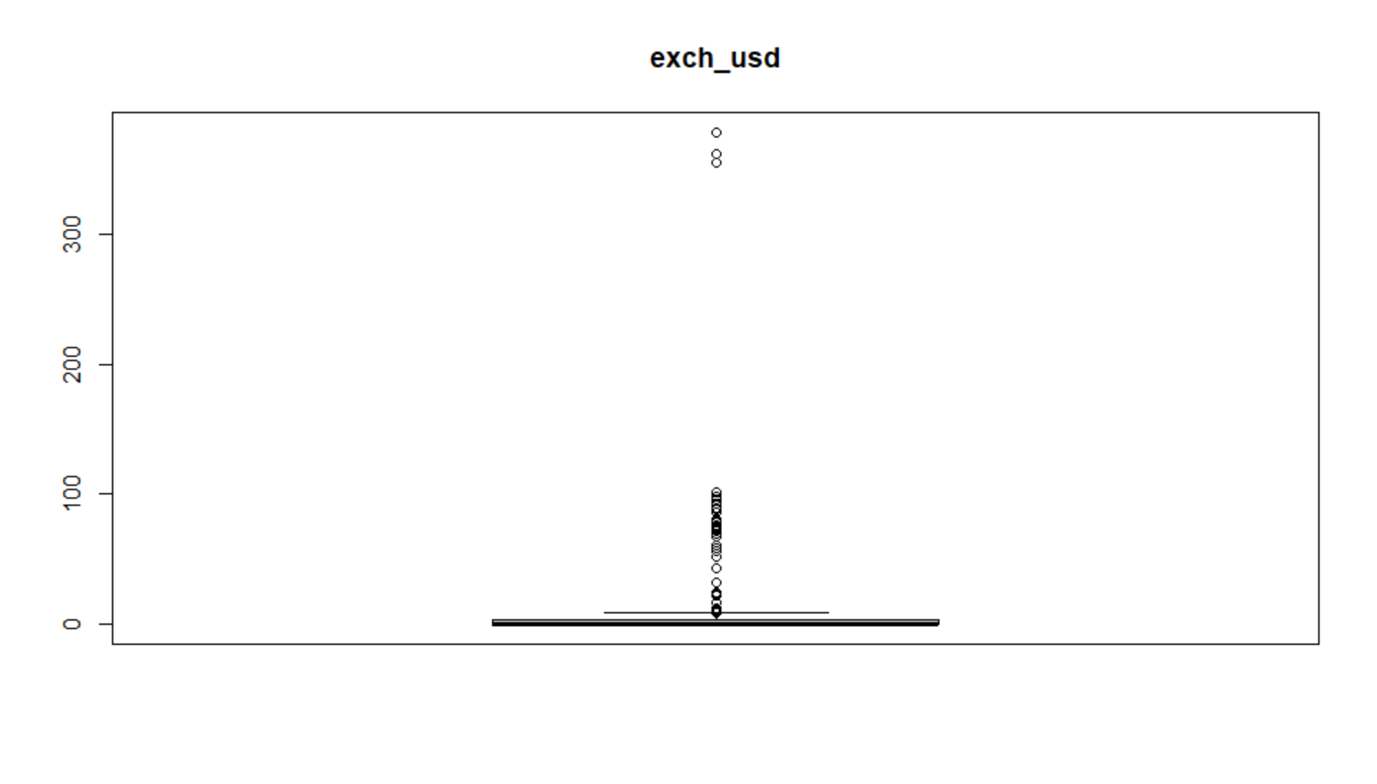
boxplot(Africa$inflation_annual_cpi, main = "inflation_annual_cpi")
> outlier_iqr <- function(x){
+ iqr <- IQR(x,na.rm = T,type = 7)
+ q <- quantile(x)
+ upper_bound = q[4]+(iqr*1.5)
+ lower_bound = q[2]-(iqr*1.5)
+ outliers <- which ((x > upper_bound) | (x < lower_bound))
+ return(outliers)
+ }
> print(outlier_iqr(Africa$inflation_annual_cpi))
[1] 4 9 10 11 13 14 52 55 75 76 77 78 79 81 102 123 124 125 126 127 128 129 130 131 132 133
[27] 134 135 136 137 138 139 140 141 186 188 192 213 306 307 400 468 474 475 476 477 478 479 480 481 482 483
[53] 484
> print(outlier_iqr(Africa$exch_usd))
[1] 50 51 52 53 54 55 56 57 58 59 60 61 62 63 64 65 66 67 68 69 70 71 72 73 74 137
[27] 138 139 140 141 142 143 144 145 146 147 148 149 150 151 387 388 394 398 399 485 486 487 488 489

Africa_data <- Africa[-c(129,130,131,132,133,137,151,479,481,482,483,484,484,485,486,487,488,489),]
> View(Africa_data)
> str(Africa_data)
'data.frame': 472 obs. of 6 variables:
$ country : chr "Algeria" "Algeria" "Algeria" "Algeria" ...
$ year : int 1881 1882 1883 1884 1939 1940 1941 1942 1943 1944 ...
$ exch_usd : num 0.05 0.05 0.05 0.05 0.45 0.49 0.45 0.75 0.5 0.5 ...
$ domestic_debt_in_default: int 0 0 0 0 0 0 0 0 0 0 ...
$ inflation_annual_cpi : num 12.62 -12.36 -1.39 -15.94 9.76 ...
$ banking_crisis : chr "no_crisis" "no_crisis" "no_crisis" "no_crisis" ...

>

summary(Africa_data)
country year exch_usd domestic_debt_in_default inflation_annual_cpi
Length:472 Min. :1881 Min. : 0.000 Min. :0.00000 Min. :-28.500
Class :character 1st Qu.:1935 1st Qu.: 0.000 1st Qu.:0.00000 1st Qu.: 1.155
Mode :character Median :1959 Median : 0.240 Median :0.00000 Median : 5.515
Mean :1958 Mean : 6.581 Mean :0.05508 Mean : 10.767
3rd Qu.:1986 3rd Qu.: 3.333 3rd Qu.:0.00000 3rd Qu.: 12.102
Max. :2014 Max. :97.560 Max. :1.00000 Max. :248.250
banking_crisis
Length:472
Class :character
Mode :character
> boxplot(Africa_data$inflation_annual_cpi)
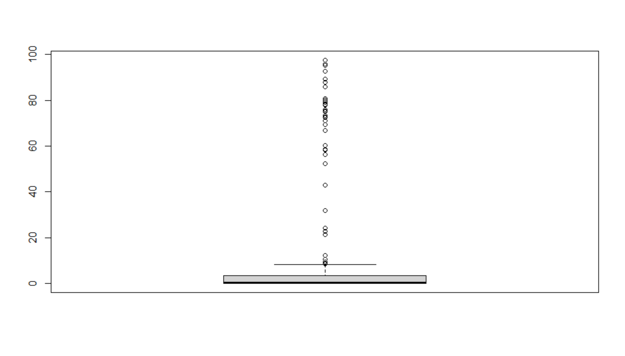

boxplot(Africa_data$exch_usd)
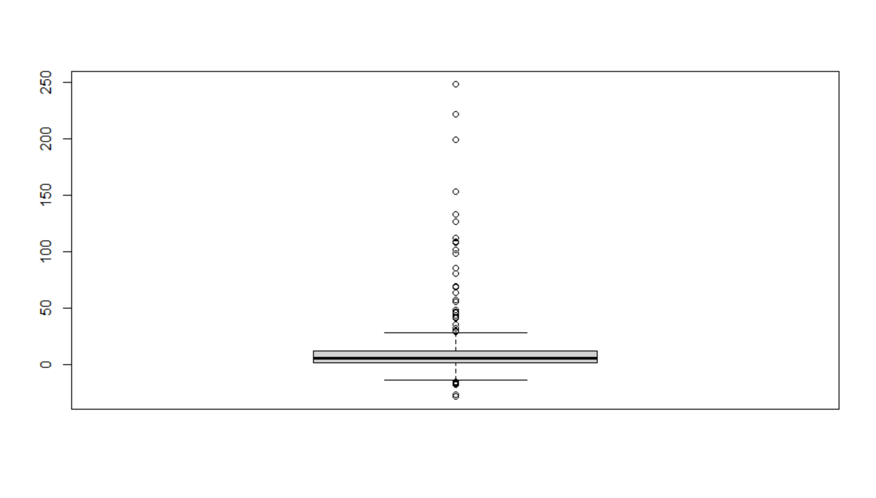
> detach(Africa)
> attach(Africa_data)
The following objects are masked from africa (pos = 3):

banking_crisis, country, domestic_debt_in_default, exch_usd, inflation_annual_cpi, year

The following objects are masked from Africa_data (pos = 9):

banking_crisis, country, domestic_debt_in_default, exch_usd, inflation_annual_cpi, year

The following objects are masked from Africa_data (pos = 10):

banking_crisis, country, domestic_debt_in_default, exch_usd, inflation_annual_cpi, year

The following objects are masked from Africa_nooutl:

banking_crisis, country, domestic_debt_in_default, exch_usd, inflation_annual_cpi, year

The following objects are masked from africa (pos = 16):

banking_crisis, country, domestic_debt_in_default, exch_usd, inflation_annual_cpi, year

The following objects are masked from Africa (pos = 19):

banking_crisis, country, domestic_debt_in_default, exch_usd, inflation_annual_cpi, year

The following objects are masked from Africa (pos = 20):

banking_crisis, country, domestic_debt_in_default, exch_usd, inflation_annual_cpi, year

The following objects are masked from Africa (pos = 21):

banking_crisis, country, domestic_debt_in_default, exch_usd, inflation_annual_cpi, year

The following objects are masked from Africa (pos = 22):

banking_crisis, country, domestic_debt_in_default, exch_usd, inflation_annual_cpi, year

The following objects are masked from Africa (pos = 23):

banking_crisis, country, domestic_debt_in_default, exch_usd, inflation_annual_cpi, year

The following objects are masked from Africa (pos = 24):

banking_crisis, country, domestic_debt_in_default, exch_usd, inflation_annual_cpi, year

The following objects are masked from Africa (pos = 25):

banking_crisis, country, domestic_debt_in_default, exch_usd, inflation_annual_cpi, year

The following objects are masked from Africa (pos = 26):

banking_crisis, country, domestic_debt_in_default, exch_usd, inflation_annual_cpi, year

The following objects are masked from Africa (pos = 29):

banking_crisis, country, domestic_debt_in_default, exch_usd, inflation_annual_cpi, year

> colnames(Africa_data)
[1] "country" "year" "exch_usd"
[4] "domestic_debt_in_default" "inflation_annual_cpi" "banking_crisis"
attach(Africa_data)
> colnames(Africa_data)
[1] "country" "year" "exch_usd"
[4] "domestic_debt_in_default" "inflation_annual_cpi" "banking_crisis"

getwd()
[1] "C:/Users/shrut/Desktop/Fall 2020/MET CS 555/project"
> write.csv(Africa_data,'Africa_dateset.csv')
> library(aod)
library(stats)
> library(pROC)

tt<-table(banking=Africa_data$banking_crisis, debt=Africa_data$domestic_debt_in_default)
> prop.test(c(22,6),c(446,26),conf.level = 0.95,correct = FALSE)
prop.debt.banking<-tt[1,1]/colSums(tt)[1]
> prop.nodebt.banking<-tt[1,2]/colSums(tt)[2]
risk_diff <- abs(prop.debt.banking-prop.nodebt.banking)*100

> model<-glm(as.factor(banking_crisis)~domestic_debt_in_default, family = binomial)
> summary(model)

Call:
glm(formula = as.factor(banking_crisis) ~ domestic_debt_in_default,
family = binomial)

Deviance Residuals:
Min 1Q Median 3Q Max
-2.4533 0.3181 0.3181 0.3181 0.7244

Coefficients:
Estimate Std. Error z value Pr(>|z|)
(Intercept) 2.9587 0.2186 13.532 < 2e-16 ***
domestic_debt_in_default -1.7547 0.5143 -3.412 0.000645 ***
---
Signif. codes: 0 ‘***’ 0.001 ‘**’ 0.01 ‘*’ 0.05 ‘.’ 0.1 ‘ ’ 1

(Dispersion parameter for binomial family taken to be 1)

Null deviance: 212.49 on 471 degrees of freedom
Residual deviance: 203.40 on 470 degrees of freedom
AIC: 207.4

Number of Fisher Scoring iterations: 5
> exp (cbind (OR = coef (model), confint.default (model)))
OR 2.5 % 97.5 %
(Intercept) 19.272727 12.55534089 29.5840642
domestic_debt_in_default 0.172956 0.06312301 0.4738965

>

> Africa_data$prob.model<-predict(model, type=c("response"))
> (g <-roc(Africa_data$banking_crisis ~ Africa_data$prob.model))
> roc(Africa_data$banking_crisis ~ Africa_data$prob.model, plot=TRUE, legacy.axes=T, percent=T,
+ xlab="False Positive (%)", ylab="True Positive (%)", col="blue", lwd=4, print.auc=T, print.auc.x=45, main = "ROC curve for model")
Call:
roc.formula(formula = Africa_data$banking_crisis ~ Africa_data$prob.model, plot = TRUE, legacy.axes = T, percent = T, xlab = "False Positive (%)", ylab = "True Positive (%)", col = "blue", lwd = 4, print.auc = T, print.auc.x = 45, main = "ROC curve for model")

Data: Africa_data$prob.model in 28 controls (Africa_data$banking_crisis crisis) < 444 cases (Africa_data$banking_crisis no_crisis).
Area under the curve: 58.46%

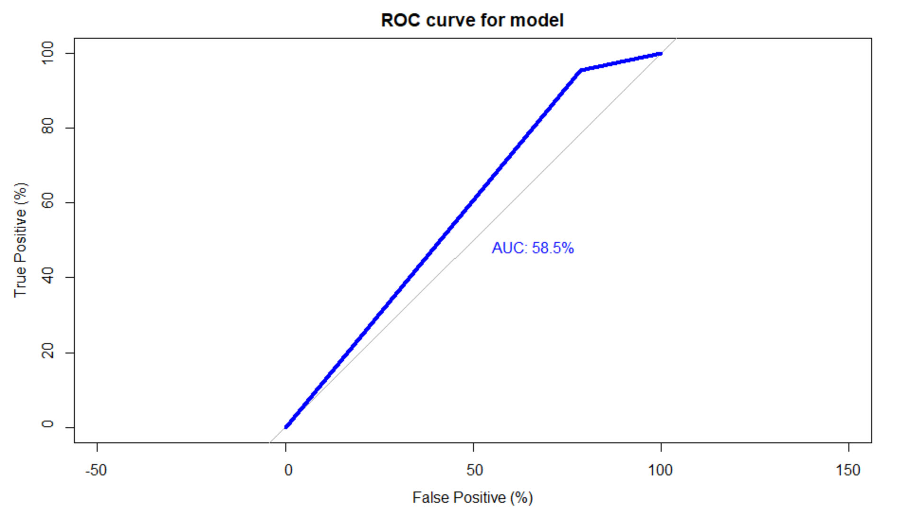
> model2<-glm(as.factor(banking_crisis)~Africa_data$domestic_debt_in_default+Africa_data$inflation_annual_cpi+Africa_data$exch_usd,family = binomial)
> summary(model2)

Call:
glm(formula = as.factor(banking_crisis) ~ Africa_data$domestic_debt_in_default +
Africa_data$inflation_annual_cpi + Africa_data$exch_usd,
family = binomial)

Deviance Residuals:
Min 1Q Median 3Q Max
-2.5541 0.2859 0.3036 0.3281 2.3172

Coefficients:
Estimate Std. Error z value Pr(>|z|)
(Intercept) 3.10222 0.24149 12.846 < 2e-16 ***
Africa_data$domestic_debt_in_default -0.23811 0.80458 -0.296 0.767270
Africa_data$inflation_annual_cpi -0.02260 0.00647 -3.493 0.000477 ***
Africa_data$exch_usd 0.02384 0.01986 1.200 0.229979
---
Signif. codes: 0 ‘***’ 0.001 ‘**’ 0.01 ‘*’ 0.05 ‘.’ 0.1 ‘ ’ 1

(Dispersion parameter for binomial family taken to be 1)

Null deviance: 212.49 on 471 degrees of freedom
Residual deviance: 186.88 on 468 degrees of freedom
AIC: 194.88

Number of Fisher Scoring iterations: 6
exp (cbind (OR = coef (model2), confint.default (model2)))
OR 2.5 % 97.5 %
(Intercept) 22.2473683 13.8587740 35.7135050
Africa_data$domestic_debt_in_default 0.7881124 0.1628264 3.8146227
Africa_data$inflation_annual_cpi 0.9776509 0.9653314 0.9901276
Africa_data$exch_usd 1.0241264 0.9850287 1.0647760

Call:
roc.formula(formula = Africa_data$banking_crisis ~ Africa_data$prob.model2, plot = TRUE, legacy.axes = T, percent = T, xlab = "False Positive (%)", ylab = "True Positive (%)", col = "blue", lwd = 2, print.auc = T, print.auc.x = 40, main = "ROC curve for model")

Data: Africa_data$prob.model2 in 28 controls (Africa_data$banking_crisis crisis) < 444 cases (Africa_data$banking_crisis no_crisis).
Area under the curve: 78.66%
> Africa_data$prob.model2<-predict(model2, type=c("response"))
> (g <-roc(Africa_data$banking_crisis ~ Africa_data$prob.model2))

Call:
roc.formula(formula = Africa_data$banking_crisis ~ Africa_data$prob.model2)

Data: Africa_data$prob.model2 in 28 controls (Africa_data$banking_crisis crisis) < 444 cases (Africa_data$banking_crisis no_crisis).
Area under the curve: 0.7866
> roc(Africa_data$banking_crisis ~ Africa_data$prob.model2, plot=TRUE, legacy.axes=T, percent=T,
+ xlab="False Positive (%)", ylab="True Positive (%)", col="blue", lwd=2, print.auc=T, print.auc.x=40, main = "ROC curve for model")

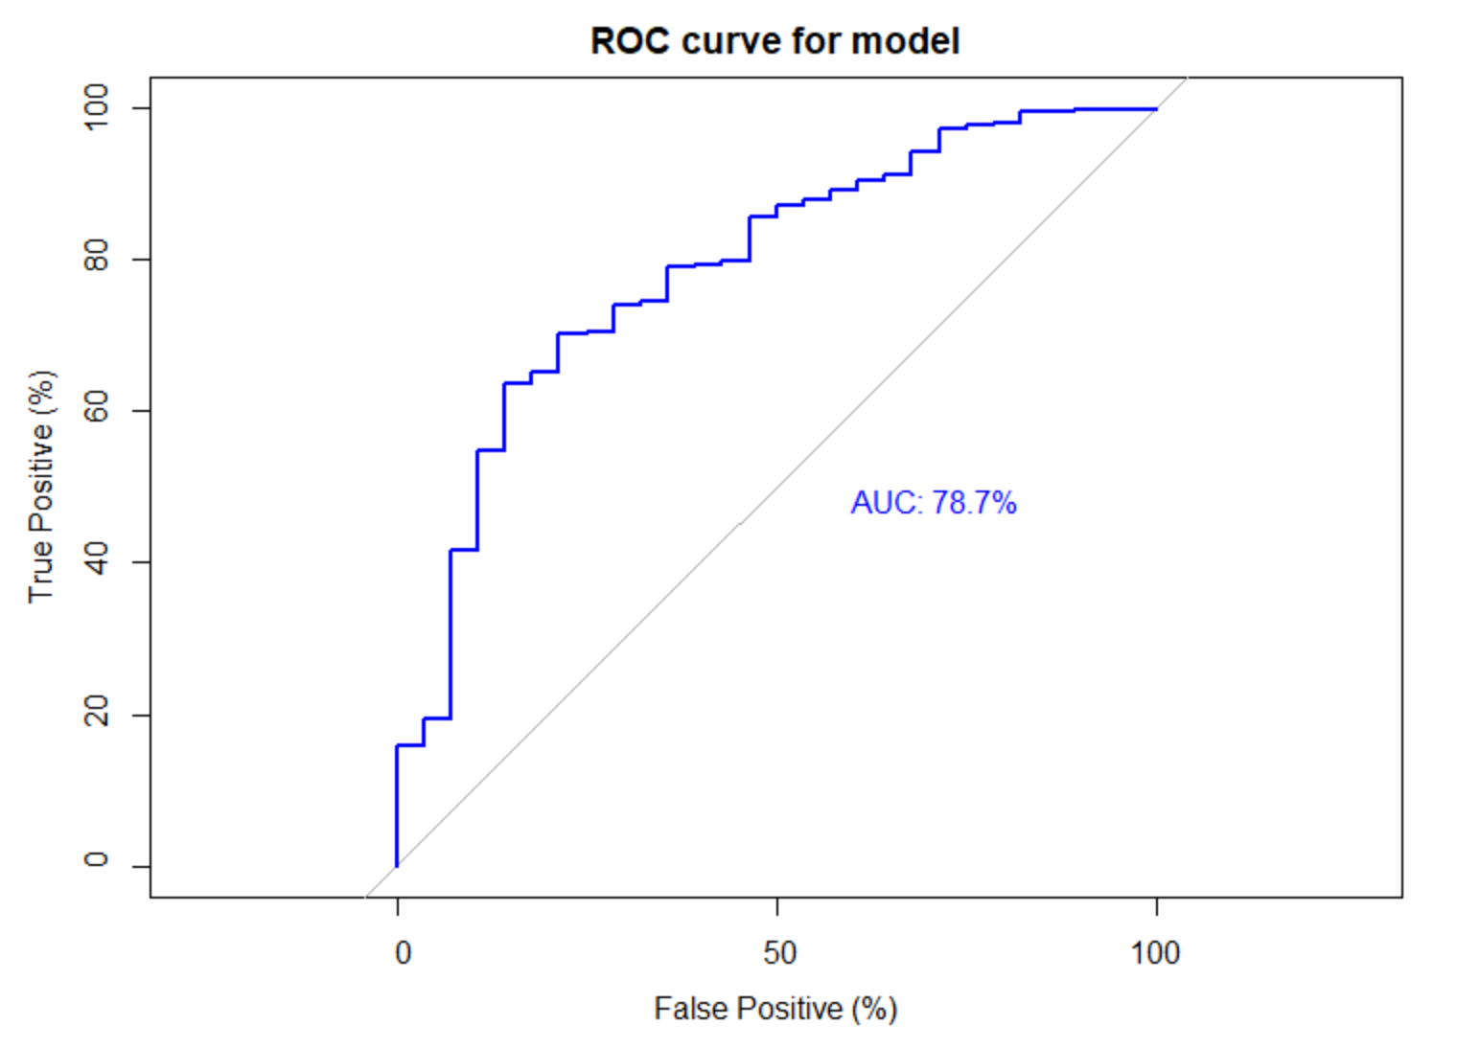

6. State Your Conclusion (no more than 100 words)
State the conclusion so that a none-statistician can understand.

After analyzing the financial stability of five African countries from 1881 to 2014, those crises are consequences of changes in exchange rate, debt, and inflation. There is an evidence that those crises in banking can be predicted by the domestic debt alone with a 58.5% sure that the model is correct. Moreover, the risk of having a banking crisis is 18.14% higher among no domestic debt as among domestic debt. Nevertheless, using debt together with exchange rate and inflation, inflation is only variable that significant enough to predict banking crisis with a 78.7% sure that the model is correct.

Solution Submission

- Fill up this word file and upload it.
- Upload your data set. This is the data set after cleaning (a small CSV file)
- Upload your R file as a file with name “mini-project-solution.R”

Grading will be done based on
- Originality of selected data set and data analysis approach
- Data Preparation set and cleanup
- General Correctness of data analysis
- Quality of your R code and output results
- Correct final conclusion

