Date 13/9/2024 shrutika Raje

Create custom VPC and Subnet

1. display already 1 default vpc

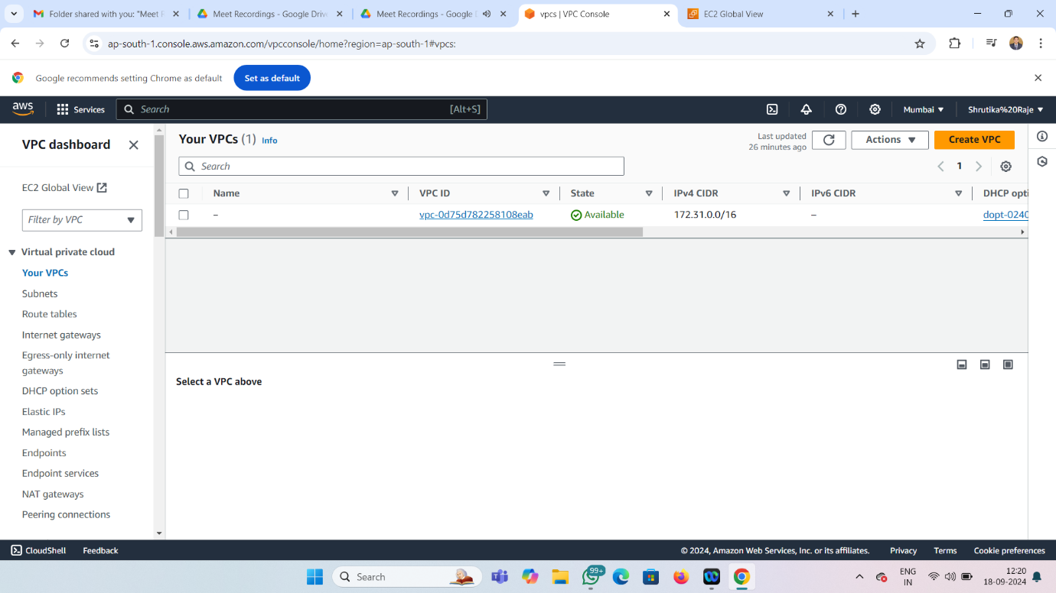

2 create vpc.

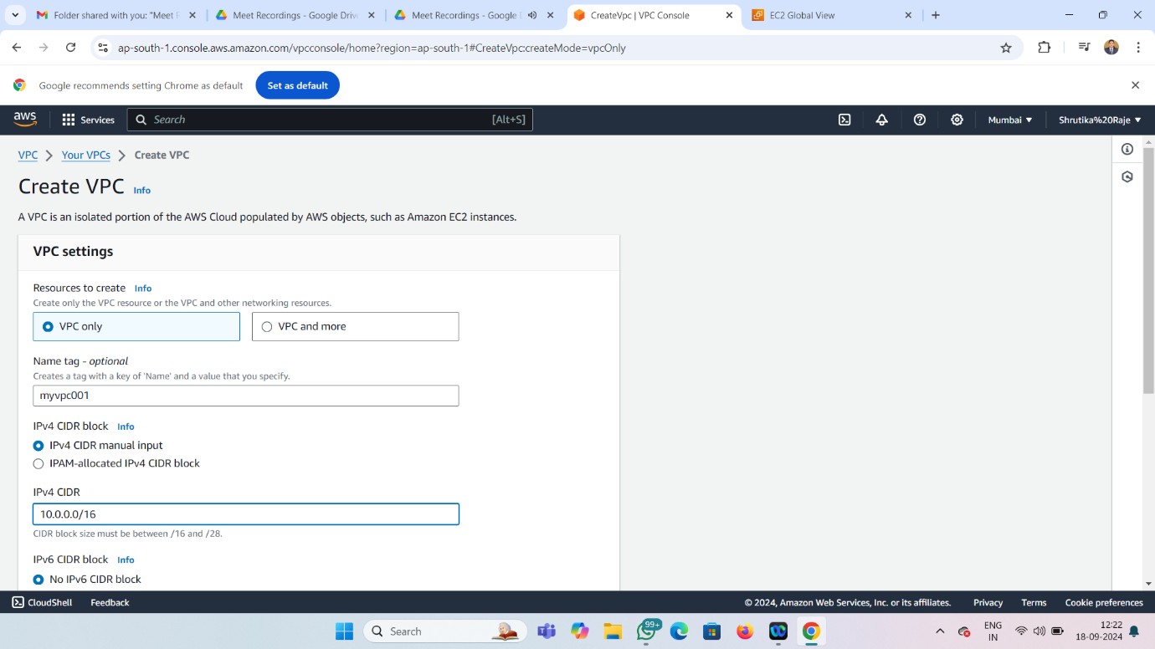

3.display default and custom vpc

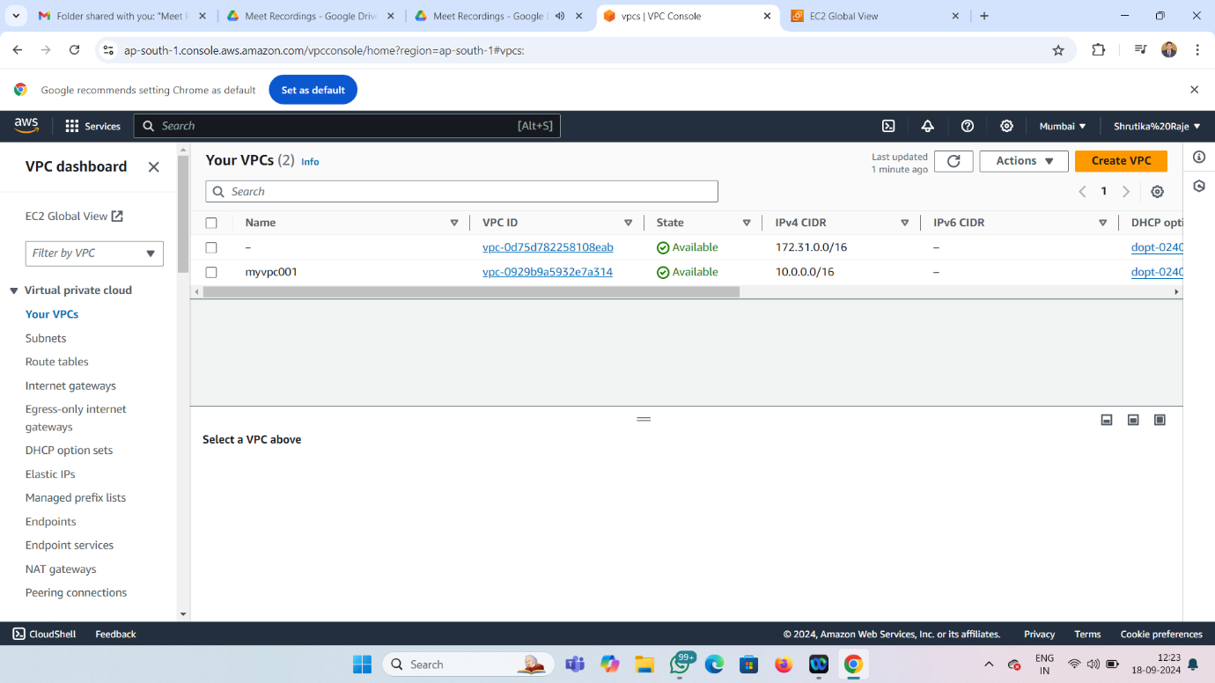

4.display already default subnet

Number of default subnet=number of AZ in the region

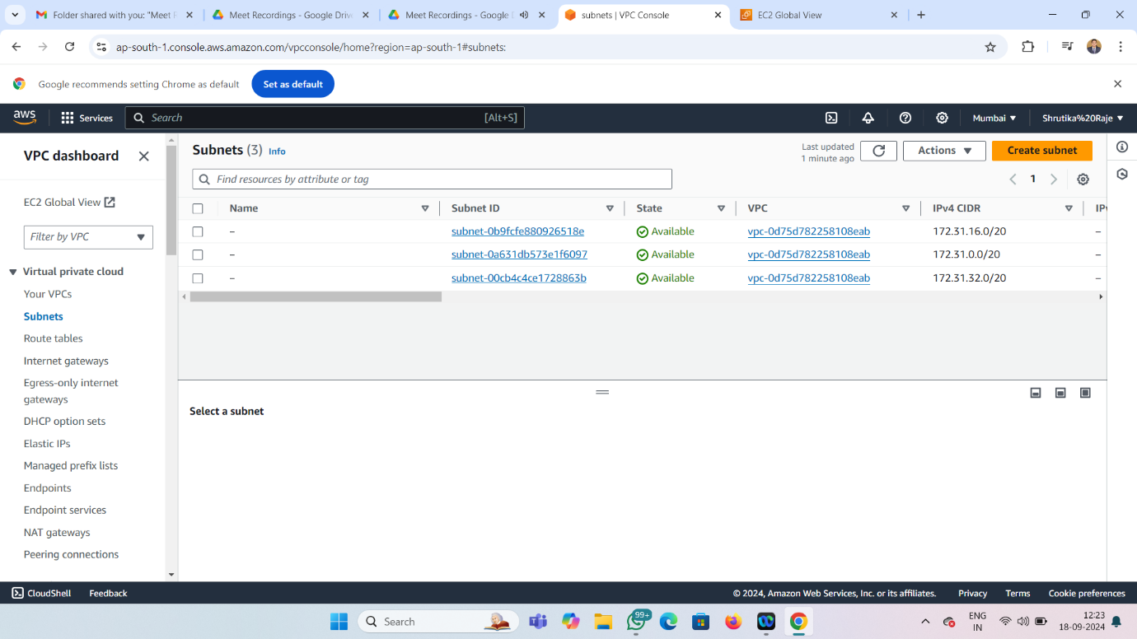

5.create custom subnet 1in custom vpc

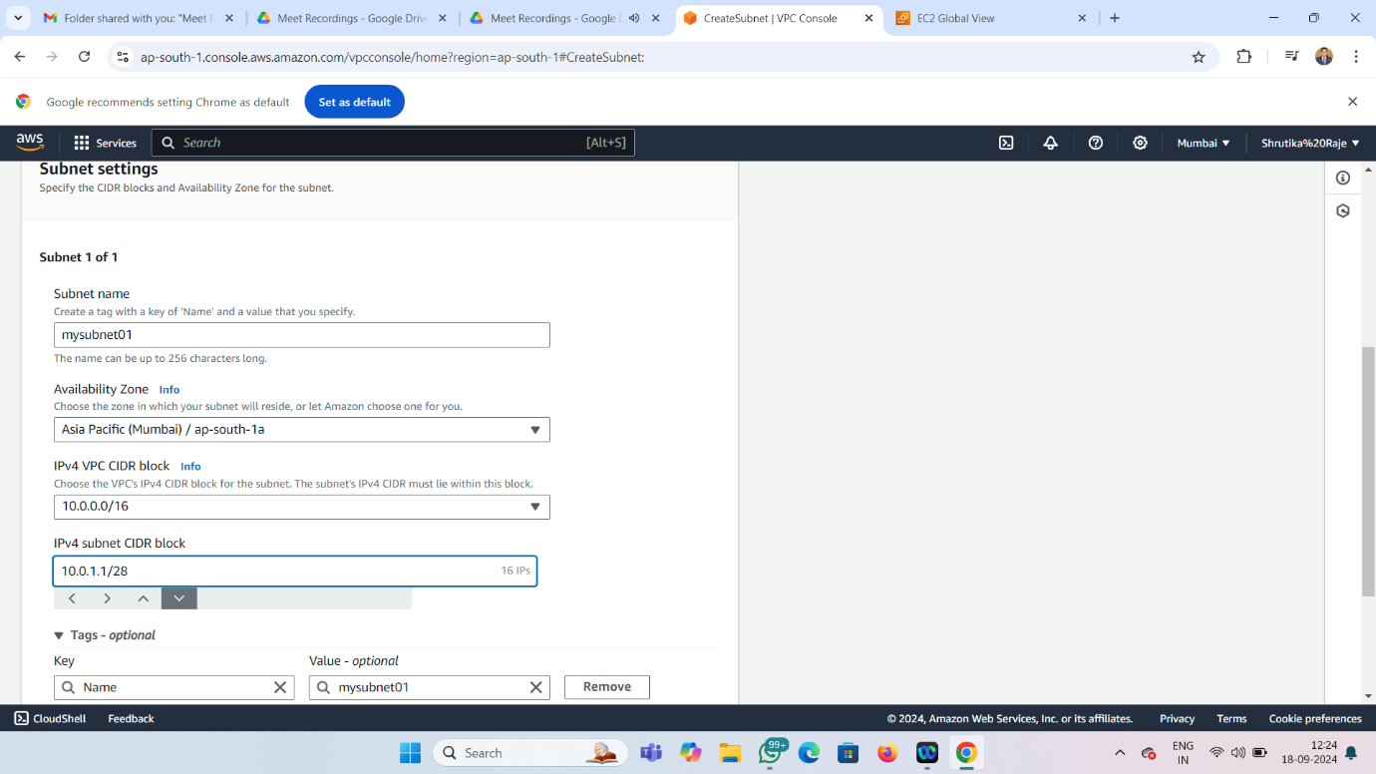

6.create custom subnet 2in custom vpc

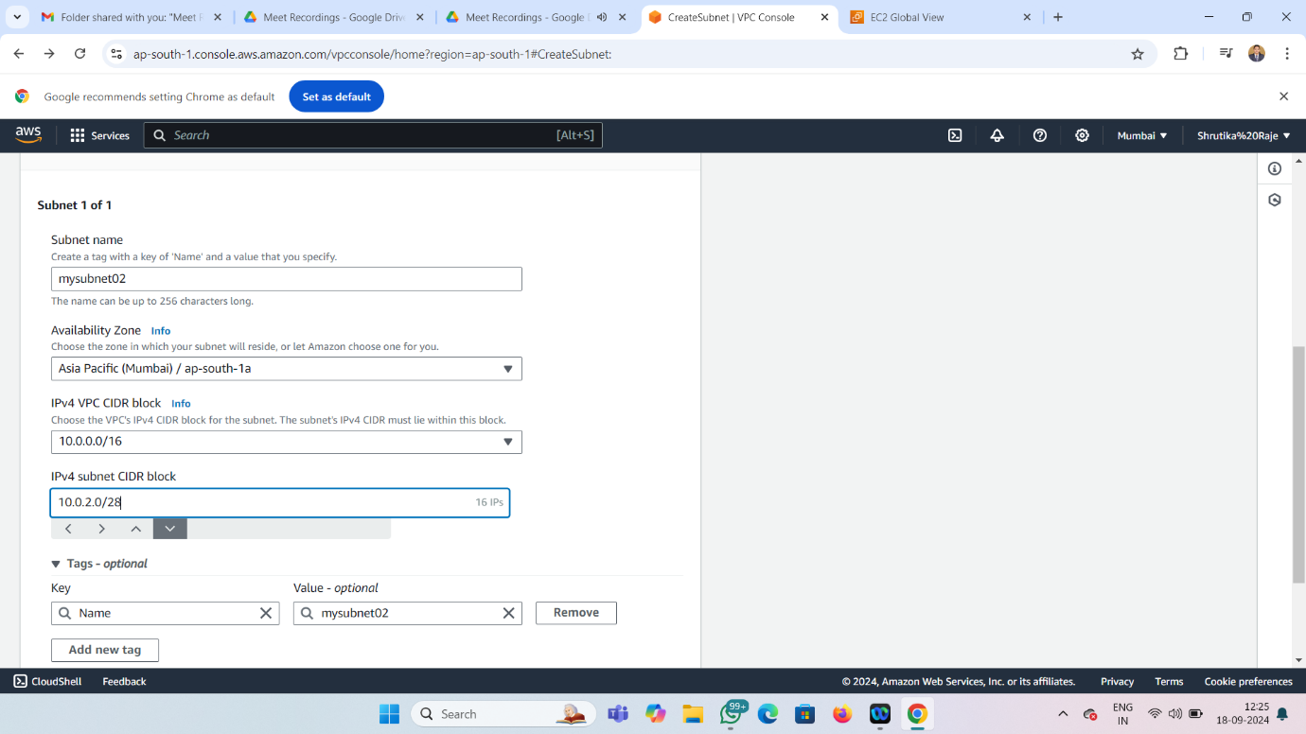

7.display all subnet in particular vpc

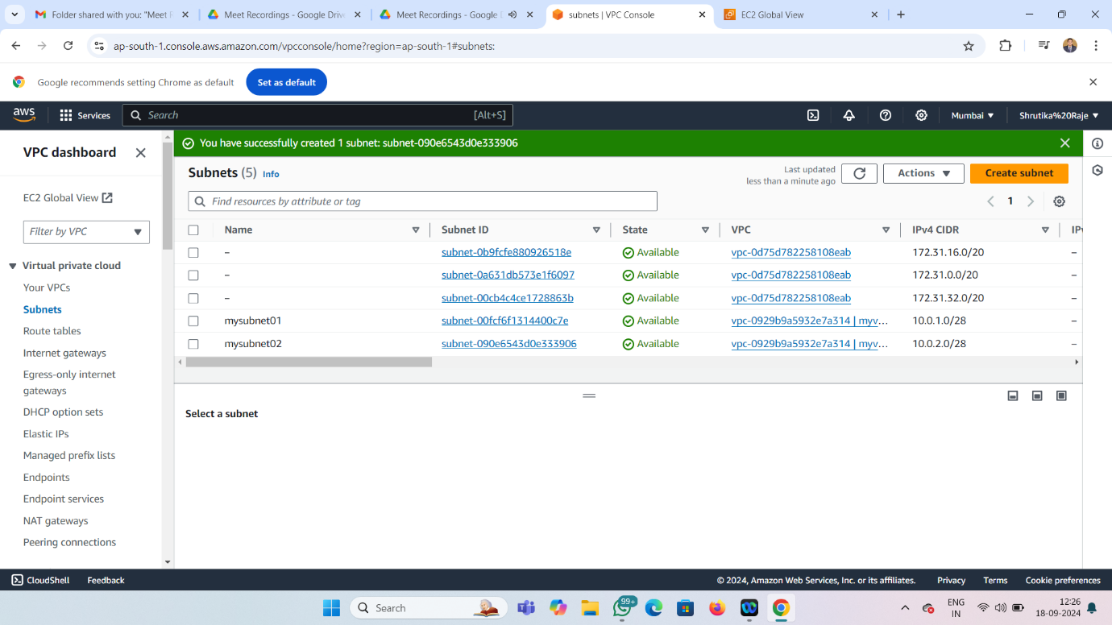



Summary:

VPC stand for virtual private network

VPC is used for creating multiple virtual network



CIDR stand for classless interdomain routing



Small CIDR=/28 =GET 11IP

Big CIDR=/16 =GET 65536IP

DIAGRAM

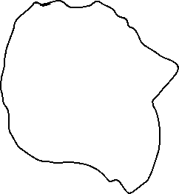

CUSTOM VPC

10.0.1.0/28

SUBNET1

SUBNET2

10.0.2.0/28