**Disaster Recovery Via Fast Deployable Optical Wireless Communication System**

**The LNM Institute of Information Technology, Jaipur**

|  |
| --- |
| **Name College ID UG/PG Course Semester** |
| Jyoti Kumari 16UEC052 UG ECE 5th |
| Shrutika Bansal 16UEC064 UG ECE 5th |
| Dr. Nikhil Sharma  (Faculty Mentor) |

**Supporting Documents:**

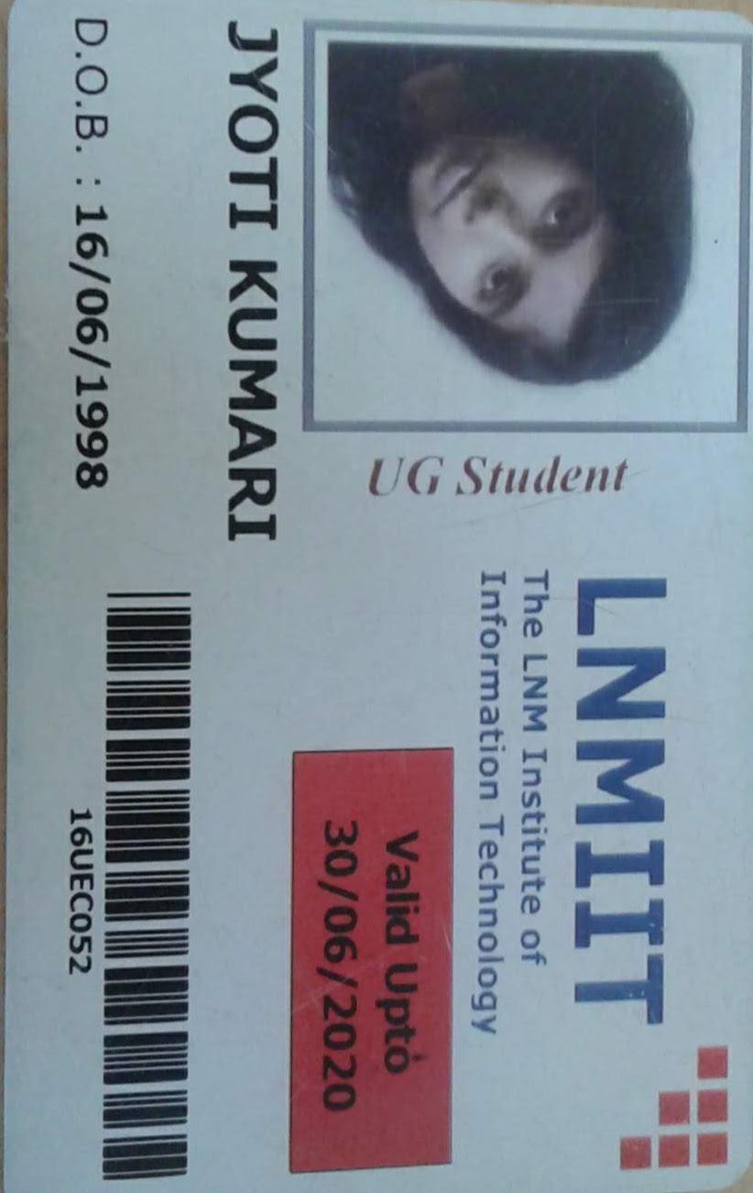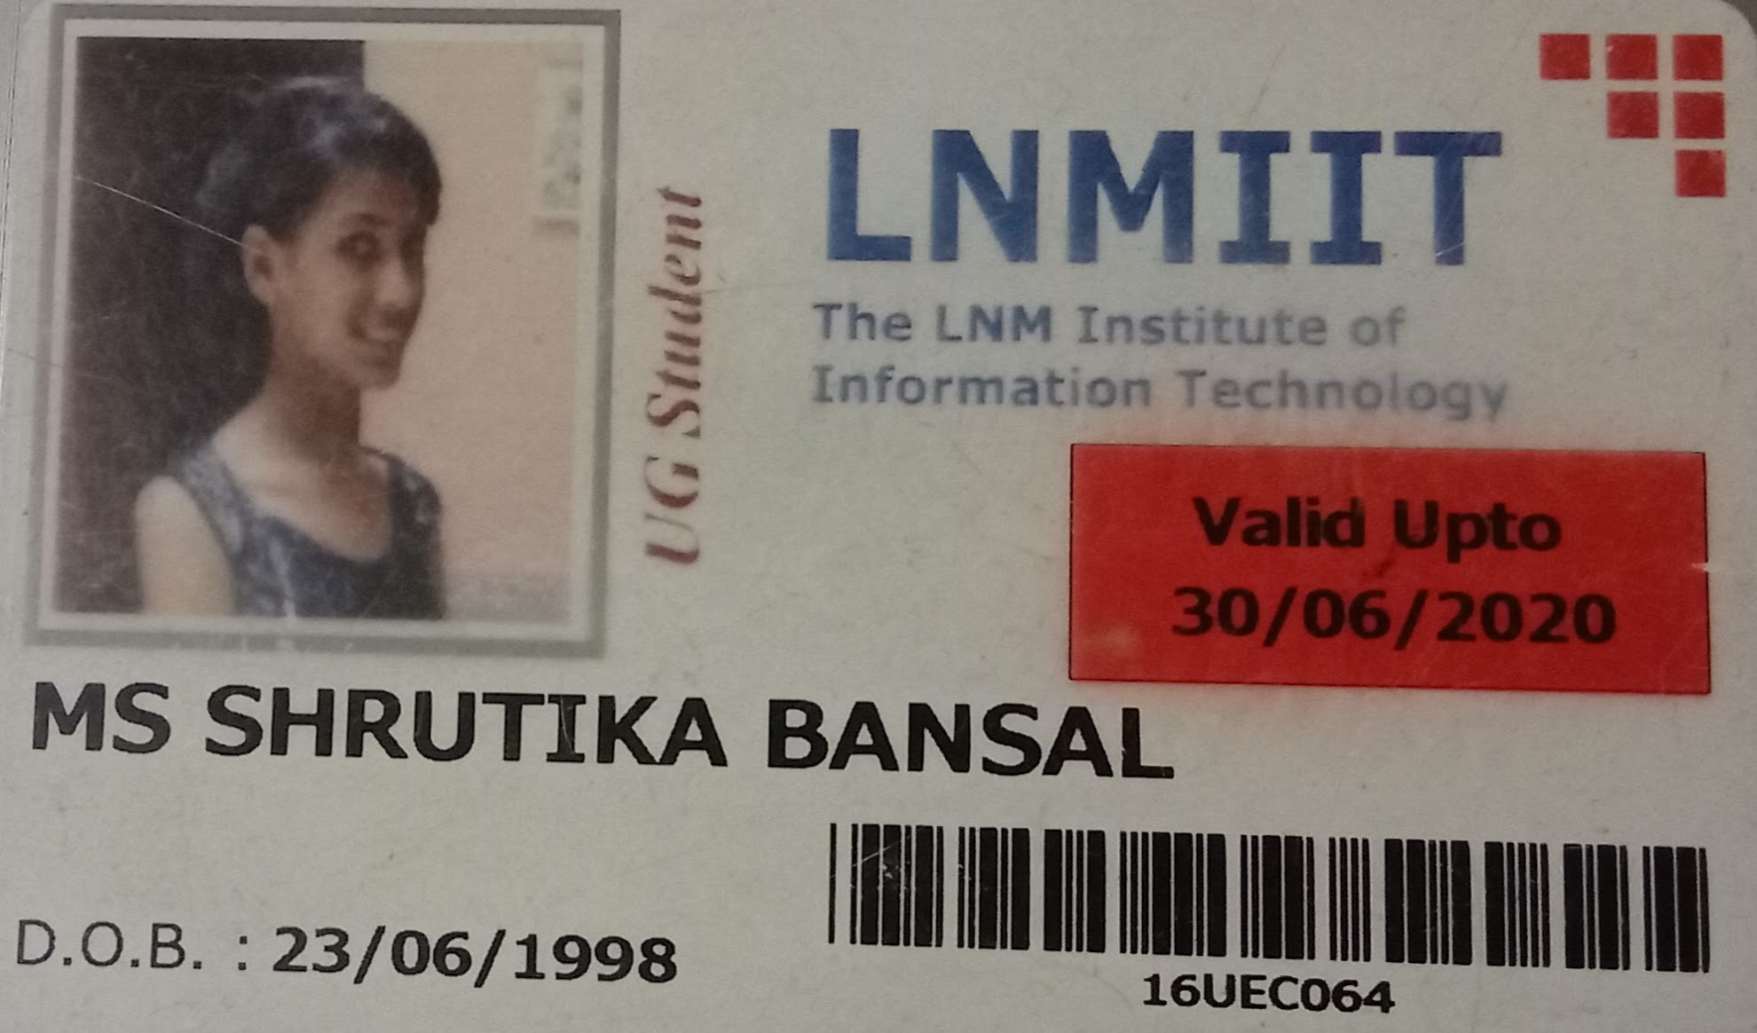

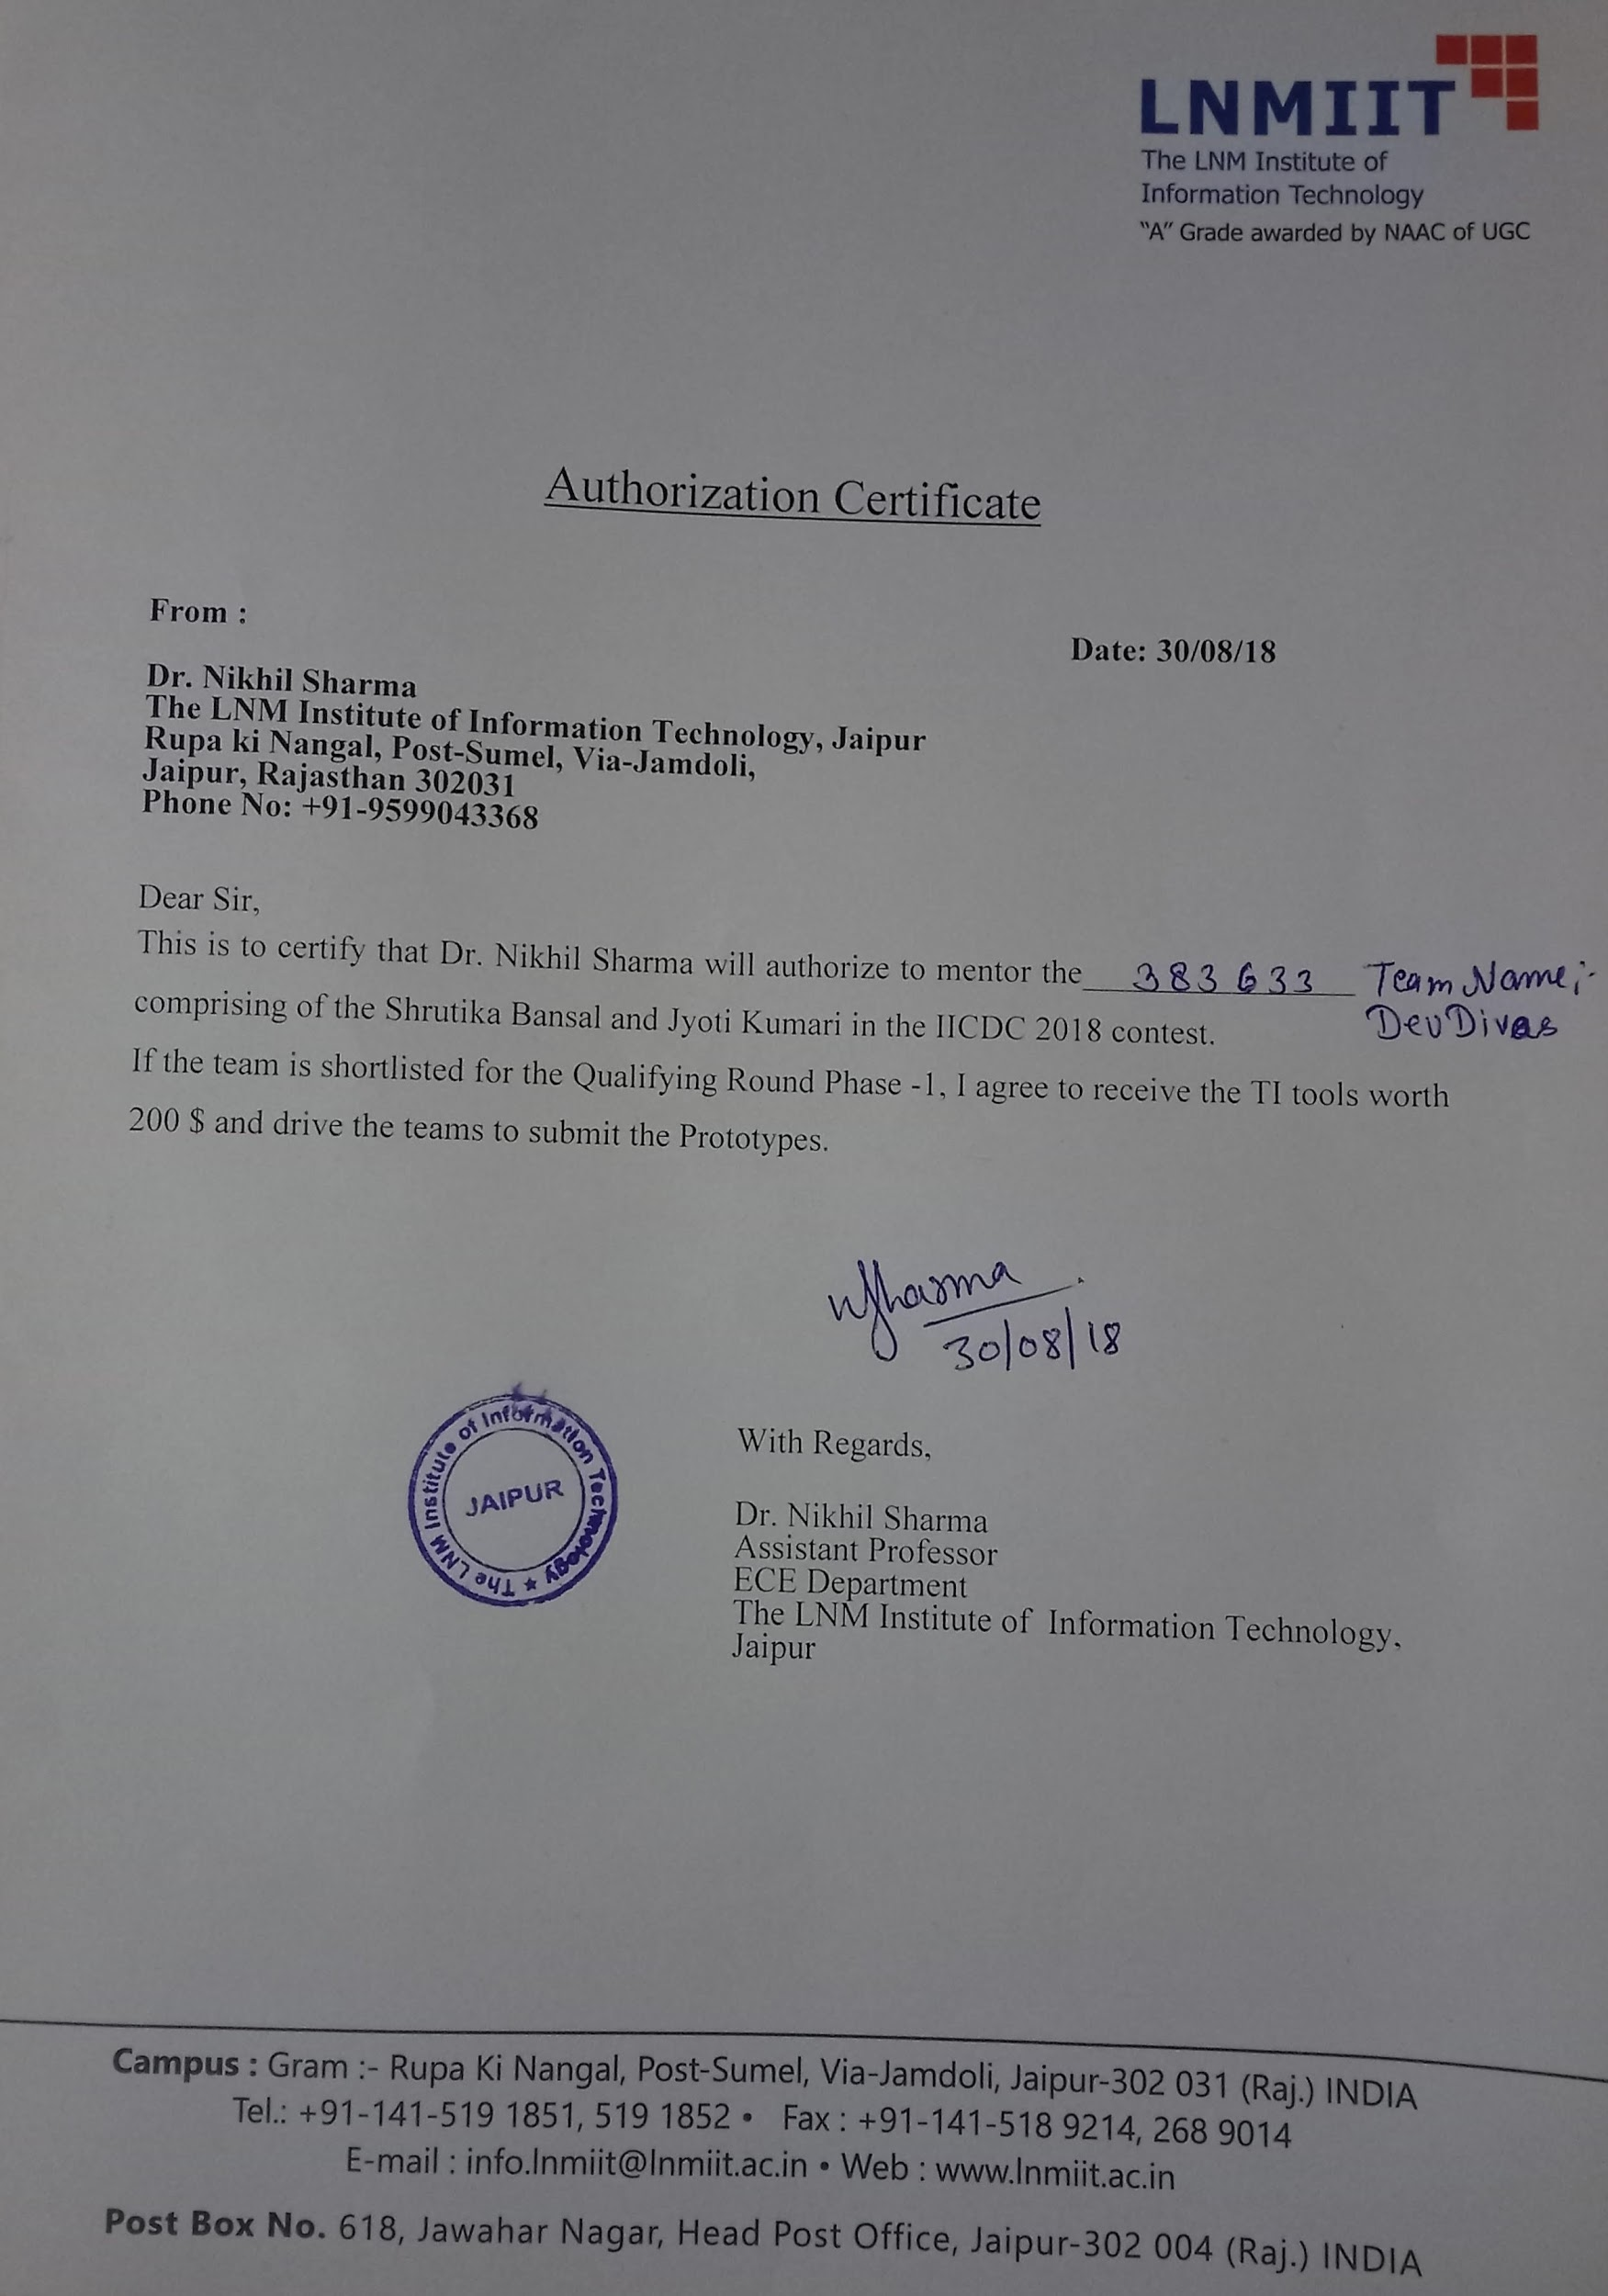

**Project Abstract:** The project will explore the elemental problem of establishing a fast deployable fail-safe type of communication link between the disaster-hit area and outside world. The key technology used here is Free Space Optical Communication (FSO). The whole setup consists mainly of a transmitter at one end and a receiver box at another end. The message is fed to the transmitter, via ethernet cable which is transmitted further. Here transmission of data is done via the light source. We use LED as a light source. When power is applied to a LED a stream of light (photons) is emitted from it. LED are semiconductor devices, which means that the brightness of the light flowing through them can be changed at extremely high speeds. This allows us to send a signal by modulating the light at different rates. The signal can then be received by a detector which interprets the changes in light intensity (the signal) as data. Received data can be accessed through various devices like Laptop, Mobile phone etc.

**Keywords -** Free-Space Optical Communication (FSO), Quick deployability, Ad-hoc robust emergency communication system, Disaster management, Trans-Receiver setup, FPGA.

**Team Members – Roles & Responsibilities :**

|  |  |  |  |
| --- | --- | --- | --- |
| **S. No.** | **Student Name** | **Role** | **Justification** |
| 1. | Jyoti Kumari | Team Leader and Operation | She has the capability to lead a team and has demonstrated her leadership skills while mentoring and motivating her team members during the projects completed earlier. Currently, she is working on a project to develop a real-time visible light communication-based Li-Fi system and she as a team leader is able to get desired results in the stipulated time frame. |
| 2. | Shrutika Bansal | Marketing and Technical | Shrutika possesses a sound knowledge of the electronic circuits and devices. She is really good in design and debugging of the electronic circuits. Moreover, she has a good understanding of public mindset and is an active member of the publicity and sponsorship team of our college. She has executed various projects and recently she has developed a proof of concept of visible light communication. |

**Market Analysis :**

**A. Customer Need Identification -**

We did a lot of research about the disaster and analyzed that lack of immediate communication between the disaster-hit area and the government relief centers further aggravates the situation and causes a massive loss of life and property. According to a report of Telecom Regulatory Authority of India (TRAI) one of the major problems faced during some of the devastating disasters like Gujarat earthquake (2001), Indian Ocean Tsunami (2004), Uttarakhand flash floods (2013) was lack of availability of immediate communication setup leading to poor communication to the state authorities and the affected area, thus delaying the whole relief mission.

**B. Serviceable Addressable Market (SAM) Identification & Justification -**

Some of the potential markets for our service composition includes -

* States that suffers frequent natural disasters like landslides, cyclone, flood, earthquake etc should have alternatives to the traditional communication system. National Disaster Management Authority of India, National Disaster Response Force (NDRF), The National Institute of Disaster Management (NIDM) etc can be approached for the funding process to develop a full commercial setup in view of national safety.
* Schools and colleges can be approached to make students aware of this new technology. Disaster management institutions like National Information Centre of Earthquake Engineering IIT Kanpur, Disaster Mitigation and Management Centre - Dehradun, National Institute of Disaster Management - New Delhi, Indian Institute of Ecology and Environment (IIEE) - New Delhi, Disaster Management Institute - Bhopal can be particularly approached.
* Radio stations can be the best way of communication between government and affected people. Even when a natural calamity occurs and communication infrastructure will be hampered, the setup can be done in a few hours and hence setting up the connection between the disaster-hit area and outside world.

**C. Product Differentiation w.r.t. Competition & Justification -**

There has been no significant ongoing effort in the country on technologies for national-level disaster recovery support. As per our research, Disaster management agencies of India still doesn’t have a fast deployable communication system which hampers relief work also.This project will be unique initiative in the disaster management field not only because of its fast deployability but also because it uses Free-space optical communication for data transmission.

**D. Understanding of your customer & user -**

**Customer-** National Disaster Management Agencies, Schools, Colleges, research centers, Radio stations.

**User-** People affected by natural calamity, research scholars.

**E. Distribution Channel Identification -**

A final product in the form of an ad-hoc robust emergency communication system will be developed through this project and The initial field testing of the FSO system model for inter-building transmission will be done in the LNMIIT campus. Further, the real-time testing for different weather conditions will be done in the difficult mountainous terrains in Jamdoli, Jaipur. After successful testing of equipment, different institutions like National Disaster Management agencies, Disaster management schools, research labs of different institutions, Broadcast stations (TV, Radio) will be contacted for funding.

**Proposed Design :**

**A. Objective -**

The team members have the primary interest in the hardware implementation of a quickly deployable real-time free space optical link. The faculty mentor, Dr. Nikhil Sharma has extensive experience on the design and analysis of free space optical communication systems, developments of algorithms for networking in FSO systems, FSO system performance evaluation and assessments and is seriously involved in mentoring interested students at LNMIIT. The main objective of this project is to exploit the virtues of networking topologies for FSO links to propose a cost-effective generic topology and routing control scheme to make the FSO network survivable under hostile weather conditions. And also to develop the system algorithm for effective networking to meet the target performance criteria. The technical objectives of the project are intertwined as follows:

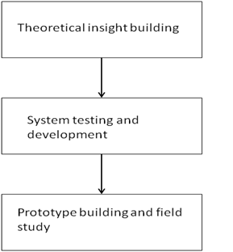

Theoretical insight building: To study via mathematical modeling, analysis and simulation of the limits of free space optical communication system to identify the key parameters and their impact on the performance of the proposed system. Identification of these parameters and their impact will reveal the deep insights into the feasibility of the FSO communication system practically. Further developing robust algorithms to design a fail-safe type of reconfigurable FSO system;  
  
System testing and development:There are some basic limitations associated with the practical FSO system, specifically the hardware imperfections such as phase noise, I/Q imbalance, power amplifier non-linearity and non-flat frequency response of analog technique. Therefore, the next step in this project will be to develop an experimental test-bench to test the existing performance analysis and propose an improved analysis which can be a ready reference for further research works based on FSO systems.  
Further, to achieve a novel design methodology along with a software/hardware system and associated high-level tools for implementation of FSO systems on modern FPGAs;   
  
Prototype and its field study: Enabling the use of the developed platforms for real-time applications to implement emergency ad-hoc FSO system at different locations in North India for hostile weather conditions.

**B. Proposed Solution -**

The proposed project is based on the design and implementation of a FSO link which is quickly deployable in the disaster-hit area. Such a link will be a fail-safe type of a link and would have the potential to reconfigure and establish itself again quickly even after multiple failures of the recovery link due to hostile conditions.

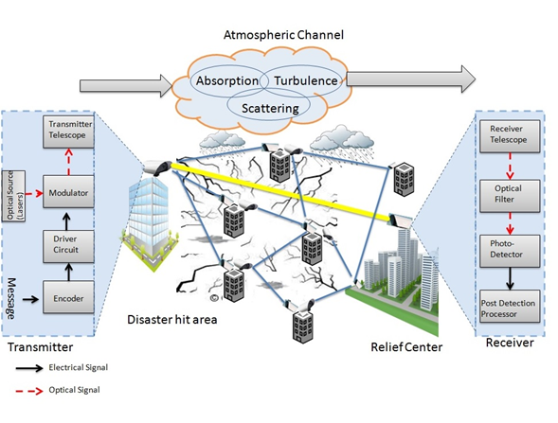

**Fig.1 Block diagram for the proposed FSO based emergency communication system**

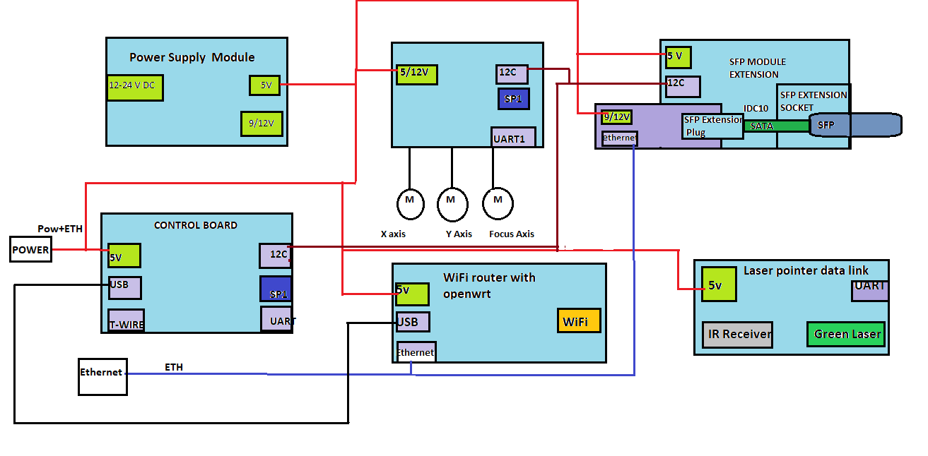 **Block diagram of Trans-Receiver setup**

|  |  |  |
| --- | --- | --- |
| **S.No.** | **Parameter** | **Value** |
| 1. | Avg. power consumption | 8-10 Watts |
| 2. | Power supply required | 24V, 0.5A |
| 3. | Attenuation   * Clear day (10Km visibility) * Moderate Fog (500m visibility) * Dense Fog (100m Visibility) * Very Dense Fog (50m Visibility) | * 0dB/Km * 1dB/Km * 4dB/Km * 10dB/Km |
| 4. | Transmission rate | 10-70 Mbps |
| 5. | Laser output power | 500mW |
| 6. | Transmitter aperture | 20cm |
| 7. | Optical carrier wavelength | 1550nm |
| 8. | Receiver Sensitivity | 2000nW |
| 9. | Link Margin (in bad weather conditions) | 7-8 dB |

**Table1: FSO link parameters**

**C. Component Used -**

|  |  |  |  |  |
| --- | --- | --- | --- | --- |
| **TI Part Number** | **Link to the Part Number** | **Qty** | **Role/Functionality** | **Available in TI Estore**  **( Y/N)** |
| OPA857 | [link](http://www.ti.com/product/opa857/toolssoftware?keyMatch=laser%20light%20detector&tisearch=Search-EN-Everything) | 2 | Transimpedance amplifier used for photodiode monitoring applications. | Y |
| LED171596A | [link](http://www.ti.com/product/LED171596A?keyMatch=led&tisearch=Search-EN-Products) | 2 | LED drivers | Y |
| TPS7A52-Q1 | [link](http://www.ti.com/product/TPS7A52-Q1?keyMatch=voltage%20regulator&tisearch=Search-EN-Products) | 2 | Voltage regulator | Y |
| TUSB1210 | [link](http://www.ti.com/product/TUSB1210/datasheet/detailed_description#SLLSE091673) | 2 | Bidirectional Trans-receiver | Y |
| TIDA-0078 | [link](http://www.ti.com/tool/TIDA-00758?keyMatch=environmental%20sensor&tisearch=Search-EN-Products) | 1 | Environmental sensor | Y |
| LP395 | [link](http://www.ti.com/product/LP395?keyMatch=transistor&tisearch=Search-EN-Products) | 4 | Transistor | Y |
| TMDSRBLED KIT | [link](http://www.ti.com/tool/TMDSRGBLEDKIT?keyMatch=LED&tisearch=Search-EN-Products) | 2 | LED | Y |
| LP5018 | [link](http://www.ti.com/product/LP5018?keyMatch=rgb%20led&tisearch=Search-EN-Products) | 2 | Used as a light source | Y |
| OMAP-L137 | [link](http://www.ti.com/product/OMAP-L137?keyMatch=COMPUTE%20MODULE%203&tisearch=Search-EN-Everything) | 2 | Core Processor | Y |
| OMAP-L132 | [link](http://www.ti.com/product/OMAP-L132?keyMatch=COMPUTE%20MODULE%203&tisearch=Search-EN-Everything) | 2 | Core Processor | Y |

**Table- 2**

|  |  |  |
| --- | --- | --- |
| **Non - TI Parts** | **Role/Functionality** | **Quantity** |
| Plano-convex lens(50mm NBK7 ) | To reflect and absorb the laser light | 2 |
| SFP cage – data, 100 Mbps Ethernet | * Interfaces a standard SFP module and socket as an extension board * Allows external I2C communication to the SFP module | 2 |
| IR detector card | To observe the light | 2 |
| Webcam | For alignment of transmitter and receiver | 2 |
| LAN9512-JZX | For multi-port USB connectivity | 4 |
| Raspberry PI (RPi.GPIO.PyPI) | Programming chip | 2 |
| Ethernet RJ45 (cable) | For connectivity | 6 |

**Table-3**

|  |  |  |
| --- | --- | --- |
| **Components** | **Value** | **Quantity** |
| Resistors | * 47 kohm * 100 ohm * 33 ohm * 470 ohm * 10k ohm | * 4 * 4 * 5 * 8 * 4 |
| Capacitors | * 100nF * 1 mF * 10mF * 20pF * 33pF * 47 mF | * 25 * 5 * 8 * 10 * 10 * 10 |
| Inductors | * 1 mH * 4.7 mH | * 8 * 8 |

**Table-4**

**Innovativeness of the Proposed Solution :**

The most vital feature of this project is its quick deployability. In gift situation, there hardly is any technology which offers a whole new communication setup in just few hours; the proposed project would serve the purpose. FSO communication uses an optical carrier of wavelength 1550 nm to establish terrestrial links within the earth’s atmosphere. Some of the situation, inherent benefits of FSO links are that they offer extremely high bandwidth, ease of deployment, unlicensed spectrum allocation, reduced power consumption (~ 1/2 of RF), reduced size (~1/10 the diameter of RF antenna) and improved channel security. The transmission rate in the range of 10-70 Mbps is expected to be easily achieved which is adequate enough for picture and video transmission from the point disaster location. The proposal envisages a comprehensive approach to the design issues related to the architectural planning, physical layer alternatives and their impact on theoretical

design, simulation and hardware implementation provisioning for low-power flexible ad-hoc FSO links. Moreover, the development of the system based on the optimal networking of the FSO trans-receivers system, which could work even in the worst weather conditions, adds to the novelty of the proposed system.

**Impact of the proposed solution :**

**Economic (Cost-benefit analysis)** **-**

The relationship socio-economic development and natural disaster remain at the fore of global discussions. An efficient disaster recovery system may limit the losses and can benefit the society in a big way.

**Employment generation -**

The natural disaster hampers the development opportunity.

Thus, tackling the disaster will lead to the development of the place and lead to employment generation.

**Social -**

The cost of a disaster in terms of life, society is equitable. Thus the project will help in social development indirectly by the efficient mechanism of disaster recovery.

**Environmental -**

Natural disasters like earthquakes, floods etc cause immense loss to our environment. The project will help in reducing this loss by an efficient disaster recovery mechanism.