**Current status and challenges:-**

**Problem faced:-**

**3.1.1 Image Transmission**

1. We are not able to retrieve the exact data values. Around 60-70% of the values obtained are correct values.

2. Data received is not arriving uniformly. Due to which we are facing problem in reconstructing back the image.

3. Calibration of the Module for the appropriate distance proved to be a challenge.

**3.2 Steps taken to overcome the problems**

1. Introducing an end marker for each data transmission.

2. Making use of guard bits at the start of transmission.

3. Making use of guard bits at the end of the transmission.

4. Padding the data segment with white spaces to prevent synchronization loss.

**Problem formulation**

Communication means have evolved to be fast, over long distances and are convenient. This has largely been possible by the use of Radio Frequencies to transmit data over long distances and instantaneously. In aerial and terrestrial applications, radio and satellite communications provide adequate speed and range. Even with the rapid advancement in throughput and data rates in terrestrial communication there is little to no advancement in the underwater scenario.Underwater scenario provides a much greater challenge in achieving wireless communication due to high absorption by water. This leads to an urgent need to find an alternative wireless communication method must be able to support data rates high enough to upload video and other sensor data. In view of the above, it is essential to explore the possibilities opened by Visible Light Communication. The proposed work is to explore VLC underwater communication.

Since humans are limited in their ability to work underwater, remotely operated vehicles (ROVs) and autonomous underwater vehicles (AUVs) have been in service since the 1950s to perform underwater tasks, such as collecting data and retrieving items. The operation of these vehicles is challenging, but as oil resources are found further, ROVs and AUVs are required to go deeper and stay deployed longer in order to perform critical tasks. One such task is monitoring a deep-sea oil well - sending tethered ROV’s thousands of meters below the surface in order to conduct surveys is expensive and time-consuming! It costs on the order of 100,000 dollars a day to operate an ROV, which can take two hours to dive to the bottom at 3000 meters. Wireless data transfer is required to provide the cost-saving benefits of stationing an AUV at a wellhead. Present underwater communication systems involve the transmission of information in the form of sound or electromagnetic (EM) waves. Since radio waves cannot be used underwater because these waves are strongly absorbed by seawater within feet of their transmission and this renders it unusable underwater.

**Motivation**

There is currently a challenge for effective underwater wireless communications due to RF absorption loss, making Wi-Fi an inefficient method of communication in underwater situations.

Present underwater communication systems involve the transmission of information in the form of sound or electromagnetic (EM) waves. Since radio waves cannot be used underwater because these waves are strongly absorbed by sea water within feet of their transmission and renders it unusable underwater.Therefore, there is a need for a robust and reliable communication system and here we explore the use of Visible Light Communication as a viable option.

**Impact on society**

**Use cases regarding the project:**

The solution to Underwater Wireless Communication and Sensor Network(UWCSN) opens the door to various uses.

1. The primary focus of its use will be for the convenience of the **Scuba divers** since it will provide for a viable communication option and vital details regarding their safety.
2. UWCSN will provide various governmental agencies/ armed forces **underwater surveillance** capabilities. For example
   1. It will be of immense use in Oil Exploration and Oil Rig maintenance and data collection in real-time.
   2. **Merchant Navy** will be immensely benefited by UWCSN.

**Rescue Operation** in Mines and Caves will become easier and drastically reduce the time to the operation of the equipment since they are lightweight, portable, low energy devices.

**Working**

**Technology Used:** Visible Light Communication(VLC), Sensor Networking, IoT; The setup will be underwater consisting of a transceiver pair where both nodes, each node can act as a transmitter as well as a receiver. The transmitter section will consist of a photon source (High powered LED) which will be mounted on the first node and the receiver will have a photon detector mounted on the second node. To cover up the losses caused in the water appropriate modulation and amplification process will be adopted. We will be using edge device technology for better user readability on the surface. Different sensors on the diver's suit will be used to acquire critical information like temperature, heartbeat and blood pressure, which will be transmitted using VLC to the surface. At the surface, RF communication modules will be used to transfer the information to a centralized server. Resulting in a dual-hop VLC-RF end-to-end communication system for acquiring underwater information

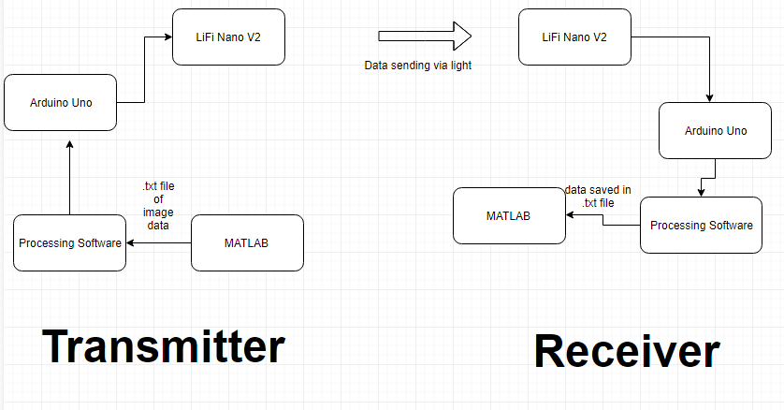

**1.Serial Data Communication**

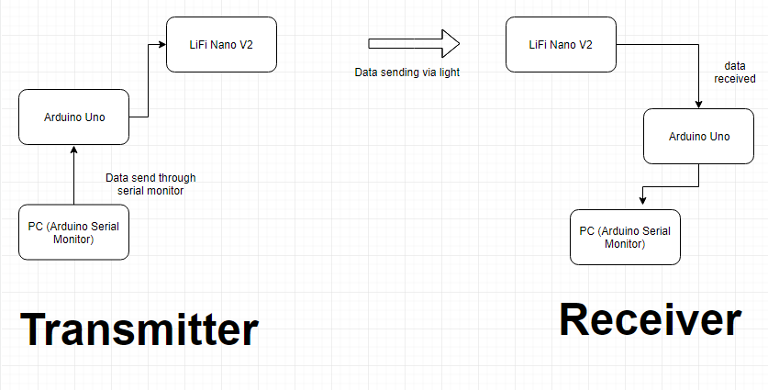

**2.Transmission of Sensor Data**

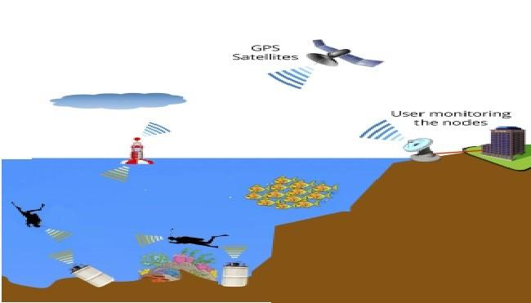

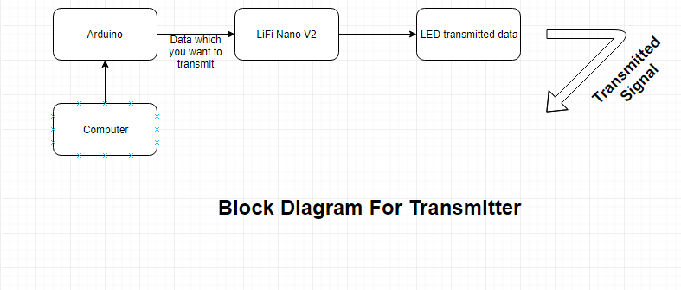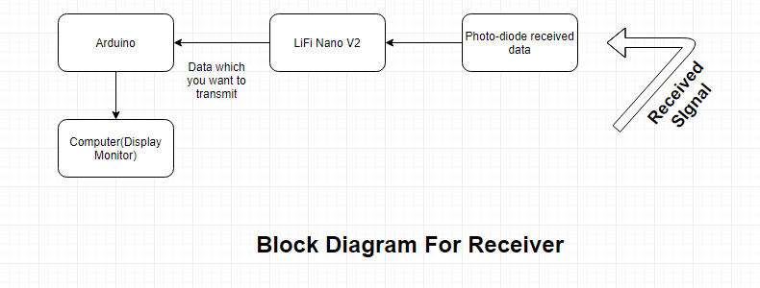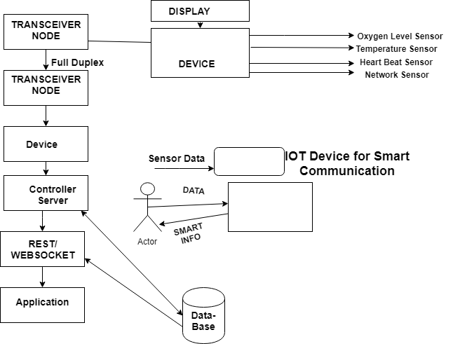

LoRa (short for long range) is a spread spectrum modulation technique derived from chirp spread spectrum (CSS) technology. LoRa devices and wireless radio frequency technology (LoRa Technology) is a long range, low power wireless platform with wide application Internet of Things (IoT) networks worldwide. LoRa Technology and the open LoRaWAN protocol enable smart IoT applications

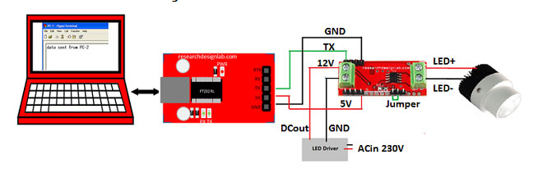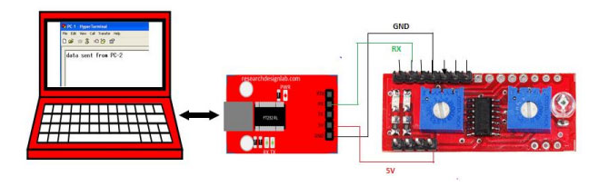

**Results:**

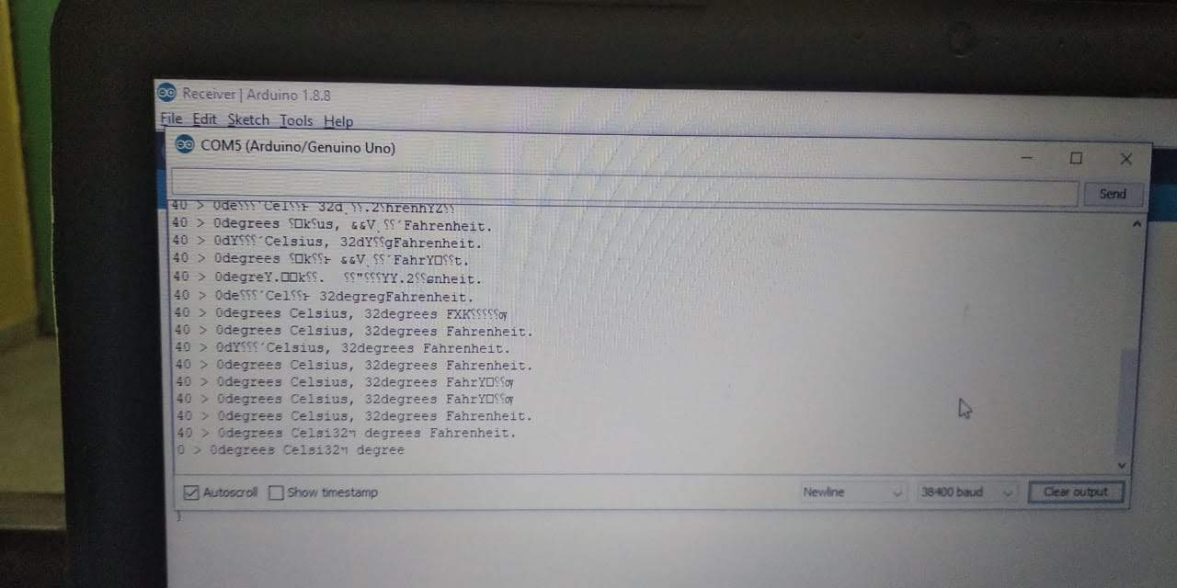

**Conclusion**

The shortcomings of RF communication in terms of spectral and bandwidth motivates the research into visible light communication. Now with the surge in LED usage has thrown open the door for many VLC potentials. One of which is LiFi capability. This, in turn, has been possible due to its fast switching capabilities. This report has sought to verify its usage as a possible data transmission means which has been successfully collaborated by the results. This report strives to enhance the physical implementation of LiFi technology for indoor purposes by making a working model of such a prototype that can be further improved upon with the basic understanding derived. Certain issues faced in the prototype are interference, noise, and shadowing which need to be further investigated. These issues are been dealt with by various research groups to make it a promising technology for the future. The results conclusively prove the versatility of LiFi as an enabling technology for the future deployment of IoT and VLC as the mode of last-mile connection in 5G. VLC can also lead to Smart Grid enhancements.

**References**

[1A]. https://en.wikipedia.org/wiki/Li-Fi [1B]. purelifi.com/technology/

[2]. Designing a Wireless Underwater Optical Communication System by Heather Brundage ,B.S. Ocean Engineering,Massachusetts Institute of Technology, 2006

[3]. What is LiFi?, Harald Haas, Liang Yin, Yunlu Wang, Cheng Chen ,JOURNAL OF LIGHTWAVE TECHNOLOGY,(1-15),2015,IEEE [4].https://lifi-information.com/limitations-and-challenges-of-li-fi/ [5].https://figshare.com/articles/Li-Fianditschallengestopracticaluse/5353195