**WEEK-7(Superset I’d-6362596)**

**ReactJS 9**

<!DOCTYPE html>

<html lang="en">

<head>

<meta charset="utf-8" />

<link rel="icon" href="%PUBLIC_URL%/favicon.ico" />

<meta name="viewport" content="width=device-width, initial-scale=1" />

<meta name="theme-color" content="#000000" />

<meta

name="description"

content="Web site created using create-react-app"

/>

<link rel="apple-touch-icon" href="%PUBLIC_URL%/logo192.png" />

<!--

manifest.json provides metadata used when your web app is installed on a

user's mobile device or desktop. See https://developers.google.com/web/fundamentals/web-app-manifest/

-->

<link rel="manifest" href="%PUBLIC_URL%/manifest.json" />

<!--

Notice the use of %PUBLIC_URL% in the tags above.

It will be replaced with the URL of the `public` folder during the build.

Only files inside the `public` folder can be referenced from the HTML.

Unlike "/favicon.ico" or "favicon.ico", "%PUBLIC_URL%/favicon.ico" will

work correctly both with client-side routing and a non-root public URL.

Learn how to configure a non-root public URL by running `npm run build`.

-->

<title>React App</title>

</head>

<body>

<noscript>You need to enable JavaScript to run this app.</noscript>

<div id="root"></div>

<!--

This HTML file is a template.

If you open it directly in the browser, you will see an empty page.

You can add webfonts, meta tags, or analytics to this file.

The build step will place the bundled scripts into the <body> tag.

To begin the development, run `npm start` or `yarn start`.

To create a production bundle, use `npm run build` or `yarn build`.

-->

</body>

</html>

{

"short_name": "React App",

"name": "Create React App Sample",

"icons": [

{

"src": "favicon.ico",

"sizes": "64x64 32x32 24x24 16x16",

"type": "image/x-icon"

},

{

"src": "logo192.png",

"type": "image/png",

"sizes": "192x192"

},

{

"src": "logo512.png",

"type": "image/png",

"sizes": "512x512"

}

],

"start_url": ".",

"display": "standalone",

"theme_color": "#000000",

"background_color": "#ffffff"

}

# https://www.robotstxt.org/robotstxt.html

User-agent: *

Disallow:

**Components:-**

import React from 'react';

function ListOfPlayers({ players }) {

return (

<ul>

{players.map((item, index) => (

<li key={index}>

Mr. {item.name} <span>{item.score}</span>

</li>

))}

</ul>

);

}

export default ListOfPlayers;

import React from 'react';

function MergedPlayers({ IndianPlayers }) {

return (

<ul>

{IndianPlayers.map((player, index) => (

<li key={index}>Mr. {player}</li>

))}

</ul>

);

}

export default MergedPlayers;

import React from 'react';

export function OddPlayers([first, , third, , fifth]) {

return (

<ul>

<li>First: {first}</li>

<li>Third: {third}</li>

<li>Fifth: {fifth}</li>

</ul>

);

}

export function EvenPlayers([, second, , fourth, , sixth]) {

return (

<ul>

<li>Second: {second}</li>

<li>Fourth: {fourth}</li>

<li>Sixth: {sixth}</li>

</ul>

);

}

import React from 'react';

function ScoreBelow70({ players }) {

const filtered = players.filter((item) => item.score < 70);

return (

<ul>

{filtered.map((item, index) => (

<li key={index}>

Mr. {item.name} <span>{item.score}</span>

</li>

))}

</ul>

);

}

export default ScoreBelow70;

**Src:-**

App {

text-align: center;

}

.App-logo {

height: 40vmin;

pointer-events: none;

}

@media (prefers-reduced-motion: no-preference) {

.App-logo {

animation: App-logo-spin infinite 20s linear;

}

}

.App-header {

background-color: #282c34;

min-height: 100vh;

display: flex;

flex-direction: column;

align-items: center;

justify-content: center;

font-size: calc(10px + 2vmin);

color: white;

}

.App-link {

color: #61dafb;

}

@keyframes App-logo-spin {

from {

transform: rotate(0deg);

}

to {

transform: rotate(360deg);

}

}

import React from 'react';

import ListOfPlayers from './components/ListOfPlayers';

import ScoreBelow70 from './components/ScoreBelow70';

import { OddPlayers, EvenPlayers } from './components/OddEvenPlayers';

import MergedPlayers from './components/MergedPlayers';

function App() {

const flag = true;

const players = [

{ name: 'Jack', score: 50 },

{ name: 'Michael', score: 70 },

{ name: 'John', score: 40 },

{ name: 'Ann', score: 61 },

{ name: 'Elisabeth', score: 61 },

{ name: 'Sachin', score: 95 },

{ name: 'Dhoni', score: 100 },

{ name: 'Virat', score: 84 },

{ name: 'Jadeja', score: 64 },

{ name: 'Raina', score: 75 },

{ name: 'Rohit', score: 80 },

];

const IndianTeam = ['Sachin1', 'Dhoniz', 'Virat3', 'Rohit4', 'Yuvarajs', 'Raina6'];

const T20Players = ['First Player', 'Second Player', 'Third Player'];

const RanjiTrophyPlayers = ['Fourth Player', 'Fifth Player', 'Sixth Player'];

const IndianPlayers = [...T20Players, ...RanjiTrophyPlayers];

if (flag) {

return (

<div>

<h1>List of Players</h1>

<ListOfPlayers players={players} />

<hr />

<h1>List of Players having Scores Less than 70</h1>

<ScoreBelow70 players={players} />

</div>

);

} else {

return (

<div>

<h1>Indian Team</h1>

<h2>Odd Players</h2>

{OddPlayers(IndianTeam)}

<hr />

<h2>Even Players</h2>

{EvenPlayers(IndianTeam)}

<hr />

<h2>List of Indian Players Merged:</h2>

<MergedPlayers IndianPlayers={IndianPlayers} />

</div>

);

}

}

export default App;

import { render, screen } from '@testing-library/react';

import App from './App';

test('renders learn react link', () => {

render(<App />);

const linkElement = screen.getByText(/learn react/i);

expect(linkElement).toBeInTheDocument();

});

body {

margin: 0;

font-family: -apple-system, BlinkMacSystemFont, 'Segoe UI', 'Roboto', 'Oxygen',

'Ubuntu', 'Cantarell', 'Fira Sans', 'Droid Sans', 'Helvetica Neue',

sans-serif;

-webkit-font-smoothing: antialiased;

-moz-osx-font-smoothing: grayscale;

}

code {

font-family: source-code-pro, Menlo, Monaco, Consolas, 'Courier New',

monospace;

}

import React from 'react';

import ReactDOM from 'react-dom/client';

import './index.css';

import App from './App';

import reportWebVitals from './reportWebVitals';

const root = ReactDOM.createRoot(document.getElementById('root'));

root.render(

<React.StrictMode>

<App />

</React.StrictMode>

);

// If you want to start measuring performance in your app, pass a function

// to log results (for example: reportWebVitals(console.log))

// or send to an analytics endpoint. Learn more: https://bit.ly/CRA-vitals

reportWebVitals();

const reportWebVitals = onPerfEntry => {

if (onPerfEntry && onPerfEntry instanceof Function) {

import('web-vitals').then(({ getCLS, getFID, getFCP, getLCP, getTTFB }) => {

getCLS(onPerfEntry);

getFID(onPerfEntry);

getFCP(onPerfEntry);

getLCP(onPerfEntry);

getTTFB(onPerfEntry);

});

}

};

export default reportWebVitals;

import '@testing-library/jest-dom';

{

"name": "cricketapp",

"version": "0.1.0",

"private": true,

"dependencies": {

"@testing-library/dom": "^10.4.1",

"@testing-library/jest-dom": "^6.6.4",

"@testing-library/react": "^16.3.0",

"@testing-library/user-event": "^13.5.0",

"react": "^19.1.1",

"react-dom": "^19.1.1",

"react-scripts": "5.0.1",

"web-vitals": "^2.1.4"

},

"scripts": {

"start": "react-scripts start",

"build": "react-scripts build",

"test": "react-scripts test",

"eject": "react-scripts eject"

},

"eslintConfig": {

"extends": [

"react-app",

"react-app/jest"

]

},

"browserslist": {

"production": [

">0.2%",

"not dead",

"not op_mini all"

],

"development": [

"last 1 chrome version",

"last 1 firefox version",

"last 1 safari version"

]

}

}

**Output:-**

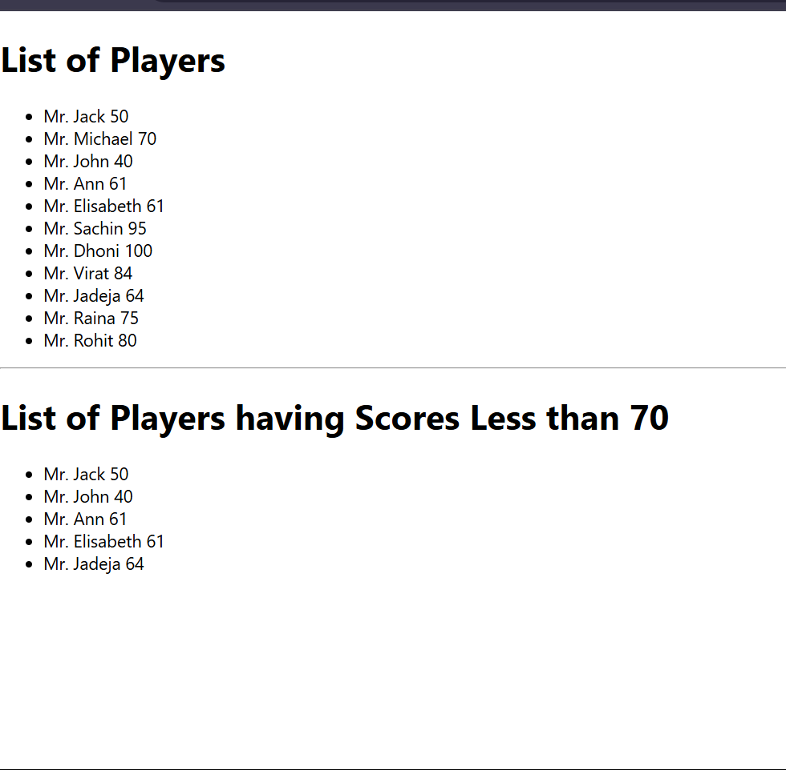

**ReactJS 10**

.App {

text-align: center;

}

.App-logo {

height: 40vmin;

pointer-events: none;

}

@media (prefers-reduced-motion: no-preference) {

.App-logo {

animation: App-logo-spin infinite 20s linear;

}

}

.App-header {

background-color: #282c34;

min-height: 100vh;

display: flex;

flex-direction: column;

align-items: center;

justify-content: center;

font-size: calc(10px + 2vmin);

color: white;

}

.App-link {

color: #61dafb;

}

@keyframes App-logo-spin {

from {

transform: rotate(0deg);

}

to {

transform: rotate(360deg);

}

.textRed {

color: red;

}

.textGreen {

color: green;

}

.App {

font-family: Arial, sans-serif;

padding: 20px;

}

}

import React from "react";

const officeList = [

{ Name: "DBS", Rent: 50000, Address: "Chennai" },

{ Name: "Regus", Rent: 70000, Address: "Bangalore" },

{ Name: "SmartWorks", Rent: 65000, Address: "Mumbai" }

];

function App() {

return (

<div>

<h1>Office Space at Affordable Range</h1>

{/* ✅ Load image from public folder */}

<img src="/office.jpg" width="25%" height="25%" alt="Office Space" />

{officeList.map((office, index) => {

const rentColor = office.Rent <= 60000 ? "red" : "green";

return (

<div key={index}>

<h2>Name: {office.Name}</h2>

<h3 style={{ color: rentColor }}>Rent: Rs. {office.Rent}</h3>

<h3>Address: {office.Address}</h3>

</div>

);

})}

</div>

);

}

export default App;

import { render, screen } from '@testing-library/react';

import App from './App';

test('renders learn react link', () => {

render(<App />);

const linkElement = screen.getByText(/learn react/i);

expect(linkElement).toBeInTheDocument();

});

body {

margin: 0;

font-family: -apple-system, BlinkMacSystemFont, 'Segoe UI', 'Roboto', 'Oxygen',

'Ubuntu', 'Cantarell', 'Fira Sans', 'Droid Sans', 'Helvetica Neue',

sans-serif;

-webkit-font-smoothing: antialiased;

-moz-osx-font-smoothing: grayscale;

}

code {

font-family: source-code-pro, Menlo, Monaco, Consolas, 'Courier New',

monospace;

}

import React from 'react';

import ReactDOM from 'react-dom/client';

import './index.css';

import App from './App';

import reportWebVitals from './reportWebVitals';

const root = ReactDOM.createRoot(document.getElementById('root'));

root.render(

<React.StrictMode>

<App />

</React.StrictMode>

);

// If you want to start measuring performance in your app, pass a function

// to log results (for example: reportWebVitals(console.log))

// or send to an analytics endpoint. Learn more: https://bit.ly/CRA-vitals

reportWebVitals();

const reportWebVitals = onPerfEntry => {

if (onPerfEntry && onPerfEntry instanceof Function) {

import('web-vitals').then(({ getCLS, getFID, getFCP, getLCP, getTTFB }) => {

getCLS(onPerfEntry);

getFID(onPerfEntry);

getFCP(onPerfEntry);

getLCP(onPerfEntry);

getTTFB(onPerfEntry);

});

}

};

export default reportWebVitals;

import '@testing-library/jest-dom';

{

"name": "officespacerentalapp",

"version": "0.1.0",

"private": true,

"dependencies": {

"@testing-library/dom": "^10.4.1",

"@testing-library/jest-dom": "^6.6.4",

"@testing-library/react": "^16.3.0",

"@testing-library/user-event": "^13.5.0",

"react": "^19.1.1",

"react-dom": "^19.1.1",

"react-scripts": "5.0.1",

"web-vitals": "^2.1.4"

},

"scripts": {

"start": "react-scripts start",

"build": "react-scripts build",

"test": "react-scripts test",

"eject": "react-scripts eject"

},

"eslintConfig": {

"extends": [

"react-app",

"react-app/jest"

]

},

"browserslist": {

"production": [

">0.2%",

"not dead",

"not op_mini all"

],

"development": [

"last 1 chrome version",

"last 1 firefox version",

"last 1 safari version"

]

}

}

**Output:-**

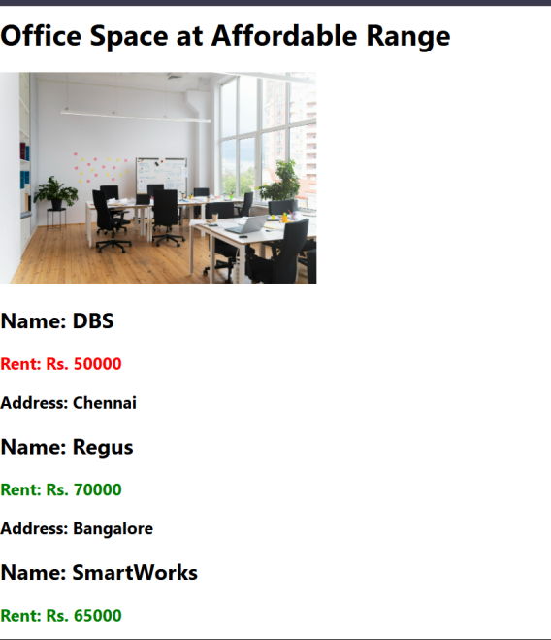

**ReactJS-11**

.App {

text-align: center;

}

.App-logo {

height: 40vmin;

pointer-events: none;

}

@media (prefers-reduced-motion: no-preference) {

.App-logo {

animation: App-logo-spin infinite 20s linear;

}

}

.App-header {

background-color: #282c34;

min-height: 100vh;

display: flex;

flex-direction: column;

align-items: center;

justify-content: center;

font-size: calc(10px + 2vmin);

color: white;

}

.App-link {

color: #61dafb;

}

@keyframes App-logo-spin {

from {

transform: rotate(0deg);

}

to {

transform: rotate(360deg);

}

}

import React from "react";

import CurrencyConvertor from "./CurrencyConvertor";

class App extends React.Component {

constructor(props) {

super(props);

this.state = {

counter: 0

};

}

increment = () => {

this.setState({ counter: this.state.counter + 1 });

};

sayHello = () => {

console.log("Hello! You clicked increment.");

alert("Hello from React!");

};

handleIncrementClick = () => {

this.increment();

this.sayHello();

};

decrement = () => {

this.setState({ counter: this.state.counter - 1 });

};

sayWelcome = (msg) => {

alert(msg);

};

handleSyntheticEvent = (e) => {

e.preventDefault(); // Synthetic event

alert("I was clicked");

};

render() {

return (

<div>

<h1>React Events Demo</h1>

<h2>Counter: {this.state.counter}</h2>

<button onClick={this.handleIncrementClick}>Increment</button>{" "}

<button onClick={this.decrement}>Decrement</button>

<br /><br />

<button onClick={() => this.sayWelcome("Welcome to React!")}>

Say Welcome

</button>

<br /><br />

<button onClick={this.handleSyntheticEvent}>Synthetic Event (OnPress)</button>

<br /><br />

<CurrencyConvertor />

</div>

);

}

}

export default App;

import { render, screen } from '@testing-library/react';

import App from './App';

test('renders learn react link', () => {

render(<App />);

const linkElement = screen.getByText(/learn react/i);

expect(linkElement).toBeInTheDocument();

});

import React, { useState } from 'react';

function CurrencyConvertor() {

const [rupees, setRupees] = useState('');

const [euro, setEuro] = useState('');

const handleSubmit = () => {

const converted = (parseFloat(rupees) / 88).toFixed(2); // Assume 1 Euro = 88 INR

setEuro(converted);

};

return (

<div>

<h2>Currency Convertor</h2>

<input

type="number"

value={rupees}

onChange={(e) => setRupees(e.target.value)}

placeholder="Enter Rupees"

/>

<button onClick={handleSubmit}>Convert</button>

<h3>{euro ? `€${euro}` : ''}</h3>

</div>

);

}

export default CurrencyConvertor;

body {

margin: 0;

font-family: -apple-system, BlinkMacSystemFont, 'Segoe UI', 'Roboto', 'Oxygen',

'Ubuntu', 'Cantarell', 'Fira Sans', 'Droid Sans', 'Helvetica Neue',

sans-serif;

-webkit-font-smoothing: antialiased;

-moz-osx-font-smoothing: grayscale;

}

code {

font-family: source-code-pro, Menlo, Monaco, Consolas, 'Courier New',

monospace;

}

import React from 'react';

import ReactDOM from 'react-dom/client';

import './index.css';

import App from './App';

import reportWebVitals from './reportWebVitals';

const root = ReactDOM.createRoot(document.getElementById('root'));

root.render(

<React.StrictMode>

<App />

</React.StrictMode>

);

// If you want to start measuring performance in your app, pass a function

// to log results (for example: reportWebVitals(console.log))

// or send to an analytics endpoint. Learn more: https://bit.ly/CRA-vitals

reportWebVitals();

const reportWebVitals = onPerfEntry => {

if (onPerfEntry && onPerfEntry instanceof Function) {

import('web-vitals').then(({ getCLS, getFID, getFCP, getLCP, getTTFB }) => {

getCLS(onPerfEntry);

getFID(onPerfEntry);

getFCP(onPerfEntry);

getLCP(onPerfEntry);

getTTFB(onPerfEntry);

});

}

};

export default reportWebVitals;

import '@testing-library/jest-dom';

{

"name": "eventexamplesapp",

"version": "0.1.0",

"private": true,

"dependencies": {

"@testing-library/dom": "^10.4.1",

"@testing-library/jest-dom": "^6.6.4",

"@testing-library/react": "^16.3.0",

"@testing-library/user-event": "^13.5.0",

"react": "^19.1.1",

"react-dom": "^19.1.1",

"react-scripts": "5.0.1",

"web-vitals": "^2.1.4"

},

"scripts": {

"start": "react-scripts start",

"build": "react-scripts build",

"test": "react-scripts test",

"eject": "react-scripts eject"

},

"eslintConfig": {

"extends": [

"react-app",

"react-app/jest"

]

},

"browserslist": {

"production": [

">0.2%",

"not dead",

"not op_mini all"

],

"development": [

"last 1 chrome version",

"last 1 firefox version",

"last 1 safari version"

]

}

}

**Output:-**

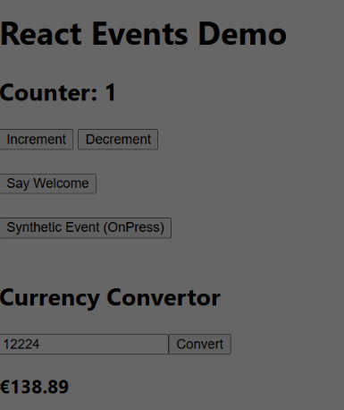

**ReactJS12:-**

import React from 'react';

function GuestGreeting() {

return (

<div>

<h2>Welcome, Guest!</h2>

<p>Here are the available flights:</p>

<ul>

<li>Flight A - 10:00 AM</li>

<li>Flight B - 2:00 PM</li>

<li>Flight C - 6:00 PM</li>

</ul>

</div>

);

}

export default GuestGreeting;

import React from 'react';

function UserGreeting() {

return (

<div>

<h2>Welcome, User!</h2>

<p>You can now book tickets.</p>

<button>Book Flight A</button>

<button>Book Flight B</button>

<button>Book Flight C</button>

</div>

);

}

export default UserGreeting;

{

"name": "ticketbookingapp",

"version": "0.1.0",

"private": true,

"dependencies": {

"@testing-library/dom": "^10.4.1",

"@testing-library/jest-dom": "^6.6.4",

"@testing-library/react": "^16.3.0",

"@testing-library/user-event": "^13.5.0",

"react": "^19.1.1",

"react-dom": "^19.1.1",

"react-scripts": "5.0.1",

"web-vitals": "^2.1.4"

},

"scripts": {

"start": "react-scripts start",

"build": "react-scripts build",

"test": "react-scripts test",

"eject": "react-scripts eject"

},

"eslintConfig": {

"extends": [

"react-app",

"react-app/jest"

]

},

"browserslist": {

"production": [

">0.2%",

"not dead",

"not op_mini all"

],

"development": [

"last 1 chrome version",

"last 1 firefox version",

"last 1 safari version"

]

}

}

**Output:-**

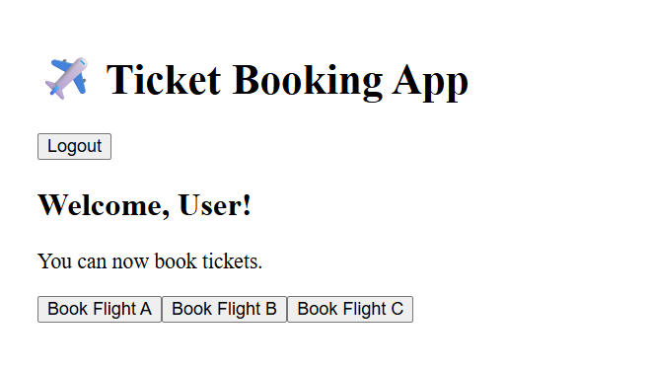

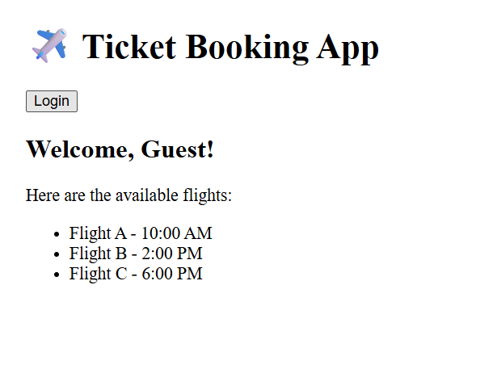

**ReactJS13:-**

import React from 'react';

function BlogDetails({ show }) {

if (!show) return null; // Conditional rendering

return (

<div className="v1">

<h1>Blog Details</h1>

<h3>React Learning</h3>

<h4>Stephen Biz</h4>

<p>Welcome to learning React!</p>

<h3>Installation</h3>

<h4>Schewzdenier</h4>

<p>You can install React from npm.</p>

</div>

);

}

export default BlogDetails;

import React from 'react';

export const books = [

{ id: 101, bname: 'Master React', price: 670 },

{ id: 102, bname: 'Deep Dive into Angular 11', price: 800 },

{ id: 103, bname: 'Mongo Essentials', price: 450 },

];

function BookDetails() {

return (

<div className="st2">

<h1>Book Details</h1>

<ul>

{books.map(book => (

<div key={book.id}>

<h3>{book.bname}</h3>

<h4>{book.price}</h4>

</div>

))}

</ul>

</div>

);

}

export default BookDetails;

import React from 'react';

const courseList = [

{ id: 1, name: "Angular", date: "6/3/20201" },

{ id: 2, name: "React", date: "6/3/20201" },

];

function CourseDetails({ show }) {

if (!show) return null;

return (

<div className="mystyle1">

<h1>Course Details</h1>

{courseList.map(course => (

<div key={course.id}>

<h3>{course.name}</h3>

<p>{course.date}</p>

</div>

))}

</div>

);

}

export default CourseDetails;

{

"name": "bloggerapp",

"version": "0.1.0",

"private": true,

"dependencies": {

"@testing-library/dom": "^10.4.1",

"@testing-library/jest-dom": "^6.6.4",

"@testing-library/react": "^16.3.0",

"@testing-library/user-event": "^13.5.0",

"react": "^19.1.1",

"react-dom": "^19.1.1",

"react-scripts": "5.0.1",

"web-vitals": "^2.1.4"

},

"scripts": {

"start": "react-scripts start",

"build": "react-scripts build",

"test": "react-scripts test",

"eject": "react-scripts eject"

},

"eslintConfig": {

"extends": [

"react-app",

"react-app/jest"

]

},

"browserslist": {

"production": [

">0.2%",

"not dead",

"not op_mini all"

],

"development": [

"last 1 chrome version",

"last 1 firefox version",

"last 1 safari version"

]

}

}

**Output:-**

