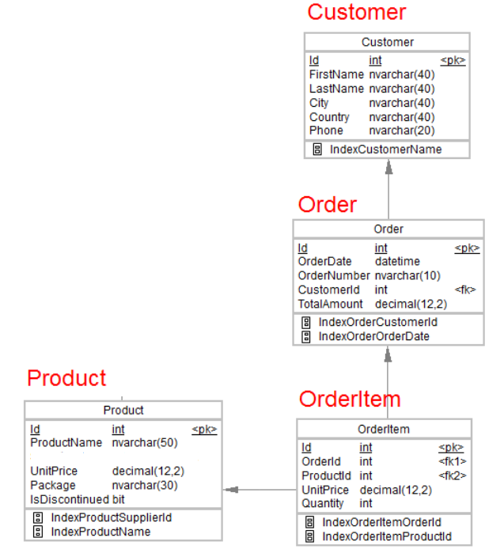

1.Desgin the above database with following table by applying Primary key and Foreign key

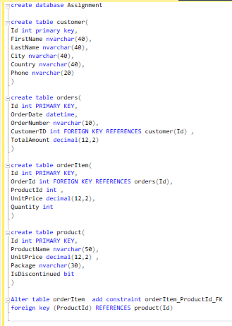

2.Insert Records in all tables

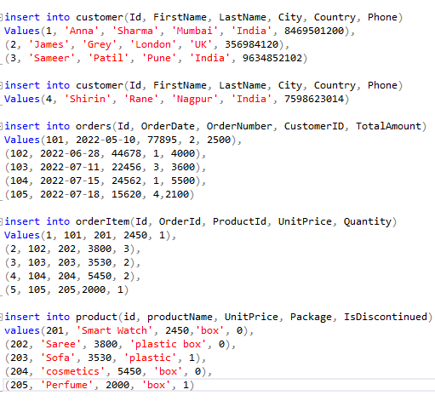

3.In Customer table FirstName Attribute should not accept null value



4.In Order table OrderDate should not accept null value



5.Display all customer details



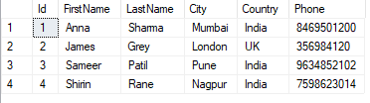

6.write a query to display Country whose name starts with A or I



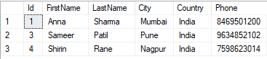

7 .write a query to display whose name of customer whose third character is i



