**INFO 5100, Section 03 (Monday batch)**

**Group No: 52**

**1. Abhishek Patil 002319098**

**2. Riya Kapadnis 002347871 Proposal Approved by: Viswanath Raju Indukuri**

**3. Shrutkeerti Sangolkar 002304742 Date: 23 Nov 2024**

**Project Proposal: Patient Complaint Management System**

**Problem Statement**

Healthcare systems often struggle with effectively managing patient complaints, assessments, and treatments. There’s a need for a streamlined platform that connects patients with healthcare professionals while enabling administrators to oversee operations and maintain accountability. Additionally, integration with drug catalogs and medication management must ensure treatment accuracy and improve efficiency.

**Solution**

A Patient Complaint management system built using Java Swing will:

1. Allow patients to submit complaints and receive assessments, treatments, or medication recommendations.
2. Enable healthcare professionals to manage complaints via a pull-based or push-based allocation model.
3. Provide an admin dashboard to track the system's activity, ensure accountability, and generate reports.
4. Integrate drug catalogs for medication recommendations.

**Ecosystem Hierarchy**

**1. Enterprises**

* **HealthCare Enterprise**: Manages healthcare professionals and patient care.
* **Pharma Enterprise**: Maintains drug catalogs and ensures the supply of medications.
* **Insurance Enterprise**: Tracks patient treatment plans and generates claims.
* **RegulatoryBody Enterprise**: Oversees compliance, system audits, and reporting.

**Organizations**

1. **Emergency Services Department (within HealthCare Enterprise)**

* **Description**: This department handles high-priority cases where immediate action is required. Patients whose complaints are flagged as critical (e.g., chest pain, severe injury) are routed here. Emergency specialists assess the issue and provide treatment recommendations or escalate cases to higher authorities.
* **Key Features**:
  + - Dashboard for viewing critical complaints.
    - Priority handling logic for complaints based on severity.
    - Reporting tools to track resolved and unresolved cases.

1. **Patient Services Department (within HealthCare Enterprise)**

* **Description**: Manages non-urgent complaints from patients. Complaints are assigned to healthcare professionals for review and follow-up. This department focuses on routine check-ups and follow-ups.
* **Key Features**:
  + - Complaint management system for healthcare professionals to pick cases.
    - Vital signs tracking for patient history.
    - Recommendations for treatment or medication for mild to moderate health issues.

1. **Pharmacy Unit (within Pharmaceutical Enterprise)**

* **Description**: Manages drug inventory, processes medication orders, and maintains the drug catalog. After a healthcare professional recommends a medication, the pharmacy unit verifies the order, checks availability, and fulfills the request.
* **Key Features**:
  + - Drug catalog search and validation.
    - Real-time inventory updates.
    - Notifications sent to patients when a medication is ready.

1. **Claims Processing Unit (within Insurance Enterprise)**

* **Description**: This organization handles the financial aspects of healthcare. It reviews and processes claims submitted for treatments and medications. Patients can check the status of their claims through the system.
* **Key Features**:
  + - Claim submission and tracking for patients.
    - Automated checks for coverage validation.
    - Manual review by insurance agents for edge cases or discrepancies.

1. **Compliance Unit (within Government/Public Health Enterprise)**

* **Description**: Oversees adherence to healthcare regulations and audits the system’s operations. The compliance unit ensures patient data privacy, treatment accuracy, and medication safety standards.
* **Key Features**:
  + - Generates compliance reports for government authorities.
    - Monitors healthcare professionals and system operations for irregularities.
    - Conducts random audits on patient records and complaint statuses.

1. **Research and Development Unit (within Pharmaceutical Enterprise)**

* **Description**: Focuses on improving drug efficacy and creating new medications. This unit collaborates with healthcare professionals to gather feedback on existing drugs and conduct clinical studies.
* **Key Features**:
  + - Tracks patient outcomes related to specific drugs.
    - Supports healthcare professionals in reporting drug side effects.
    - Generates insights for developing new drugs or improving current ones.

**Roles**

1. **Patient**: Submits complaints, views assessments, and receives notifications.
2. **Healthcare Professional**: Handles complaints, assesses patients, and recommends treatments.
3. **Admin**: Oversees complaint management, tracks accountability, and generates reports.
4. **Pharmacist**: Manages medications, validates orders, and updates inventory.
5. **Insurance Agent**: Reviews and processes treatment claims.
6. **Emergency Specialist**: Handles critical complaints in the emergency department.
7. **Government Auditor**: Monitors compliance and audits the system.
8. **Research Scientist**: Tracks patient outcomes and supports drug development efforts.

**Use Cases**

**1. Submit Complaint (Patient)**

**Role**: Patient  
**Goal**: A patient submits a health complaint for assessment.  
**Steps**:

1. The patient logs into the system.
2. Navigates to the "Submit Complaint" section.
3. Enters the details of their symptoms and selects the priority level (optional).
4. The system generates a unique complaint ID and routes it to the appropriate department (Emergency Services for critical cases or Outpatient Services for non-urgent ones).
5. The patient receives a notification confirming the complaint submission.

**Alternate Flow**:

* If the complaint is flagged critical (e.g., chest pain), it is auto-routed to Emergency Services.

**2. Pull Complaint (Healthcare Professional)**

**Role**: Healthcare Professional  
**Goal**: Handle a complaint assigned to their department.  
**Steps**:

1. The healthcare professional logs into the system.
2. Opens the "Complaints Dashboard."
3. Pulls a complaint based on the priority or selects one manually.
4. Views the patient’s vital signs and complaint details.
5. Performs an assessment and provides a diagnosis.
6. Recommends treatment, medication, or both.
7. Updates the complaint status to "Resolved."

**Alternate Flow**:

* If additional expertise is required, the complaint can be re-routed to a specialist.

**3. Process Medication Order (Pharmacist)**

**Role**: Pharmacist  
**Goal**: Manage and process a medication request for a patient.  
**Steps**:

1. The pharmacist logs into the system.
2. Opens the "Medication Orders" dashboard.
3. Selects a pending medication order.
4. Validates the order and checks drug availability in the catalog.
5. Updates the system with the medication's fulfillment status.
6. Sends a notification to the patient regarding order readiness.

**Alternate Flow**:

* If the medication is unavailable, the pharmacist suggests alternatives to the healthcare professional.

**4. Approve Treatment Claim (Insurance Agent)**

**Role**: Insurance Agent  
**Goal**: Validate and approve or deny claims for treatments or medications.  
**Steps**:

1. The insurance agent logs into the system.
2. Navigates to the "Claims Review Dashboard."
3. Opens a pending claim submitted by a patient.
4. Verifies claim details, including treatment costs and coverage.
5. Approves or denies the claim.
6. If approved, updates the claim status and sends reimbursement details to the patient.

**Alternate Flow**:

* If the claim has missing information, the agent marks it for further review.

**5. Monitor System Activity (Admin)**

**Role**: Admin  
**Goal**: Oversee system activity and ensure accountability.  
**Steps**:

1. The admin logs into the system.
2. Opens the "Admin Dashboard."
3. Reviews the number of complaints handled by each healthcare professional.
4. Tracks unresolved complaints and delays in processing medication orders or claims.
5. Generates performance and accountability reports.

**Alternate Flow**:

* If an unusual delay or irregularity is found, the admin sends alerts to the relevant department.

**6. Regulatory Body (Auditor)**

**Role**: Auditor  
**Goal**: Monitor the system’s compliance with healthcare regulations.  
**Steps**:

1. The auditor logs into the compliance dashboard.
2. Reviews system-generated compliance reports.
3. Randomly selects patient records and checks for irregularities, such as incomplete assessments or privacy violations.
4. Generates an audit report summarizing findings and sends it to the admin.

**Alternate Flow**:

* If compliance violations are found, the system sends warnings to the relevant department for corrective action.

**7. Analyze Drug Performance (Research Scientist)**

**Role**: Research Scientist  
**Goal**: Collect feedback on drug efficacy and identify opportunities for improvement.  
**Steps**:

1. The scientist logs into the "Research Dashboard."
2. Reviews feedback from healthcare professionals about the drug’s performance (e.g., side effects or patient outcomes).
3. Analyzes data trends to identify potential issues or improvements.
4. Generates reports for the pharmaceutical enterprise to develop new drugs or improve existing ones.

**Alternate Flow**:

* If significant side effects are reported, the scientist recommends pulling the drug from the catalog or keep it on hold until further improvements.

**8. Track Treatment Status (Patient)**

**Role**: Patient  
**Goal**: View the status of their complaint, assessment, and treatment.  
**Steps**:

1. The patient logs into the system.
2. Navigates to the "My Treatments" section.
3. Views the history of complaints, including:

* Assessment details.
* Recommended treatments or medications.
* Drug details and medication order status.

1. Receives notifications for updates on medication fulfillment or claim approvals.

**Alternate Flow**:

* If any assessment or medication is pending, the patient sees a “Pending” status with an estimated completion time.

**9. Handle Critical Complaint (Emergency Specialist)**

**Role**: Emergency Specialist  
**Goal**: Handle complaints flagged as high-priority or life-threatening.  
**Steps**:

1. The emergency specialist logs into the system.
2. Opens the "Emergency Dashboard" to view flagged complaints.
3. Selects a critical case and reviews the patient’s details and symptoms.
4. Records vital signs and performs an immediate diagnosis.
5. Recommends urgent treatment or escalates the case for advanced care.
6. Updates the system with the resolution or next steps.

**Alternate Flow**:

* If the patient cannot wait, the system sends an automatic notification for the patient to visit the nearest emergency center.

**10. Generate Compliance Report (Admin)**

**Role**: Admin  
**Goal**: Create a summary report on system compliance and performance.  
**Steps**:

1. The admin opens the "Compliance Reporting" section.
2. Selects the desired date range for the report.
3. Generates a system-wide report, including:

* Number of complaints resolved.
* Treatment times.
* Regulatory compliance checks.

1. Sends the report to the government auditor.

**Alternate Flow**:

* If any department is underperforming, the admin flags the issue for further investigation.

**High Level Component Diagram:**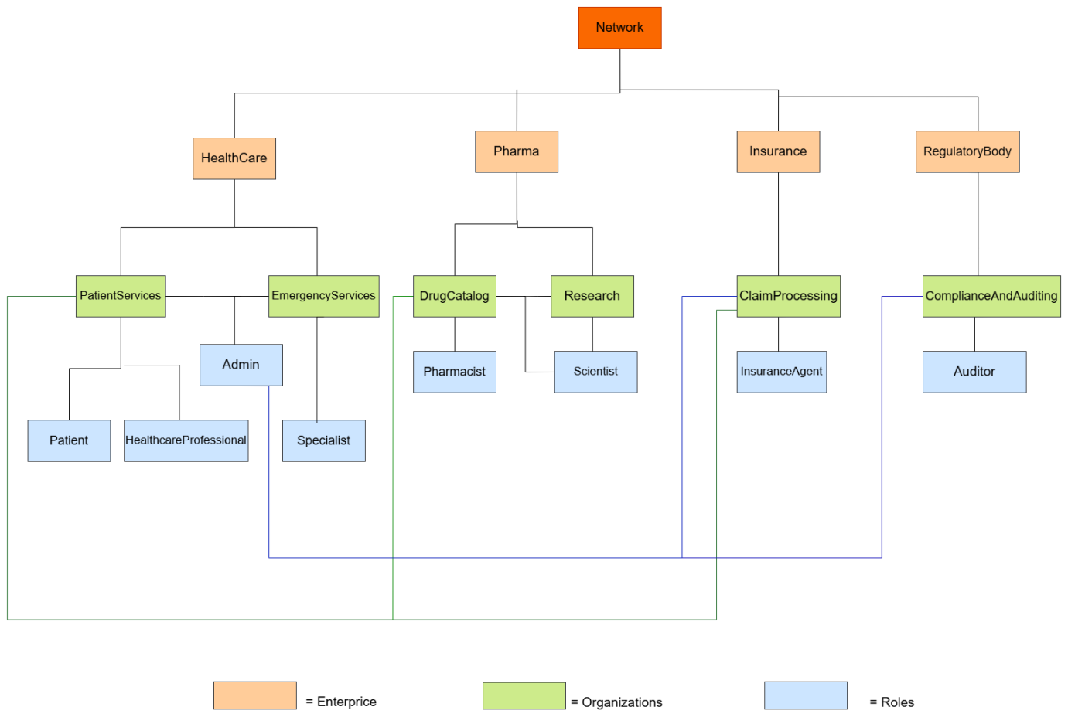

**Class UML:**

