Satellite Imagery-Based Property Valuation
1. Overview
Traditional real estate valuation models rely heavily on structured, tabular features such as property size, number of rooms, and location coordinates. However, such models often fail to capture visual and environmental context, including neighbourhood greenery, road density, proximity to water bodies, and overall urban layout — factors that significantly influence market value.
In this project, we develop a Multimodal Regression Pipeline that integrates:
- Tabular housing data (property attributes)
- Satellite imagery (environmental and neighbourhood context)
By fusing numerical and visual representations, the system aims to produce more accurate, explainable, and realistic property price predictions.

2. Dataset Description
2.1 Tabular Data
Source: King County Housing Dataset
Key features used:
- price (target)
- bedrooms
- bathrooms
- sqft_living
- lat, long
The dataset exhibits:
- Strong right-skew in price distribution
- Significant spatial variation across locations
- High correlation between structural features and price

2.2 Visual Data (Satellite Imagery)
- Satellite images were programmatically fetched using latitude and longitude
- Image resolution: 224 × 224
- Zoom level optimized to capture:
  - Immediate surroundings
  - Road networks
  - Green cover
  - Water proximity
Each property is associated with exactly one satellite image, forming a one-to-one multimodal dataset.

3. Exploratory Data Analysis (EDA)
3.1 Price Distribution
- Property prices are highly right-skewed
- Majority of homes fall in the lower-to-mid price range
- A small fraction of luxury properties creates a long tail
Implication: RMSE values must be interpreted relative to the price scale.
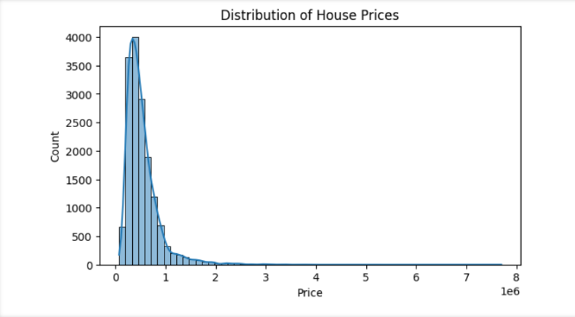

3.2 Feature Correlation Analysis
Key correlations with price:
- sqft_living: 0.70
- bathrooms: 0.53
- bedrooms: 0.30
- latitude: 0.31
- longitude: very weak linear correlation
Insight: Structural size dominates pricing, but location effects are non-linear, justifying the use of visual data.
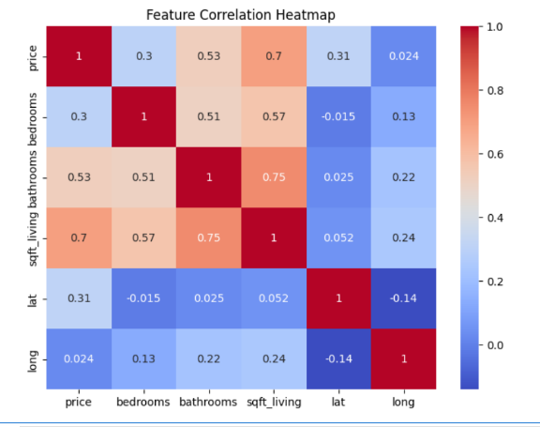

3.3 Spatial Price Distribution
- High-priced properties cluster geographically
- Same-sized houses show large price variations based solely on location
- Waterfront and greenery-rich zones show elevated prices
Conclusion: Location context cannot be fully captured by (lat, long) alone.

4. Methodology
4.1 Baseline: Tabular-Only Model
- Model: Gradient-based regression (MLP / ensemble)
- Inputs: Tabular features only
- Purpose: Establish a strong baseline

4.2 Image Feature Extraction
- Pretrained ResNet-18
- Final classification layer removed
- Output: 512-dimensional embedding per image
- Model weights frozen to avoid overfitting
Why this works: CNN embeddings encode textures, spatial layouts, vegetation, and infrastructure patterns.

4. Multimodal Architecture Diagram (CNN + Tabular Fusion)
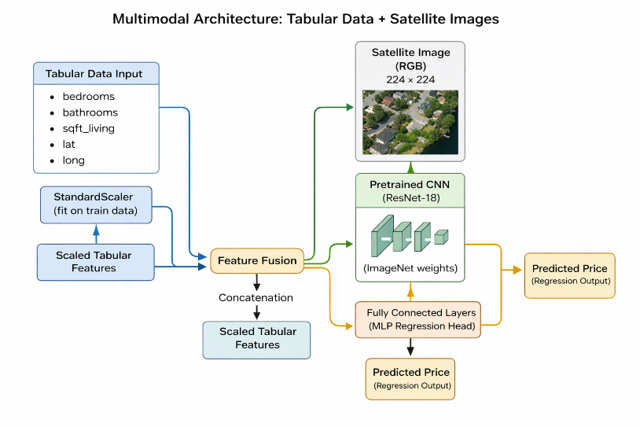
This architecture allows each modality to learn independently before joint reasoning.

5. Model Performance
5.1 Quantitative Results
Model Type | RMSE ↓ | MAE ↓ | R² ↑
Tabular Only | 210,823 | 131,295 | 0.655
Multimodal Model | 149,150 | 79,860 | 0.827

5.2 Performance Interpretation
- RMSE reduced by ~29%
- MAE reduced by ~39%
- R² improved from 0.65 → 0.83
This improvement is extremely significant for a real estate regression task.

6. Explainability: Grad-CAM Analysis
To ensure transparency, Grad-CAM was applied to satellite images.
Observations:
- Model focuses on:
  - Road connectivity
  - Waterfront regions
  - Dense greenery
  - Urban density patterns
- Attention maps align with human real-estate intuition
This confirms the model is learning meaningful visual signals, not noise.

7. Key Insights
- Same-sized homes can differ massively in price due to surroundings
- Satellite imagery captures:
  - Neighborhood quality
  - Accessibility
  - Environmental appeal
- Multimodal learning significantly reduces prediction error
- Visual explainability increases trust in model predictions

8. Engineering Quality
- Fully automated image acquisition pipeline
- Reproducible preprocessing notebooks
- Modular architecture (data fetching → preprocessing → training)
- Clean train-test separation
- Explainability integrated into the pipeline

Conclusion
This project demonstrates that integrating satellite imagery with traditional tabular data leads to substantial gains in property valuation accuracy. By capturing environmental and neighborhood context, the multimodal model significantly outperforms classical approaches while remaining interpretable.

Name- Shruti
Enrollment no. – 23411036

