Evaluating Algorithmic Bias and Feature Thresholds in Predicting Geopolitical Attack Success
Prepared by: Abelardo, Aquino, Balingit, & Gumban. | Course & Section: 3CSD - Machine Learning | Date: May 2026
Abstract
This study examines how machine-learning models predict attack success in the Global Terrorism Database (GTD). Our four-person group compared class-weighted logistic regression, XGBoost, and a feedforward neural network using a temporal train-validation-test split. We were not only interested in which model produced the highest score. We also wanted to understand how feature choices, decision thresholds, and subgroup differences changed the behavior of the models. To reduce leakage, we excluded variables that describe consequences after the attack, including casualties, property damage, ransom outcomes, and hostage outcomes. The results show that nonlinear models can improve some forms of prediction, but they also show that model behavior changes when thresholds are adjusted. Subgroup analysis further suggests that errors are not distributed evenly across countries, regions, attack types, target types, and weapon types. Because of this, the paper treats machine learning as a tool for studying patterns in recorded events, not as a complete or neutral explanation of real-world political violence.
Keywords: Global Terrorism Database; attack success prediction; logistic regression; XGBoost; neural network; algorithmic bias; threshold analysis

1. Introduction
Machine learning is now used in many areas where people need to make sense of large, messy, and fast-growing datasets. Geopolitical violence is one of the harder examples. It is not just a technical problem, because the data come from real events, media reports, institutional records, and coding decisions. A model trained on those records is therefore not learning the full reality of violence. It is learning patterns in what was observed, reported, and entered into a database.
Our group focused on the Global Terrorism Database because it gives a large historical record of terrorist incidents across countries and years. The task was to predict whether a recorded attack was marked as successful. At first, that sounds simple: take the event information and predict the success label. After looking more closely, though, the label is not as simple as it looks. A successful attack in the dataset may mean that the immediate tactical goal was completed, but it does not necessarily measure long-term political impact, social harm, fear, or strategic value.
This is why the project is connected to real-world complexity. A failed attack can still injure people or create fear. A successful attack may be small in scale. Some regions may have better reporting than others, and some events may be easier to classify. These issues do not make the dataset unusable, but they do mean that the results need careful interpretation. In our paper, the success label is treated as a useful modeling target, not as the whole meaning of success in a social or political sense.
The real-world part of the problem also affected how we read false positives and false negatives. In a normal classification task, those errors may look like simple counts. In this topic, the meaning is heavier. A false positive could make a context look riskier than the recorded outcome supports, while a false negative could hide a pattern that the model should have noticed. We did not assign real policy costs, but we kept this trade-off in mind.
The study compares three kinds of models. Logistic regression is used as the interpretable baseline because it gives readable coefficients and clear assumptions. XGBoost is used because boosted trees are often strong on tabular data and can capture nonlinear interactions. A feedforward neural network is added as another flexible model, mainly to see whether it improves prediction or changes the pattern of errors. Comparing the three helped us see the trade-off between simplicity, performance, and interpretability.
We also treated the decision threshold as part of the experiment. A probability score does not become a class label until a threshold is chosen. If the threshold is lowered, recall may improve, but false positives can increase. If it is raised, predictions may become more conservative, but more successful attacks may be missed. Because of that, the paper reports both default-threshold results and validation-selected threshold results.
Another motivation for the project came from the way security-related predictions are sometimes presented as if they are purely technical. In reality, every modeling choice carries assumptions. Choosing which variables to include, deciding how to split the data, and selecting a threshold all shape the final result. Our group wanted the paper to show those choices instead of hiding them behind a single accuracy number.

2. Related Work
The literature on terrorism data starts with an important warning: the dataset is not the same thing as the phenomenon. LaFree and Dugan (2007) introduced the GTD as a major open-source resource for studying terrorism across time and place. Its size is one reason it is useful for machine learning, but the authors also make it clear that the database depends on available information and coding rules. START (2022) also explains that variables such as success, attack type, target type, weapon type, and location follow specific definitions. For this paper, that means our model is learning from coded records rather than from a perfect record of all political violence.
This matters because terrorism events are not observed equally everywhere. Some conflicts receive more media attention. Some countries have stronger documentation systems. Some incidents are easier to classify than others. A machine-learning model may still find useful patterns in this kind of data, but its outputs have to be read with these limits in mind. In our study, we tried to avoid language that would make the model sound more certain than it really is.
The machine-learning literature supports the use of a simple baseline before moving to more flexible models. Logistic regression is still common in applied work because it is transparent and relatively easy to explain. Pedregosa et al. (2011) describe scikit-learn as a practical framework for preprocessing, model fitting, and evaluation, which is why it fits the structure of this project. In our case, logistic regression is not included because we expected it to win. It is included because it gives us a clear reference point.
XGBoost is included because boosted trees are often effective for structured or tabular data. Chen and Guestrin (2016) describe XGBoost as a scalable tree-boosting system that can model nonlinear relationships and interactions. That is important for GTD data because an attack type, weapon type, or target type may not mean the same thing in every country or period. A linear model can miss some of those combinations unless they are manually added. Boosted trees can find many of them through repeated splits.
The neural-network model plays a different role. Paszke et al. (2019) describe PyTorch as a flexible framework for training neural networks, and that flexibility makes it possible to test a feedforward model on the processed GTD features. Still, neural networks are not automatically better for tabular data. For that reason, we treated the neural network as a comparison model rather than as the expected best model. Its value was in showing whether additional flexibility changed precision, recall, and error behavior.
Interpretability is another important part of the related work. Lundberg and Lee (2017) proposed SHAP as a way to explain model predictions and summarize feature contributions. This is useful for XGBoost because the model can perform well while still being harder to explain than logistic regression. SHAP-style summaries and feature-importance plots do not make a model perfectly transparent, but they help connect model behavior back to the variables in the dataset.
Fairness and bias literature is also relevant to this project. Barocas, Hardt, and Narayanan (2019) explain that machine-learning systems can produce uneven error patterns across groups, even when a model does not explicitly use unfair intentions. Chouldechova and Roth (2020) also discuss fairness as a problem that depends on measurement, error trade-offs, and context. In our paper, we do not claim to solve fairness. Instead, we measure whether false positives and false negatives vary across regions, countries, attack types, target types, and weapon types.
Other work on explainable and responsible machine learning also shaped the paper. Miller (2019) argues that explanations should be understandable to people, not only mathematically correct. Rudin (2019) warns against relying too heavily on black-box explanations in high-stakes settings. Suresh and Guttag (2021) describe how harms can enter a machine-learning system at many points, including data collection, modeling, evaluation, and deployment. These sources helped us frame the project as more than a score comparison.
Taken together, the related work supports the structure of this study. The GTD literature explains the usefulness and limits of the data. The machine-learning literature supports the comparison among logistic regression, XGBoost, and a neural network. The interpretability literature supports coefficient analysis and feature-importance summaries. The fairness literature supports subgroup error analysis. This combination makes the paper a review of model behavior, not just a baseline prediction exercise.
A common theme across these sources is caution. The GTD makes large-scale analysis possible, but it still depends on how events are reported and coded. Machine-learning tools can process that structure quickly, but speed does not remove the need for interpretation. This is why the related work is connected directly to the later experiments: the literature gives us reasons to check leakage, thresholds, feature importance, and subgroup errors.

3. Models & Algorithms
The target variable is the GTD success field, coded as a binary label. The input features were selected to represent information that would plausibly be known at or near the time the event was recorded. We included timing, geography, attack type, target type, weapon type, suicide indicator, multiple-incident indicator, claim-related fields, and other event descriptors. We excluded casualty, property-damage, ransom, and hostage-outcome variables because those fields describe consequences and could leak information about the target.
Logistic regression estimates the log-odds of attack success as a weighted sum of the input features. Numeric variables are standardized and categorical variables are one-hot encoded. Class weighting is used because the success and failure labels are not perfectly balanced. The main strength of logistic regression is that its coefficients can be inspected. A positive coefficient increases the estimated log-odds of success, while a negative coefficient decreases it, holding other encoded features constant.
XGBoost estimates the probability of success using an ensemble of gradient-boosted decision trees. Each tree splits the data according to feature values, and later trees try to correct the mistakes of earlier trees. This lets the model capture interactions that are difficult to write by hand. For example, a weapon category may have a different relationship with success depending on the attack type or region. The cost of this flexibility is that interpretation requires feature-importance or SHAP-style summaries rather than a single readable coefficient table.
The feedforward neural network is a multilayer perceptron trained on the processed feature matrix. Its hidden layers transform the input into nonlinear representations, and the final layer outputs a probability of success. The neural network can learn complex patterns, but it is also more sensitive to preprocessing, optimization settings, and threshold choice. In this project, it is useful as a flexible comparison model, not as an automatic replacement for XGBoost or logistic regression.
All three models are evaluated with several metrics because no single score tells the whole story. ROC-AUC measures ranking ability. Average precision is useful when the positive class is important. Accuracy is reported, but it can be misleading under imbalance. Balanced accuracy, precision, recall, F1 score, false-positive rate, false-negative rate, Brier score, and Matthews correlation coefficient give a more complete view of model behavior.
These models also make different assumptions about the shape of the data. Logistic regression assumes one global linear pattern after preprocessing. XGBoost breaks the feature space into many smaller regions. The neural network learns hidden representations from the encoded inputs. Because the assumptions are different, disagreement among the models is not just noise. It can show where the prediction problem itself is unstable or context-dependent.

4. Implementation
The implementation is organized around the main notebook, notebooks/3CSD_Group 8_Implementation.ipynb. The raw GTD files are expected in data/raw/, including the main GTD workbook and the separate Jan-June 2021 supplement. The notebook loads the files, deduplicates events by event identifier, applies feature filtering, trains the models, and saves tables and figures under the results directory.
We used a temporal split rather than a random split. Events through 2014 were used for training, events from 2015 to 2017 were used for validation, and events from 2018 onward were used for testing. This design is stricter than a random split because the model is evaluated on later events. It also better matches the idea of using past data to make predictions about future records.
Preprocessing includes numeric scaling and categorical encoding. Logistic regression uses the transformed feature matrix directly. XGBoost uses the same general feature set but learns tree-based splits. The neural network is implemented in PyTorch and trained as a feedforward classifier. GPU acceleration is requested when available for XGBoost and PyTorch, while logistic regression remains CPU-based.
Threshold simulation was one of the more important experiments. We evaluated thresholds from 0.30 to 0.70 and recorded precision, recall, F1 score, false-positive rate, and false-negative rate. This helped us see how the models behaved when the decision boundary moved. The validation set was used to choose thresholds before applying those choices to the test set, so the test results were not used for threshold selection.
Subgroup analysis was performed after predictions were produced. For each model, false-positive and false-negative rates were calculated by region, country, attack type, target type, and weapon type, subject to minimum group-size filters. This was not meant to prove causality. It was meant to check whether the models made errors unevenly across the groups that appear in the dataset.
We used subgroup analysis as a diagnostic rather than as a final judgment. If one country or target type had a high error rate, that did not automatically mean the model was unfair in a legal sense. It meant the model was less reliable for that slice of the data and deserved a closer look. This helped us keep the discussion grounded in measurable model behavior.
As a group, we divided the work across data preparation, model implementation, evaluation, and manuscript checking. This helped us catch issues that a single run of the notebook might miss, especially around leakage control, threshold selection, and whether the results were being described too strongly.
For reproducibility, we kept the notebook as the main record of the experiment. The tables used in the manuscript come from saved CSV files rather than manually typed calculations. This reduced the chance of copying errors. When a result changed after rerunning a model or adjusting a threshold, we used the generated output files as the reference point before updating the discussion.

5. Results
At the default threshold of 0.50, the feedforward neural network produced the highest test ROC-AUC at about 0.803. XGBoost followed with about 0.780, and logistic regression reached about 0.770. This shows that the neural network ranked cases well overall. However, ROC-AUC is not the only metric that matters, especially when the final output must become a class label.
XGBoost performed best at the default threshold when looking at F1 score. Its test F1 was about 0.864, compared with about 0.839 for logistic regression and about 0.815 for the neural network. XGBoost also reached about 0.781 accuracy, about 0.913 precision, and about 0.820 recall. Logistic regression had similar precision but lower recall, while the neural network had the highest precision but missed more successful cases.
The validation-selected thresholds changed the results in a noticeable way. Logistic regression selected a threshold of 0.40, and XGBoost selected 0.46. On the test set, both models reached an F1 score of about 0.876 using those selected thresholds. Their recall increased to about 0.845, but their false-positive rates also rose above 0.45. This is the main trade-off shown by the threshold experiment: recall improved, but at the cost of more false alarms.
The feature summaries also helped explain what the models were using. For XGBoost, strong signals included attack type, year, extended incident status, unknown target type, armed assault, bombing or explosion, latitude, longitude, ideological internationality, Iraq, private-citizen targets, projectile subtype, arson or fire subtype, and explosives. These features suggest that the model used a mix of tactical, temporal, and geographic information.
The subgroup analysis showed that aggregate performance hides important differences. Country-level gaps in false-positive and false-negative rates were large for all models. Region, attack type, and target type also showed noticeable variation. Weapon-type gaps were smaller in some cases, but they were still present. For our group, this was one of the most important findings because it showed that a model can look acceptable on average while still being uneven across contexts.
This also changed how we viewed the best-performing model. XGBoost had strong overall results, but the subgroup tables showed that good average performance can still contain weak spots. For a research project, that finding is useful because it points to where future modeling could improve. For any real-world use, it would be even more important because decisions are made in specific contexts, not on averages.
The notebook also produced ROC curves, precision-recall curves, calibration plots, learning curves, and feature-importance graphics. These visualizations are saved in the results/figures directory. In the manuscript, the most important point from those plots is that different visualizations emphasize different parts of model behavior. ROC curves show ranking, precision-recall curves show performance under imbalance, and feature-importance plots show which variables carry much of the signal.
The Brier scores and calibration plots were also useful because high ranking performance does not always mean reliable probabilities. A model can place successful cases above failed cases and still give probability values that are too confident or not confident enough. For that reason, we treated calibration as a supporting result. It helped us avoid reading every model score as if it were a perfectly calibrated risk estimate.

Results Figures and Statistical Summary
Model | ROC-AUC | Avg. Precision | Accuracy | Precision | Recall | F1 | FPR | FNR
Logistic Regression | 0.770 | 0.944 | 0.748 | 0.917 | 0.773 | 0.839 | 0.389 | 0.227
XGBoost | 0.780 | 0.948 | 0.781 | 0.913 | 0.820 | 0.864 | 0.432 | 0.180
Feedforward NN | 0.803 | 0.951 | 0.723 | 0.937 | 0.722 | 0.815 | 0.270 | 0.278
Table 1. Test-set statistical summary at the default 0.50 threshold. Values are rounded to three decimals.
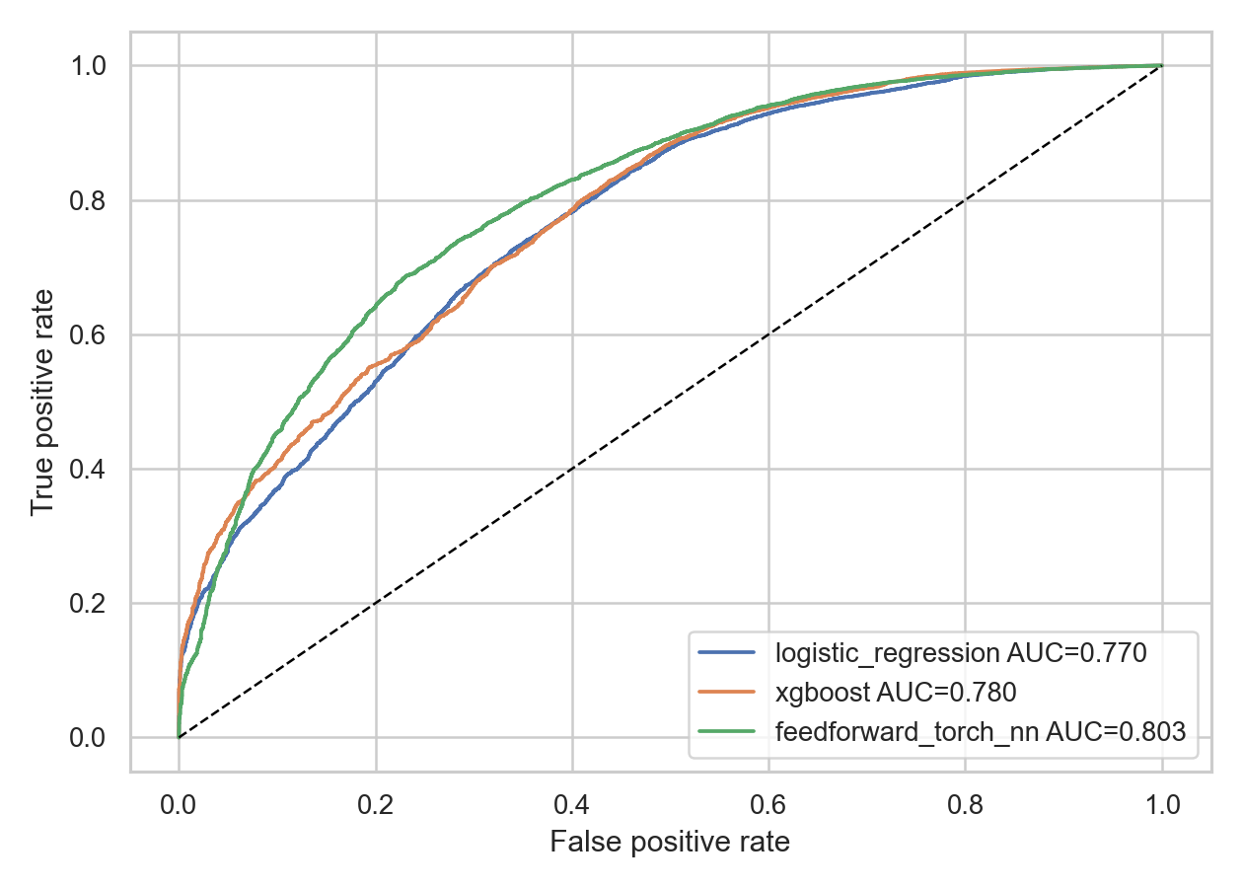
Figure 1. ROC curves for the three models on the test set.
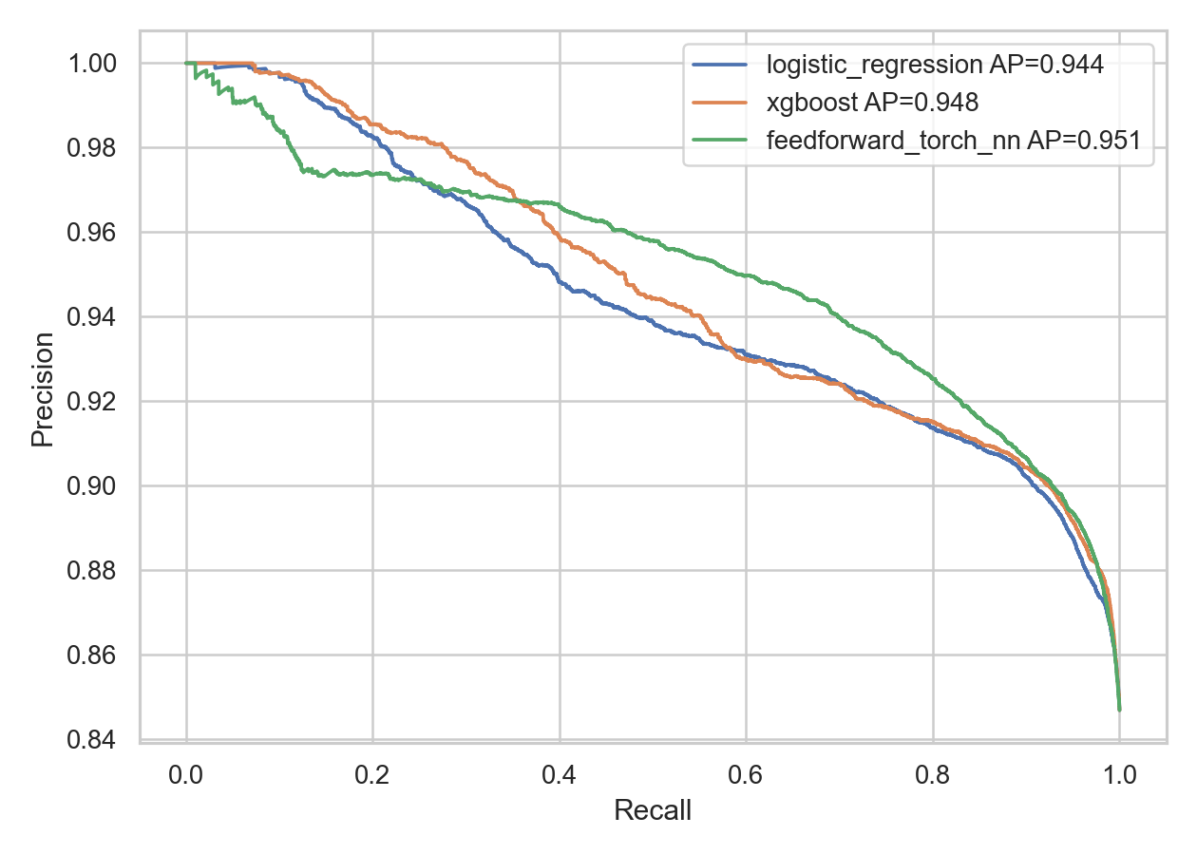
Figure 2. Precision-recall curves on the test set, useful for viewing behavior under class imbalance.
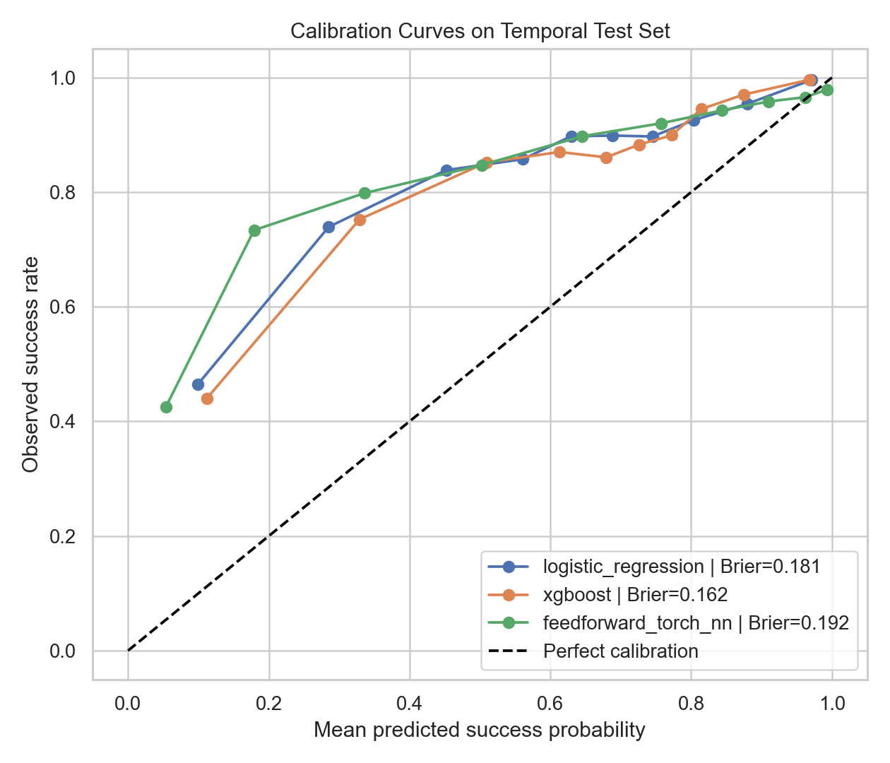
Figure 3. Calibration curves showing how predicted probabilities compare with observed outcomes.
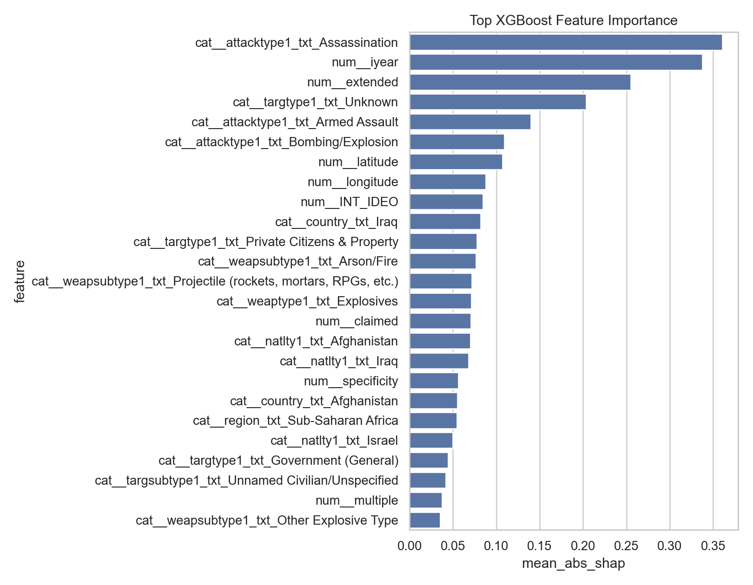
Figure 4. XGBoost feature-importance summary for the most influential predictors.
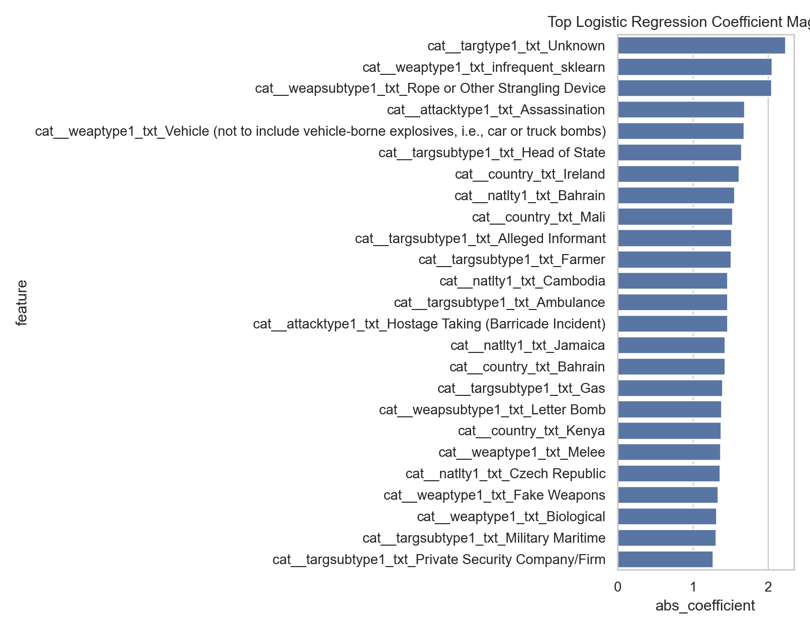
Figure 5. Logistic-regression coefficient importance summary.
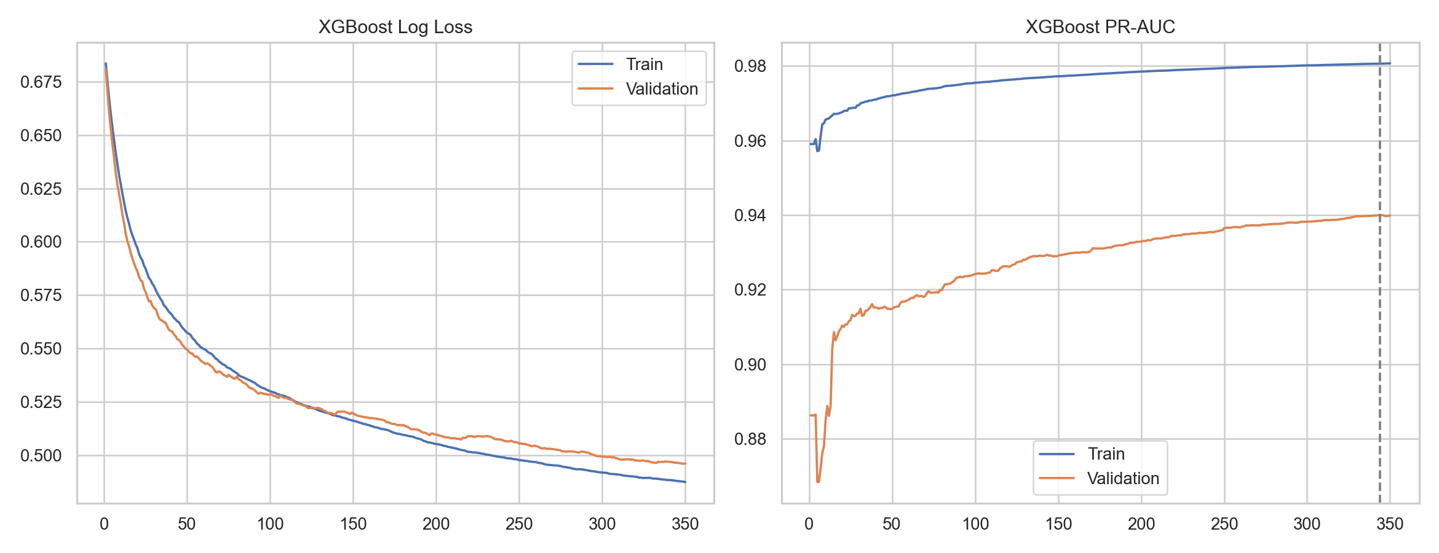
Figure 6. XGBoost learning-curve behavior during training and validation.
These tables and figures were added to make the results easier to verify from the notebook outputs. The table gives the main test-set metrics, while the figures show ranking behavior, precision-recall trade-offs, calibration, and feature importance. Together, they support the written results without relying only on paragraph descriptions.

6. Discussion
The main takeaway from the results is that flexible models can improve prediction, but they do not remove the uncertainty in the data. XGBoost and the neural network can capture nonlinear patterns that logistic regression may miss. Still, all three models depend on how the GTD records events. If reporting is uneven or if a label is simplified, the model inherits that limitation.
The comparison also shows why interpretability matters. Logistic regression was not the strongest model by every metric, but it gives readable coefficients and a clear baseline. XGBoost performed very well, but its reasoning has to be interpreted through feature-importance or SHAP-style tools. The neural network ranked cases strongly by ROC-AUC, but its default-threshold classification was less balanced. Choosing a model therefore depends on the goal of the analysis, not just the highest number in one column.
Threshold choice matters a great deal. A lower threshold may be useful if missing successful attacks is considered more costly, but it also creates more false positives. A higher threshold may make positive predictions more conservative, but it can miss more true successes. Since the dataset does not tell us the real-world cost of each error, we cannot claim that one threshold is universally best. The threshold should match the purpose of the analysis and the ability of people to review the results responsibly.
The subgroup results were also important. If a model performs worse in some countries, regions, or attack types, then overall performance can give a false sense of reliability. This does not mean the model is intentionally biased, and it does not prove a causal claim about any group. It does mean that model evaluation should look beyond averages. For geopolitical data, subgroup error analysis should be part of the normal evaluation process.
There are several limitations. The GTD is based on reported and coded events, so it reflects documentation patterns as well as real incidents. The success label is useful, but it is simplified. Some variables may be missing or uncertain. The models also do not use full event narratives, political context, organization networks, or external country-level indicators. Future work could add text features, newer validation data, confidence intervals for subgroup metrics, and stronger calibration analysis.
One limitation we noticed while writing the paper is that the most useful features are not always the most comfortable ones to interpret. Geographic and country-related features can improve prediction, but they may also reflect reporting differences, conflict history, and other background conditions. Because of that, we avoided saying that a country or region directly causes a prediction. The safer claim is that those variables help the model separate patterns in the recorded data.

7. Conclusion
This paper presented a machine-learning study of attack-success prediction using the Global Terrorism Database. Our group compared logistic regression, XGBoost, and a feedforward neural network under a temporal split. We also checked threshold sensitivity, feature importance, and subgroup error behavior. The results showed that XGBoost was strongest at the default threshold by F1 score, while the neural network had the highest ROC-AUC. Validation-selected thresholds improved F1 for logistic regression and XGBoost, but they also increased false-positive rates.
For our group, the main value of the project was not only the final comparison among three algorithms. It was the process of checking how the results changed when we adjusted the design. The temporal split, leakage filtering, threshold simulation, and subgroup analysis each changed how we understood the models. Without those checks, the paper would have been much closer to a simple leaderboard.
The broader lesson is that prediction in geopolitical data should be handled carefully. The models can reveal useful patterns in recorded events, but they should not be treated as complete explanations or automatic decision systems. Future work should focus on better calibration, stronger subgroup uncertainty estimates, external validation, and richer features such as event narratives or political context. Most importantly, any use of this type of model should include human review and clear limits on interpretation. We also see this as a starting point for better class discussions about data quality, model limits, and responsible reporting.

References
Barocas, S., Hardt, M., & Narayanan, A. (2019). Fairness and machine learning: Limitations and opportunities. fairmlbook.org. https://fairmlbook.org/
Chen, T., & Guestrin, C. (2016). XGBoost: A scalable tree boosting system. In Proceedings of the 22nd ACM SIGKDD International Conference on Knowledge Discovery and Data Mining (pp. 785-794). Association for Computing Machinery. https://doi.org/10.1145/2939672.2939785
Chouldechova, A., & Roth, A. (2020). A snapshot of the frontiers of fairness in machine learning. Communications of the ACM, 63(5), 82-89. https://doi.org/10.1145/3376898
LaFree, G., & Dugan, L. (2007). Introducing the Global Terrorism Database. Terrorism and Political Violence, 19(2), 181-204. https://doi.org/10.1080/09546550701246817
Lundberg, S. M., & Lee, S.-I. (2017). A unified approach to interpreting model predictions. In I. Guyon et al. (Eds.), Advances in Neural Information Processing Systems 30. https://proceedings.neurips.cc/paper/2017/hash/8a20a8621978632d76c43dfd28b67767-Abstract.html
Miller, T. (2019). Explanation in artificial intelligence: Insights from the social sciences. Artificial Intelligence, 267, 1-38. https://doi.org/10.1016/j.artint.2018.07.007
National Consortium for the Study of Terrorism and Responses to Terrorism (START). (2022). Global Terrorism Database codebook: Methodology, inclusion criteria, and variables. University of Maryland. https://www.start.umd.edu/gtd/
Paszke, A., Gross, S., Massa, F., Lerer, A., Bradbury, J., Chanan, G., Killeen, T., Lin, Z., Gimelshein, N., Antiga, L., Desmaison, A., Kopf, A., Yang, E., DeVito, Z., Raison, M., Tejani, A., Chilamkurthy, S., Steiner, B., Fang, L., ... Chintala, S. (2019). PyTorch: An imperative style, high-performance deep learning library. In Advances in Neural Information Processing Systems 32. https://proceedings.neurips.cc/paper/2019/hash/bdbca288fee7f92f2bfa9f7012727740-Abstract.html
Pedregosa, F., Varoquaux, G., Gramfort, A., Michel, V., Thirion, B., Grisel, O., Blondel, M., Prettenhofer, P., Weiss, R., Dubourg, V., VanderPlas, J., Passos, A., Cournapeau, D., Brucher, M., Perrot, M., & Duchesnay, E. (2011). Scikit-learn: Machine learning in Python. Journal of Machine Learning Research, 12, 2825-2830. https://jmlr.org/papers/v12/pedregosa11a.html
Rudin, C. (2019). Stop explaining black box machine learning models for high stakes decisions and use interpretable models instead. Nature Machine Intelligence, 1, 206-215. https://doi.org/10.1038/s42256-019-0048-x
Suresh, H., & Guttag, J. V. (2021). A framework for understanding sources of harm throughout the machine learning life cycle. In Equity and Access in Algorithms, Mechanisms, and Optimization. Association for Computing Machinery. https://doi.org/10.1145/3465416.3483305

