Evaluating Algorithmic Bias and Feature Thresholds in Predicting Geopolitical Attack Success
Prepared by: Abelardo, Aquino, Balingit, & Gumban. | Course & Section: 3CSD - Machine Learning | Date: May 2026
Abstract
This paper examines how four machine-learning models predict attack success in the Global Terrorism Database (GTD). Our group compared class-weighted logistic regression, CART, XGBoost, and a feedforward neural network using a temporal train-validation-test split. We were interested in the usual performance scores, but we also wanted to see what happened when thresholds changed, when model errors were separated by subgroup, and when overfitting was checked across train, validation, and test data. To reduce leakage, we left out post-event consequence variables such as casualties, property damage, ransom outcomes, and hostage outcomes. The results show a clear trade-off. XGBoost gave the strongest default-threshold F1 score, the neural network had the best ROC-AUC, CART worked as a useful single-tree baseline, and logistic regression remained the most stable baseline. Overall, the project shows that machine learning can reveal patterns in recorded GTD events, but those patterns still need careful interpretation because the data come from real-world reporting and coding processes.
Keywords: Global Terrorism Database; attack success prediction; logistic regression; CART; XGBoost; feedforward neural network; algorithmic bias; threshold analysis

1. Introduction
Machine learning is now used in many settings where people have to make sense of large, uneven datasets. Geopolitical violence is one of the harder cases. It is not only a technical problem. The data come from actual events, reports, institutional records, and coding choices made after the fact. Because of that, a model trained on these records is not learning the full reality of violence. It is learning patterns in what was observed, reported, and entered into a database.
Our group used the Global Terrorism Database because it gives a broad historical record of terrorist incidents across countries and years. The task was to predict whether a recorded attack was marked as successful. At first, that sounds like a straightforward classification problem. After looking more closely, though, the label becomes more complicated. A successful attack in the GTD may mean that the immediate tactical goal was achieved, but it does not necessarily measure long-term political impact, social harm, fear, or strategic value.
This is where the project connects to real-world complexity. A failed attack can still injure people or create fear, while a successful attack may be limited in scale. Some regions may also have stronger reporting systems than others, and some incidents are easier to classify. These issues do not make the GTD unusable. They simply mean that the results should be read with caution. In this paper, success is treated as a useful modeling target, not as the complete meaning of success in a social or political sense.
False positives and false negatives also carry more meaning in this topic than they would in a simple classroom dataset. A false positive may make a context look riskier than the recorded outcome supports. A false negative may hide a pattern that the model should have caught. We did not assign real policy costs to these errors, but we kept the trade-off in mind when comparing thresholds and subgroup behavior.
The study compares four models. Logistic regression is the linear baseline because its coefficients are readable and its assumptions are clear. CART is the single-tree baseline, which makes it easier to inspect than an ensemble and more appropriate for this tabular dataset than the CNN idea we considered earlier. XGBoost is the stronger boosted-tree model because it usually performs well on structured data and can capture interactions. The feedforward neural network gives a different nonlinear comparison. Looking at all four models gave us a better sense of the trade-off between simplicity, interpretability, and predictive strength.
We also treated the decision threshold as part of the experiment. A probability score does not become a class label until a threshold is chosen. Lowering the threshold can improve recall, but it usually increases false positives. Raising the threshold can make positive predictions more conservative, but it can also miss more successful attacks. For that reason, we reported both default-threshold results and validation-selected threshold results.
Another reason for doing the project this way is that security-related predictions are sometimes presented as if they are purely technical. They are not. Choosing the features, deciding how to split the data, setting a threshold, and deciding which errors matter all shape the final result. We wanted the paper to make those choices visible instead of hiding them behind one accuracy score.

2. Related Work
The Review of Related Literature begins with the way terrorism event data are defined and collected. LaFree and Dugan (2007) describe the Global Terrorism Database as an open-source event database built from recorded reports of terrorist incidents. That scope is what makes the GTD useful for large-scale modeling. At the same time, the GTD is not a perfect record of every act of political violence. START (2022) explains that variables such as success, attack type, target type, weapon type, location, and perpetrator information are coded using specific rules. Because of this, our paper treats the GTD success label as an operational database outcome, not as a universal definition of whether an attack truly succeeded.
Other terrorism studies support the same caution. Drakos and Gofas (2006) discuss underreporting bias and show why event counts can be distorted when some incidents are less likely to appear in the record. Enders, Sandler, and Gaibulloev (2011) also show that terrorism measurement depends on how incidents are separated, coded, and interpreted across time. This matters for our project because a model can only learn from the patterns available in the recorded data. If reporting differs by country, period, or conflict setting, then geographic and temporal variables may reflect documentation patterns as well as the underlying events.
The meaning of "success" also comes from the dataset rather than from a universal theory of terrorism. The GTD codebook defines success in relation to whether the incident achieved its immediate tactical objective, while also noting that coding depends on available evidence and incident type (START, 2022). We so avoid treating success as long-term strategic effectiveness. A failed attack can still cause fear or harm, and a successful attack can be limited in scale. For modeling, however, success is the binary target because it is the consistent field available in the dataset.
The machine-learning design follows a practical rule: start with models that are easier to understand before moving to more flexible ones. Logistic regression is a standard binary-classification baseline because it models log-odds and gives coefficients that can be inspected (Hastie, Tibshirani, & Friedman, 2009). King and Zeng (2001) also show why uneven event distributions require care, since class imbalance can affect probability estimates and threshold decisions. In our study, logistic regression is included as a transparent reference point, not because we expected it to outperform every other model.
CART is included as the second baseline because it gives a simple nonlinear comparison. Breiman, Friedman, Olshen, and Stone (1984) introduced Classification and Regression Trees as models that recursively split the feature space into decision regions. CART can represent interactions and threshold effects without manually adding interaction terms. At the same time, it is still only one tree. That makes it easier to explain than XGBoost, but also more prone to overfitting if it is not depth-limited or regularized.
XGBoost represents the stronger tree-based model. Gradient boosting builds an ensemble of weak learners, with each new tree improving on errors made by the previous ones (Friedman, 2001). Chen and Guestrin (2016) developed XGBoost as a scalable version of this idea, using regularization, shrinkage, column subsampling, and efficient tree construction. Those features are useful for GTD data because attack type, target type, weapon type, geography, and year probably interact in ways that are not purely linear.
The feedforward neural network is included as a flexible nonlinear comparison. Goodfellow, Bengio, and Courville (2016) describe neural networks as models that can learn layered representations, and Paszke et al. (2019) provide the PyTorch framework used in this project. Still, the literature does not suggest that neural networks automatically win on tabular data. We used the neural network to see whether a dense architecture could improve ranking performance after preprocessing, not because we assumed it would be the best model.
The evaluation metrics were chosen because accuracy alone can be misleading. If one class is more common, a model can look good while mostly predicting the majority class. Saito and Rehmsmeier (2015) argue that precision-recall analysis can be more informative than ROC analysis under class imbalance, and Davis and Goadrich (2006) explain how ROC and precision-recall curves relate to each other. For that reason, we report ROC-AUC, average precision, balanced accuracy, precision, recall, F1 score, false-positive rate, false-negative rate, Matthews correlation coefficient, and Brier score.
Threshold selection is also important in probabilistic classification. A model score is not a final decision until a threshold is chosen, and that threshold controls the balance between false positives and false negatives. Guo, Pleiss, Sun, and Weinberger (2017) show that modern models can be miscalibrated, meaning predicted probabilities may not match observed frequencies. That is why our study includes calibration curves, Brier scores, threshold simulation, and validation-selected thresholds.
Interpretability is handled in different ways for different models. Logistic regression coefficients are directly readable after preprocessing, and CART can be inspected as a tree. XGBoost and neural networks are harder to explain, so we use feature-importance and SHAP-style summaries. Lundberg and Lee (2017) proposed SHAP as a way to assign feature contributions to model predictions, while Ribeiro, Singh, and Guestrin (2016) argue that explanations help users decide whether a model should be trusted. Miller (2019) adds that explanations should make sense to people, not only to the mathematics of the model.
The fairness and bias literature is relevant because this project compares errors across geopolitical and tactical subgroups. Barocas, Hardt, and Narayanan (2019) explain that machine-learning systems can produce unequal outcomes even when unfairness is not the stated goal. Chouldechova and Roth (2020) also emphasize that fairness depends on measurement, error rates, and context. Suresh and Guttag (2021) trace possible harms across the machine-learning life cycle, from data collection to evaluation and deployment. In this paper, subgroup analysis does not prove discrimination or causality. It simply checks whether false-positive and false-negative behavior changes across region, country, attack type, target type, and weapon type.
Overall, the literature shaped the design of the study. The terrorism-data literature explains why GTD labels need careful interpretation (Drakos & Gofas, 2006; LaFree & Dugan, 2007; START, 2022). The machine-learning literature supports comparing a linear model, a single decision tree, a boosted-tree ensemble, and a neural network (Breiman et al., 1984; Chen & Guestrin, 2016; Goodfellow et al., 2016; Hastie et al., 2009). The evaluation literature supports multiple metrics, calibration, threshold analysis, and precision-recall curves (Davis & Goadrich, 2006; Guo et al., 2017; Saito & Rehmsmeier, 2015). The responsible-ML literature supports interpretability and subgroup error analysis (Barocas et al., 2019; Lundberg & Lee, 2017; Suresh & Guttag, 2021). Taken together, these sources helped us frame the project as a study of model behavior under assumptions, not just a ranking of algorithms.

3. Models & Algorithms
The target variable is the GTD success field, coded as a binary label. We selected input features that would plausibly be known at or near the time the event was recorded. These include timing, geography, attack type, target type, weapon type, suicide indicator, multiple-incident indicator, claim-related fields, and other event descriptors. We excluded casualty, property-damage, ransom, and hostage-outcome variables because they describe consequences and could leak information about the target.
Logistic regression estimates the log-odds of attack success as a weighted sum of the input features. Numeric variables are standardized, and categorical variables are one-hot encoded. Class weighting is used because the success and failure labels are not evenly balanced. The main advantage of logistic regression is that the coefficients can be inspected. A positive coefficient raises the estimated log-odds of success, while a negative coefficient lowers it, assuming the other encoded features stay fixed.
Equation (1). Logistic regression probability model
p(y = 1 | x) = σ(z), z = β₀ + ∑ⱼ βⱼxⱼ
σ(z) = 1 / (1 + e⁻ᶻ)
In this equation, beta_j is the learned weight for feature x_j. A positive weight increases the log-odds of a recorded successful attack, while a negative weight lowers it, assuming the other encoded features stay fixed.
CART is the single-tree model in the experiment. It uses recursive binary splits to divide the feature space into regions with different success probabilities. We limited the tree depth and required larger minimum leaf sizes to reduce overfitting, since an unrestricted tree can memorize training patterns. CART is useful here because it sits between logistic regression and XGBoost: it is nonlinear like XGBoost, but much simpler and easier to inspect than a boosted ensemble.
Equation (2). CART Gini impurity and split gain
Gini(t) = 1 − ∑ₖ p(k | t)²
ΔGini = Gini(t) − ∑c∈children (N_c / N_t) Gini(c)
CART chooses splits that reduce impurity, so each split tries to make the resulting child nodes more class-pure. We limited depth and leaf size because a tree that keeps splitting too freely can memorize training cases instead of learning a useful pattern.
XGBoost estimates the probability of success using many gradient-boosted decision trees. Each tree splits the data according to feature values, and later trees correct patterns missed by earlier trees. This helps the model capture interactions that would be difficult to write by hand. For example, a weapon category may relate to success differently depending on the attack type or region. The trade-off is that interpretation requires feature-importance or SHAP-style summaries instead of one simple coefficient table.
Equation (3). XGBoost additive tree model
ŷᵢ = σ(∑ₘ fₘ(xᵢ))
𝓛 = ∑ᵢ ℓ(yᵢ, ŷᵢ) + ∑ₘ Ω(fₘ)
Here, each f_m is one decision tree in the boosted ensemble. The loss term rewards correct predictions, while the regularization term Omega(f_m) penalizes overly complex trees. This is why XGBoost can be flexible without simply growing one unrestricted tree.
The feedforward neural network is a multilayer perceptron trained on the processed feature matrix. Its hidden layers transform the inputs into nonlinear representations, and the final layer outputs a probability of success. This gives the model flexibility, but it also makes the results more sensitive to preprocessing, optimization settings, calibration, and threshold choice. In this project, the neural network is best understood as a flexible comparison model, not as an automatic replacement for XGBoost or the simpler baselines.
Equation (4). Feedforward neural-network transformation
h^(ℓ) = ReLU(W^(ℓ)h^(ℓ−1) + b^(ℓ))
ŷ = σ(W^(L)h^(L−1) + b^(L))
The hidden layers transform the processed feature vector into learned representations before the final sigmoid output. This gives the model more flexibility than logistic regression, but it also makes interpretation and calibration more difficult.
All four models are evaluated with several metrics because no single score tells the whole story. ROC-AUC measures ranking ability. Average precision is useful under class imbalance. Accuracy is reported, but it can be misleading when one class dominates. Balanced accuracy, precision, recall, F1 score, false-positive rate, false-negative rate, Brier score, and Matthews correlation coefficient give a more complete picture of model behavior.
Equation (5). Main threshold-based evaluation metrics
Precision = TP / (TP + FP), Recall = TP / (TP + FN)
F₁ = 2 · (Precision · Recall) / (Precision + Recall)
We also tracked FPR = FP / (FP + TN), FNR = FN / (FN + TP), and Brier score = (1/n)∑ᵢ(yᵢ − pᵢ)². These formulas matter because the models are not judged by accuracy alone; they are judged by how they trade off missed successful attacks, false alarms, and probability quality.
The four models also make different assumptions about the data. Logistic regression assumes one global linear pattern after preprocessing. CART uses one interpretable tree. XGBoost builds many boosted trees to improve on a single-tree approach. The neural network learns hidden representations from the encoded inputs. Because the assumptions are different, disagreement among the models is useful. It can show where the prediction problem itself may be unstable or context-dependent.

4. Implementation
The implementation is organized around the main notebook, notebooks/3CSD_Group 8_Implementation.ipynb. This is now the CART-aligned implementation used for the manuscript. The raw GTD files are expected in data/raw/, including the main GTD workbook and the separate Jan-June 2021 supplement. The notebook loads the files, deduplicates events by event identifier, applies feature filtering, trains Logistic Regression, CART, XGBoost, and the Feedforward Neural Network, and saves the resulting tables and figures under the results directory.
We used a temporal split rather than a random split. Events through 2014 were used for training, events from 2015 to 2017 were used for validation, and events from 2018 onward were used for testing. This design is stricter than a random split because the model is evaluated on later events. It also better matches the idea of using past data to make predictions about future records.
Preprocessing includes numeric scaling and categorical encoding. Logistic regression uses the transformed feature matrix directly. CART and XGBoost use the same feature set but learn tree-based splits, with CART limited to a single regularized tree and XGBoost using a boosted ensemble. The neural network is implemented in PyTorch and trained as a feedforward classifier. GPU acceleration is requested when available for XGBoost and PyTorch, while logistic regression and CART remain CPU-based.
Threshold simulation was one of the more useful experiments. We evaluated thresholds from 0.30 to 0.70 and recorded precision, recall, F1 score, false-positive rate, and false-negative rate. This helped us see how each model behaved when the decision boundary moved. The validation set was used to choose thresholds before applying them to the test set, so the test results were not used to make the threshold choice.
Subgroup analysis was performed after predictions were produced. For each model, false-positive and false-negative rates were calculated by region, country, attack type, target type, and weapon type, subject to minimum group-size filters. The goal was not to prove causality. The goal was to check whether the models made errors unevenly across groups that appear in the GTD.
We treated subgroup analysis as a diagnostic tool, not as a final judgment. If one country or target type had a high error rate, that did not automatically mean the model was unfair in a legal sense. It meant the model was less reliable for that slice of the data and needed closer attention. This helped keep the discussion tied to measurable model behavior rather than broad claims.
As a group, we divided the work across data preparation, model implementation, evaluation, and manuscript checking. That helped us catch issues that a single run of the notebook might miss, especially around leakage control, threshold selection, and how strongly the results should be described.
For reproducibility, we kept the notebook as the main record of the experiment. The manuscript tables come from saved CSV files rather than manually typed calculations. That reduced the chance of copying errors. When a result changed after rerunning a model or adjusting a threshold, we used the generated output files as the reference before updating the discussion.

5. Results
The results are easier to understand if they are read as a sequence of checks rather than as a set of disconnected charts. We first looked at the default 0.50 threshold because it gives every model the same starting point. After that, we compared the temporal split with a random split, since the split design changes how difficult the test problem is. The remaining figures then help explain why the models behave the way they do: ranking curves show separability, calibration shows whether scores behave like probabilities, overfitting plots show stability, and feature-importance plots show what information the models leaned on.
At the default threshold, no single model wins every category. The feedforward neural network has the highest ROC-AUC, so it ranks cases well overall. XGBoost, however, gives the strongest F1 score at the 0.50 threshold because it balances precision and recall better in the final class predictions. Logistic regression remains useful because it is stable and readable. CART is not the strongest model, but it gives us a simpler nonlinear tree baseline that helps explain what XGBoost improves on.
Model | ROC-AUC | Avg. Precision | Accuracy | Precision | Recall | F1 | MCC
Logistic Regression | 0.770 | 0.944 | 0.748 | 0.917 | 0.773 | 0.839 | 0.306
CART | 0.741 | 0.930 | 0.742 | 0.904 | 0.778 | 0.836 | 0.259
XGBoost | 0.780 | 0.948 | 0.781 | 0.913 | 0.820 | 0.864 | 0.327
Feedforward NN | 0.803 | 0.951 | 0.723 | 0.937 | 0.722 | 0.815 | 0.342
Table 1. Temporal test-set metrics at the default 0.50 threshold. Values are rounded to three decimals.
Table 1 is the main performance summary for the stricter temporal test set. The most important reading is that XGBoost is the best default-threshold classifier, while the neural network is the best ranking model. This difference is useful because it reminds us that probability ranking and final yes/no classification are related, but not identical. CART lands close to logistic regression in F1, but its weaker ROC-AUC and MCC suggest that the single tree is less reliable than the boosted-tree approach.

Temporal and Random Split Comparison
We then repeated the same pipeline using a stratified random split. This was not meant to replace the temporal design. It was a check to see how much easier the task becomes when the train, validation, and test sets all contain events from the full 1970-2021 period. In that setup, the model can learn from cases that are historically closer to the test examples, so higher scores are expected.
Model | Temp ROC | Rand ROC | Delta ROC | Temp F1 | Rand F1 | Temp BalAcc | Rand BalAcc
Logistic Regression | 0.770 | 0.825 | 0.055 | 0.839 | 0.855 | 0.692 | 0.747
CART | 0.741 | 0.825 | 0.084 | 0.836 | 0.875 | 0.660 | 0.742
XGBoost | 0.780 | 0.859 | 0.079 | 0.864 | 0.881 | 0.694 | 0.771
Feedforward NN | 0.803 | 0.862 | 0.059 | 0.815 | 0.860 | 0.726 | 0.774
Table 2. Temporal-vs-random split test comparison. Delta values are random split minus temporal split.
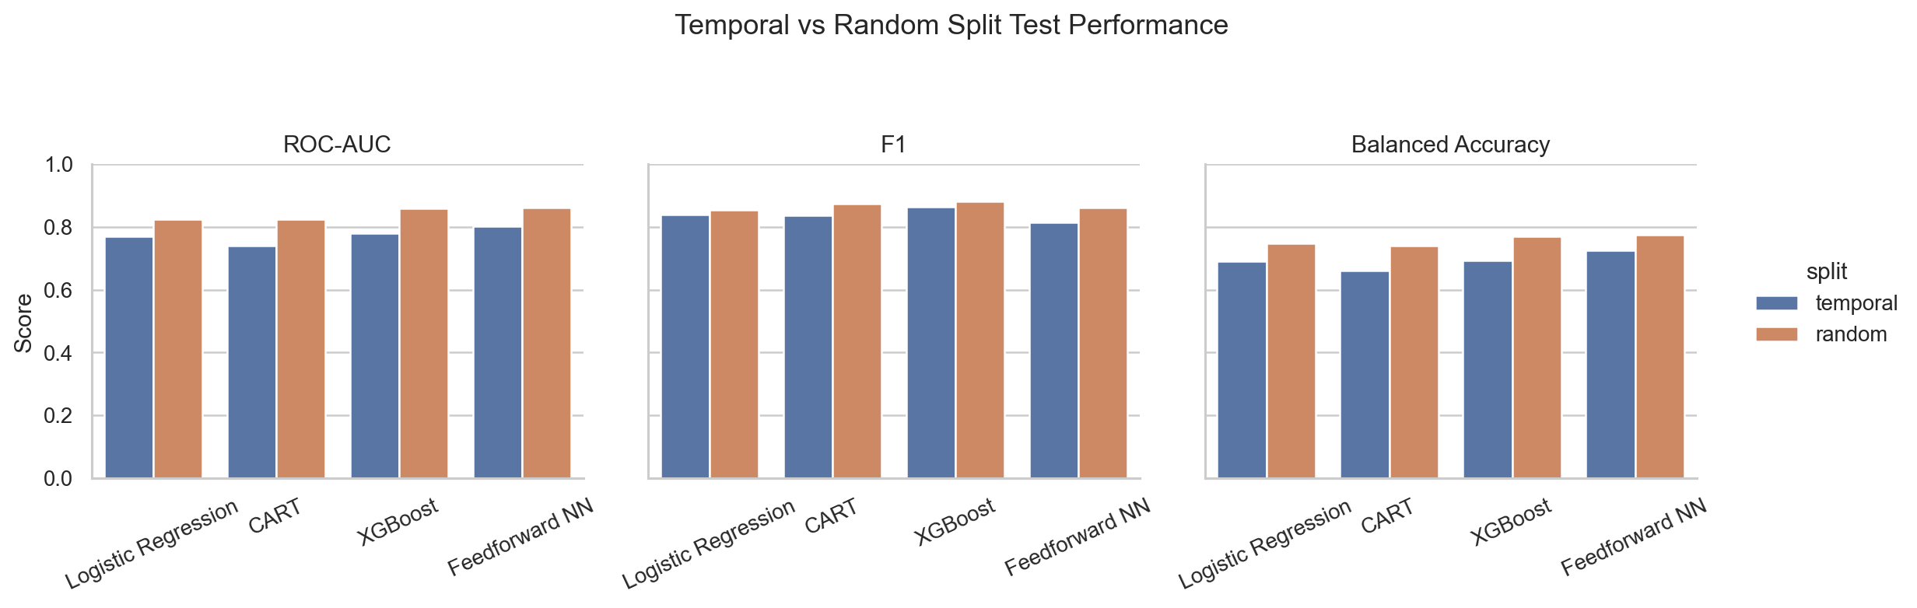
Figure 1. Temporal and random split comparison for ROC-AUC, F1, and balanced accuracy.
Table 2 and Figure 1 tell the same story in two ways. Every model improves under the random split, especially CART and XGBoost in ROC-AUC and balanced accuracy. That improvement is not surprising, and it should not be treated as proof that the random split is better. It mainly shows that the temporal split is a tougher test. For the manuscript, we still treat the temporal split as the main result because it better resembles training on the past and evaluating on later events.

Ranking and Threshold Behavior
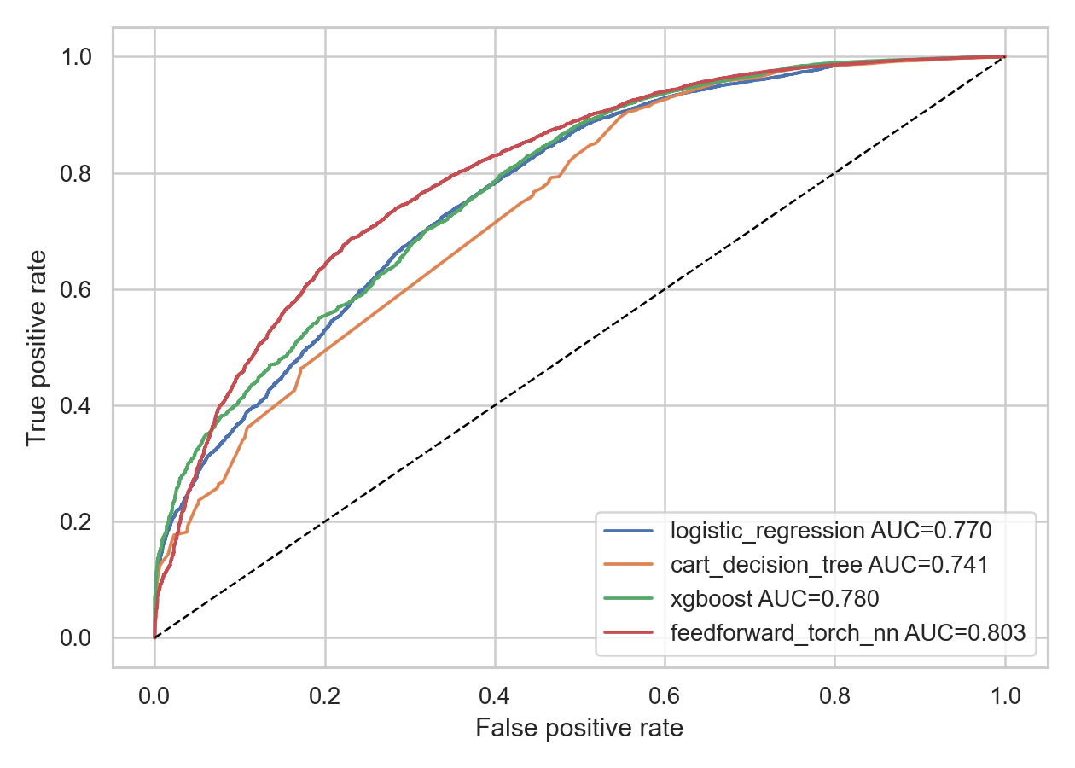
Figure 2. ROC curves for Logistic Regression, CART, XGBoost, and the Feedforward Neural Network on the temporal test set.
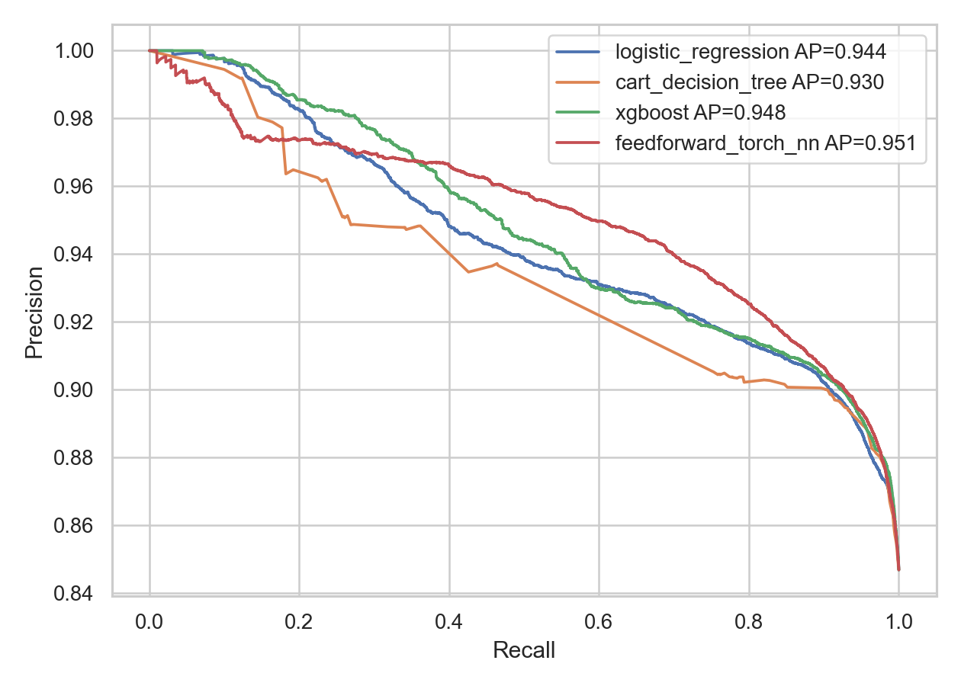
Figure 3. Precision-recall curves for the four models under class imbalance.
Figures 2 and 3 should be read together. The ROC curves show that the neural network separates higher-probability and lower-probability cases well, which matches its strong ROC-AUC. The precision-recall curves add another layer: they show what happens when recall is pushed higher in an imbalanced setting. In practice, this is where XGBoost becomes attractive. It does not have the highest ROC-AUC, but its thresholded predictions are more balanced, which is why it performs better by F1 at the default threshold.
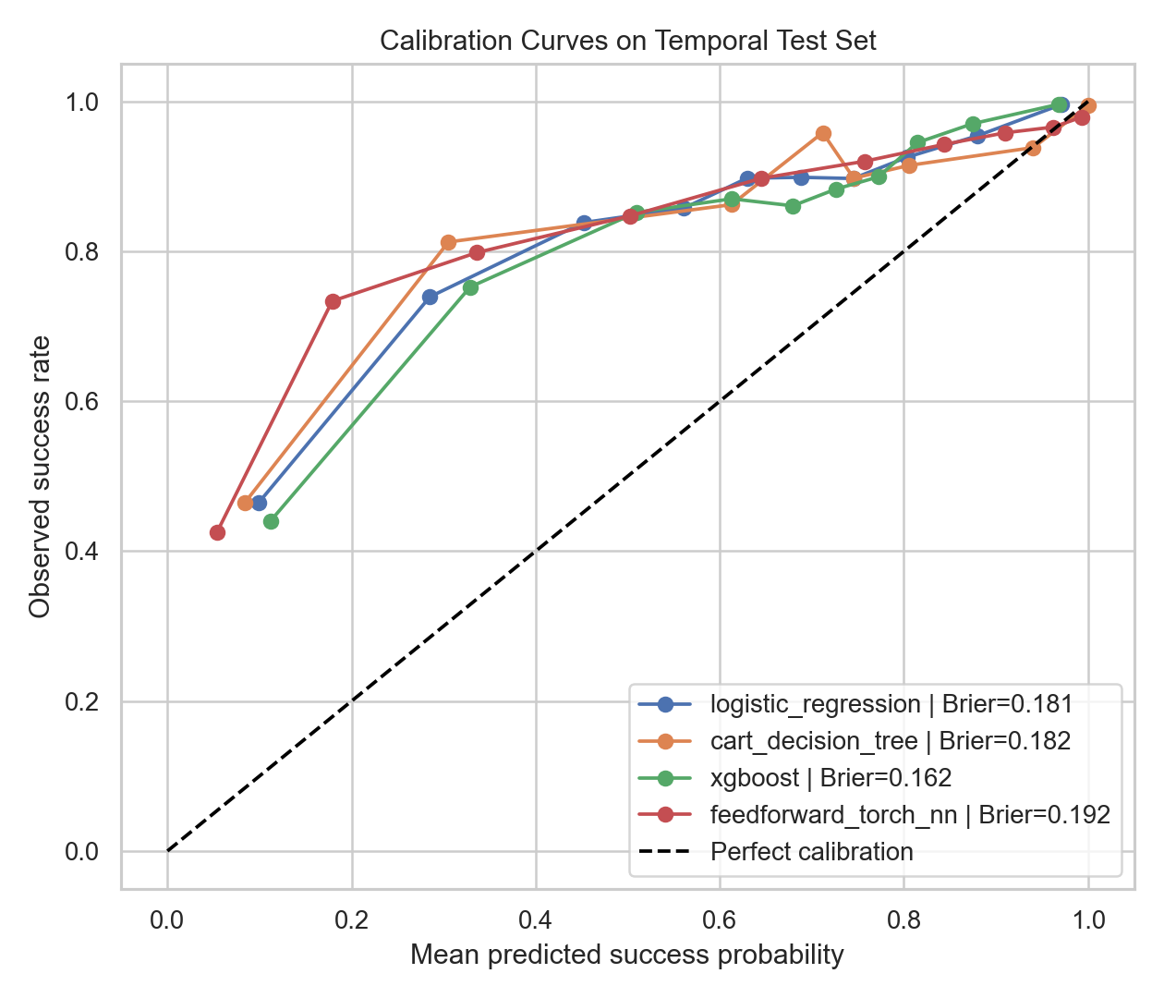
Figure 4. Calibration curves comparing predicted probabilities with observed outcomes.
Figure 4 adds a probability-quality check. A model can rank cases correctly and still give probability values that are too confident or not confident enough. This is why we included Brier score and calibration curves instead of relying only on ROC-AUC. The calibration results also help explain why threshold choice matters: if probabilities are not perfectly calibrated, the meaning of a threshold such as 0.50 can differ from model to model.
The threshold simulation fits naturally with this point. Lower thresholds improved recall for some models, but they also increased false positives. CART, for example, reached a high threshold-tuned F1, but it did so by accepting a much higher false-positive rate. For a research paper, that is an interesting trade-off. For a real decision setting, it would require a clear discussion of costs and review capacity.

Generalization and Overfitting
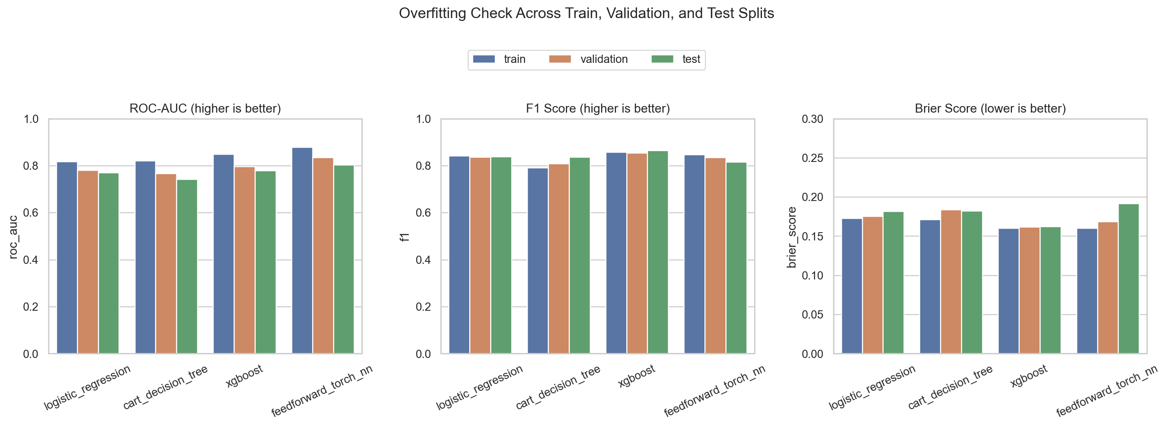
Figure 5. Overfitting check comparing train, validation, and test ROC-AUC, F1, and Brier score across all models.
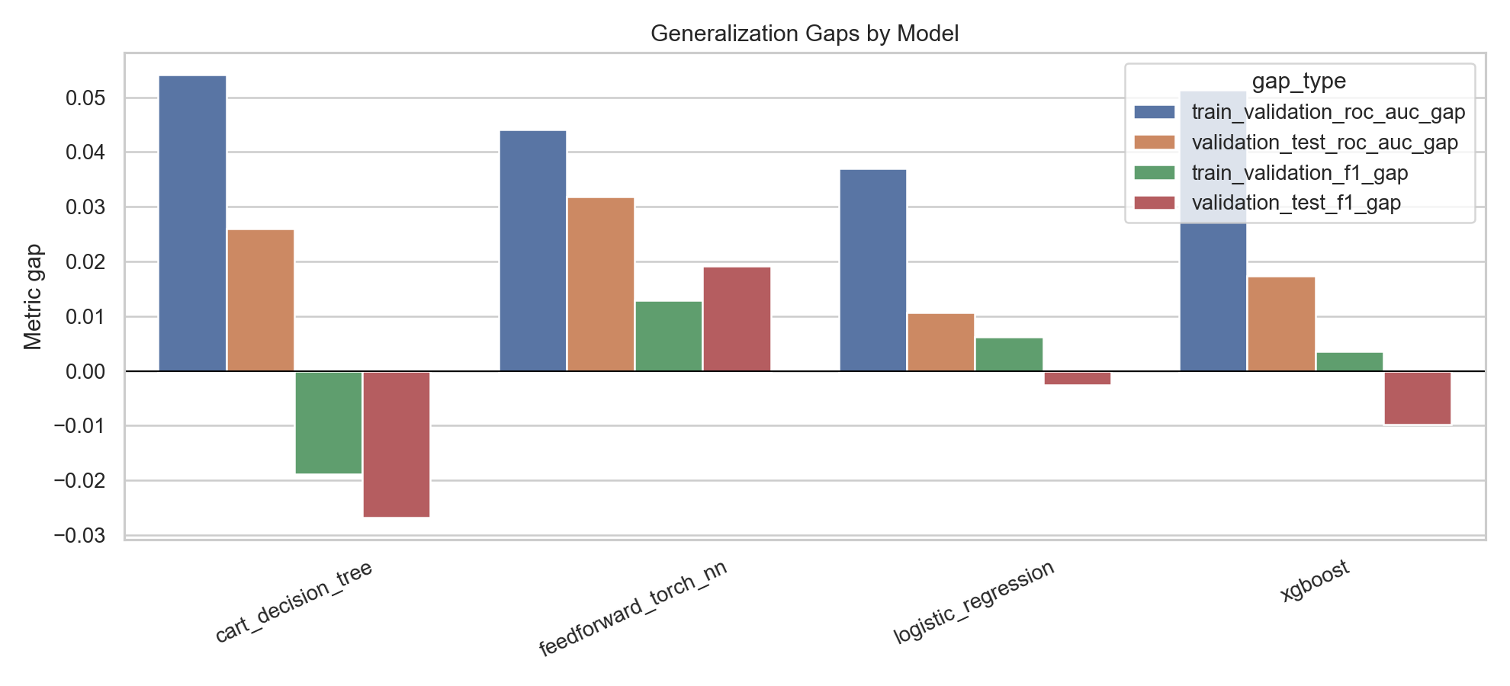
Figure 6. Generalization-gap comparison across Logistic Regression, CART, XGBoost, and the Feedforward Neural Network.
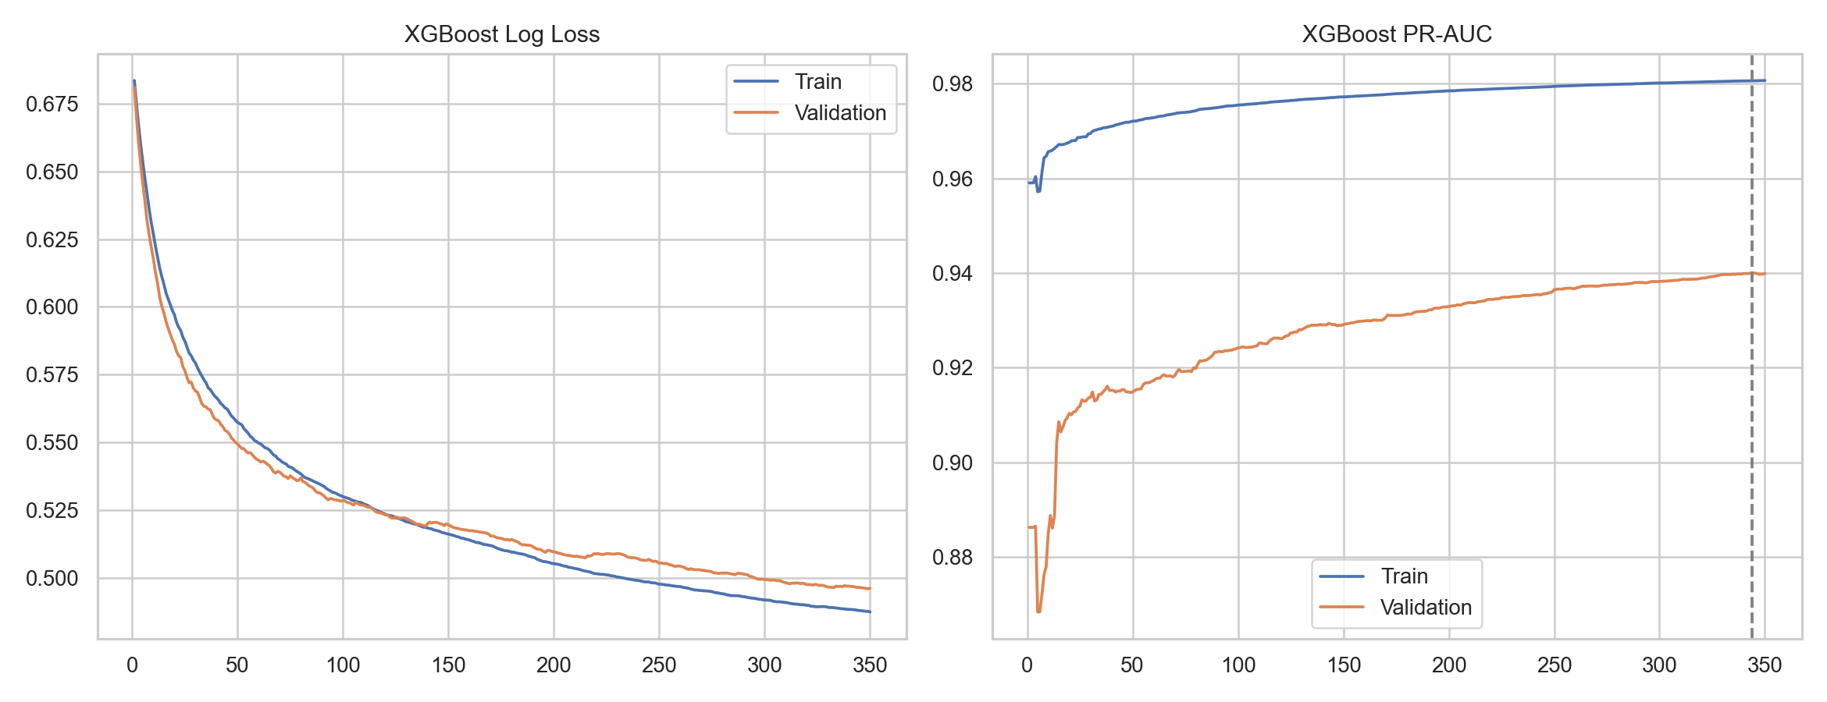
Figure 7. XGBoost learning curves during training and validation.
Figures 5, 6, and 7 are grouped together because they all answer the same question: are the models learning patterns that hold up outside the training period? Logistic regression is the steadiest model. CART, XGBoost, and the neural network show moderate gaps, but the gaps are not severe enough to reject them. The XGBoost learning curve is especially useful here because validation performance does not collapse as boosting continues. That supports the idea that XGBoost is learning useful structure, even though temporal generalization remains harder than random-split evaluation.

Feature Interpretation
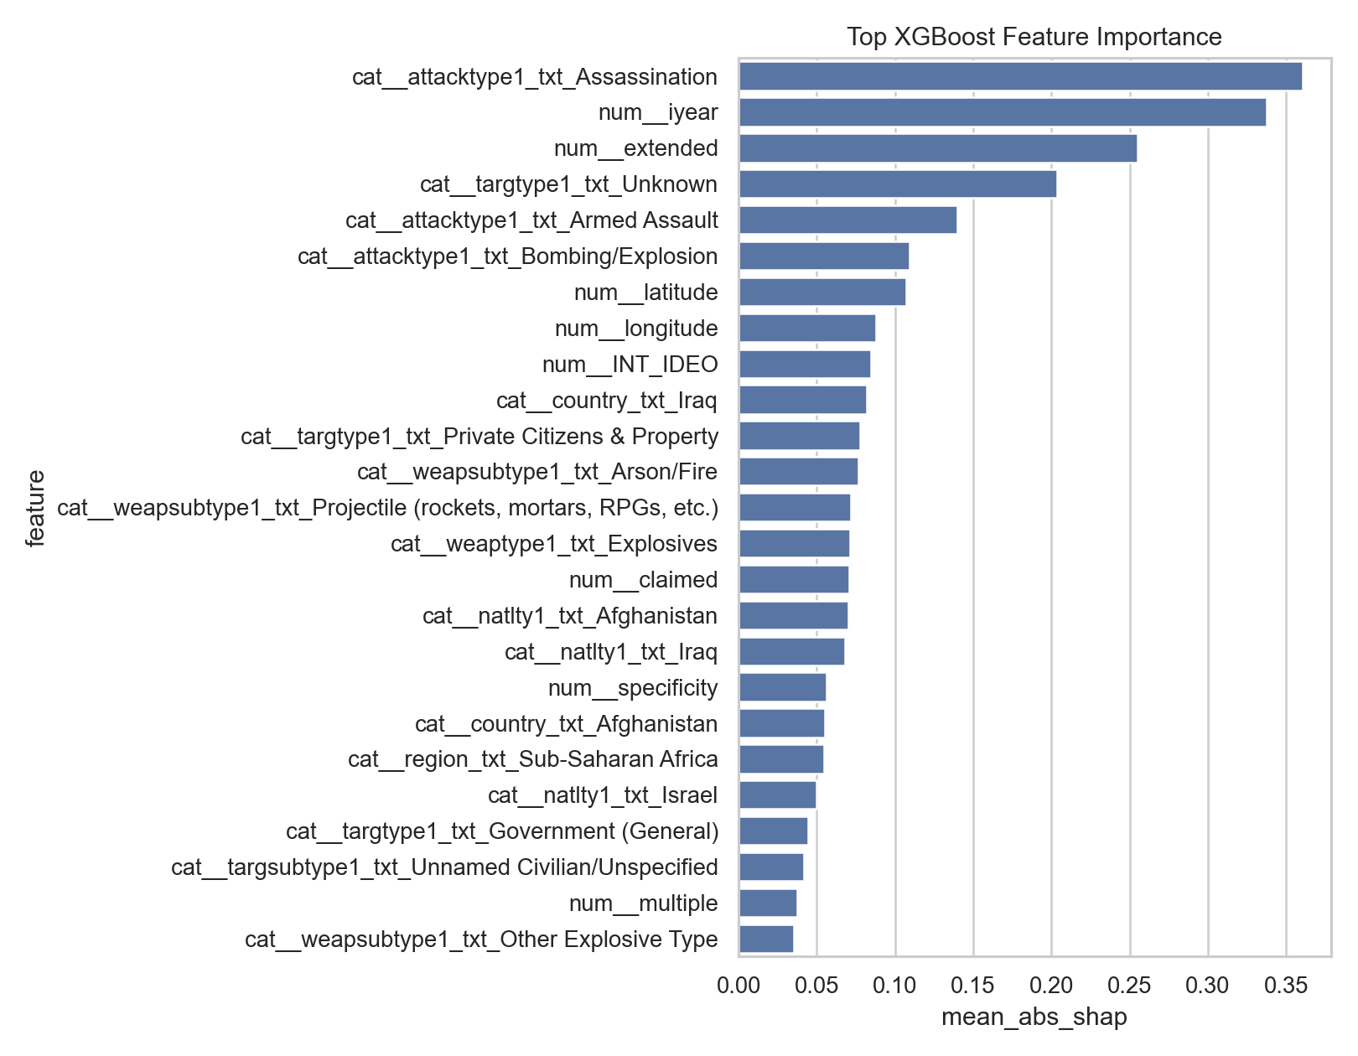
Figure 8. XGBoost feature-importance summary for the strongest predictors.
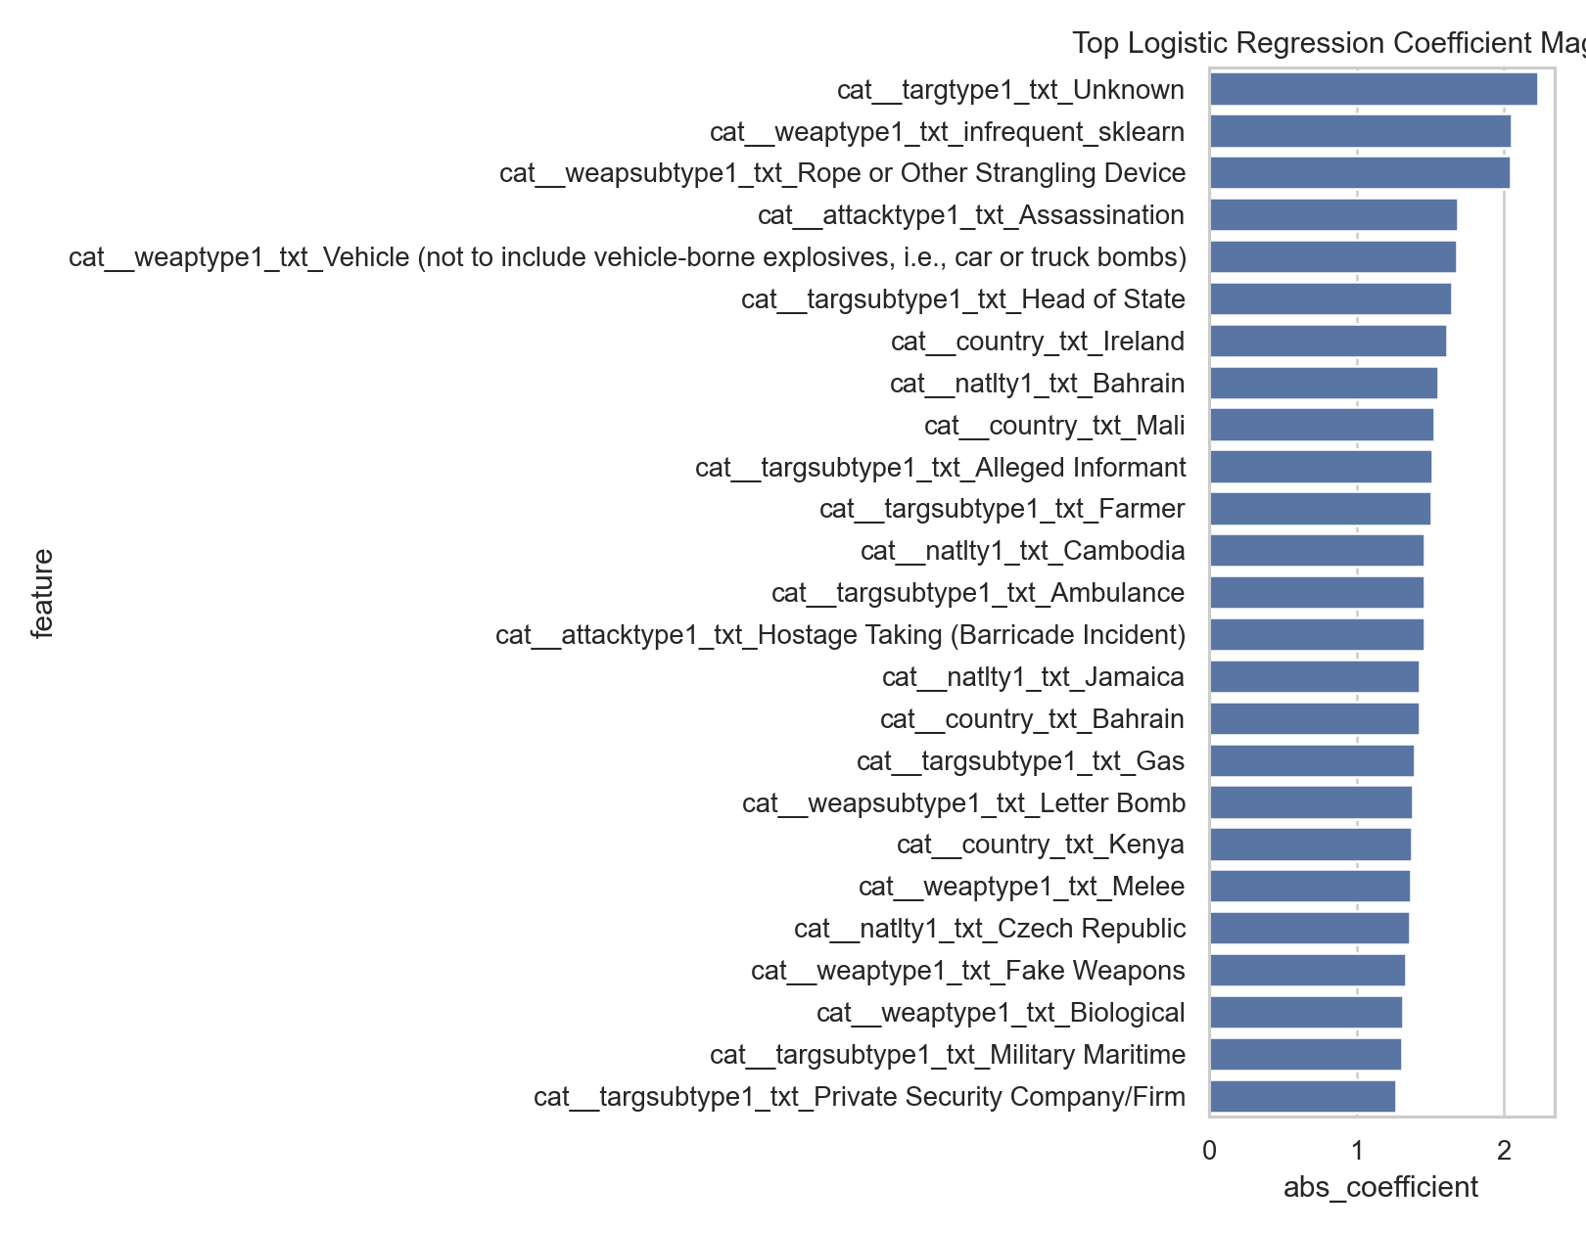
Figure 9. Logistic-regression coefficient importance summary.
Figures 8 and 9 shift the focus from performance to explanation. XGBoost relies on a mix of tactical, temporal, and geographic fields, including attack type, year, target categories, and weapon-related variables. Logistic regression gives a cleaner coefficient-based view, but it is limited by its linear assumption. We do not read these plots as causal proof. Instead, they show which recorded GTD fields helped the models separate success from failure under the feature set we allowed.
Overall, the results support a cautious but useful conclusion. XGBoost is the strongest default-threshold model, the neural network is strong at ranking, logistic regression is the most stable baseline, and CART gives an interpretable single-tree comparison. The random split confirms that the models can perform better when the evaluation is easier, but the temporal split gives the more honest test of forward-looking generalization.

6. Discussion
The main takeaway is that flexible models can improve prediction, but they do not remove uncertainty from the data. XGBoost and the neural network can capture nonlinear patterns that logistic regression may miss. CART also captures nonlinear splits, but as a single tree it is less powerful than XGBoost. All four models still depend on how the GTD records events. If reporting is uneven or if a label is simplified, the model inherits that limitation.
The comparison also shows why interpretability matters. Logistic regression was not the strongest model by every metric, but it gives readable coefficients and a clear baseline. CART adds another interpretable baseline because its splits can be inspected more directly than an ensemble. XGBoost performed very well, but its reasoning has to be interpreted through feature-importance or SHAP-style tools. The neural network ranked cases strongly by ROC-AUC, but its default-threshold classification was less balanced. Model choice so depends on the goal of the analysis, not just the highest value in one metric column.
Threshold choice matters a great deal. A lower threshold may be useful if missing successful attacks is considered more costly, but it also creates more false positives. A higher threshold may make positive predictions more conservative, but it can miss more true successes. Since the dataset does not tell us the real-world cost of each error, we cannot claim that one threshold is universally best. The threshold should match the purpose of the analysis and the ability of people to review the results responsibly.
The subgroup results were also important. If a model performs worse in some countries, regions, or attack types, then overall performance can give a false sense of reliability. This does not mean the model is intentionally biased, and it does not prove a causal claim about any group. It does mean that model evaluation should look beyond averages. For geopolitical data, subgroup error analysis should be part of the normal evaluation process.
There are several limitations. The GTD is based on reported and coded events, so it reflects documentation patterns as well as real incidents. The success label is useful, but it is simplified. Some variables may be missing or uncertain. The models also do not use full event narratives, political context, organization networks, or external country-level indicators. Future work could add text features, newer validation data, confidence intervals for subgroup metrics, and stronger calibration analysis.
One limitation we noticed while writing the paper is that the most useful features are not always the most comfortable ones to interpret. Geographic and country-related variables can improve prediction, but they may also reflect reporting differences, conflict history, and other background conditions. Because of that, we avoided saying that a country or region directly causes a prediction. The safer claim is that those variables help the model separate patterns in the recorded data.

7. Conclusion
This paper presented a machine-learning study of attack-success prediction using the Global Terrorism Database. Our group compared logistic regression, CART, XGBoost, and a feedforward neural network under a temporal split. We also checked threshold sensitivity, feature importance, overfitting behavior, calibration, and subgroup error behavior. The results showed that XGBoost was strongest at the default threshold by F1 score, while the neural network had the highest ROC-AUC. CART was useful as an interpretable single-tree comparison, but it was not stronger than XGBoost overall. Validation-selected thresholds improved F1 for several models, but they also increased false-positive rates.
For our group, the main value of the project was not only the final comparison among four algorithms. It was the process of checking how the results changed when we adjusted the design. The temporal split, leakage filtering, threshold simulation, overfitting graphs, calibration checks, and subgroup analysis each changed how we understood the models. Without those checks, the paper would have been much closer to a simple leaderboard.
The broader lesson is that prediction in geopolitical data should be handled carefully. The models can reveal useful patterns in recorded events, but they should not be treated as complete explanations or automatic decision systems. Future work should focus on better calibration, stronger subgroup uncertainty estimates, external validation, and richer features such as event narratives or political context. Most importantly, any use of this type of model should include human review and clear limits on interpretation. We also see this as a starting point for better class discussions about data quality, model limits, and responsible reporting.

References
Barocas, S., Hardt, M., & Narayanan, A. (2019). Fairness and machine learning: Limitations and opportunities. fairmlbook.org. https://fairmlbook.org/
Breiman, L., Friedman, J. H., Olshen, R. A., & Stone, C. J. (1984). Classification and regression trees. Wadsworth International Group.
Chen, T., & Guestrin, C. (2016). XGBoost: A scalable tree boosting system. In Proceedings of the 22nd ACM SIGKDD International Conference on Knowledge Discovery and Data Mining (pp. 785-794). Association for Computing Machinery. https://doi.org/10.1145/2939672.2939785
Chouldechova, A., & Roth, A. (2020). A snapshot of the frontiers of fairness in machine learning. Communications of the ACM, 63(5), 82-89. https://doi.org/10.1145/3376898
Davis, J., & Goadrich, M. (2006). The relationship between precision-recall and ROC curves. In Proceedings of the 23rd International Conference on Machine Learning (pp. 233-240). Association for Computing Machinery. https://doi.org/10.1145/1143844.1143874
Drakos, K., & Gofas, A. (2006). The devil you know but are afraid to face: Underreporting bias and its distorting effects on the study of terrorism. Journal of Conflict Resolution, 50(5), 714-735. https://doi.org/10.1177/0022002706291051
Enders, W., Sandler, T., & Gaibulloev, K. (2011). Domestic versus transnational terrorism: Data, decomposition, and dynamics. Journal of Peace Research, 48(3), 319-337. https://doi.org/10.1177/0022343311398926
Friedman, J. H. (2001). Greedy function approximation: A gradient boosting machine. The Annals of Statistics, 29(5), 1189-1232. https://doi.org/10.1214/aos/1013203451
Goodfellow, I., Bengio, Y., & Courville, A. (2016). Deep learning. MIT Press. https://www.deeplearningbook.org/
Guo, C., Pleiss, G., Sun, Y., & Weinberger, K. Q. (2017). On calibration of modern neural networks. In Proceedings of the 34th International Conference on Machine Learning (pp. 1321-1330). PMLR. https://proceedings.mlr.press/v70/guo17a.html
Hastie, T., Tibshirani, R., & Friedman, J. (2009). The elements of statistical learning: Data mining, inference, and prediction (2nd ed.). Springer. https://hastie.su.domains/ElemStatLearn/
King, G., & Zeng, L. (2001). Logistic regression in rare events data. Political Analysis, 9(2), 137-163. https://doi.org/10.1093/oxfordjournals.pan.a004868
LaFree, G., & Dugan, L. (2007). Introducing the Global Terrorism Database. Terrorism and Political Violence, 19(2), 181-204. https://doi.org/10.1080/09546550701246817
Lundberg, S. M., & Lee, S.-I. (2017). A unified approach to interpreting model predictions. In I. Guyon et al. (Eds.), Advances in Neural Information Processing Systems 30. https://proceedings.neurips.cc/paper/2017/hash/8a20a8621978632d76c43dfd28b67767-Abstract.html
Miller, T. (2019). Explanation in artificial intelligence: Insights from the social sciences. Artificial Intelligence, 267, 1-38. https://doi.org/10.1016/j.artint.2018.07.007
National Consortium for the Study of Terrorism and Responses to Terrorism (START). (2022). Global Terrorism Database codebook: Methodology, inclusion criteria, and variables. University of Maryland. https://www.start.umd.edu/gtd/
Paszke, A., Gross, S., Massa, F., Lerer, A., Bradbury, J., Chanan, G., Killeen, T., Lin, Z., Gimelshein, N., Antiga, L., Desmaison, A., Kopf, A., Yang, E., DeVito, Z., Raison, M., Tejani, A., Chilamkurthy, S., Steiner, B., Fang, L., ... Chintala, S. (2019). PyTorch: An imperative style, high-performance deep learning library. In Advances in Neural Information Processing Systems 32. https://proceedings.neurips.cc/paper/2019/hash/bdbca288fee7f92f2bfa9f7012727740-Abstract.html
Pedregosa, F., Varoquaux, G., Gramfort, A., Michel, V., Thirion, B., Grisel, O., Blondel, M., Prettenhofer, P., Weiss, R., Dubourg, V., VanderPlas, J., Passos, A., Cournapeau, D., Brucher, M., Perrot, M., & Duchesnay, E. (2011). Scikit-learn: Machine learning in Python. Journal of Machine Learning Research, 12, 2825-2830. https://jmlr.org/papers/v12/pedregosa11a.html
Ribeiro, M. T., Singh, S., & Guestrin, C. (2016). "Why should I trust you?": Explaining the predictions of any classifier. In Proceedings of the 22nd ACM SIGKDD International Conference on Knowledge Discovery and Data Mining (pp. 1135-1144). Association for Computing Machinery. https://doi.org/10.1145/2939672.2939778
Rudin, C. (2019). Stop explaining black box machine learning models for high stakes decisions and use interpretable models instead. Nature Machine Intelligence, 1, 206-215. https://doi.org/10.1038/s42256-019-0048-x
Saito, T., & Rehmsmeier, M. (2015). The precision-recall plot is more informative than the ROC plot when evaluating binary classifiers on imbalanced datasets. PLOS ONE, 10(3), Article e0118432. https://doi.org/10.1371/journal.pone.0118432
Suresh, H., & Guttag, J. V. (2021). A framework for understanding sources of harm throughout the machine learning life cycle. In Equity and Access in Algorithms, Mechanisms, and Optimization. Association for Computing Machinery. https://doi.org/10.1145/3465416.3483305

