PES UNIVERSITY
100 Feet Ring Road, BSK 3rd Stage, Bengaluru 560085

Department of Computer Science and Engineering
(AI & ML)
B. Tech. CSE - 5th Semester
Aug - Dec 2026

UE23CS351A
DATABASE MANAGEMENT SYSTEMS (DBMS)

PROJECT REPORT on

LabTrace: An Intelligent Laboratory Asset Failure Tracking, Maintenance Management and Predictive Reliability System

Submitted by:
PES1UG24AM272 | Shryes M
PES1UG24AM261 | Shesanth K

Class of Prof. Junaid Rasool
Lab Faculty: Prof. Junaid Rasool

Abstract
Engineering colleges and research laboratories depend on hundreds of physical assets - desktops, GPU workstations, servers, network devices, instruments, projectors and embedded kits. Failures are usually reported through informal channels such as messaging apps, e-mail or paper registers, while repair notes and spare-part usage live in separate spreadsheets. As a result, nobody can see the complete history of an asset, recurring failures go unnoticed and technicians repeatedly diagnose problems that were already solved.
LabTrace is a centralised web application that connects every laboratory asset with its reported failures, technician assignments, maintenance records, spare parts and status history. Structured data is stored in a PostgreSQL relational database with constraints, triggers, stored procedures, functions, views, recursive common table expressions and database-level role-based access control (database roles, column privileges and row-level security). Free-text failure descriptions, diagnoses, repair notes and technical articles are stored in a MongoDB document repository together with 384-dimension text embeddings, enabling semantic vector search: a description such as "the computer gets too hot and turns off" retrieves earlier incidents described as "system powers off during heavy processing" together with their documented fixes.
The application is built with Next.js 16 (App Router, server components and API route handlers) and supports three roles - student, technician and administrator. It also computes reliability indicators such as Mean Time Between Failures (MTBF), Mean Time To Repair (MTTR), repeat failures, a reliability score, a risk level and an estimated next-failure date, helping administrators decide which equipment needs preventive maintenance or replacement. The system was verified with SQL demonstration scripts and a 29-step automated end-to-end test of the complete workflow and access rules.

Table of Contents
Sl. No | Topic | Page No.
1. | Introduction - Problem Statement | 4
2. | User Requirements Specification - Tech Stack | 4
3. | E-R Model - List of Entities (weak ones labelled), non-simple attributes, ER Diagram | 6
4. | Relational Model - List of Relations (non-entity relations labelled), Schema Diagram | 8
5. | SQL DDL Statements | 10
6. | SQL DML Statements and Queries | 19
7. | NoSQL / Vector Database Commands | 27
8. | Results - Resulting Tables' Screenshots | 31
9. | Next.js Project Tree Structure | 38
10. | Sample Screenshots of Application Code and Demo | 41
11. | Testing, GitHub and Individual Contribution | 59
12. | Evaluation Rubrics - Completion Status | 61

1. Introduction

1.1 Problem Statement
Educational institutions lack an integrated, intelligent and centralised system for managing laboratory equipment failures and maintenance. Existing informal processes record individual complaints and resolve them independently; they do not preserve the relationship between an asset, its recurring failures, earlier diagnoses, repair procedures and outcomes. Because users describe the same technical problem in different words, keyword search cannot connect similar failures, so technicians repeat troubleshooting that has already been done. Administrators cannot easily answer questions such as which equipment fails most often, which laboratory has the most breakdowns, how long repairs take, or which assets should be prioritised for preventive maintenance or replacement.

1.2 Short Description
LabTrace provides a single platform in which:
- Students report a failure against a specific asset in plain language and track its progress. While typing, the system shows similar resolved incidents and help articles found by semantic search.
- Administrators see unassigned incidents, assign a technician manually or automatically (a stored procedure selects the technician whose skills best match the equipment category, using a recursive category hierarchy, and who has the lowest workload), and manage labs, equipment, spare parts and users.
- Technicians work on their assigned incidents and record the diagnosis, root cause, action taken, outcome and spare parts used. A stored procedure saves all of this in one transaction; a trigger checks and reduces the spare-part stock.
- Every status change is recorded automatically in an incident status log (a weak entity) by triggers that also reject invalid transitions and keep the equipment status in sync.
- The reporter confirms the repair (closes the incident) or reopens it if the problem returns.
- The analytics page computes MTBF, MTTR, repeat failures, a reliability score, a risk level and a predicted next-failure date per asset, plus breakdowns by lab, category and root cause.

2. User Requirements Specification

2.1 Functional Requirements
Role | Requirements
Student | Self-register with SRN; log in / log out  Report an incident (equipment, title, description, severity)  See similar past failures while typing  View only own incidents, their status timeline and repair details  Close a resolved incident or reopen it; add discussion notes  Search the knowledge base and read articles
Technician | View all incidents and asset histories (shared knowledge)  View own active jobs; start work on an assigned incident  Record maintenance with spare parts (stock updated automatically)  Create and edit knowledge-base articles; edit incident tags  View spare-part inventory
Administrator | Everything above, plus: assign / re-assign technicians (manual or automatic)  Create, edit and delete equipment and labs (JSON specifications)  Add spare parts, restock  Create users, change roles, activate / deactivate accounts  Close / reopen / cancel incidents  Reliability analytics dashboard; delete KB articles; rebuild the knowledge base

2.2 Non-Functional Requirements
- Security: passwords hashed with bcrypt; sessions are signed JWTs in httpOnly cookies; access is checked in the front-end route guard, in every API route and again inside PostgreSQL through database roles and row-level security.
- Integrity: primary, foreign, unique and CHECK constraints; triggers enforce business rules (valid status transitions, stock never negative, only technicians own repair records).
- Consistency: multi-step operations (repair + parts + status) run in a single transaction inside a stored procedure.
- Availability: the relational workflow keeps working even if the knowledge-base database is unavailable.
- Usability: plain-language reporting, live suggestions, clean role-specific dashboards.

2.3 Technology Stack and Justification
Layer | Technology | Why it fits LabTrace
Relational database | PostgreSQL 16 | Equipment, incidents, assignments, repairs and parts are highly related and need strict integrity. PostgreSQL offers rich constraints, PL/pgSQL triggers, procedures and functions, recursive CTEs (category hierarchy), JSONB (variable equipment specifications), generated columns, and - importantly - database roles with column privileges and Row-Level Security, so role-based access is enforced by the database itself.
NoSQL / vector database | MongoDB 7 (Docker) + vector search | Failure narratives, diagnoses, notes, tags and articles are free text of varying shape that grows over time (e.g. an array of discussion notes). A document model stores each incident's knowledge as one flexible document with embedded equipment details. Each document also stores a 384-dimension embedding; exact cosine k-NN over these vectors (or MongoDB Atlas $vectorSearch when available) finds semantically similar failures.
Embeddings | Built-in offline concept embedder (default); optional all-MiniLM-L6-v2 sentence-transformer | Converts any description into a vector so that "gets too hot and turns off" and "thermal shutdown" end up close together. Runs fully locally with no paid API; the neural model can be switched on with one setting.
Web framework | Next.js 16 (App Router), React 19 | One project contains UI pages, server components that query the database directly, and REST API route handlers. The proxy (middleware) protects routes before pages render.
Authentication | bcryptjs + jose (JWT), httpOnly cookie | Simple, standard and secure session handling without an external service.
Database drivers | node-postgres (pg), MongoDB Node driver | Official, parameterised queries (protection against SQL injection).
Tooling | Docker Compose, Git/GitHub, Playwright | Reproducible database setup, version control and automated screenshots / tests.

2.4 Justification for the Choice of NoSQL Database
- The heart of the problem (Section 3.3 / 3.4 of the problem description) is inconsistent natural-language descriptions. Answering "has this happened before?" requires similarity by meaning, which needs vectors and nearest-neighbour search - not exact matching on relational columns.
- Incident knowledge is semi-structured and evolving: a report starts with only a description, later gains a diagnosis and resolution, collects any number of notes and tags, and may be re-embedded with a better model. A schema-flexible document fits this naturally while the authoritative, transactional facts stay in PostgreSQL.
- MongoDB keeps the text and its vector in the same document, so a single query returns the matching incident together with its fix. The same data works with MongoDB Atlas $vectorSearch (index script included) when the project is moved to the cloud.
- Separating the two stores applies polyglot persistence: PostgreSQL for integrity and analytics, MongoDB for flexible knowledge and similarity search. The incident_id links both.

3. E-R Model

3.1 List of Entities
Entity | Type | Key attribute(s) | Description
USER | Strong | user_id | Student, technician or administrator (role attribute)
LAB | Strong | lab_id | Laboratory with a composite location
EQUIPMENT_CATEGORY | Strong | category_id | Hierarchical category (recursive relationship SUBCATEGORY_OF)
EQUIPMENT | Strong | equipment_id | A laboratory asset
INCIDENT | Strong | incident_id | A reported failure of an equipment
INCIDENT_STATUS_LOG | WEAK | partial key log_seq (+ incident_id of owner) | History of status changes; cannot exist without its INCIDENT (identifying relationship HAS_LOG, total participation)
MAINTENANCE_RECORD | Strong | record_id | Repair work done by a technician for an incident
SPARE_PART | Strong | part_id | Inventory item consumed during repairs
Weak entity highlighted.

3.2 Non-Simple Attributes
Attribute | Entity | Kind | Mapping
location (building, floor_no, room_no) | LAB | Composite | Flattened into three columns with a UNIQUE constraint
phone_no | USER | Multivalued | Separate relation user_phones(user_id, phone_no, phone_type)
labour_hours | MAINTENANCE_RECORD | Derived (completed_at - started_at) | STORED GENERATED column
age_years | EQUIPMENT | Derived (now - purchase_date) | Computed in fn_reliability_score()
specifications | EQUIPMENT | Composite / semi-structured (cpu, gpu, ram_gb…) | JSONB column
log_seq | INCIDENT_STATUS_LOG | Partial key of weak entity | Composite PK (incident_id, log_seq)

3.3 Relationships and Cardinalities
Relationship | Entities | Cardinality | Attributes
IN_CHARGE_OF | USER - LAB | 1 : N (partial) | -
HOUSES | LAB - EQUIPMENT | 1 : N (total on equipment) | -
BELONGS_TO | EQUIPMENT - CATEGORY | N : 1 (total on equipment) | -
SUBCATEGORY_OF | CATEGORY - CATEGORY | 1 : N (recursive) | -
REPORTS | USER - INCIDENT | 1 : N | -
FAILURE_OF | INCIDENT - EQUIPMENT | N : 1 | -
ASSIGNED_TO | INCIDENT - USER (technician) | M : N (over time; one active) | assigned_at, is_active, notes
HAS_LOG (identifying) | INCIDENT - STATUS_LOG | 1 : N (total) | -
CHANGED_BY | STATUS_LOG - USER | N : 1 | -
REPAIRED_BY | INCIDENT - MAINTENANCE_RECORD | 1 : N | -
PERFORMS | USER (technician) - MAINTENANCE_RECORD | 1 : N | -
USES | MAINTENANCE_RECORD - SPARE_PART | M : N | quantity, unit_cost_at_use
SKILLED_IN | USER (technician) - CATEGORY | M : N | proficiency

3.4 ER Diagram
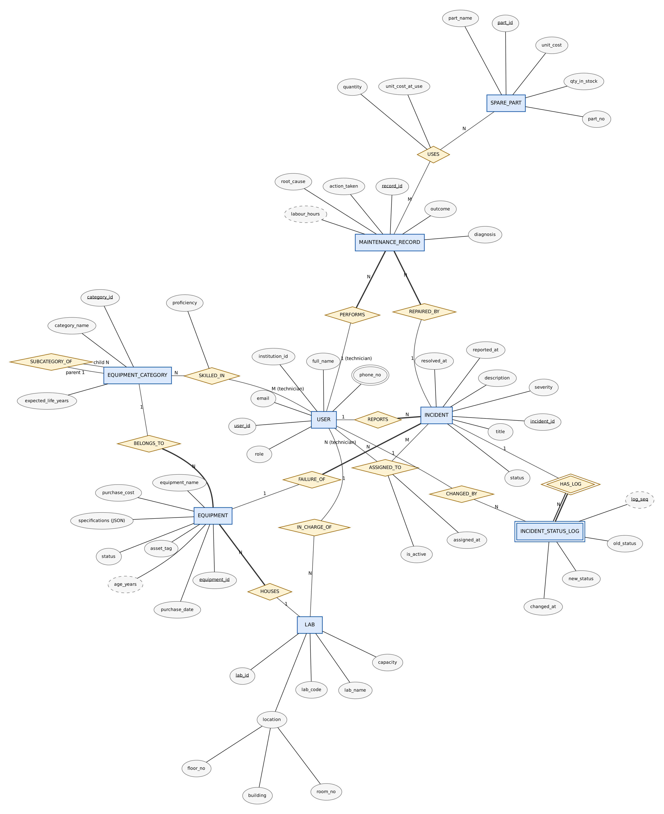
Figure 1 - ER diagram (Chen notation; double rectangle = weak entity, double diamond = identifying relationship, double ellipse = multivalued, dashed ellipse = derived, underline = key, thick line = total participation).

4. Relational Model

4.1 List of Relations
Relation (schema) | From ER | Keys
users(user_id, institution_id, full_name, email, password_hash, role, department, is_active, created_at) | Entity USER | PK user_id; UQ email, institution_id
user_phones(user_id, phone_no, phone_type) | NOT an entity - multivalued attribute | PK (user_id, phone_no); FK user_id
labs(lab_id, lab_code, lab_name, building, floor_no, room_no, capacity, incharge_id) | Entity LAB + IN_CHARGE_OF | PK lab_id; FK incharge_id → users
equipment_categories(category_id, category_name, parent_id, expected_life_years, description) | Entity + recursive SUBCATEGORY_OF | PK category_id; FK parent_id → itself
equipment(equipment_id, asset_tag, equipment_name, category_id, lab_id, manufacturer, model_no, serial_no, purchase_date, purchase_cost, warranty_expiry, status, specifications) | Entity EQUIPMENT + HOUSES + BELONGS_TO | PK equipment_id; FK category_id, lab_id
incidents(incident_id, equipment_id, reported_by, title, description, severity, status, reported_at, resolved_at, closed_at) | Entity INCIDENT + REPORTS + FAILURE_OF | PK incident_id; FK equipment_id, reported_by
incident_status_log(incident_id, log_seq, old_status, new_status, changed_by, changed_at, remarks) | WEAK entity | PK (incident_id, log_seq); FK incident_id ON DELETE CASCADE
assignments(assignment_id, incident_id, technician_id, assigned_by, assigned_at, is_active, notes) | NOT an entity - M:N relationship ASSIGNED_TO | PK assignment_id; partial UNIQUE (incident_id) WHERE is_active
technician_skills(technician_id, category_id, proficiency) | NOT an entity - M:N relationship SKILLED_IN | PK (technician_id, category_id)
maintenance_records(record_id, incident_id, technician_id, diagnosis, root_cause, action_taken, outcome, started_at, completed_at, labour_hours) | Entity + REPAIRED_BY + PERFORMS | PK record_id; FK incident_id, technician_id
spare_parts(part_id, part_no, part_name, part_category, unit_cost, qty_in_stock, reorder_level) | Entity SPARE_PART | PK part_id; UQ part_no
part_usage(record_id, part_id, quantity, unit_cost_at_use) | NOT an entity - M:N relationship USES | PK (record_id, part_id)
Relations that are not entities in the ER model are highlighted.
Normalisation: every relation has an atomic-valued schema (1NF; the multivalued phone attribute is in its own relation), every non-key attribute depends on the whole key (2NF; e.g. proficiency depends on both technician and category) and there are no transitive dependencies (3NF; lab and category details are referenced by foreign keys instead of being repeated in equipment). unit_cost_at_use is intentionally stored in part_usage because it is the historical price at the time of use, not a copy of the current price.

4.2 Schema Diagram
The diagram is rotated to use the full page (a full-resolution copy is in docs/diagrams/schema_diagram.png).
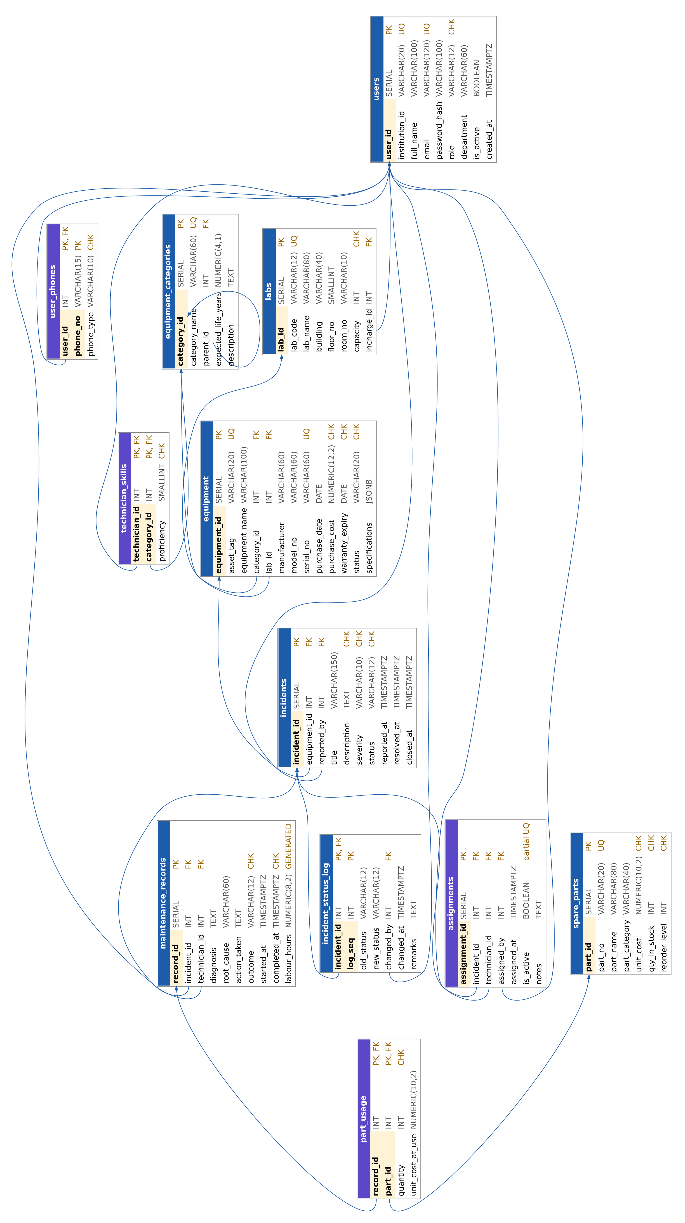
Figure 2 - Relational schema with primary keys (highlighted), data types, constraints and foreign keys (arrows). Purple headers = relations that are not entities.

5. SQL DDL Statements
The database is created by five scripts in the sql/ folder, run in order by scripts/setup_db.sh. The complete table definitions (sql/01_schema.sql) are shown below; the functions, procedures, triggers, views and security scripts follow with their key parts. Execution logs are in sql/logs/.

5.1 Tables, Keys and Constraints (01_schema.sql)

DROP SCHEMA IF EXISTS labtrace CASCADE;
CREATE SCHEMA labtrace;
SET search_path TO labtrace, public;

-- ---------------------------------------------------------------------
-- 1. USERS (students, technicians, administrators)
-- ---------------------------------------------------------------------
CREATE TABLE users (
user_id SERIAL PRIMARY KEY,
institution_id VARCHAR(20) NOT NULL UNIQUE, -- SRN for students, EMP id for staff
full_name VARCHAR(100) NOT NULL,
email VARCHAR(120) NOT NULL UNIQUE,
password_hash VARCHAR(100) NOT NULL,
role VARCHAR(12) NOT NULL DEFAULT 'student',
department VARCHAR(60),
is_active BOOLEAN NOT NULL DEFAULT TRUE,
created_at TIMESTAMPTZ NOT NULL DEFAULT now(),
CONSTRAINT chk_users_role CHECK (role IN ('student','technician','admin')),
CONSTRAINT chk_users_email CHECK (email ~* '^[A-Za-z0-9._%+-]+@[A-Za-z0-9.-]+\.[A-Za-z]{2,}$')
);

-- Multivalued attribute of USER (a user may have many phone numbers)
CREATE TABLE user_phones (
user_id INT NOT NULL REFERENCES users(user_id) ON DELETE CASCADE,
phone_no VARCHAR(15) NOT NULL,
phone_type VARCHAR(10) NOT NULL DEFAULT 'mobile',
PRIMARY KEY (user_id, phone_no),
CONSTRAINT chk_phone_no CHECK (phone_no ~ '^\+?[0-9]{10,14}$'),
CONSTRAINT chk_phone_type CHECK (phone_type IN ('mobile','office','home'))
);

-- ---------------------------------------------------------------------
-- 2. LABS
-- ---------------------------------------------------------------------
CREATE TABLE labs (
lab_id SERIAL PRIMARY KEY,
lab_code VARCHAR(12) NOT NULL UNIQUE,
lab_name VARCHAR(80) NOT NULL,
building VARCHAR(40) NOT NULL, -- composite attribute "location"
floor_no SMALLINT NOT NULL, -- = building + floor + room
room_no VARCHAR(10) NOT NULL,
capacity INT NOT NULL,
incharge_id INT REFERENCES users(user_id) ON DELETE SET NULL,
CONSTRAINT chk_labs_capacity CHECK (capacity > 0),
CONSTRAINT chk_labs_floor CHECK (floor_no BETWEEN -2 AND 20),
CONSTRAINT uq_labs_location UNIQUE (building, floor_no, room_no)
);

-- ---------------------------------------------------------------------
-- 3. EQUIPMENT CATEGORIES (self-referencing hierarchy -> recursive CTE)
-- ---------------------------------------------------------------------
CREATE TABLE equipment_categories (
category_id SERIAL PRIMARY KEY,
category_name VARCHAR(60) NOT NULL UNIQUE,
parent_id INT REFERENCES equipment_categories(category_id) ON DELETE RESTRICT,
expected_life_years NUMERIC(4,1) NOT NULL DEFAULT 5,
description TEXT,
CONSTRAINT chk_cat_life CHECK (expected_life_years > 0),
CONSTRAINT chk_cat_parent CHECK (parent_id IS NULL OR parent_id <> category_id)
);

-- ---------------------------------------------------------------------
-- 4. EQUIPMENT (laboratory assets)
-- ---------------------------------------------------------------------
CREATE TABLE equipment (
equipment_id SERIAL PRIMARY KEY,
asset_tag VARCHAR(20) NOT NULL UNIQUE,
equipment_name VARCHAR(100) NOT NULL,
category_id INT NOT NULL REFERENCES equipment_categories(category_id) ON DELETE RESTRICT,
lab_id INT NOT NULL REFERENCES labs(lab_id) ON DELETE RESTRICT,
manufacturer VARCHAR(60),
model_no VARCHAR(60),
serial_no VARCHAR(60) UNIQUE,
purchase_date DATE NOT NULL,
purchase_cost NUMERIC(12,2) NOT NULL DEFAULT 0,
warranty_expiry DATE,
status VARCHAR(20) NOT NULL DEFAULT 'operational',
specifications JSONB NOT NULL DEFAULT '{}'::jsonb, -- composite/semi-structured specs
created_at TIMESTAMPTZ NOT NULL DEFAULT now(),
CONSTRAINT chk_eq_status CHECK (status IN ('operational','faulty','under_maintenance','retired')),
CONSTRAINT chk_eq_cost CHECK (purchase_cost >= 0),
CONSTRAINT chk_eq_warranty CHECK (warranty_expiry IS NULL OR warranty_expiry >= purchase_date)
);
CREATE INDEX idx_equipment_lab ON equipment(lab_id);
CREATE INDEX idx_equipment_category ON equipment(category_id);
CREATE INDEX idx_equipment_status ON equipment(status);

-- ---------------------------------------------------------------------
-- 5. INCIDENTS (failure reports)
-- ---------------------------------------------------------------------
CREATE TABLE incidents (
incident_id SERIAL PRIMARY KEY,
equipment_id INT NOT NULL REFERENCES equipment(equipment_id) ON DELETE RESTRICT,
reported_by INT NOT NULL REFERENCES users(user_id) ON DELETE RESTRICT,
title VARCHAR(150) NOT NULL,
description TEXT NOT NULL,
severity VARCHAR(10) NOT NULL DEFAULT 'medium',
status VARCHAR(12) NOT NULL DEFAULT 'open',
reported_at TIMESTAMPTZ NOT NULL DEFAULT now(),
resolved_at TIMESTAMPTZ,
closed_at TIMESTAMPTZ,
CONSTRAINT chk_inc_severity CHECK (severity IN ('low','medium','high','critical')),
CONSTRAINT chk_inc_status CHECK (status IN ('open','assigned','in_progress','resolved','closed','reopened')),
CONSTRAINT chk_inc_resolved CHECK (resolved_at IS NULL OR resolved_at >= reported_at),
CONSTRAINT chk_inc_closed CHECK (closed_at IS NULL OR closed_at >= reported_at),
CONSTRAINT chk_inc_desc_len CHECK (length(description) >= 10)
);
CREATE INDEX idx_incidents_equipment ON incidents(equipment_id);
CREATE INDEX idx_incidents_reporter ON incidents(reported_by);
CREATE INDEX idx_incidents_status ON incidents(status);

-- ---------------------------------------------------------------------
-- 6. INCIDENT STATUS LOG (WEAK ENTITY - identified by incident + seq)
-- ---------------------------------------------------------------------
CREATE TABLE incident_status_log (
incident_id INT NOT NULL REFERENCES incidents(incident_id) ON DELETE CASCADE,
log_seq INT NOT NULL, -- partial key
old_status VARCHAR(12),
new_status VARCHAR(12) NOT NULL,
changed_by INT REFERENCES users(user_id) ON DELETE SET NULL,
changed_at TIMESTAMPTZ NOT NULL DEFAULT now(),
remarks TEXT,
PRIMARY KEY (incident_id, log_seq)
);

-- ---------------------------------------------------------------------
-- 7. TECHNICIAN SKILLS (M:N technician <-> category)
-- ---------------------------------------------------------------------
CREATE TABLE technician_skills (
technician_id INT NOT NULL REFERENCES users(user_id) ON DELETE CASCADE,
category_id INT NOT NULL REFERENCES equipment_categories(category_id) ON DELETE CASCADE,
proficiency SMALLINT NOT NULL DEFAULT 3,
PRIMARY KEY (technician_id, category_id),
CONSTRAINT chk_skill_prof CHECK (proficiency BETWEEN 1 AND 5)
);

-- ---------------------------------------------------------------------
-- 8. ASSIGNMENTS (incident -> technician, assigned by admin)
-- ---------------------------------------------------------------------
CREATE TABLE assignments (
assignment_id SERIAL PRIMARY KEY,
incident_id INT NOT NULL REFERENCES incidents(incident_id) ON DELETE CASCADE,
technician_id INT NOT NULL REFERENCES users(user_id) ON DELETE RESTRICT,
assigned_by INT REFERENCES users(user_id) ON DELETE SET NULL,
assigned_at TIMESTAMPTZ NOT NULL DEFAULT now(),
is_active BOOLEAN NOT NULL DEFAULT TRUE,
notes TEXT
);
-- only ONE active assignment per incident
CREATE UNIQUE INDEX uq_assignment_active ON assignments(incident_id) WHERE is_active;
CREATE INDEX idx_assignment_tech ON assignments(technician_id) WHERE is_active;

-- ---------------------------------------------------------------------
-- 9. MAINTENANCE RECORDS (repair work done for an incident)
-- ---------------------------------------------------------------------
CREATE TABLE maintenance_records (
record_id SERIAL PRIMARY KEY,
incident_id INT NOT NULL REFERENCES incidents(incident_id) ON DELETE CASCADE,
technician_id INT NOT NULL REFERENCES users(user_id) ON DELETE RESTRICT,
diagnosis TEXT NOT NULL,
root_cause VARCHAR(60),
action_taken TEXT NOT NULL,
outcome VARCHAR(12) NOT NULL DEFAULT 'fixed',
started_at TIMESTAMPTZ NOT NULL,
completed_at TIMESTAMPTZ NOT NULL DEFAULT now(),
-- DERIVED ATTRIBUTE (stored generated column)
labour_hours NUMERIC(8,2) GENERATED ALWAYS AS
(ROUND((EXTRACT(EPOCH FROM (completed_at - started_at)) / 3600.0)::numeric, 2)) STORED,
CONSTRAINT chk_mr_outcome CHECK (outcome IN ('fixed','partial','not_fixed','replaced')),
CONSTRAINT chk_mr_time CHECK (completed_at >= started_at)
);
CREATE INDEX idx_mr_incident ON maintenance_records(incident_id);
CREATE INDEX idx_mr_tech ON maintenance_records(technician_id);

-- ---------------------------------------------------------------------
-- 10. SPARE PARTS (inventory)
-- ---------------------------------------------------------------------
CREATE TABLE spare_parts (
part_id SERIAL PRIMARY KEY,
part_no VARCHAR(20) NOT NULL UNIQUE,
part_name VARCHAR(80) NOT NULL,
part_category VARCHAR(40) NOT NULL,
unit_cost NUMERIC(10,2) NOT NULL,
qty_in_stock INT NOT NULL DEFAULT 0,
reorder_level INT NOT NULL DEFAULT 2,
CONSTRAINT chk_sp_cost CHECK (unit_cost >= 0),
CONSTRAINT chk_sp_qty CHECK (qty_in_stock >= 0),
CONSTRAINT chk_sp_reorder CHECK (reorder_level >= 0)
);

-- ---------------------------------------------------------------------
-- 11. PART USAGE (M:N maintenance_record <-> spare_part, with attributes)
-- ---------------------------------------------------------------------
CREATE TABLE part_usage (
record_id INT NOT NULL REFERENCES maintenance_records(record_id) ON DELETE CASCADE,
part_id INT NOT NULL REFERENCES spare_parts(part_id) ON DELETE RESTRICT,
quantity INT NOT NULL,
unit_cost_at_use NUMERIC(10,2),
PRIMARY KEY (record_id, part_id),
CONSTRAINT chk_pu_qty CHECK (quantity > 0)
);

5.2 Database Objects Summary
Object | Name | Purpose
Trigger (BEFORE UPDATE) | trg_incident_validate_status | Allows only valid status transitions; sets resolved_at / closed_at
Trigger (AFTER INSERT) | trg_incident_after_insert | Writes first status-log row; marks equipment faulty for high/critical
Trigger (AFTER UPDATE) | trg_incident_status_log | Appends to incident_status_log (weak entity); syncs equipment status
Trigger (BEFORE INSERT) | trg_assignment_before_insert | Checks user is an active technician; deactivates previous assignment
Trigger (AFTER INSERT) | trg_assignment_after_insert | Moves incident to "assigned"
Trigger (BEFORE INSERT) | trg_part_usage_stock | Locks the part row, rejects insufficient stock, decrements stock, freezes unit cost
Trigger (BEFORE INSERT/UPDATE) | trg_mr_check_technician | Only technicians may own maintenance records
Procedure | sp_assign_technician | Manual or automatic assignment (recursive CTE over category ancestors + workload)
Procedure | sp_complete_maintenance | Repair record + parts (JSONB loop) + status change in one transaction
Procedure | sp_restock_part | Adds stock with validation
Function | fn_equipment_mtbf_hours / fn_equipment_mttr_hours | Mean time between failures / to repair
Function | fn_repeat_failures | Failures within 30 days after a repair (correlated sub-query)
Function | fn_reliability_score / fn_risk_level / fn_predicted_next_failure | Predictive reliability indicators
Function (SECURITY DEFINER) | fn_auth_lookup / fn_register_student | Only operations allowed before login
Function | app_uid() | Returns the logged-in user id from the session variable app.user_id
View (security_invoker) | v_incident_overview, v_equipment_reliability, v_technician_workload, v_low_stock_parts | Reusable joined / analytical views that respect RLS

5.3 Trigger Example - Stock Check (02_functions_triggers.sql)
-- C6. BEFORE INSERT on part_usage: check stock, decrement inventory and
-- freeze the unit cost at time of use.
CREATE OR REPLACE FUNCTION trg_fn_part_usage_stock()
RETURNS TRIGGER LANGUAGE plpgsql SECURITY DEFINER SET search_path = labtrace, public AS $$
DECLARE
v_stock INT;
v_cost NUMERIC;
v_name TEXT;
BEGIN
SELECT qty_in_stock, unit_cost, part_name INTO v_stock, v_cost, v_name
FROM spare_parts WHERE part_id = NEW.part_id
FOR UPDATE; -- row lock (concurrency)
IF NOT FOUND THEN
RAISE EXCEPTION 'Spare part % does not exist', NEW.part_id;
END IF;
IF v_stock < NEW.quantity THEN
RAISE EXCEPTION 'Insufficient stock for "%": available %, requested %',
v_name, v_stock, NEW.quantity USING ERRCODE = 'check_violation';
END IF;
UPDATE spare_parts SET qty_in_stock = qty_in_stock - NEW.quantity
WHERE part_id = NEW.part_id;
NEW.unit_cost_at_use := COALESCE(NEW.unit_cost_at_use, v_cost);
RETURN NEW;
END $$;

CREATE TRIGGER trg_part_usage_stock
BEFORE INSERT ON part_usage
FOR EACH ROW EXECUTE FUNCTION trg_fn_part_usage_stock();

5.4 Trigger Example - Status Transition Validation
-- C1. BEFORE UPDATE on incidents: validate status transitions and
-- maintain resolved_at / closed_at timestamps.
CREATE OR REPLACE FUNCTION trg_fn_incident_validate_status()
RETURNS TRIGGER LANGUAGE plpgsql AS $$
BEGIN
IF NEW.status IS DISTINCT FROM OLD.status THEN
IF NOT (
(OLD.status = 'open' AND NEW.status IN ('assigned','closed')) OR
(OLD.status = 'assigned' AND NEW.status IN ('in_progress','open','closed')) OR
(OLD.status = 'in_progress' AND NEW.status IN ('resolved','assigned')) OR
(OLD.status = 'resolved' AND NEW.status IN ('closed','reopened')) OR
(OLD.status = 'reopened' AND NEW.status IN ('assigned','in_progress','closed')) OR
(OLD.status = 'closed' AND NEW.status IN ('reopened'))
) THEN
RAISE EXCEPTION 'Invalid incident status change: % -> %', OLD.status, NEW.status
USING ERRCODE = 'check_violation';
END IF;

IF NEW.status = 'resolved' THEN
NEW.resolved_at := COALESCE(NEW.resolved_at, now());
ELSIF NEW.status = 'reopened' THEN
NEW.resolved_at := NULL;
NEW.closed_at := NULL;
ELSIF NEW.status = 'closed' THEN
NEW.closed_at := COALESCE(NEW.closed_at, now());
END IF;
END IF;
RETURN NEW;
END $$;

CREATE TRIGGER trg_incident_validate_status
BEFORE UPDATE OF status ON incidents
FOR EACH ROW EXECUTE FUNCTION trg_fn_incident_validate_status();

5.5 Stored Procedure - Automatic Technician Assignment (recursive CTE)
CREATE OR REPLACE PROCEDURE sp_assign_technician(
p_incident_id INT,
INOUT p_technician_id INT DEFAULT NULL,
p_notes TEXT DEFAULT NULL)
LANGUAGE plpgsql AS $$
DECLARE
v_category INT;
v_status TEXT;
BEGIN
SELECT e.category_id, i.status INTO v_category, v_status
FROM incidents i JOIN equipment e ON e.equipment_id = i.equipment_id
WHERE i.incident_id = p_incident_id;
IF NOT FOUND THEN
RAISE EXCEPTION 'Incident % not found', p_incident_id;
END IF;
IF v_status IN ('resolved','closed') THEN
RAISE EXCEPTION 'Incident % is already %', p_incident_id, v_status;
END IF;

IF p_technician_id IS NULL THEN
WITH RECURSIVE cat_chain AS ( -- category + all its ancestors
SELECT category_id, parent_id, 0 AS depth
FROM equipment_categories WHERE category_id = v_category
UNION ALL
SELECT c.category_id, c.parent_id, cc.depth + 1
FROM equipment_categories c JOIN cat_chain cc ON c.category_id = cc.parent_id
),
workload AS (
SELECT technician_id, COUNT(*) AS active_jobs
FROM assignments a JOIN incidents i ON i.incident_id = a.incident_id
WHERE a.is_active AND i.status IN ('assigned','in_progress','reopened')
GROUP BY technician_id
)
SELECT u.user_id INTO p_technician_id
FROM users u
LEFT JOIN technician_skills s ON s.technician_id = u.user_id
LEFT JOIN cat_chain cc ON cc.category_id = s.category_id
LEFT JOIN workload w ON w.technician_id = u.user_id
WHERE u.role = 'technician' AND u.is_active
GROUP BY u.user_id, w.active_jobs
ORDER BY (MIN(cc.depth) IS NULL), -- skilled technicians first
MIN(cc.depth), -- closest category match
COALESCE(w.active_jobs, 0), -- least loaded
MAX(s.proficiency) DESC NULLS LAST,
u.user_id
LIMIT 1;
END IF;

IF p_technician_id IS NULL THEN
RAISE EXCEPTION 'No active technician available';
END IF;

INSERT INTO assignments (incident_id, technician_id, assigned_by, notes)
VALUES (p_incident_id, p_technician_id, app_uid(), p_notes);
END $$;

5.6 Stored Procedure - Complete Maintenance in One Transaction
CREATE OR REPLACE PROCEDURE sp_complete_maintenance(
p_incident_id INT,
p_diagnosis TEXT,
p_root_cause TEXT,
p_action_taken TEXT,
p_outcome TEXT,
p_started_at TIMESTAMPTZ,
p_parts JSONB DEFAULT '[]'::jsonb,
INOUT p_record_id INT DEFAULT NULL)
LANGUAGE plpgsql AS $$
DECLARE
v_status TEXT;
v_part JSONB;
BEGIN
SELECT status INTO v_status FROM incidents WHERE incident_id = p_incident_id;
IF v_status IS NULL THEN
RAISE EXCEPTION 'Incident % not visible or does not exist', p_incident_id;
END IF;
IF v_status IN ('assigned','reopened') THEN
UPDATE incidents SET status = 'in_progress' WHERE incident_id = p_incident_id;
ELSIF v_status <> 'in_progress' THEN
RAISE EXCEPTION 'Incident % is %, cannot record maintenance', p_incident_id, v_status;
END IF;

INSERT INTO maintenance_records (incident_id, technician_id, diagnosis, root_cause,
action_taken, outcome, started_at, completed_at)
VALUES (p_incident_id, app_uid(), p_diagnosis, p_root_cause,
p_action_taken, p_outcome, COALESCE(p_started_at, now()), now())
RETURNING record_id INTO p_record_id;

FOR v_part IN SELECT * FROM jsonb_array_elements(COALESCE(p_parts, '[]'::jsonb)) LOOP
INSERT INTO part_usage (record_id, part_id, quantity)
VALUES (p_record_id, (v_part->>'part_id')::INT, (v_part->>'quantity')::INT);
END LOOP;

IF p_outcome IN ('fixed','replaced') THEN
UPDATE incidents SET status = 'resolved' WHERE incident_id = p_incident_id;
END IF;
END $$;

5.7 Function - Reliability Score
CREATE OR REPLACE FUNCTION fn_reliability_score(p_equipment_id INT)
RETURNS NUMERIC LANGUAGE plpgsql STABLE AS $$
DECLARE
v_recent INT;
v_repeat INT;
v_open_crit INT;
v_age_years NUMERIC;
v_life_years NUMERIC;
v_score NUMERIC := 100;
BEGIN
SELECT COUNT(*) INTO v_recent
FROM incidents WHERE equipment_id = p_equipment_id
AND reported_at >= now() - INTERVAL '180 days';

v_repeat := fn_repeat_failures(p_equipment_id);

SELECT COUNT(*) INTO v_open_crit
FROM incidents WHERE equipment_id = p_equipment_id
AND severity IN ('high','critical')
AND status NOT IN ('resolved','closed');

SELECT EXTRACT(EPOCH FROM (now() - e.purchase_date::timestamptz)) / (365.25*86400),
c.expected_life_years
INTO v_age_years, v_life_years
FROM equipment e JOIN equipment_categories c ON c.category_id = e.category_id
WHERE e.equipment_id = p_equipment_id;

v_score := v_score
- 10 * v_recent
- 12 * v_repeat
- 10 * v_open_crit
- 25 * LEAST(GREATEST(v_age_years / NULLIF(v_life_years,0), 0), 1.5);
RETURN ROUND(GREATEST(LEAST(v_score, 100), 0), 1);
END $$;

5.8 Role-Based Access Control in the Database (04_security.sql)
The web server connects as labtrace_app, a NOINHERIT login role that owns no privileges itself. For every request lib/db.js opens a transaction, runs SET LOCAL ROLE lt_student / lt_technician / lt_admin and stores the user id in app.user_id. PostgreSQL then applies the GRANTs, column privileges and Row-Level Security policies below - even a bug in the web code cannot let a student read another student's incidents or a password hash.
DO $$
BEGIN
IF NOT EXISTS (SELECT 1 FROM pg_roles WHERE rolname = 'lt_student') THEN CREATE ROLE lt_student NOLOGIN; END IF;
IF NOT EXISTS (SELECT 1 FROM pg_roles WHERE rolname = 'lt_technician') THEN CREATE ROLE lt_technician NOLOGIN; END IF;
IF NOT EXISTS (SELECT 1 FROM pg_roles WHERE rolname = 'lt_admin') THEN CREATE ROLE lt_admin NOLOGIN; END IF;
IF NOT EXISTS (SELECT 1 FROM pg_roles WHERE rolname = 'labtrace_app') THEN
CREATE ROLE labtrace_app LOGIN NOINHERIT PASSWORD 'labtrace_app';
END IF;
END $$;

GRANT lt_student, lt_technician, lt_admin TO labtrace_app;

-- ---------- common read access (all roles) ----------
GRANT SELECT ON labs, equipment_categories, equipment, spare_parts, technician_skills
TO lt_student, lt_technician;
-- column-level privilege: password_hash is NOT readable by students / technicians
GRANT SELECT (user_id, institution_id, full_name, email, role, department, is_active, created_at)
ON users TO lt_student, lt_technician;
GRANT SELECT, INSERT, DELETE ON user_phones TO lt_student, lt_technician;

-- ---------- STUDENT ----------
GRANT SELECT ON incidents TO lt_student;
GRANT INSERT (equipment_id, reported_by, title, description, severity) ON incidents TO lt_student;
GRANT UPDATE (status) ON incidents TO lt_student;
GRANT USAGE ON SEQUENCE incidents_incident_id_seq TO lt_student;
GRANT SELECT ON incident_status_log, assignments, maintenance_records, part_usage TO lt_student;
GRANT SELECT ON v_incident_overview TO lt_student;

-- ---------- TECHNICIAN ----------
GRANT SELECT ON incidents TO lt_technician;
GRANT UPDATE (status) ON incidents TO lt_technician;
GRANT SELECT ON incident_status_log, assignments TO lt_technician;
GRANT SELECT, INSERT, UPDATE (diagnosis, root_cause, action_taken, outcome)
ON maintenance_records TO lt_technician;
GRANT USAGE ON SEQUENCE maintenance_records_record_id_seq TO lt_technician;
GRANT SELECT, INSERT ON part_usage TO lt_technician;
GRANT SELECT ON v_incident_overview, v_equipment_reliability, v_technician_workload, v_low_stock_parts
TO lt_technician;

-- ---------- ADMIN ----------
GRANT ALL ON ALL TABLES IN SCHEMA labtrace TO lt_admin;
GRANT ALL ON ALL SEQUENCES IN SCHEMA labtrace TO lt_admin;

-- ----- incidents -----
CREATE POLICY p_inc_admin_all ON incidents FOR ALL TO lt_admin USING (true) WITH CHECK (true);
CREATE POLICY p_inc_tech_select ON incidents FOR SELECT TO lt_technician USING (true);
CREATE POLICY p_inc_tech_update ON incidents FOR UPDATE TO lt_technician
USING (EXISTS (SELECT 1 FROM assignments a
WHERE a.incident_id = incidents.incident_id
AND a.technician_id = app_uid() AND a.is_active))
WITH CHECK (status IN ('in_progress','resolved') -- technicians cannot close
AND EXISTS (SELECT 1 FROM assignments a
WHERE a.incident_id = incidents.incident_id
AND a.technician_id = app_uid() AND a.is_active));
CREATE POLICY p_inc_student_select ON incidents FOR SELECT TO lt_student USING (reported_by = app_uid());
CREATE POLICY p_inc_student_insert ON incidents FOR INSERT TO lt_student WITH CHECK (reported_by = app_uid());
-- a student may only CLOSE or REOPEN his/her own resolved/closed incident
CREATE POLICY p_inc_student_update ON incidents FOR UPDATE TO lt_student
USING (reported_by = app_uid() AND status IN ('resolved','closed'))
WITH CHECK (reported_by = app_uid() AND status IN ('closed','reopened'));

6. SQL DML Statements

6.1 Sample Data (INSERT) - 05_seed.sql
scripts/generate_seed.py deterministically generates realistic data: 28 users, 6 labs, 18 hierarchical categories, 57 assets, 22 spare parts and two years of history - 167 incidents, 785 status-log rows, 162 assignments, 156 maintenance records and 118 part-usage rows. An excerpt:
INSERT INTO labs (lab_id, lab_code, lab_name, building, floor_no, room_no, capacity, incharge_id) VALUES
(1, 'CSL-101', 'Computer Science Lab 1', 'B Block', 1, 'B-101', 60, 3),
(2, 'AIML-GPU', 'AI & ML GPU Research Lab', 'F Block', 3, 'F-305', 30, 4),
(3, 'NET-201', 'Computer Networks Lab', 'B Block', 2, 'B-204', 40, 5),
(4, 'ECE-110', 'Electronics & Instrumentation Lab', 'MRD Block', 1, 'M-110', 45, 6),
...

INSERT INTO equipment_categories (category_id, category_name, parent_id, expected_life_years, description) VALUES
(1, 'Computing Equipment', NULL, 6, 'All general-purpose computing assets'),
(2, 'Desktop Workstation', 1, 6, 'Lab desktop PCs used for coursework'),
(3, 'GPU Workstation', 2, 5, 'Workstations with NVIDIA/AMD GPUs for deep learning'),
(4, 'Laptop', 1, 4, 'Portable computers issued to labs'),
...

INSERT INTO equipment (equipment_id, asset_tag, equipment_name, category_id, lab_id, manufacturer, model_no, serial_no, purchase_date, purchase_cost, warranty_expiry, status, specifications) VALUES
(1, 'LT-CSL-001', 'Dell OptiPlex Desktop #1', 2, 1, 'Dell', 'OptiPlex 7090', 'SN91030736', '2022-05-13', 62000, '2024-05-12', 'operational', '{"cpu": "Intel i7-11700", "ram_gb": 16, "storage": "512GB SSD", "os": "Ubuntu 22.04 / Windows 11"}'),
(2, 'LT-CSL-002', 'Dell OptiPlex Desktop #2', 2, 1, 'Dell', 'OptiPlex 7090', 'SN71662963', '2022-06-06', 62000, '2023-06-06', 'operational', '{"cpu": "Intel i7-11700", "ram_gb": 16, "storage": "512GB SSD", "os": "Ubuntu 22.04 / Windows 11"}'),
...

INSERT INTO incidents (incident_id, equipment_id, reported_by, title, description, severity, status, reported_at, resolved_at, closed_at) VALUES
(1, 27, 14, 'Keyboard / mouse not working', 'Mouse is not detected and the cursor does not move.', 'low', 'closed', '2024-11-24 11:21:36+0530', '2024-11-25 18:28:36+0530', '2024-11-27 14:59:36+0530'),
(2, 17, 18, 'Reboot under full GPU load', 'Workstation powers off during long PyTorch training runs.', 'critical', 'closed', '2024-12-03 12:52:56+0530', '2024-12-05 17:04:56+0530', '2024-12-05 23:34:56+0530'),
...

6.2 INSERT / UPDATE / DELETE with Triggers, Procedures and RLS (07_dml_demo.sql)
Each block below runs as a specific database role and is rolled back so that it can be repeated. Expected errors (RLS rejection, column privilege, insufficient stock, invalid transition, foreign key, CHECK constraint) prove that the rules are enforced by the database.
\set ON_ERROR_STOP off
\echo '================ 1. STUDENT reports an incident (INSERT + trigger) ================'
BEGIN;
SET LOCAL ROLE lt_student;
SELECT set_config('app.user_id', '9', true); -- Aarav Sharma (student)
INSERT INTO incidents (equipment_id, reported_by, title, description, severity)
VALUES (5, 9, 'Workstation switches off', 'The computer gets too hot and turns off during compilation', 'high')
RETURNING incident_id, status, reported_at;
-- trigger trg_incident_after_insert wrote the first log row and marked equipment faulty
SELECT log_seq, old_status, new_status, remarks FROM incident_status_log
WHERE incident_id = currval('incidents_incident_id_seq');
SELECT asset_tag, status FROM equipment WHERE equipment_id = 5;
\echo '--- RLS: the student only sees his own incidents'
SELECT COUNT(*) AS my_incidents FROM incidents;
\echo '--- RLS: reporting on behalf of another student is rejected'
SAVEPOINT s1;
INSERT INTO incidents (equipment_id, reported_by, title, description, severity)
VALUES (5, 10, 'Fake', 'Trying to report as someone else', 'low');
ROLLBACK TO s1;
\echo '--- Column privilege: password_hash is not readable'
SAVEPOINT s2;
SELECT password_hash FROM users LIMIT 1;
ROLLBACK TO s2;
ROLLBACK;

\echo '================ 2. ADMIN assigns automatically (PROCEDURE + recursive CTE) ================'
BEGIN;
SET LOCAL ROLE lt_admin;
SELECT set_config('app.user_id', '1', true);
INSERT INTO incidents (equipment_id, reported_by, title, description, severity)
VALUES (12, 9, 'GPU not detected', 'nvidia-smi shows no devices were found after reboot', 'high')
RETURNING incident_id \gset
CALL sp_assign_technician(:incident_id, NULL, 'Auto assigned by procedure');
SELECT a.incident_id, u.full_name AS technician, i.status
FROM assignments a JOIN users u ON u.user_id = a.technician_id
JOIN incidents i ON i.incident_id = a.incident_id
WHERE a.incident_id = :incident_id AND a.is_active;
SELECT log_seq, old_status, new_status, changed_by FROM incident_status_log
WHERE incident_id = :incident_id ORDER BY log_seq;
ROLLBACK;

\echo '================ 3. TECHNICIAN completes job (PROCEDURE + stock trigger) ================'
BEGIN;
SET LOCAL ROLE lt_admin;
SELECT set_config('app.user_id', '1', true);
INSERT INTO incidents (equipment_id, reported_by, title, description, severity)
VALUES (3, 9, 'PC overheating', 'System suddenly powers off during heavy processing', 'high')
RETURNING incident_id \gset
CALL sp_assign_technician(:incident_id, 3, 'Ravi please check');
SET LOCAL ROLE lt_technician;
SELECT set_config('app.user_id', '3', true); -- Ravi Kumar (technician)
SELECT part_no, qty_in_stock FROM spare_parts WHERE part_id IN (1, 2);
CALL sp_complete_maintenance(:incident_id, 'Heat sink clogged, CPU at 97C', 'Thermal / cooling',
'Cleaned heat sink, replaced fan and thermal paste', 'fixed', now() - INTERVAL '90 minutes',
'[{"part_id":1,"quantity":1},{"part_id":2,"quantity":1}]');
SELECT part_no, qty_in_stock FROM spare_parts WHERE part_id IN (1, 2); -- stock decremented
SELECT record_id, labour_hours, outcome FROM maintenance_records WHERE incident_id = :incident_id;
SELECT status, resolved_at IS NOT NULL AS has_resolved_time FROM incidents WHERE incident_id = :incident_id;
\echo '--- Trigger blocks using more parts than available'
SAVEPOINT s3;
INSERT INTO part_usage (record_id, part_id, quantity)
SELECT record_id, 8, 99 FROM maintenance_records WHERE incident_id = :incident_id;
ROLLBACK TO s3;
\echo '--- Technician may not close an incident (RLS WITH CHECK)'
SAVEPOINT s4;
UPDATE incidents SET status = 'closed' WHERE incident_id = :incident_id;
ROLLBACK TO s4;
\echo '--- Invalid status jump is rejected by trigger'
SET LOCAL ROLE lt_admin;
SAVEPOINT s5;
UPDATE incidents SET status = 'open' WHERE incident_id = :incident_id;
ROLLBACK TO s5;
ROLLBACK;

\echo '================ 4. ADMIN DML on master data ================'
BEGIN;
SET LOCAL ROLE lt_admin;
SELECT set_config('app.user_id', '1', true);
INSERT INTO labs (lab_code, lab_name, building, floor_no, room_no, capacity)
VALUES ('VLSI-210', 'VLSI Design Lab', 'MRD Block', 2, 'M-210', 30) RETURNING lab_id \gset
INSERT INTO equipment (asset_tag, equipment_name, category_id, lab_id, manufacturer, model_no,
serial_no, purchase_date, purchase_cost, warranty_expiry, specifications)
VALUES ('LT-VLSI-900', 'FPGA Workstation #1', 2, :lab_id, 'Dell', 'Precision 3660',
'SNDEMO900', CURRENT_DATE, 145000, CURRENT_DATE + 1095, '{"fpga":"Xilinx Zynq"}');
UPDATE spare_parts SET unit_cost = unit_cost * 1.05 WHERE part_category = 'Cables';
CALL sp_restock_part(8, 3);
UPDATE users SET is_active = FALSE WHERE institution_id = 'PES1UG24AM220';
DELETE FROM equipment WHERE asset_tag = 'LT-VLSI-900';
\echo '--- Foreign key protects equipment that has incidents'
SAVEPOINT s6;
DELETE FROM equipment WHERE equipment_id = 3;
ROLLBACK TO s6;
\echo '--- CHECK constraint protects data quality'
SAVEPOINT s7;
INSERT INTO spare_parts (part_no, part_name, part_category, unit_cost, qty_in_stock)
VALUES ('BAD-1', 'Negative stock part', 'Test', 10, -5);
ROLLBACK TO s7;
ROLLBACK;

Execution output (excerpt of sql/logs/07_dml_demo.log)
================ 1. STUDENT reports an incident (INSERT + trigger) ================
------------
incident_id | status | reported_at
-------------+--------+-------------------------------
170 | open | 2026-11-11 20:32:04.596319+00
INSERT 0 1
log_seq | old_status | new_status | remarks
---------+------------+------------+-------------------
1 | | open | Incident reported
asset_tag | status
------------+--------
LT-CSL-005 | faulty
--- RLS: the student only sees his own incidents
my_incidents
--------------
--- RLS: reporting on behalf of another student is rejected
psql:sql/07_dml_demo.sql:26: ERROR: new row violates row-level security policy for table "incidents"
--- Column privilege: password_hash is not readable
psql:sql/07_dml_demo.sql:30: ERROR: permission denied for table users
================ 2. ADMIN assigns automatically (PROCEDURE + recursive CTE) ================
------------
INSERT 0 1
p_technician_id
-----------------
incident_id | technician | status
-------------+-------------+----------
172 | Suresh Babu | assigned
log_seq | old_status | new_status | changed_by
---------+------------+------------+------------
1 | | open | 9
2 | open | assigned | 1
================ 3. TECHNICIAN completes job (PROCEDURE + stock trigger) ================
------------
INSERT 0 1
p_technician_id
-----------------
------------
part_no | qty_in_stock
------------+--------------
SP-FAN-002 | 6
SP-TP-001 | 12
-------------
part_no | qty_in_stock
------------+--------------
SP-TP-001 | 11
SP-FAN-002 | 5
record_id | labour_hours | outcome
-----------+--------------+---------
159 | 1.50 | fixed
status | has_resolved_time
----------+-------------------
resolved | t
--- Trigger blocks using more parts than available
psql:sql/07_dml_demo.sql:70: ERROR: Insufficient stock for "ATX Power Supply 1200W Platinum": available 1, requested 99
CONTEXT: PL/pgSQL function trg_fn_part_usage_stock() line 14 at RAISE
--- Technician may not close an incident (RLS WITH CHECK)
psql:sql/07_dml_demo.sql:74: ERROR: new row violates row-level security policy for table "incidents"
--- Invalid status jump is rejected by trigger
psql:sql/07_dml_demo.sql:79: ERROR: Invalid incident status change: resolved -> open
================ 4. ADMIN DML on master data ================
------------
INSERT 0 1
INSERT 0 1
--- Foreign key protects equipment that has incidents
psql:sql/07_dml_demo.sql:99: ERROR: update or delete on table "equipment" violates foreign key constraint "incidents_equipment_id_fkey" on table "incidents"
--- CHECK constraint protects data quality
psql:sql/07_dml_demo.sql:104: ERROR: new row for relation "spare_parts" violates check constraint "chk_sp_qty"
DETAIL: Failing row contains (23, BAD-1, Negative stock part, Test, 10.00, -5, 2).

6.3 Queries: Join, Nested, Correlated, Recursive, CTE (06_queries.sql)

Q1. Join (5 tables)
-- ---------------------------------------------------------------------
-- Q1 (JOIN - 5 tables) : full history of one asset
-- ---------------------------------------------------------------------
SELECT e.asset_tag, i.incident_id, i.title, i.severity, i.status,
t.full_name AS technician, m.diagnosis, m.action_taken, m.labour_hours
FROM equipment e
JOIN incidents i ON i.equipment_id = e.equipment_id
LEFT JOIN assignments a ON a.incident_id = i.incident_id AND a.is_active
LEFT JOIN users t ON t.user_id = a.technician_id
LEFT JOIN maintenance_records m ON m.incident_id = i.incident_id
WHERE e.asset_tag = 'LT-CSL-003'
ORDER BY i.reported_at DESC;

Q2. Join + GROUP BY + HAVING
-- ---------------------------------------------------------------------
-- Q2 (JOIN + GROUP BY + HAVING) : labs with the most breakdowns
-- ---------------------------------------------------------------------
SELECT l.lab_code, l.lab_name,
COUNT(i.incident_id) AS total_incidents,
COUNT(*) FILTER (WHERE i.severity IN ('high','critical')) AS serious_incidents,
ROUND(AVG(EXTRACT(EPOCH FROM (i.resolved_at - i.reported_at))/3600)::numeric, 1) AS avg_resolution_hrs
FROM labs l
JOIN equipment e ON e.lab_id = l.lab_id
JOIN incidents i ON i.equipment_id = e.equipment_id
GROUP BY l.lab_id, l.lab_code, l.lab_name
HAVING COUNT(i.incident_id) > 5
ORDER BY total_incidents DESC;

Q3. Outer join
-- ---------------------------------------------------------------------
-- Q3 (LEFT OUTER JOIN) : equipment that has NEVER failed
-- ---------------------------------------------------------------------
SELECT e.asset_tag, e.equipment_name, l.lab_code
FROM equipment e
JOIN labs l ON l.lab_id = e.lab_id
LEFT JOIN incidents i ON i.equipment_id = e.equipment_id
WHERE i.incident_id IS NULL
ORDER BY e.asset_tag;

Q4. Nested sub-query
-- ---------------------------------------------------------------------
-- Q4 (NESTED sub-query) : assets whose failure count is above the
-- average failure count of all assets
-- ---------------------------------------------------------------------
SELECT e.asset_tag, e.equipment_name, COUNT(*) AS failures
FROM equipment e JOIN incidents i ON i.equipment_id = e.equipment_id
GROUP BY e.equipment_id, e.asset_tag, e.equipment_name
HAVING COUNT(*) > (SELECT AVG(cnt)
FROM (SELECT COUNT(*) AS cnt FROM incidents GROUP BY equipment_id) x)
ORDER BY failures DESC;

Q5. Nested IN (two levels)
-- ---------------------------------------------------------------------
-- Q5 (NESTED with IN) : technicians who have used a 'Power' category part
-- ---------------------------------------------------------------------
SELECT user_id, full_name
FROM users
WHERE role = 'technician'
AND user_id IN (SELECT m.technician_id
FROM maintenance_records m
WHERE m.record_id IN (SELECT pu.record_id
FROM part_usage pu
JOIN spare_parts sp ON sp.part_id = pu.part_id
WHERE sp.part_category = 'Power'));

Q6. Correlated sub-query
-- ---------------------------------------------------------------------
-- Q6 (CORRELATED sub-query) : for every equipment, its most recent
-- incident (incident whose reported_at is the max for that asset)
-- ---------------------------------------------------------------------
SELECT e.asset_tag, i.incident_id, i.title, i.reported_at
FROM incidents i
JOIN equipment e ON e.equipment_id = i.equipment_id
WHERE i.reported_at = (SELECT MAX(i2.reported_at)
FROM incidents i2
WHERE i2.equipment_id = i.equipment_id) -- correlated
ORDER BY i.reported_at DESC
LIMIT 15;

Q7. Correlated EXISTS - repeat failures
-- ---------------------------------------------------------------------
-- Q7 (CORRELATED + EXISTS) : repeat failures - incidents reported within
-- 30 days after an earlier incident on the same asset was resolved
-- ---------------------------------------------------------------------
SELECT e.asset_tag, cur.incident_id, cur.title, cur.reported_at
FROM incidents cur
JOIN equipment e ON e.equipment_id = cur.equipment_id
WHERE EXISTS (SELECT 1 FROM incidents prev
WHERE prev.equipment_id = cur.equipment_id
AND prev.incident_id <> cur.incident_id
AND prev.resolved_at IS NOT NULL
AND cur.reported_at BETWEEN prev.resolved_at AND prev.resolved_at + INTERVAL '30 days')
ORDER BY e.asset_tag, cur.reported_at;

Q8. Correlated in SELECT and WHERE
-- ---------------------------------------------------------------------
-- Q8 (CORRELATED in SELECT list) : technicians faster than the overall
-- average repair time
-- ---------------------------------------------------------------------
SELECT u.full_name,
(SELECT ROUND(AVG(m.labour_hours),2) FROM maintenance_records m WHERE m.technician_id = u.user_id) AS avg_hours
FROM users u
WHERE u.role = 'technician'
AND (SELECT AVG(m.labour_hours) FROM maintenance_records m WHERE m.technician_id = u.user_id)
< (SELECT AVG(labour_hours) FROM maintenance_records);

Q9. Recursive CTE - category tree
-- ---------------------------------------------------------------------
-- Q9 (RECURSIVE CTE) : complete equipment category tree with path,
-- depth and number of assets under every node (including children)
-- ---------------------------------------------------------------------
WITH RECURSIVE tree AS (
SELECT category_id, category_name, parent_id, 0 AS depth,
category_name::TEXT AS path, ARRAY[category_id] AS id_path
FROM equipment_categories WHERE parent_id IS NULL
UNION ALL
SELECT c.category_id, c.category_name, c.parent_id, t.depth + 1,
t.path || ' > ' || c.category_name, t.id_path || c.category_id
FROM equipment_categories c JOIN tree t ON c.parent_id = t.category_id
)
SELECT repeat(' ', t.depth) || t.category_name AS category, t.path, t.depth,
(SELECT COUNT(*) FROM equipment e
JOIN tree d ON d.category_id = e.category_id
WHERE t.category_id = ANY (d.id_path)) AS assets_in_subtree
FROM tree t
ORDER BY t.id_path;

Q10. Recursive CTE - weak-entity timeline
-- ---------------------------------------------------------------------
-- Q10 (RECURSIVE CTE) : status time-line of an incident walking the
-- weak entity incident_status_log seq -> seq+1
-- ---------------------------------------------------------------------
WITH RECURSIVE timeline AS (
SELECT incident_id, log_seq, old_status, new_status, changed_at,
INTERVAL '0' AS since_previous
FROM incident_status_log WHERE incident_id = 1 AND log_seq = 1
UNION ALL
SELECT l.incident_id, l.log_seq, l.old_status, l.new_status, l.changed_at,
l.changed_at - t.changed_at
FROM incident_status_log l JOIN timeline t
ON l.incident_id = t.incident_id AND l.log_seq = t.log_seq + 1
)
SELECT * FROM timeline ORDER BY log_seq;

Q11. Multiple CTEs
-- ---------------------------------------------------------------------
-- Q11 (multiple CTEs) : monthly incident trend + maintenance cost
-- ---------------------------------------------------------------------
WITH monthly_incidents AS (
SELECT date_trunc('month', reported_at)::date AS month, COUNT(*) AS incidents
FROM incidents GROUP BY 1
),
monthly_cost AS (
SELECT date_trunc('month', m.completed_at)::date AS month,
SUM(pu.quantity * pu.unit_cost_at_use) AS parts_cost
FROM maintenance_records m JOIN part_usage pu ON pu.record_id = m.record_id
GROUP BY 1
)
SELECT mi.month, mi.incidents, COALESCE(mc.parts_cost, 0) AS parts_cost
FROM monthly_incidents mi LEFT JOIN monthly_cost mc USING (month)
ORDER BY mi.month DESC
LIMIT 12;

Q12. Window function
-- ---------------------------------------------------------------------
-- Q12 (WINDOW functions) : rank root causes inside every category
-- ---------------------------------------------------------------------
SELECT category_name, root_cause, occurrences,
RANK() OVER (PARTITION BY category_name ORDER BY occurrences DESC) AS rank_in_category
FROM (
SELECT c.category_name, m.root_cause, COUNT(*) AS occurrences
FROM maintenance_records m
JOIN incidents i ON i.incident_id = m.incident_id
JOIN equipment e ON e.equipment_id = i.equipment_id
JOIN equipment_categories c ON c.category_id = e.category_id
GROUP BY c.category_name, m.root_cause
) s
ORDER BY category_name, rank_in_category;

Q13. Set operation - UNION ALL
-- ---------------------------------------------------------------------
-- Q13 (SET operation - UNION) : everything that needs attention today
-- ---------------------------------------------------------------------
SELECT 'Unassigned incident' AS item, 'INC-' || incident_id AS ref, title AS detail
FROM incidents WHERE status IN ('open','reopened')
UNION ALL
SELECT 'Low stock part', part_no, part_name || ' (stock ' || qty_in_stock || ')'
FROM spare_parts WHERE qty_in_stock <= reorder_level
UNION ALL
SELECT 'High-risk asset', asset_tag, equipment_name || ' (score ' || reliability_score || ')'
FROM v_equipment_reliability WHERE risk_level = 'High';

Q14. Set operation - EXCEPT
-- ---------------------------------------------------------------------
-- Q14 (SET operation - EXCEPT) : skilled technicians that currently have
-- no active job
-- ---------------------------------------------------------------------
SELECT DISTINCT technician_id FROM technician_skills
EXCEPT
SELECT technician_id FROM assignments a JOIN incidents i ON i.incident_id = a.incident_id
WHERE a.is_active AND i.status IN ('assigned','in_progress','reopened');

7. NoSQL / Vector Database Commands
Database labtrace_kb has two collections. incident_knowledge holds one document per incident (description, embedded equipment details, diagnosis, resolution, tags, notes array and the 384-d embedding). kb_articles holds technical guides. The web application performs the same operations through lib/knowledge.js (create on report, update on repair / notes / tags / article edit, read for search, delete by admin).

7.1 Sample Document
{
"_id": "bcb2a9a345037e90c28c7db4",
"incident_id": 168,
"notes": [],
"tags": [
"desktop workstation",
"high"
],
"created_at": "2026-11-11T20:31:39.212Z",
"title": "PC switches off while compiling",
"description": "The computer gets too hot and turns off after some time when I compile big programs.",
"severity": "high",
"status": "resolved",
"equipment": {
"id": 4,
"asset_tag": "LT-CSL-004",
"name": "Dell OptiPlex Desktop #4",
"category": "Desktop Workstation",
"lab_code": "CSL-101"
},
"diagnosis": "CPU temperature 96 C under load; heat sink clogged with dust, thermal paste dry.",
"root_cause": "Thermal / cooling",
"resolution": "Cleaned heat sink and fans, applied fresh thermal paste, load temperature now 67 C.",
"outcome": "fixed",
"technician": "Ravi Kumar",
"reported_at": "2026-11-11T20:31:39.202Z",
"resolved_at": "2026-11-11T20:31:52.689Z",
"embedding": [
0,
0,
0.0198,
0,
"… 380 more values"
],
"embedding_model": "labtrace-concept-hash-v1",
"updated_at": "2026-11-11T20:31:52.702Z"
}

7.2 Collection Creation with Schema Validation and Indexes (nosql/01_create_collections.js)
// =====================================================================
// LabTrace | MongoDB knowledge repository - collection creation
// Run: mongosh "mongodb://localhost:27017/?directConnection=true" nosql/01_create_collections.js
// =====================================================================
db = db.getSiblingDB('labtrace_kb');

// ---- 1. incident_knowledge : one flexible document per incident -----
db.createCollection('incident_knowledge', {
validator: {
$jsonSchema: {
bsonType: 'object',
required: ['incident_id', 'title', 'description', 'status', 'embedding', 'embedding_model'],
properties: {
incident_id: { bsonType: 'int', description: 'link to PostgreSQL incidents.incident_id' },
title: { bsonType: 'string' },
description: { bsonType: 'string', description: 'free-text failure description' },
severity: { enum: ['low', 'medium', 'high', 'critical'] },
status: { enum: ['open', 'assigned', 'in_progress', 'resolved', 'closed', 'reopened'] },
equipment: { bsonType: 'object', description: 'embedded copy: asset_tag, name, category, lab_code' },
diagnosis: { bsonType: ['string', 'null'] },
root_cause: { bsonType: ['string', 'null'] },
resolution: { bsonType: ['string', 'null'] },
tags: { bsonType: 'array', items: { bsonType: 'string' } },
notes: { bsonType: 'array', description: 'discussion notes [{author, role, text, at}]' },
embedding: { bsonType: 'array', minItems: 384, maxItems: 384, description: '384-d sentence embedding' },
embedding_model: { bsonType: 'string' }
}
}
},
validationLevel: 'moderate'
});

// ---- 2. kb_articles : technical guides / SOPs -------------------------
db.createCollection('kb_articles', {
validator: {
$jsonSchema: {
bsonType: 'object',
required: ['title', 'body', 'embedding'],
properties: {
title: { bsonType: 'string', minLength: 5 },
body: { bsonType: 'string', minLength: 20 },
category: { bsonType: 'string' },
tags: { bsonType: 'array', items: { bsonType: 'string' } },
author: { bsonType: 'object' },
views: { bsonType: ['int', 'long', 'double'] },
embedding:{ bsonType: 'array' }
}
}
}
});

// ---- ordinary indexes --------------------------------------------------
db.incident_knowledge.createIndex({ incident_id: 1 }, { unique: true });
db.incident_knowledge.createIndex({ 'equipment.category': 1, status: 1 });
db.incident_knowledge.createIndex({ tags: 1 }); // multikey index
db.incident_knowledge.createIndex({ title: 'text', description: 'text', resolution: 'text' }); // keyword search
db.kb_articles.createIndex({ category: 1 });
db.kb_articles.createIndex({ tags: 1 });

printjson(db.getCollectionNames());

7.3 Vector Search Index (nosql/02_vector_index.js)
// =====================================================================
// LabTrace | Vector search index - OPTIONAL, needs MongoDB Atlas or the
// mongodb/mongodb-atlas-local image (plain MongoDB 7 uses the app's exact cosine k-NN instead)
// Run AFTER `npm run kb:sync` has inserted documents:
// mongosh "mongodb://localhost:27017/?directConnection=true" nosql/02_vector_index.js
// then set MONGODB_VECTOR_SEARCH=atlas in .env.local
// =====================================================================
db = db.getSiblingDB('labtrace_kb');

const definition = {
fields: [
{ type: 'vector', path: 'embedding', numDimensions: 384, similarity: 'cosine' },
{ type: 'filter', path: 'embedding_model' },
{ type: 'filter', path: 'status' },
{ type: 'filter', path: 'incident_id' }
]
};
db.incident_knowledge.createSearchIndex({ name: 'vector_index', type: 'vectorSearch', definition });
db.kb_articles.createSearchIndex({
name: 'vector_index', type: 'vectorSearch',
definition: { fields: [
{ type: 'vector', path: 'embedding', numDimensions: 384, similarity: 'cosine' },
{ type: 'filter', path: 'embedding_model' }
] }
});
printjson(db.incident_knowledge.getSearchIndexes());

7.4 Create, Read, Update, Delete and Vector Queries (nosql/03_crud_and_vector_queries.js)
// =====================================================================
// LabTrace | NoSQL / Vector commands: CREATE, READ, UPDATE, DELETE
// Run: mongosh "mongodb://localhost:27017/?directConnection=true" nosql/03_crud_and_vector_queries.js
// (the web app performs the same operations through lib/knowledge.js)
// =====================================================================
db = db.getSiblingDB('labtrace_kb');

// ---------------- CREATE ----------------
db.kb_articles.insertOne({
title: 'Checklist: UPS battery replacement in server racks',
body: 'Switch the UPS to bypass, disconnect the battery pack, replace with the same model and run a self test.',
category: 'Server', tags: ['ups', 'battery', 'server'],
author: { id: 1, name: 'Dr. Sunita Rao' },
embedding: Array(384).fill(0).map((_, i) => Math.sin(i)), // the app stores a real model embedding here
embedding_model: 'demo', views: 0, created_at: new Date(), updated_at: new Date()
});

// ---------------- READ ----------------
// 1. one incident document by its PostgreSQL id
printjson(db.incident_knowledge.findOne({ incident_id: 1 }, { embedding: 0 }));

// 2. filter on embedded document fields + projection + sort + limit
db.incident_knowledge.find(
{ 'equipment.category': 'Desktop Workstation', status: { $in: ['resolved', 'closed'] } },
{ _id: 0, incident_id: 1, title: 1, 'equipment.asset_tag': 1, resolution: 1 }
).sort({ reported_at: -1 }).limit(5).forEach(printjson);

// 3. array query (multikey index) and regex keyword search
db.incident_knowledge.find({ tags: 'thermal / cooling' }, { _id: 0, incident_id: 1, title: 1 }).limit(5).forEach(printjson);
db.incident_knowledge.find({ description: { $regex: 'hot', $options: 'i' } }, { _id: 0, title: 1, description: 1 }).limit(5).forEach(printjson);

// 4. aggregation pipeline - most common root causes per category
db.incident_knowledge.aggregate([
{ $match: { root_cause: { $ne: null } } },
{ $group: { _id: { category: '$equipment.category', cause: '$root_cause' }, n: { $sum: 1 } } },
{ $sort: { n: -1 } }, { $limit: 8 }
]).forEach(printjson);

// 5. VECTOR SEARCH - semantic k-NN on the embedding of a query text.
// The query vector is produced by the same embedding model (see lib/embeddings.js);
// here we reuse the stored vector of incident 1 as the query.
const q = db.incident_knowledge.findOne({ incident_id: 1 });
db.incident_knowledge.aggregate([
{ $vectorSearch: {
index: 'vector_index', path: 'embedding', queryVector: q.embedding,
numCandidates: 100, limit: 5,
filter: { embedding_model: q.embedding_model, status: { $in: ['resolved', 'closed'] } } } },
{ $project: { _id: 0, incident_id: 1, title: 1, resolution: 1, score: { $meta: 'vectorSearchScore' } } }
]).forEach(printjson);

// ---------------- UPDATE ----------------
// $set, $addToSet, $push (array of embedded notes), $inc
db.incident_knowledge.updateOne({ incident_id: 1 }, { $addToSet: { tags: 'recurring' }, $set: { updated_at: new Date() } });
db.incident_knowledge.updateOne({ incident_id: 1 }, {
$push: { notes: { author: 'Ravi Kumar', role: 'technician', text: 'Same fan model failed in 3 PCs - order spares.', at: new Date() } }
});
db.kb_articles.updateOne({ title: /UPS battery/ }, { $inc: { views: 1 }, $set: { category: 'Power' } });
db.kb_articles.updateMany({ category: 'General' }, { $set: { reviewed: true } });

// ---------------- DELETE ----------------
db.incident_knowledge.updateOne({ incident_id: 1 }, { $pull: { tags: 'recurring' } }); // remove array element
db.kb_articles.deleteOne({ title: /UPS battery/ });
db.kb_articles.deleteMany({ embedding_model: 'demo' });

print('incident docs:', db.incident_knowledge.countDocuments(), ' articles:', db.kb_articles.countDocuments());

7.5 How Semantic Search Works
- When an incident is reported or repaired, the text (title + description + diagnosis + resolution + category) is converted into a 384-number vector by the all-MiniLM-L6-v2 sentence-transformer and stored with the document (field embedding, plus embedding_model).
- A search query is embedded the same way. The app computes exact cosine similarity between the query vector and the stored vectors (k-NN) and ranks the results; on MongoDB Atlas the same search can run inside the database with $vectorSearch.
- Results are filtered (only resolved incidents, same embedding model, excluding the current incident) and near-duplicates are removed. Students receive problem summaries only; staff also see diagnosis and fix.
- Comparison in the app: the query "computer gets too hot and turns off" returns 0 keyword matches but the top semantic results are earlier thermal-shutdown incidents with their fixes (see Figure in Section 10).

8. Results
Resulting tables after loading the schema and sample data and running the application workflow (psql output).
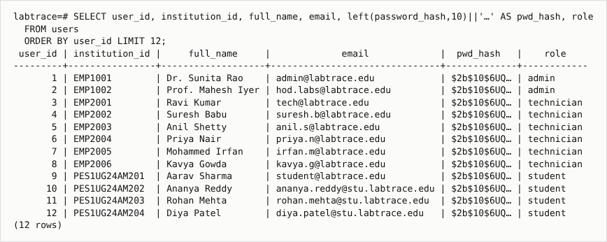
Result 1 - users (password_hash truncated)
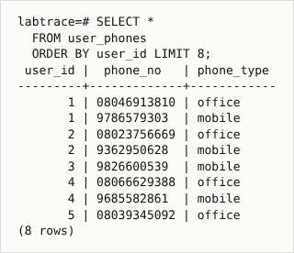
Result 2 - user_phones (multivalued attribute)
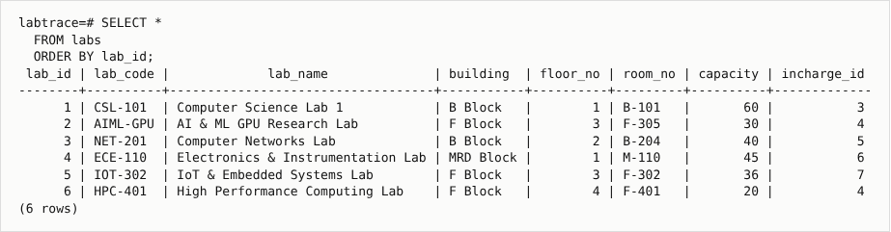
Result 3 - labs
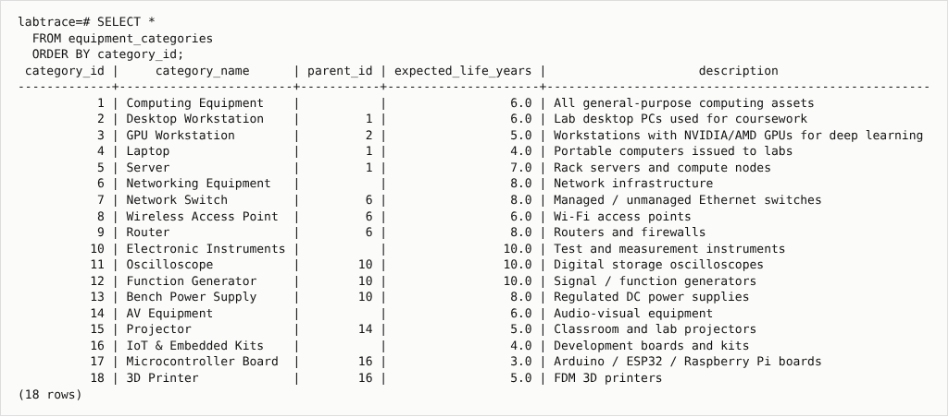
Result 4 - equipment_categories (self-referencing)
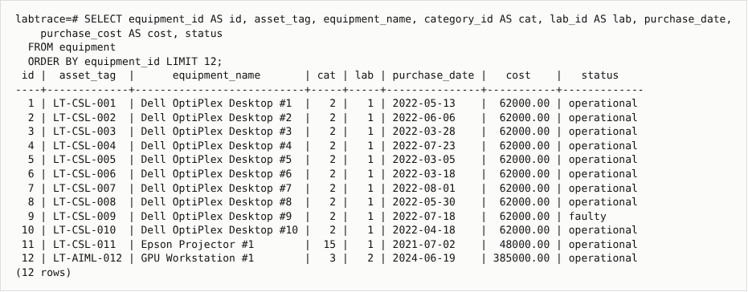
Result 5 - equipment
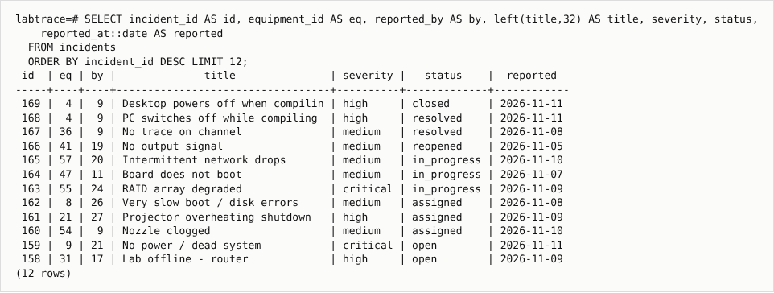
Result 6 - incidents (latest)
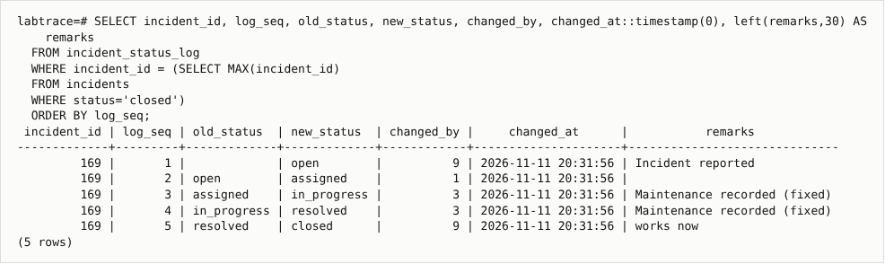
Result 7 - incident_status_log (weak entity) for one incident
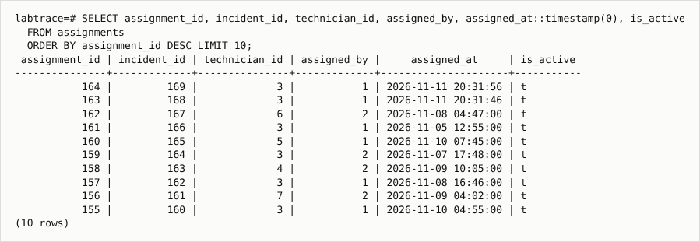
Result 8 - assignments
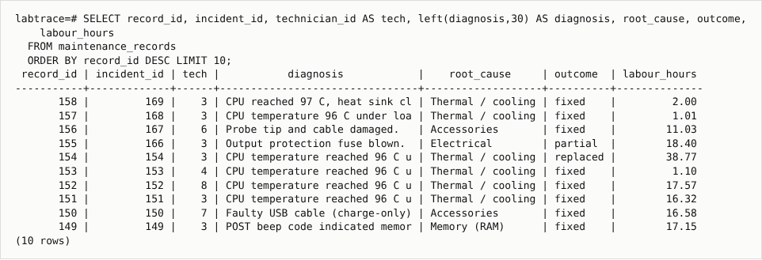
Result 9 - maintenance_records (labour_hours is generated)
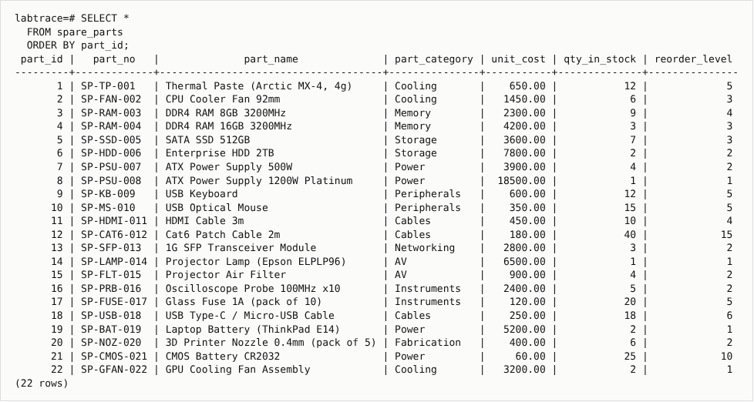
Result 10 - spare_parts
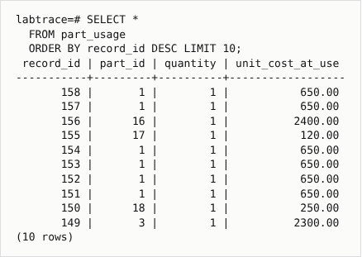
Result 11 - part_usage
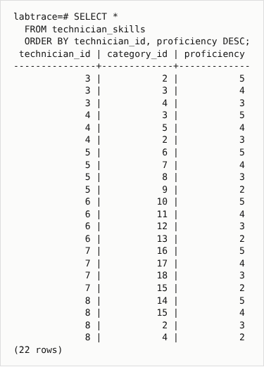
Result 12 - technician_skills
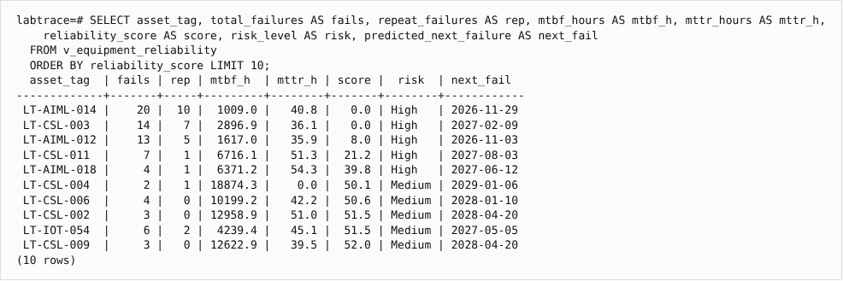
Result 13 - v_equipment_reliability (functions MTBF/MTTR/score/risk/prediction)
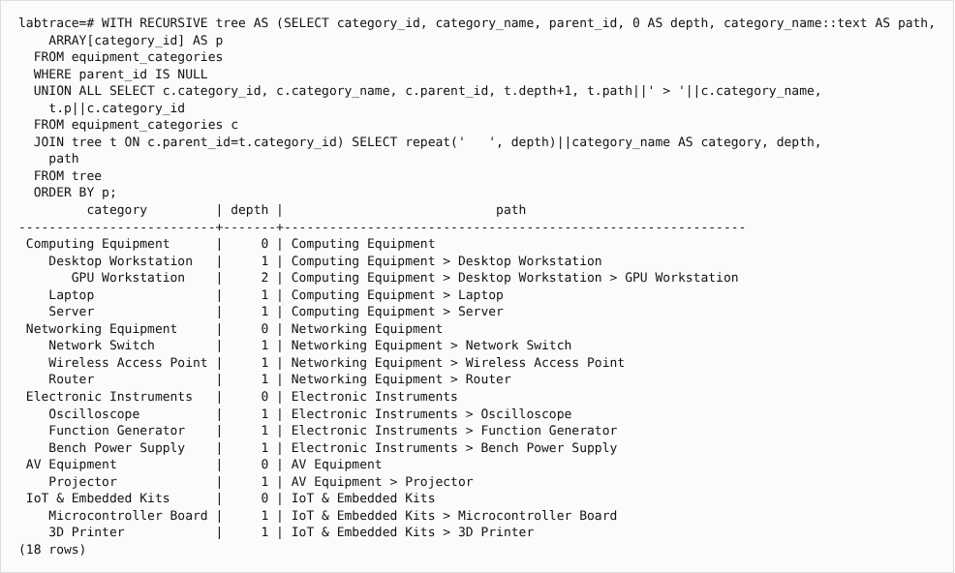
Result 14 - Recursive CTE result - category tree
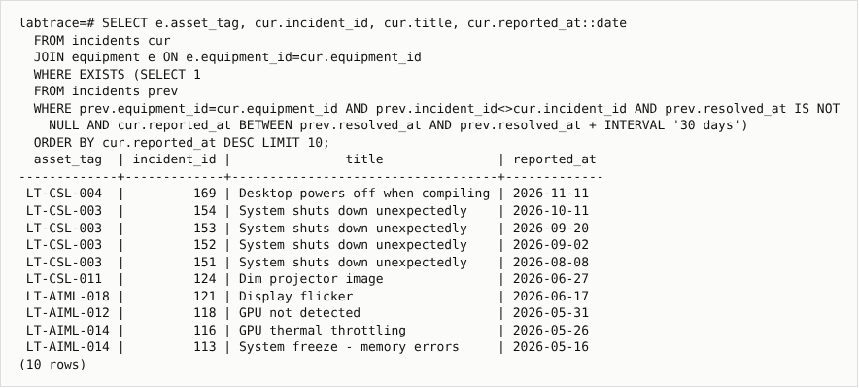
Result 15 - Correlated EXISTS - repeat failures
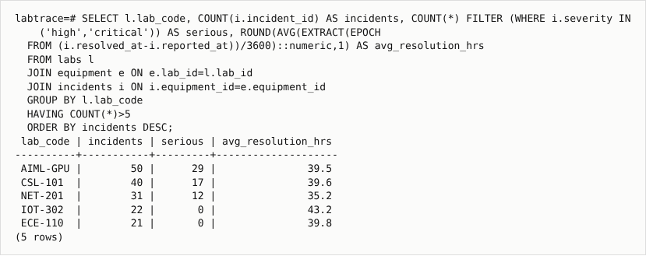
Result 16 - Join + GROUP BY + HAVING - incidents per lab
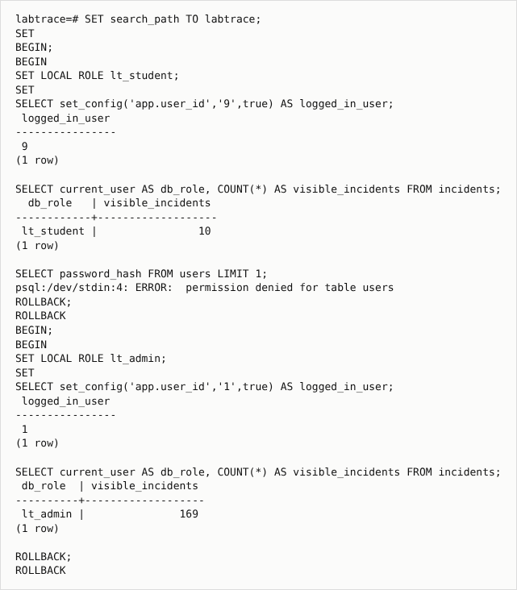
Result 17 - Row-Level Security: same query, student sees 10 rows, admin sees all; password_hash denied

9. Next.js Project Tree Structure
labtrace/
├── app/
│ ├── (app)/
│ │ ├── analytics/
│ │ │ ├── page.js
│ │ │ └── ReindexButton.js
│ │ ├── dashboard/
│ │ │ └── page.js
│ │ ├── equipment/
│ │ │ ├── [id]/
│ │ │ │ └── page.js
│ │ │ ├── new/
│ │ │ │ └── page.js
│ │ │ ├── EquipmentForm.js
│ │ │ └── page.js
│ │ ├── incidents/
│ │ │ ├── [id]/
│ │ │ │ ├── Actions.js
│ │ │ │ └── page.js
│ │ │ ├── new/
│ │ │ │ ├── page.js
│ │ │ │ └── ReportForm.js
│ │ │ └── page.js
│ │ ├── knowledge/
│ │ │ ├── [id]/
│ │ │ │ └── page.js
│ │ │ ├── new/
│ │ │ │ └── page.js
│ │ │ ├── ArticleForm.js
│ │ │ ├── KnowledgeSearch.js
│ │ │ └── page.js
│ │ ├── labs/
│ │ │ ├── LabForm.js
│ │ │ └── page.js
│ │ ├── parts/
│ │ │ ├── page.js
│ │ │ └── PartActions.js
│ │ ├── users/
│ │ │ ├── page.js
│ │ │ └── UserActions.js
│ │ └── layout.js
│ ├── (auth)/
│ │ ├── login/
│ │ │ └── page.js
│ │ ├── register/
│ │ │ └── page.js
│ │ └── AuthHero.js
│ ├── api/
│ │ ├── auth/
│ │ │ ├── login/
│ │ │ │ └── route.js
│ │ │ ├── logout/
│ │ │ │ └── route.js
│ │ │ └── register/
│ │ │ └── route.js
│ │ ├── equipment/
│ │ │ ├── [id]/
│ │ │ │ └── route.js
│ │ │ └── route.js
│ │ ├── incidents/
│ │ │ ├── [id]/
│ │ │ │ ├── assign/
│ │ │ │ │ └── route.js
│ │ │ │ ├── maintenance/
│ │ │ │ │ └── route.js
│ │ │ │ ├── notes/
│ │ │ │ │ └── route.js
│ │ │ │ ├── status/
│ │ │ │ │ └── route.js
│ │ │ │ ├── tags/
│ │ │ │ │ └── route.js
│ │ │ │ └── route.js
│ │ │ └── route.js
│ │ ├── knowledge/
│ │ │ ├── articles/
│ │ │ │ ├── [id]/
│ │ │ │ │ └── route.js
│ │ │ │ └── route.js
│ │ │ ├── incidents/
│ │ │ │ └── [id]/
│ │ │ │ └── route.js
│ │ │ ├── reindex/
│ │ │ │ └── route.js
│ │ │ ├── search/
│ │ │ │ └── route.js
│ │ │ └── similar/
│ │ │ └── route.js
│ │ ├── labs/
│ │ │ └── route.js
│ │ ├── parts/
│ │ │ ├── [id]/
│ │ │ │ └── restock/
│ │ │ │ └── route.js
│ │ │ └── route.js
│ │ └── users/
│ │ ├── [id]/
│ │ │ └── route.js
│ │ └── route.js
│ ├── globals.css
│ ├── layout.js
│ └── not-found.js
├── components/
│ ├── Badges.js
│ ├── BarChart.js
│ ├── format.js
│ ├── LogoutButton.js
│ ├── NavLinks.js
│ ├── SimilarList.js
│ └── useApi.js
├── data/
│ └── kb-articles.json
├── docs/
│ ├── code/ (6 images)
│ ├── diagrams/
│ │ ├── er_diagram.dot
│ │ ├── er_diagram.png
│ │ ├── schema_diagram.dot
│ │ └── schema_diagram.png
│ ├── results/ (17 images)
│ ├── screenshots/ (20 images)
│ └── smoke_test_results.log
├── lib/
│ ├── auth.js
│ ├── db.js
│ ├── devstore.js
│ ├── embeddings.js
│ ├── kbsync.js
│ ├── knowledge.js
│ ├── mongo.js
│ ├── queries.js
│ ├── session.js
│ └── validate.js
├── nosql/
│ ├── 01_create_collections.js
│ ├── 02_vector_index.js
│ └── 03_crud_and_vector_queries.js
├── scripts/
│ ├── code_screens.py
│ ├── generate_seed.py
│ ├── kb-sync.mjs
│ ├── result_screens.py
│ ├── screenshots.py
│ ├── setup_db.sh
│ └── smoke-test.mjs
├── sql/
│ ├── logs/
│ │ ├── 06_queries.log
│ │ ├── 07_dml_demo.log
│ │ └── database_objects.log
│ ├── 01_schema.sql
│ ├── 02_functions_triggers.sql
│ ├── 03_views.sql
│ ├── 04_security.sql
│ ├── 05_seed.sql
│ ├── 06_queries.sql
│ └── 07_dml_demo.sql
├── .env.example
├── .gitignore
├── docker-compose.yml
├── jsconfig.json
├── next.config.mjs
├── package-lock.json
├── package.json
├── proxy.js
└── README.md

10. Sample Screenshots of Application Code and Demo

10.1 Application Code
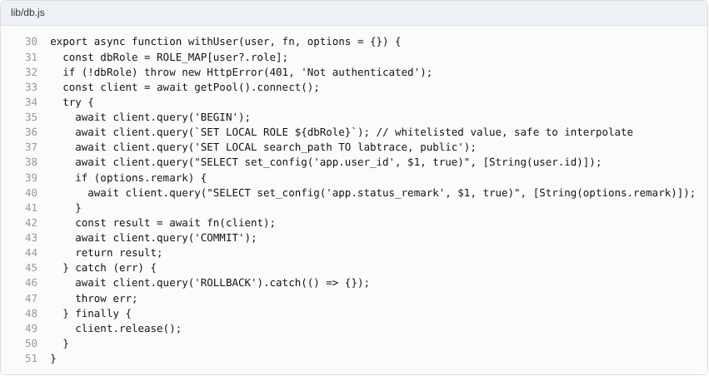
lib/db.js - every request switches to the user's PostgreSQL role
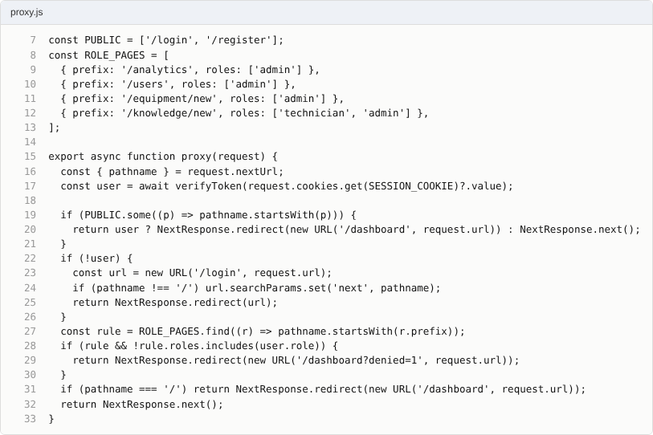
proxy.js - front-end route protection and role-based page access
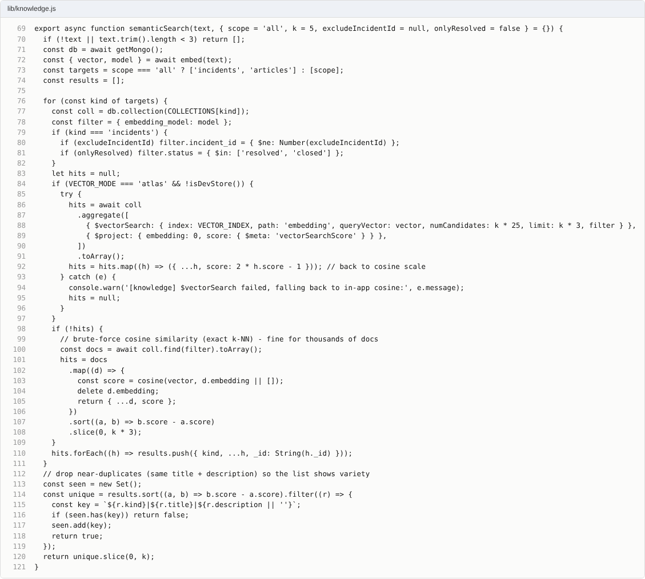
lib/knowledge.js - vector search ($vectorSearch or cosine k-NN)
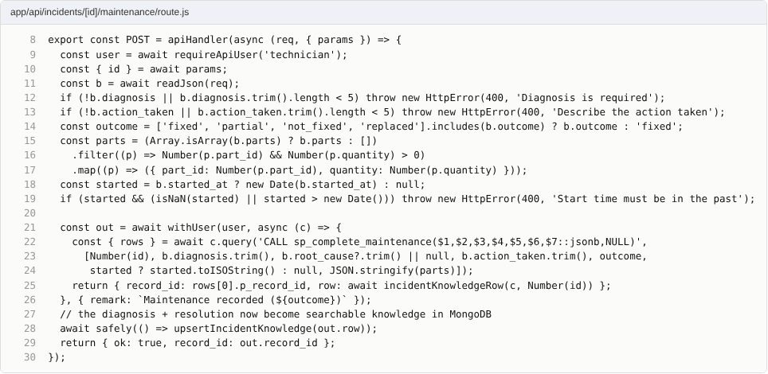
API route calling the stored procedure and updating MongoDB
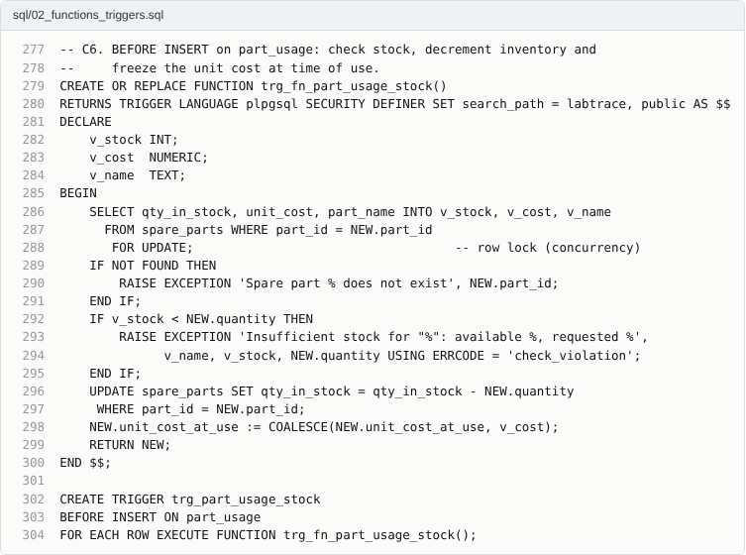
Stock trigger
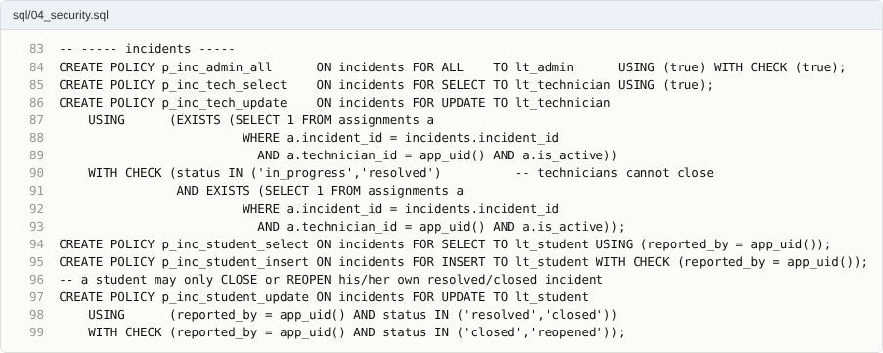
Row-Level Security policies

10.2 Demo
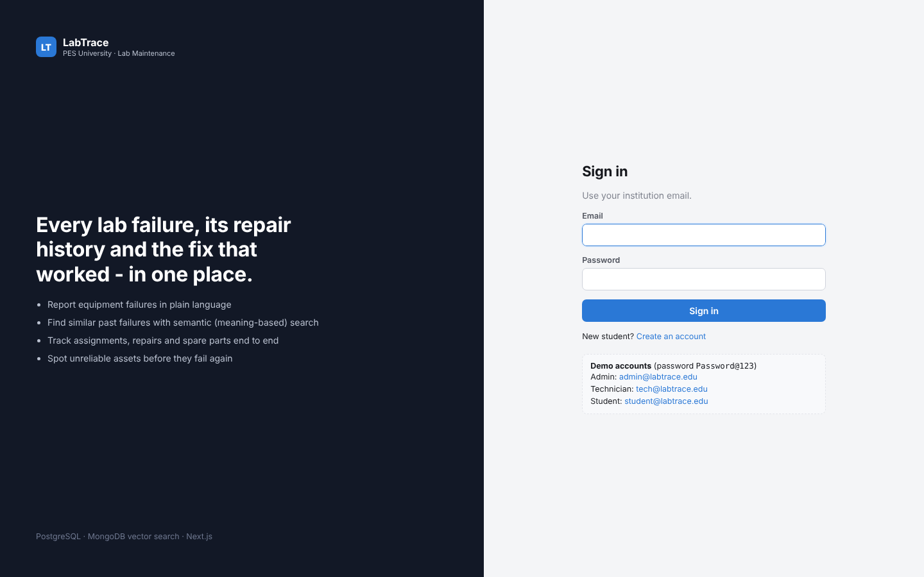
Login page with demo accounts
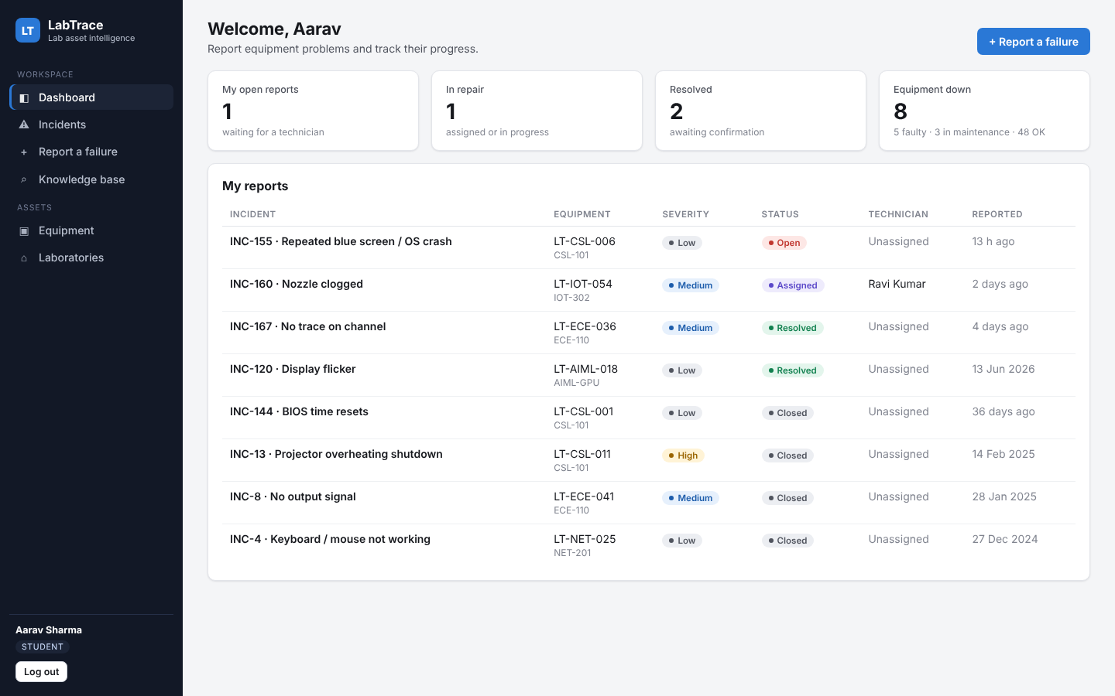
Student dashboard - only own reports
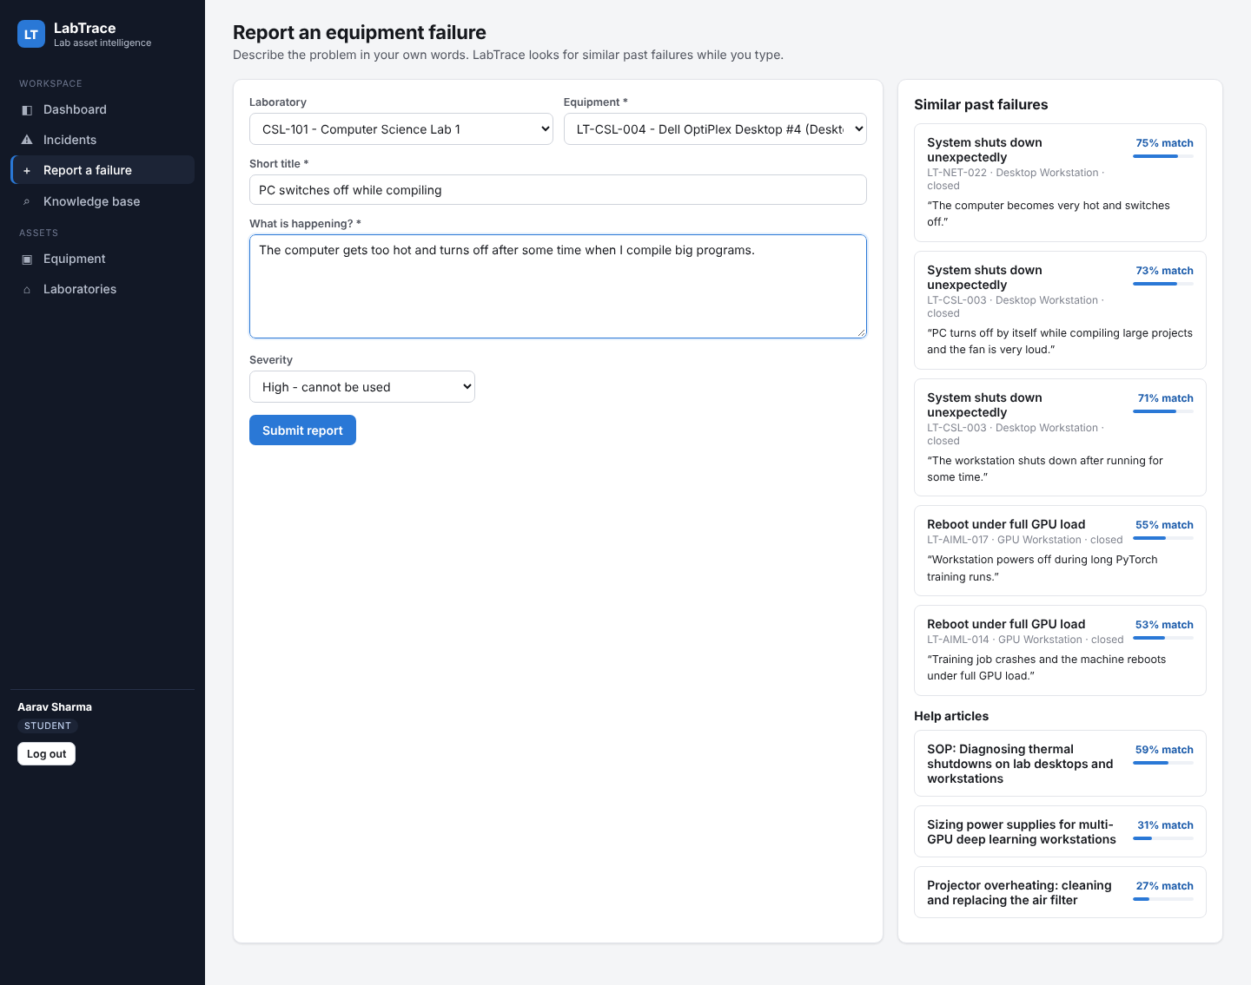
Reporting a failure: similar past failures appear while typing (semantic search)
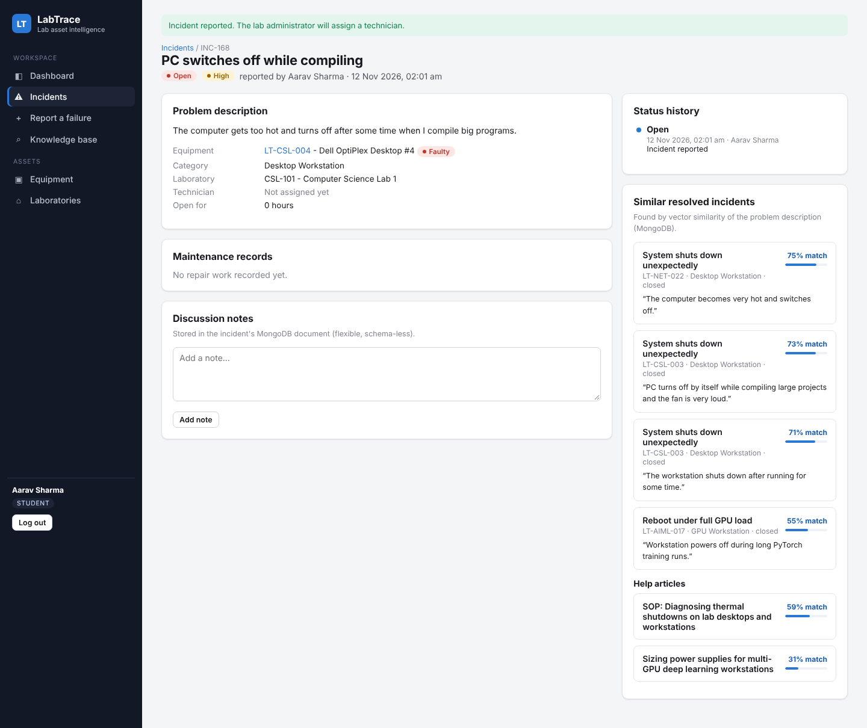
Incident created - status history written by trigger
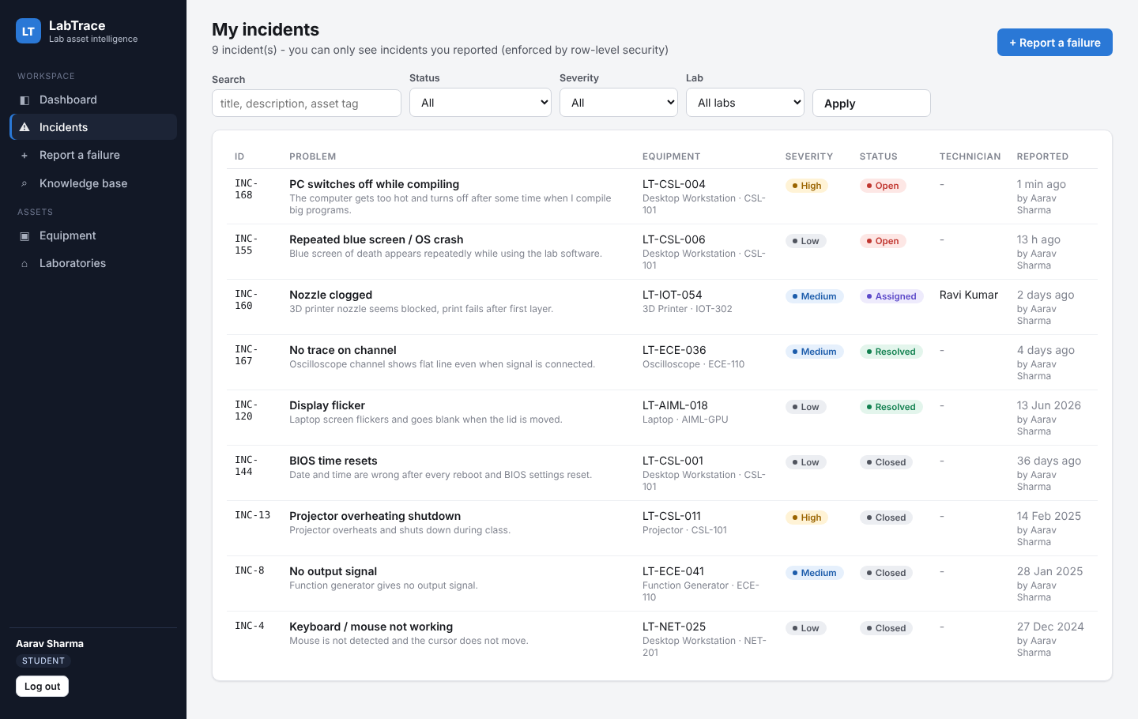
Student incident list restricted by row-level security
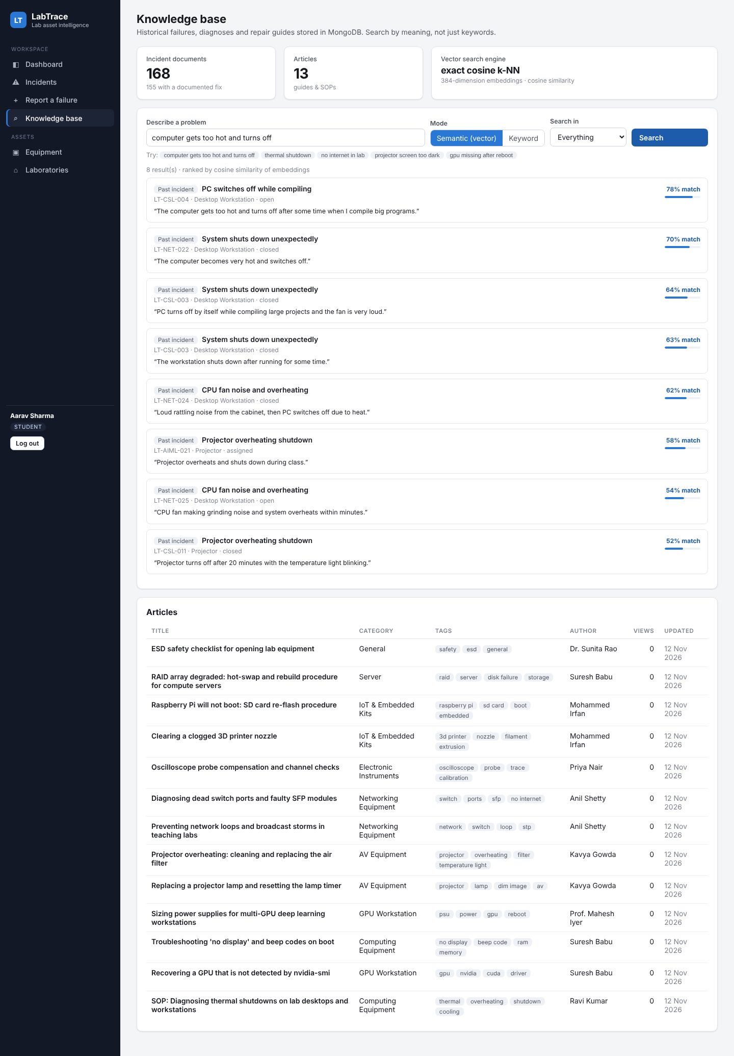
Knowledge base - semantic (vector) search
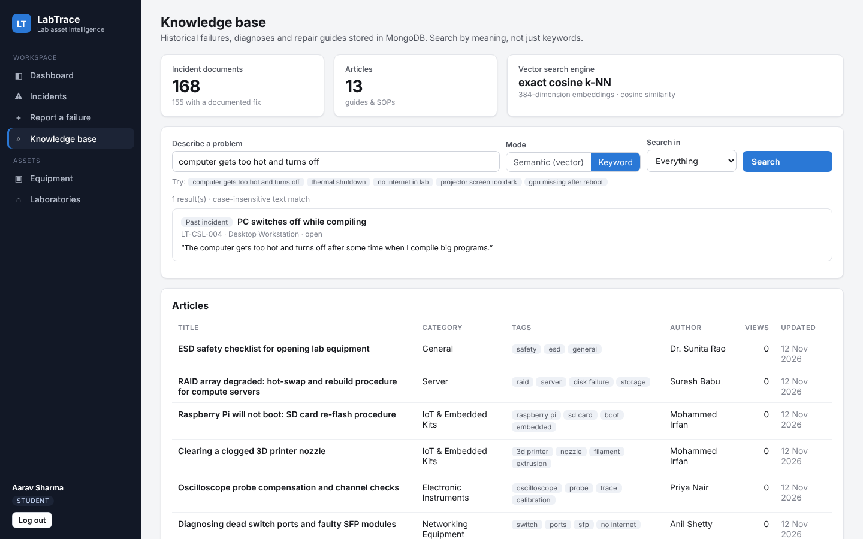
Same query with keyword search finds nothing
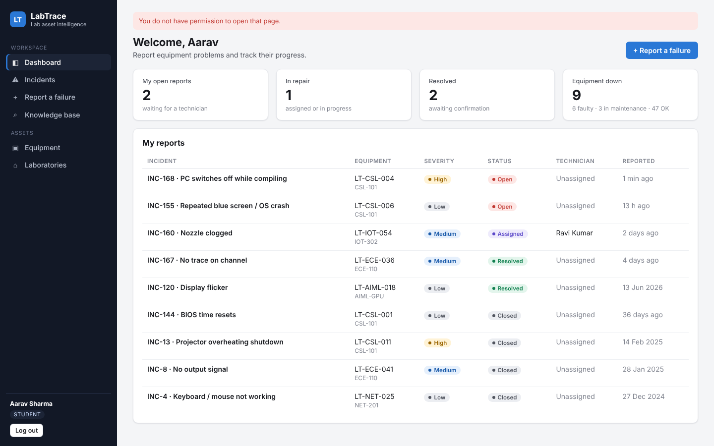
Role-based access: a student opening /analytics is redirected
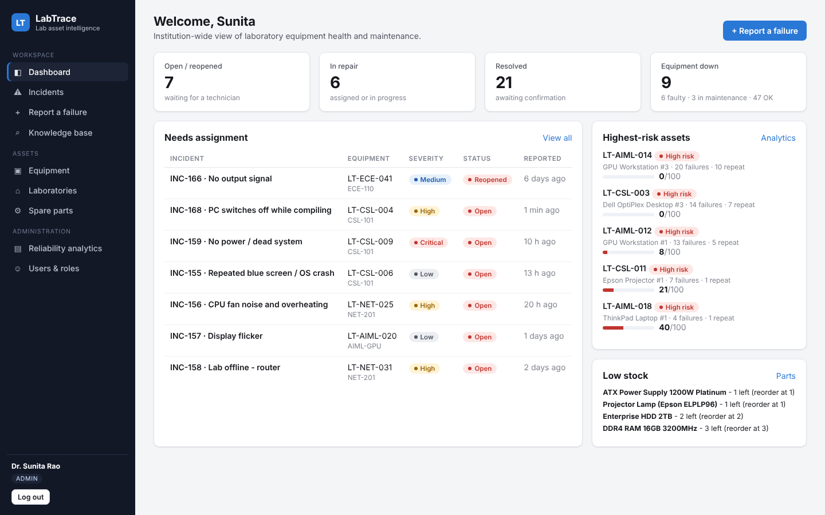
Admin dashboard - unassigned incidents, highest-risk assets, low stock
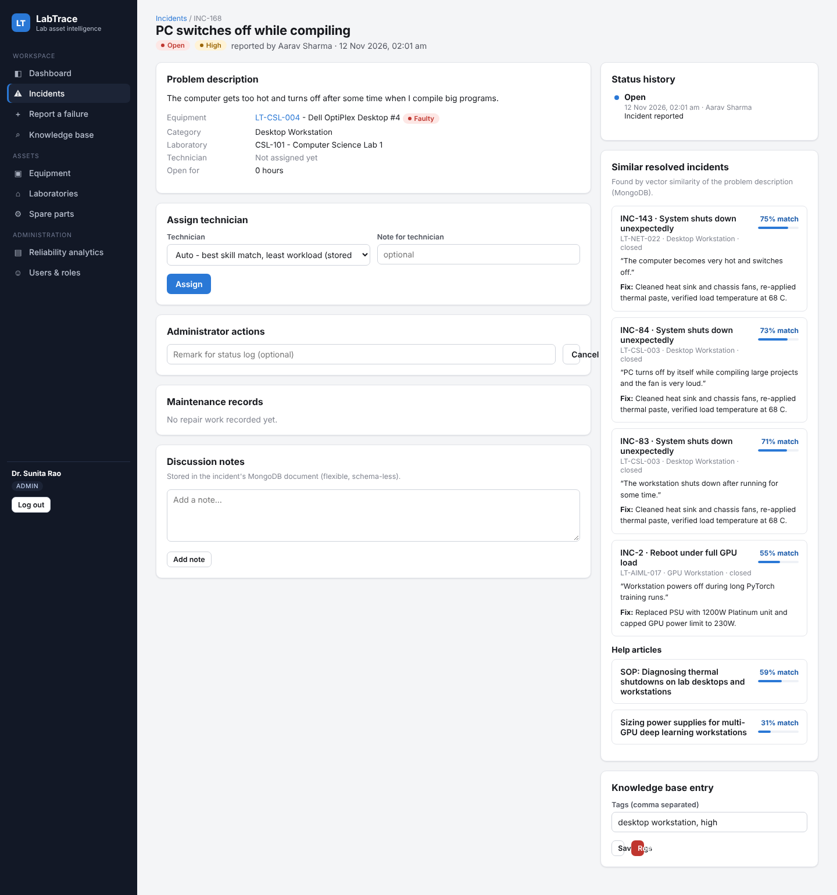
Admin assigns a technician (manual or automatic stored procedure)
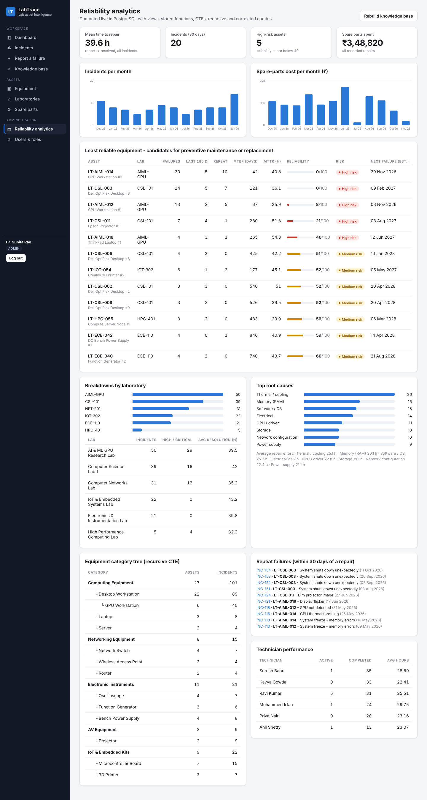
Reliability analytics
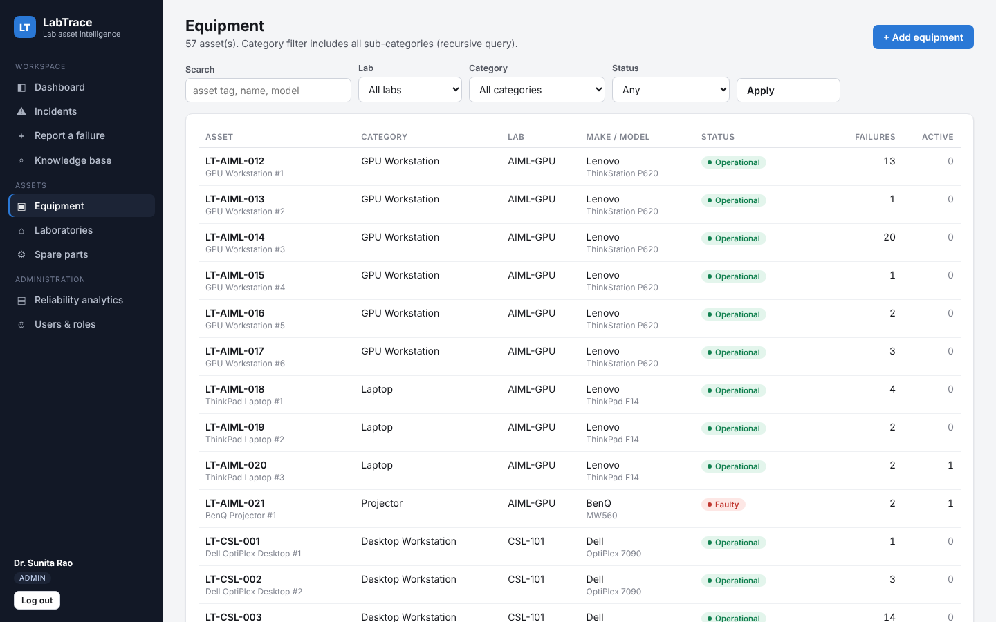
Equipment list (recursive category filter)
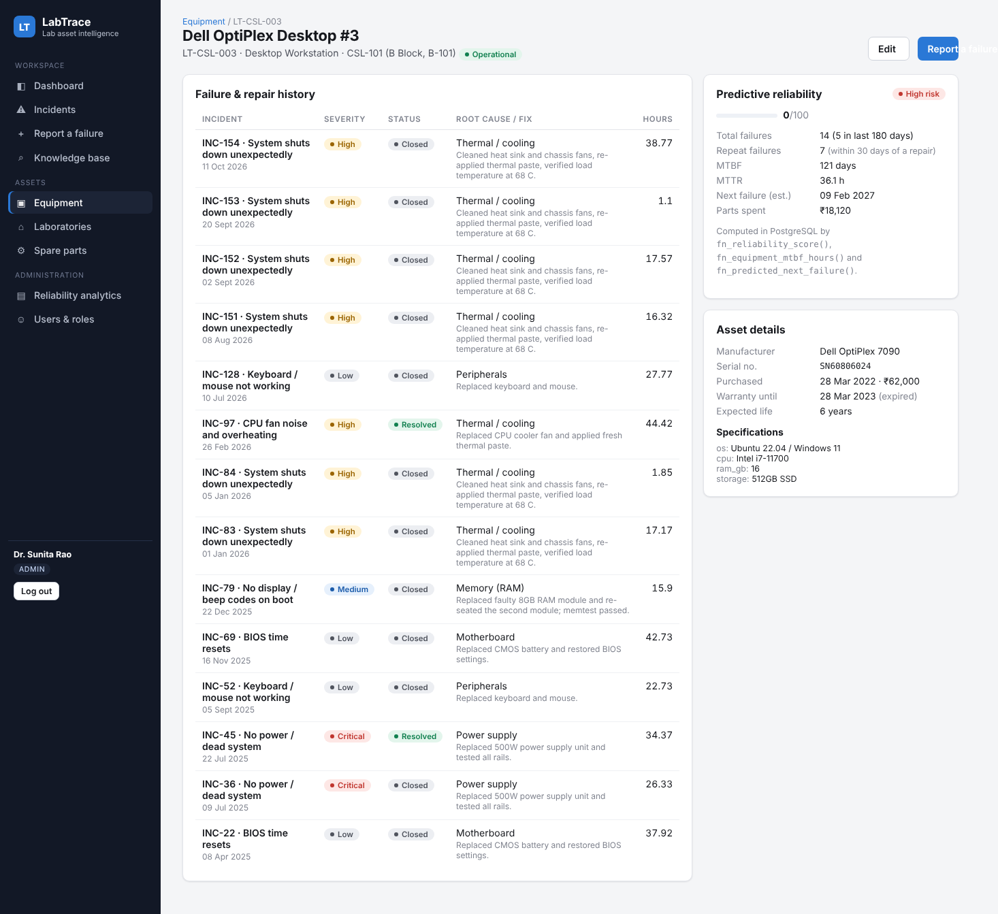
Equipment detail - predictive reliability and history
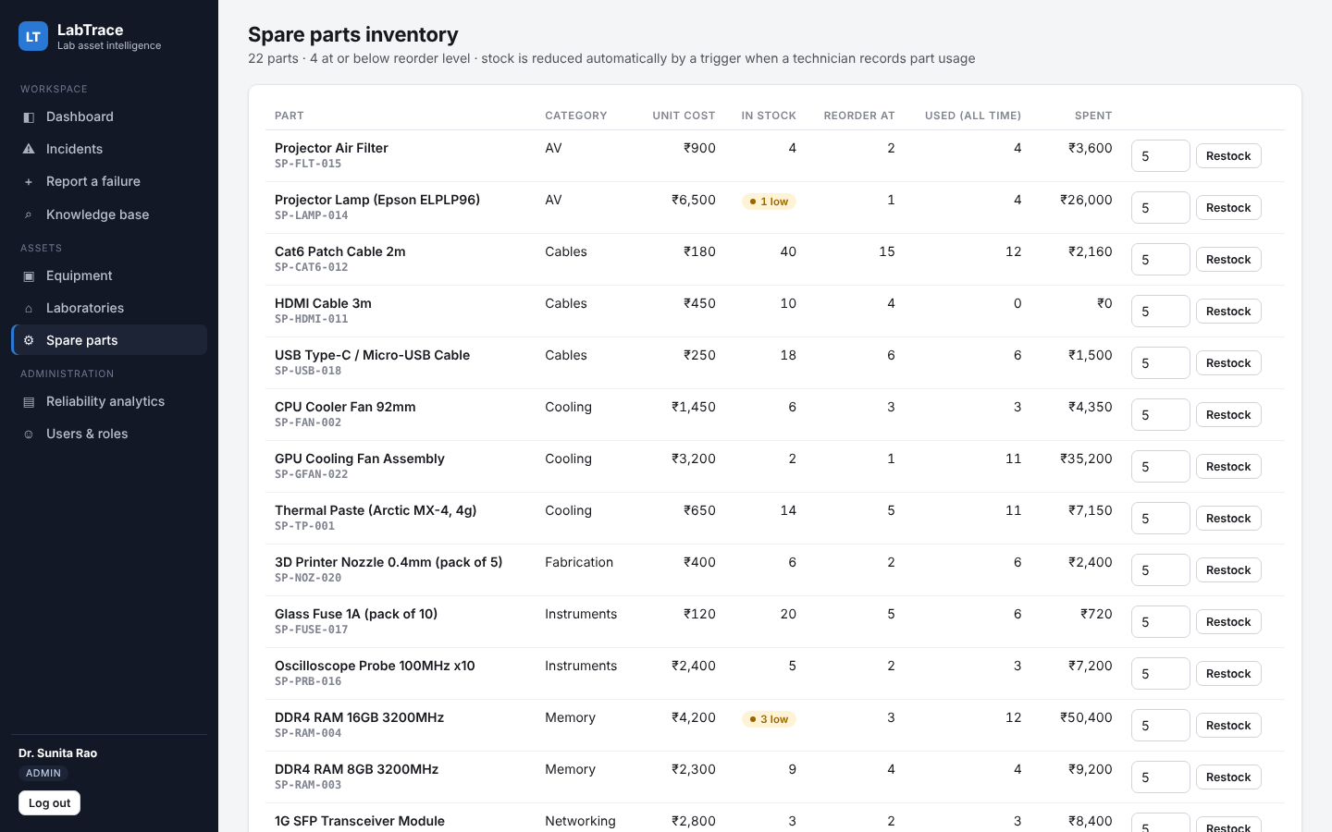
Spare-part inventory
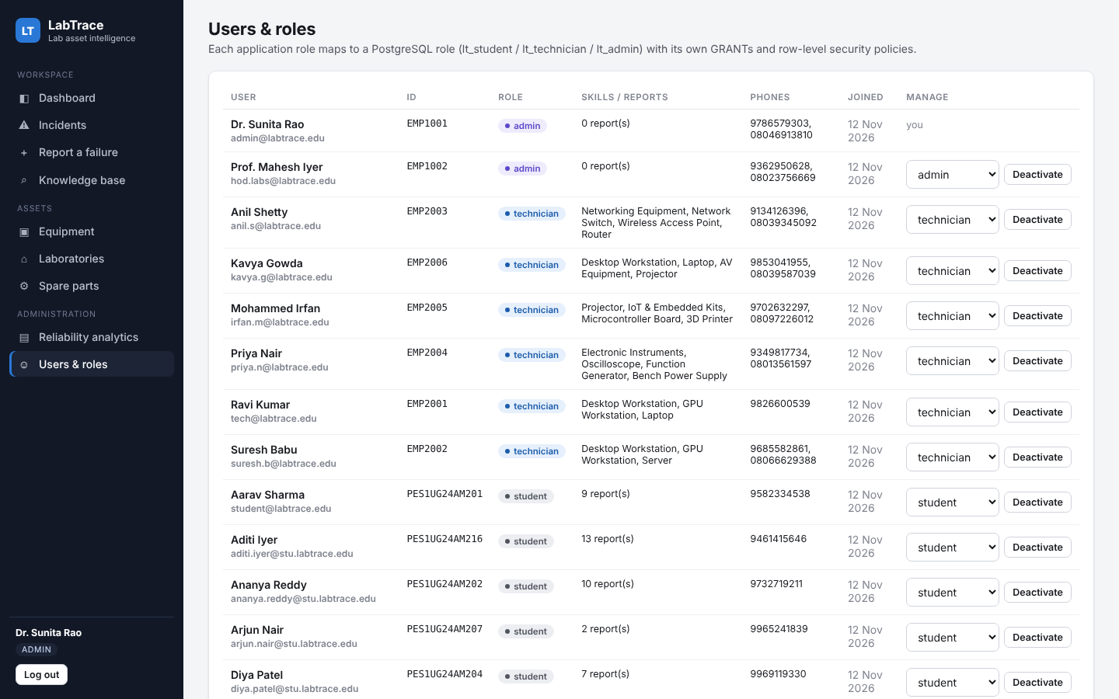
User and role management
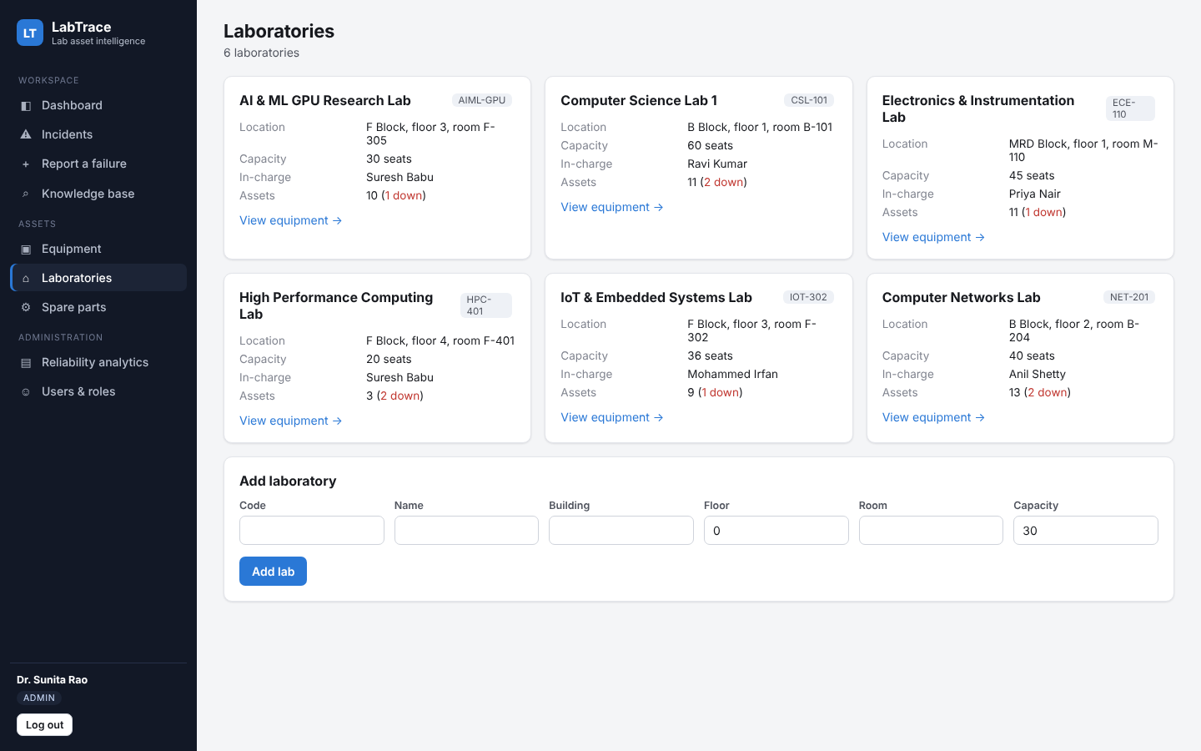
Laboratories
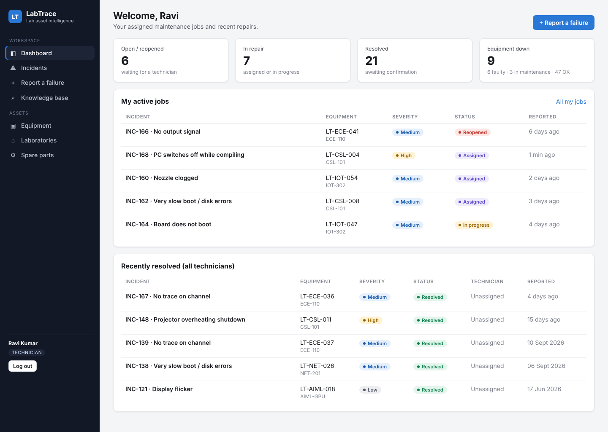
Technician dashboard - my active jobs
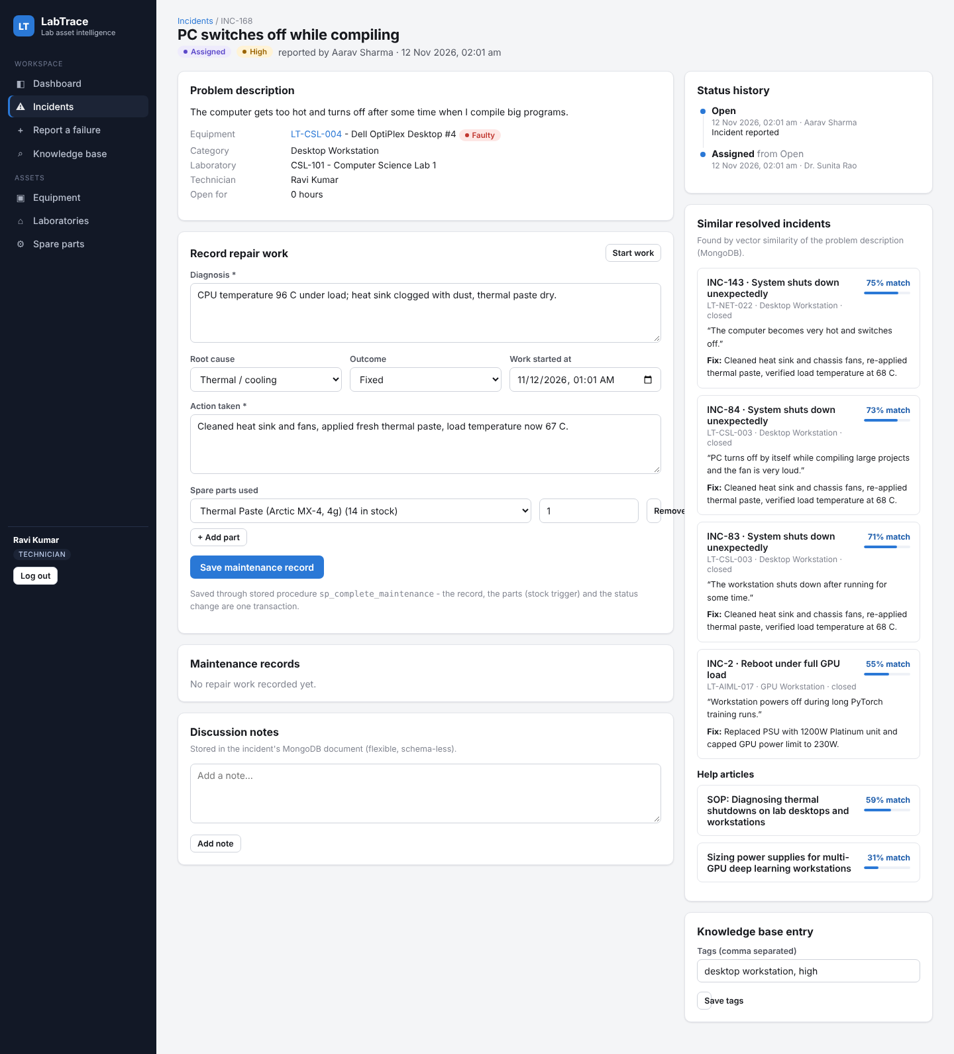
Technician records diagnosis, action and spare parts
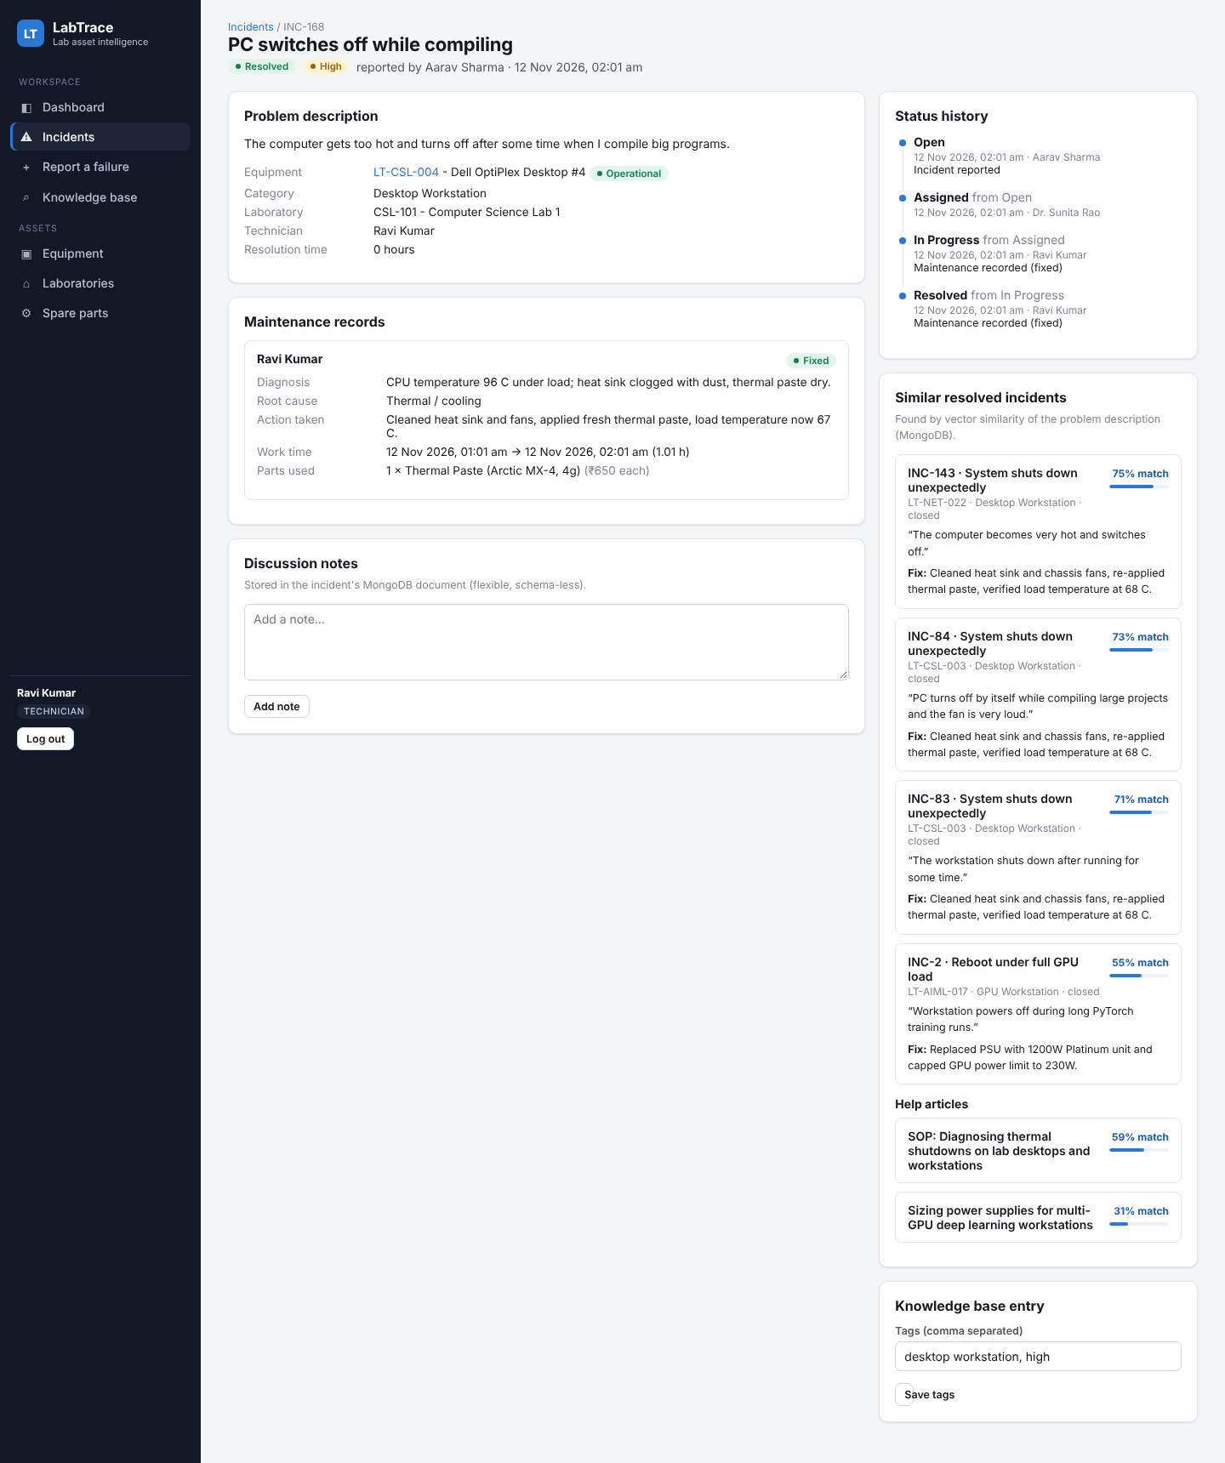
Resolved incident - maintenance record, timeline and similar incidents
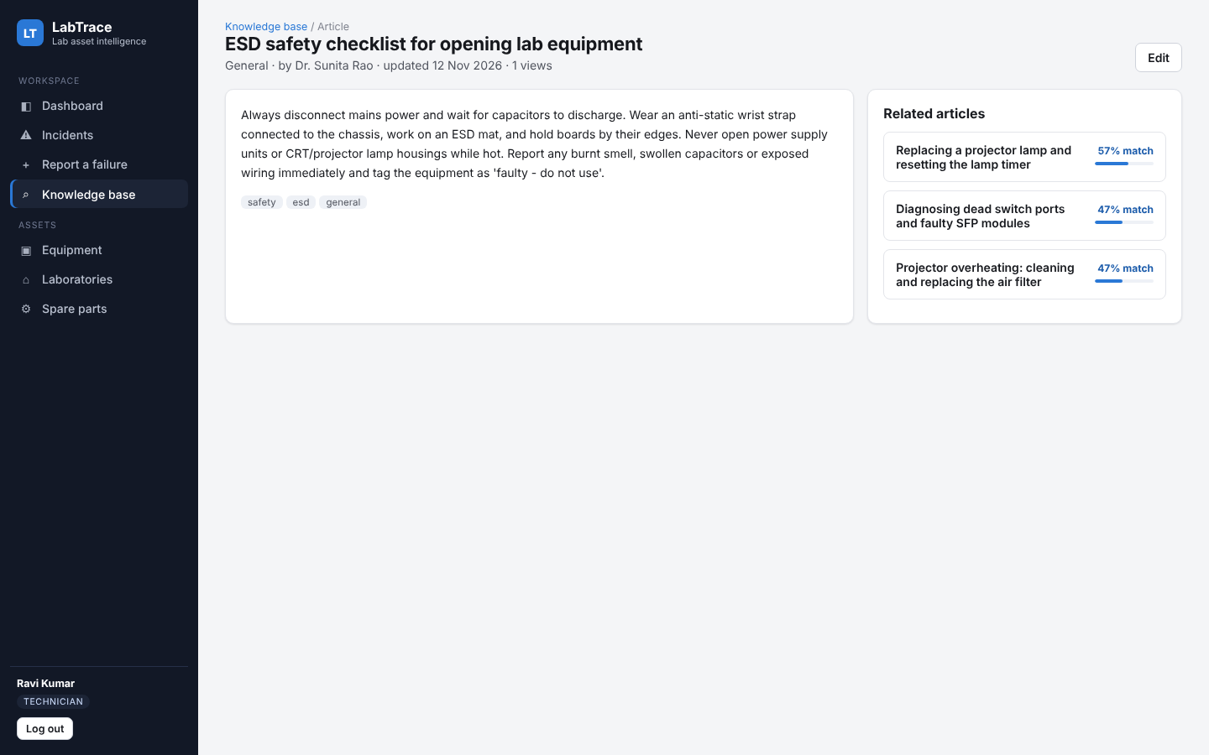
Knowledge-base article

11. Testing, GitHub and Individual Contribution

11.1 Testing
sql/07_dml_demo.sql tests the database rules directly (Section 6.2). scripts/smoke-test.mjs is an automated end-to-end test that drives the REST API as the three roles and checks both the workflow and the access rules. Result of the final run:
LabTrace smoke test against http://localhost:3000

PASS anonymous API call is rejected (401)
PASS wrong password is rejected (401)
PASS student sees only own incidents (RLS)
PASS admin sees more incidents than student
PASS student cannot create equipment (403)
PASS technician cannot assign (403)
PASS student cannot delete KB article (403)
PASS student cannot open another student's incident (404 via RLS)
PASS student reports an incident
PASS semantic search finds similar past incidents
PASS students do not receive repair details
PASS admin assigns technician (stored procedure)
PASS student cannot close an unresolved incident (RLS)
PASS technician records maintenance (procedure + trigger)
PASS stock decremented by trigger
PASS cannot record maintenance on resolved incident
PASS incident is resolved
PASS status log written by triggers (open→assigned→in_progress→resolved)
PASS technician cannot close (RLS WITH CHECK)
PASS reporter closes incident
PASS invalid transition rejected by trigger
PASS add note to incident document ($push)
PASS incident knowledge document contains the resolution
PASS technician creates article
PASS read article
PASS update article
PASS technician cannot delete article (403)
PASS admin deletes article
PASS deleted article is gone (404)

29 passed, 0 failed

11.2 GitHub Repository
Repository: https://github.com/Shryes19/labtrace - contains the complete source code, SQL and NoSQL scripts, diagrams, screenshots, this report and a README with step-by-step setup instructions (docker compose, database scripts, npm run kb:sync, npm run dev).

11.3 Individual Contribution
SRN | Name | Contribution
PES1UG24AM272 | Shryes M | MongoDB knowledge base and vector (semantic) search; Next.js pages and API routes with PostgreSQL / MongoDB integration; authentication (bcrypt, JWT, route proxy); reliability analytics dashboard; testing (DML demo and automated end-to-end test), screenshots and documentation
PES1UG24AM261 | Shesanth K | ER model and relational schema design; PostgreSQL DDL with constraints; triggers, stored procedures, functions and views; role-based access control with database roles and row-level security; sample data generator; analytical SQL queries (join, nested, correlated, recursive CTE)

12. Evaluation Rubrics - Completion Status
# | Criteria | Distribution | Status / where implemented
1 | Database Design | ER diagram (2), relational schema with keys, relationships and constraints (3) | Completed - Sections 3 and 4; weak entity, composite / multivalued / derived attributes, recursive and M:N relationships
2 | Database Creation | SQL DDL with constraints (4), NoSQL / vector database creation (4), technology justification (1) | Completed - 11 tables with PK/FK/UNIQUE/CHECK/generated column/partial index (sql/01); MongoDB collections with validators, indexes and vector index (nosql/01-02); Section 2.3-2.4
3 | SQL Operations and Queries | DML operations (4), nested / correlated / recursive and join queries (4) | Completed - seed + DML demo (sql/05, 07) and app CRUD; 16 analytical queries (sql/06)
4 | Advanced Database Concepts | Procedure / function, trigger, CTE (6), NoSQL / vector feature RUD (7) | Completed - 3 procedures, 9 functions, 7 triggers, 4 views, recursive CTEs; MongoDB read (vector + keyword search), update ($set/$push/$addToSet/$inc), delete
5 | Web Application and Database Integration | Next.js interface (3), backend / API and database integration (2) | Completed - 16 pages, 23 API routes, PostgreSQL + MongoDB integration
6 | Authentication and Authorization | Authentication front end and backend, minimum two roles and RBAC in the database (4) | Completed - bcrypt + JWT login/registration; 3 roles; proxy + API checks; PostgreSQL roles, column privileges and RLS policies
7 | Documentation, Git/GitHub, Demonstration, Testing and Originality | Documentation, Git/GitHub (2), originality and individual contribution (4) | Completed - this report, README, diagrams, logs, 29-step automated test; GitHub repository

