Gagan Shrestha

MIT235219

Lab 3

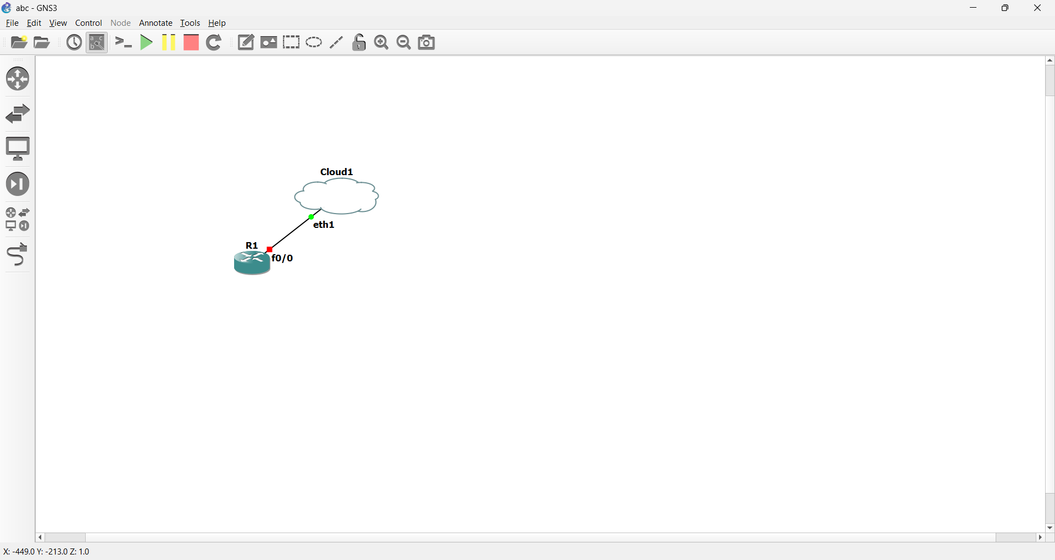

After that just following the thing according to the lab

Assigning the ip address manually in the consol in the router

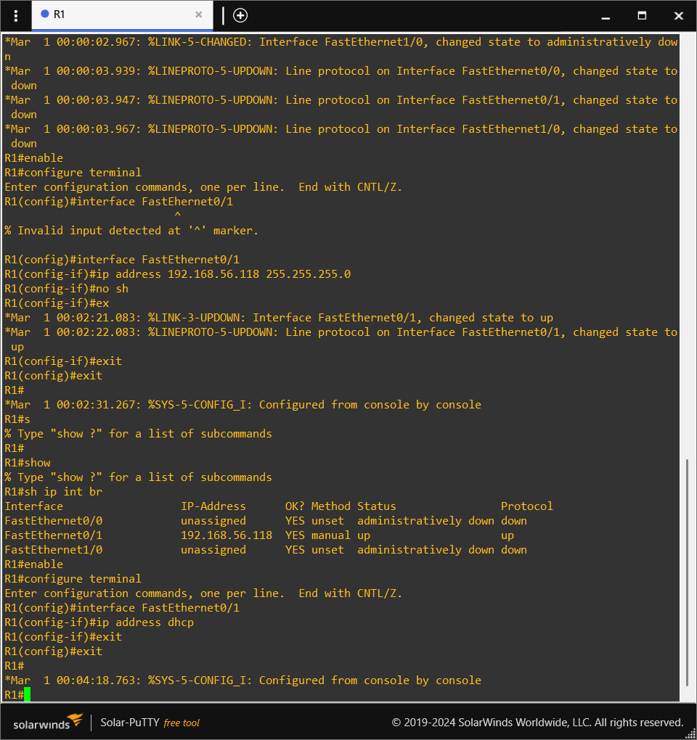

2. Enable the router and switches to access them remotely using SSH.

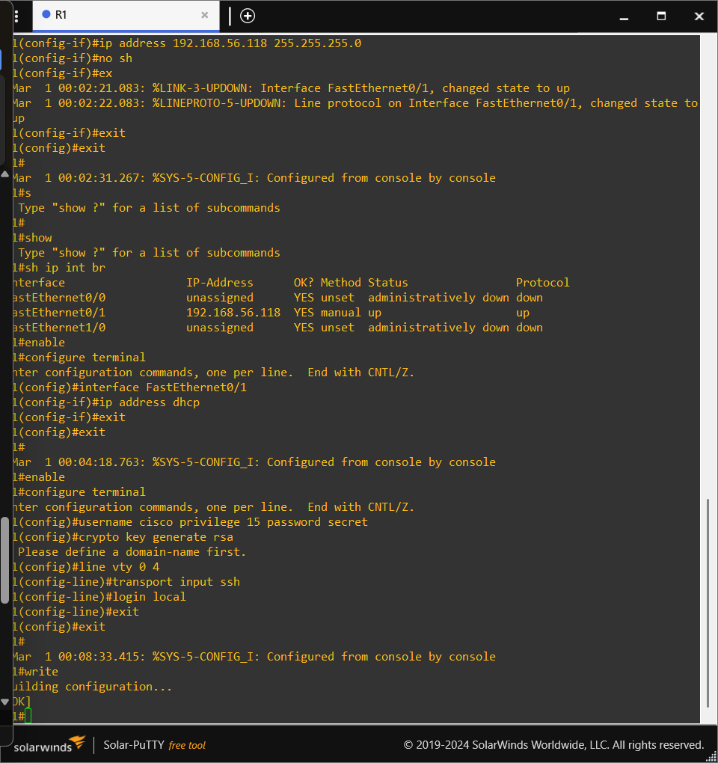

And after that running the given code in the vs code