February 15th 2018

Final Project

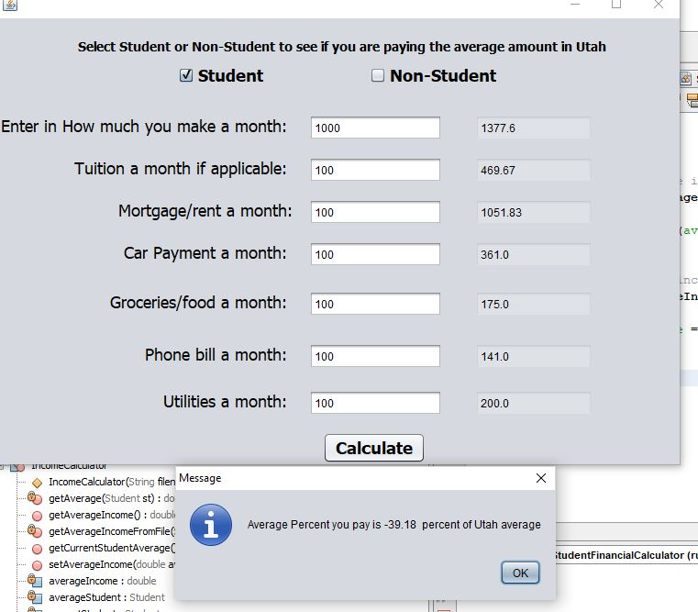

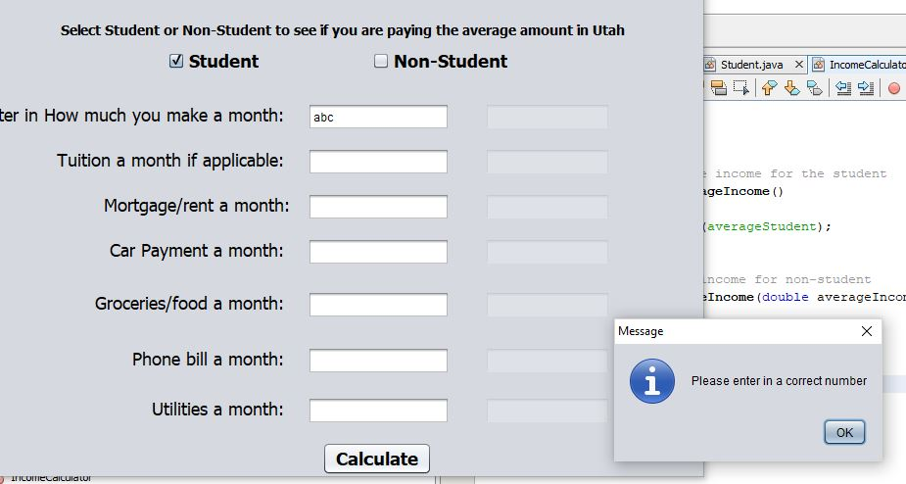

Programming Journal

After having Tom look over my project he advised me to do it a different way and so I did I made text fields right next to the user input txt fields. To show what the average Student spends on each item in Utah. I tried to mess with the color selection for the average txt box and this is as light that I could get it to I looked up on the internet and I couldn’t find anything that will guide me find how to lighten the txt field and also have it disabled for editing. After all this it took me about 1 hour to fix all the problems that where going on. Below is the final code for everything.

package studentvsnonstudentfinancialcalculator;

import java.io.File;

import java.io.FileNotFoundException;

import java.util.Scanner;

import java.util.logging.Level;

import java.util.logging.Logger;

import javax.swing.JOptionPane;

public class StudentVsNotStudent extends javax.swing.JFrame {

/**

* Creates new form StudentVsNotStudent

*/

public StudentVsNotStudent()

{

initComponents();

}

@SuppressWarnings("unchecked")

// <editor-fold defaultstate="collapsed" desc="Generated Code">

private void initComponents() {

phoneTxt = new javax.swing.JTextField();

utilitiesTxt = new javax.swing.JTextField();

tuitionTxt = new javax.swing.JTextField();

Student = new javax.swing.JCheckBox();

nonStudent = new javax.swing.JCheckBox();

intro = new javax.swing.JLabel();

calculate = new javax.swing.JButton();

Monthly = new javax.swing.JLabel();

monthlyTxt = new javax.swing.JTextField();

rent = new javax.swing.JLabel();

car = new javax.swing.JLabel();

foodTxt = new javax.swing.JLabel();

phone = new javax.swing.JLabel();

jLabel5 = new javax.swing.JLabel();

tuition = new javax.swing.JLabel();

mortgageTxt = new javax.swing.JTextField();

carTxt = new javax.swing.JTextField();

groceryTxt = new javax.swing.JTextField();

txtAverageMonth = new javax.swing.JTextField();

txtAverageTuition = new javax.swing.JTextField();

txtAverageRent = new javax.swing.JTextField();

txtAverageCar = new javax.swing.JTextField();

txtAverageFood = new javax.swing.JTextField();

txtAveragePhone = new javax.swing.JTextField();

txtAverageUtilites = new javax.swing.JTextField();

setDefaultCloseOperation(javax.swing.WindowConstants.EXIT_ON_CLOSE);

Student.setFont(new java.awt.Font("Tahoma", 1, 18)); // NOI18N

Student.setText("Student");

Student.setToolTipText("");

nonStudent.setFont(new java.awt.Font("Tahoma", 1, 18)); // NOI18N

nonStudent.setText("Non-Student");

nonStudent.setToolTipText("");

intro.setFont(new java.awt.Font("Tahoma", 1, 14)); // NOI18N

intro.setText("Select Student or Non-Student\n to see if you are paying the \naverage amount in Utah ");

calculate.setFont(new java.awt.Font("Tahoma", 1, 18)); // NOI18N

calculate.setText("Calculate");

calculate.addActionListener(new java.awt.event.ActionListener() {

public void actionPerformed(java.awt.event.ActionEvent evt) {

calculateActionPerformed(evt);

}

});

Monthly.setFont(new java.awt.Font("Tahoma", 0, 18)); // NOI18N

Monthly.setText("Enter in How much you make a month: ");

rent.setFont(new java.awt.Font("Tahoma", 0, 18)); // NOI18N

rent.setText("Mortgage/rent a month:");

car.setFont(new java.awt.Font("Tahoma", 0, 18)); // NOI18N

car.setText("Car Payment a month: ");

foodTxt.setFont(new java.awt.Font("Tahoma", 0, 18)); // NOI18N

foodTxt.setText("Groceries/food a month: ");

phone.setFont(new java.awt.Font("Tahoma", 0, 18)); // NOI18N

phone.setText("Phone bill a month: ");

jLabel5.setFont(new java.awt.Font("Tahoma", 0, 18)); // NOI18N

jLabel5.setText("Utilities a month: ");

tuition.setFont(new java.awt.Font("Tahoma", 0, 18)); // NOI18N

tuition.setText("Tuition a month if applicable: ");

carTxt.addActionListener(new java.awt.event.ActionListener() {

public void actionPerformed(java.awt.event.ActionEvent evt) {

carTxtActionPerformed(evt);

}

});

txtAverageMonth.setToolTipText("");

txtAverageMonth.setCaretColor(new java.awt.Color(255, 255, 255));

txtAverageMonth.setDisabledTextColor(new java.awt.Color(0, 0, 0));

txtAverageMonth.setEnabled(false);

txtAverageMonth.setSelectedTextColor(new java.awt.Color(0, 0, 0));

txtAverageMonth.setSelectionColor(new java.awt.Color(255, 255, 255));

txtAverageTuition.setDisabledTextColor(new java.awt.Color(0, 0, 0));

txtAverageTuition.setEnabled(false);

txtAverageRent.setDisabledTextColor(new java.awt.Color(0, 0, 0));

txtAverageRent.setEnabled(false);

txtAverageCar.setEditable(false);

txtAverageCar.setBackground(new java.awt.Color(255, 255, 255));

txtAverageCar.setDisabledTextColor(new java.awt.Color(0, 0, 0));

txtAverageCar.setEnabled(false);

txtAverageFood.setDisabledTextColor(new java.awt.Color(0, 0, 0));

txtAverageFood.setEnabled(false);

txtAveragePhone.setDisabledTextColor(new java.awt.Color(0, 0, 0));

txtAveragePhone.setEnabled(false);

txtAverageUtilites.setDisabledTextColor(new java.awt.Color(0, 0, 0));

txtAverageUtilites.setEnabled(false);

javax.swing.GroupLayout layout = new javax.swing.GroupLayout(getContentPane());

getContentPane().setLayout(layout);

layout.setHorizontalGroup(

layout.createParallelGroup(javax.swing.GroupLayout.Alignment.LEADING)

.addGroup(javax.swing.GroupLayout.Alignment.TRAILING, layout.createSequentialGroup()

.addGap(0, 0, Short.MAX_VALUE)

.addGroup(layout.createParallelGroup(javax.swing.GroupLayout.Alignment.LEADING)

.addGroup(javax.swing.GroupLayout.Alignment.TRAILING, layout.createSequentialGroup()

.addComponent(calculate)

.addGap(277, 277, 277))

.addGroup(javax.swing.GroupLayout.Alignment.TRAILING, layout.createSequentialGroup()

.addComponent(intro)

.addGap(76, 76, 76))))

.addGroup(layout.createSequentialGroup()

.addGroup(layout.createParallelGroup(javax.swing.GroupLayout.Alignment.LEADING)

.addGroup(layout.createSequentialGroup()

.addGap(199, 199, 199)

.addComponent(Student)

.addGap(116, 116, 116)

.addComponent(nonStudent))

.addGroup(layout.createSequentialGroup()

.addContainerGap()

.addGroup(layout.createParallelGroup(javax.swing.GroupLayout.Alignment.TRAILING)

.addGroup(layout.createSequentialGroup()

.addComponent(rent)

.addGap(18, 18, 18)

.addComponent(mortgageTxt, javax.swing.GroupLayout.PREFERRED_SIZE, 145, javax.swing.GroupLayout.PREFERRED_SIZE))

.addGroup(javax.swing.GroupLayout.Alignment.LEADING, layout.createParallelGroup(javax.swing.GroupLayout.Alignment.TRAILING)

.addGroup(layout.createSequentialGroup()

.addComponent(Monthly)

.addGap(18, 18, 18)

.addComponent(monthlyTxt, javax.swing.GroupLayout.PREFERRED_SIZE, 145, javax.swing.GroupLayout.PREFERRED_SIZE))

.addGroup(layout.createSequentialGroup()

.addGroup(layout.createParallelGroup(javax.swing.GroupLayout.Alignment.TRAILING)

.addComponent(car)

.addComponent(tuition)

.addComponent(foodTxt)

.addComponent(phone)

.addComponent(jLabel5))

.addGap(18, 18, 18)

.addGroup(layout.createParallelGroup(javax.swing.GroupLayout.Alignment.LEADING)

.addComponent(tuitionTxt, javax.swing.GroupLayout.PREFERRED_SIZE, 145, javax.swing.GroupLayout.PREFERRED_SIZE)

.addComponent(carTxt, javax.swing.GroupLayout.PREFERRED_SIZE, 145, javax.swing.GroupLayout.PREFERRED_SIZE)

.addComponent(groceryTxt, javax.swing.GroupLayout.PREFERRED_SIZE, 145, javax.swing.GroupLayout.PREFERRED_SIZE)

.addComponent(phoneTxt, javax.swing.GroupLayout.PREFERRED_SIZE, 145, javax.swing.GroupLayout.PREFERRED_SIZE)

.addComponent(utilitiesTxt, javax.swing.GroupLayout.PREFERRED_SIZE, 145, javax.swing.GroupLayout.PREFERRED_SIZE)))))

.addGap(36, 36, 36)

.addGroup(layout.createParallelGroup(javax.swing.GroupLayout.Alignment.LEADING)

.addComponent(txtAverageTuition, javax.swing.GroupLayout.PREFERRED_SIZE, 128, javax.swing.GroupLayout.PREFERRED_SIZE)

.addComponent(txtAverageMonth, javax.swing.GroupLayout.PREFERRED_SIZE, 128, javax.swing.GroupLayout.PREFERRED_SIZE)

.addComponent(txtAverageRent, javax.swing.GroupLayout.PREFERRED_SIZE, 128, javax.swing.GroupLayout.PREFERRED_SIZE)

.addComponent(txtAverageCar, javax.swing.GroupLayout.PREFERRED_SIZE, 128, javax.swing.GroupLayout.PREFERRED_SIZE)

.addComponent(txtAverageFood, javax.swing.GroupLayout.PREFERRED_SIZE, 128, javax.swing.GroupLayout.PREFERRED_SIZE)

.addComponent(txtAveragePhone, javax.swing.GroupLayout.PREFERRED_SIZE, 128, javax.swing.GroupLayout.PREFERRED_SIZE)

.addComponent(txtAverageUtilites, javax.swing.GroupLayout.PREFERRED_SIZE, 128, javax.swing.GroupLayout.PREFERRED_SIZE))))

.addContainerGap(95, Short.MAX_VALUE))

);

layout.setVerticalGroup(

layout.createParallelGroup(javax.swing.GroupLayout.Alignment.LEADING)

.addGroup(layout.createSequentialGroup()

.addGap(22, 22, 22)

.addComponent(intro)

.addPreferredGap(javax.swing.LayoutStyle.ComponentPlacement.UNRELATED)

.addGroup(layout.createParallelGroup(javax.swing.GroupLayout.Alignment.BASELINE)

.addComponent(nonStudent)

.addComponent(Student))

.addGap(32, 32, 32)

.addGroup(layout.createParallelGroup(javax.swing.GroupLayout.Alignment.BASELINE)

.addComponent(Monthly)

.addComponent(monthlyTxt, javax.swing.GroupLayout.PREFERRED_SIZE, javax.swing.GroupLayout.DEFAULT_SIZE, javax.swing.GroupLayout.PREFERRED_SIZE)

.addComponent(txtAverageMonth, javax.swing.GroupLayout.PREFERRED_SIZE, javax.swing.GroupLayout.DEFAULT_SIZE, javax.swing.GroupLayout.PREFERRED_SIZE))

.addGap(18, 18, 18)

.addGroup(layout.createParallelGroup(javax.swing.GroupLayout.Alignment.LEADING)

.addGroup(layout.createParallelGroup(javax.swing.GroupLayout.Alignment.BASELINE)

.addComponent(tuitionTxt, javax.swing.GroupLayout.PREFERRED_SIZE, javax.swing.GroupLayout.DEFAULT_SIZE, javax.swing.GroupLayout.PREFERRED_SIZE)

.addComponent(tuition))

.addComponent(txtAverageTuition, javax.swing.GroupLayout.PREFERRED_SIZE, javax.swing.GroupLayout.DEFAULT_SIZE, javax.swing.GroupLayout.PREFERRED_SIZE))

.addGap(18, 18, 18)

.addGroup(layout.createParallelGroup(javax.swing.GroupLayout.Alignment.BASELINE)

.addComponent(rent)

.addComponent(mortgageTxt, javax.swing.GroupLayout.PREFERRED_SIZE, javax.swing.GroupLayout.DEFAULT_SIZE, javax.swing.GroupLayout.PREFERRED_SIZE)

.addComponent(txtAverageRent, javax.swing.GroupLayout.PREFERRED_SIZE, javax.swing.GroupLayout.DEFAULT_SIZE, javax.swing.GroupLayout.PREFERRED_SIZE))

.addGap(18, 18, Short.MAX_VALUE)

.addGroup(layout.createParallelGroup(javax.swing.GroupLayout.Alignment.BASELINE)

.addComponent(carTxt, javax.swing.GroupLayout.PREFERRED_SIZE, javax.swing.GroupLayout.DEFAULT_SIZE, javax.swing.GroupLayout.PREFERRED_SIZE)

.addComponent(car)

.addComponent(txtAverageCar, javax.swing.GroupLayout.PREFERRED_SIZE, javax.swing.GroupLayout.DEFAULT_SIZE, javax.swing.GroupLayout.PREFERRED_SIZE))

.addGap(26, 26, 26)

.addGroup(layout.createParallelGroup(javax.swing.GroupLayout.Alignment.BASELINE)

.addComponent(groceryTxt, javax.swing.GroupLayout.PREFERRED_SIZE, javax.swing.GroupLayout.DEFAULT_SIZE, javax.swing.GroupLayout.PREFERRED_SIZE)

.addComponent(foodTxt)

.addComponent(txtAverageFood, javax.swing.GroupLayout.PREFERRED_SIZE, javax.swing.GroupLayout.DEFAULT_SIZE, javax.swing.GroupLayout.PREFERRED_SIZE))

.addGap(29, 29, 29)

.addGroup(layout.createParallelGroup(javax.swing.GroupLayout.Alignment.BASELINE)

.addComponent(phoneTxt, javax.swing.GroupLayout.PREFERRED_SIZE, javax.swing.GroupLayout.DEFAULT_SIZE, javax.swing.GroupLayout.PREFERRED_SIZE)

.addComponent(phone)

.addComponent(txtAveragePhone, javax.swing.GroupLayout.PREFERRED_SIZE, javax.swing.GroupLayout.DEFAULT_SIZE, javax.swing.GroupLayout.PREFERRED_SIZE))

.addGap(23, 23, 23)

.addGroup(layout.createParallelGroup(javax.swing.GroupLayout.Alignment.BASELINE)

.addComponent(utilitiesTxt, javax.swing.GroupLayout.PREFERRED_SIZE, javax.swing.GroupLayout.DEFAULT_SIZE, javax.swing.GroupLayout.PREFERRED_SIZE)

.addComponent(jLabel5)

.addComponent(txtAverageUtilites, javax.swing.GroupLayout.PREFERRED_SIZE, javax.swing.GroupLayout.DEFAULT_SIZE, javax.swing.GroupLayout.PREFERRED_SIZE))

.addGap(18, 18, 18)

.addComponent(calculate)

.addGap(1, 1, 1))

);

pack();

}// </editor-fold>

private void carTxtActionPerformed(java.awt.event.ActionEvent evt) {

}

private void calculateActionPerformed(java.awt.event.ActionEvent evt) {

// seeing if Student is selceted or not

String filename = Student.isSelected() ? "StudentAverage.txt" : "Average.txt";

Student st = new Student();

try{

//grabbing the text from the text fileds and comparing

st.setFood(Double.parseDouble(groceryTxt.getText()));

st.setCar(Double.parseDouble(carTxt.getText()));

st.setPhone(Double.parseDouble(phoneTxt.getText()));

st.setIncome(Double.parseDouble(monthlyTxt.getText()));

st.setTuition(Double.parseDouble(tuitionTxt.getText()));

st.setRent(Double.parseDouble(mortgageTxt.getText()));

st.setUtilities(Double.parseDouble(utilitiesTxt.getText()));

try {

// calling the classes and and doing the calculations

IncomeCalculator IC = new IncomeCalculator(filename, st);

double percent = (IC.getCurrentStudentAverage() / IC.getAverageIncome()) * 100;

// output

JOptionPane.showMessageDialog(null, String.format("Average Percent you pay is %.2f percent of Utah average", percent ));

} catch (FileNotFoundException ex) {

Logger.getLogger(StudentVsNotStudent.class.getName()).log(Level.SEVERE, null, ex);

}

} catch (NumberFormatException e){

JOptionPane.showMessageDialog(null, "Please enter in a correct number");

}

// putting in the average text box to compare what the user puts in

if(Student.isSelected())

{

// Making the code to read from the file and grab the numbers after the :

String line;

File file = new File("StudentAverage.txt");

Double[] prices = new Double[7];

try {

Scanner fileReader = new Scanner(file);

int i = 0;

while(fileReader.hasNext())

{

line = fileReader.nextLine();

String averages[] = line.split(":");

prices[i] = Double.parseDouble(averages[1]);

i++;

}

// putting the txt in the filed box to compare

txtAverageMonth.setText(prices[0].toString());

txtAverageTuition.setText(prices[1].toString());

txtAverageRent.setText(prices[2].toString());

txtAverageCar.setText(prices[3].toString());

txtAverageFood.setText(prices[4].toString());

txtAveragePhone.setText(prices[5].toString());

txtAverageUtilites.setText(prices[6].toString());

} catch (FileNotFoundException ex) {

Logger.getLogger(StudentVsNotStudent.class.getName()).log(Level.SEVERE, null, ex);

}

}

else

{

// Making the code to read from the file and grab the numbers after the :

String line;

File file = new File("Average.txt");

Double[] prices = new Double[6];

try {

Scanner fileReader = new Scanner(file);

int i = 0;

while(fileReader.hasNext())

{

line = fileReader.nextLine();

String averages[] = line.split(":");

prices[i] = Double.parseDouble(averages[1]);

i++;

}

// putting the txt in the filed box to compare

txtAverageMonth.setText(prices[0].toString());

txtAverageRent.setText(prices[1].toString());

txtAverageCar.setText(prices[2].toString());

txtAverageFood.setText(prices[3].toString());

txtAveragePhone.setText(prices[4].toString());

txtAverageUtilites.setText(prices[5].toString());

} catch (FileNotFoundException ex) {

Logger.getLogger(StudentVsNotStudent.class.getName()).log(Level.SEVERE, null, ex);

}

}

}

public static void main(String args[]) throws FileNotFoundException

{

/* Set the Nimbus look and feel */

//<editor-fold defaultstate="collapsed" desc=" Look and feel setting code (optional) ">

/* If Nimbus (introduced in Java SE 6) is not available, stay with the default look and feel.

* For details see http://download.oracle.com/javase/tutorial/uiswing/lookandfeel/plaf.html

*/

try {

for (javax.swing.UIManager.LookAndFeelInfo info : javax.swing.UIManager.getInstalledLookAndFeels()) {

if ("Nimbus".equals(info.getName())) {

javax.swing.UIManager.setLookAndFeel(info.getClassName());

break;

}

}

} catch (ClassNotFoundException ex) {

java.util.logging.Logger.getLogger(StudentVsNotStudent.class.getName()).log(java.util.logging.Level.SEVERE, null, ex);

} catch (InstantiationException ex) {

java.util.logging.Logger.getLogger(StudentVsNotStudent.class.getName()).log(java.util.logging.Level.SEVERE, null, ex);

} catch (IllegalAccessException ex) {

java.util.logging.Logger.getLogger(StudentVsNotStudent.class.getName()).log(java.util.logging.Level.SEVERE, null, ex);

} catch (javax.swing.UnsupportedLookAndFeelException ex) {

java.util.logging.Logger.getLogger(StudentVsNotStudent.class.getName()).log(java.util.logging.Level.SEVERE, null, ex);

}

//</editor-fold>

/* Create and display the form */

java.awt.EventQueue.invokeLater(new Runnable()

{

public void run()

{

new StudentVsNotStudent().setVisible(true);

}

});

}

// Variables declaration - do not modify

private javax.swing.JLabel Monthly;

private javax.swing.JCheckBox Student;

private javax.swing.JButton calculate;

private javax.swing.JLabel car;

private javax.swing.JTextField carTxt;

private javax.swing.JLabel foodTxt;

private javax.swing.JTextField groceryTxt;

private javax.swing.JLabel intro;

private javax.swing.JLabel jLabel5;

private javax.swing.JTextField monthlyTxt;

private javax.swing.JTextField mortgageTxt;

private javax.swing.JCheckBox nonStudent;

private javax.swing.JLabel phone;

private javax.swing.JTextField phoneTxt;

private javax.swing.JLabel rent;

private javax.swing.JLabel tuition;

private javax.swing.JTextField tuitionTxt;

private javax.swing.JTextField txtAverageCar;

private javax.swing.JTextField txtAverageFood;

private javax.swing.JTextField txtAverageMonth;

private javax.swing.JTextField txtAveragePhone;

private javax.swing.JTextField txtAverageRent;

private javax.swing.JTextField txtAverageTuition;

private javax.swing.JTextField txtAverageUtilites;

private javax.swing.JTextField utilitiesTxt;

// End of variables declaration

}

package studentvsnonstudentfinancialcalculator;

public class Student {

// Variables

private double income;

private double rent;

private double car;

private double food;

private double phone;

private double utilities;

private double tuition;

// returning the income variable

public double getIncome() {

return income;

}

//setting the income variable

public void setIncome(double income) {

this.income = income;

}

//returning the rent variable

public double getRent() {

return rent;

}

//setting the rent variable

public void setRent(double rent) {

this.rent = rent;

}

//returning the car variable

public double getCar() {

return car;

}

// setting the car variable

public void setCar(double car) {

this.car = car;

}

// returning the food variable

public double getFood() {

return food;

}

//setting the food variable

public void setFood(double food) {

this.food = food;

}

// returning the phone variable

public double getPhone() {

return phone;

}

//setting the phone variable

public void setPhone(double phone) {

this.phone = phone;

}

// returning the utilities variable

public double getUtilities() {

return utilities;

}

// setting the utilities variable

public void setUtilities(double utilities) {

this.utilities = utilities;

}

// returnig the tutiton variavle

public double getTuition() {

return tuition;

}

//setting the tuition variable

public void setTuition(double tuition) {

this.tuition = tuition;

}

}

package studentvsnonstudentfinancialcalculator;

import java.awt.BorderLayout;

import java.io.File;

import java.io.FileNotFoundException;

import java.util.*;

import javax.swing.JLabel;

import javax.swing.JPanel;

public class IncomeCalculator {

// variables

private double averageIncome;

private Student currentStudent;

private Student averageStudent;

public IncomeCalculator(String filename, Student student) throws FileNotFoundException

{

averageStudent = getAverageIncomeFromFile(filename);

currentStudent = student;

}

private Student getAverageIncomeFromFile(String filename) throws FileNotFoundException

{

// reading the file depinging on which check box is selected

String line;

File file = new File(filename);

Student averageStudentFile = new Student();

Scanner fileReader = new Scanner(file);

// reading file

line = fileReader.nextLine();

String titles[] = line.split(":");

averageStudentFile.setIncome(Double.parseDouble(titles[1]));

// seeing if the student check box is selected

if (filename == "StudentAverage.txt")

{

line = fileReader.nextLine();

titles = line.split(":");

averageStudentFile.setTuition(Double.parseDouble(titles[1]));

}

else

{

averageStudentFile.setTuition(0);

}

line = fileReader.nextLine();

titles = line.split(":");

averageStudentFile.setRent(Double.parseDouble(titles[1]));

line = fileReader.nextLine();

titles = line.split(":");

averageStudentFile.setCar(Double.parseDouble(titles[1]));

line = fileReader.nextLine();

titles = line.split(":");

averageStudentFile.setFood(Double.parseDouble(titles[1]));

line = fileReader.nextLine();

titles = line.split(":");

averageStudentFile.setPhone(Double.parseDouble(titles[1]));

line = fileReader.nextLine();

titles = line.split(":");

averageStudentFile.setUtilities(Double.parseDouble(titles[1]));

fileReader.close();

return averageStudentFile;

}

// getting ythe Current Student input variables

public double getCurrentStudentAverage()

{

return getAverage(currentStudent);

}

// getting the average amount

private double getAverage(Student st)

{

double total = 0;

total = st.getIncome();

total -= st.getRent();

total -= st.getCar();

total -= st.getFood();

total -= st.getPhone();

total -= st.getUtilities();

total -= st.getTuition();

return total;

}

// getting the average income for the student

public double getAverageIncome()

{

return getAverage(averageStudent);

}

// setting the average income for non-student

public void setAverageIncome(double averageIncome)

{

this.averageIncome = averageIncome;

}}