Pubs

<https://getoutglasgow.com/10-best-bars-in-glasgows-west-end/>

1.

The Pot Still, 154 Hope Street, G2  2TH

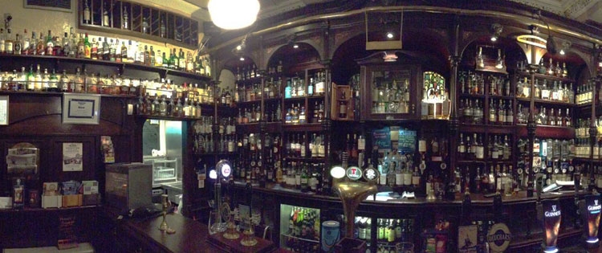

2.

### Tabac, 10 Mitchell Lane, G1 3NU

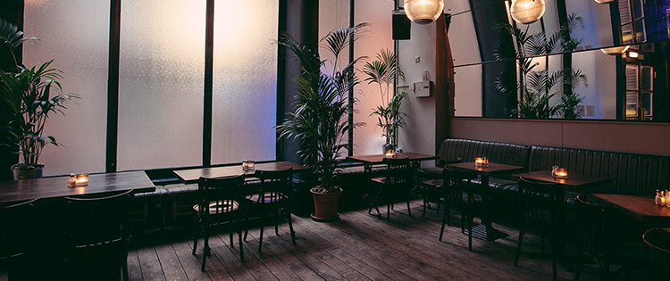

## 3. Oran Mor, 731-735 Great Western Road G12 8QX

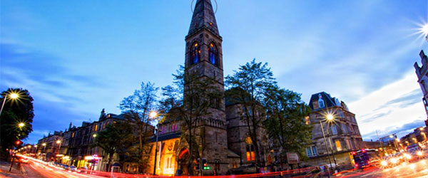

### Sloans, 62 Argyll Arcade, G2 8BG

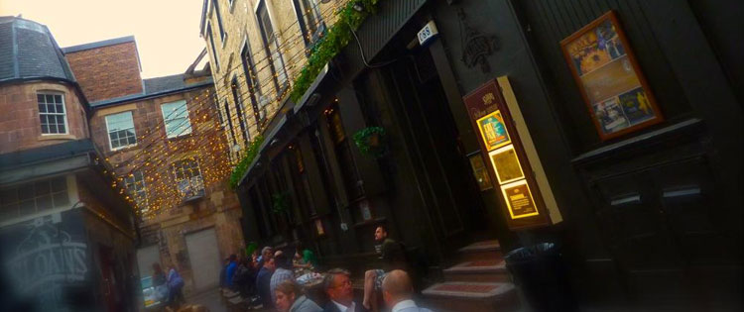

4.

### The Flying Duck, 142 Renfield Street, G2 3AU

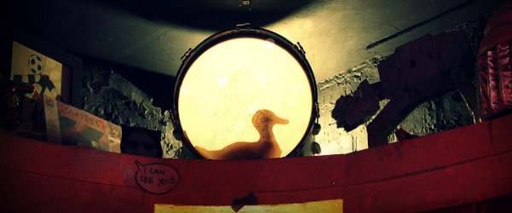

5.

### Blackfriars, 36 Bell Street, G1 1LG Best Bars Glasgow Merchant City Blackfriars

6.

## Curlers Rest, 256-260 Byres Road G12 8SH

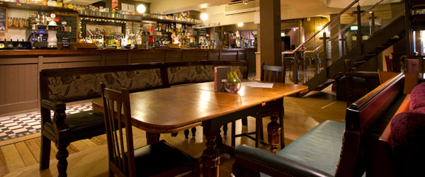

7.

## The Rock, 205 Hyndland Road G12 9HE

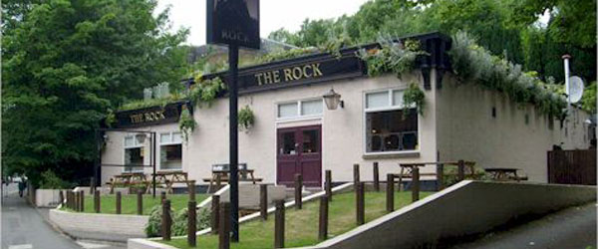

### 8. Hummingbird, 186 Bath Street, G2 4HG

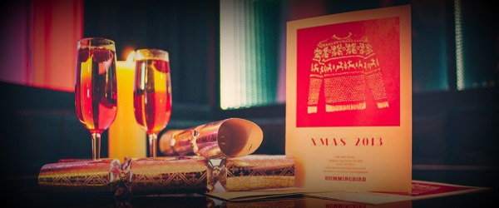

9.

### [The Sparkle Horse](https://www.timeout.com/glasgow/bars-and-pubs/the-sparkle-horse)

**16 Dowanhill Street**  
**Glasgow**  
**G11 5QS**

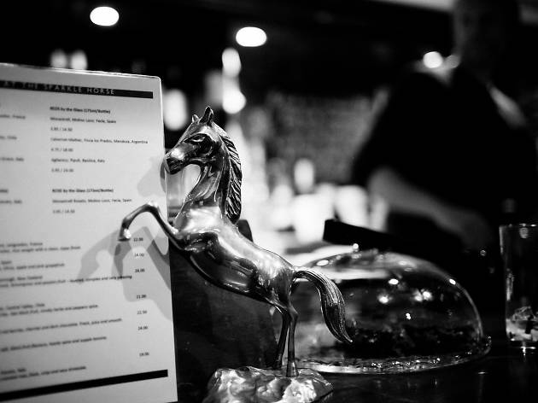

10.

### The Lab, 26 Springfield Court, G1  3DQ

