# Solution M1: Introduction to Linux and Virtualization

One possible solution could be:

1. Machine #1 – CentOS

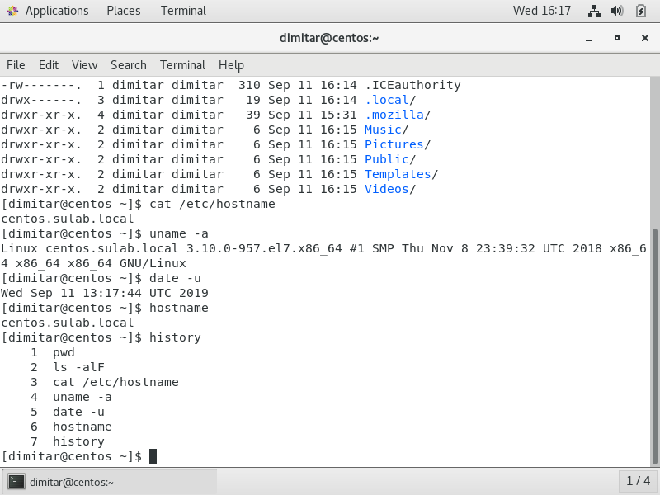

1. Machine #2 – Debian

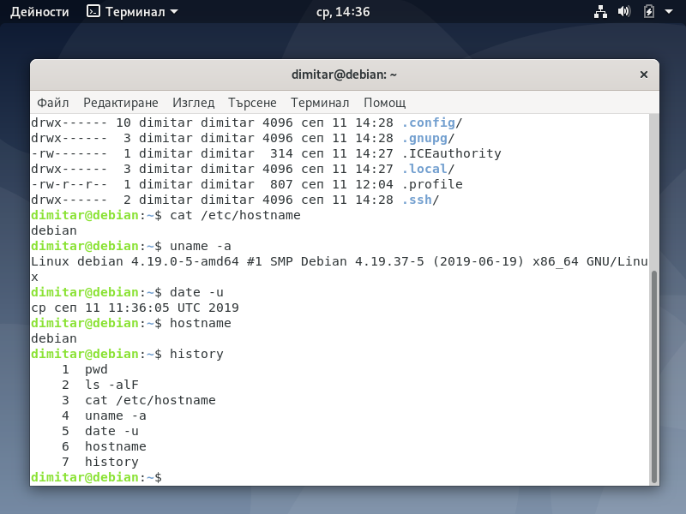

Of course, other distributions are also acceptable. The aim of this homework is to encourage us to experiment with different distributions.