# Homework M4: Network. Software. Services

For a successful completion of the tasks, you should have at least one server and one client configured according to the class practice. Should you have any questions about its setup, do not hesitate to contact your colleagues or me.

You must create a small environment, separate from the one you are working in class. The environment should consist of one VM (name it **rila.lsa.lab**) with two network adapters and another one (name it **pirin.lsa.lab**) with just one network adapter. More or less the environment should look like this:

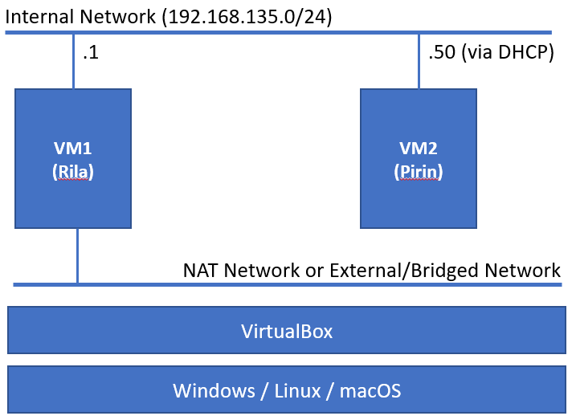

Pick two **different** (from different families) distributions.

The following tasks must be performed on the **Rila** host:

1. Set one of the network cards with static IP **192.168.135.1/24** (and in the **same virtual network** as the only card of the other VM).
2. Install and configure **DHCP** with range from **192.168.135.50 – 192.168.135.99**
3. **SSH** service installed and running
4. Firewall up and running, and allowing **SSH** connections
5. Enabled **NAT** functionality, so the internal station can have access to Internet

The following tasks must be performed on the **Pirin** host:

1. Make sure that the network adapter is set to get its IP address via **DHCP**
2. Installed and running **FTP** server
3. **SSH** service installed and running
4. Firewall up and running, and allowing **SSH** and **FTP** connections
5. Access to Internet (for example ping to **distrowatch.com**)

## Proof

Upload a document (txt, doc, docx, pdf) containing the commands that you executed in order to accomplish the above tasks.