## Exam Simulation: Linux System Administration 2021.04

You are presented with two virtual machines with **CentOS 8.3** installed. They are connected like this:

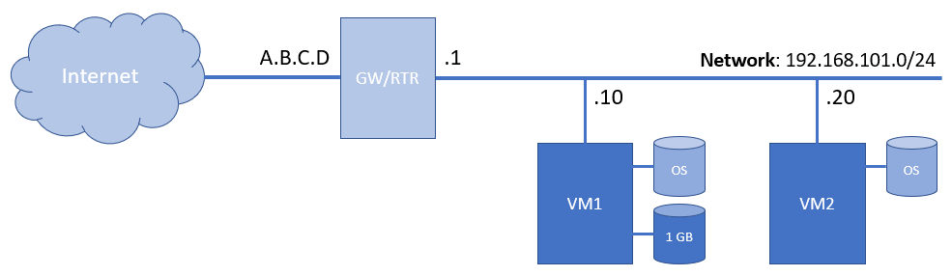

The first one (VM1) is with one spare (extra) hard disk (1 GB in size).

Pease note that if you are given IP address of **A.B.C.D** then the following port-forwarding rules are in place:

|  |  |  |  |
| --- | --- | --- | --- |
| VM1 | A.B.C.D:10022 -> 192.168.101.10:22 | VM2 | A.B.C.D:20022 -> 192.168.101.20:22 |
| A.B.C.D:10080 -> 192.168.101.10:80 | A.B.C.D:20080 -> 192.168.101.20:80 |

You are expected to accomplish the following set of tasks grouped into six categories (groups).

### Tasks

#### Group 1 (Tasks)

Complete the following set of sub-tasks on **VM1**:

* (T101, 2 pts) Create the following users **user1**, **user2** and **user3**
* (T102, 2 pts) Each of the users should have a full name like **Exam User #x** where **x** is a number between **1** and **3**
* (T103, 2 pts) Create group **examusers**
* (T104, 2 pts) Make the recently created users members of the **examusers** group

#### Group 2 (Tasks)

Complete the following set of sub-tasks on **VM1**:

* (T201, 2 pts) Create an **/exam** folder
* (T202, 2 pts) Create **STEP1, STEP2,** and **STEP3** sub-folders in **/exam**
* (T203, 2 pts) In every **STEPx** folder create three more sub-folders - **CODE**, **DOC**, and **OTHERS**
* (T204, 2 pts) In every **CODE** folder create empty files named **program1.code**, **program2.code**, and **program3.code**
* (T205, 2 pts) In every **DOC** folder create an **author.txt** file containing your SoftUni username
* (T206, 2 pts) Set the **examgroup** as a group owner of the **/exam** folder and all sub-folders and files

#### Group 3 (Tasks)

Complete the following set of sub-tasks on **VM1**:

* (T301, 2 pts) Install **MariaDB** client and server
* (T302, 2 pts) Do an initial configuration of **MariaDB** and set **Password1** for the **root** user
* (T303, 2 pts) Ensure that **MariaDB** is started and enabled to start on boot
* (T304, 2 pts) Create a database named **top_cities**
* (T305, 2 pts) Create a **tc_user** for the **top_cities** database with password set to **12345**
* (T306, 2 pts) Create table **cities** in the **top_cities** database with the following structure
  + **city_name** of type **varchar(50)**
  + **city_population** of type **int**
* (T307, 2 pts) Insert the following three records in the **cities** table
  + **Sofia, 1500000**
  + **Plovdiv, 450000**
  + **Varna, 350000**

#### Group 4 (Tasks)

Complete the following set of sub-tasks on **VM2**:

* (T401, 2 pts) Install web server of your choice
* (T402, 2 pts) Make sure the server is running and enabled to start on boot
* (T403, 2 pts) Create a custom **index.html** page with your SoftUni username
* (T404, 2 pts) Make sure the page is accessible from the outside (open a port in the firewall, if running)

#### Group 5 (Tasks)

Complete the following set of sub-tasks on **VM1**:

* (T501, 2 pts) Create a shell script **/scripts/backup.sh** that when executed creates a **bzip2** compressed archive of the **/etc** folder and stores it in the **/backup** folder with name like **etc-yyyy-mm-dd.tar.bz2**
* (T502, 2 pts) Create a schedule to execute **every day at 20:00** the backup script from the previous task

#### Group 6 (Tasks)

Complete the following set of sub-tasks on **VM1**:

* (T601, 2 pts) Using the MBR partitioning scheme on the spare disk create one partition 200 MB in size and a second one 400 MB in size
* (T602, 2 pts) Format the first partition with **EXT4** file system
* (T603, 2 pts) Mount it at **/data/ext4** and add an entry in the **/etc/fstab** file
* (T604, 2 pts) Format the second partition with **XFS** file system
* (T605, 2 pts) Mount it at **/data/xfs** and add an entry in the **/etc/fstab** file

### (Possible) Solution

#### Group 1 (Solution)

We can create each user either manually or by using a loop

Let us create the first one manually

sudo useradd -m -c "Exam User #1" user1

And the other two with a loop

for i in {2..3}; do useradd -m -c "Exam User #$i" user$i; done

Next, we will create the **examusers** group

sudo groupadd examusers

Finally, we will make the users members of the group

This time we will use a loop for the first two

for i in {1..2}; do usermod -aG examusers user$i; done

And will add the third one manually

sudo usermod -aG examusers user3

#### Group 2 (Solution)

We can create all required folders manually

Instead, we will create them in one single step

sudo mkdir -p /exam/STEP{1..3}/{CODE,DOC,OTHERS}

The same applies to the **programX.code** files that we must create in every **CODE** folder

sudo touch /exam/STEP{1..3}/CODE/program{1..3}.code

Next is the **author.txt** file

Because they are only three, we can create one

echo 'user_name' | sudo tee /exam/STEP1/DOC/author.txt

And then copy it to the other two folders

sudo cp /exam/STEP1/DOC/author.txt /exam/STEP2/DOC/author.txt

sudo cp /exam/STEP1/DOC/author.txt /exam/STEP3/DOC/author.txt

Alternatively, we can use a loop and create all three files in one step

for i in {1..3}; do echo 'user_name' | sudo tee /exam/STEP$i/DOC/author.txt; done

Finally, let us change the group owner of the **/exam** folder to **examusers** group

sudo chgrp -R examusers /exam

#### Group 3 (Solution)

First, install the required packages

sudo dnf install -y mariadb mariadb-server

Then start and enable **MariaDB** service

sudo systemctl enable mariadb

sudo systemctl start mariadb

Next, do the initial configuration and set the required password for the **root** user of **MariaDB**

mysql_secure_installation

Then, open a session to the database

mysql -u root -p

Create the requested database

create database top_cities;

Create the user for the database

grant all on top_cities.* to tc_user@localhost identified by '12345';

flush privileges;

Next, create the table

create table cities (city_name varchar(50), city_population int);

Finally, insert the rows

insert into cities (city_name, city_population) values ('Sofia', 1500000), ('Plovdiv', 450000), ('Varna', 350000);

#### Group 4 (Solution)

We will install Apache HTTP server

First, let us install the required packages

sudo dnf install -y httpd

Then enable and start the service

sudo systemctl enable --now httpd

Next, we can create a custom **index.html** file

echo '<h1>user_name</h1>' | sudo tee /var/www/html/index.html

Finally, we can open a port in the firewall

sudo firewall-cmd --add-service http --permanent

sudo firewall-cmd --reload

#### Group 5 (Solution)

First, we must make sure that we have the **bzip2** utilities installed

sudo dnf install bzip2

Then, we must prepare the target and the scripts folders

sudo mkdir /scripts /backup

Next, we can create the backup script with the following content

#!/bin/bash

tar -cjf /backup/etc-$(date +\%Y-\%m-%\d).tar.bzip2 /etc > /tmp/tar.log 2>&1

Finally, we must open crontab for editing

crontab -e

And add the following record

00 20 * * * /scripts/backup.sh

Save and close the file

#### Group 6 (Solution)

Use the **fdisk** utility to partition the drive

sudo fdisk /dev/sdb

Create two primary partitions with the requested sizes

Don't forget to save the changes

Create **EXT4** file system on the first

sudo fdisk /dev/sdb

Create **XFS** file system on the second

Use the **blkid** to get the **UUID** values of both partitions

Add them to the **/etc/fstab** file

Create the mountpoint folders

sudo mkdir -p /data/{ext4,xfs}

Test (and mount) the changes made to the **/etc/fstab** file

sudo mount -a

Use either **mount** or **lsblk** to make sure that the file systems are successfully mounted