# Exam: WSAA 2021.06 (2021.08.22)

### Infrastructure and connectivity

You will have to accomplish a set of tasks in the following infrastructure:

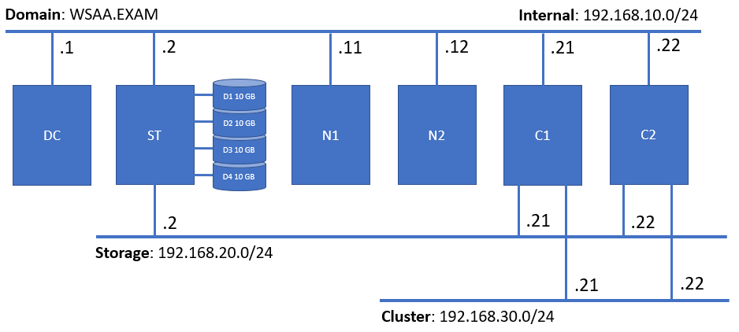

All machines are of the same type (in terms of OS and hardware parameters) but with different roles (stated on the picture above)

In terms of connectivity, please note that if you received an IP address **A.B.C.D** then the following port-forwarding rules are in place:

|  |  |  |
| --- | --- | --- |
| A.B.C.D:10001 -> 192.168.10.1:3389 | A.B.C.D:10002 -> 192.168.10.2:3389 | A.B.C.D:10003 -> 192.168.10.11:3389 |
| A.B.C.D:10004 -> 192.168.10.12:3389 | A.B.C.D:10005 -> 192.168.10.21:3389 | A.B.C.D:10006 -> 192.168.10.22:3389 |

In order to save bandwidth and allow for relatively normal experience for everyone, try to follow these guidelines:

* Use the **Show Options** button when making an RDP connection with ***Remote Desktop Connection*** application (other similar apps have more or less the same set of options) to adjust the settings
* On the **Display** tab lower the color settings by selecting a lower color depth in the **Choose the color depth of the remote session** drop-down list
* Make sure the on the **Local Resources** tab in the **Local devices and resources** section only the **Clipboard** option is selected
* On the **Experience** tab either select on of the low-speed options (for example **Low-speed broadband**) or **uncheck** some of the settings (for example **Desktop background**, **Font smoothing**, etc.)
* Don’t open simultaneous connections to all six machines, you won’t need all of them at the same time

### General rules

Be sure to **follow** the **naming** **conventions** specified in the tasks checklist

Tasks execution order should not be derived from the order in which they are listed below. Please note that there are tasks that depend on the successful completion of one or more other tasks

Usually, most steps could be achieved following different paths and using different tools. In the end, not the means, but the **end results** are being **measured**

### Tasks checklist

#### Infrastructure [3 pts]

Considering the setup, and the tasks you are expected to fulfill, do some preliminary work:

* (T101 / 2 pts) Install **File Server** role on **C1** and **C2**
* (T102 / 1 pts) On **DC** install the following additional features from the **RSAT Tools** node – **NLB** and **Failover Cluster** including any related PowerShell modules

#### Storage [15 pts]

Deploy a simple storage solution utilizing **storage pools** and **iSCSI** technologies:

* (T201 / 2 pts) Create a storage pool out of the four spare disks (use all of them) on **ST** and name it **POOL**
* (T202 / 1 pts) Create a **thin** virtual disk in **mirror mode** that consumes **20 GB** of space on the pool
* (T203 / 2 pts) Create a volume that occupies the whole space of the virtual disk, format it with **NTFS** and allocation unit of **64KB**, set the label to **DATA**, and assign to it the drive letter **P**
* (T204 / 6 pts) Convert the **ST** machine to an **iSCSI target server** by installing and configuring the appropriate components
* (T205 / 2 pts) Create a new **dynamically** expanding iSCSI virtual disk **1 GB** in size and store it on drive **P**
* (T206 / 2 pts) Create a new **dynamically** expanding iSCSI virtual disk **8 GB** in size and store it on drive **P**

#### Network Load Balancing [12 pts]

Create and configure a two-node **NLB cluster** by completing the following tasks:

* (T301 / 3 pts) Prepare both **N1** and **N2** to become a part of an NLB cluster
* (T302 / 3 pts) Create a two-node **NLB cluster** named **NLB.WSAA.EXAM** with IP address **192.168.10.33**
* (T303 / 1 pts) Configure the cluster mode to be **multicast**
* (T304 / 1 pts) Configure the rule (it should be the only one) for port **80/tcp** and affinity set to **none**
* (T305 / 2 pts) Create a DNS **A** record named **nlb** pointing to the ***IP address*** of the NLB cluster
* (T306 / 2 pts) Create a DNS **CNAME** record named **portal** pointing to the ***FQDN*** of the **nlb** record

#### Failover Cluster [18 pts]

Create and configure **Windows Server Failover Cluster** that meets the following requirements:

* (T401 / 3 pts) Configure the initiator part on both **C1** and **C2** nodes
* (T402 / 4 pts) Initialize, format, and attach (where applicable) storage for quorum and data to both nodes
* (T403 / 2 pts) Install the required **failover cluster** role components on both nodes
* (T404 / 3 pts) Create the cluster **FSC.WSAA.EXAM** with IP address set to **192.168.10.44**
* (T405 / 1 pts) Ensure that the storage is appropriately recognized and that there is a **cluster shared volume**
* (T406 / 2 pts) Configure a **Scale-Out File Server** cluster role named **FSRole**
* (T407 / 2 pts) Create a share named **FSShare** for the **FSRole**
* (T408 / 1 pts) Create a **Readme.txt** file containing you ***SoftUni ID*** (or ***username***) and store it on the share

#### Desired State Configuration [12 pts]

Create a configuration script using the **PowerShell DSC** techniques that meet the following requirements:

* (T501 / 1 pts) The script should be named **Exam.ps1** and must be stored in **C:\DSC** on the **domain controller**
* (T502 / 2 pts) Creates a **share** named **Exam** on the **domain controller** pointing to the **C:\Exam** folder
* (T503 / 2 pts) Creates **two** **index.html** files, **personalized** for every node of the **NLB cluster**. Every file should contain the text **Running on Nx** , where ***Nx*** is the name of the node for which is the file. The two files should be stored **on the share** either in different folders or with different names
* (T504 / 2 pts) Installs **IIS** (the role itself and management tools) on the two NLB nodes
* (T505 / 1 pts) Distributes **index.html** files from the share to the root folder of the default site on each node
* (T506 / 1 pts) Creates **C:\version.txt** file on both **NLB nodes** containing the text **v.20210822**
* (T507 / 3 pts) Executes **successfully**