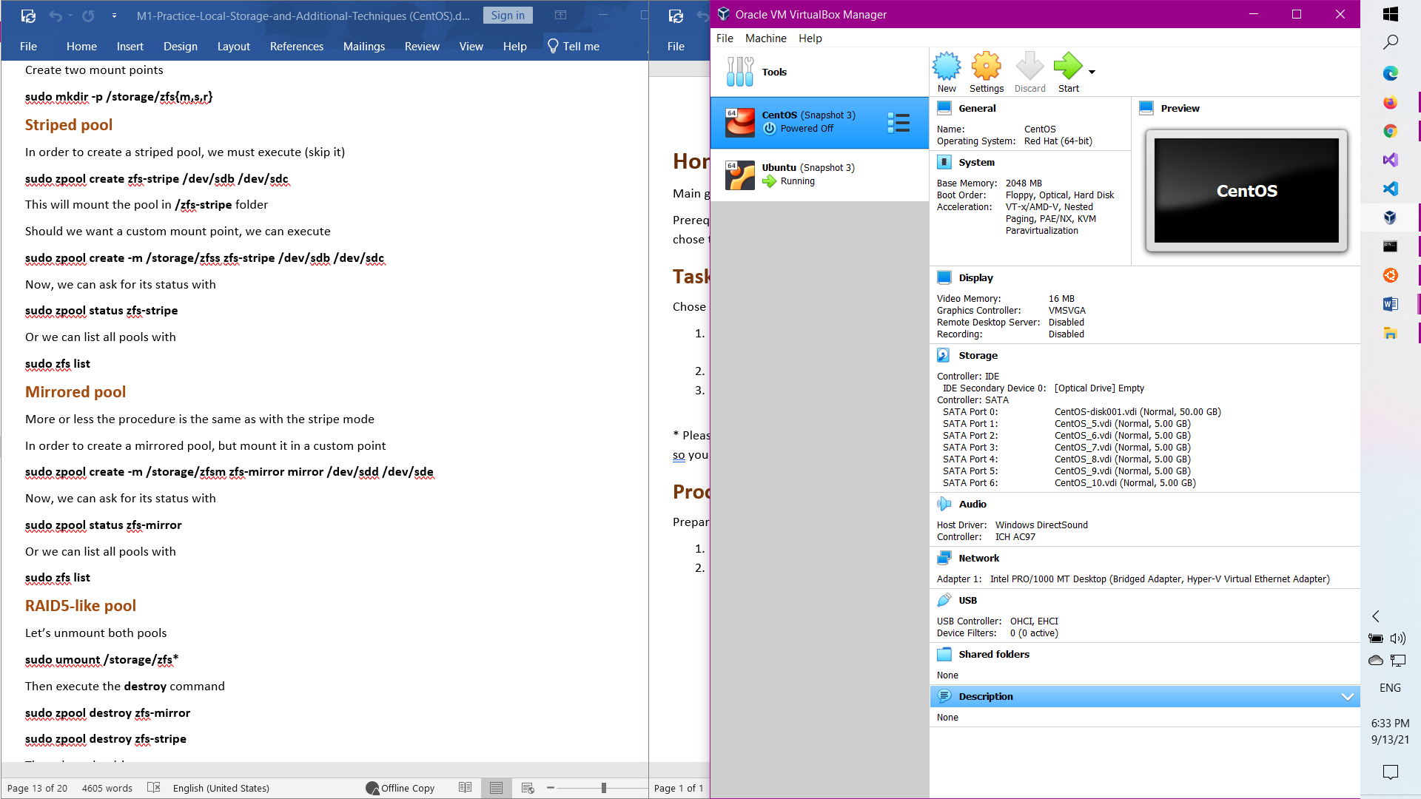

**sudo dnf install https://zfsonlinux.org/epel/zfs-release.el8_4.noarch.rpm**

**sudo rpm --import /etc/pki/rpm-gpg/RPM-GPG-KEY-zfsonlinux**

sudo vi /etc/yum.repos.d/zfs.repo

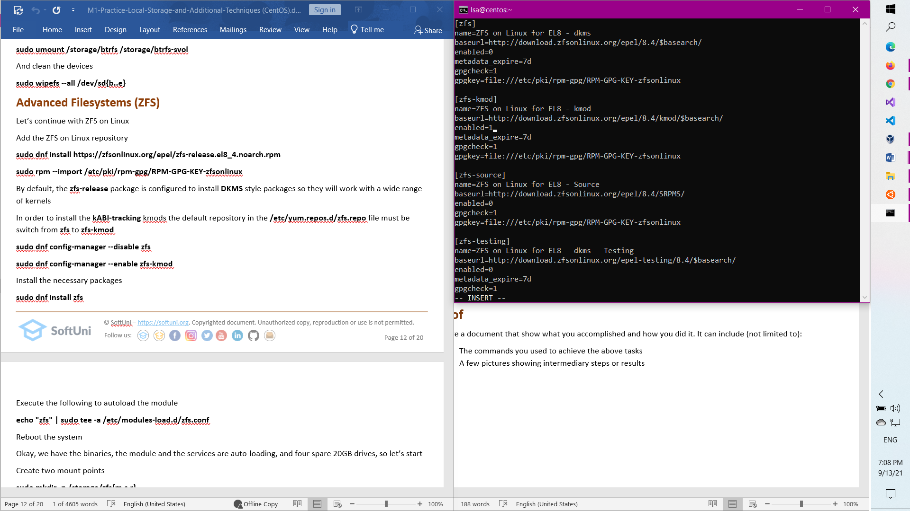

**sudo dnf config-manager --disable zfs**

**sudo dnf config-manager --enable zfs-kmod**

**sudo dnf install zfs**

**echo "zfs" | sudo tee -a /etc/modules-load.d/zfs.conf**

sudo mkdir -p /storage/zfs{10,6}

sudo reboot

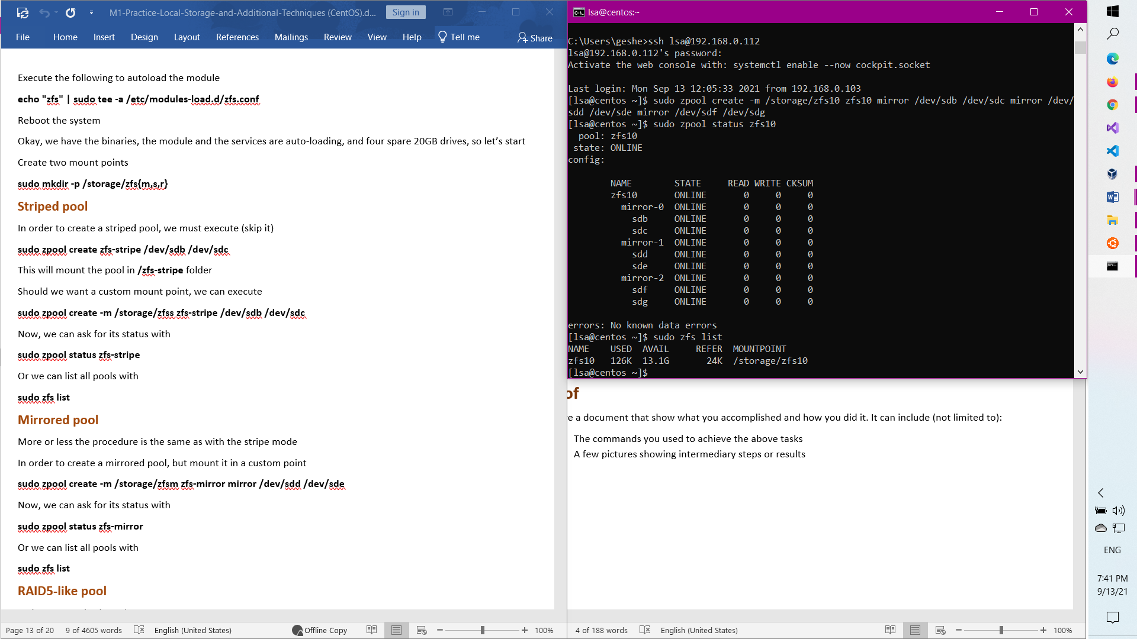

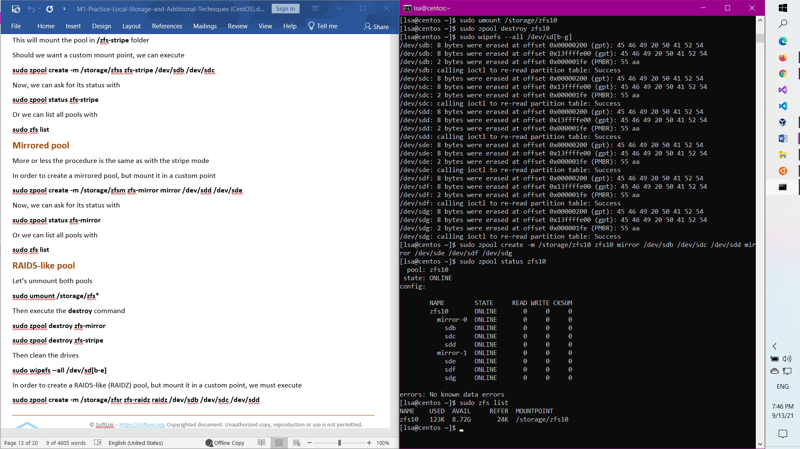

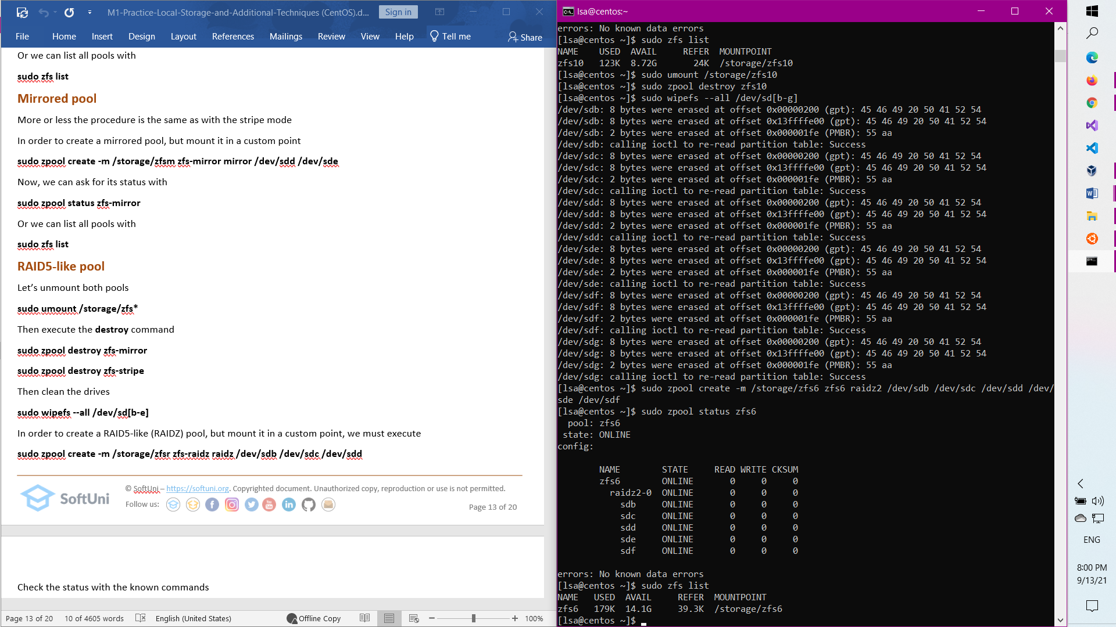

[lsa@centos ~]$ sudo mkdir /storage/cript

[lsa@centos ~]$ sudo modprobe dm_crypt

[lsa@centos ~]$ sudo lsmod | grep dm_crypt

dm_crypt 49152 0

dm_mod 151552 9 dm_crypt,dm_log,dm_mirror

[lsa@centos ~]$ sudo dnf install cryptsetup

Last metadata expiration check: 0:01:59 ago on Mon 13 Sep 2021 01:11:10 PM EDT.

Package cryptsetup-2.3.3-4.el8.x86_64 is already installed.

Dependencies resolved.

Nothing to do.

Complete!

