# Course Login Instructions

This document is intended to describe the procedure and the steps that each student must follow in order to successfully join and attend the course.

Note: After the live training session, the recording will be uploaded online so you can view it at any time. The link for the recorded video will be put in the main site of the training after each session.

# Student accounts

Each student will receive an account which will be used to access the training. The account will be in the format ***firstname.lastname*@students.softuni.bg** (if the names of the student are not available for the administrators during the account creation, it will be in the format *username*@students.softuni.bg, where *username* comes from your SoftUni account)

# Login instructions

1. When you receive your student account, you will also receive initial password and you need to change it. To do this, go to <http://portal.office.com>, put your student account username and click Next (select “work or school account” if asked)

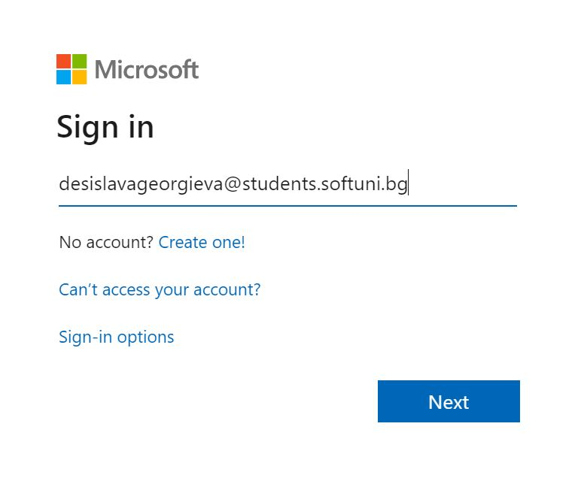

1. Make sure that you see the logo of the Software University, enter your initial password and click on Sign in

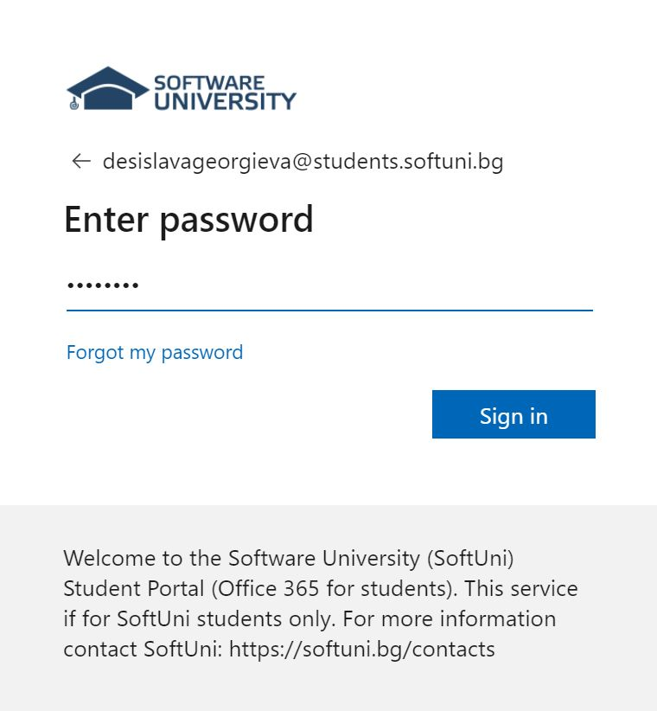

1. You will be prompted to change your password. Do it and click Sign in

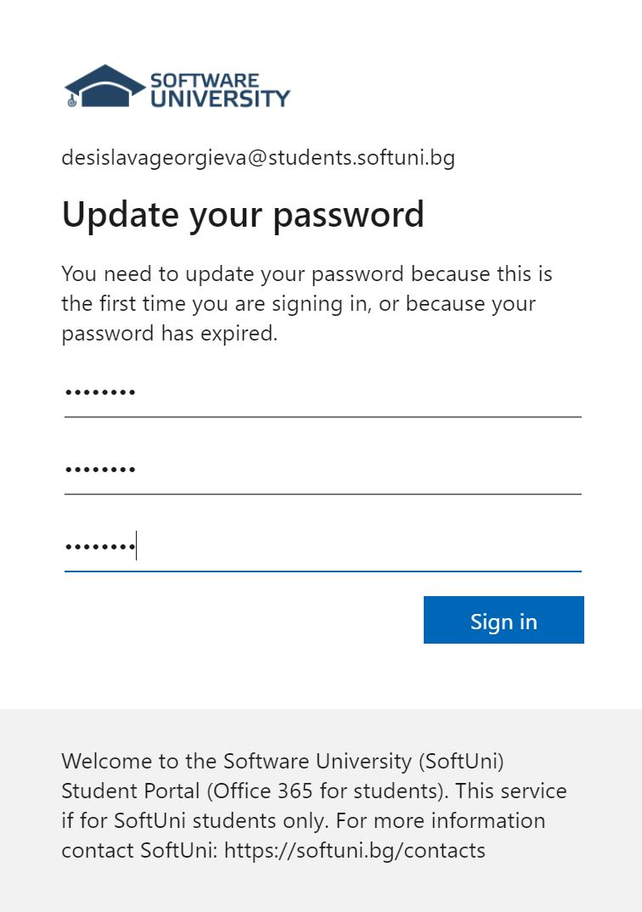

1. You may want to choose to remember your credentials, but it is up to you

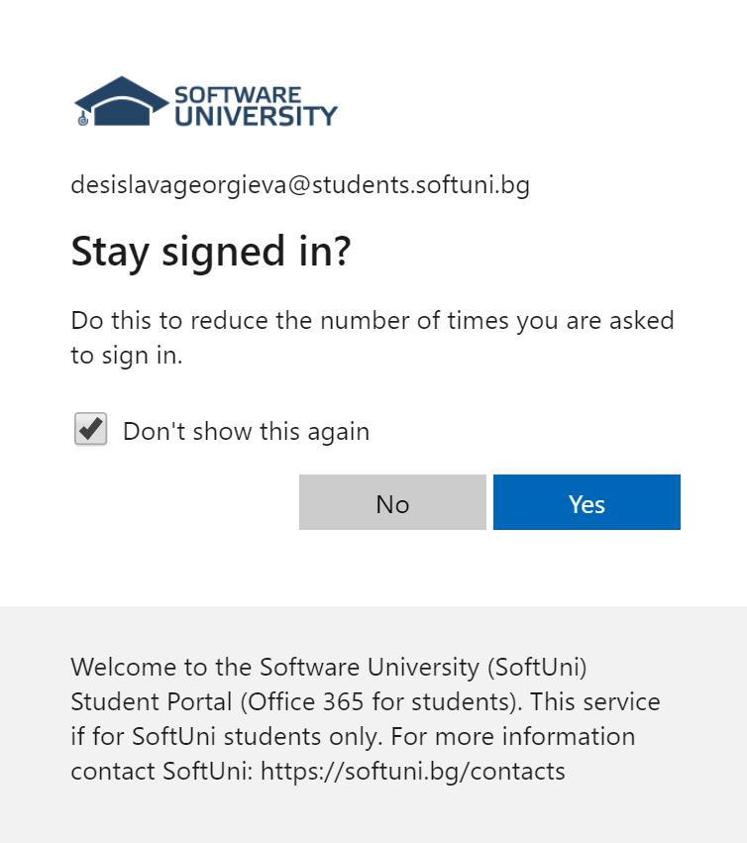

1. Then go to <https://www.microsoft.com/bg-bg/microsoft-365/microsoft-teams/download-app> and install the app
2. Go to [www.softuni.bg](http://www.softuni.bg) -> “Computer Networking Fundamentals” -> “Resources” and click on the link which will add you to the team (“Линк за добавяне към Teams”). Or simply use [this link](https://teams.microsoft.com/l/team/19%3akUgEL7YWof_EmpN8vJJjm4rrmbh10-iMKUr5r_NlFXI1%40thread.tacv2/conversations?groupId=6befea28-d8a4-4940-9541-6610d8522bea&tenantId=4a06d40c-e447-42be-baef-dd0421ed10bd) (admin approval will be required, you may need to wait before you are approved)
3. Go to [www.softuni.bg](http://www.softuni.bg) -> “Computer Networking Fundamentals” -> “Introduction to Networking” and click the link to join the first Teams meeting (which will be on April 19th, from 18:30 to 21:30). Alternatively, you can use [this link](https://teams.microsoft.com/l/meetup-join/19%3ameeting_MjJhZjJiZWItNmZiYy00YWNmLThhMzYtYWYxYzdiZWYyYWU5%40thread.v2/0?context=%7b%22Tid%22%3a%224a06d40c-e447-42be-baef-dd0421ed10bd%22%2c%22Oid%22%3a%226d50da5e-ecb8-476a-95aa-9afd8ac8d02a%22%7d) to join our first meeting. You may want to select “Computer audio” when joining the meeting.
4. See you there! :)