LAB 1: Introduction to Networking

Contents

How to use the lab guides 2

Introduction to LAB 1 2

Exercise 1: Explore, download and install Cisco Packet Tracer 2

# How to use the lab guides

The lab guides in this training are designed to be completed in class or at home. This means that depending on your time and availability, you can accomplish the tasks in each lab either during (after) the corresponding lecture, use it as a homework or split it for class/home work as you wish. Important is that you are finished with each lab before the date of the next lecture.

# Introduction to LAB 1

In this first LAB, you will be asked to download and install Cisco Packet Tracer and to spend some time learning how to use it. This simulator will be your primary tool for practicing with network configuration commands, protocols, and configurations.

# Exercise 1: Explore, download and install Cisco Packet Tracer

In this exercise, you are going to do the following:

* Register an account at Netacad/Skills For All
* Watch the online course to learn how to work with it
* Download and install the **Cisco Packet Tracer** simulator on your computer

1. Navigate to <https://www.netacad.com/courses/packet-tracer>

Scroll down and you will see three free courses related to how to use **Cisco Packet Tracer**. If you wish, you can view all of them, but the first one is recommended

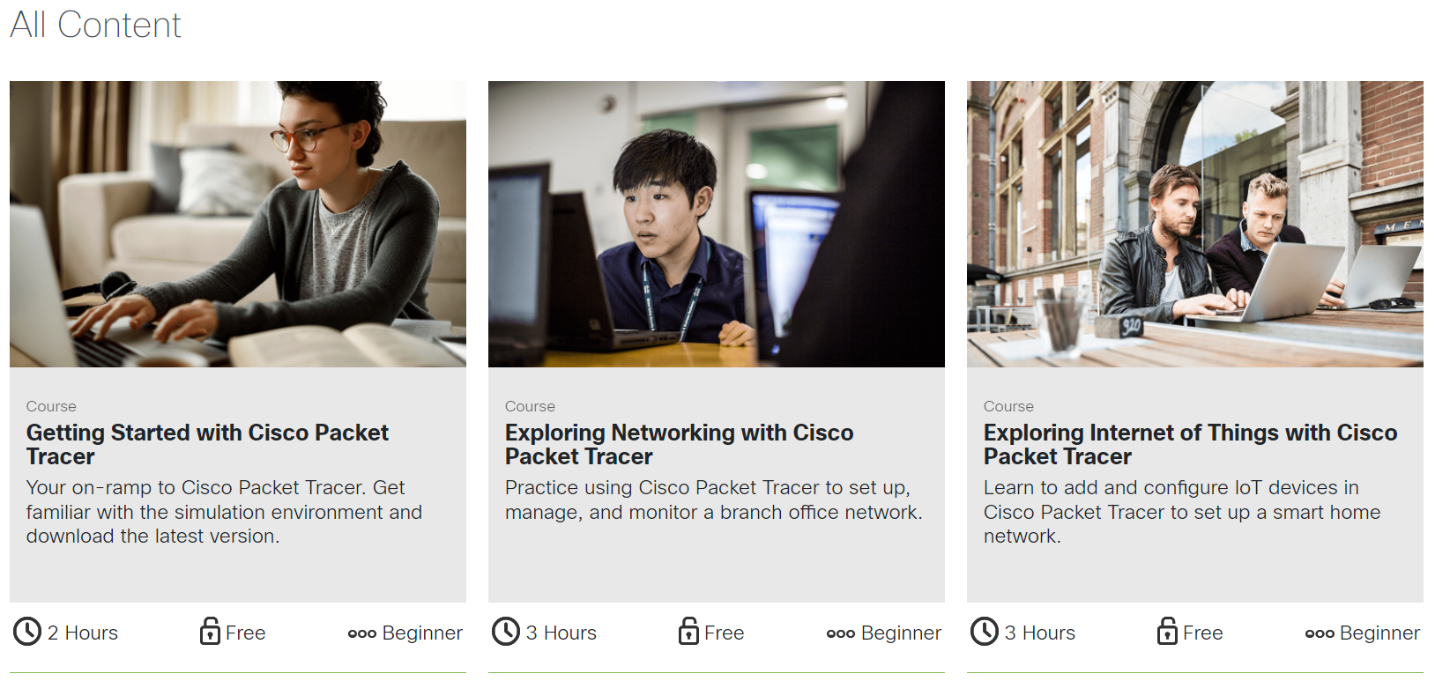

1. Click **View course** for the **Getting Started with Cisco Packet Tracer**



1. You will be redirected to a page where you can start this course. If this does not happen automatically, click on the button as shown below



1. Click on the course image again or click on the **Start Today** button. Then, click on **Sign up** and follow the steps to create an account



1. Once you have an account, go to the **Getting Started with Cisco packet Tracer** course and specifically to the **Download and Use Cisco Packet Tracer** section as shown below

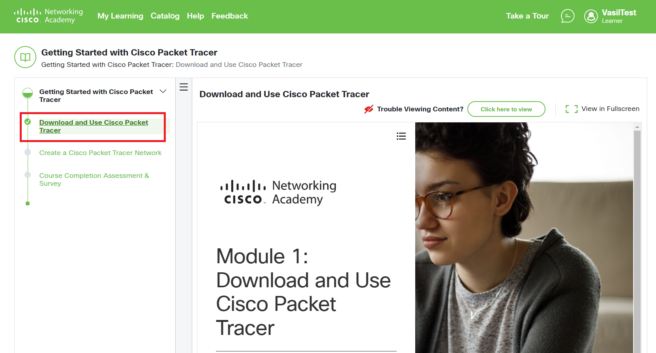

1. Scroll down, click on **Install Cisco Packet Tracer** section and scroll down again until you see the link to download the simulator

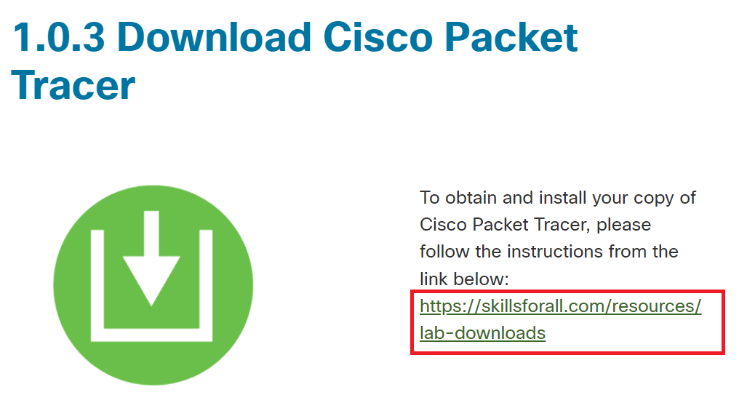

1. Click on the link from the screenshot above (it is [this one](https://skillsforall.com/resources/lab-downloads), but you have to be logged in) and you will see the links for downloads

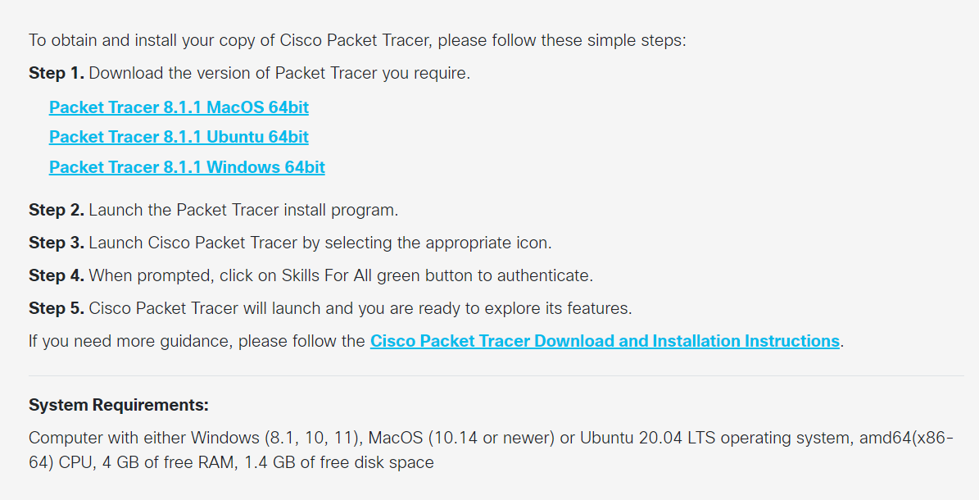

1. Download the appropriate version for you (we recommend the Windows version, if you have multiple platforms) and install it on your computer
2. If you receive a firewall security alert (for the Windows installations), click on **Allow access**
3. First time you run the simulator, you may receive a **Would you like to run multi-user when application starts?** question. We are not going to use this feature, so you can answer with **No**

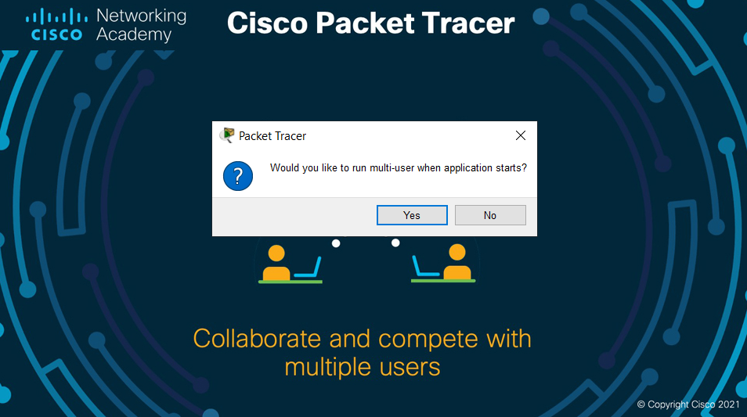

Note: Although you have already downloaded a copy of the software and installed it locally, you still need to login with your Netacad/Skills For All account when you use it. That is why having an account is not optional.

1. You should now have installed and logged in to Cisco Packet Tracer. Please have a look around and play with it by adding devices and connecting them. In the next lab, we will start building topologies and explore different protocols for communication.
2. [Optional] Return to the **Getting Started with Cisco Packet Tracer** course and review the materials (text and video) to get familiar with the simulator

You have completed LAB 1.