Lab 5: IP Services and Basic Routing

Contents

Introduction to LAB 5 2

Exercise 1: DHCP and DNS configuration within a single subnet 2

Exercise 2: Routing between LANs connected with a single router 9

Exercise 3: Routing between LANs connected with multiple routers 12

Exercise 4: Inter-VLAN routing (Router on a stick) 16

Exercise 5: (optional): DHCP relay 20

Useful commands for checking your configurations and troubleshooting 24

# Introduction to LAB 5

In this lab, you will practice what you have learned about DHCP, DNS and static routing.

Two general things to note about the configuration of the routers:

* When you open a router CLI for the first time, you will see a message saying Continue with configuration dialog? [yes/no]: Answer **no** and start configuring your router normally.
* Their interfaces are usually disabled by default, so you have to enable them (**no shut**)

# Exercise 1: DHCP and DNS configuration within a single subnet

1. Create the topology.

Move one switch (2960), three end devices (PC) and one server. Rename them so their numbers start from one and connect all the devices to the switch as per the picture below

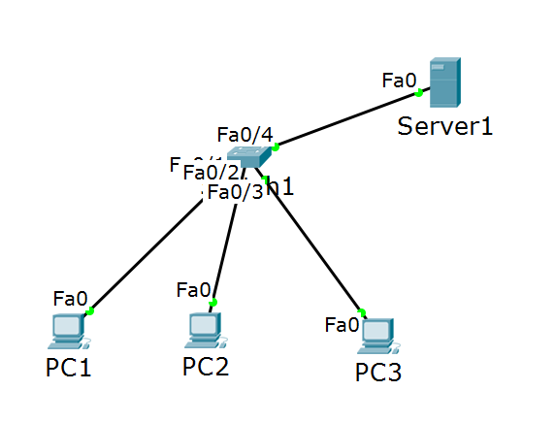

1. All the devices in this network belong to a single LAN and therefore will be in the same subnet. You will use the 192.168.1.0/24 subnet for device IP addresses in this network. This time, you will not setup the addresses manually but instead you will configure the Server to act like DHCP server and to provide IP addresses (and other information) in the network.

The first step is to setup a manual IP address only for the DHCP server itself. Open the Server, go to Config -> FastEthernet0 and in IP Configuration section, setup the IP address and the mask for the server. Use **192.168.1.100** with **255.255.255.0** (24-bit mask)

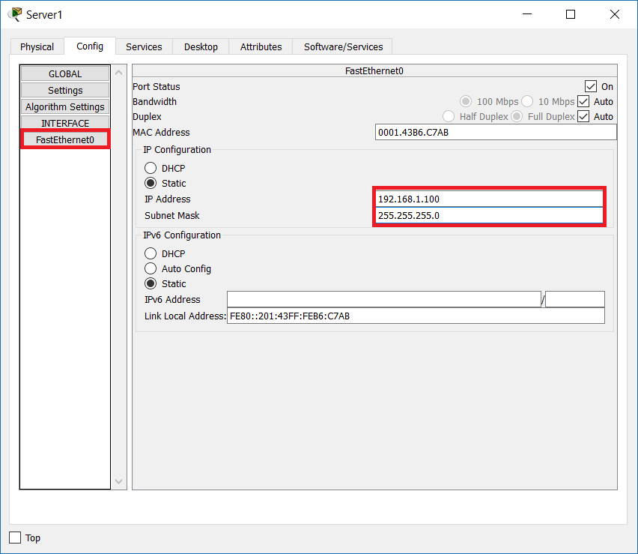

1. Configure the DHCP.

In the Server, go to Services -> DHCP and look at the default configuration. First, the whole DHCP service is turned OFF so you will have to turn it on. Then, look at the Pool configuration. There is a pool named serverPool which tries to “guess” your desired config, because in the Start IP Address section you see 192.168.1.0 which is the same subnet (the server knows it because in the previous step you have configured IP address in this subnet). This default pool cannot be deleted or renamed, so directly modify the following parameters:

* Change the status of the DHCP service to **On**
* Leave the Pool Name to **serverPool**
* Change the DNS Server to **192.168.1.100**. This is because we want to point the clients to use the same server also as their DNS server. The DNS entries will be configured in a later step
* Change the Start IP Address to **192.168.1.1**
* Change the Maximum number of Users to **20**
* Click on Save

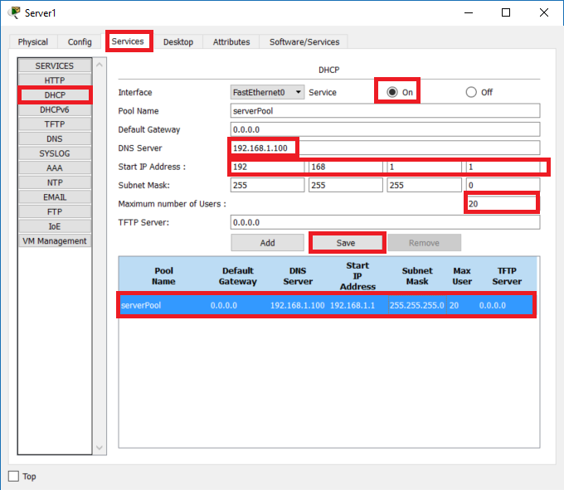

1. Configure the clients.

For each client, go to Config -> Settings and select DHCP for the Gateway/DNS IPv4. Then, go to the FastEthernet0 and select DHCP under the IP Configuration section

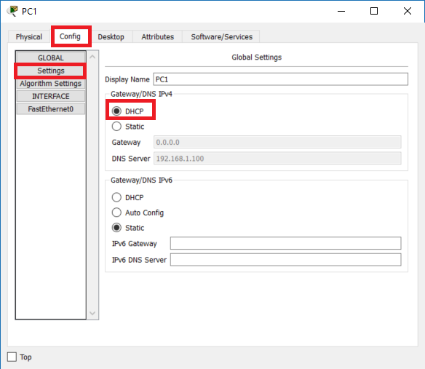

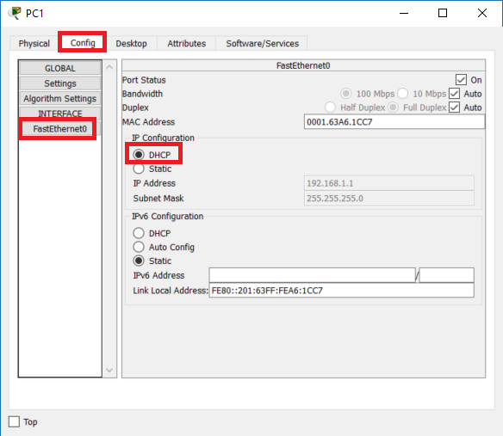

1. Request the IP configurations.

In each client, open a command prompt and type the following commands:

* **ipconfig /release** – this releases the already received ip configurations, if any. This is optional since the client was previously not configured to use DHCP
* **ipconfig /renew** – this forces the client to search for a DHCP server and obtain an IP configuration

At this point the three clients should have received IP address, subnet mask and DNS server from the DHCP. You can see an example for PC1 below

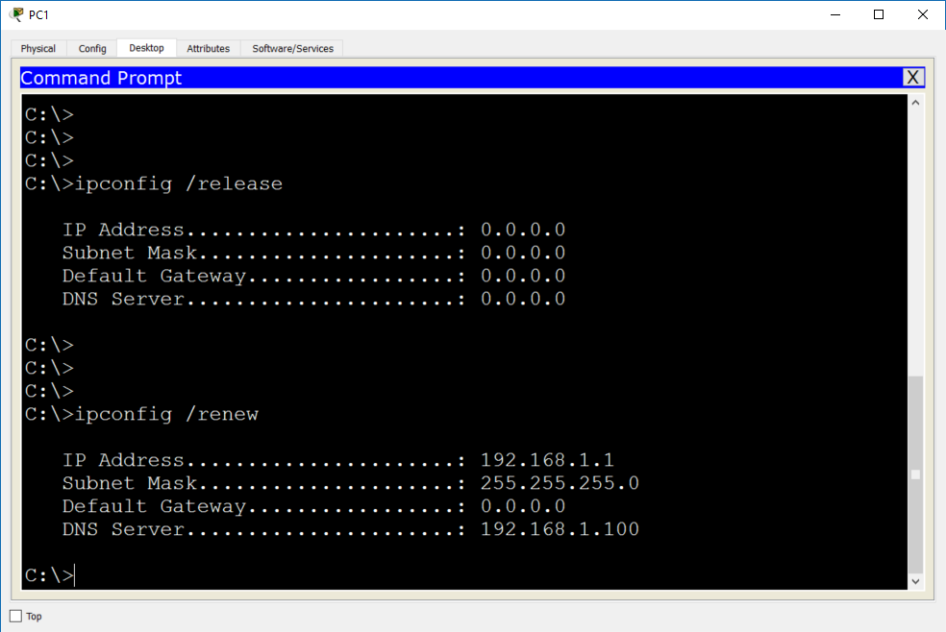

Why default gateway is not needed? The default gateway was not configured in the DHCP server because all the devices in this network belong to the same LAN and IP subnet.

1. Test the connectivity.

Open the CLI of PC1 and ping PC2, PC3 and the Server by using their IP addresses. The IP addresses of PC2 and PC3 are also received from the DHCP so you first have to check them (with **ipconfig** on each device). The IP address of the server is 192.168.1.100. All pings should succeed.

1. Enable the DNS service and create records.

Your clients are already configured to use a DNS server (this is the same machine as the DHCP server, 192.168.1.100) but the DNS service is not yet enabled and there are no DNS entries at this point. Now you will configure them.

Open the Server, go to Services -> DNS and enable the DNS service. Then, create the following Resource Records (click Add after each of them):

* Name: **pc1**, address 192.168.1.X (check what is the actual address of pc1 with **ipconfig**)
* Name: **pc2**, address 192.168.1.X (check what is the actual address of pc2 with **ipconfig**)
* Name: **pc3**, address 192.168.1.X (check what is the actual address of pc3 with **ipconfig**)
* Name: **server**, address 192.168.1.100 (this address is static)

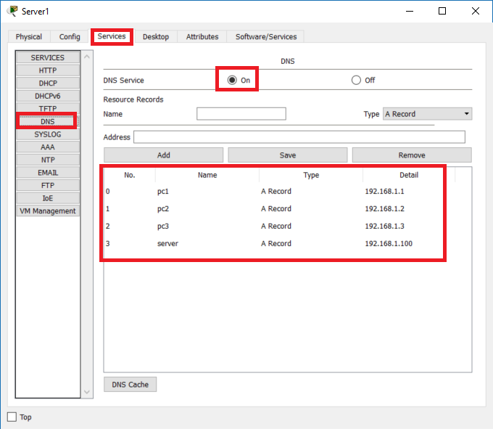

Note that in this example the addresses for pc1, pc2 and pc3 are respectively 192.168.1.1, 192.168.1.2 and 192.168.1.3 but this may not be the case in your situation. These are the first three addresses that the DHCP server allocates and the order of their distribution depends on the order which you have used to enable the DHCP on the clients.

1. Test the DNS resolution.

Open the CLI of PC1 and ping the other devices – this time using their names. Type the following commands:

* **ping pc2**
* **ping pc3**
* **ping server**

As a result, you will see that the hostnames that you enter are resolved to IP addresses (and the pings again succeed). This is because the source devices finds its assigned DNS server and performs DNS resolution to find the corresponding IP address for each of the pings.

1. (Optional) Monitor the DHCP process in the simulation mode.

* Release the IP configuration in one of the clients (**ipconfig /release**)
* Open the simulation mode and filter to see only DHCP events
* Type **ipconfig /renew** on the same client and by clicking Capture / Forward monitor the packet flow and observe that all packets are using broadcast

Note that if you do this, most likely this client will receive another IP address from the DHCP pool and the DNS record (name-to-IP) will not be valid since it is static.

1. (Optional) You can save this topology but it will not be used for a later lab

# Exercise 2: Routing between LANs connected with a single router

1. This lab will use a different topology so open a blank new instance of the Cisco Packet Tracer. Then create the new topology. To do this, drag the following devices into the workspace:

* One router (2911)
* Two switches (2960)
* Four end devices (generic)

Then, rename the devices so the numbering start from 1 (not from 0) and connect them as per the picture below

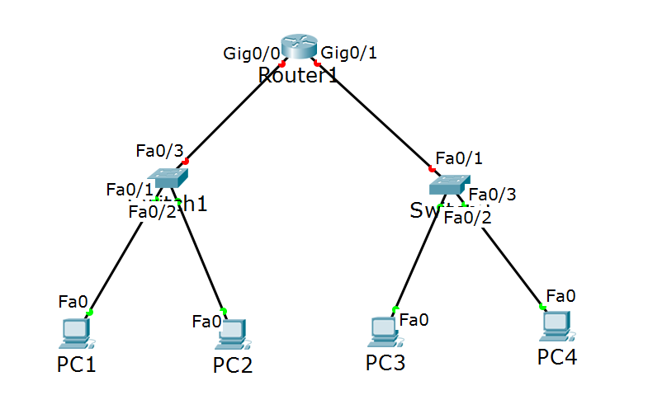

1. Assign IP addresses (statically).

The router separates the network into two LANs and each of them will have a separate IP subnet assigned. On the left side, you will use 10.1.1.0 /24 and on the right side, you will use 10.2.2.0 /24. Assign the following addresses to the devices:

|  |  |  |
| --- | --- | --- |
| Device/Port | IP Address/Mask | Belongs to network (informational only) |
| Router1, Gig0/0 (left interface) | 10.1.1.100 /24 | 10.1.1.0 /24 |
| PC1/Fa0 | 10.1.1.1 /24 | 10.1.1.0 /24 |
| PC2/Fa0 | 10.1.1.2 /24 | 10.1.1.0 /24 |
| Router1, Gig0/1 (right interface) | 10.2.2.100 /24 | 10.2.2.0 /24 |
| PC3/Fa0 | 10.2.2.1 /24 | 10.2.2.0 /24 |
| PC4/Fa0 | 10.2.2.2 /24 | 10.2.2.0 /24 |

Do not forget to enable the interfaces on the router (**no shut**) since they are disabled by default.

1. Test the connectivity within the subnets.

From PC1 ping PC2 (use IP addresses since you do not have DNS). Then, from PC3 ping PC4 – both pings should succeed.

Optionally, you can use the drawing palette functionality in the packet tracer to put different colors for the different networks (and subnets) as shown in the picture below

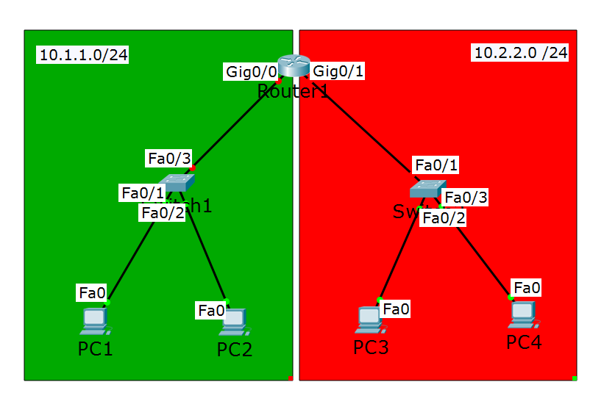

1. Test the connectivity between the subnets.

From PC1 try to ping PC3 or PC4. Was it successful? The pings will fail because:

1. The destination address does not belong to PC1’s local network (10.1.1.0/24)
2. PC1 does not have in its configuration a default gateway (neither it has a static route to this network)
3. Configure default gateways for the end devices.

In each end device, go to Config -> Settings and in the Gateway/DNS IPv4 section, select Static and specify a default gateway address as follows:

* For PC1 and PC2 the default gateway address should be **10.1.1.100**
* For PC3 and PC4 the default gateway address should be **10.2.2.100**

1. Test the connectivity between the subnets again.

Repeat the ping attempts from PC1 to PC3 and PC4 (or between any other two computers). This time it will be successful because the end devices have default gateway configured.

Note1: the router routes automatically between these two networks because they are directly connected to it, and it “knows” about them. No other static or dynamic routing configuration is required in the router itself.

Note2: As you may have seen before, the first ping packet may fail. This is because the ARP request/response process takes some time and it may not always finish before the ICMP packet timer expires. Once the ARP entry is added, all other pings will be successful.

# Exercise 3: Routing between LANs connected with multiple routers

In this exercise, you will add one more router which will create one more routing “hop” in the network. For successful connectivity, you need to have routes in the routing table of each device. Although this is possible, you can imagine how complex, less manageable and difficult to troubleshoot it will become if you add more and more routers. This time we are only using static routing to show this and in the next module we will talk about dynamic routing which reduces the configuration and adds more benefits for the network and administrators.

1. Add one more router (2911) in the topology. Delete the link between Router1 and Switch2, connect Switch2 to Router2, and then Router2 to Router1. This will create one more network and the three networks that you have now are:
2. The network on the left side of Router1 (it will stay with the **10.1.1.0 /24** subnet)
3. The network between Router1 and Router2 (it will have the **192.168.1.0 /24** subnet)
4. The network on the right side of Router2 (it will have **10.2.2.0 /24** subnet)

Optionally, you can use the drawing palette functionality in the packet tracer to put different colors for the different networks (and subnets) as shown in the picture below

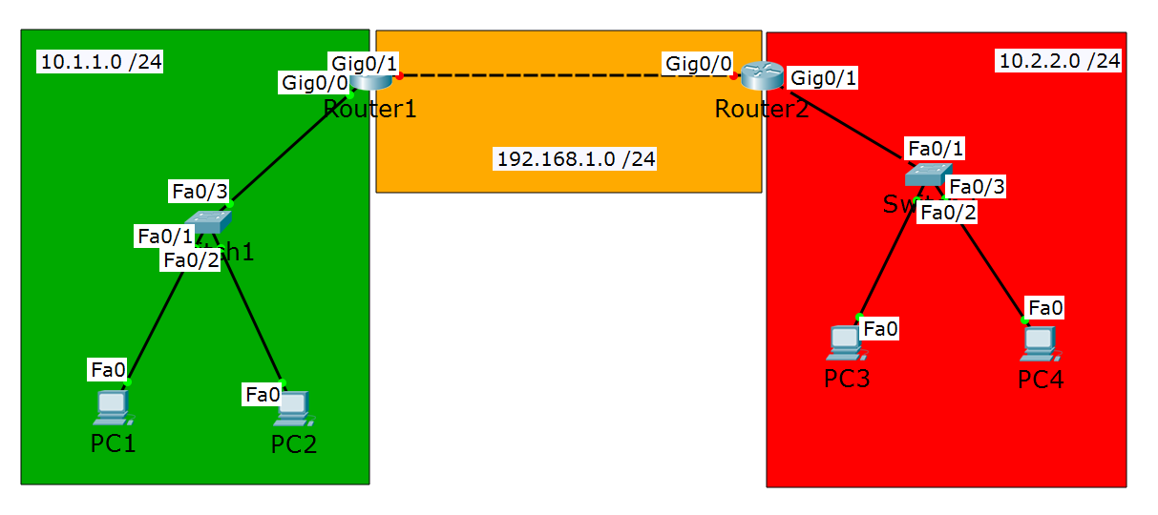

1. Assign IP addresses.

Assign the following IP addresses to the end devices and to the routers’ ports. Note that whenever you already have an IP address configured on a router interface and you have to change it, first remove the old one, using **no ip address** command from the interface configuration mode and then configure the new one. Also, do not forget to enable the interfaces on Router2 (**no shut**) since they are disabled by default.

|  |  |  |
| --- | --- | --- |
| Device/Port | IP Address/Mask | Belongs to network (informational only) |
| Router1, Gig0/0 (left interface) | 10.1.1.100 /24 | 10.1.1.0 /24 |
| PC1/Fa0 | 10.1.1.1 /24 | 10.1.1.0 /24 |
| PC2/Fa0 | 10.1.1.2 /24 | 10.1.1.0 /24 |
| Router2, Gig0/1 (right interface) | 10.2.2.100 /24 | 10.2.2.0 /24 |
| PC3/Fa0 | 10.2.2.1 /24 | 10.2.2.0 /24 |
| PC4/Fa0 | 10.2.2.2 /24 | 10.2.2.0 /24 |
| Router1, Gig0/1 (right interface) | 192.168.1.1 /24 | 192.168.1.0 /24 |
| Router2, Gig0/0 (left interface) | 192.168.1.2 /24 | 192.168.1.0 /24 |

1. Test the connectivity inside each subnet.

Confirm that you can ping PC2 from PC1, Router2 from Router1 and PC4 from PC3 (use the IP addresses for these test, you do not have DNS here). These pings should succeed.

1. Test the connectivity between the subnets.

Now, try to reach (ping) PC3 from PC1, PC4 from PC1 (or PC2). Also, try to ping Router2 (either interface) from PC1. All of these pings will fail because you do not have the correct information in the routing tables.

1. Configure static routing.

In order to reach any device from any other device in this network, you have to have routes configured in all of them. We will use static routing configuration. Try to answer the following questions before you read the answers in order to better understand the routing process:

1. Which IP network is local and known for PC1 and PC2? What you need to configure for them in order to reach different networks?
2. Which IP network(s) is local and known for Router1? What you need to configure in this device to reach other networks?
3. What about Router2?
4. What about PC3 and PC4?

Answers:

1. PC1 and PC2 belong to network 10.1.1.0 /24 and they do not need another configuration to reach devices from this network. But they need a default gateway to reach different networks. Their default gateway should point to the first routing device (and interface), which is 10.1.1.100. (They may already have it, this was configured in Exercise 2, Step 5)
2. Router1 belongs to two networks – 10.1.1.0 /24 and 192.168.1.0 /24. It does not need additional configuration to route between them. But Router1 does not know how to reach network 10.2.2.0 /24 so you need to configure a static route to this network. To do this, type

**ip route 10.2.2.0 255.255.255.0 192.168.1.2** This instructs the router that to reach the 10.2.2.0 /24 network, it has to go to the next-hop device, 192.168.1.2 (Router2)

1. Router2 belongs to two networks – 192.168.1.0 /24 and 10.2.2.0 /24. It does not need additional configuration to route between them. But Router2 does not know how to reach network 10.1.1.0 /24 so you need to configure a static route to this network. To do this, type

**ip route 10.1.1.0 255.255.255.0 192.168.1.1** This instructs the router that to reach the 10.1.1.0 /24 network, it has to go to the next-hop device, 192.168.1.1 (Router1)

1. PC3 and PC4 belong to network 10.2.2.0 /24 and they do not need another configuration to reach devices from this network. But they need a default gateway to reach different networks. Their default gateway should point to the first routing device (and interface), which is 10.2.2.100. (They may already have it, this was configured in Exercise 2, Step 5)

The required configurations are summarized in the next table:

|  |  |  |
| --- | --- | --- |
| Device | Needs access to networks | Configuration needed |
| PC1 | 192.168.1.0 /24  10.2.2.0 /24 | Set a default gateway: 10.1.1.100 |
| PC2 | 192.168.1.0 /24  10.2.2.0 /24 | Set a default gateway: 10.1.1.100 |
| Router1 | 10.2.2.0 /24 | ip route 10.2.2.0 255.255.255.0 192.168.1.2 |
| Router2 | 10.1.1.0 /24 | ip route 10.1.1.0 255.255.255.0 192.168.1.1 |
| PC3 | 192.168.1.0 /24  10.1.1.0 /24 | Set a default gateway: 10.2.2.100 |
| PC4 | 192.168.1.0 /24  10.1.1.0 /24 | Set a default gateway: 10.2.2.100 |

1. Test the connectivity between the subnets again.

Now ping PC3 and PC4 from PC1 and PC2. Also, ping Router2 (either interface) from PC1. Try all possible combinations – you will be able to reach any device from any other device now. This is because you have configured static routes - they instruct each device where to forward a packet which has an IP address from a different subnet (non-local) in the destination field.

1. (Optional) Save your topology. In the Packet Tracer, go to File -> Save As… and save it as LAB 5 - Exercise3.pkt on your local disk.

# Exercise 4: Inter-VLAN routing (Router on a stick)

Back in Lab 3 (Exercise 4) you configured two VLANs and you extended them via trunk link. You were able to reach the devices inside VLAN5 and the devices inside VLAN6 but not between these VLANs. In this exercise, you will configure routing in order to provide inter-vlan connectivity. You need to add a routing device in your topology and configure it to route between the VLANs. This approach is also known as “router on a stick” or “one-armed router” because one interface on the router is required to route between multiple networks (VLANs)

1. Load your basic topology (from Lab3).

Previously you were asked to save the topology from LAB3, Exercise 4. Now, open a blank new instance of Cisco Packet Tracer and go to File -> Open… and load the LAB 3.pkt file. Also, open the lab guide for Module 3 for reference

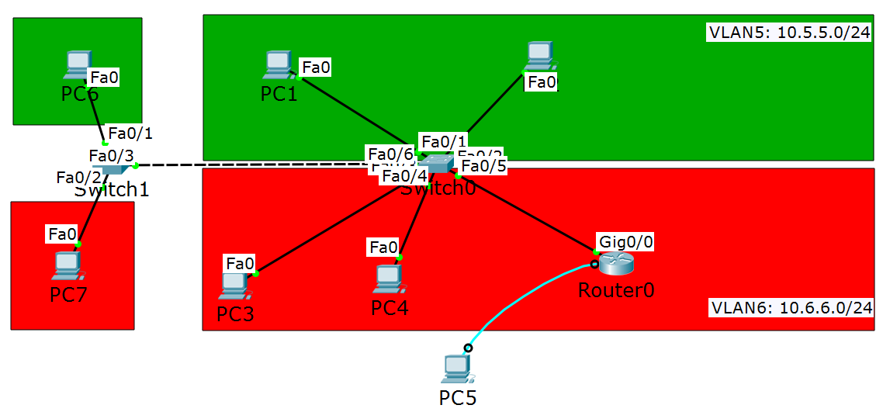

Note: If you haven’t saved it before, use the lab guide for Lecture 3 and create the topology (you need Exercise 1 and Exercise 4)

1. Add one more router.

Add a 2911 router and connect it to Switch0 as per the picture below

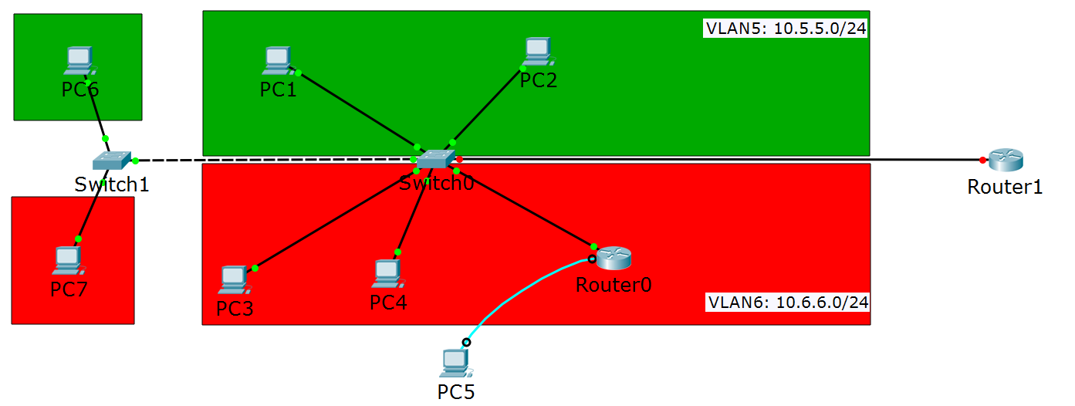

1. Configure Switch0.

The port which goes to Router1 should be configured as trunk in order to carry VLAN5 and VLAN6 to the router (remember, you need to route between these VLANs). Go in this port configuration mode and type:

* **switchport mode trunk**

1. Configure Router1.

Router1 has one physical interface but you will create two sub-interfaces – one for VLAN5 and one for VLAN6. In this example, the physical interface which connects to Switch0 is G0/0 and that is why it will be used in the instructions.

* Go to interface g0/0 config and type **no shutdown** to enable the interface
* Type **exit**
* Type **interface g0/0.5** (this enters into sub-interface g0/0.5)
* Type **encapsulation dot1Q 5** (this associates the sub-interface with VLAN5)
* Type **ip address 10.5.5.100 255.255.255.0** (the IP address for the sub-interface)
* Type **exit**
* Type **interface g0/0.6** (this enters into sub-interface g0/0.6)
* Type **encapsulation dot1Q 6** (this associates the sub-interface with VLAN6)
* Type **ip address 10.6.6.100 255.255.255.0** (the IP address for the sub-interface)

At this point, Router1 is configured to route between the VLANs (5 and 6). Note that no other static or dynamic routing protocol is required for Router1 and it will route between these VLANs because:

* It is a Layer 3 device
* It has IP address for each of the IP networks (VLANs)

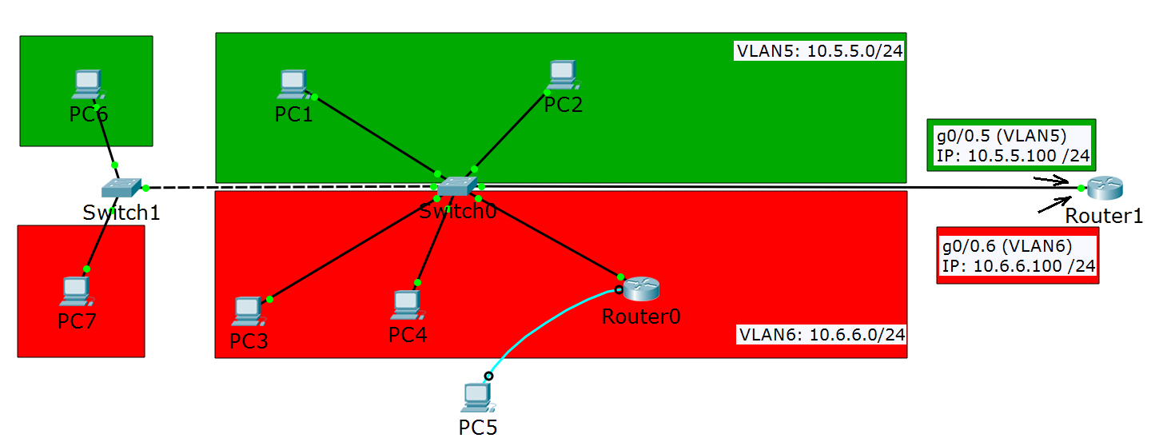

1. Configure the end devices.

The end devices also need to be configured. Specify the following default gateway configurations:

* For the VLAN5 devices (PC1, PC2 and PC6) use **10.5.5.100**
* For the VLAN6 devices (PC3, PC4 and PC7) use **10.6.6.100**

1. Router0 belongs to VLAN6 so if you also want to reach this device (via ping, telnet, etc.) you need to provide default gateway on this device as well. To do this, go in global config mode and type:

**ip route 0.0.0.0 0.0.0.0 10.6.6.100**

This command instructs the router that to reach any non-local network (0.0.0.0) with any mask (0.0.0.0) it has to send the traffic to 10.6.6.100. In other words, this is how you specify a default gateway for a router.

1. Test the connectivity between the VLANs.

Open the CLI of PC1 and ping all devices in VLAN5. This should work even without a default gateway since they all belong to the same VLAN. Then, again from PC1, ping all the devices in VLAN6 – PC3 (10.6.6.1), PC4 (10.6.6.2), PC7 (10.6.6.6) and Router0 (10.6.6.3). Try all combinations (with source and destination) and confirm that you can reach/ping between the VLANs!

Note: PC5 was previously used for console access only and you did not configure IP address on it, so it is not part of any network communication.

# Exercise 5: (optional): DHCP relay

In Exercise 1, you have configured a DHCP for a single LAN. Now, we want to configure again a single DHCP server but this time it has to serve two networks (one for VLAN5 and one for VLAN6). To do this, you have to configure a DHCP relay.

1. Add a DHCP server in the topology.

Add a server (end device, generic, the third one) and connect it to Router1 as shown in the picture. You will use the 172.16.1.0 /24 network for this segment. Configure the following:

* On Router1, enable (**no shut**) the interface which goes to the server and setup **172.16.1.1 /24** as IP address
* On Server0, setup **172.16.1.2 /24** as IP address on FastEthernet0
* On Server0, setup **172.16.1.1** as a Default Gateway address

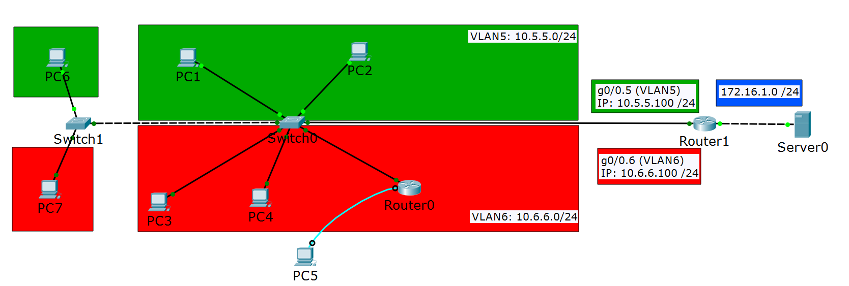

1. Configure all end devices to use DHCP instead of static configuration (this is valid for PC1, PC2, PC3, PC4, PC6 and PC7)
2. Configure the DHCP server.

Go to Server0 -> Services -> DHCP and configure the following:

* Enable the service (click **On**)
* Change the Pool Name to **serverPool - VLAN5**
* For Default Gateway, specify **10.5.5.100**
* For Start IP Address, type **10.5.5.20** (and use 24-bit mask)
* In Maximum number of Users, type **20**
* Click Add

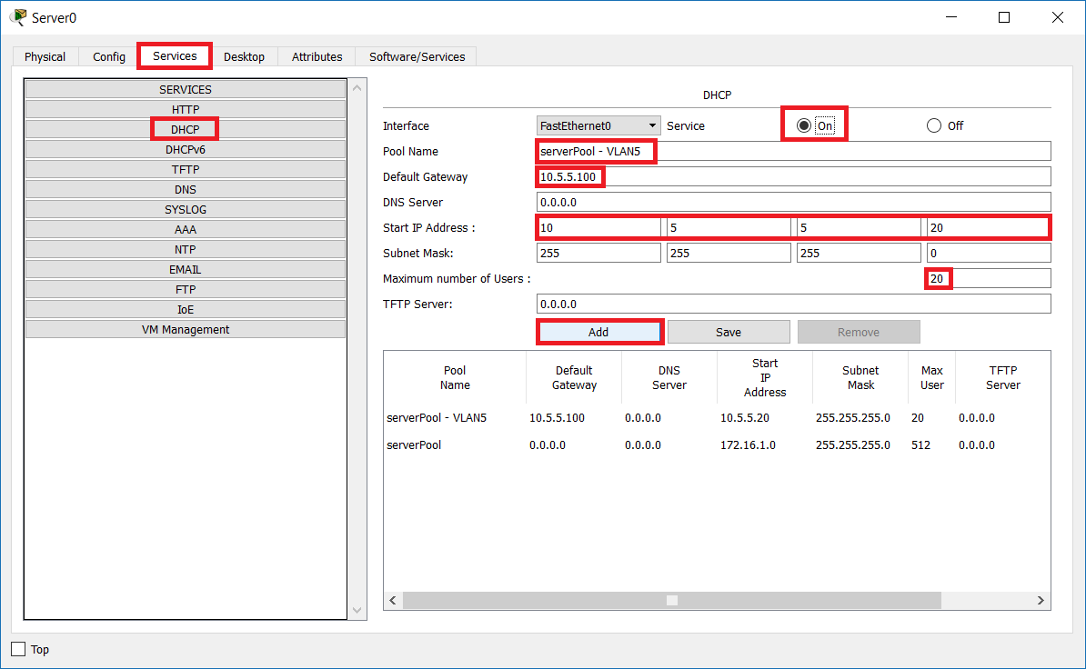

Repeat the process, this time for VLAN6:

* Change the Pool Name to **serverPool - VLAN6**
* For Default Gateway, specify **10.6.6.100**
* For Start IP Address, type **10.6.6.20** (and use 24-bit mask)
* In Maximum number of Users, type **20**
* Click Add

Your configuration should look like this:

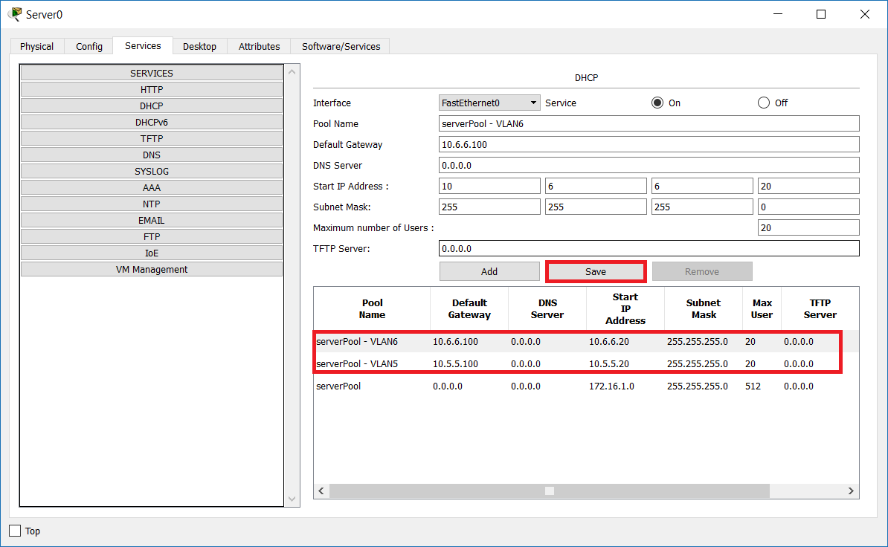

Then click Save

1. Configure the router.

In Router1, put the following configuration. Start from the global config mode

* type **interface g0/0.5** (this goes into the sub-interface)
* type **ip helper-address 172.16.1.2** (this shows where the DHCP server is)
* type **exit**
* type **interface g0/0.6** (this goes into the sub-interface)
* type **ip helper-address 172.16.1.2** (this shows where the DHCP server is)

1. Test the DHCP and the connectivity

In each client, go to the CLI and type **ipconfig /all**. Confirm that you have a dynamic IP address from the DHCP pool and a correct gateway assigned. There are two signs showing that the IP information is from the pool and not statically configured:

* You see 172.16.1.2 in the DHCP Servers section – this proves that the address is dynamic
* The last octet (byte) of the IP address is a number between 20 and 39 – remember that you configured 20 as starting IP and maximum of 20 users

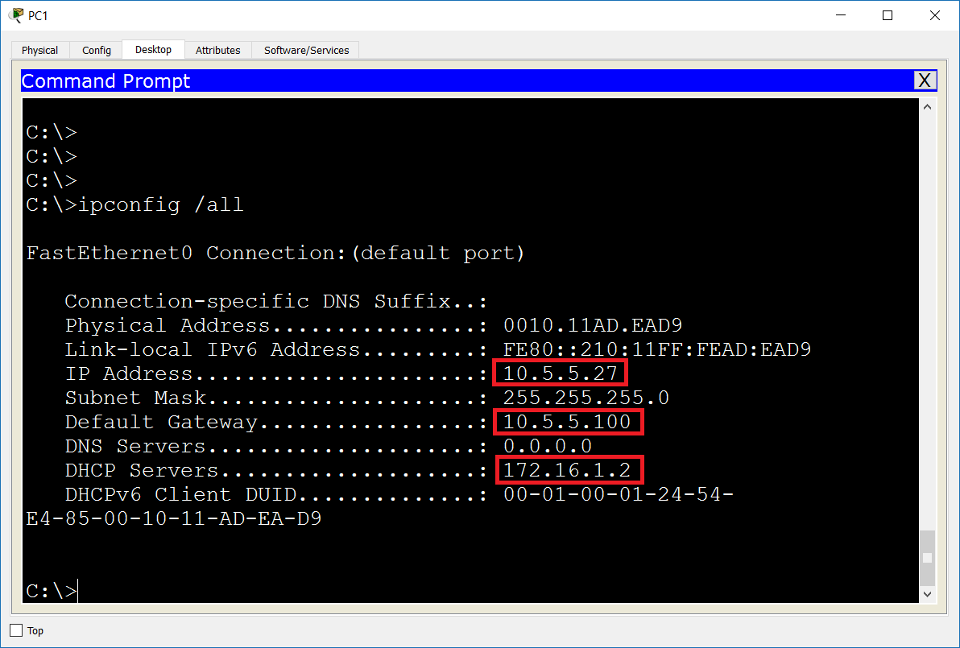

Take any two computers – one from VLAN5 and one from VLAN6, for example PC6 and PC7, check their addresses and ping between them. Note that the devices from each VLAN receive IP address from their corresponding subnet and also each of them receives the correct default gateway – all this information come from the DHCP server. All the pings should be successful.

1. (Optional) Save your topology.

You have completed LAB 5.

# Useful commands for checking your configurations and troubleshooting

* **show ip interface brief** (router or switch command) – check all IP addresses on the device
* **show ip route** (router command) – check the routing table and how each route is learned
* **show interfaces trunk** (switch command) – check which interfaces/ports are configured as trunks (multiple VLANs), which VLANs are allowed, which are actually passing and which is the native VLAN
* **ipconfig** (Windows command) – basic check of the IP parameters
* **ipconfig /all** (Windows command) – detailed check of the IP parameters
* **ipconfig /release** (Windows command) – releases the IP information that was received from a DHCP server
* **ipconfig /renew** (Windows command) – forces the client to start the DHCP discover process and to obtain a new IP information from a DHCP server