Lab 2: Layer 2 technologies advanced

Contents

Introduction to LAB 1 2

Exercise 1: Install H3C Cloud Lab 2

Task 1: Install the H3C Cloud Lab simulator 3

Task 2: Run and test the simulator 3

Exercise 2: Link aggregation (LACP) 3

Exercise 3: Multiple Spanning Tree Protocol 9

Exercise 4: Intelligent Resilient Framework (IRF) 13

Exercise 5: LACP between IRF stack and a standalone switch. LACP MAD 18

Task 1: Create the topology 18

Task 2: Test IRF split stack without MAD (Multi Active Detection) 20

Task 3: Configure LACP MAD 21

Task 4: Test the IRF split stack and MAD 22

# Introduction to LAB 1

In this lab, we are going to use another simulator – **H3C Cloud Lab**. This is a HPE device simulator, which simulates the Comware operating system. With this simulator, you are going to configure link aggregation, spanning tree (MSTP) and device stacking (IRF)

# Exercise 1: Install H3C Cloud Lab

Please read the whole section first (with all updates) before choosing the right simulator for you.

H3C Cloud Lab is a software switch/router simulator and it runs on top of Oracle’s VirtualBox virtualization. That is why, when you start with the installation of H3C Cloud Lab file called “HCL_7.1.59”, it will also install VirtualBox version 4.2.24.   
To easily find the H3C Cloud Lab installation and not to download a different version, go to the respective course page and download it as a resource from there (or ask your instructor where to download it from)

Note: Another tested and working combination is first to install VirtualBox version 5.2.22 and then on top of it HCL_7.1.59. Both of these installations are available for free. If this also does not work, you can try to install first VirtualBox version 4.2.18 and then install the simulator.

Update (29.06.2021): A newer version of the HCL, named “HCL_v2.1.2.1” can also be used. It will automatically install VirtualBox version 6.0.14. Please note, that you have to uninstall previous versions of HCL and VirtualBox prior installing the updated HCL version. It can be downloaded from [here](https://www.h3c.com/en/d_201811/1129464_294551_0.htm) or from the course resources

Update (28.06.2022): The latest version at this moment is “HCL_v3.0.1.1” It still installs VirtualBox version 6.0.14. Please note, that you have to uninstall previous versions of HCL and VirtualBox prior installing the updated HCL version. It can be downloaded from [here](https://www.h3c.com/en/d_201811/1129464_294551_0.htm) or from the course resources

## Task 1: Install the H3C Cloud Lab simulator

When you find and download the correct version, install the **H3C Cloud Lab** simulator. Use the default settings unless you have some special requirements.

Note: Even if it is not required by the setup, you may need to reboot your machine after the installation if you have issues with adding or starting the simulated devices.

## Task 2: Run and test the simulator

Open the **H3C Cloud Lab** and learn how to use it. You can search for a documentation how to use it, but typically, you just need to move/drag devices (switches, routers and other) to the topology area, start them (right click -> Start), connect to the console (right click -> Start CLI) and create connections between them. Note that when you add and start a device it actually runs in **VirtualBox** behind the scenes.

# Exercise 2: Link aggregation (LACP)

1. Using the **H3C Cloud Lab** simulator, move four devices to the topology – two switches and two routers.

Note: With the current version of the simulator (HCL_v3.0.1.1) there are two devices in the Add routers and in the Add switches sections. In this document, we will always use **S5820V2-54QS-GE** for a switch and **MSR36_20** for a router

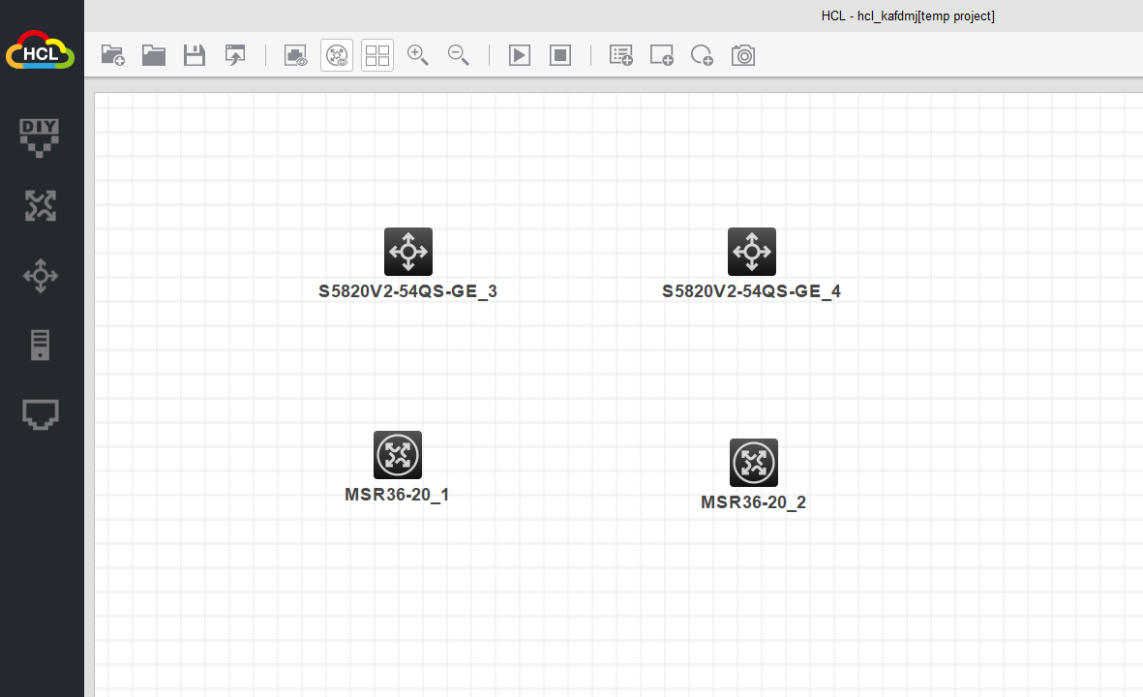

1. Rename the devices (right click -> rename) so the routers become **Host1** and **Host2** and the switches become **SW-1** and **SW-2**. Please note that renaming is possible only when the devices are stopped
2. Use the Add links tool to connect the devices as per the picture below. Use the GigabitEthernet option for the links

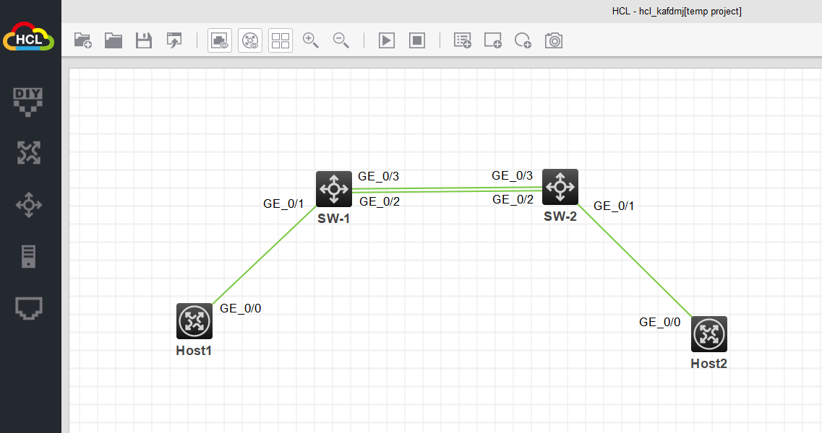

Note: Connect **SW-1** and **SW-2** with two links – they will be used to create the link aggregation group.

Note: You can show/hide the device and interface names by selecting the correct icon



1. Assign IP addresses. Set 10.1.1.1/24 to GE0/0 on **Host1** (which is the first router) and 10.1.1.2/24 to GE0/0 on **Host2** (which is the second router).

To assign an IP address on HPE Comware, use the following commands (the example is for **Host1**):

* From the user view <>, go to system view [], by typing **sys**
* From system view, type **interface GigabitEthernet 0/0**
* If needed, enable the interface by typing **undo shutdown**
* Set the IP address: **ip address 10.1.1.1 24**

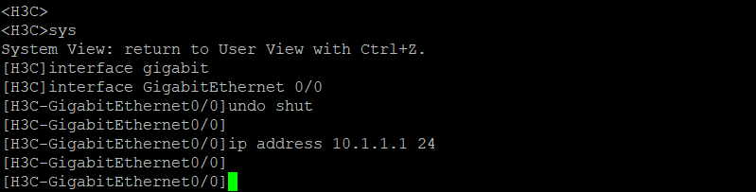

1. Test the connectivity between **Host1** and **Host2** using **ping** – it should succeed
2. Check STP.

**SW-1** and **SW-2** are connected to each other with two links which is a potential loop problem. The good news is that spanning tree is turned on by default so it should have already blocked one of the ports.

To check if STP is working, the port roles and states, who is the Root and other related information, use **display stp** commands. Some of the most useful are:

* **display stp brief**
* **display stp interface [*interface number*]**
* **display stp**

1. Configure link aggregation. We are going to use static LACP (Link Aggregation Control Protocol)

Use the following procedure to create a virtual port for link aggregation and to assign the two physical ports to the newly created virtual one. The example below uses **SW-1** and the two physical ports **GE1/0/2** and **GE1/0/3**:

* **interface Bridge-Aggregation 1**
* **link-aggregation mode dynamic**
* **quit**
* **interface GigabitEthernet 1/0/2**
* **port link-aggregation group 1**
* **quit**
* **interface GigabitEthernet 1/0/3**
* **port link-aggregation group 1**

Note: Believe it or not, the command **link-aggregation mode dynamic** actually configures the virtual port for **static LACP**. This is Comware (HPE) specific terminology and logic. If the mode is configured as “static” (you simply do not type the above command), this means that the virtual port will be configured without any link aggregation protocol.

Use the same procedure to do this for **SW-2**.

1. Check the link aggregation configuration.

There are several useful commands to check link aggregation configuration. One of the most useful is **display link-aggregation verbose**. Several things to note about the output of this command:

* Aggregation mode is **dynamic**. As we already know, this actually means “static LACP” (If the aggregation mode is **static**, this would mean “link aggregation without a protocol like LACP”)
* The individual physical port’s status is **S**, which means selected – this is a good sign that LACP is working properly
* The flags. Typically, when you see the flags **ACDEF** for the physical ports, this means that the static LACP is working properly – not only on our side, but on the remote device as well

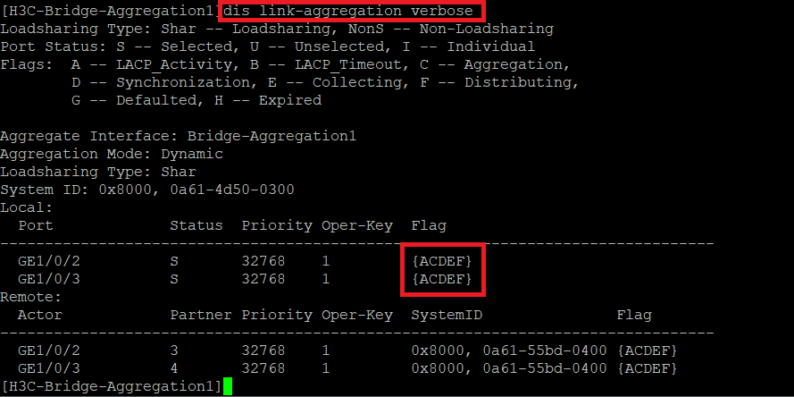

Another useful command to check will be **display stp brief**. If the LACP configuration is working correct, you should see something like the output below – spanning tree does not “see” GE1/0/2 and GE1/0/3 as two individual ports and instead, it “sees” it as one port – the **Bridge-Aggregation1** port.

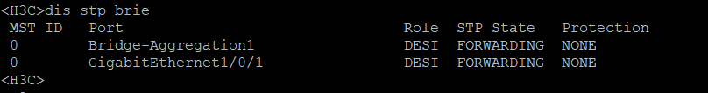

1. Test link failure.

The benefits of link aggregation are two – first, we want to increase the bandwidth and second, we have redundancy in the case of one physical link/cable/port down. This is what we are going to simulate now. To do this, open a continuous ping from **Host1** to **Host1** and then delete one of the links.

You can use **ping -c 1000 10.1.1.2** to initiate ping from **Host1** with 1000 requests to the destination - **Host2**. While the ping is running, try deleting one of the links and monitor the results – the ping should continue to work, you may lose maximum several packets. Then, recreate the link-aggregation by connecting again the second cable, and delete the other one. You should see that the ping does not stop.

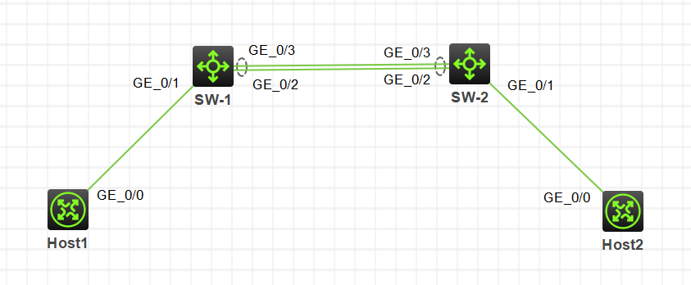

# Exercise 3: Multiple Spanning Tree Protocol

In this exercise, you will have three switches and four VLANs – 5,6,7 and 8. Then, you will create MSTP configuration with two instances – Instance 1 and Instance 2. Each of the instances will be mapped (associated) with two VLANs (Instance 1 to VLAN 5 and VLAN 6 and Instance 2 to VLAN 7 and VLAN 8). Finally, you will make one of the switches Root for Instance 1 and another switch – Root for Instance 2.

1. Create the topology. Move three switches to the topology and using the Add links tool connect them to each other as per the picture below

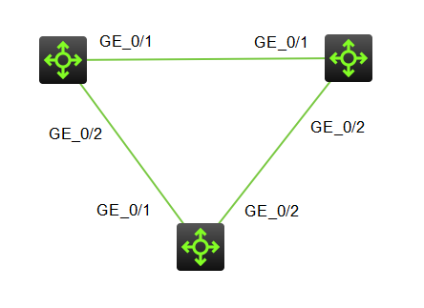

1. Create the four VLANs in each switch. To do this, you have to go first to system view (by typing **sys**) and then use the **VLAN X** command. On each switch check if you have configured all the VLANs by typing **display VLAN**. In the picture below, “5-8” is a range and means that we have all the VLANs

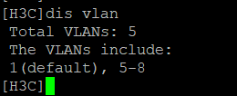

1. Configure the trunk ports.

On each switch, you need to configure the connected ports to be trunk. To do this:

* **sys**
* **interface G1/0/1**
* **port link-type trunk**
* **port trunk permit vlan all**
* **interface G1/0/2**
* **port link-type trunk**
* **port trunk permit vlan all**

1. Look at the STP/MSTP configuration at this moment – each switch is in its own region, because their “Region names” are different (by default this is the MAC address of each switch). Type **display stp region-configuration** on two of the switches (doesn’t matter which two exactly) and you will see the different regions

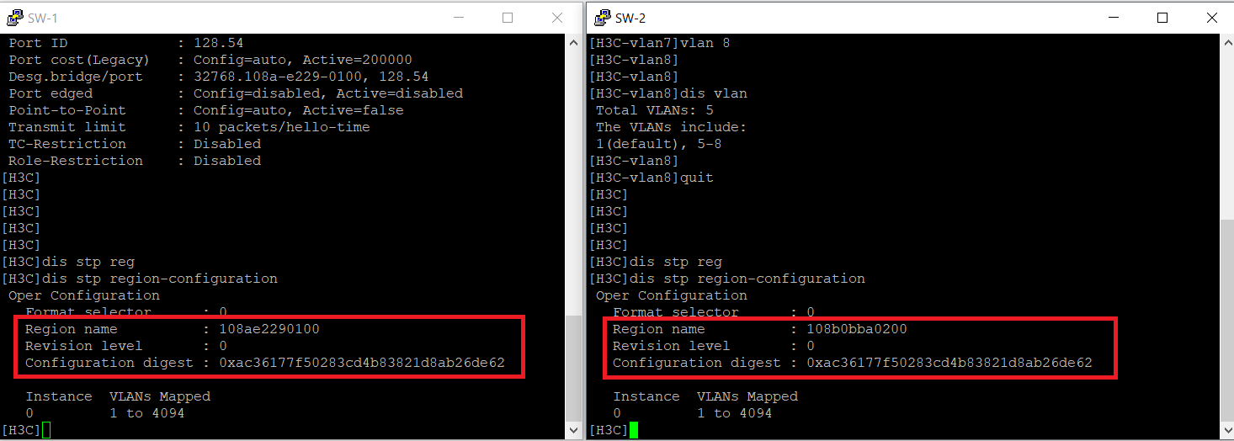

1. Put all three switches in the same region.

Now, for each switch, you need to configure two instances, assign VLANs to them and make them part of the same region by configuring exactly the same the three configuration options:

* Region name
* Revision level
* VLAN to instance mappings (Configuration digest)

On each of the switches, create the following configuration:

**sys** – goes to system view

**stp region-configuration** – enters to MSTP configuration mode

**region-name SoftUni** (this is case sensitive!) – sets the region name

**revision-level 1** – sets the revision level/number

**instance 1 vlan 5 6** – creates Instance 1 and associates VLAN 5 and VLAN 6 to Instance 1

**instance 2 vlan 7 8** – creates Instance 2 and associates VLAN 7 and VLAN 8 to Instance 2

**active region-configuration** – activates the configuration (without this, it will not be applied)

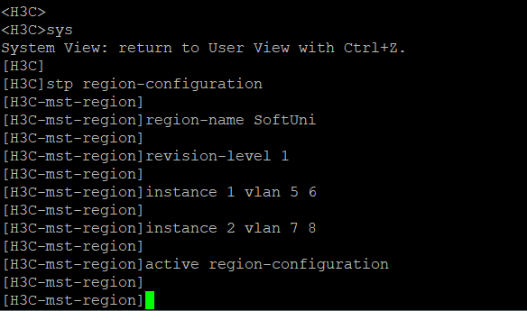

1. Check your MSTP configuration.

Type **display stp region-configuration** on each switch again. This time, the output should be exactly the same on each switch, meaning that they are in the same region.

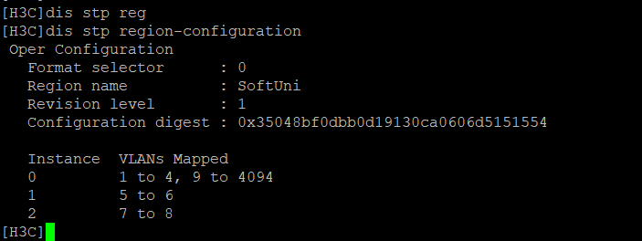

1. Set priorities for the instances.

On the first switch, type:

**sys**

**stp instance 1 priority 0**

On the second switch, type:

**sys**

**stp instance 2 priority 0**

1. Check the roots for the instances.

Now, with **display** commands, confirm that the first switch is Root for Instance 1 (VLAN 5 and VLAN 6) and the second switch is Root for Instance 2 (VLAN 7 and VLAN 8). Also, you can see which ports are forwarding and which are blocked for the particular instance. Use these commands on all switches:

* **display stp instance 1**
* **display stp instance 2**

# Exercise 4: Intelligent Resilient Framework (IRF)

The Intelligent Resilient Framework, or IRF, is a HPE Comware stacking technology. To mention some of the benefits:

* Redundancy
* More physical ports
* Simplicity – a single device to manage
* Efficiency – no blocked ports (like in STP)
* Fast failover

In this exercise, you are going to configure IRF with two switches from the **H3C Cloud Lab** simulator.

1. Create the topology. Move two switches to the topology and using the Add links tool connect them to each other using two Ten-GigabitEthernet connections (remember, 10Gbps is a requirement for IRF)

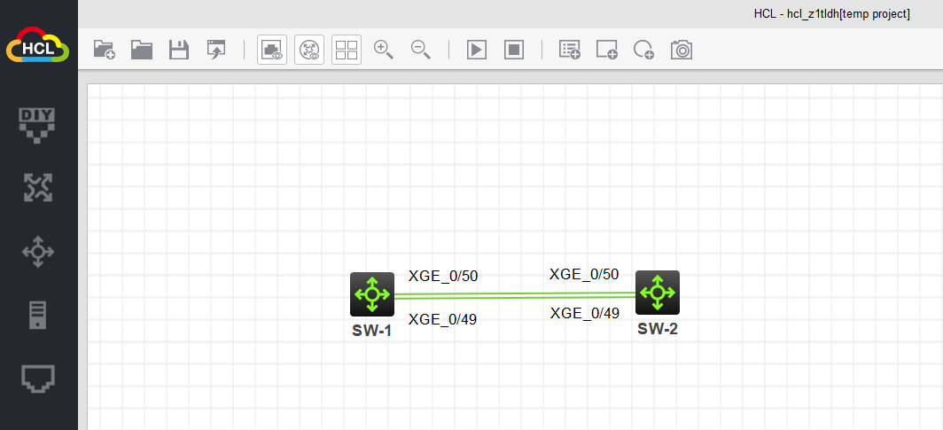

1. Prepare the devices.

Rename the switches to **SW-1** and **SW-2** in the topology (right click -> Rename). Remember, you can do this only if the devices are stopped. Then, go in the device configurations and rename them with the same names (as the names in the topology). To do this, you need to go to system view (type **sys**) and then rename each device by typing **sysname SW-1** (for the first switch) and **sysname SW-2** (for the second switch)

1. Create the IRF configuration.

Below is the step-by-step procedure to configure IRF and to create one virtual device from the two physical switches. The commands are in bold and next to each command is an explanation of what it does. Please note that the order of execution is very important.

You may have different interfaces/ports which you use to connect the switches and that is why we will use **X** and **Y** for the last portion of the interface number:

1/0/X = First ten gigabit interface on switch

1/0/Y = Second ten gigabit interface on switch

SW-1:

**sys** – goes to system view

**irf member 1 priority 32** – sets the highest priority, because we want SW-1 to be the Master

**interface ten-gigabit 1/0/X** – enters into the first physical interface configuration

**shutdown** – shuts down the port

**interface ten-gigabit 1/0/Y** - enters into the second physical interface configuration

**shutdown** – shuts down the port

**quit** – exits the interface configuration mode

**irf-port 1/1** – creates the IRF virtual port and enters to its configuration

**port group interface ten-gigabit 1/0/X** - assigns the physical port to the virtual port 1/1

**port group interface ten-gigabit 1/0/Y** - assigns the physical port to the virtual port 1/1

**quit** – goes back to system view

**save force** – saves the config (at this moment this step is optional)

SW-2:

**sys** – goes to system view

**irf member 1 renumber 2** – changes the Member ID of the second physical switch (this is mandatory, since the Member ID of each switch should be different)

**save force** – this saves the configuration

**quit** – exits and goes to “user” view

**reboot** – changing Member ID requires reboot.

Note: after **SW-2** reboots, type **display interface brief** and pay attention on something important -the interface numbers are now **2**/0/X and not as before – **1**/0/X. This is because the Member ID (which is now **2** on this switch) affects the port numbering.

**sys** – goes to system view

**interface ten-gigabit 2/0/X** - enters into the first physical interface configuration

**shutdown** – shuts down the port

**interface ten-gigabit 2/0/Y** - enters into the first physical interface configuration

**shutdown** – shuts down the port

**quit** – exits the interface configuration mode

**irf-port 2/2** - creates the IRF virtual port and enters to its configuration. Note that port 1 on device 1 should be connected to port 2 on device 2 and that is why we use the 2/2 port on this device

**port group interface ten-gigabit 2/0/X** - assigns the physical port to the virtual port 2/2

**port group interface ten-gigabit 2/0/Y** - assigns the physical port to the virtual port 2/2

**quit** – goes back to system view

**save force** – saves the config (at this moment this step is optional)

Do the following last:

SW-1:

**interface ten-gigabit 1/0/X** - enters into the first physical interface configuration

**undo shutdown** – enables the port

**interface ten-gigabit 1/0/Y** - enters into the second physical interface configuration

**undo shutdown** – enables the port

**quit** – goes back to system view

**irf-port-configuration active** – this activates IRF and the virtual port. Since the configuration on SW-2 is not complete, nothing happens at this time.

SW-2:

**interface ten-gigabit 2/0/X** - enters into the first physical interface configuration

**undo shutdown** – enables the port

**interface ten-gigabit 2/0/Y** - enters into the second physical interface configuration

**undo shutdown** – enables the port

**quit** – goes back to system view

**save force** – this save is very important! Why? Because it is just before the IRF merge and if you do not save here, the following will happen: IRF merge will occur -> the slave/standby member will reboot (this is SW-2) -> it will run with disabled ports -> IRF stack will not work since the members are not connected.

**irf-port-configuration active** - this activates IRF and the virtual port.

Now SW-2 should reboot and after this you should have the IRF stack up and running. How to check this? There are several options:

* **display irf** – you should see the two members with their IDs, roles and MAC addresses, who is the master and to which physical device you are connected
* **display irf topology** – here you can see the topology – which IRF port is connected to which member. This way you can understand if you have daisy chain or ring topology
* **display irf configuration** – here you can see the virtual (IRF) ports to the physical port mappings for each of the members of the stack
* **display interface brief** – this is not an IRF specific command but looking at the number of the interfaces (and their names), you can see that the stack has double number of ports comparing to the single individual device – you can see the 1/0/X ports and 2/0/X ports. And this is true regardless to which physical device you are connected at the moment – they both are part of the IRF stack.

You can do another test – set an IP address, for example on VLAN 1 and then type **display ip interface brief** from each of the members of the IRF stack – you should see the same IP address, because it is actually the same device.

Do not delete the topology, you will need it for the next exercise.

# Exercise 5: LACP between IRF stack and a standalone switch. LACP MAD

In this exercise, we are going to create LACP between the IRF stack (from the previous exercise) and another switch. This configuration can be used to increase the redundancy, and this is enough reason to implement it, but we are going to use it for one more thing – we are going to implement MAD (Multi-Active Detection) using the LACP configuration

## Task 1: Create the topology

1. Add one more switch to the topology and rename it to SW-3
2. Connect **SW-3** to the IRF stack with two links – each link goes to a different member of the stack. Now you can use gigabit connections

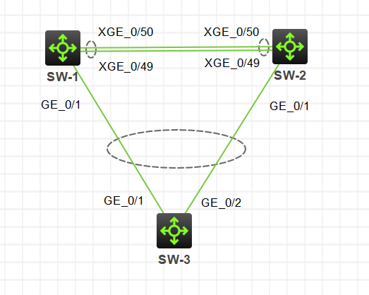

1. Create the static LACP configuration

For **SW-3**, assuming that the connected ports are G1/0/1 and G1/0/2, create the following configuration:

* **system-view**
* **interface Bridge-Aggregation 1**
* **link-aggregation mode dynamic**
* **quit**
* **interface GigabitEthernet 1/0/1**
* **port link-aggregation group 1**
* **quit**
* **interface GigabitEthernet 1/0/2**
* **port link-aggregation group 1**
* **quit**

For the IRF stack device, assuming that the connected ports are G1/0/1 and G2/0/1 (note that these are the first ports from each module), create the following configuration:

* **system-view**
* **interface Bridge-Aggregation 1**
* **link-aggregation mode dynamic**
* **quit**
* **interface GigabitEthernet 1/0/1**
* **port link-aggregation group 1**
* **quit**
* **interface GigabitEthernet 2/0/1**
* **port link-aggregation group 1**
* **quit**

Note that it does not matter from which physical switch (or stack member) you are doing this configuration – in either case you are working on the same virtual device (that is the idea of IRF).

1. Check the LACP configuration.

To check if your configuration is working, use the following commands:

* **display link-aggregation verbose**
* **display stp brief**

The result should prove that LACP is working and spanning tree is not blocking any port.

## Task 2: Test IRF split stack without MAD (Multi Active Detection)

Connect a router (and rename it to **Host1**) to the second member of the IRF stack (not the master). Configure IP address on VLAN 1 on the IRF stack and configure IP address on the **Host1** from the same network (the interface which goes to the stack. Enable it if needed with **undo shutdown**). Then, run a continuous ping from **Host1** to the IRF stack (using **ping -c 1000 *IP_address***). While the ping is running, disconnect/delete the links between the members of the stack (the ten-gigabit links). **Host1** should continue to have successful ping to **SW-2** (which can be a problem, because **SW-1** has the same IP address)

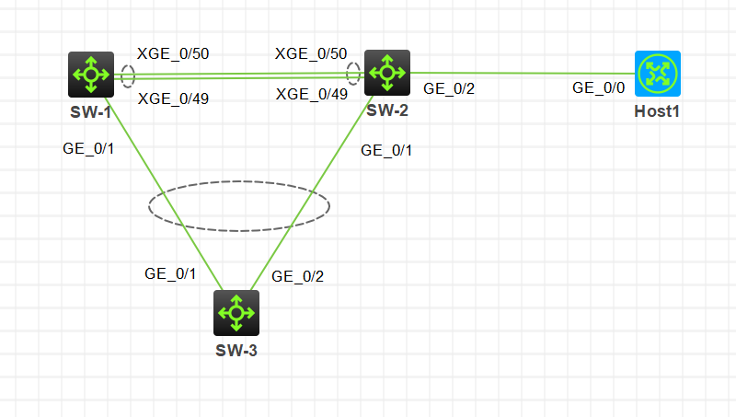

## Task 3: Configure LACP MAD

Now you will create LACP MAD in order to detect split-stack situation in the IRF stack and to automatically disable most of the ports.

First, recreate the connections between the members of the stack (SW-1 and SW-2). When you connect the switches with the two ten-gigabit links (using the same interfaces), the IRF stack will recreate itself and SW-2 will reboot. Wait for SW-2 to reboot and confirm that IRF stack is back on (you can use the **display irf** command on either device)

Create LACP MAD configuration.

On the IRF stack, go to the virtual port (link aggregation) and enable LACP mad:

* **interface Bridge-Aggregation 1**
* **mad enable**

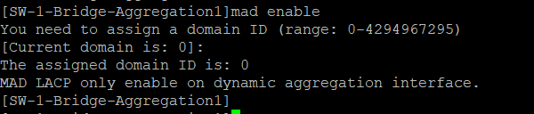

You can check LACP mad configuration with these commands:

* **display mad**
* **display mad verbose**
* Press Enter to assign the default domain ID: 0

## Task 4: Test the IRF split stack and MAD

Repeat the procedure from Task 2 – make a continuous ping from **Host1** to the IRF stack (the IP address in VLAN 1) and in the meantime disconnect/delete the links between the members of the stack. Since LACP MAD is running, it should detect the split stack situation, trigger election process (who will become the “real master”) and disable G2/0/2 (on **SW-2**), so the ping should stop.



After this, you can reconnect the links (the ten-gigabit links) between the members of the stack - **SW-2** should reboot and the IRF stack should be recreated, again.

You have completed LAB 1.