Lab 2: OSPF advanced

Contents

Introduction to LAB 2 2

Exercise 1: Create the topology and assign the IP addresses 2

Exercise 2: Configure OSPF in the autonomous system 5

Exercise 3: Configure external routing protocol and redistribute to OSPF 7

Task 1: Configure OSPF in another Autonomous System (between Router 6 and Router 7) 7

Task 2: Redistribute the external routes to OSPF 8

Exercise 4: Configure stub, totally stubby and not-so-stubby (NSSA) areas 9

Task 1: Configure Area 1 as a stub area 10

Task 2: Configure Area 2 as a totally stubby area 10

Task 3: Configure Area 3 as a NSSA (not-so-stubby area) 11

# Introduction to LAB 2

In this lab, you are going to create multi-area OSPF, redistribution from another autonomous system and from a single static route and finally, you are going to create stub, totally stubby and not-so-stubby (NSSA) areas to filter some of the traffic (LSAs).

Note: Due to the specifics of **Cisco Packet Tracer**, sometimes the neighbor relationships between the routers are not correctly established. To fix this, you can reset the OSPF process by typing **clear ip ospf process** from privileged mode. There are some signs when you need to do it, for example:

* You do not see the routes which you expect to see
* When you type show **ip ospf neighbor**, you see FULL/DROther in the “State column” Since we have only two routers in each segment, they are either DR or BDR, so you typically should not see this

When you do the **clear ip ospf process** command, it is preferred to use it on all routers.

# Exercise 1: Create the topology and assign the IP addresses

1. Create the physical topology

In **Cisco Packet Tracer**, use 2911 routers to create the topology. You will need 8 routers from this type. Connect them as per the picture below. You can use the drawing tools to visually represent the different OSPF areas and autonomous systems that you are going to configure later.

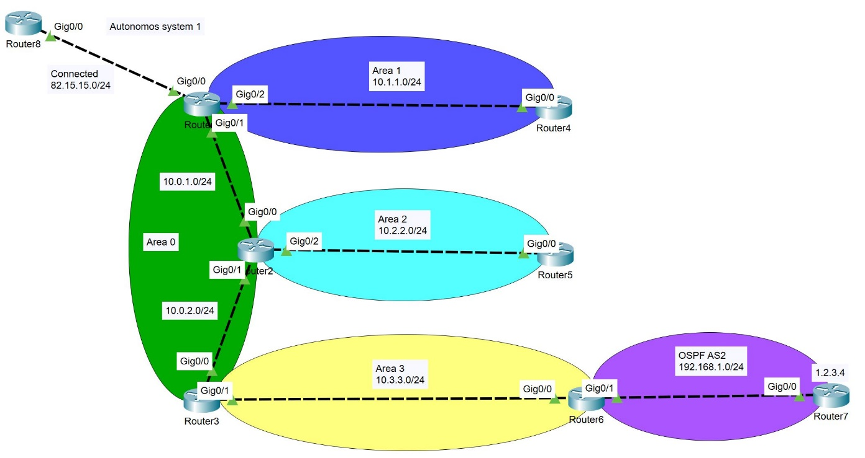

1. Assign IP addresses

In our network, we have 8 routers, 7 subnets and 15 IP addresses.

In the picture above, you can see the different IP networks which you will use. Please note the following explanations about the IP addressing convention:

* All of the networks and IP addresses have /24 subnet masks. The only exception is **Router7**’s Loopback 0 IP address, which is with 32 bit mask.
* The exact IP address on a router’s port has the router’s number in the last octet (byte).

Example for **Router1** IP addresses:

* 82.15.15.1
* 10.1.1.1
* 10.0.1.1

Example for **Router2** IP addresses:

* 10.0.1.2
* 10.0.2.2
* 10.2.2.2

With this in mind, you can only use the picture above to assign all the IP addresses. For more clearness, in the table below you will see all IP address assignments for each interface. Do not forget to enable the interfaces.

Note: You can have different interface numbers/names in your topologies and that is why exact interface names are not mentioned here (like gigabitEthernet 0/0, for example). Instead, we use the “port-to-device” approach which clearly defines it.

|  |  |
| --- | --- |
| Device/Port | IP Address |
| Router1/port-to-Router8 | 82.15.15.1 |
| Router1/port-to-Router2 | 10.0.1.1 |
| Router1/port-to-Router4 | 10.1.1.1 |
| Router2/port-to-Router1 | 10.0.1.2 |
| Router2/port-to-Router3 | 10.0.2.2 |
| Router2/port-to-Router5 | 10.2.2.2 |
| Router3/port-to-Router2 | 10.0.2.3 |
| Router3/port-to-Router6 | 10.3.3.3 |
| Router4/port-to-Router1 | 10.1.1.4 |
| Router5/port-to-Router2 | 10.2.2.5 |
| Router6/port-to-Router3 | 10.3.3.6 |
| Router6/port-to-Router7 | 192.168.1.6 |
| Router7/port-to-Router6 | 192.168.1.7 |
| Router7/Loopback0 | 1.2.3.4/32 |
| Router8/port-to-Router1 | 82.15.15.8 |

To check that your addresses are assigned correctly, and all the interfaces are enabled, test your setup by pinging the directly connected devices from each router.

# Exercise 2: Configure OSPF in the autonomous system

In the fundamentals course, you learned how to configure single area OSPF. Now, we are first going to configure multi area OSPF in a single autonomous system. Area 0, the backbone area, will have **Router1**, **Router2** and **Router3**. Note that they are two subnets in Area 0. You also have 3 more areas, you have external autonomous system (**Router6** and **Router7**) and **Router8**, which will represent just a connected network. Note that when you do the configurations, some of the routers will have their roles, as following:

**Router1** – ABR and ASBR

**Router2** – ABR

**Router3** – ABR

**Router6** - ASBR

Use the following configurations to create multi area OSPF in a single autonomous system:

**Router1**:

* **router ospf 1**
* **router-id 1.1.1.1**
* **network 10.0.1.0 0.0.0.255 a 0**
* **network 10.1.1.0 0.0.0.255 a 1**

**Router2**:

* **router ospf 1**
* **router-id 2.2.2.2**
* **network 10.0.1.0 0.0.0.255 a 0**
* **network 10.0.2.0 0.0.0.255 a 0**
* **network 10.2.2.0 0.0.0.255 a 2**

**Router3**:

* **router ospf 1**
* **router-id 3.3.3.3**
* **network 10.0.2.0 0.0.0.255 a 0**
* **network 10.3.3.0 0.0.0.255 a 3**

**Router4**:

* **router ospf 1**
* **router-id 4.4.4.4**
* **network 10.1.1.0 0.0.0.255 a 1**

**Router5**:

* **router ospf 1**
* **router-id 5.5.5.5**
* **network 10.2.2.0 0.0.0.255 a 2**

**Router6**:

* **router ospf 1**
* **router-id 6.6.6.6**
* **network 10.3.3.0 0.0.0.255 a 3**

At this point, you should have multi area OSPF in a single autonomous system.

When you type **show ip route ospf** on each router, you should be able to see routes to all the networks within the AS (autonomous system). Some of them will be marked as “O”, which means “OSPF intra-area” (inside the area) and some will be marked as “O IA”, which means “OSPF inter-area” (between the areas).

# Exercise 3: Configure external routing protocol and redistribute to OSPF

Now we want to add external routes. For this reason, we will configure another autonomous system.

## Task 1: Configure OSPF in another Autonomous System (between Router 6 and Router 7)

**Router6**:

* **router ospf 2** (note that this is another process for this router)
* **router-id 66.66.66.66** (because it cannot match the router-id in the other process)
* **network 192.168.1.0 0.0.0.255 a 0** (this is the backbone area for the second autonomous system)

**Router7**:

* **router ospf 1** (remember, the process-id does not need to match with the neighboring router)
* **router-id 7.7.7.7**
* **network 192.168.1.0 0.0.0.255 a 0**
* **network 1.2.3.4 0.0.0.0 a 0** (this way **Router7** will advertise its loopback address)

## Task 2: Redistribute the external routes to OSPF

There are two sources (networks) that we can and will redistribute in our main autonomous system – the first one is the OSPF autonomous system 2 (this is the network between **Router6** and **Router7**, let’s call it AS2) and the other is the network between **Router1** and **Router8** – this network is connected for **Router1**.

To redistribute AS2 routes into AS1, go to **Router6** and type the following:

* **router ospf 1**
* **redistribute ospf 2 subnets**

To redistribute the network 82.15.15.0/24 into AS1, go to **Router1** and type the following:

* **router ospf 1**
* **redistribute connected subnets**

Now, each area should have all the routes to the other areas and also the external routes to 82.15.15.0/24, 192.168.1.0/24 and 1.2.3.4/32.

For example, the routes learned by **Router4** (only the OSPF routes) are in the picture below. Note that the 3 external routes are marked as “O E2”.

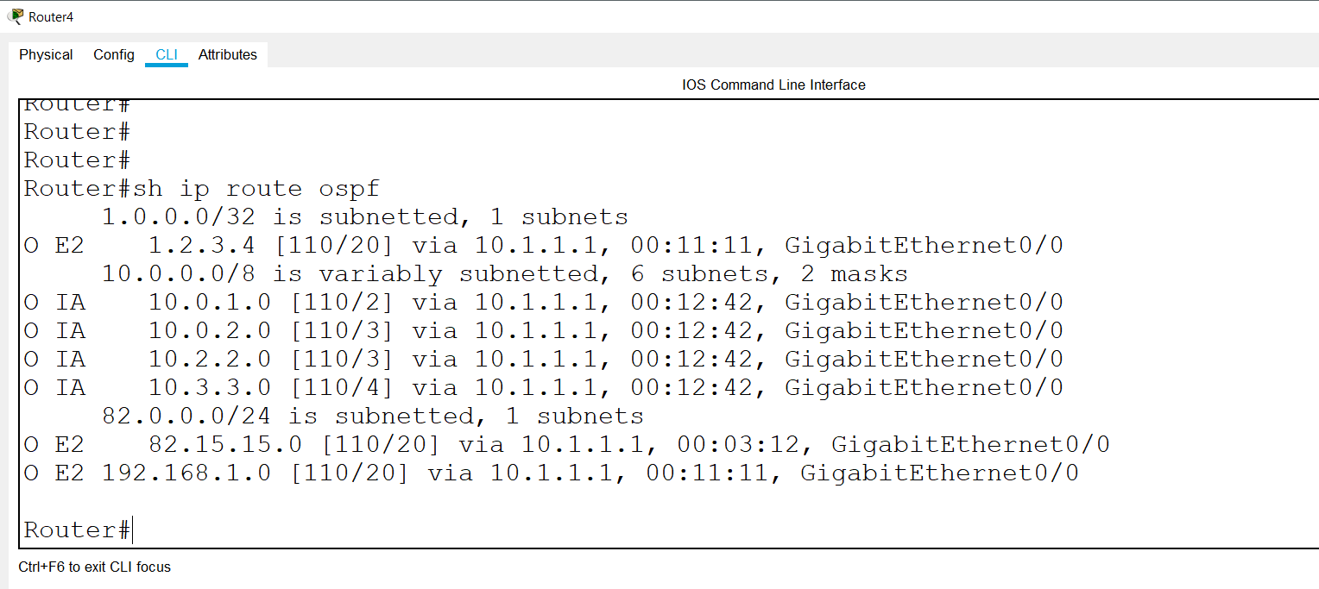

# Exercise 4: Configure stub, totally stubby and not-so-stubby (NSSA) areas

In the previous exercise, you configured multi area OSPF and external routes redistribution. It is good to have all the routing information in details, but sometimes it can become too much for the routers – too many individual entries in the routing tables can overload the devices and impact their performance. That is why we can filter some of the details and summarize information if needed. We are going to create:

* Stub area – the stub area will have all the internal routes (from its own area and from the other areas in the same AS), but will filter the external routes – it will provide a default route to all external networks. This will be area 1.
* Totally stubby area – this area will filter all the routes coming from other areas and all the external routes – it will provide a default route to both of them – the other area’s routes and the external ones. This will be area 2.
* NSSA (Not-so-stubby-area) – this area is interesting. First, it has ASBR (**Router6**) and because of this is connected to external routes. It has all the routes in its AS and it has the external routes from its “local” ASBR. All other external routes (from other ASBRs) are filtered. This will be area 3.

## Task 1: Configure Area 1 as a stub area

On **Router1** and **Router4**, type:

* **router ospf 1**
* **area 1 stub**

The result, from **Router4**:

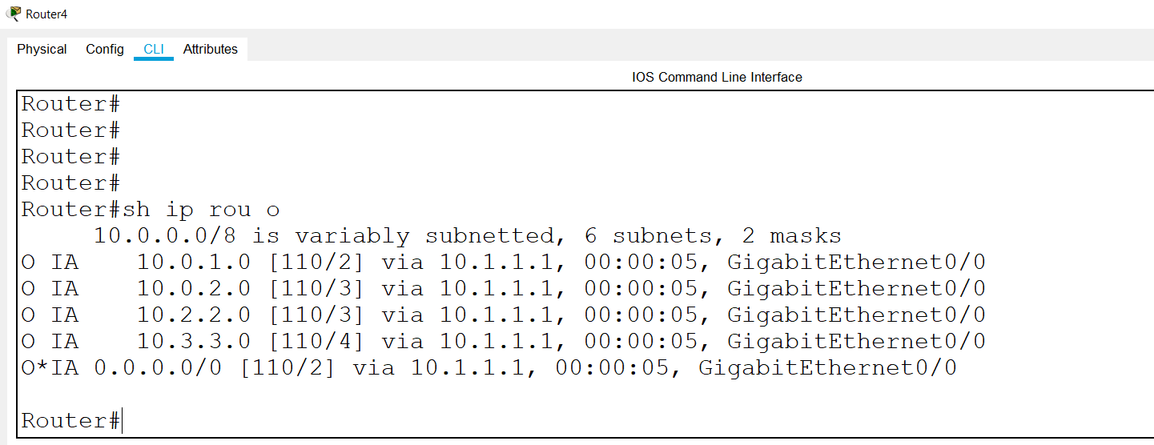

Explanation – we have all the routes in the local AS and we have a default route to the external routes.

## Task 2: Configure Area 2 as a totally stubby area

On **Router2**, type:

* **router ospf 1**
* **area 2 stub no-summary**

On **Router5**, type:

* **router ospf 1**
* **area 2 stub**

The result, from **Router5**:

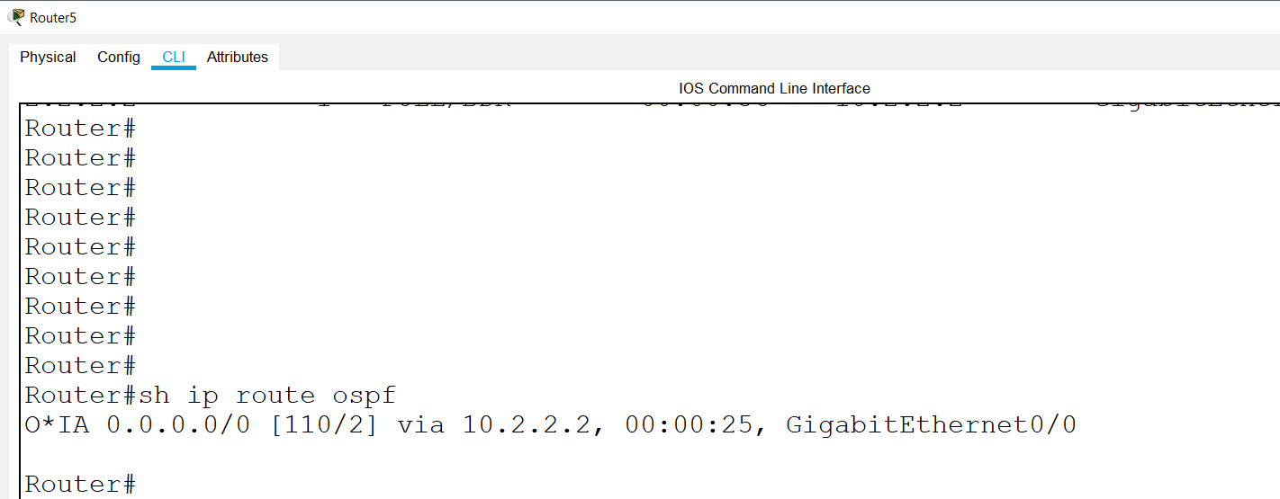

Explanation – we have only the routes in the area (in this case we have zero, because 10.2.2.0 is also local for **Router5** and it is not learned via OSPF) and for the other areas and the external routes – we have a default route.

## Task 3: Configure Area 3 as a NSSA (not-so-stubby area)

On **Router3** and **Router6**, type:

* **router ospf 1**
* **area 3 nssa**

The result, from **Router6**:

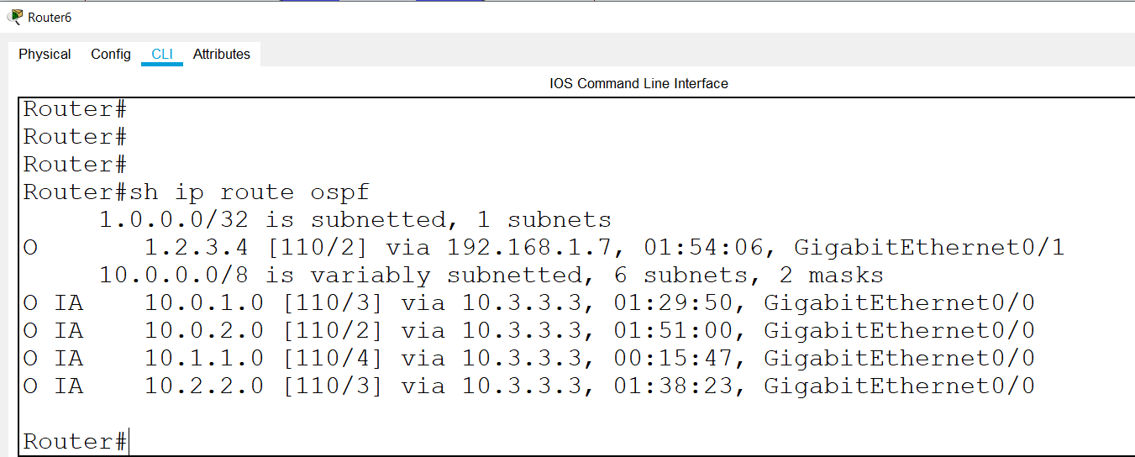

Explanation – we have all the routes to the different areas in the AS and we have the external routes provided by our local ASBR (in this case, the same router). But we do not have the routes from the other ASBRs (in this case, we do not have a route to 82.15.15.0/24)

You have completed LAB 2.