Using Mininet and Miniedit

This document describes the general steps which needs to be done in order to install Mininet, an SDN simulator, and use it with Miniedit, the Mininet’s GUI.

1. Install VirtualBox (or other virtualization which can run vmdk disk files)
2. Download Mininet - <https://github.com/mininet/mininet/wiki/Mininet-VM-Images>
3. Install Mininet – just create a new VM inside VirtualBox/VMware and during the wizard, in the “hard disk” section, select the Mininet’s disk (a vmdk file)

Note: At this point, you have Mininet installed and can work with it using a CLI. If you want to use a GUI and see and create topologies with different devices using a graphical interface, you need Miniedit. Miniedit is pre-installed inside Mininet. If your host OS is Windows and your Mininet is installed inside a VM, then to run Miniedit, you need a X11 display server for Windows software, like Xming.

1. Download and install Xming - <https://sourceforge.net/projects/xming/> (or find a different source)
2. Make your VM (with the Mininet installation) visible (pingable) from the host. To do this, attach to the VM a “Host-only adapter”

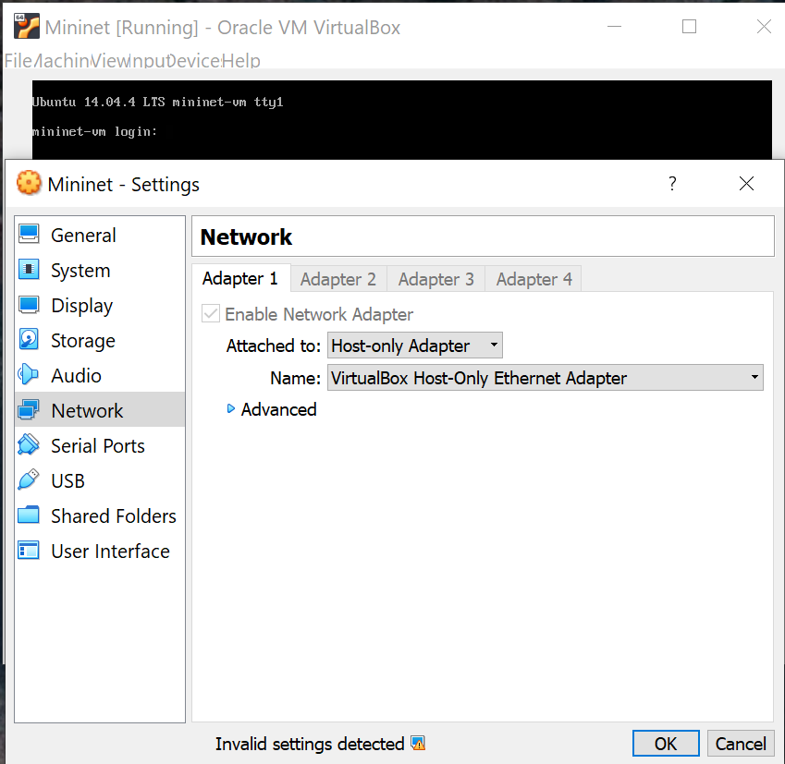

1. Start your Xming server on the host OS
2. Using PuTTY, open an SSH connection from your host to your Mininet VM. Before connecting to it, enable the X11 forwarding (this is for Miniedit) under the SSH settings

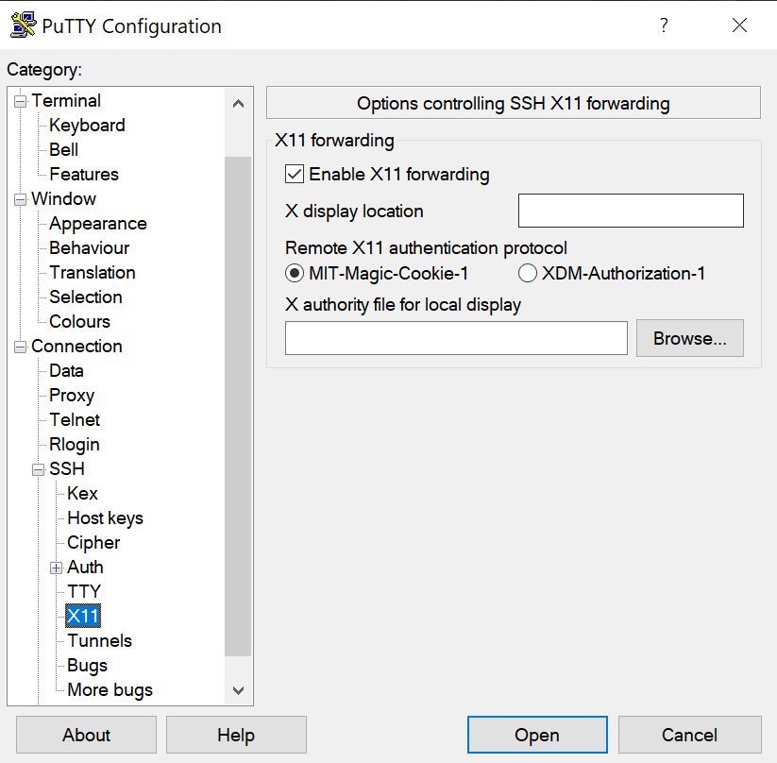

1. Connect via SSH and login with “mininet” as both username and password

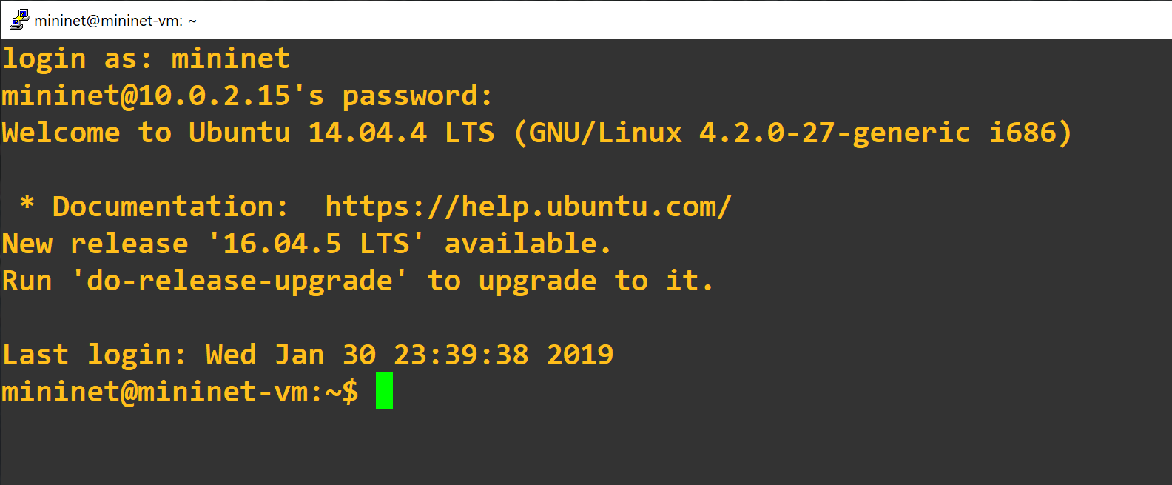

1. Start Miniedit by typing:

sudo ~/mininet/examples/miniedit.py

Note: If you see errors end Miniedit is not launching, you can fix it with the following command: sudo cp ~/.Xauthority ~root/

The result should be that Miniedit launches and you can work now with the GUI:

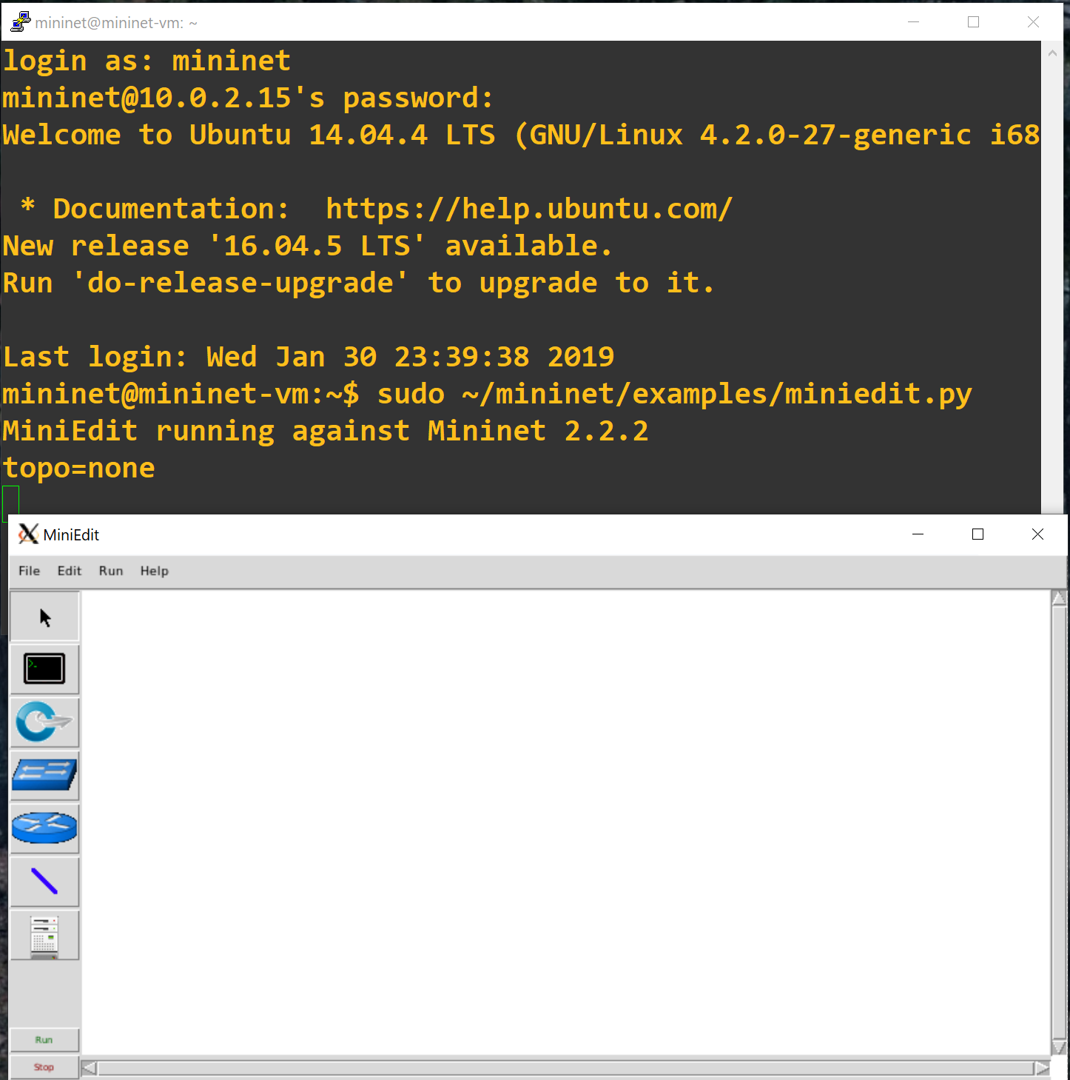

**Some example commands:**

* Mininet> nodes
* Mininet> net
* Mininet> h1 ifconfig -a
* Mininet> s1 ifconfig -a
* Mininet> h1 ps -a
* If you see an error like “Error creating interface pair (h1-eth0,s1-eth1)”, then make “sudo mn -c” to remove the previous topology

**Useful URLs:**

* <http://www.brianlinkletter.com/mininet-test-drive/>
* <http://www.brianlinkletter.com/set-up-mininet/>
* <https://www.brianlinkletter.com/how-to-use-miniedit-mininets-graphical-user-interface/>