# ***App Tutorial: Project***

When you open a project by creating a new project you will get a popup menu that looks like this:

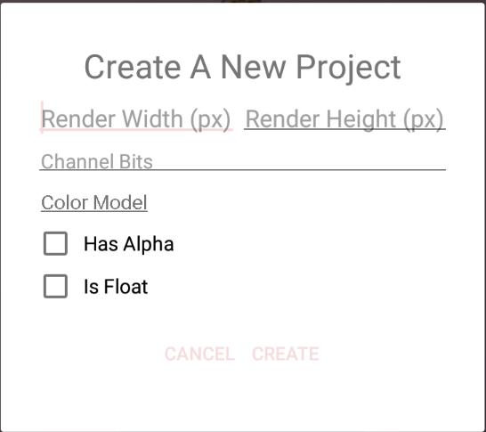

Each option changes to type of picture you will create:

Render width and height: The resolution of the image in pixels.

Channel Bits: How many bits each color channel holds (1 bit is 0 or 1, 2 is 0-4, 4 is 0-16, 8 is 0-256, 16 is 0-65536 and ect…).

Color Model: The type of rendered color. Can be:

Gray – One color channel, the color is between white and black.

RGB – Three channels. Red, green, and blue.

HSV - Three channels. Hue (Color), saturation (the intensity of the color) and value(brightness).

CMYK – Four channels. Cyan, magenta, yellow and key(black). Unlike RGB, all first three channels have to be 0 is order for the color to be white (unless key is also 0).

Has Alpha: Adds an additional color channel that affects the invisibility of each pixel.

Is Float: Instead of a whole number, you could use a number that ranged between 0 to 1 for each pixel.

After the creation of your sketch, you will get three windows:

Script: The main screen, here you write the code and execute it.

Render: Here you will get the resulting Image.

Error: If something went wrong, you would get and error message here.

After you write the code and execute it. You can share your project. If you want to share it via WhatsApp, email etc. you can press on the “Share” and select your social media of choice.

If you want to save your project you have to press on the “Share to Galley” button and the project will be saved in your personal gallery.

To publish it, you must enter the gallery and press on your project in the “My Projects” category that you can access by pressing it on the top left section. After you will press the project you can press publish to publish it to the public gallery, delete for deleting your project and edit for edit the project.

If you want to see other’s people project you must open on of these options:

New Projects: Most recently uploaded projects.

Top Projects: Most high voted projects.

Hot Projects: Most viewed projects.