Southwest University

“Security in Computing”
Experiment Report

School：School of Computer & information Science
Major：Software engineering
Class： SE3
Name: 舒航
Student Number： 222019321062076
Experiment Report 1
- Objective：
- Understand the functions and types of firewalls.
- Flexible use of firewalls to close software, ports, ping links.
二、Detailed requirements：
- Restrict network access to specified applications.
- Restrict network access to specified ip addresses.
- Restrict network access to designated ports.
- ping prevention.
- Procedure:
Ex1:
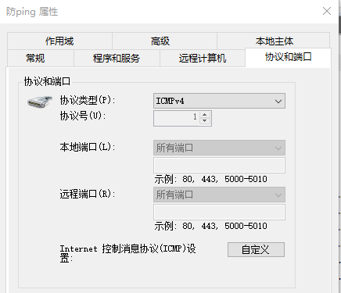
Ex2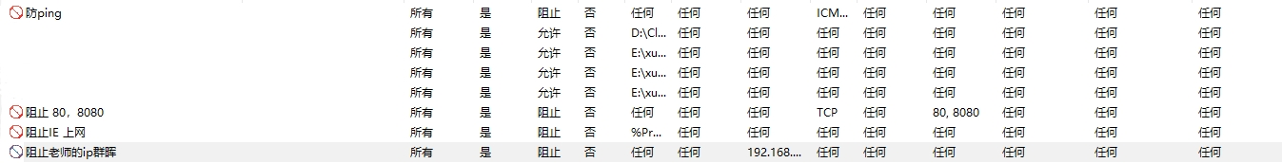:
Ex3: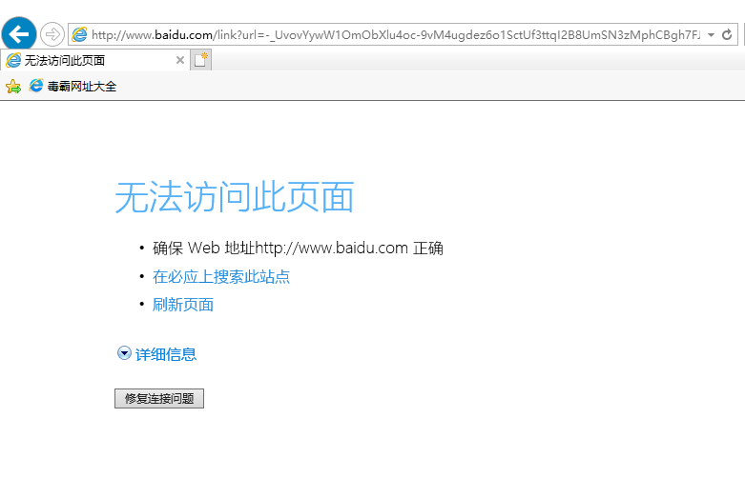
Ex4:
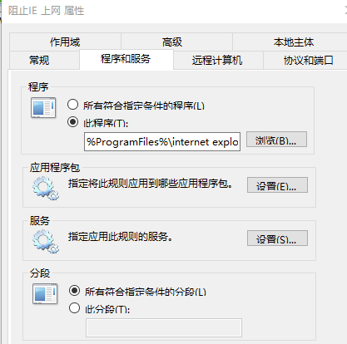
Ex5:
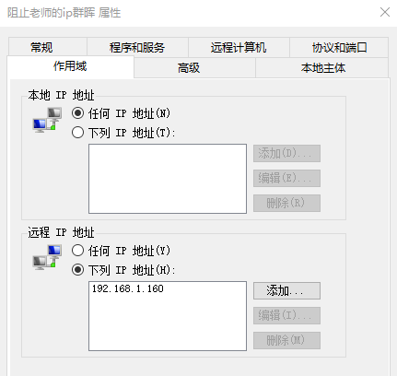
Ex6:
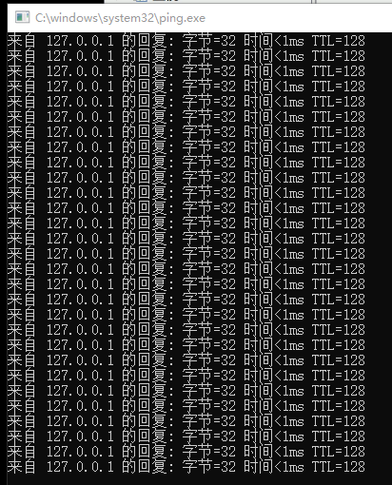
四、Analysis：
I understand that firewall technology is a variety of security management and screening of software or hardware equipment organically combined, to establish a relatively isolated protection barrier, to protect user data and information security of a technology. A firewall is deployed as a network communication line between the user's own equipment, system, and the external network. Firewalls are divided into hardware firewalls and software firewalls. And through learning to set up the corresponding software to update the Windows firewall, IP address, specific port, ping(to prevent external invasion) and other security measures to better understand the Windows system and my own computers.

