Southwest University

“Security in Computing”
Experiment Report

School：School of Computer & information Science
Major：Software engineering
Class： SE3
Name: 舒航
Student Number： 222019321062076
Experiment Report 1
- Objective：
- Discover web-based system security vulnerabilities and risks.
- Download and learn about the software used for external and internal scanning.
二、Detailed requirements：
- Through specific software, when entering certain web pages, the external network for external scanning and internal scanning in the internal network, so as to find vulnerabilities.
三、Result：
扫描网站：www.dota2.com.cn/
扫描结果示意图：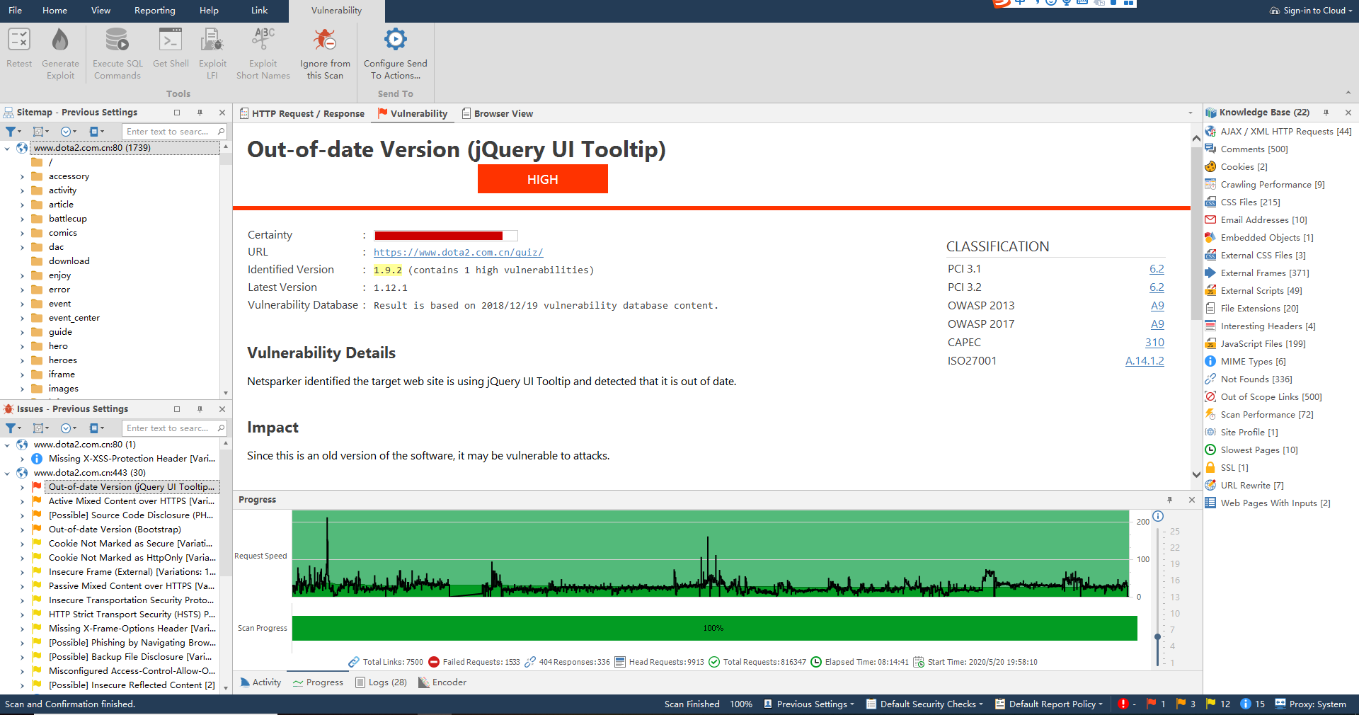
该软件将发现的问题进行归类，红色为高风险，橙色为中风险，黄色为低风险,然后为不确定风险。每个问题点进去可以知道里面的详细内容。
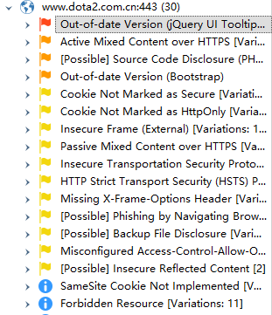
四、Analysis：I learned how to independently use netsparker to scan a website that I wanted to scan, analyze the data after getting it, find the website's vulnerabilities and categorize them. This will help me a lot when I write my own website in the future.

