Southwest University

“Introduction to Web Development” Experiment Report

School：School of Computer & information Science
Major：Software engineering
Class： 软工3班
Name: 舒航（Jerry）
Student Number： 222019321062076
Experiment Report 3
一、Objective：
- Master the use of CSS.
- Use div and CSS to optimize the corresponding webpage.
二、Detailed requirements：
- Review HTML and CSS content and get familiar with them .
- Start by writing the content of the web page in HTML. Use the
<div> tag to turn the sections into a box and name each box.
- CSS uses hover and selects the color so that when the cursor is placed in the box area, the area changes color.
- Div img sets the image width and height.
- ".Box name "to sets various properties of the box.
- Use floats to make several boxes side by side.
- Use margins to create gaps between columns.
<!doctype html>
<html>
<head>
<meta charset="utf-8">
<title>舒航电影网</title>
<link rel="stylesheet" type="text/css" href="css.css">
<style type="text/css">
body{color:aqua;
background: url(森林.jpg);
font-family: 隶书;宋体,楷体;
font-size:20px;
margin:0px;
text-align: center
}
a{text-decoration: none;
color:#118AEF;
font-size: 25px;}
a:hover{color:darkgrey;}
p{color:mediumblue;
text-decoration: none;
margin:0px auto;}
.header{font-size: 50px;
margin:10px auto;
color:#5287F7;
font-family:华文琥珀;宋体,楷体;
cursor: auto;
position:relative;
height: 70px;}
.wrapper{width:960px;
margin:0px auto;
text-align: center;}
.movie{width:320px;
border-bottom: 1px solid #C64BFB;}
img{width:300px;height:400px;
margin: 10px auto;}
}
</style>
</head>
<div class="container_12"><p class="header">→SH每日电影资讯←</p>
</div>
<div class="wrapper container_12">
<div class="grid_6"><a href="双子杀手.html"><img src="双子杀手.jpg"></a><p><a href="双子杀手.html">双子杀手</a></p><p class="movie">导演: 李安<br/></p><p class="movie">主演: 威尔·史密斯 / 玛丽·伊丽莎白·温斯特德<br/> / 克里夫·欧文 / 本尼迪克特·王</p></div>
<div class="grid_6"><a href="终结者：黑暗命运.html"><img src="终结者：黑暗命运.jpg" ></a><p><a href="movie/plane.html">终结者：黑暗命运</a></p><p class="movie">导演: 蒂姆·米勒</p><p class="movie">主演: 阿诺·施瓦辛格 / 琳达·汉密尔顿 / 麦肯兹·戴维斯 <br/>/ 娜塔利娅·雷耶斯 / 加布里埃尔</p></div>
<div class="grid_6"> <a href="沉睡魔咒2.html"><img src="沉睡魔咒2.jpg" ></a> <p><a href='沉睡魔咒2.html'>沉睡魔咒2</a></p><p class="movie">导演: 乔阿吉姆·罗恩尼</p><p class=movie>主演: 安吉丽娜·朱莉 / 艾丽 <br/>米歇尔·菲佛 / 萨姆·赖利 </p></div>
<div class="grid_6"><a href="天气之子.html"><img src="天气之子.jpg" ></a><p><a href="天气之子.html">天气之子</a></p><p class="movie">导演: 新海诚</p><p class="movie">主演: 醍醐虎汰朗 / 森七菜 / 小栗旬 / 本田翼 / 倍赏千惠子</p></div>
<div class="container_12">
<div class="grid_5">&nbsp;</div><div class="grid_7"><div class="footer clearfix">
<a href="https://movie.douban.com/" target="_blank">更多详细资讯：豆瓣电影</a>
<br/><a href="http://email.swu.edu.cn/" target="_blank">如若有任何意见提出，欢迎点击此处：</a></div></div></div>
</body>
</html>

Result：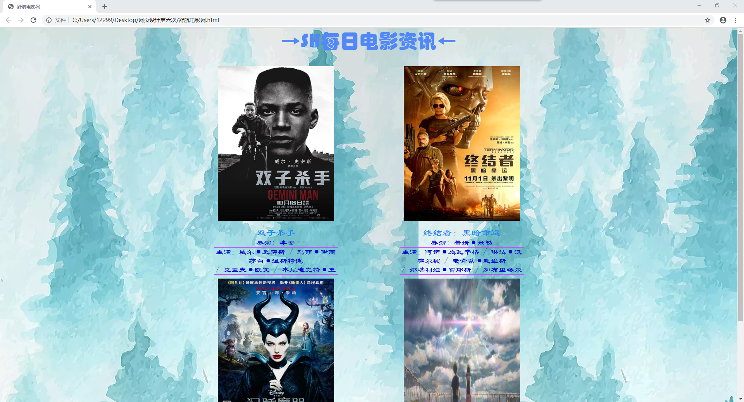
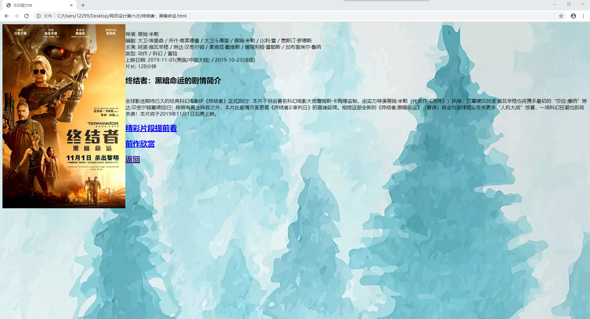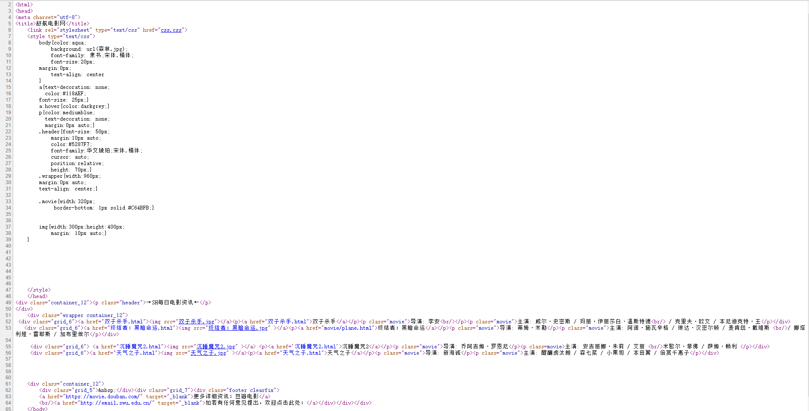
- Analysis：
- Be clear about what each label does and what it means
- Before making web pages, I will first conceive the images I may need and put them into folders, so as not to change the position of the images and sub-pages after the web pages are finished and the original code cannot display the desired content.
- Understand how to use CSS rules to control the style and layout of a page, such as controlling text colors and fonts, setting font sizes, adding background images, and controlling the position of elements on the screen.
- Pay special attention to the size, name, and location of the box.

