Southwest University

“Introduction to Web Development” Experiment Report

School：School of Computer & information Science
Major：Software engineering
Class： 软件工程3班
Name: 舒航
Student Number： 222019321062076
Experiment Report 1
一、Objective：
- Mater the usage of table and form element
- Apply these elements to the website construction
二、Detailed requirements：
- Create table
- Represent complex data in tables
Ex1：Revise the pages of Ex1 to Ex4 last week (show the content in tables).
- Different kinds of form controls
- New HTML5 form controls
- Ex2：Design a page for collecting personal information. This experiment require user to provide information as follows: name, username, password, sex, birth date, Email, mobile phone, ID card number, interest(multiple-choice), remark, etc. Notice: use all controls as possible, and make your pages more beautiful.
- Procedure:
Ex 1: <title>舒航电影表格</title>
<style type="text/css">body {background-image:url(森林.jpg);background-size: cover}</style>
</head>
<body> <P align="center"><font size="+4">→SH每日电影资讯←</font></P>
<table width="1109" border="20" cellspacing="8" cellpadding="2" align="center">
<tr>
<th width="89" scope="col">&nbsp;</th>
<th width="46" scope="col">双子杀手</th>
<th width="129" scope="col">终结者：黑暗命运</th>
<th width="129" scope="col">沉睡魔咒2</th>
<th width="129" scope="col">天气之子</th>
</tr>
<tr>
<thscope="row"></th>
<td><div align="center">图片介绍</div></td>
<td><a href="双子杀手.html"><img src="双子杀手.jpg" width='250' height=375 title='双子杀手'/></a></td>
<td><a href="终结者：黑暗命运.html"><img src="终结者：黑暗命运.jpg" width='250' height=375 title='终结者：黑暗命运'/></a></td>
<td ><a href="沉睡魔咒2.html"><img src="沉睡魔咒2.jpg" width='250' height='375' title='沉睡魔咒2'/></a></td>
<td><a href="天气之子.html"><img src="天气之子.jpg" width='250' height='375' title='天气之子'/></a></td>

</tr>
<tr>
<td><div align="center">主演</div></td>
<td>主演: 威尔·史密斯 / 玛丽·伊丽莎白·温斯特德 / 克里夫·欧文 / 本尼迪克特·王 / 道格拉斯·霍奇斯</td> <td>主演: 阿诺·施瓦辛格 / 琳达·汉密尔顿 / 麦肯兹·戴维斯 / 娜塔利娅·雷耶斯 / 加布里埃尔·鲁纳</td> <td>主演: 安吉丽娜·朱莉 / 艾丽·范宁 / 米歇尔·菲佛 / 萨姆·赖利 / 哈里斯·迪金森</td> <td>主演: 醍醐虎汰朗 / 森七菜 / 小栗旬 / 本田翼 / 倍赏千惠子</td>
</tr>
<tr>
<td><div align="center">内容简介</div></td>
<td>…</td>
<td>…</td>
</tr>
<tr>
<td height="25"><div align="center">上映时间</div></td>
<td rowspan="2" align="center">2019-10-18(中国大陆) / 2019-10-11(美国)</td>
<td rowspan="2" align="center">2019-11-01(美国/中国大陆) / 2019-10-23(法国)</td>
<td rowspan="2" align="center"> 2019-10-18(美国/中国大陆)</td> <td>2019-11-01(中国大陆) / 2019-07-19(日本)</td>
</tr>
</table>
<h2>更多详细资讯：<a href="https://movie.douban.com/" target="_blank">豆瓣电影</a></h2>
<h2>&nbsp;&nbsp;&nbsp;&nbsp;&nbsp;&nbsp;&nbsp;&nbsp;&nbsp;&nbsp;&nbsp;&nbsp;&nbsp;&nbsp;&nbsp;&nbsp;&nbsp;&nbsp;&nbsp;&nbsp;&nbsp;&nbsp;&nbsp;<a href="https://maoyan.com/" target="_blank">猫眼电影</a></h2>
<h2>如若有任何意见提出，欢迎点击此处：<a href="http://email.swu.edu.cn/" target="_blank">编者邮箱</a></h2>
</body>
Ex 2: <body bgcolor="#509B0C">
<font color="#FDFDFD">
<P align="center"><font size="+2">校园网注册</font></P>
<form method="post" action="您已成功提交！.html">
<p>用户名:<input type="text" name="用户名" /></p>
<p>密码:<input type="password" name="密码" size="22" maxlength="18" /></p>
<p>性别:<input name="性别" type="radio" />男<input name="性别" type="radio" />女</p>
<p>爱好:<input name="爱好" type="checkbox" />羽毛球<input name="爱好" type="checkbox" />篮球<input name="爱好" type="checkbox" />游泳<input name="爱好" type="checkbox" />长跑<input name="爱好" type="checkbox" />足球<input name="爱好" type="checkbox" />其他<input type="text" name="其他" size="10" maxlength="10" /></p>
<p>省份
<select name="省份" size="3">
<option value="四川">四川</option>
<option value="浙江">浙江</option>
<option>广东</option><option>湖南</option><option>湖北</option><option>吉林</option><option>广西</option><option>福建</option><option>西藏</option><option>北京</option><option>天津</option><option>上海</option><option>河北</option><option>河南</option><option>辽宁</option><option>黑龙江</option><option>江苏</option><option>安徽</option><option>海南</option><option>贵州</option><option>山西</option><option>陕西</option><option>云南</option><option>江西</option><option>山东</option><option>甘肃</option><option>青海</option><option>新疆</option><option>宁夏</option><option>香港</option><option>台湾</option><option>澳门</option></p>
<option selected>重庆</option></form></select>
<p>上传图片:<input type="file" /></p>
<p>评论与建议:<textarea rows="8" cols="50"></textarea>
<input type="hidden" value=""></input>
<input type="submit" value="提交" /><input type="reset"></p>
</body>
Result：Ex1：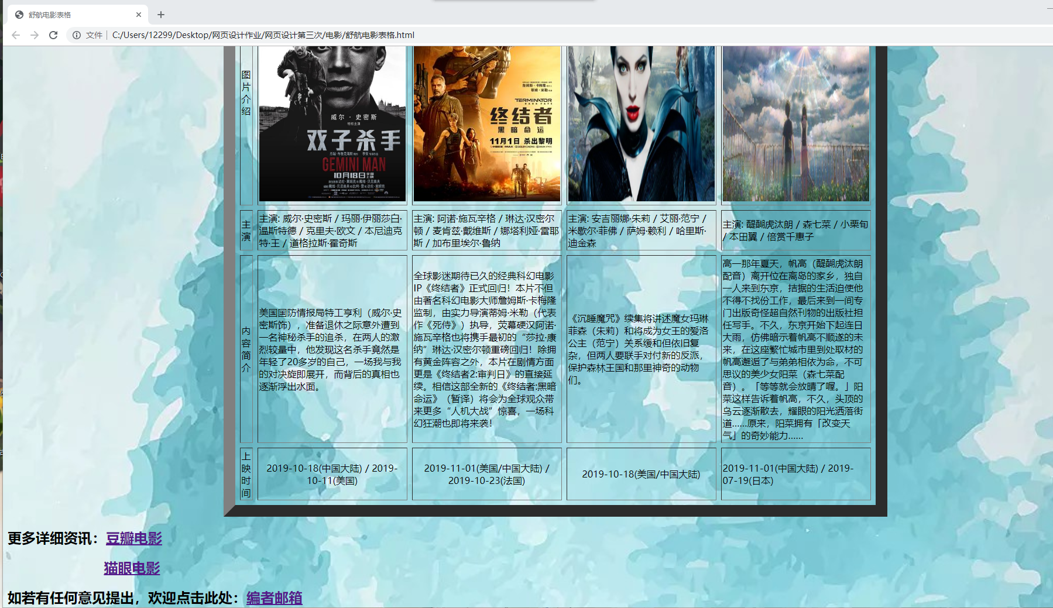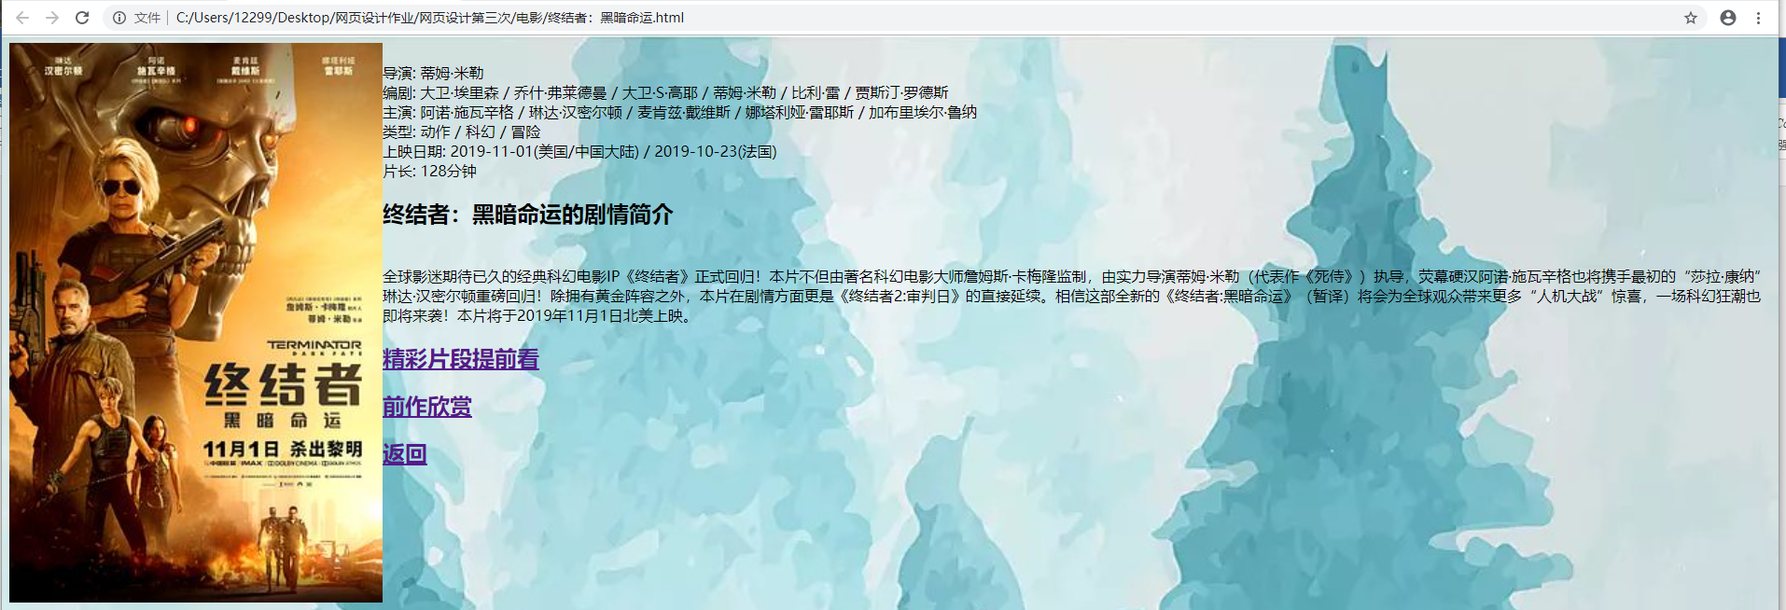 Ex 2：

- Analysis：
Ex1:Through this exercise homework , I learned how to use tables,how to insert pictures which can link to another brand new webpage, and how to layout the table into a beautiful and uniform format.Also I enjoy the process not only can I learn knowledge about HTML but also learn about the movies that interest me.
Ex 2: From this task, I have known the principle of registration interface which we use a lot but ignore,and how to hide passwords when user is inputing.And the skill to make parallel choices to be chose from.the only one thing I am not familiar with is how to limit the size of any input box.
Total:With the two exercises,I learned much about how to make a table and a form .Every matter needing attention I have tried again and again and have summed up my own experience. Although they contained little information,I can make them better through the further study. I believe I can do better in the next excel.

