**Mid-term Exam--Writing Assessment Answer Sheet**

**University**: SWU西南大学__________________________________________________________________

**Major:** SE软件工程

**Cohort & Class**: SE3

**Name**: 舒航Jerry

**Student No**. 222019321062076

**Teacher:** Cindy

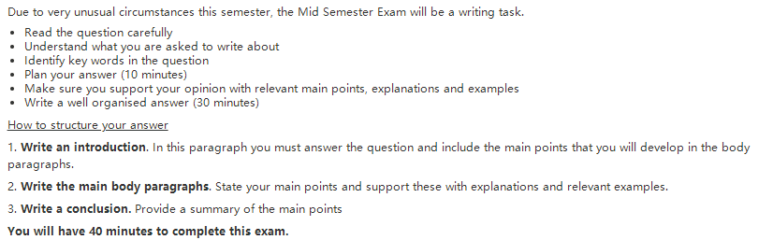

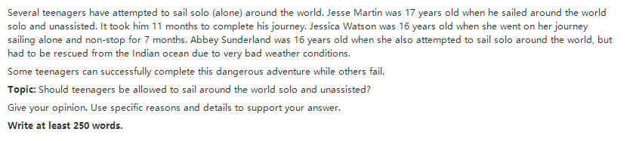

You will have 40 minutes to complete this exam.

Please write your essay here:

In my opinion, it is unnessarry and dangerous for teenagers to sail around the world solo and unassisted. Here are some ideas below.

Firstly ,sailing around the world solo is not something easy like cooking .It's an extreme sport .Actually when there are many people take part in and enjoy the sport , there are also many people lose their life forever in the sea due to some bad conditions .And they have been trained for a long time , spending a lot of money and energy to prepare for it. Also you need the nessarry knowledge to save yourself when you get in trouble. Obviously the teenagers don’t have the experience much like adults. As you can see, some of teenagers can sail alone for months, but they may need the support from adult eventually because of the lack of ability and knowledge.

What’s more ,teenage is the most important period to learn the knowledge to improve the sight and mind .Some people may say that children can be practiced and make more friends during the sailing alone .But every coin has two sides .It is too dangerous .Studying in the class room with classmates peacefully also can reach the goal .There is a Chinese proverb saying that ”you need to read thousands of books before you travel thousands of miles”. It is not too late to realize the dream after hard-work learning.

Last but not the least, the extreme sport may cause really bad hurt and affect teenagers’ growing. As their body are not strong like adults’.

Although there are some reasons to support the advantages, it’s better to realize that teenagers will spend a lot more than earn. So teenagers should not be allow to sail around the world alone and unassisted.