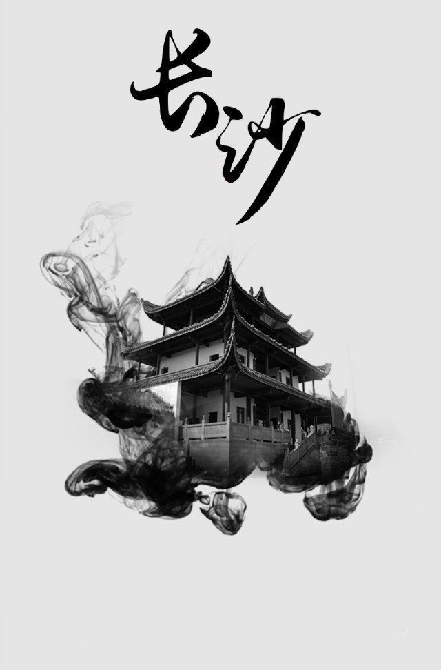

**By Jerry**

The City of Entertainment

**Tang You BaBa（Sugar and Oil cake）：Anyone who loves life and knows how to enjoy food has the wonderful feeling of eating it.**

**茶颜悦色：Milk tea exclusive to Changsha.**

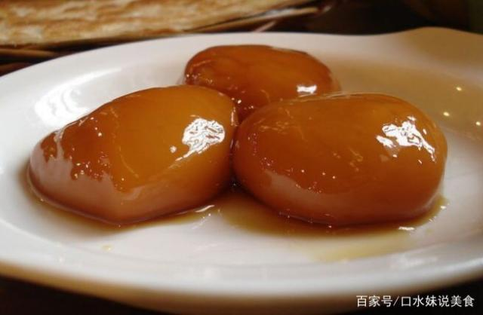

**Spicy crayfish: Changsha people's favorite. Spicy, fragrant but not greasy**

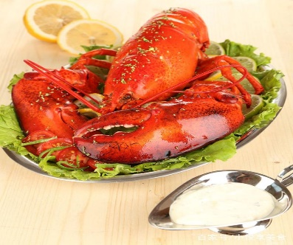

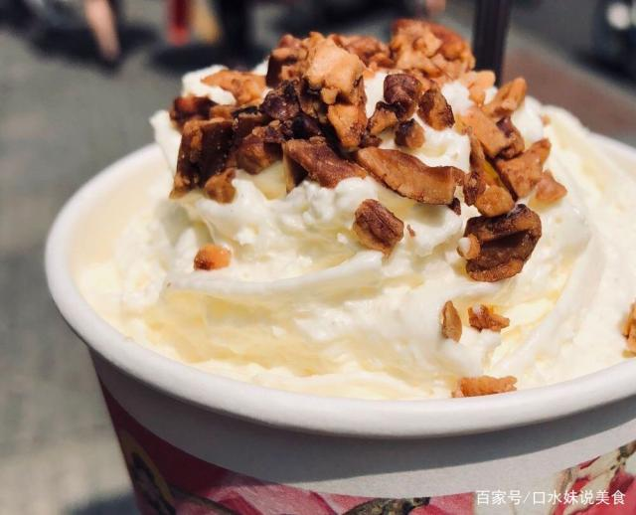

**Cates in CSC**

**Mawangdui Han Tomb:The most famous two things here are Xinzhui’s corpse,which hasn’t rotted for thousands of years,and the plain gauze cloth,which weighs only 48 grams**

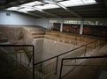

**Tianxin Pavilion :It stares at the Yuelu Mountain right across the river,providing visitors with great views of the mountain and the billowing Xiang river.**

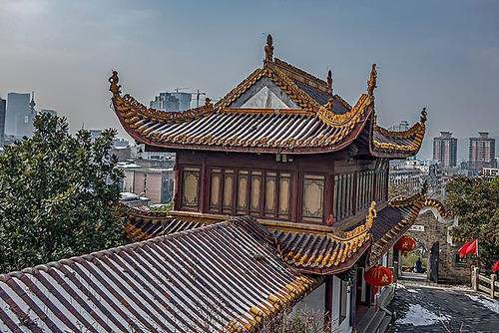

Places of interest

-Star city