The Great Pacific Garbage Patch

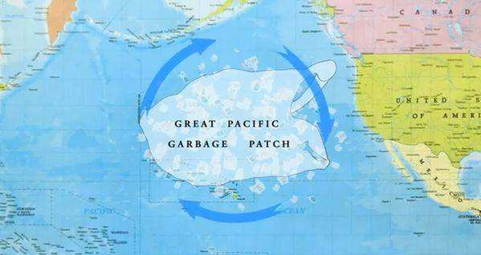

Also known as the “Eighth Continent”

The "Eighth Continent" is located between the west coast of the United States and Hawaii, covering an area equivalent to two Texas states. It is a vortex of 4 million tons of disposable plastic waste in the Pacific Ocean.

**Disposable plastic is the plastic products that we can only use once in our daily life or industrial production, including disposable plastic bags, condoms, plastic cups and so on.**

Due to the stable physical and chemical structure of plastics, they may not be decomposed in the natural environment for decades to hundreds of years. The disposal of plastic waste is a recognized environmental problem in the world. Pollution from disposable plastic products kills thousands of marine animals every year. Researchers once found 80 plastic bags in the stomach of a dead pilot whale washed ashore in Thailand. When the disposable plastic products are deeply buried in the soil, it will affect the absorption of nutrients and water by crops, resulting in crop yield reduction. Once used plastic waste is buried in the land, the occupied land can not be reduced for a long time, which affects the sustainable use of the land.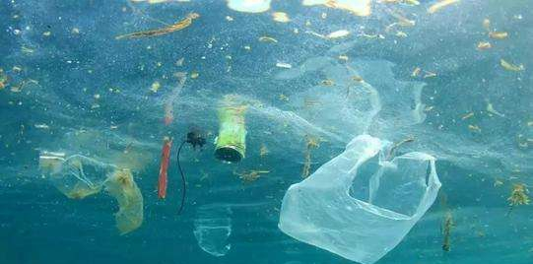

So the top priority is to reduce the use of plastic. On the one hand, we should actively develop high-quality and low-cost substitutes, on the other hand, we should constantly improve the level of ordinary people's awareness of the harm of plastic waste, so that more enterprises and more people can participate in the action of reducing plastic.