Homework Number: hw08

Name: Shu Hwai Teoh

ECN Login: teoh0

Due Date: Thursday 3/26/2020 at 4:29PM

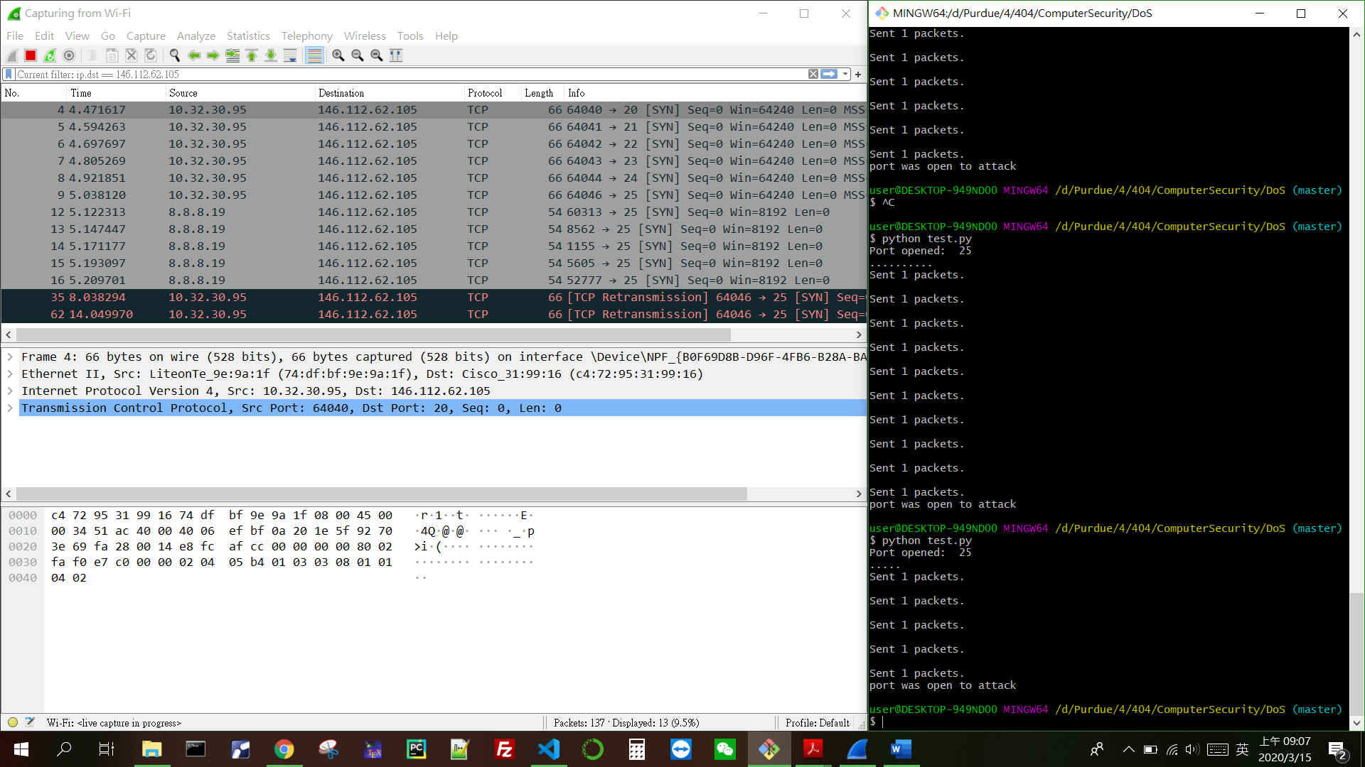

DoS attack

Scan port