Movement –

Initially SPUG is considered to be at the Origin and is facing North as shown in figure 1. The directions are considered to be absolute.

SPUG receives the coordinates of the Products that the user has desired to buy. The product location coordinates are sent as JSON messages through MQTT Communication established between the Server and the specific SPUG. Once product locations are received it waits for the Blocking points. Blocking points are the locations which are occupied by the other SPUGs’. Blocking points are considered to be static in this scenario. The messages are sent in the same way as before.

The product location points and the blocking points updated on a cartesian coordinates map is shown in figure 2 for the following example:

Product Location Points: [(0, 2), (2, 4), (6, 2), (3, 1), (5, 5)]

Blocking Points: [(0 ,1), (1, 4), (4, 4), (4, 5)]

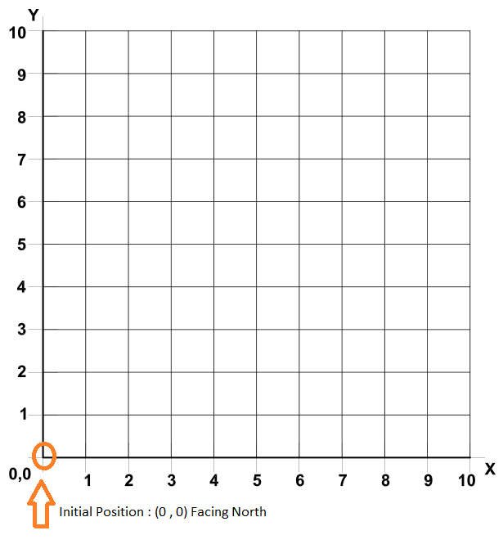 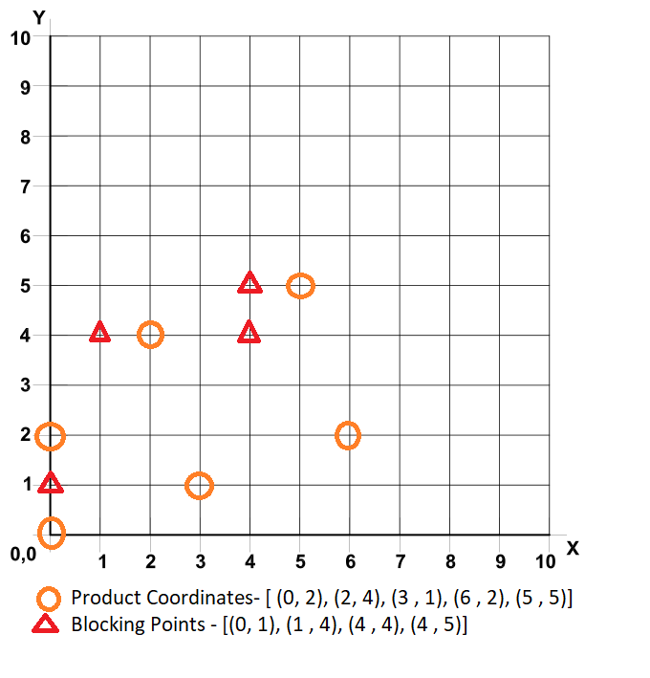

Afterward the shortest path to reach all the product locations and back to the origin point is calculated. The shortest path is calculated according to the “Travelling Salesman Problem” by considering the “Manhattan” distance between the product location points. According to the travelling salesman problem a shortest possible route that visits each city and back to the origin city has to be found given a list of cities and the distances between each pair of cities.

The product location coordinates are ordered according to the shortest path calculated as show in figure 3. The origin and the first product coordinate as per the sequence and the blocking points are given to the AI Planner. AI planner considers the origin as initial point and the first product location as destination point and finds a possible solution to reach the destination by avoiding the blocking points. The SPUG reads the solution from the AI planner and moves accordingly to reach the product location as shown in figure 4. Similarly, a path is calculated between a pair of points as per the shortest path sequence by the AI Planner as shown in figure 5 to figure 10.

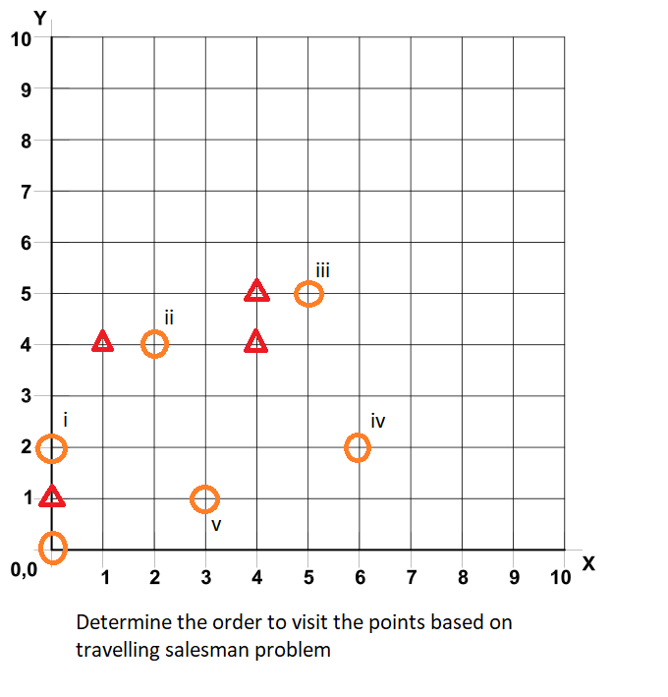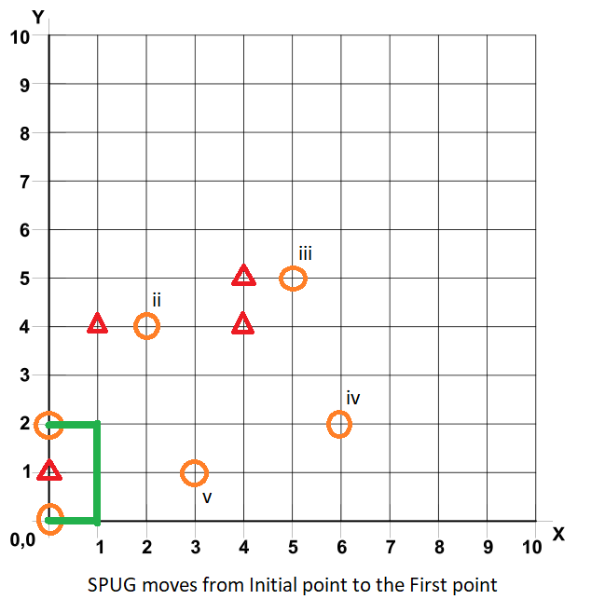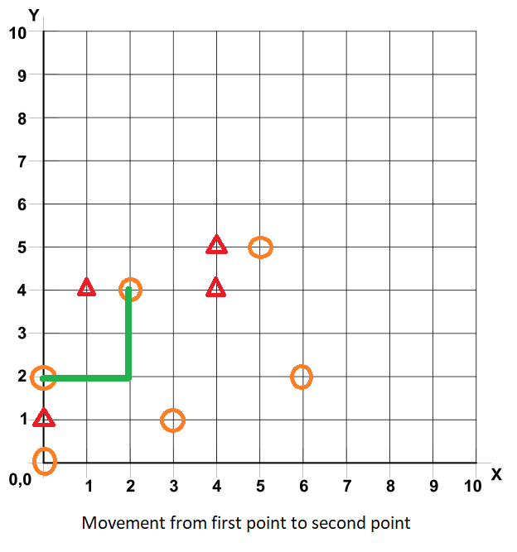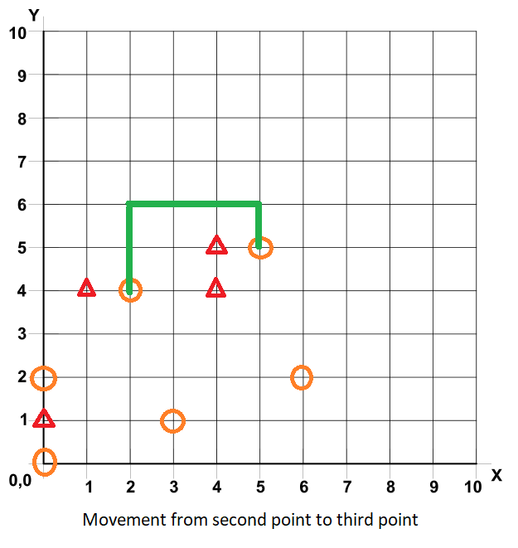

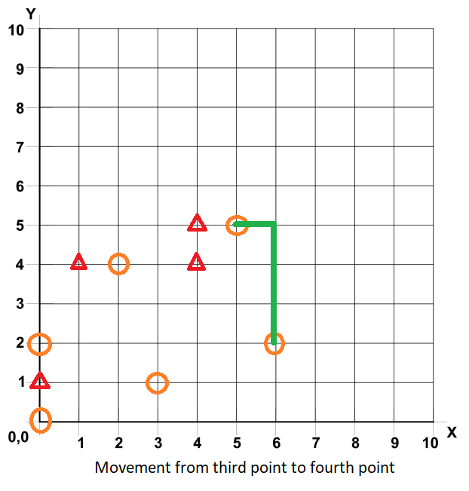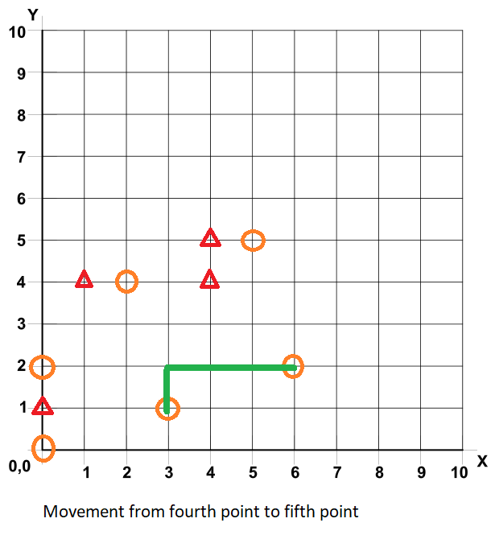

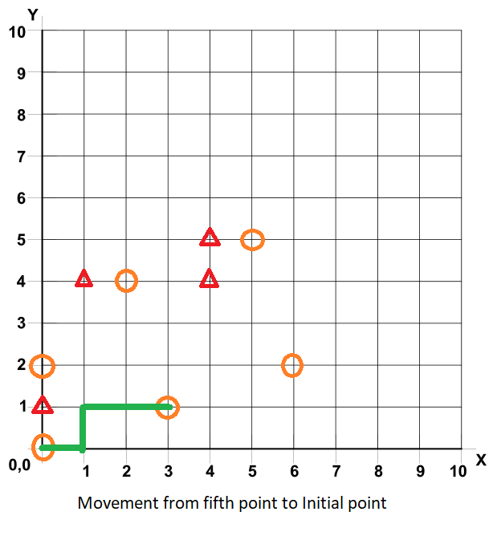

Once the SPUG reaches the product location a MQTT message will be sent to the server indicating that the product location is reached. User gets a notification in the mobile application to confirm if he wants to buy the product. If yes, the product will be added to the cart and a message will be sent to the SPUG to move the next product location. If no, SPUG just moves on to the next location. SPUG waits till it gets the response from the user.

While the SPUG is at a particular coordinate a path occupy message is sent to the server as a MQTT message. Server receives this message and sets that particular path as occupied. Once it moves away from the occupied path PUG send a path un-occupy message to the server. Server frees the path which was occupied before. In this was the server gets to know the free paths and the location of all the SPUGs’ in the map.