**FLOOD MONITORING ALARM SYSTEM**

Joshua S. Rebuta

Mark Nelson A. Bentulan

Emman Ace G. Menion

Welbert C. Lumapguid

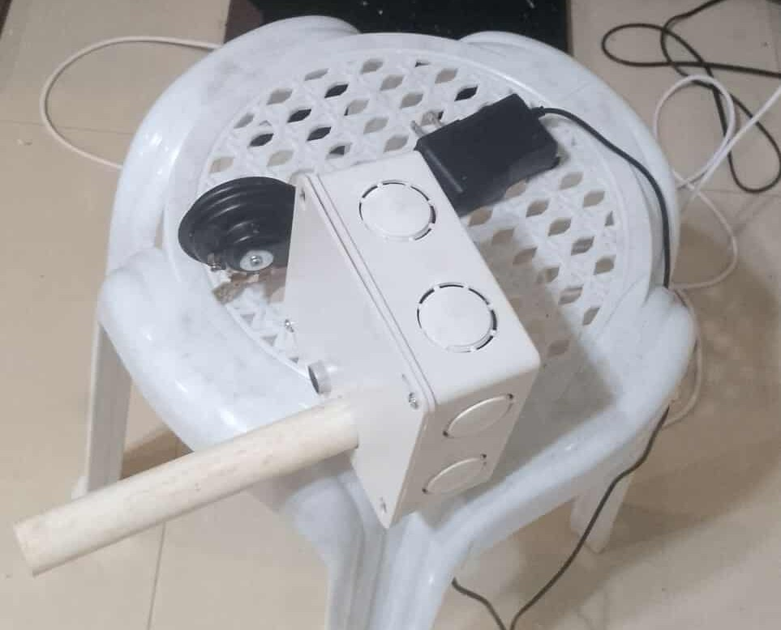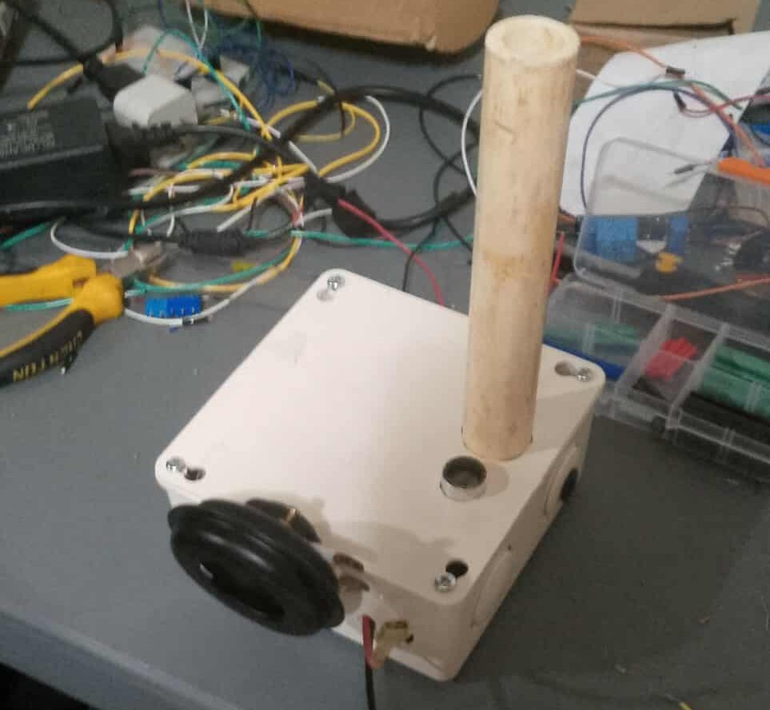

The device is aim to monitor the water level of rivers or other bodies of water. If the water rises to a critical level, the device will detect it and trigger an alarm through a siren. Motor horn is used as a siren in the device. An Ultra Sonic Sensor (HC-SR04T) is used to detect the water level.

The device is plan to be installed where the sensor is facing the water in a downward position. One example is installing the device under a bridge of a river where overflow that leads to flooding may happen.

**System’s Schematic Diagram**

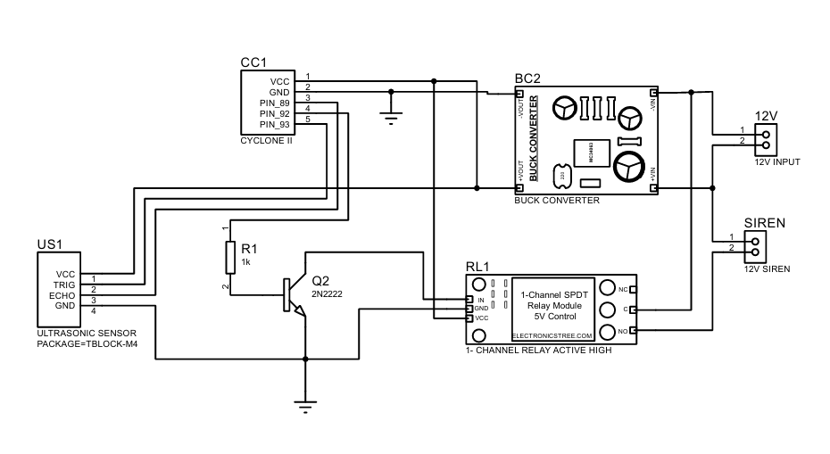

**Electrical components used:**

* Ultra Sonic Sensor (HC-SR04T)
* 12V motor horn
* 2n2222 transistor
* FPGA Cyclone 2 Altera (EP2C5T144C8N)
* Buck converter (DC to DC)
* 5V relay module (1 channel)

**SYSTEM’S CODE (FPGA Cyclone 2)**

library IEEE;

use IEEE.STD_LOGIC_1164.ALL;

use IEEE.NUMERIC_STD.ALL;

entity sample is

Port (

clk : in STD_LOGIC; -- 50MHz clock

trig : out STD_LOGIC; -- HC-SR04 Trigger

echo : in STD_LOGIC; -- HC-SR04 Echo

relay : out STD_LOGIC -- Relay output (PIN_92)

);

end sample;

architecture Behavioral of sample is

-- Constants for 50MHz operation

constant CLK_FREQ : integer := 50_000_000;

constant SOUND_SPEED : integer := 34300; -- cm/s

constant DIST_ON : integer := 35;

constant DIST_OFF : integer := 36;

-- Timing constants

constant TRIG_CYCLES : integer := 500; -- 10µs trigger

constant MEASURE_DELAY : integer := 1_500_000; -- 30ms between measurements

constant ECHO_TIMEOUT : integer := 750_000; -- 15ms max echo timeout

constant RELAY_TIME : integer := 250_000_000; -- 5s hold time

-- Debouncing

constant NUM_SAMPLES : integer := 5; -- Consistent readings required

constant SAMPLE_DEV : integer := 1; -- Max deviation between samples (cm)

-- State machine

type state_type is (IDLE, TRIGGER, WAIT_ECHO, MEASURE, VERIFY);

signal state : state_type := IDLE;

-- Synchronized echo input

signal echo_sync : std_logic_vector(2 downto 0) := "000";

-- Measurement system

signal counter : integer range 0 to MEASURE_DELAY := 0;

signal echo_timer : integer range 0 to ECHO_TIMEOUT := 0;

signal distance_cm : integer range 0 to 500 := 0;

-- Precision detection system

type sample_array is array (0 to NUM_SAMPLES-1) of integer range 0 to 500;

signal samples : sample_array := (others => 0);

signal sample_index : integer range 0 to NUM_SAMPLES-1 := 0;

signal relay_reg : std_logic := '0';

signal hold_timer : integer range 0 to RELAY_TIME := 0;

signal object_detected : std_logic := '0';

signal power_on_reset : std_logic := '1';

signal reset_counter : integer range 0 to 1_000_000 := 0; -- 20ms reset at 50MHz

begin

process(clk)

begin

if rising_edge(clk) then

if reset_counter < 1_000_000 then

reset_counter <= reset_counter + 1;

power_on_reset <= '1';

else

power_on_reset <= '0';

end if;

end if;

end process;

process(clk)

begin

if rising_edge(clk) then

echo_sync <= echo_sync(1 downto 0) & echo;

end if;

end process;

process(clk)

variable sample_avg : integer range 0 to 500;

variable consistent : boolean;

begin

if rising_edge(clk) then

if power_on_reset = '1' then

-- Initialize all signals (like JTAG mode)

relay_reg <= '0';

object_detected <= '0';

hold_timer <= 0;

state <= IDLE;

counter <= 0;

echo_timer <= 0;

samples <= (others => 0);

else

trig <= '0'; -- Default trigger off

case state is

when IDLE =>

if object_detected = '1' then

-- Hold relay ON for RELAY_TIME

if hold_timer < RELAY_TIME then

hold_timer <= hold_timer + 1;

else

hold_timer <= 0;

object_detected <= '0';

relay_reg <= '0';

end if;

elsif counter < MEASURE_DELAY then

counter <= counter + 1;

else

counter <= 0;

state <= TRIGGER;

end if;

when TRIGGER =>

trig <= '1';

if counter < TRIG_CYCLES then

counter <= counter + 1;

else

counter <= 0;

state <= WAIT_ECHO;

end if;

when WAIT_ECHO =>

if echo_sync(2) = '1' then

echo_timer <= 0;

state <= MEASURE;

elsif counter < ECHO_TIMEOUT then

counter <= counter + 1;

else

state <= IDLE; -- Timeout

end if;

when MEASURE =>

if echo_sync(2) = '1' then

if echo_timer < ECHO_TIMEOUT then

echo_timer <= echo_timer + 1;

else

state <= IDLE; -- Timeout

end if;

else

distance_cm <= (echo_timer * SOUND_SPEED + CLK_FREQ) /(2*CLK_FREQ);

state <= VERIFY;

end if;

when VERIFY =>

samples(sample_index) <= distance_cm;

sample_index <= (sample_index + 1) mod NUM_SAMPLES;

consistent := true;

sample_avg := (samples(0) + samples(1) + samples(2) +

samples(3) + samples(4)) / NUM_SAMPLES;

for i in 0 to NUM_SAMPLES-1 loop

if abs(samples(i) - sample_avg) > SAMPLE_DEV then

consistent := false;

end if;

end loop;

if consistent then

if sample_avg <= DIST_ON and object_detected = '0' then

relay_reg <= '1';

object_detected <= '1';

hold_timer <= 0;

elsif sample_avg >= DIST_OFF and object_detected = '1' then

relay_reg <= '0';

object_detected <= '0';

end if;

end if;

state <= IDLE;

when others =>

state <= IDLE;

end case;

end if;

relay <= relay_reg;

end if;

end process;

end Behavioral;

**PIN CONFIGURATION (FPGA Cyclone 2)**

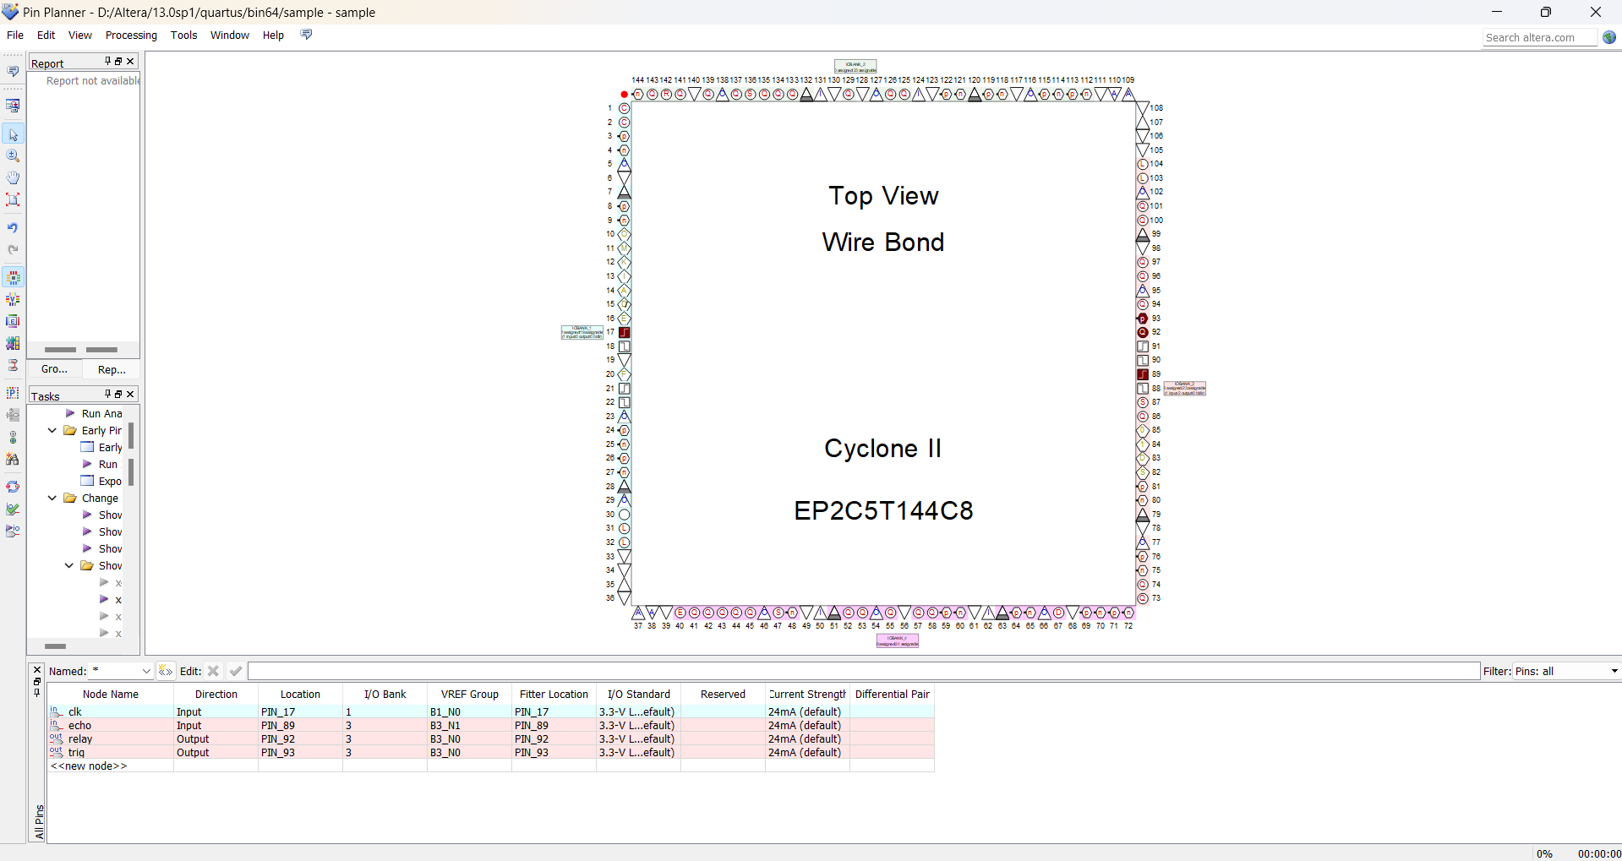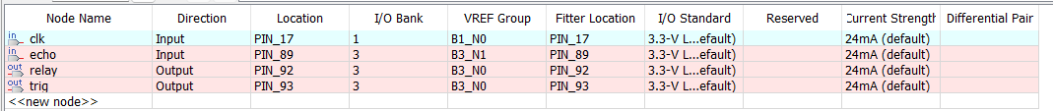

**PCB LAYOUT**

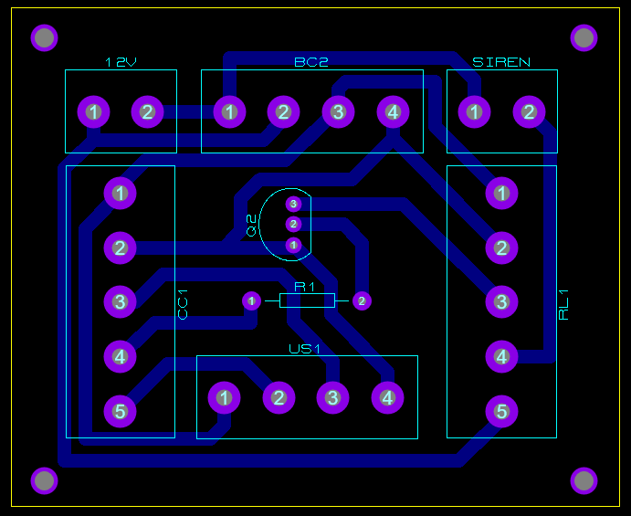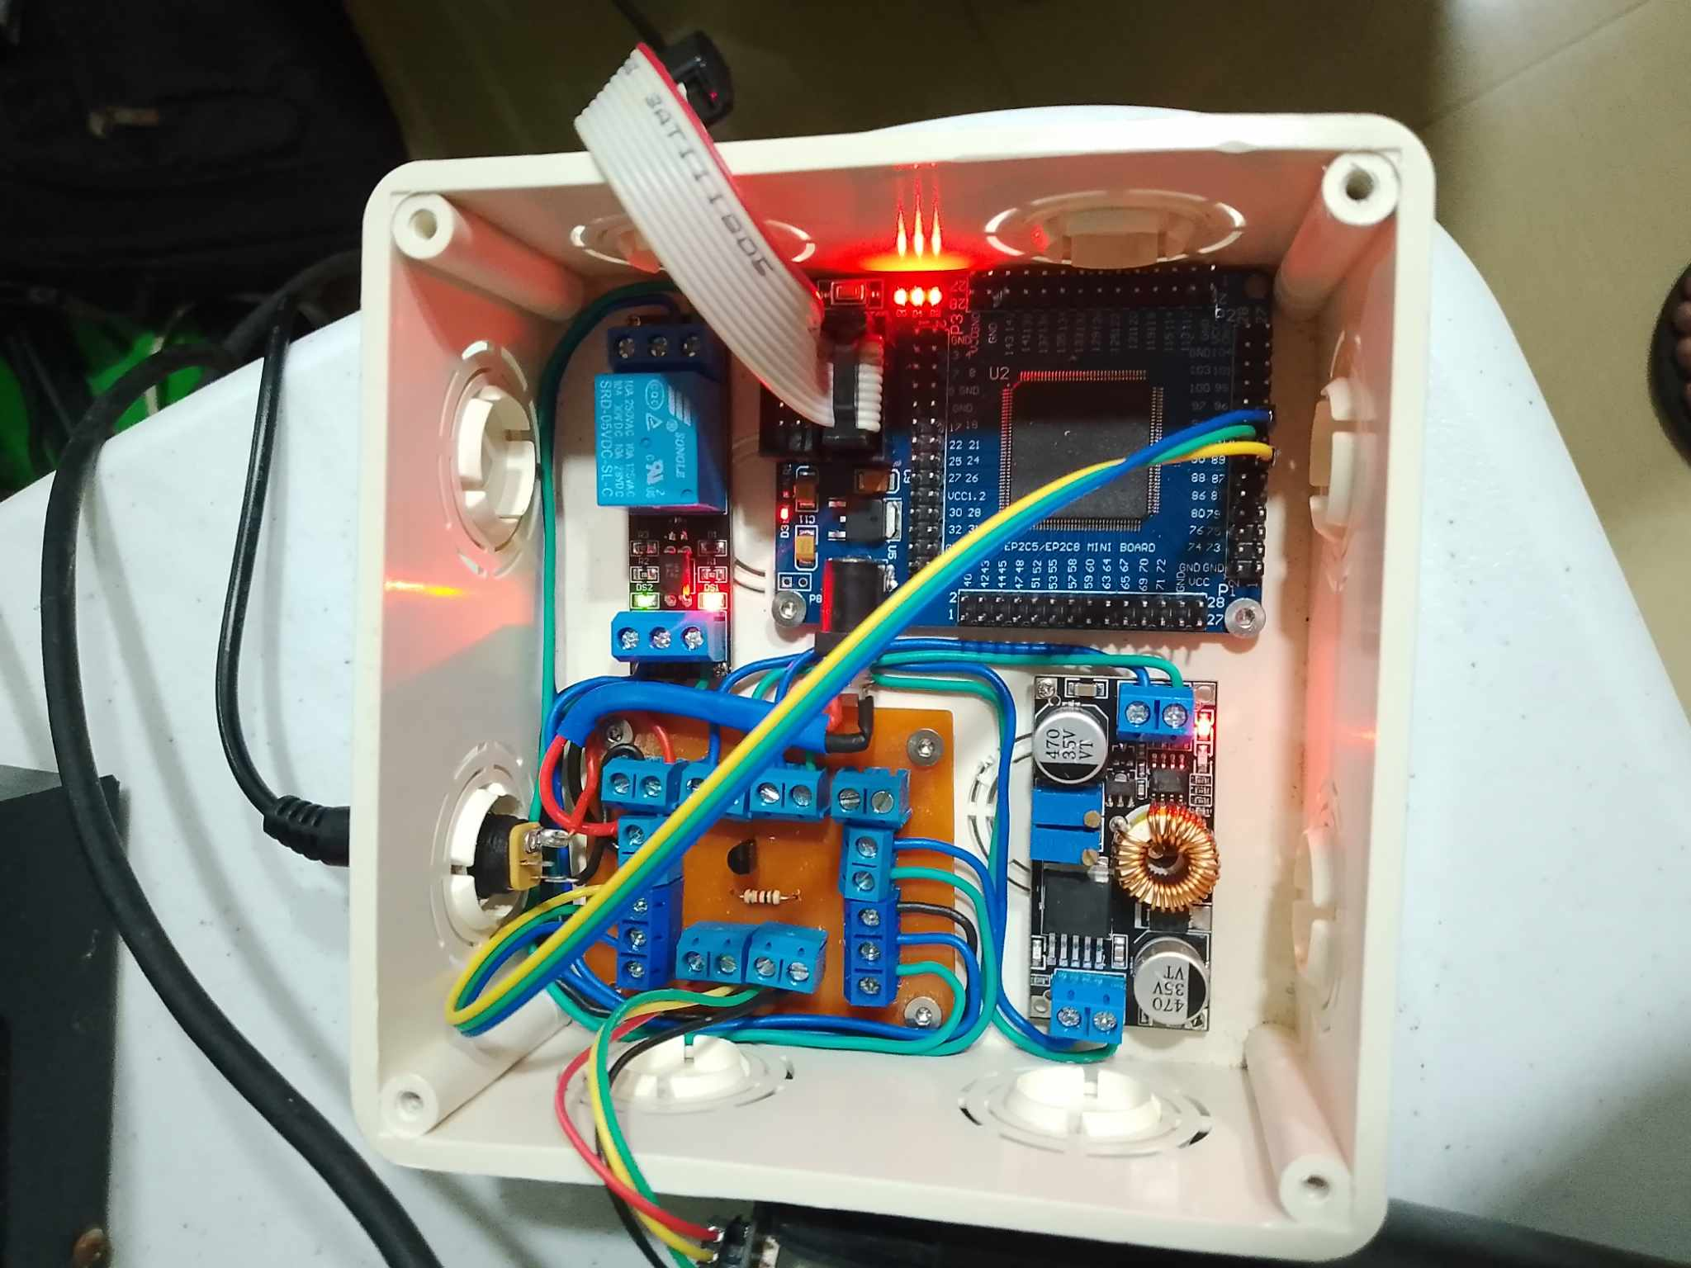

The device is powered by a 12V 5A power supply. FPGA Cyclone 2 is used as a microcontroller for the system to function by uploading a series of codes.

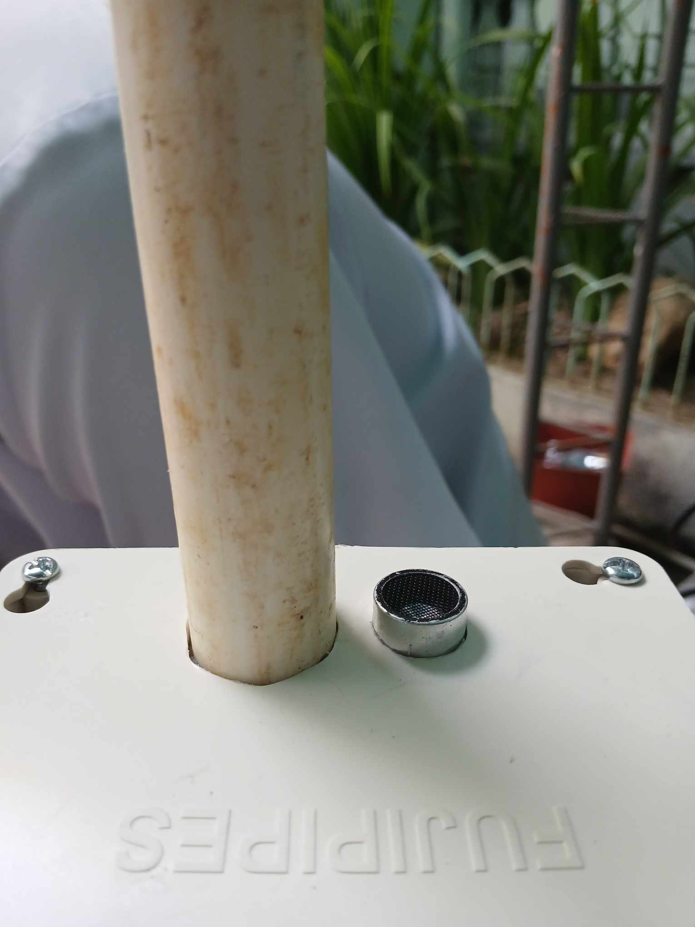

The PVC pipe is used to narrow down the sensor’s width of detection. The receiver part of the sensor is where the PVC pipe is installed while the transmitter is laid bare.