**Task 1**

1. Expectation value of S(3)

$$E[S\left(t\right)]=S\left(0\right)e^{\left(ut\right) }$$

$$E[S\left(3\right)]=39e^{\left(0.1(3)\right) }$$

= 52.6444935

1. Variance of S(3)

$$Var\left[S\left(t\right)\right]={S\left(0\right)}^{2}e^{2ut}\left(e^{σ^{2}t}-1\right)$$

$$Var\left[S\left(3\right)\right]={39}^{2}e^{2(0.1)(3)}\left(e^{{(0.26)}^{2}(3)}-1\right)$$

= 623.0964723

1. Explanation on method to obtained (GBM)

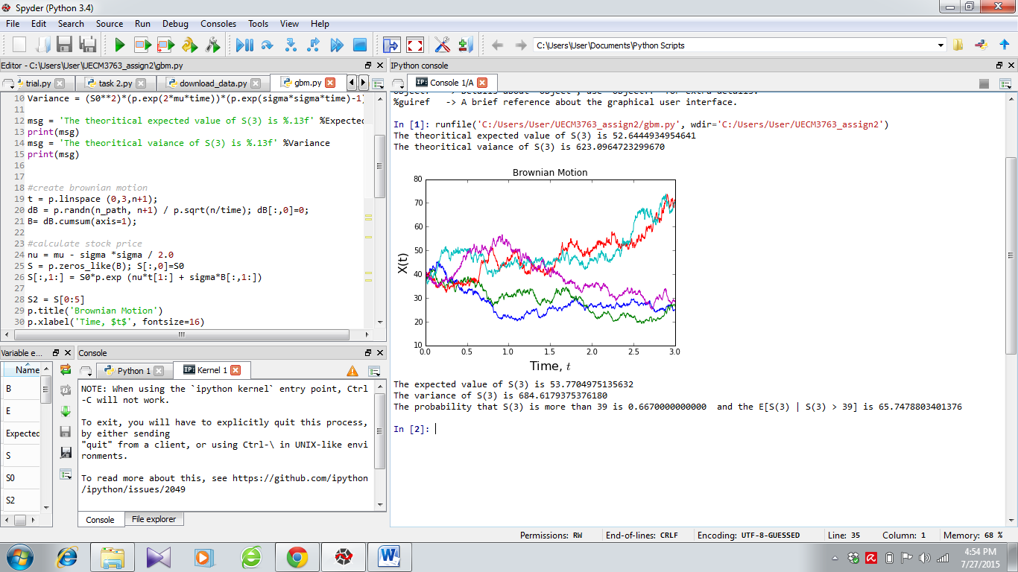

1. Expectation
2. Obtain only the last column of the array “S” which represent stock price at time 3 for each of the 1000 path. Assign the values to variable “S3”
3. Sum up the values and divide by n_path
4. Variance
5. Each term in array “S3” are minus from expected value calculated above and square them up respectively. The answers were stored in “V1”
6. Sum up the term in “V1” and divide by (n_path-1)
7. P[S(3)> 39] and E[S(3) | S(3) > 39]
8. Let count and total = 0
9. Using *for* loop, loop the term stored in array “S3” one by one
10. If the term is bigger than “S0”, “count” will increase by 1 and value of the term will be added to “total”. Otherwise, nothing will happen
11. The loop will end after n_path iterations
12. For P[S(3)> 39], calculate by taking final value of “count” divide by number of path
13. For E[S(3) | S(3) > 39], final value of “total” divide by “count” which represent number of term in “S3” that is bigger than “S0”
14. Explanation on method to obtained (MR)

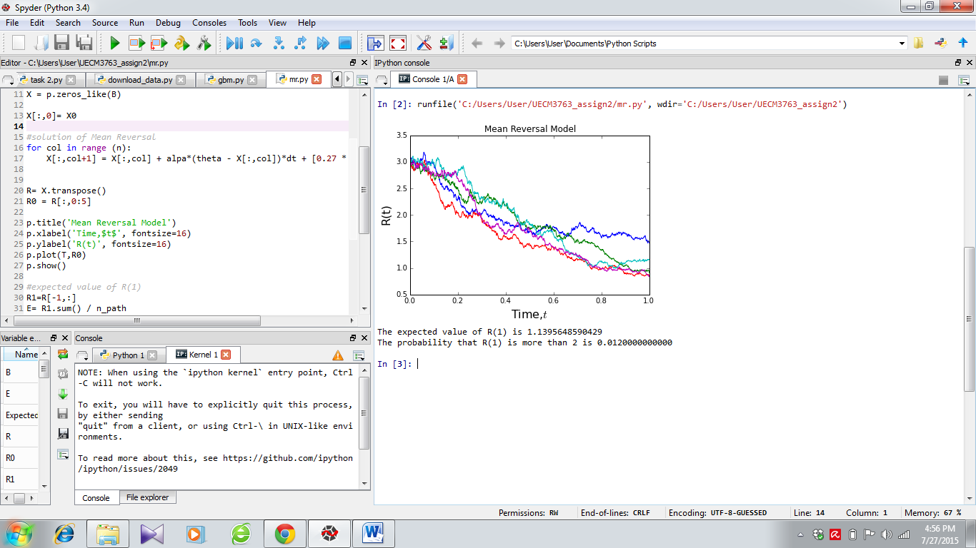

1. Expectation value of R(1)
2. Obtain only the last row of the array “R” which represent stock price at time 1 for each of the n_path. Assign the values to variable “R1”.
3. Sum up the values and divide by number of path which is 1000
4. P[R(1)>2]
5. Let count = 0
6. Using *for* loop, loop the term stored in array “R1” one by one
7. If the term is bigger than “2”, “count” will increase by 1. Otherwise, nothing will happen
8. The loop will end after 1000 iterations
9. For P[R(1)> 2], calculate by taking final value of “count” divide by number of path

**Task 2**

1. There are **30** component stocks in FTSE Bursa Malaysia KLCI Index

|  |  |  |  |  |  |
| --- | --- | --- | --- | --- | --- |
| **Stock Name** | **Code** | **Stock Sector** | **Weightage(%)** | **PE Ratio** | **Net Market Capital (B)** |
| Public Bank Bhd | 1295 | Banks | 11.6 | 15.2 | 73.29 |
| Malayan Banking | 1155 | Banks | 9.32 | 12.39 | 87.75 |
| Tenaga Nasional | 5347 | Alternative Electricity | 9.28 | 9.31 | 69.76 |
| CIMB Group Holdings | 1023 | Banks | 5.76 | 17.51 | 46.52 |
| Axiata Group Bhd | 6888 | Mobile Telecommunications | 5.62 | 24.31 | 55.43 |
| Sime Darby Bhd | 4197 | Diversified Industrials | 5.51 | 20.8 | 52.09 |
| Digi.com | 6947 | Mobile Telecommunications | 4.16 | 20.81 | 42.06 |
| Genting | 3182 | Hotels | 3.68 | 16.5 | 30.86 |
| PETRONAS Chemicals Group Bhd | 5183 | Commodity Chemicals | 3.55 | 22.07 | 51.2 |
| Maxis Bhd | 6012 | Mobile Telecommunications | 3.45 | 29.73 | 48.88 |
| Petronas Gas | 6033 | Exploration & Production | 3.4 | 22.51 | 42.23 |
| IHH Healthcare | 5225 | Health Care Providers | 3.28 | 63.12 | 48.25 |
| IOI | 1961 | Farming & Fishing | 2.99 | 66.31 | 27.24 |
| Telekom Malaysia | 4863 | Fixed Line Telecommunications | 2.96 | 32.79 | 24.88 |
| Genting Malaysia Bhd | 4715 | Hotels | 2.5 | 20.14 | 23.99 |
| MISC | 3816 | Marine Transportation | 2.45 | 16.28 | 35.89 |
| AMMB Holdings | 1015 | Banks | 2.38 | 9.22 | 17.67 |
| Kuala Lumpur Kepong | 2445 | Farming & Fishing | 2.28 | 29.83 | 24.49 |
| SapuraKencana Petroleum | 5218 | Oil Equipment & Services | 1.98 | 11.97 | 14.15 |
| PBB Group | 4065 | Food Products | 1.8 | 17.74 | 17.83 |
| British American Tobacco (Malaysia) | 4162 | Tobacco | 1.7 | 20.67 | 19.02 |
| Hong Leong Bank | 5819 | Banks | 1.67 | 11.01 | 23.66 |
| YTL Corp | 4677 | Multiutilities | 1.63 | 14.81 | 16.67 |
| UMW Holdings | 4588 | Automobiles | 1.37 | 20.4 | 11.87 |
| Astro Malaysia Holdings | 6399 | Broadcasting & Entertainment | 1.22 | 28.41 | 15.81 |
| Petronas Dagangan Bhd | 5681 | Intrgrated Oil & Gas | 1.21 | 37.12 | 20.5 |
| RHB Capital | 1066 | Banks | 1.06 | 9.47 | 19.58 |
| Westports Holdings | 5246 | Transportation Services | 0.93 | 27.44 | 14.36 |
| Hong Leong Financial | 1082 | Banks | 0.64 | 10.21 | 16.62 |
| KLCC Prop & Reits - Stapled Sec | 5235SS | Real Estate Holding & Development | 0.63 | 26.42 | 12.64 |

1. Component stocks in FTSEKLCI index (Details at 22 June 2015)
2. Explanation for method to calculate the 5-day moving average

A 5-day moving average is the 5-day sum of closing prices divided by 5. After each calculation, first data is dropped as 1 new data comes available. The 5-days average price will move along the time scale.

1. We begin by creating a new array, “mean2” which has same size as variable “PB”
2. Using *for* loop, loop the stock prices stored in array “PB” one by one
3. After we reach the 6th term, list down the last 5 term before 6th term which are [term1, term2, term3, term4, term5] and stored them to variable “mean”
4. In general, if i=N term, we will list down the last 5 term which are [term N-5, term N-4, term N-3, term N-2, term N-1]
5. Thus, if we have N-term of variable, we have to run N+1 times
6. Sum up the term in variable “mean” then divide it by 5
7. The output is then stored to the array “mean2” that we had assign at the beginning
8. The process continues until the loop had iterate num+1 times

