# B2. Data interpretation 2

A city’s municipality has multiple departments. The information below pertains to ﬁve such departments: A, B, C, D, and E. All of the workers are paid on an hourly basis, and all members of the same department are paid the same, but the hourly wage of each department changes from month to month due to demand and budget constraints. Below is employment time and salary information by department for the months May-November, as well as a table with the total hours worked each month (across all departments). Answer the following questions based on this information:

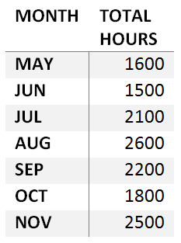

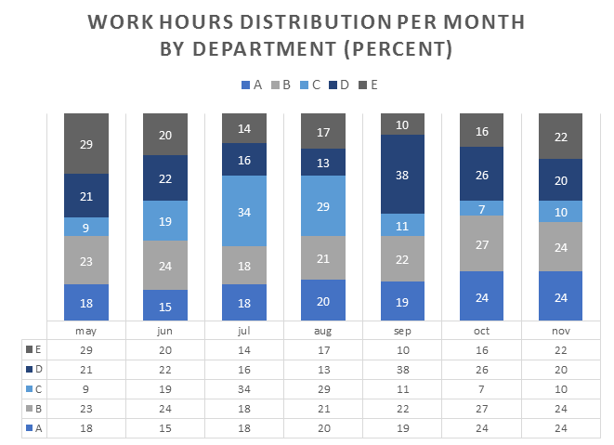 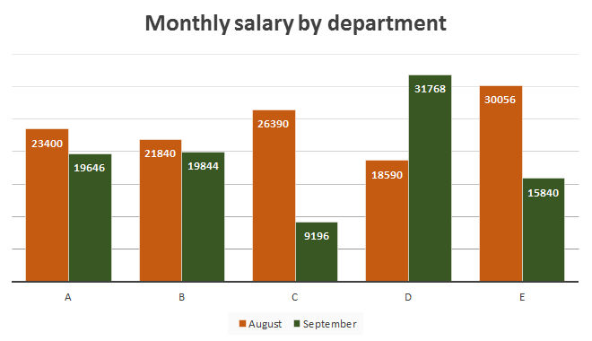

1. In what month have department B employees worked the most hours?

A. May

B. June

C. August

D. October

E. November

E. -- Divide total hours * decimal percentage , 2500 * .24 = 600, the smallest amount.

1. What is the ratio between the number of department C man-hours in May and department E man-hours in Oct?

1:2

1600 * .09 : 1800 * .16 = 144:288 = 1:2

1. Over the period from May till August, which department had the most stable work load?

A. Department A

B. Department B

C. Department C

D. Department D

E. Department E

D. Got this by eyeballing. In total hours, May - June: -100 , June - July: +600, July- August: +500. Department D’s percent changes of hours most accurately reflected this trend (slight change up, big change down, big change down.).

1. The employees of the veterinary services department were very disgruntled after receiving September salary, and many of them quit. Which department is veterinary services?

A. Department A

B. Department B

C. Department C

D. Department D

E. Department E

D.

Department D’s workload jumped tremendously, however they weren’t compensated. August: 18590/(2600 *.13)= 55 Dollars /H. September: 31,768/ (2200*.38) = 38. They worked more hours (836>338), with less pay.

1. It is commonly known that no matter how the salaries change over time, the employees of the accounting department are always the best paid. Which department is accounting?

A. Department A

B. Department B

C. Department C

D. Department D

E. Department E

E

Go to Aug or Sept and find the highest salary:

E: 30,056/(2200*.17)= 80

A: 18590/(2200*.2) = 42

B: = 47

C = 41

D = 47

1. Which of the following is the lifeguard services department?

A. Department A

B. Department B

C. Department C

D. Department D

E. Department E

C

HAs the biggest drop off from August- September in regards to %hours, meaning they are working less because the summer season is over.