A survey was performed to study the paying habits of a restaurant’s customers. Among 2500 meal orders, 30% were made by delivery, 20% by takeaway, and the rest were sit-down at the restaurant itself.

The table below shows the results in terms of the fraction of responders in each of the three categories (takeaway, delivery and sit-down).

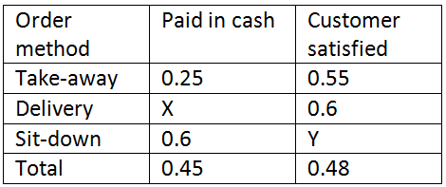

**Q1**. What is the ratio of the total number of sit-down orders paid for in cash to takeaway orders paid by means other than cash?

* 1:2

Total sit-down = 0.6(.5) = .3 Total Non-takeaway = 0.75(.2) = .15, ratio: .3:.1 = 2:1

**Q2**. If a given customer replied that they were satisﬁed with their meal, what is the probability that their meal was a delivery? (It is known that the mode of payment, customer satisfaction and order method are independent of each other).

* .3750

% of deliverys that marked satisfied: 06(.3)= .18 , total satisfied: .48 ,,,,

% of deliveries satisfied/total satisfied = .18/.48 = .3750