北京工业大学

2020 - 2021 学年 第1学期

信息学部 计算机学院

|  |  |  |  |
| --- | --- | --- | --- |
| 课程名称： | 数据结构课程设计 | | |
| 报告性质： | 实验报告 | | |
| 学号： | 18074102 | 姓名： | 左帅 |
| 任课教师： | 王众 | 课程性质： | 学科基础必修课 |
| 学分： | 2 | 学时： | 60 |
| 班级： | 180701 | 成绩： |  |
| 教师评语： |  | | |

|  |  |  |
| --- | --- | --- |
| 需求分析 | 根据题中需求，提供功能划分说明 |  |
| 设计 | 逻辑结构、存储结构设计、算法描述 |  |
| 使用说明 | 界面是否友好 |  |
| 总结 | 是否感悟有收获 |  |
| 摘要 | 考察文字抽象能力 |  |
| 格式 | 是否有目录、页号 |  |

2020年 12 月 17 日

目录

1需求分析

1.1功能概述

1.1.1基础功能

1.1.2拓展功能

1.2需要处理的数据

1.3程序开发运行环境

1.4用户界面设计

2数据结构设计

2.1主要数据结构定义

2.1.1逻辑结构

2.1.2存储结构

2.2整体结构及模块功能描述

2.3各模块功能描述

2.3.1电影节点类（movie）

2.3.2电影链表类（Movielist）

2.4核心算法流程图

3详细设计

3.1各模块设计

3.1.1 movie

3.1.2 Movielist

3.2各模块核心函数

1.1、交换值函数

1.2添加评论函数

2.1判断链表是否为空

2.2清空链表

2.3访问节点

2.4尾插入

2.4遍历搜索

2.5快速排序

4用户手册及测试结果

1、排序演示

2、添加评论

3、 交叉查询演示

4、 访问网页

5、初始化

5、 修改原数据文件

5总结提高

5.1体会与收获

5.2问题与解决

5.3评价

6参考文献

# 1需求分析

## 1.1功能概述

### 1.1.1基础功能

本程序需要实现一个电影检索系统，拥有以下功能：

1、设计实现一个图形界面，能根据不同的分类如豆瓣评分、名著改编、地域、剧情、导演、演员、语言查询到想要的电影，并且各种分类之间要有交叉。

2、设计实现用户可以通过输入电影名，直接查询电影

3、可以按照最新、最热排行查询。

### 1.1.2拓展功能

1、可以让用户添加评语

2、可以点击访问外部链接

## 1.2需要处理的数据

针对三个基础功能，对于功能一需要有电影的评分、地域、剧情、导演、演员、语言这几种数据，其中地域,剧情,语言和演员包含多个数据。电影文件存储于filmlist.txt文件中。数据总计250部电影。

## 1.3程序开发运行环境

开发环境：

* Visual Studio Code 1.52.1
* Python 3.8.5 64bit

运行环境：

* Windows 10 Professional 64bit 18363

## 1.4用户界面设计



在基础功能1的查找中，用户可以输入电影名，导演名，类别等对电影进行筛选。用户同时也可以点击左边的区域查看电影的信息。所有搜索得到的电影和点击查看的电影热度均会增加。右方的文本框用于信息显示，热度与评分用于对应的排序，添加影评可以与许用户添加影评。

# 2数据结构设计

## 2.1主要数据结构定义

### 2.1.1逻辑结构

对于名称查找使用的是树形结构，同时对于名称和热度排序使用的是x。

### 2.1.2存储结构

电影存储于链表中，选择链表的原因是逻辑简单、操作方便（差删等等），但是在后续中发现链表并不是最优的选择，因为并没有过多的差删操作，更多的访问操作，因此顺序表会更好一点，不过针对链表，在一些算法上做了优化。

为了方便进行快速排序，选择的双向链表。

## 2.2整体结构及模块功能描述

改电影查询系统又电影节点类和电影链表类组成，节点类主要用于存储数据和对数据操作，链表类主要用于实现各种功能。

## 2.3各模块功能描述

### 2.3.1电影节点类（movie）

链表中的节点，负责储存电影的信息。

数据：电影名（name），豆瓣评分（score），名著改编（original），地域（country），语言（language），导演（director），演员（actors），剧情（plot）。

此外为了实现另外两个基础功能，又加入了热度（hot），上架时间（time），两个数据，为了方便后续排序、热度文件写入，又加入了number（按链表顺序从0到n，方便快速排序指针移动，判断指针重合），filenumber（按原电影文件顺序从0-n，用于热度写入）。

为了实现拓展功能，后续又加入了评论（pinglun[]），网页链接（url）

功能 ：

1、交换两个节点数值（用于排序）

2、更新热度

3、添加评论

### 2.3.2电影链表类（Movielist）

链表本体

功能：

1. 按类型查找，各类有交叉
2. 按照时间、热度、默认排序

## 2.4核心算法流程图

开始

读取文件内容

将文件信息储存到AVL树与链表中

是否点击了电影图片

将电影信息，影评，链接显示在信息框

是

否

是否点击了搜索按钮

判断其为电影名或者为其他如导演并进行搜索

是

否

是否点击了热度或评分

根据对应排序方法切换排序好的链表

是

是否点击影评按钮

是

输入搜索的内容

输入影评

为对应的电影添加影评

是否退出

结束

是

否

否

+

# 3详细设计

## 3.1各模块设计

### 3.1.1 movie

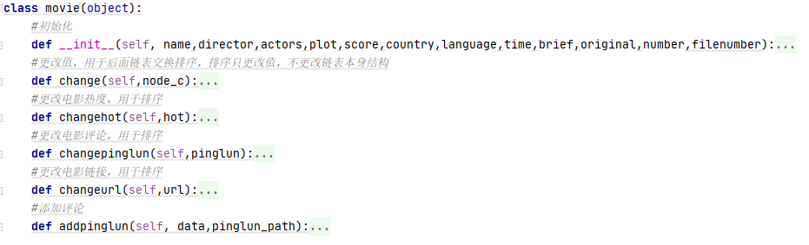

### 3.1.2 Movielist

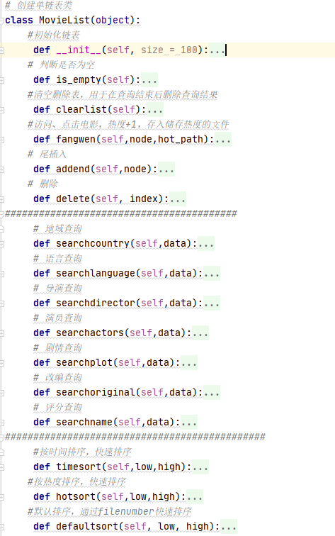

## 3.2各模块核心函数

### 1.1、交换值函数

#更改值，用于后面链表交换排序，排序只更改值，不更改链表本身结构

def change(self,node_c):

self.name = node_c.name

self.score = node_c.score

self.country = node_c.country

self.language = node_c.language

self.director = node_c.director

self.actors = node_c.actors

self.plot = node_c.plot

self.original = node_c.original # 改编

self.brief = node_c.brief # 剧情简介

self.hot = node_c.hot # 记录点击量

self.time = node_c.time

self.filenumber = node_c.filenumber

self.pinglun = node_c.pinglun

self.url = node_c.url

#更改电影热度，用于排序

def changehot(self,hot):

self.hot = hot

#更改电影评论，用于排序

def changepinglun(self,pinglun):

self.pinglun = pinglun

#更改电影链接，用于排序

def changeurl(self,url):

self.url = url

该类函数作用是在快速排序和搜索电影功能中。用于快速排序是以为对于链表，交换值的效率要比交换链表的节点效率要高。用于搜索电影是因为每次搜索都会把结果存入一个链表中，下一次搜索会从这个新表中搜索，在创建新表时要用其赋值。

### 1.2添加评论函数

def addpinglun(self, data,pinglun_path):

if self.pinglun == '':

self.pinglun = list(self.pinglun)

self.pinglun.append(data)

f = open(pinglun_path, 'r+',encoding='utf-8')

flist = f.readlines()

#newpinglun = str(self.pinglun)

flist[self.filenumber] = data + "/" +flist[self.filenumber]

f = open(pinglun_path, 'w+',encoding='utf-8')

f.writelines(flist)

f.close()

该函数的作用是添加评论到节点的pinglun[]中，并将pinglun[]写入txt文件中

### 2.1判断链表是否为空

def is_empty(self):

if self.header == None:

return True

else:

return False

判断链表是否为空，用于插入节点

### 2.2清空链表

def clearlist(self):

self.header = None

self.tail = None

self.length = 0

清空删除表，用于在查询结束后删除查询结果

### 2.3访问节点

def fangwen(self,node,hot_path):

node.hot = node.hot +1

f = open(hot_path, 'r+')

flist = f.readlines()

newhot = str(node.hot)

flist[node.filenumber] = newhot+'\n'

f = open(hot_path, 'w+')

f.writelines(flist)

f.close()

访问、点击电影，热度+1，存入储存热度的文件

### 2.4尾插入

def addend(self,node):

current_node = self.header

if self.is_empty():

self.header = node

self.tail = node

else:

while current_node.next != None:

current_node=current_node.next

current_node.next = node

node.before = current_node

self.tail = node

self.length += 1

在链表结尾插入节点

### 2.4遍历搜索

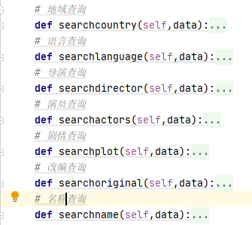

def searchcountry(self,data):

current_Node = self.header # 头指针，用于遍历当前链表

empty_list = MovieList() # 空表，存储这次检索出的信息

#data = input("请输入剧情地域:")

len = 0

while len <= self.length:

if data in current_Node.country:

# node用于暂存符合检索条件的current_node的信息，但是其next=None

node = movie(current_Node.name, current_Node.director, current_Node.actors, current_Node.plot,

current_Node.score, current_Node.country, current_Node.language, current_Node.time,

current_Node.brief, current_Node.original,current_Node.number,current_Node.filenumber)

node.changehot(current_Node.hot)

node.changepinglun(current_Node.pinglun)

node.changeurl(current_Node.url)

empty_list.addend(node) # 将符合检索信息的节点加入空链表

current_Node = current_Node.next # 检索当前表下一个节点

else:

current_Node = current_Node.next # 检索当前表下一个节点

len += 1

print("查询结束")

self.length = empty_list.length

self.header = empty_list.header

self.tail = empty_list.tail

遍历搜索包括遍历搜索地域、语言、导演、演员、剧情、名字、是否改编，每个搜索函数的机构类似，只是更改了搜索的数据类型。

此处以遍历搜索地域为例子。其逻辑为遍历链表，当当前节点的值等于搜索的Data值时，将改节点的值复制到新链表中，并在最后将这个新链表代替当前链表进行下一次的搜索。

### 2.5快速排序

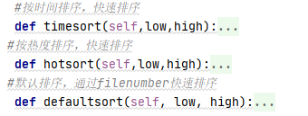

def timesort(self,low,high):

key = movie('abc', 'abc', 'abc', 'abc', 'abc', 'abc', 'abc', 'abc', 'abc','no',-1,-1)

if not low or not low.next:

return

if low.number != high.number:

p=low

q=high

key.change(p)

while p.number != q.number:

while p.number != q.number and q.time <= key.time:

q = q.before

p.change(q)

while p.number != q.number and p.time >= key.time:

p = p.next

q.change(p)

q.change(key)

if low.time != p.time:

self.timesort(low,p.before)

if p.time != high.time:

self.timesort(p.next,high)

排序分为时间排序、热度排序、默认排序，采用的都是快速排序的思路（O (nlogn)）。两个指针，p是头、q是尾，在交换节点时，不对链表本身进行改动，只是交换数据（调用节点中的change（）函数），这样稍微弥补了一些链表本身交换位置效率低的缺陷。

热度排序与默认排序与时间排序结构相同，只是排序所根据的值换成了hot和filenumber（文件中的顺序号）

## 3.3详细代码

### 1.1 AVLTree.py

from Film import film

from linkedlist import linked_list

class AVLTree:

    class film_node:

        def __init__(self, film):

            self.film_name = film.name

            self.left = None

            self.right = None

            self.height = 1

            self.film = film

            self.strs=''

    def __init__(self):

        self.root = None

        self.size = 0

        self.need_refresh_list=[]

    def get_size(self):

        return self.size

    def add_from_root(self,film):

        self.root=self.add(self.root,film)

    def add(self, node,film):

        if not node:

            self.size += 1#若节点为空，则创建一个节点

            return self.film_node(film)

        elif node.film_name > film.name:

            node.left = self.add(node.left,film)

        else:

            node.right = self.add(node.right,film)

        # 更新height,获取平衡因子

        node.height = 1 + max(self.get_height(node.left), self.get_height(node.right))

        banlance_factor = self.get_balance_factor(node)

        # 维护平衡性，共四种情况LL,RR,LR,RL

        #LL

        if banlance_factor > 1 and self.get_balance_factor(node.left) >= 0:

            return self.right_rotate(node)

        #RR

        if banlance_factor < -1 and self.get_balance_factor(node.right) <= 0:

            return self.left_rotate(node)

        #LR

        if banlance_factor > 1 and self.get_balance_factor(node.left) < 0:

            node.left = self.left_rotate(node.left)

            return self.right_rotate(node)

        #RL

        if banlance_factor < -1 and self.get_balance_factor(node.right) > 0:

            node.right = self.right_rotate(node.right)

            return self.left_rotate(node)

        return node

    def get_height(self, node):

        if not node:

            return 0

        return node.height

    def get_balance_factor(self, node):

        if not node:

            return 0

        return self.get_height(node.left) - self.get_height(node.right)

    def right_rotate(self, y):

        x = y.left

        T3 = x.right

        # 右旋转

        x.right = y

        y.left = T3

        # 更新height

        y.height = max(self.get_height(y.left), self.get_height(y.right)) + 1

        x.height = max(self.get_height(x.left), self.get_height(x.right)) + 1

        return x

    def left_rotate(self, y):

        x = y.right

        T2 = x.left

        x.left = y

        y.right = T2

        # 更新height

        y.height = max(self.get_height(y.left), self.get_height(y.right)) + 1

        x.height = max(self.get_height(x.left), self.get_height(x.right)) + 1

        return x

    def get_node(self, node, film_name):

        if not node:

            return

        if node.film_name == film_name:

            return node

        elif node.film_name > film_name:

            return self.get_node(node.left, film_name)

        else:

            return self.get_node(node.right, film_name)

    def get_film_from_node(self,film_name):

        s = self.get_node(self.root, film_name)

        if s is not None:

            return s.film

        else:

            return film('noname','norating','noregion','nointro','notypes','nosuchdirector','noactor','nolanguage','notime','nourl','nope')

    def preorder_traversal_save(self):

        film=open("filmlist.txt", "w",encoding='utf-8')

        self._preorder_traversal_save(self.root,film)

        film.close()

    def _preorder_traversal_save(self,node,film):

        if node is not None:

            #filmname,director,actors,types,ratings,regions,languages,date,intro

            film.write(node.film.name)

            film.write('#')

            film.write(node.film.director)

            film.write('#')

            film.write('/'.join(node.film.actors))

            film.write('#')

            film.write('/'.join(node.film.types))

            film.write('#')

            film.write(node.film.rating)

            film.write('#')

            film.write('/'.join(node.film.region))

            film.write('#')

            film.write('/'.join(node.film.language))

            film.write('#')

            film.write(node.film.time)

            film.write('#')

            film.write(node.film.plot)

            film.write('#')

            film.write(node.film.url)

            film.write('#')

            film.write(str(node.film.click_times))

            film.write('#')

            film.write('/'.join(node.film.review))

            film.write('\n')

            self._preorder_traversal_save(node.left,film)

            self._preorder_traversal_save(node.right,film)

    def get_film_from_node_llist(self,film_name):

        s = self.get_node(self.root, film_name)

        llist = linked_list()

        self.need_refresh_list=[]

        if s is not None:

            llist.append(s.film)

            s.film.clicked()

            self.need_refresh_list=[s]

            return llist

        else:

            return film('noname','norating','noregion','nointro','notypes','nosuchdirector','noactor','nolanguage','notime', 'nourl','nope')

    def get_film_from_node_print(self,film_name):

        self.searched_film = self.get_film_from_node(film_name)

        if self.searched_film.name != 'noname':

            print(self.searched_film.name,self.searched_film.director,self.searched_film.types)

            self.searched_film.clicked()

            self.need_refresh_list=[self.searched_film]

            return '电影名称:'+self.searched_film.name+ \

            '\n导演:'+self.searched_film.director+ \

            '\n演员:'+' '.join(self.searched_film.actors)+ \

            '\n类型:'+' '.join(self.searched_film.types)+ \

            '\n上映日期: '+self.searched_film.time+ \

            '\n语言:'+' '.join(self.searched_film.language)+ \

            '\n区域:'+' '.join(self.searched_film.region)+ \

            '\n评分:'+self.searched_film.rating+ \

            '\n剧情梗概:'+self.searched_film.plot+'\n'

        else:

            print('No Such Film!')

            return 'No Such Film!'

    def contains(self, film_name):

        return self.get_node(self.root, film_name) is not None

    def preorder_traversal(self,node):

        if node is not None:

            print(node.film_name,node.film.director,node.film.types)

            self.strs=self.strs+node.film_name+'  ['+' '.join(node.film.types)+']\n'

            self.preorder_traversal(node.left)

            self.preorder_traversal(node.right)

    def root_preorder_traversal(self):

        self.strs=''

        self.preorder_traversal(self.root)

        return self.strs

    def root_preorder_traversal_search(self,types):

        self.flag = 0

        self.strs = ''

        self.llist = linked_list()

        self.need_refresh_list=[]

        self.preorder_traversal_search(self.root,types)

        if self.flag == 0:

            print("No Such Film!")

            return 'No Such Film!'

        #return self.strs

        return self.llist

    def preorder_traversal_search(self,node,search_str):

        if node is not None:

            i = 1

            strs=search_str.split()

            for string in strs:

                if node.film.types.count(string) < 1 and node.film.director!=string and node.film.actors.count(string) < 1:

                    i = 0

            if i == 1:

                self.flag = 1

                #print(node.film_name,node.film.director,node.film.actors,node.film.types)

                node.film.clicked()

                self.need_refresh_list.append(node)

                self.llist.append(node.film)

                #self.strs =self.strs + '电影名称：'+node.film.name+ \

                #'\n导演:'+node.film.director+ \

                #'\n演员:'+' '.join(node.film.actors)+ \

                #'\n类型:'+' '.join(node.film.types)+ \

                #'\n上映日期: '+node.film.time+ \

                #'\n语言:'+' '.join(node.film.language)+ \

                #'\n区域:'+' '.join(node.film.region)+ \

                #'\n评分:'+node.film.rating+ \

                #'\n剧情梗概:'+node.film.plot+'\n\n'

            self.preorder_traversal_search(node.left,search_str)

            self.preorder_traversal_search(node.right,search_str)

    def remove(self, film_name):

        node = self.get_node(self.root, film_name)

        if node:

            self.root = self._remove(self.root, film_name)

        # 删除以node为根的BST中键值为key的节点，递归算法

        # 返回删除节点后的新的BSTMap的根

    def minimum(self, node):

        if not node.left:

            return node

        return self.minimum(node.left)

    def _remove(self, node, film_name):

        if not node:

            return

        # 递归条件

        if node.film_name > film_name:

            node.left = self._remove(node.left, film_name)

            ret_node = node

        elif node.film_name < film_name:

            node.right = self._remove(node.right, film_name)

            ret_node = node

        else:  # node.film_name == film_name

            if not node.left:

                right_node = node.right

                node.right = None

                self.size -= 1

                ret_node = right_node

            elif not node.right:

                left_node = node.left

                node.left = None

                self.size -= 1

                ret_node = left_node

            else:

                successor = self.minimum(node.right)

                successor.right = self._remove(node.right, successor.film_name)

                successor.left = node.left

                node.left = node.right = None

                ret_node = successor

        if not ret_node:

            return

            # 需要更新height

        ret_node.height = 1 + max(

            self.get_height(ret_node.left),

            self.get_height(ret_node.right),

        )

        banlance_factor = self.get_balance_factor(ret_node)

        #LL

        if banlance_factor > 1 and self.get_balance_factor(ret_node.left) >= 0:

            return self.right_rotate(ret_node)

        #RR

        if banlance_factor < -1 and self.get_balance_factor(ret_node.right) <= 0:

            return self.left_rotate(ret_node)

        # LR

        if banlance_factor > 1 and self.get_balance_factor(ret_node.left) < 0:

            ret_node.left = self.left_rotate(ret_node.left)

            return self.right_rotate(ret_node)

        # RL

        if banlance_factor < -1 and self.get_balance_factor(ret_node.right) > 0:

            ret_node.right = self.right_rotate(ret_node.right)

            return self.left_rotate(ret_node)

        return ret_node

### 1.2 Film.py

class film():

    def __init__(self,name,director,actors,types,rating,region,language,time,plot,url,click_times=0,review='noreview'):

        #filmname,director,actors,types,ratings,regions,languages,date,intro

    #def __init__(self,name,director,types):

        self.name = name

        self.rating = rating

        #self.adapt_from = adapt_from

        self.region = region.split('/')

        self.types = types.split('/')

        self.plot = plot

        self.director = director

        self.actors = actors.split('/')

        self.language = language.split('/')

        self.time = time

        #self.types = types

        self.click_times = int(click_times)

        self.image='./img/'+self.name+'.webp'

        self.url=url

        self.review=review.split('/')

    def clicked(self):

        self.click_times = self.click_times + 1

### 1.3 GUI.py

import sys

from PyQt5.QtWidgets import QApplication, QMainWindow, QMessageBox

from PyQt5 import QtCore

from Ui_GUI import *

from Ui_review import *

from search import Search

import webbrowser

class MyQLabel(QtWidgets.QLabel):

    button_clicked_signal = QtCore.pyqtSignal()

    def __init__(self, parent=None):

        super(MyQLabel, self).__init__(parent)

        self.node=None

    def mouseReleaseEvent(self, QMouseEvent):

        self.button_clicked_signal.emit()

    def connect_customized_slot(self, func):

        self.button_clicked_signal.connect(func)

class Review(QtWidgets.QMainWindow, Ui_review):

    def __init__(self, parent=None):

        super(Review, self).__init__(parent)

        self.setupUi(self)

        self.review=''

    def ConfirmClicked(self):

        self.review=self.Enter.toPlainText()

        self.my_Signal.emit(self.review)

        self.close()

    def CancelClicked(self):

        self.close()

    my_Signal = QtCore.pyqtSignal(str)

class MyWindow(QMainWindow, Ui_FSS):

    def __init__(self, parent=None):

        super(MyWindow, self).__init__(parent)

        self.s=Search()

        self.setFocusPolicy(QtCore.Qt.StrongFocus)

        self.rev=Review()

        self.setFocus()

#        self.SearchButton.clicked.connect(self.SearchButtonClicked)

        self.setupUi(self)

        self.lastimg=None

        self.allhead=None

        self.init_pages()

        self.sym=1

        self.current_url=''

        self.currentfilm=None

    my_Signal = QtCore.pyqtSignal(str)

    def eventFilter(self, obj, event):

        #if obj == self.SearchText:

        if event.type() == QtCore.QEvent.KeyPress and event.key() == QtCore.Qt.Key_Enter:

            self.SearchButtonClicked()

            return True

        return QtCore.QObject.eventFilter(self, obj, event)

    def SearchButtonClicked(self):

        strs=self.s.search(self.SearchText.text())

        if strs=='No Such Film!':

            self.imformation.setText(strs)

            QMessageBox.question(self, '错误',"未找到符合条件的电影",QMessageBox.Ok)

            return

        #self.imformation.setText(strs)

        self.allhead=strs.head

        self.lastimg=strs.head

        pointer=self.lastimg

        self.sym=4

        self.img1.node=pointer

        if pointer is not None:

            self.img1.setPixmap(QtGui.QPixmap(pointer.film.image))

            pointer=pointer.next

        else:

            self.img1.setPixmap(QtGui.QPixmap('./img/timg.png'))

        self.img2.node=pointer

        if pointer is not None:

            self.img2.setPixmap(QtGui.QPixmap(pointer.film.image))

            pointer=pointer.next

        else:

            self.img2.setPixmap(QtGui.QPixmap('./img/timg.png'))

        self.img3.node=pointer

        if pointer is not None:

            self.img3.setPixmap(QtGui.QPixmap(pointer.film.image))

            pointer=pointer.next

        else:

            self.img3.setPixmap(QtGui.QPixmap('./img/timg.png'))

        self.img4.node=pointer

        if pointer is not None:

            self.img4.setPixmap(QtGui.QPixmap(pointer.film.image))

            pointer=pointer.next

        else:

            self.img4.setPixmap(QtGui.QPixmap('./img/timg.png'))

        self.img5.node=pointer

        if pointer is not None:

            self.img5.setPixmap(QtGui.QPixmap(pointer.film.image))

            pointer=pointer.next

        else:

            self.img5.setPixmap(QtGui.QPixmap('./img/timg.png'))

        self.img6.node=pointer

        if pointer is not None:

            self.img6.setPixmap(QtGui.QPixmap(pointer.film.image))

            pointer=pointer.next

        else:

            self.img6.setPixmap(QtGui.QPixmap('./img/timg.png'))

        self.img7.node=pointer

        if pointer is not None:

            self.img7.setPixmap(QtGui.QPixmap(pointer.film.image))

            pointer=pointer.next

        else:

            self.img7.setPixmap(QtGui.QPixmap('./img/timg.png'))

        if pointer is not None:

            self.img8.setPixmap(QtGui.QPixmap(pointer.film.image))

        else:

            self.img8.setPixmap(QtGui.QPixmap('./img/timg.png'))

        self.img8.node=pointer

        if pointer is not None:

            self.lastimg=pointer.next

    def DeleteButtonClicked(self):

        if self.s.avl.contains(self.SearchText.text()):

            reply=QMessageBox.question(self, '提示',"您确定要删除吗?", QMessageBox.Yes | QMessageBox.No, QMessageBox.No)

            if reply==QMessageBox.Yes:

                self.s.delete(self.SearchText.text())

                QMessageBox.question(self, '成功',"已删除",QMessageBox.Ok)

        else:

            self.imformation.setText('No Such Film!')

            QMessageBox.question(self, '错误',"未找到符合条件的电影",QMessageBox.Ok)

            return

    def init_pages(self):

        pointer=self.s.rating_sort.head.filmlist.head

        self.allhead=pointer

        self.img1.node=pointer

        if pointer is not None:

            self.img1.setPixmap(QtGui.QPixmap(pointer.film.image))

            pointer=self.s.rating_sort.gnext(pointer)

        else:

            self.img1.setPixmap(QtGui.QPixmap('./img/timg.png'))

        self.img2.node=pointer

        if pointer is not None:

            self.img2.setPixmap(QtGui.QPixmap(pointer.film.image))

            pointer=self.s.rating_sort.gnext(pointer)

        else:

            self.img2.setPixmap(QtGui.QPixmap('./img/timg.png'))

        self.img3.node=pointer

        if pointer is not None:

            self.img3.setPixmap(QtGui.QPixmap(pointer.film.image))

            pointer=self.s.rating_sort.gnext(pointer)

        else:

            self.img3.setPixmap(QtGui.QPixmap('./img/timg.png'))

        self.img4.node=pointer

        if pointer is not None:

            self.img4.setPixmap(QtGui.QPixmap(pointer.film.image))

            pointer=self.s.rating_sort.gnext(pointer)

        else:

            self.img4.setPixmap(QtGui.QPixmap('./img/timg.png'))

        self.img5.node=pointer

        if pointer is not None:

            self.img5.setPixmap(QtGui.QPixmap(pointer.film.image))

            pointer=self.s.rating_sort.gnext(pointer)

        else:

            self.img5.setPixmap(QtGui.QPixmap('./img/timg.png'))

        self.img6.node=pointer

        if pointer is not None:

            self.img6.setPixmap(QtGui.QPixmap(pointer.film.image))

            pointer=self.s.rating_sort.gnext(pointer)

        else:

            self.img6.setPixmap(QtGui.QPixmap('./img/timg.png'))

        self.img7.node=pointer

        if pointer is not None:

            self.img7.setPixmap(QtGui.QPixmap(pointer.film.image))

            pointer=self.s.rating_sort.gnext(pointer)

        else:

            self.img7.setPixmap(QtGui.QPixmap('./img/timg.png'))

        if pointer is not None:

            self.img8.setPixmap(QtGui.QPixmap(pointer.film.image))

        else:

            self.img8.setPixmap(QtGui.QPixmap('./img/timg.png'))

        self.img8.node=pointer

        if pointer is not None:

            self.lastimg=self.s.rating_sort.gnext(pointer)

    def NextPageClicked(self):

        pointer=self.lastimg

        self.img1.node=pointer

        if self.sym == 1:

            if pointer is not None:

                self.img1.setPixmap(QtGui.QPixmap(pointer.film.image))

                pointer=self.s.rating_sort.gnext(pointer)

            else:

                self.img1.setPixmap(QtGui.QPixmap('./img/timg.png'))

            self.img2.node=pointer

            if pointer is not None:

                self.img2.setPixmap(QtGui.QPixmap(pointer.film.image))

                pointer=self.s.rating_sort.gnext(pointer)

            else:

                self.img2.setPixmap(QtGui.QPixmap('./img/timg.png'))

            self.img3.node=pointer

            if pointer is not None:

                self.img3.setPixmap(QtGui.QPixmap(pointer.film.image))

                pointer=self.s.rating_sort.gnext(pointer)

            else:

                self.img3.setPixmap(QtGui.QPixmap('./img/timg.png'))

            self.img4.node=pointer

            if pointer is not None:

                self.img4.setPixmap(QtGui.QPixmap(pointer.film.image))

                pointer=self.s.rating_sort.gnext(pointer)

            else:

                self.img4.setPixmap(QtGui.QPixmap('./img/timg.png'))

            self.img5.node=pointer

            if pointer is not None:

                self.img5.setPixmap(QtGui.QPixmap(pointer.film.image))

                pointer=self.s.rating_sort.gnext(pointer)

            else:

                self.img5.setPixmap(QtGui.QPixmap('./img/timg.png'))

            self.img6.node=pointer

            if pointer is not None:

                self.img6.setPixmap(QtGui.QPixmap(pointer.film.image))

                pointer=self.s.rating_sort.gnext(pointer)

            else:

                self.img6.setPixmap(QtGui.QPixmap('./img/timg.png'))

            self.img7.node=pointer

            if pointer is not None:

                self.img7.setPixmap(QtGui.QPixmap(pointer.film.image))

                pointer=self.s.rating_sort.gnext(pointer)

            else:

                self.img7.setPixmap(QtGui.QPixmap('./img/timg.png'))

            if pointer is not None:

                self.img8.setPixmap(QtGui.QPixmap(pointer.film.image))

            else:

                self.img8.setPixmap(QtGui.QPixmap('./img/timg.png'))

            self.img8.node=pointer

            if pointer is not None:

                self.lastimg=self.s.rating_sort.gnext(pointer)

        elif self.sym==2:

            if pointer is not None:

                self.img1.setPixmap(QtGui.QPixmap(pointer.film.image))

                pointer=self.s.clicks_sort.gnext(pointer)

            else:

                self.img1.setPixmap(QtGui.QPixmap('./img/timg.png'))

            self.img2.node=pointer

            if pointer is not None:

                self.img2.setPixmap(QtGui.QPixmap(pointer.film.image))

                pointer=self.s.clicks_sort.gnext(pointer)

            else:

                self.img2.setPixmap(QtGui.QPixmap('./img/timg.png'))

            self.img3.node=pointer

            if pointer is not None:

                self.img3.setPixmap(QtGui.QPixmap(pointer.film.image))

                pointer=self.s.clicks_sort.gnext(pointer)

            else:

                self.img3.setPixmap(QtGui.QPixmap('./img/timg.png'))

            self.img4.node=pointer

            if pointer is not None:

                self.img4.setPixmap(QtGui.QPixmap(pointer.film.image))

                pointer=self.s.clicks_sort.gnext(pointer)

            else:

                self.img4.setPixmap(QtGui.QPixmap('./img/timg.png'))

            self.img5.node=pointer

            if pointer is not None:

                self.img5.setPixmap(QtGui.QPixmap(pointer.film.image))

                pointer=self.s.clicks_sort.gnext(pointer)

            else:

                self.img5.setPixmap(QtGui.QPixmap('./img/timg.png'))

            self.img6.node=pointer

            if pointer is not None:

                self.img6.setPixmap(QtGui.QPixmap(pointer.film.image))

                pointer=self.s.clicks_sort.gnext(pointer)

            else:

                self.img6.setPixmap(QtGui.QPixmap('./img/timg.png'))

            self.img7.node=pointer

            if pointer is not None:

                self.img7.setPixmap(QtGui.QPixmap(pointer.film.image))

                pointer=self.s.clicks_sort.gnext(pointer)

            else:

                self.img7.setPixmap(QtGui.QPixmap('./img/timg.png'))

            if pointer is not None:

                self.img8.setPixmap(QtGui.QPixmap(pointer.film.image))

            else:

                self.img8.setPixmap(QtGui.QPixmap('./img/timg.png'))

            self.img8.node=pointer

            if pointer is not None:

                self.lastimg=self.s.clicks_sort.gnext(pointer)

        elif self.sym == 4:

            if pointer is not None:

                self.img1.setPixmap(QtGui.QPixmap(pointer.film.image))

                pointer=pointer.next

            else:

                self.img1.setPixmap(QtGui.QPixmap('./img/timg.png'))

            self.img2.node=pointer

            if pointer is not None:

                self.img2.setPixmap(QtGui.QPixmap(pointer.film.image))

                pointer=pointer.next

            else:

                self.img2.setPixmap(QtGui.QPixmap('./img/timg.png'))

            self.img3.node=pointer

            if pointer is not None:

                self.img3.setPixmap(QtGui.QPixmap(pointer.film.image))

                pointer=pointer.next

            else:

                self.img3.setPixmap(QtGui.QPixmap('./img/timg.png'))

            self.img4.node=pointer

            if pointer is not None:

                self.img4.setPixmap(QtGui.QPixmap(pointer.film.image))

                pointer=pointer.next

            else:

                self.img4.setPixmap(QtGui.QPixmap('./img/timg.png'))

            self.img5.node=pointer

            if pointer is not None:

                self.img5.setPixmap(QtGui.QPixmap(pointer.film.image))

                pointer=pointer.next

            else:

                self.img5.setPixmap(QtGui.QPixmap('./img/timg.png'))

            self.img6.node=pointer

            if pointer is not None:

                self.img6.setPixmap(QtGui.QPixmap(pointer.film.image))

                pointer=pointer.next

            else:

                self.img6.setPixmap(QtGui.QPixmap('./img/timg.png'))

            self.img7.node=pointer

            if pointer is not None:

                self.img7.setPixmap(QtGui.QPixmap(pointer.film.image))

                pointer=pointer.next

            else:

                self.img7.setPixmap(QtGui.QPixmap('./img/timg.png'))

            if pointer is not None:

                self.img8.setPixmap(QtGui.QPixmap(pointer.film.image))

            else:

                self.img8.setPixmap(QtGui.QPixmap('./img/timg.png'))

            self.img8.node=pointer

            if pointer is not None:

                self.lastimg=pointer.next

    def Show_film(self):

        send = self.sender()

        self.currentfilm=send.node.film

        if send.node is not None:

            send.node.film.clicked()

            self.s.refresh_list_external(self.s.clicks_sort,send.node.film)

            _translate = QtCore.QCoreApplication.translate

            self.current_url=send.node.film.url

            if send.node.film.review[0]=='noreview':

                self.imformation.setHtml('电影名称:'+send.node.film.name+'<br />'+\

                    '导演:'+send.node.film.director+'<br />'+\

                    '演员:'+' '.join(send.node.film.actors)+'<br />'+\

                    '类型:'+' '.join(send.node.film.types)+'<br />'+\

                    '上映日期: '+send.node.film.time+'<br />'+\

                    '语言:'+' '.join(send.node.film.language)+'<br />'+\

                    '区域:'+' '.join(send.node.film.region)+'<br />'+\

                    '评分:'+send.node.film.rating+'<br />'+\

                    '剧情梗概:'+send.node.film.plot+'<br />'+\

                    '<p style=\" margin-top:0px; margin-bottom:0px; margin-left:0px; margin-right:0px; -qt-block-indent:0; text-indent:0px;\"><a href=\"'+\

                    send.node.film.url+\

                    '\"><span style=\" text-decoration: underline; color:#0000ff;\">'+\

                    send.node.film.url+'</span></a></p>')

            else:

                self.imformation.setHtml('电影名称:'+send.node.film.name+'<br />'+\

                    '导演:'+send.node.film.director+'<br />'+\

                    '演员:'+' '.join(send.node.film.actors)+'<br />'+\

                    '类型:'+' '.join(send.node.film.types)+'<br />'+\

                    '上映日期: '+send.node.film.time+'<br />'+\

                    '语言:'+' '.join(send.node.film.language)+'<br />'+\

                    '区域:'+' '.join(send.node.film.region)+'<br />'+\

                    '评分:'+send.node.film.rating+'<br />'+\

                    '剧情梗概:'+send.node.film.plot+'<br />'+\

                    '影评:<br />'+'<br />'.join(send.node.film.review)+'<br />'+\

                    '<p style=\" margin-top:0px; margin-bottom:0px; margin-left:0px; margin-right:0px; -qt-block-indent:0; text-indent:0px;\"><a href=\"'+\

                    send.node.film.url+\

                    '\"><span style=\" text-decoration: underline; color:#0000ff;\">'+\

                    send.node.film.url+'</span></a></p>')

        else:

            #self.imformation.setText('error')

            pass

    def FrontPageClicked(self):

        pointer=self.allhead

        if pointer!=self.lastimg:

            tmp1=pointer

            tmp=pointer

            while pointer is not None:

                tmp1=tmp

                tmp=pointer

                if self.sym == 1:

                    if pointer is not None:

                        pointer=self.s.rating_sort.gnext(pointer)

                    if pointer is not None:

                        pointer=self.s.rating_sort.gnext(pointer)

                    if pointer is not None:

                        pointer=self.s.rating_sort.gnext(pointer)

                    if pointer is not None:

                        pointer=self.s.rating_sort.gnext(pointer)

                    if pointer is not None:

                        pointer=self.s.rating_sort.gnext(pointer)

                    if pointer is not None:

                        pointer=self.s.rating_sort.gnext(pointer)

                    if pointer is not None:

                        pointer=self.s.rating_sort.gnext(pointer)

                    if pointer is not None:

                        pointer=self.s.rating_sort.gnext(pointer)

                    if pointer == self.lastimg:

                        pointer=tmp1

                        if pointer == None:

                            pointer=tmp

                        if self.img1.node == self.lastimg:

                            pointer=tmp

                        self.img1.node=pointer

                        if pointer is not None:

                            self.img1.setPixmap(QtGui.QPixmap(pointer.film.image))

                            pointer=self.s.rating_sort.gnext(pointer)

                        else:

                            self.img1.setPixmap(QtGui.QPixmap('./img/timg.png'))

                        self.img2.node=pointer

                        if pointer is not None:

                            self.img2.setPixmap(QtGui.QPixmap(pointer.film.image))

                            pointer=self.s.rating_sort.gnext(pointer)

                        else:

                            self.img2.setPixmap(QtGui.QPixmap('./img/timg.png'))

                        self.img3.node=pointer

                        if pointer is not None:

                            self.img3.setPixmap(QtGui.QPixmap(pointer.film.image))

                            pointer=self.s.rating_sort.gnext(pointer)

                        else:

                            self.img3.setPixmap(QtGui.QPixmap('./img/timg.png'))

                        self.img4.node=pointer

                        if pointer is not None:

                            self.img4.setPixmap(QtGui.QPixmap(pointer.film.image))

                            pointer=self.s.rating_sort.gnext(pointer)

                        else:

                            self.img4.setPixmap(QtGui.QPixmap('./img/timg.png'))

                        self.img5.node=pointer

                        if pointer is not None:

                            self.img5.setPixmap(QtGui.QPixmap(pointer.film.image))

                            pointer=self.s.rating_sort.gnext(pointer)

                        else:

                            self.img5.setPixmap(QtGui.QPixmap('./img/timg.png'))

                        self.img6.node=pointer

                        if pointer is not None:

                            self.img6.setPixmap(QtGui.QPixmap(pointer.film.image))

                            pointer=self.s.rating_sort.gnext(pointer)

                        else:

                            self.img6.setPixmap(QtGui.QPixmap('./img/timg.png'))

                        self.img7.node=pointer

                        if pointer is not None:

                            self.img7.setPixmap(QtGui.QPixmap(pointer.film.image))

                            pointer=self.s.rating_sort.gnext(pointer)

                        else:

                            self.img7.setPixmap(QtGui.QPixmap('./img/timg.png'))

                        if pointer is not None:

                            self.img8.setPixmap(QtGui.QPixmap(pointer.film.image))

                        else:

                            self.img8.setPixmap(QtGui.QPixmap('./img/timg.png'))

                        self.img8.node=pointer

                        if pointer is not None:

                            self.lastimg=self.s.rating_sort.gnext(pointer)

                        break

                elif self.sym == 2:

                    if pointer is not None:

                        pointer=self.s.clicks_sort.gnext(pointer)

                    if pointer is not None:

                        pointer=self.s.clicks_sort.gnext(pointer)

                    if pointer is not None:

                        pointer=self.s.clicks_sort.gnext(pointer)

                    if pointer is not None:

                        pointer=self.s.clicks_sort.gnext(pointer)

                    if pointer is not None:

                        pointer=self.s.clicks_sort.gnext(pointer)

                    if pointer is not None:

                        pointer=self.s.clicks_sort.gnext(pointer)

                    if pointer is not None:

                        pointer=self.s.clicks_sort.gnext(pointer)

                    if pointer is not None:

                        pointer=self.s.clicks_sort.gnext(pointer)

                    if pointer == self.lastimg:

                        pointer=tmp1

                        if pointer == None:

                            pointer=tmp

                        if self.img1.node == self.lastimg:

                            pointer=tmp

                        self.img1.node=pointer

                        if pointer is not None:

                            self.img1.setPixmap(QtGui.QPixmap(pointer.film.image))

                            pointer=self.s.clicks_sort.gnext(pointer)

                        else:

                            self.img1.setPixmap(QtGui.QPixmap('./img/timg.png'))

                        self.img2.node=pointer

                        if pointer is not None:

                            self.img2.setPixmap(QtGui.QPixmap(pointer.film.image))

                            pointer=self.s.clicks_sort.gnext(pointer)

                        else:

                            self.img2.setPixmap(QtGui.QPixmap('./img/timg.png'))

                        self.img3.node=pointer

                        if pointer is not None:

                            self.img3.setPixmap(QtGui.QPixmap(pointer.film.image))

                            pointer=self.s.clicks_sort.gnext(pointer)

                        else:

                            self.img3.setPixmap(QtGui.QPixmap('./img/timg.png'))

                        self.img4.node=pointer

                        if pointer is not None:

                            self.img4.setPixmap(QtGui.QPixmap(pointer.film.image))

                            pointer=self.s.clicks_sort.gnext(pointer)

                        else:

                            self.img4.setPixmap(QtGui.QPixmap('./img/timg.png'))

                        self.img5.node=pointer

                        if pointer is not None:

                            self.img5.setPixmap(QtGui.QPixmap(pointer.film.image))

                            pointer=self.s.clicks_sort.gnext(pointer)

                        else:

                            self.img5.setPixmap(QtGui.QPixmap('./img/timg.png'))

                        self.img6.node=pointer

                        if pointer is not None:

                            self.img6.setPixmap(QtGui.QPixmap(pointer.film.image))

                            pointer=self.s.clicks_sort.gnext(pointer)

                        else:

                            self.img6.setPixmap(QtGui.QPixmap('./img/timg.png'))

                        self.img7.node=pointer

                        if pointer is not None:

                            self.img7.setPixmap(QtGui.QPixmap(pointer.film.image))

                            pointer=self.s.clicks_sort.gnext(pointer)

                        else:

                            self.img7.setPixmap(QtGui.QPixmap('./img/timg.png'))

                        if pointer is not None:

                            self.img8.setPixmap(QtGui.QPixmap(pointer.film.image))

                        else:

                            self.img8.setPixmap(QtGui.QPixmap('./img/timg.png'))

                        self.img8.node=pointer

                        if pointer is not None:

                            self.lastimg=self.s.clicks_sort.gnext(pointer)

                        break

                elif self.sym == 4:

                    if pointer is not None:

                        pointer=pointer.next

                    if pointer is not None:

                        pointer=pointer.next

                    if pointer is not None:

                        pointer=pointer.next

                    if pointer is not None:

                        pointer=pointer.next

                    if pointer is not None:

                        pointer=pointer.next

                    if pointer is not None:

                        pointer=pointer.next

                    if pointer is not None:

                        pointer=pointer.next

                    if pointer is not None:

                        pointer=pointer.next

                    if pointer == self.lastimg:

                        pointer=tmp1

                        if pointer == None:

                            pointer=tmp

                        if self.img1.node == self.lastimg:

                            pointer=tmp

                        self.img1.node=pointer

                        if pointer is not None:

                            self.img1.setPixmap(QtGui.QPixmap(pointer.film.image))

                            pointer=pointer.next

                        else:

                            self.img1.setPixmap(QtGui.QPixmap('./img/timg.png'))

                        self.img2.node=pointer

                        if pointer is not None:

                            self.img2.setPixmap(QtGui.QPixmap(pointer.film.image))

                            pointer=pointer.next

                        else:

                            self.img2.setPixmap(QtGui.QPixmap('./img/timg.png'))

                        self.img3.node=pointer

                        if pointer is not None:

                            self.img3.setPixmap(QtGui.QPixmap(pointer.film.image))

                            pointer=pointer.next

                        else:

                            self.img3.setPixmap(QtGui.QPixmap('./img/timg.png'))

                        self.img4.node=pointer

                        if pointer is not None:

                            self.img4.setPixmap(QtGui.QPixmap(pointer.film.image))

                            pointer=pointer.next

                        else:

                            self.img4.setPixmap(QtGui.QPixmap('./img/timg.png'))

                        self.img5.node=pointer

                        if pointer is not None:

                            self.img5.setPixmap(QtGui.QPixmap(pointer.film.image))

                            pointer=pointer.next

                        else:

                            self.img5.setPixmap(QtGui.QPixmap('./img/timg.png'))

                        self.img6.node=pointer

                        if pointer is not None:

                            self.img6.setPixmap(QtGui.QPixmap(pointer.film.image))

                            pointer=pointer.next

                        else:

                            self.img6.setPixmap(QtGui.QPixmap('./img/timg.png'))

                        self.img7.node=pointer

                        if pointer is not None:

                            self.img7.setPixmap(QtGui.QPixmap(pointer.film.image))

                            pointer=pointer.next

                        else:

                            self.img7.setPixmap(QtGui.QPixmap('./img/timg.png'))

                        if pointer is not None:

                            self.img8.setPixmap(QtGui.QPixmap(pointer.film.image))

                        else:

                            self.img8.setPixmap(QtGui.QPixmap('./img/timg.png'))

                        self.img8.node=pointer

                        if pointer is not None:

                            self.lastimg=pointer.next

                        break

    def DirectorButtonClicked(self):

        strs=self.s.search('directors')

        self.imformation.setText(strs)

    def ActorButtonClicked(self):

        strs=self.s.search('actors')

        self.imformation.setText(strs)

    def ListButtonClicked(self):

        strs=self.s.search('list')

        self.imformation.setText(strs)

    def TypesButtonClicked(self):

        strs=self.s.search('types')

        self.imformation.setText(strs)

    def RatingButtonClicked(self):

        pointer=self.s.rating_sort.head.filmlist.head

        self.allhead=pointer

        self.img1.node=pointer

        self.sym=1

        if pointer is not None:

            self.img1.setPixmap(QtGui.QPixmap(pointer.film.image))

            pointer=self.s.rating_sort.gnext(pointer)

        else:

            self.img1.setPixmap(QtGui.QPixmap('./img/timg.png'))

        self.img2.node=pointer

        if pointer is not None:

            self.img2.setPixmap(QtGui.QPixmap(pointer.film.image))

            pointer=self.s.rating_sort.gnext(pointer)

        else:

            self.img2.setPixmap(QtGui.QPixmap('./img/timg.png'))

        self.img3.node=pointer

        if pointer is not None:

            self.img3.setPixmap(QtGui.QPixmap(pointer.film.image))

            pointer=self.s.rating_sort.gnext(pointer)

        else:

            self.img3.setPixmap(QtGui.QPixmap('./img/timg.png'))

        self.img4.node=pointer

        if pointer is not None:

            self.img4.setPixmap(QtGui.QPixmap(pointer.film.image))

            pointer=self.s.rating_sort.gnext(pointer)

        else:

            self.img4.setPixmap(QtGui.QPixmap('./img/timg.png'))

        self.img5.node=pointer

        if pointer is not None:

            self.img5.setPixmap(QtGui.QPixmap(pointer.film.image))

            pointer=self.s.rating_sort.gnext(pointer)

        else:

            self.img5.setPixmap(QtGui.QPixmap('./img/timg.png'))

        self.img6.node=pointer

        if pointer is not None:

            self.img6.setPixmap(QtGui.QPixmap(pointer.film.image))

            pointer=self.s.rating_sort.gnext(pointer)

        else:

            self.img6.setPixmap(QtGui.QPixmap('./img/timg.png'))

        self.img7.node=pointer

        if pointer is not None:

            self.img7.setPixmap(QtGui.QPixmap(pointer.film.image))

            pointer=self.s.rating_sort.gnext(pointer)

        else:

            self.img7.setPixmap(QtGui.QPixmap('./img/timg.png'))

        if pointer is not None:

            self.img8.setPixmap(QtGui.QPixmap(pointer.film.image))

        else:

            self.img8.setPixmap(QtGui.QPixmap('./img/timg.png'))

        self.img8.node=pointer

        if pointer is not None:

            self.lastimg=self.s.rating_sort.gnext(pointer)

    def HeatButtonClicked(self):

        pointer=self.s.clicks_sort.head.filmlist.head

        self.allhead=pointer

        self.img1.node=pointer

        self.sym=2

        if pointer is not None:

            self.img1.setPixmap(QtGui.QPixmap(pointer.film.image))

            pointer=self.s.clicks_sort.gnext(pointer)

        else:

            self.img1.setPixmap(QtGui.QPixmap('./img/timg.png'))

        self.img2.node=pointer

        if pointer is not None:

            self.img2.setPixmap(QtGui.QPixmap(pointer.film.image))

            pointer=self.s.clicks_sort.gnext(pointer)

        else:

            self.img2.setPixmap(QtGui.QPixmap('./img/timg.png'))

        self.img3.node=pointer

        if pointer is not None:

            self.img3.setPixmap(QtGui.QPixmap(pointer.film.image))

            pointer=self.s.clicks_sort.gnext(pointer)

        else:

            self.img3.setPixmap(QtGui.QPixmap('./img/timg.png'))

        self.img4.node=pointer

        if pointer is not None:

            self.img4.setPixmap(QtGui.QPixmap(pointer.film.image))

            pointer=self.s.clicks_sort.gnext(pointer)

        else:

            self.img4.setPixmap(QtGui.QPixmap('./img/timg.png'))

        self.img5.node=pointer

        if pointer is not None:

            self.img5.setPixmap(QtGui.QPixmap(pointer.film.image))

            pointer=self.s.clicks_sort.gnext(pointer)

        else:

            self.img5.setPixmap(QtGui.QPixmap('./img/timg.png'))

        self.img6.node=pointer

        if pointer is not None:

            self.img6.setPixmap(QtGui.QPixmap(pointer.film.image))

            pointer=self.s.clicks_sort.gnext(pointer)

        else:

            self.img6.setPixmap(QtGui.QPixmap('./img/timg.png'))

        self.img7.node=pointer

        if pointer is not None:

            self.img7.setPixmap(QtGui.QPixmap(pointer.film.image))

            pointer=self.s.clicks_sort.gnext(pointer)

        else:

            self.img7.setPixmap(QtGui.QPixmap('./img/timg.png'))

        if pointer is not None:

            self.img8.setPixmap(QtGui.QPixmap(pointer.film.image))

        else:

            self.img8.setPixmap(QtGui.QPixmap('./img/timg.png'))

        self.img8.node=pointer

        if pointer is not None:

            self.lastimg=self.s.clicks_sort.gnext(pointer)

    def openlinks(self):

        webbrowser.open(self.current_url)

    def save_file(self):

        self.s.avl.preorder_traversal_save()

    def Show_review(self):

        self.rev=Review()

        self.rev.my_Signal.connect(self.AddReview)

        self.rev.show()

    def AddReview(self):

        if self.currentfilm != None:

            if self.currentfilm.review[0]=='noreview':

                self.currentfilm.review=[]

                self.currentfilm.review.append(self.rev.Enter.toPlainText())

            else:

                self.currentfilm.review.append(self.rev.Enter.toPlainText())

    def closeEvent(self, QCloseEvent):

        choice = QMessageBox.question(self, '提示', '您确定要关闭吗？', QMessageBox.Yes | QMessageBox.No)

        if choice == QMessageBox.Yes:

            self.save_file()

            QCloseEvent.accept()

        elif choice == QMessageBox.No:

            QCloseEvent.ignore()

if __name__ == '__main__':

    app = QApplication(sys.argv)

    myWin = MyWindow()

    myWin.show()

    sys.exit(app.exec_())

1.4

from Film import film

class linked_list():

    class node():

        def __init__(self,film):

            self.film = film

            self.next = None

            self.strs=''

    def __init__(self):

        self.head = None

    def _append(self,film,node):

        if self.head == None:

            self.head = self.node(film)

        elif node.next is not None:

            self._append(film,node.next)

        else:

            node.next = self.node(film)

    def append(self,film):

        self._append(film,self.head)

    def is_empty(self):

        if self.head is None:

            return True

        else:

            return False

    def delete(self,film_name):

        p=self.head

        q=self.head

        if p is not None:

            if p.film.name == film_name:

                self.head=p.next

                return

            q=q.next

            while q is not None:

                if q.film.name == film_name:

                    p.next=q.next

                    break

                q=q.next

                p=p.next

    def _show(self,node):

        if node is not None:

            print(node.film.name,end=' ')

            self.strs=self.strs+'   '+node.film.name

            self._show(node.next)

    def show(self):

        self.strs=''

        self._show(self.head)

        return self.strs

    def lenth(self):

        i=0

        p=self.head

        while p!=None:

            p=p.next

            i=i+1

        return i

# 

# 4用户手册及测试结果



全部选择不限，再点击搜索，可以看到全部250部电影的信息，并可以点击查看详情



## 1、排序演示

在未选择排序时，默认为默认排序，可以在左侧点击切换排序。

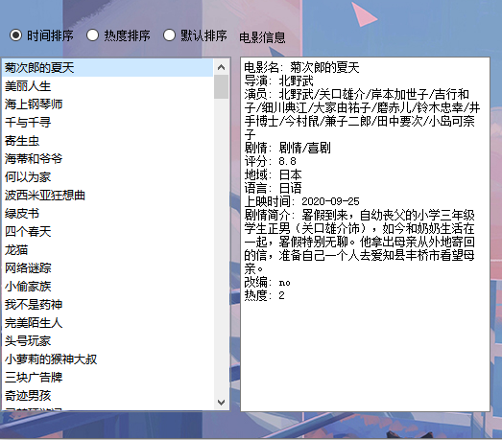

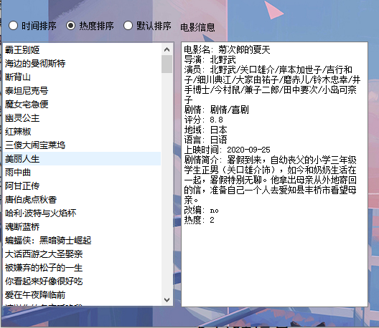

## 2、添加评论

之后可以为阿甘正传添加评语，在右下角添加评论框中输入评语

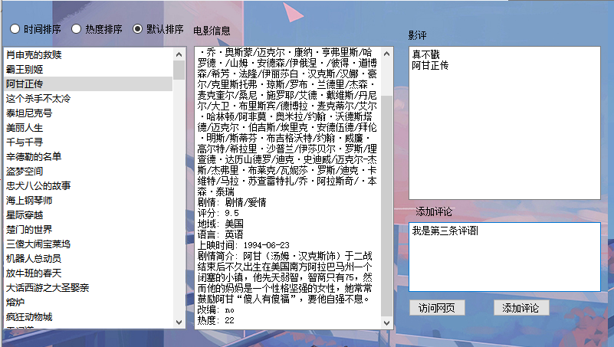

点击添加，成功显示

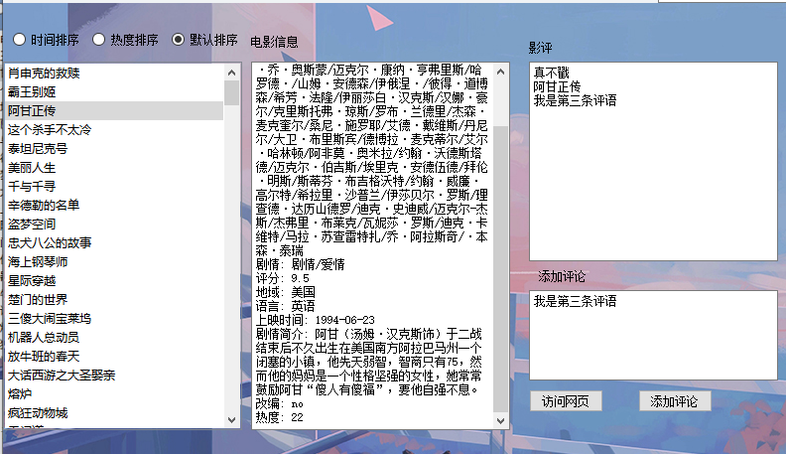

当评论为空时，会提示错误

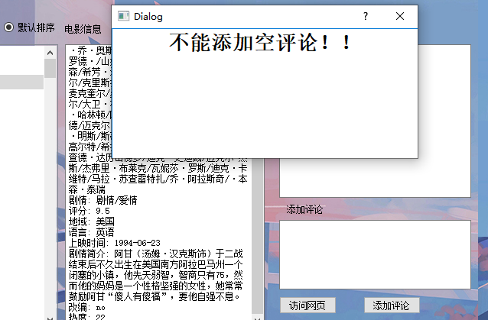

## 交叉查询演示

点击爱情，搜索，在左侧显示了全部爱情类型的电影。



进一步选择美国，语言，非改编，可以看到搜索的范围变小了



在进一步缩小范围，选择导演，输入卡梅隆，就只剩下泰坦尼克号了



## 访问网页

点击访问网页，会自动打开浏览器，弹出该电影的豆瓣网页，可以通过豆瓣观看电影的部分画面（很多电影并没有免费的观看网页，因此统一选择了豆瓣）。

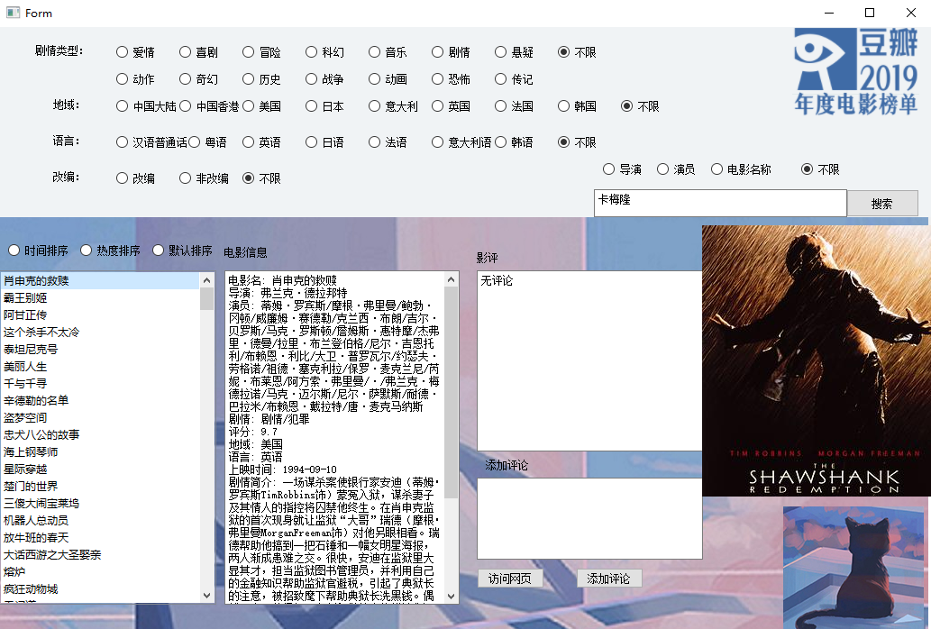

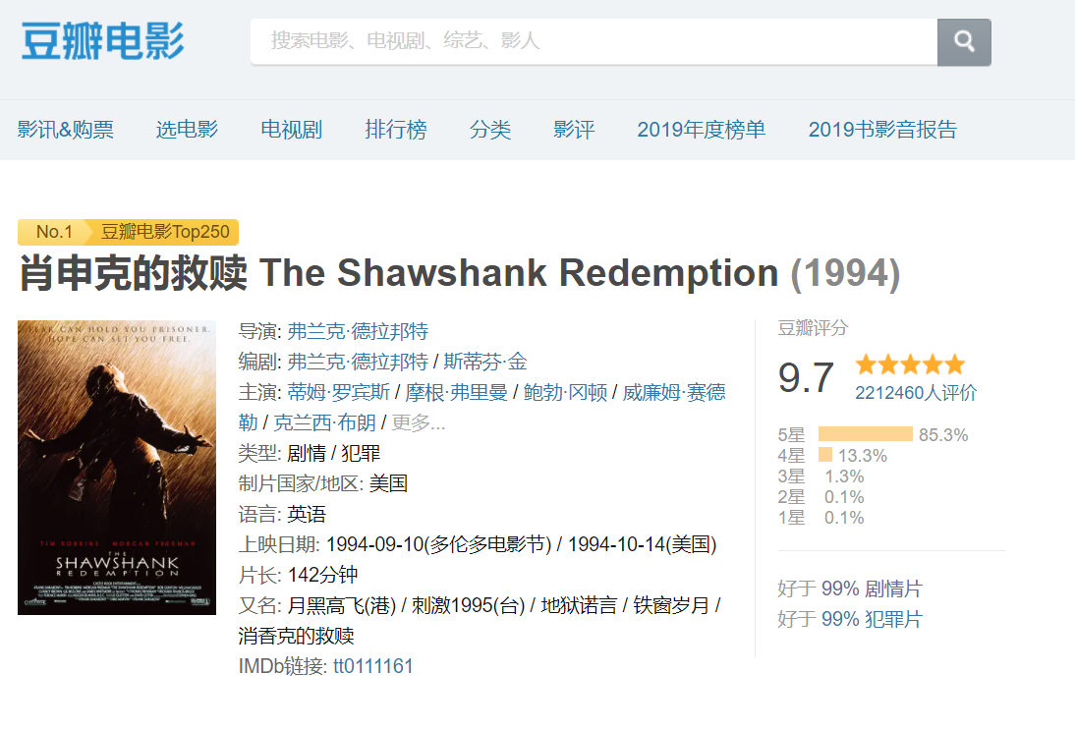

## 5、初始化

全部点击不限，并在此点击搜索，就可以重新搜索（并未找到重置按钮的方法）



## 修改原数据文件





hot.txt 存储电影的热度

urllist.txt 存储电影的网页链接

评语.txt 存储电影的评语

movielist.txt 存储电影的主要数据（不包含热度、网页链接、评语）

热度、网页链接、评语单独存储的目的是方便修改，因为修改数据时是采用全部覆盖的形式，分开存储可以更加效率。

Img文件夹存储图片

# 5总结提高

同学依据自己的经历写出个性化的总结。内容可以包括：程序开发中的体会与收获，开发中遇到的问题与解决情况，自己对自己完成课设情况的评价等等。

## 5.1体会与收获

每次课设的制作都让我收获很多，他能让我重新巩固以前学习的知识，更加熟练的运用编程语言，尤其是这次使用了以前从未使用的python，对于我来说还是有着很大的挑战的。在最开始的阶段，选择哪种数据结构、选择那些算法才能使效率变高让我苦恼不已，这使得我畏手畏脚，迟迟不敢动手，直到后来检查的时间越来越近，才逼迫自己采用最简单、最容易想到的方法先去入手做数据结构的部分，因此选择了思路简单的链表和遍历搜索。

但是这在后面的制作中为我添了很大的麻烦，比如在排序时，链表的快速排序，尤其是单链表的快速排序相比顺序表更复杂、效率也低，此时很多一开始和我思路相同的同学改用了顺序表的存储结构，而我认为通过链表实现快速排序，也是一种练习，因此继续坚持使用了链表，不过还是做出了改进，改为了双向链表。在与其他同学的交流中，我也了解到了树的存储结构的优缺点，可以说通过这次课设，让我对存储结构有了更深刻的认识和体会。

另一个收获就是让我学会了使用python，以前一直听说python是很方便很容易学习理解的语言，并且功能强大，但是一直没有一个时机去学习它，这次课设给我提供了这个时机。虽然在过程中因为不了解python绕了很多弯路（比如python没有指针），但是当到了后期，我真的体会到了python的便利和强大。

最后一个收获就是让我体会到了编程的魅力，以前对编程一直非常抵触，甚至一度因为不想接触编程而想放弃走IT这条路，但是在这次课设中，每当解决一个问题后，所获得的那种巨大的成就感，让我感受到了编程的魅力，这将鼓励我、支持我继续走下去。

## 5.2问题与解决

这次遇到的问题主要有两个方面

一是对python的不熟悉，让我受了很多苦，比如我一开始并不会使用python中的self，再比如没有指针使得我对链表的操作、以及数据更改上遇到了很大的问题，最让我困扰的就是python和c完全是两种存储方式，比如同样的a=1，这两种语言的逻辑完全不同。克服的办法就是在网上搜索解决办法，更深入了解python，实在不行就用些笨办法，比如电影每次重新搜索我都是将数据全部导入一遍。

二是图形界面，python的图形界面用的是pyqt5，学习使用pyqt5和Qtdesiner就花了不少的时间。在制作的过程中有时候因为用错了某个功能，让我不得不推翻从做，总之在制作界面时花费了超过制作功能模块的时间。

## 5.3评价

在界面的美化上也不够精致，应该吧电影图片和电影名字一起在搜索结果中显示。

# 6参考文献

1. 《a byte of python》 Swaroop C H

2、《数据结构与算法》（张铭版）

3、PyQt5，弹窗，自定义输入对话框

<https://blog.csdn.net/qq_39315153/article/details/88241517?utm_medium=distribute.pc_relevant.none-task-blog-BlogCommendFromBaidu-1.control&depth_1-utm_source=distribute.pc_relevant.none-task-blog-BlogCommendFromBaidu-1.control>

4、PyQt5-按钮控件使用

<https://www.cnblogs.com/ygzhaof/p/10059540.html>

5、QT designer的安装与汉化（pycharm）

https://blog.csdn.net/qq_36374896/article/details/83513828