Package Title: Testbank
Course Title: pap16 Sensory, Motor, and Integrative Systems
Chapter Number: 20
Shuffle: Yes
Case Sensitive: No

Question type: Multiple Choice

1) This is the term for the anatomical region found between the lungs extending from the sternum to the vertebral column and from the first rib to the diaphragm

a) epicardium.
b) abdominal cavity.
c) pericardium.
d) mediastinum.
e) thoracic cavity.

Answer: d

Difficulty: Easy
Bloomcode: Knowledge
Learning Objective 1: LO 20.1 Describe the position and structure of the heart.
Section Reference 1: Sec 20.1 Anatomy of the Heart

2) The membrane that surrounds and protects the heart is called the

a) pericardium.
b) pleura.
c) myocardium.
d) mediastinum.
e) endocardium.

Answer: a

Difficulty: Easy
Bloomcode: Knowledge
Learning Objective 1: LO 20.1 Describe the position and structure of the heart.
Section Reference 1: Sec 20.1 Anatomy of the Heart

3) The apex of the heart is normally pointed

a) at the midline.
b) to the left of the midline.
c) to the right of the midline.
d) differently for males and females.
e) posteriorly.

Answer: b

Difficulty: Easy
Bloomcode: Knowledge
Learning Objective 1: LO 20.1 Describe the position and structure of the heart.
the heart.
Section Reference 1: Sec 20.1 Anatomy of the Heart

4) Trauma to the pericardium associated with bleeding into the pericardial cavity, might cause

a) myocarditis.
b) endocarditis.
c) cardiac tamponade.
d) rapid heart rate.
e) ventricular tachycardia.

Answer: c

Difficulty: Hard
Bloomcode: Comprehension
Learning Objective 1: LO 20.1 Describe the position and structure of the heart.
Section Reference 1: Sec 20.1 Anatomy of the Heart

5) Which of the following is used to reduce friction between the layers of membranes surrounding the heart?

a) Synovial fluid
b) Endocardium
c) Pleural fluid
d) Pericardial fluid
e) Capillary endothelium

Answer: d

Difficulty: Easy
Bloomcode: Knowledge
Learning Objective 1: LO 20.1 Describe the position and structure of the heart.
Section Reference 1: Sec 20.1 Anatomy of the Heart Question type: Multiple Choice

6) The visceral layer of the serous pericardium is also called the

a) epicardium.
b) myocardium.
c) endocardium.
d) fibrous pericardium.
e) pericardial fluid.

Answer: a

Difficulty: Medium
Bloomcode: Comprehension
Learning Objective 1: LO 20.1 Describe the position and structure of the heart
Section Reference 1: Sec 20.1 Anatomy of the Heart

7) Which layer of the heart wall consists of cardiac muscle tissue?

a) Epicardium
b) Pericardium
c) Myocardium
d) Endocardium
e) Hypocardium

Answer: c

Difficulty: Medium
Bloomcode: Comprehension
Learning Objective 1: LO 20.1 Describe the position and structure of the heart
Section Reference 1: Sec 20.1 Anatomy of the Heart

8) A patient presents with a fever, heart murmur, irregular heartbeat, fatigue, loss of appetite and night sweats. As a physician, your diagnosis would be that of endocarditis typically caused by

a) a virus.
b) an autoimmune condition.
c) a bacterial infection.
d) exposure to radiation.
e) cancer.

Answer: c

Difficulty: Hard
Bloomcode: Synthesis
Learning Objective 1: LO 20.1 Describe the position and structure of the heart
Section Reference 1: Sec 20.1 Anatomy of the Heart

9) Cardiac tamponade may develop following a case of

a) myocarditis.
b) endocarditis.
c) palpitation.
d) pericarditis.
e) tachycardia.

Answer: d

Difficulty: Hard
Bloomcode: Synthesis
Learning Objective 1: LO 20.1 Describe the position and structure of the heart
Section Reference 1: Sec 20.1 Anatomy of the Heart

Question type: Text Drop Down

10) The coronary sulcus marks the external boundary between the [dropdown 1] and the [dropdown 2].

Dropdown 1 Choices:
auricles
coronary arteries
coronary sinus
superior atria

Dropdown 2 Choices:
apex
auricles
base
inferior ventricles

Answer 1: superior atria
Answer 2: inferior ventricles

Difficulty: Medium
Bloomcode: Comprehension
Learning Objective 1: LO 20.1 Describe the position and structure of the heart.
Section Reference 1: Sec 20.1 Anatomy of the Heart

Question type: Multiple Choice

11) Pectinate muscles extend from the atrial internal wall into the pouch-like structures that increase the total filling capacity of the atrium. These structure are the

a) ventricles.
b) coronary sulci.
c) fossa ovalis.
d) interatrial septa.
e) auricles.

Answer: e

Difficulty: Hard
Bloomcode: Comprehension
Learning Objective 1: LO 20.1 Describe the position and structure of the heart.
Section Reference 1: Sec 20.1 Anatomy of the Heart

12) Identify the groove found on the surface of the heart that marks the boundary between the right and left ventricles.

a) Coronary sulcus
b) Anterior interventricular sulcus
c) Posterior interventricular sulcus
d) Coronary sinus
e) Anterior intraventricular sulcus

Answer: b

Difficulty: Hard
Bloomcode: Comprehension
Learning Objective 1: LO 20.1 Describe the position and structure of the heart.
Section Reference 1: Sec 20.1 Anatomy of the Heart

13) Identify the muscular ridges that are found on the anterior wall of the right atrium and extend into the auricles.

a) Pectinate muscles
b) Trabeculae carneae
c) Coronary sulci
d) Papillary muscles
e) Chordae tendinae

Answer: a

Difficulty: Medium
Bloomcode: Comprehension
Learning Objective 1: LO 20.1 Describe the position and structure of the heart.
Section Reference 1: Sec 20.1 Anatomy of the Heart

14) Through which structure does blood pass from the right atrium to the right ventricle?

a) Bicuspid valve
b) Interventricular septum
c) Tricuspid valve
d) Mitral valve
e) Ascending aorta

Answer: c

Difficulty: Easy
Bloomcode: Knowledge
Learning Objective 1: LO 20.1 Describe the position and structure of the heart.
Section Reference 1: Sec 20.1 Anatomy of the Heart

15) What type of tissue comprises the valves of the heart?

a) Dense connective tissue
b) Areolar connective tissue
c) Hyaline cartilage
d) Cardiac muscle tissue
e) Adipose tissue

Answer: a

Difficulty: Medium
Bloomcode: Comprehension
Learning Objective 1: LO 20.1 Describe the position and structure of the heart.
Section Reference 1: Sec 20.1 Anatomy of the Heart

16) Blood leaving the left ventricle passes through which of the following structures?

a) Right atrium
b) Interventricular septum
c) Bicuspid valve
d) Aortic semilunar valve
e) Pulmonary semilunar valve

Answer: d

Difficulty: Medium
Bloomcode: Comprehension
Learning Objective 1: LO 20.1 Describe the position and structure of the heart.
Section Reference 1: Sec 20.1 Anatomy of the Heart

17) Identify the structure found in a fetus that allows blood to flow directly from the pulmonary trunk into the aorta.

a) Fossa ovalis
b) Foramen ovale
c) Trabeculae carneae
d) Descending aorta
e) Ductus arteriosus

Answer: e

Difficulty: Hard
Bloomcode: Analysis
Learning Objective 1: LO 20.1 Describe the position and structure of the heart.
Section Reference 1: Sec 20.1 Anatomy of the Heart

Question type: Essay

18) Explain the difference in myocardial thickness between the left and right ventricles.

Answer:

Difficulty: Medium
Bloomcode: Analysis
Learning Objective 1: LO 20.1 Describe the position and structure of the heart.
Section Reference 1: Sec 20.1 Anatomy of the Heart
Solution: The left ventricle muscular wall is thicker than the right ventricle because it has to generate higher pressure to overcome the greater resistance of the longer systemic circulation route versus the shorter pulmonary circulation route. Basically, the more work a muscle does, the larger it gets.

Question type: Multiple Choice

19) Contraction of the ventricles of the heart leads to blood moving directly

a) into arteries.
b) into capillaries.
c) into veins.
d) through atrioventricular valves.
e) through semilunar valves.

Answer: e

Difficulty: Medium
Bloomcode: Comprehension
Learning Objective 1: LO 20.1 Describe the position and structure of the heart.
Section Reference 1: Sec 20.1 Anatomy of the Heart

20) Contraction of the atria of the heart leads to blood moving directly

a) into auricles.
b) into arteries.
c) into veins.
d) through atrioventricular valves.
e) through semilunar valves.

Answer: d

Difficulty: Medium
Bloomcode: Comprehension
Learning Objective 1: LO 20.1 Describe the position and structure of the heart.
Section Reference 1: Sec 20.1 Anatomy of the Heart

21) Which valve below prevents blood from flowing back into the right ventricle?

a) Tricuspid valve
b) Bicuspid valve
c) Pulmonary semilunar valve
d) Aortic semilunar valve
e) Mitral valve

Answer: c

Difficulty: Medium
Bloomcode: Comprehension
Learning Objective 1: LO 20.1 Describe the position and structure of the heart.
Section Reference 1: Sec 20.1 Anatomy of the Heart

Question type: Essay

22) Explain how the heart pumps blood into two separate closed circuits that are arranged in series.

Answer:

Difficulty: Easy
Bloomcode: Knowledge
Learning Objective 1: LO 20.2. Describe the valves of the heart and the circulation of blood.
Section Reference 1: Sec 20.2 Heart Valves and Circulation of Blood
Solution: The two circuits are the pulmonary and systemic circuits. Venous blood from the systemic circulation enters the right atrium. The blood moves from the right atrium into the right ventricle of the heart, which pumps blood through the pulmonary circuit eventually filling the left atrium. The blood moves from the left atrium into the left ventricle of the heart, which pumps blood through the systemic circuit back into the right atrium.

Question type: Multiple Choice

23) Which of the following chambers of the heart contains deoxygenated blood?

a) Left atrium and left ventricle
b) Left atrium only
c) Right atrium and right ventricle
d) Right ventricle only
e) Left atrium and right ventricle

Answer: c

Difficulty: Medium
Bloomcode: Comprehension
Learning Objective 1: LO 20.1 Describe the position and structure of the heart.
Section Reference 1: Sec 20.1 Anatomy of the Heart

24) Which of the following blood vessels is used to distribute oxygenated blood to the myocardium?

a) Coronary artery
b) Coronary vein
c) Coronary sinus
d) Vena cava
e) Myocardial vein

Answer: a

Difficulty: Easy
Bloomcode: Knowledge
Learning Objective 1: LO 20.1 Describe the position and structure of the heart.
Section Reference 1: Sec 20.1 Anatomy of the Heart

25) Cardiac muscle fibers are electrically connected to neighboring fibers by

a) desmosomes.
b) tight junctions.
c) gap junctions.
d) interneurons.
e) chordae tendinae.

Answer: c

Difficulty: Medium
Bloomcode: Comprehension
Learning Objective 1: LO 20.3 Describe the structure and function of cardiac muscle tissue and the cardiac conduction system.
Section Reference 1: Sec 20.3 Cardiac Muscle Tissue and the Cardiac Conduction System

26) Which of the following types of muscle contains the largest number of mitochondria per cell?

a) Smooth muscle
b) Skeletal muscle
c) Cardiac muscle
d) All the muscle types contain approximately the same number.
e) Mitochondria are not found in muscle cells.

Answer: c

Difficulty: Easy
Bloomcode: Knowledge
Learning Objective 1: LO 20.3 Describe the structure and function of cardiac muscle tissue and the cardiac conduction system.
Section Reference 1: Sec 20.3 Cardiac Muscle Tissue and the Cardiac Conduction System

Question type: Essay

27) Briefly describe why cardiac tissue cannot repair itself after damage?

Answer:

Difficulty: Medium
Bloomcode: Analysis
Learning Objective 1: LO 20.3 Describe the structure and function of cardiac muscle tissue and the cardiac conduction system.
Section Reference 1: Sec 20.3 Cardiac Muscle Tissue and the Cardiac Conduction System
Solution: Cardiac muscle lacks stem cells and mature cardiac muscle fibers cannot go through mitosis.

28) Describe the recent research that showed significant replacement of heart cells is possible as well as the presence of stem cells in heart muscle tissue.

Answer:

Difficulty: Medium
Bloomcode: Analysis
Learning Objective 1: LO 20.3 Describe the structure and function of cardiac muscle tissue and the cardiac conduction system.
Section Reference 1: Sec 20.3 Cardiac Muscle Tissue and the Cardiac Conduction System
Solution: A study of male heart transplant patients where the donor was female was conducted in order to determine if heart cells can be replaced. Because males have an X and a Y chromosome in all of their cells (except gametes) and females have two X chromosomes in all of their cells (except gametes), researchers analyzed the heart cells in the donor heart several years after the transplant took place. It would be expected that all of the cells would contain two X chromosomes since the heart came from a female. However, researchers were surprised to find that between 7% and 16% of the heart cells in the transplanted heart had been replaced by the recipients own cells. This was determined by the presence of a Y chromosome in those cells. In addition, the presence of cells with some of the characteristics of stem cells were present in both transplanted hearts and control hearts. It was determined that stem cells can migrate from the blood into the heart and differentiate into functional muscle cells.

Question type: Multiple Choice

29) Which network of specialized cardiac muscle fibers provides a path for each cycle of cardiac excitation to progress through the heart?

a) Systemic circuit
b) Intercalated discs
c) Cardiovascular center
d) Cardiac conduction system
e) Pulmonary circuit

Answer: d

Difficulty: Easy
Bloomcode: Comprehension
Learning Objective 1: LO 20.3 Describe the structure and function of cardiac muscle tissue and the cardiac conduction system.
Section Reference 1: Sec 20.3 Cardiac Muscle Tissue and the Cardiac Conduction System

30) Which of the following correctly lists the sequence of structures that a cardiac action potential follows in order to excite normal contraction of the heart?

a) Bundle of His, Subendocardial conducting network, Atrioventricular (AV) node
b) Sinoatrial (SA) node, Subendocardial conducting network, AV node, Bundle of His
c) Subendocardial conducting network, AV node, SA node, Bundle of His
d) SA node, AV node, Bundle of His, Subendocardial conducting network
e) Bundle of His, SA node, AV node, Subendocardial conducting network

Answer: d

Difficulty: Medium
Bloomcode: Comprehension
Learning Objective 1: LO 20.3 Describe the structure and function of cardiac muscle tissue and the cardiac conduction system.
Section Reference 1: Sec 20.3 Cardiac Muscle Tissue and the Cardiac Conduction System

Question type: Text Dropdown

31) In comparison to skeletal muscle fibers, the contractile fibers of the heart are depolarized for [dropdown 1] period of time.

Dropdown Choices:
a longer
a shorter
a variable
the same

Answer: a longer

Difficulty: Easy
Bloomcode: Knowledge
Learning Objective 1: LO 20.3 Describe the structure and function of cardiac muscle tissue and the cardiac conduction system.
Section Reference 1: Sec 20.3 Cardiac Muscle Tissue and the Cardiac Conduction System

Question type: Multiple Choice

32) The volume of blood ejected from the left ventricle into the aorta each minute is called the

a) cardiac output.
b) cardiac input.
c) stroke volume.
d) heart rate.
e) pulse pressure.

Answer: a

Difficulty: Easy
Bloomcode: Knowledge
Learning Objective 1: LO 20.5 Describe the factors involved in the regulation of cardiac output and heart rate.
Section Reference 1: Sec 20.5 Cardiac Output

33) Which term refers to the period of time during a cardiac cycle when contraction of a chamber occurs and pressure within the chamber rises?

a) Filling
b) Systole
c) Repolarization
d) Diastole
e) Fibrillation

Answer: b

Difficulty: Medium
Bloomcode: Comprehension
Learning Objective 1: LO 20.4 Describe the events of the cardiac cycle.
Section Reference 1: Sec 20.4 The Cardiac Cycle

Question type: Text Drop Down

34) The period of atrial systole lasts about [dropdown 1] while the period of ventricular systole lasts approximately [dropdown 2].

Dropdown 1 Choices:
0.4 second
0.3 second
0.1 second
0.6 second

Dropdown 2 Choices:
0.4 second
0.3 second
0.1 second
0.6 second

Answer 1: 0.1 second
Answer 2: 0.3 second

Difficulty: Medium
Bloomcode: Comprehension
Learning Objective 1: LO 20.4 Describe the events of the cardiac cycle.
Section Reference 1: 20.4 The Cardiac Cycle

Question type: Multiple Choice

35) During which of the following periods does the largest volume of blood enter the arteries?

a) Atrial diastole
b) Ventricular diastole
c) Atrial systole
d) Ventricular systole
e) The volume is about the same during each period

Answer: d

Difficulty: Medium
Bloomcode: Comprehension
Learning Objective 1: LO 20.4 Describe the events of the cardiac cycle.
Section Reference 1: Sec 20.4 The Cardiac Cycle

36) The second heart sound (dupp) closely follows which of the events listed below?

a) Valvular stenosis
b) Semilunar valves opening
c) Atrioventricular valves closing
d) Semilunar valves closing
e) Atrioventricular valves opening

Answer: d

Difficulty: Medium
Bloomcode: Comprehension
Learning Objective 1: LO 20.4 Describe the events of the cardiac cycle.
Section Reference 1: Sec 20.4 The Cardiac Cycle

Question type: Multiple Selection

37) Which of the following correctly describes ventricular ejection? Select all that apply.

a) Occurs when semilunar valves are open
b) Occurs when semilunar valves are closed
c) Lasts for about 0.25 second
d) Lasts for about 0.1 second
e) Occurs when atrioventricular valves are open
f) Occurs when atrioventricular valves are closed

Answer 1: a
Answer 2: c
Answer 3: f

Difficulty: Medium
Bloomcode: Comprehension
Learning Objective 1: LO 20.4 Describe the events of the cardiac cycle.
Section Reference 1: Sec 20.4 The Cardiac Cycle

Question type; Multiple Choice

38) Which structure in the heart initiates action potentials that stimulate contraction of the heart at a constant rate of about 100 beats per minute?

a) Cardiac accelerator nerves
b) Atrioventricular node
c) Cardiovascular center
d) Sinoatrial node
e) Bundle of His

Answer: d

Difficulty: Hard
Bloomcode: Evaluation
Learning Objective 1: LO 20.3 Describe the structure and function of cardiac muscle tissue and the cardiac conduction system.
Section Reference 1: Sec 20.3 Cardiac Muscle Tissue and the Cardiac Conduction System

39) Stimulation of which nerve reduces heart rate?

a) Cardiac accelerator nerve
b) Hypoglossal nerve
c) Spinal accessory
d) Vagus nerve
e) Phrenic nerve

Answer: d

Difficulty: Medium
Bloomcode: Comprehension
Learning Objective 1: LO 20.5 Describe the factors involved in the regulation of cardiac output and heart rate.
Section Reference 1: Sec 20.5 Cardiac Output

40) Which of the following would lead to a decreased heart rate?

a) Increased norepinephrine release
b) Increased thyroid hormone release
c) Increased potassium levels in plasma
d) Increased calcium levels in plasma
e) Increased sympathetic stimulation

Answer: c

Difficulty: Hard
Bloomcode: Synthesis
Learning Objective 1: LO 20.5 Describe the factors involved in the regulation of cardiac output and heart rate.
Section Reference 1: Sec 20.5 Cardiac Output

Question type: Essay

41) What is the relationship between strenuous exercise (a heart rate exceeding 160 beats/minute) and the Frank-Starling law of the heart?

Answer:

Difficulty: Hard
Bloomcode: Analysis
Learning Objective 1: LO 20.5 Describe the factors involved in the regulation of cardiac output and heart rate.
Section Reference 1: Sec 20.5 Cardiac Output
Solution: The Frank-Starling law of the heart states that the more the heart fills with blood during diastole, the greater the force of contraction during systole. When an individual is exercising strenuously, it would not be unusual for the heart rate to exceed 160 beats per minute. When this happens, stroke volume usually declines because the filling time is reduced thus leading to a reduced end diastolic volume (EDV). The reduced EDV means that, according to the Frank-Starling law, the preload is lower and the stroke volume is also reduced.

Question type: Multiple Choice

42) An increase in the carbon dioxide levels in the blood leads to a change in the chemical composition of the blood. This input would be received by which part of the brain that regulates heart rate?

a) Midbrain
b) Cerebrum
c) Medulla oblongata
d) Cerebellum
e) Thalamus

Answer: c

Difficulty: Hard
Bloomcode: Comprehension
Learning Objective 1: LO 20.5 Describe the factors involved in the regulation of cardiac output and heart rate.
Section Reference 1: Sec 20.5 Cardiac Output

43) Which wave in an electrocardiogram represents repolarization of the ventricles?

a) R wave
b) T wave
c) S wave
d) P wave
e) Q wave

Answer: b

Difficulty: Easy
Bloomcode: Knowledge
Learning Objective 1: LO 20.3 Describe the structure and function of cardiac muscle tissue and the cardiac conduction system.
Section Reference 1: Sec 20.3 Cardiac Muscle Tissue and the Cardiac Conduction System

44) Which of the following selections lists conditions that would lead to increased stroke volume?

a) Increased preload, increased afterload, increased contractility
b) Decreased preload, decreased afterload, decreased contractility
c) Increased preload, decreased afterload, increased contractility
d) Decreased preload, increased afterload, increased contractility
e) Increased preload, increased afterload, decreased contractility

Answer: c

Difficulty: Hard
Bloomcode: Analysis
Learning Objective 1: LO 20.5 Describe the factors involved in the regulation of cardiac output and heart rate.
Section Reference 1: Sec 20.5 Cardiac Output

45) Which of the following electrocardiogram (ECG) waves represents atrial depolarization?

a) R wave
b) T wave
c) S wave
d) P wave
e) Q wave

Answer: d

Difficulty: Easy
Bloomcode: Knowledge
Learning Objective 1: LO 20.3 Describe the structure and function of cardiac muscle tissue and the cardiac conduction system.
Section Reference 1: Sec 20.3 Cardiac Muscle Tissue and the Cardiac Conduction System

46) Prior to physical activity, the heart rate may climb. This anticipatory increase is caused by nerve impulses traveling to the cardiovascular center of the medulla oblongata that originate in the

a) cerebral cortex.
b) hypothalamus.
c) baroreceptors.
d) limbic system.
e) proprioceptors.

Answer: d

Difficulty: Medium
Bloomcode: Comprehension
Learning Objective 1: LO 20.5 Describe the factors involved in the regulation of cardiac output and heart rate.
Section Reference 1: Sec 20.5 Cardiac Output

47) The formula for calculating cardiac output (CO) is

a) heart rate multiplied by cardiac reserve.
b) heart rate multiplied by end diastolic volume.
c) heart rate multiplied by stroke volume.
d) end diastolic volume multiplied by cardiac reserve.
e) venous return multiplied by stroke volume.

Answer: c

Difficulty: Easy
Bloomcode: Knowledge
Learning Objective 1: LO 20.5 Describe the factors involved in the regulation of cardiac output and heart rate.
Section Reference 1: Sec 20.5 Cardiac Output

48) Positive inotropic agents often promote inflow of which cation to increase contractility of the heart?

a) Sodium
b) Potassium
c) Magnesium
d) Phosphorus
e) Calcium

Answer: e

Difficulty: Medium
Bloomcode: Comprehension
Learning Objective 1: LO 20.5 Describe the factors involved in the regulation of cardiac output and heart rate.
Section Reference 1: Sec 20.5 Cardiac Output

49) In the diagram, where is the left auricle of the left atrium?
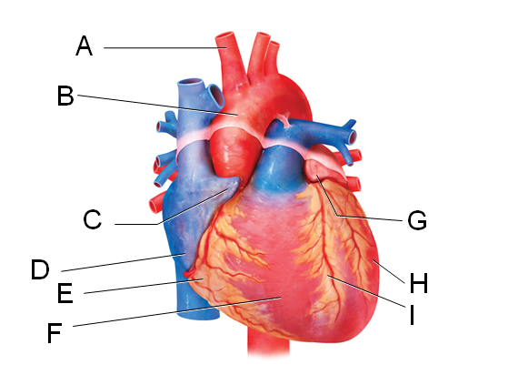

a) C
b) F
c) G
d) H
e) I

Answer: c

Difficulty: Medium
Bloomcode: Comprehension
Learning Objective 1: LO 20.1 Describe the position and structure of the heart.
Section Reference 1: Sec 20.1 Anatomy of the Heart

50) In the diagram, which labeled structure prevents blood flow from the right ventricle back into the right atrium?
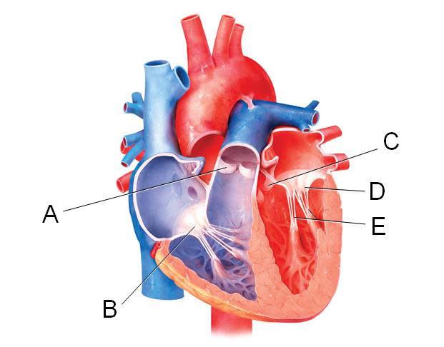

a) A
b) B
c) C
d) D
e) E

Answer: b

Difficulty: Easy
Bloomcode: Knowledge
Learning Objective 1: LO 20.1 Describe the position and structure of the heart.
Section Reference 1: Sec 20.1 Anatomy of the Heart

51) In the diagram, which labeled structure is the pulmonary semilunar valve?

a) B
b) D
c) E
d) A
e) C

Answer: d

Difficulty: Medium
Bloomcode: Comprehension
Learning Objective 1: LO 20.1 Describe the position and structure of the heart.
Section Reference 1: Sec 20.1 Anatomy of the Heart

52) In the diagram, which labeled structures are atrioventricular valves?

a) A and B
b) C and D
c) A and C
d) B and D
e) A, B, C and D

Answer: d

Difficulty: Medium
Bloomcode: Comprehension
Learning Objective 1: LO 20.1 Describe the position and structure of the heart.
Section Reference 1: Sec 20.1 Anatomy of the Heart

Question type: Essay

53) Describe what is happening during the phase of the cardiac action potential labeled 2 in the diagram.
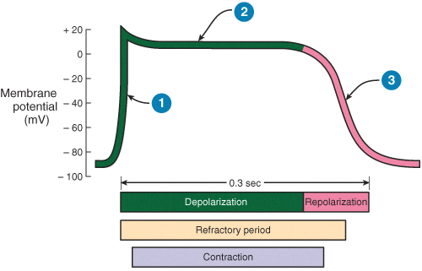

Answer:

Difficulty: Hard
Bloomcode: Comprehension
Learning Objective 1: LO 20.3 Describe the structure and function of cardiac muscle tissue and the cardiac conduction system.
Section Reference 1: Sec 20.3 Cardiac Muscle Tissue and the Cardiac Conduction System
Solution: Phase 2 is the plateau phase which occurs due to opening of voltage-gated slow calcium channels, which allows continued inflow of Ca²⁺ from ICF into the cytosol. This continuous inflow of Ca⁺² causes sustained depolarization of the cardiac muscle cells.

54) Briefly describe what is happening at the stage of the ECG labeled 5 in the diagram.
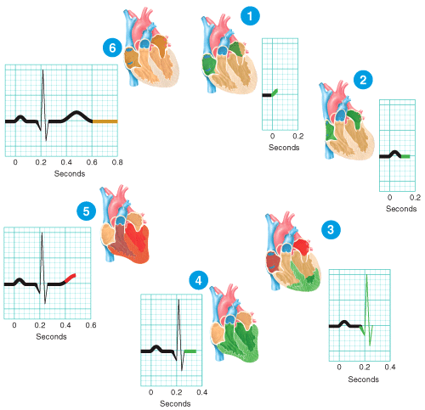

Difficulty: Medium
Bloomcode: Comprehension
Learning Objective 1: LO 20.3 Describe the structure and function of cardiac muscle tissue and the cardiac conduction system.
Section Reference 1: Sec 20.3 Cardiac Muscle Tissue and the Cardiac Conduction System
Solution: The contractile fibers of the ventricles are repolarizing, which generates the T wave in the ECG.

Question type: Multiple Choice

55) Which phases of a heartbeat shown in the diagram involve depolarization of any of the heart's four chambers?

a) 1 and 3
b) 2 and 4
c) 4 and 6
d) 1, 3, and 5
e) 1 and 5

Answer: a

Difficulty: Medium
Bloomcode: Comprehension
Learning Objective 1: LO 20.3 Describe the structure and function of cardiac muscle tissue and the cardiac conduction system.
Section Reference 1: Sec 20.3 Cardiac Muscle Tissue and the Cardiac Conduction System

56) Which of the labeled diagrams shows coarctation of the aorta?
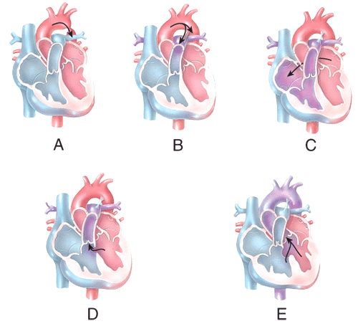

a) A
b) B
c) C
d) D
e) E

Answer: a

Difficulty: Medium
Bloomcode: Comprehension
Learning Objective 1: LO 20.8 Describe the development of the heart.
Section Reference 1: 20.8 Development of the Heart

57) Which of the labeled diagrams shows an atrial septal defect?

a) A
b) B
c) C
d) D
e) E

Answer: c

Difficulty: Medium
Bloomcode: Comprehension
Learning Objective 1: LO 20.8 Describe the development of the heart.
Section Reference 1: 20.8 Development of the Heart

58) Which of the labeled steps in the diagram represents formation of the primitive heart tube?
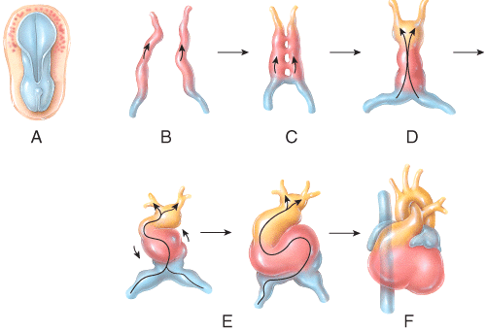

a) A
b) B
c) C
d) D
e) E

Answer: c

Difficulty: Medium
Bloomcode: Comprehension
Learning Objective 1: LO 20.8 Describe the development of the heart.
Section Reference 1: Sec 20.8 Development of the Heart

59) Which of the labeled steps in the diagram represents formation of the endocardial tubes?

a) A
b) B
c) C
d) D
e) E

Answer: b

Difficulty: Medium
Bloomcode: Comprehension
Learning Objective 1: LO 20.8 Describe the development of the heart.
Section Reference 1: Sec 20.8 Development of the Heart

60) Which week of fetal development might be considered the stage of development of the heart with the chambers as they will be oriented for the rest of the individual's life?

a) Fourth
b) Fifth
c) Sixth
d) Seventh
e) Eighth

Answer: a

Difficulty: Hard
Bloomcode: Analysis
Learning Objective 1: LO 20.8 Describe the development of the heart.
Section Reference 1: Sec 20.8 Development of the Heart

61) Which labeled structure shown in the diagram is a remnant of fetal circulation that is NOT directly involved in adult circulation?
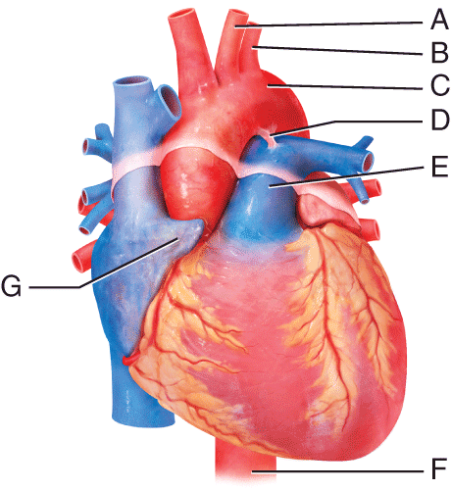

a) A
b) B
c) H
d) D
e) E

Answer: d

Difficulty: Hard
Bloomcode: Analysis
Learning Objective 1: LO 20.1 Describe the position and structure of the heart.
Section Reference 1: Sec 20.1 Anatomy of the Heart

62) Which labeled blood vessel in the diagram is an artery carrying deoxygenated blood?

a) A
b) B
c) C
d) E
e) F

Answer: d

Difficulty: Hard
Bloomcode: Evaluation
Learning Objective 1: LO 20.1 Describe the position and structure of the heart.
Section Reference 1: Sec 20.1 Anatomy of the Heart

63) Which labeled blood vessel shown in the diagram is the left common carotid artery?

a) A
b) B
c) E
d) F
e) H

Answer: a

Difficulty: Easy
Bloomcode: Knowledge
Learning Objective 1: LO 20.1 Describe the position and structure of the heart.
Section Reference 1: Sec 20.1 Anatomy of the Heart

64) Which labeled structure shown in the diagram is a pouch-like extension that serves to slightly increase the capacity of an atrium?

a) F
b) E
c) G
d) I
e) D

Answer: c

Difficulty: Medium
Bloomcode: Comprehension
Learning Objective 1: LO 20.1 Describe the position and structure of the heart.
Section Reference 1: Sec 20.1 Anatomy of the Heart

65) Which labeled structure in the figure is the ligamentum arteriosum?

a) A
b) B
c) C
d) D
e) G

Answer: d

Difficulty: Easy
Bloomcode: Knowledge
Learning Objective 1: LO 20.1 Describe the position and structure of the heart.
Section Reference 1: Sec 20.1 Anatomy of the Heart

Question type: Essay

66) Explain the difference in the functions of low-density lipoproteins and high-density lipoproteins and explain why one is called "good" cholesterol and the other is called "bad" cholesterol.

Answer:

Difficulty: Medium
Bloomcode: Comprehension
Learning Objective 1: LO 20.9 Describe the disorders that affect the heart.
Section Reference 1: Sec Ch 20: Disorders: Homeostatic Imbalance
Solution: Low-density lipoproteins (LDL) transport cholesterol from the liver to body cells. Excess LDLs lead to the development of atherosclerotic plaque, so they are referred to as "bad" cholesterol. High-density lipoproteins (HDL) remove excess cholesterol from body cells and transport it back to the liver for elimination, so they are referred to as "good" cholesterol.

Question type: Multiple Choice

67) Which structure in the figure is labeled B?

a) Left common carotid artery
b) Left subclavian artery
c) Left pulmonary vein
d) Superior vena cava
e) Brachiocephalic trunk

Answer: b

Difficulty: Medium
Bloomcode: Analysis
Learning Objective 1: LO 20.1 Describe the position and structure of the heart.
Section Reference 1: Sec 20.1 Anatomy of the Heart

68) Which structure in the figure is labeled A?

a) Left common carotid artery
b) Left subclavian artery
c) Left pulmonary vein
d) Pulmonary trunk
e) Superior vena cava

Answer: a

Difficulty: Medium
Bloomcode: Comprehension
Learning Objective 1: LO 20.1 Describe the position and structure of the heart.
Section Reference 1: Sec 20.1 Anatomy of the Heart

69) Which labeled structure in the figure acts as the natural pacemaker of the heart?
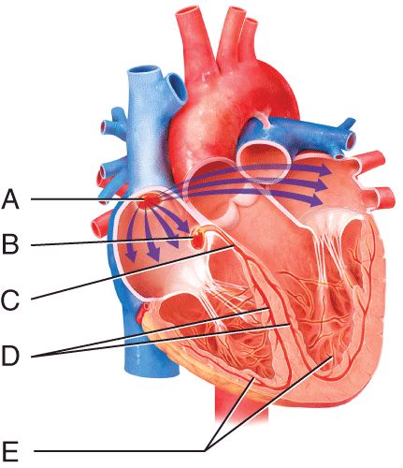

a) A
b) B
c) C
d) D
e) E

Answer: a

Difficulty: Medium
Bloomcode: Comprehension
Learning Objective 1: LO 20.3 Describe the structure and function of cardiac muscle tissue and the cardiac conduction system.
Section Reference 1: Sec 20.3 Cardiac Muscle Tissue and the Cardiac Conduction System

70) Which labeled structure in the figure is the AV node?

a) A
b) B
c) C
d) D
e) E

Answer: b

Difficulty: Easy
Bloomcode: Knowledge
Learning Objective 1: LO 20.3 Describe the structure and function of cardiac muscle tissue and the cardiac conduction system.
Section Reference 1: Sec 20.3 Cardiac Muscle Tissue and the Cardiac Conduction System

Question type: Text Drop Down

71) Two hormones that increase heart rate are [dropdown 1] and [dropdown 2].

Dropdown 1 Choices:
adrenocorticotropic hormone
growth hormone
testosterone
thyroid hormone

Dropdown 2 Choices:
acetylcholine
epinephrine
insulin
melatonin

Answer 1: thyroid hormone
Answer 2: epinephrine

Difficulty: Medium
Bloomcode: Comprehension
Learning Objective 1: LO 20.5 Describe the factors involved in the regulation of cardiac output and heart rate.
Section Reference 1: Sec 20.5 Cardiac Output

Question type: Multiple Choice

72) Athletes tend to have higher cardiac reserves because

a) they produce less epinephrine.
b) they eat more protein and vitamins.
c) their hearts operate more efficiently due to training.
d) they take in less oxygen than average individuals.
e) they put out more carbon dioxide than average individuals.

Answer: c

Difficulty: Hard
Bloomcode: Analysis
Learning Objective 1: LO 20.5 Describe the factors involved in the regulation of cardiac output and heart rate.
Section Reference 1: Sec 20.5 Cardiac Output

73) Which labeled structure in the figure represents the only pathway for conducting action potentials from the atria to the ventricles?

a) A
b) B
c) C
d) D
e) E

Answer: c

Difficulty: Medium
Bloomcode: Comprehension
Learning Objective 1: LO 20.3 Describe the structure and function of cardiac muscle tissue and the cardiac conduction system.
Section Reference 1: Sec 20.3 Cardiac Muscle Tissue and the Cardiac Conduction System

74) Which labeled structure in the figure carries the cardiac action potential directly into the contractile fibers of the ventricular myocardium?

a) A
b) B
c) C
d) D
e) E

Answer: e

Difficulty: Medium
Bloomcode: Comprehension
Learning Objective 1: LO 20.3 Describe the structure and function of cardiac muscle tissue and the cardiac conduction system.
Section Reference 1: Sec 20.3 Cardiac Muscle Tissue and the Cardiac Conduction System

Question type: Essay

75) Discuss the common nutrient sources used by cardiac muscle to produce ATP in a resting individual.

Answer:

Difficulty: Medium
Bloomcode: Analysis
Learning Objective 1: LO 20.3 Describe the structure and function of cardiac muscle tissue and the cardiac conduction system.
Section Reference 1: Sec 20.3 Cardiac Muscle Tissue and the Cardiac Conduction System
Solution: At rest, the heart relies exclusively on aerobic cellular respiration. At rest, the heart's ATP comes mainly from oxidation of fatty acids (60%), and glucose (35%) with smaller contributions from lactic acid, amino acids, and ketone bodies.

76) Define arrhythmia and discuss different categories of arrhythmias.

Answer:

Difficulty: Hard
Bloomcode: Evaluation
Learning Objective 1: LO 20.9 Describe the disorders that affect the heart.
Section Reference 1: Sec 20.8 Development of the Heart (Disorders: Homeostatic Imbalances)
Solution: The term arrhythmia or dysrhythmia refers to an abnormal rhythm as a result of a defect in the conduction system of the heart. Arrhythmias are categorized by their speed, rhythm, and origination of the problem. Bradycardia refers to a slow heart rate (below 50 bpm); tachycardia refers to a rapid heart rate (over 100 bpm); and fibrillation refers to rapid, uncoordinated heartbeats. Arrhythmias that originate in the atria are called supraventricular or atrial arrhythmias; those that originate in the ventricles are called ventricular arrhythmias.

Question type: Text Dropdown

77) Cardiac output is the volume of blood ejected from the [dropdown 1] ventricle into the [dropdown 2] each minute.

Dropdown 1 choices:
left
right
left or right
both left and right

Dropdown 2 choices:
aorta
pulmonary trunk
aorta or pulmonary trunk

Answer 1: left or right
Answer 2: aorta or pulmonary trunk

Difficulty: Medium
Bloomcode: Comprehension
Learning Objective 1: LO 20.5 Describe the factors involved in the regulation of cardiac output and heart rate.
Section Reference 1: Sec 20.5 Cardiac Output

Question type: Multiple Choice

78) The difference between a person's maximum cardiac output and resting cardiac output is called the

a) stroke volume.
b) peripheral resistance.
c) afterload.
d) cardiac reserve.
e) venous return.

Answer: d

Difficulty: Easy
Bloomcode: Knowledge
Learning Objective 1: LO 20.5 Describe the factors involved in the regulation of cardiac output and heart rate.
Section Reference 1: Sec 20.5 Cardiac Output

79) What is the function of the foramen ovale during fetal life?

a) Allowing blood to flow directly from the right atrium into the left atrium.
b) Allowing blood to flow directly from the right ventricle into the left ventricle.
c) Serves as a valve in the vena cava to regulate venous blood flow.
d) Prevents back flow of blood from aorta into the left ventricle.
e) Prevents back flow of blood from pulmonary trunk into the right ventricle.

Answer: a

Difficulty: Medium
Bloomcode: Comprehension
Learning Objective 1: LO 20.8 Describe the development of the heart.
Section Reference 1: Sec 20.8 Development of the Heart

80) Isovolumetric contraction is the phase of the cardiac cycle in which

a) the semilunar valves are open.
b) ventricular repolarization occurs.
c) atrial depolarization occurs.
d) oxygenated blood leaves the heart into the systemic circulation.
e) ventricular pressure increases and ventricular volume remains the same.

Answer: e

Difficulty: Hard
Bloomcode: Analysis
Learning Objective 1: LO 20.4 Describe the events of the cardiac cycle.
Section Reference 1: Sec 20.4 The Cardiac Cycle

81) Which of the following chambers of the heart is surrounded by the thickest layer of myocardium?

a) Right atrium
b) Left atrium
c) Right ventricle
d) Left ventricle
e) Right auricle

Answer: d

Difficulty: Easy
Bloomcode: Knowledge
Learning Objective 1: LO 20.1 Describe the position and structure of the heart.
Section Reference 1: Sec 20.1 Anatomy of the Heart

Question Type: Text Drop Down

82) Heart murmurs are often heard in individuals with abnormalities in the [dropdown 1] of the heart.

Dropdown Choices:

AV node
endocardium
myocardium
SA node
valves

Answer: valves

Difficulty: Medium
Bloomcode: Application
Learning Objective 1: LO 20.4 Describe the events of the cardiac cycle.
Section Reference 1: Sec 20.4 The Cardiac Cycle

83) In comparison to a sedentary individual, a well-trained athlete will usually have all the following characteristics EXCEPT

a) a higher cardiac reserve.
b) a higher resting cardiac output.
c) a higher stroke volume.
d) hypertrophy of the heart.
e) resting bradycardia.

Answer: b

Difficulty: Hard
Bloomcode: Synthesis
Learning Objective 1: LO 20.6 Explain how the heart is affected by exercise.
Section Reference 1: Sec 20.6 Exercise and the Heart

Question Type: Text Dropdown

84) During heart transplants, the [dropdown 1] nerves are severed resulting in a faster resting heart rate (approximately 100 beats per minute) after the transplant.

Dropdown choices:
cardiac accelerator
cervical spinal
glossopharyngeal
phrenic
vagus

Answer: vagus

Difficulty: Hard
Bloomcode: Evaluation
Learning Objective 1: LO 20.7 Describe several techniques used for failing hearts.
Section Reference 1: Sec 20.7 Help for Failing Hearts

Question Type: Multiple Choice

85) Which of the following is a corrective cardiac procedure in which a large piece of a patient's own latissimus dorsi muscle is wrapped around the heart and stimulated by an implanted pacemaker to assist the pumping action of a damaged heart?

a) Cardioversion
b) Cardiogenic transplant
c) Cardiomyopathy
d) Cardiomegaly
e) Cardiomyoplasty

Answer: e

Difficulty: Hard
Bloomcode: Evaluation
Learning Objective 1: LO 20.7 Describe several techniques used for failing hearts.
Section Reference 1: Sec 20.7 Help for Failing Hearts

© John Wiley & Sons, Inc. or the author. All rights reserved. Instructors who are authorized users of this course are permitted to download these materials and use them in connection with the course. Except as permitted herein or by law, no part of these materials should be reproduced, stored in a retrieval system, or transmitted, in any form or by any means, electronic, mechanical, photocopying, recording or otherwise.

