Package Title: Test bank
Course Title: pap16
Chapter Number: 18
Shuffle: Yes
Case Sensitive: No

Question type: Multiple Choice

1) Which of the following is NOT a function of a hormone?

a) Regulates chemical composition and volume of the internal environment
b) Regulates metabolism
c) Regulates glandular secretions
d) Produces electrolytes
e) Controls growth and development

Answer: d

Difficulty: Easy
Bloomcode: Knowledge
Learning Objective 1: LO 18.1 Compare control of body functions by the nervous system and endocrine system.
Section Reference 1: Sec 18.1 Comparison of Control by the Nervous and Endocrine Systems

Question type: Multiple Choice

2) When a hormone is present in excessive levels, the number of target-cell receptors may decrease. This is called

a) receptor recognition.
b) sensory adaptation.
c) paracrine regulation.
d) up-regulation.
e) down-regulation.

Answer: e

Difficulty: Medium
Bloomcode: Application
Learning Objective 1: LO 18.3 Describe how the various classes of hormones interact with target-cell receptors.
Section Reference 1: Sec 18.3 Hormone Activity

Question type: Multiple Choice

3) Differences between endocrine and exocrine glands include

a) endocrine glands secrete hormones while exocrine glands secrete non-hormonal substances
b) exocrine glands secrete their contents into ducts; endocrine glands have no ducts
c) products of exocrine glands work at sites distant from the actual glands
d) choices a and b
e) choices b and c

Answer: d

Difficulty: Medium
Bloomcode: Analysis
Learning Objective 1: LO 18.2 Distinguish between exocrine and endocrine glands
Section Reference 1: Sec 18.2 Endocrine Glands

Question type: Multiple Choice

4) Which of the choices below is a type of hormone that acts on neighboring cells without entering the bloodstream?
1. Local hormone
2. Paracrine
3. Autocrine
4. Circulating hormone

a) 1 only
b) 2 only
c) 3 only
d) 4 only
e) Both 1 and 2

Answer: e

Difficulty: Medium
Bloomcode: Application
Learning Objective 1: LO 18.3 Describe how the various classes of hormones interact with target-cell receptors.
Section Reference 1: Sec 18.3 Hormone Activity

Question type: Multiple Selection

5) Which of the following is a group of lipid-soluble hormones derived from cholesterol? Select all that apply.

a) Steroids
b) Thyroid hormones
c) Eicosanoid hormones
d) Amine hormones
e) Peptide hormones

Answer 1: a
Answer 2: b

Difficulty: Medium
Bloomcode: Analysis
Learning Objective 1: LO 18.3 Describe how the various classes of hormones interact with target-cell receptors.
Section Reference 1: Sec 18.3 Hormone Activity

Question type: Multiple Choice

6) Which of the following is an eicosanoid?
1. Prostaglandin
2. Leukotriene
3. Glycoprotein

a) 1 only
b) 2 only
c) 3 only
d) Both 1 and 2
e) All of these choices

Answer: d

Difficulty: Medium
Bloomcode: Analysis
Learning Objective 1: LO 18.3 Describe how the various classes of hormones interact with target-cell receptors.
Section Reference 1: Sec 18.3 Hormone Activity

Question type: Multiple Choice

7) An individual with a deficiency in fatty acid intake might have difficulty producing which type of hormones?

a) Amine hormones
b) Peptide hormones
c) Thyroid hormones
d) Steroid hormones
e) Eicosanoid hormones

Answer: e

Difficulty: Medium
Bloomcode: Analysis
Learning Objective 1: LO 18.3 Describe how the various classes of hormones interact with target-cell receptors.
Section Reference 1: Sec 18.3 Hormone Activity

Question type: Multiple Choice

8) Which of the following statements correctly compares water-soluble hormones with lipid-soluble hormones?

a) Both types of hormones are carried in the blood attached to a carrier protein.
b) Both types of hormone almost always stimulate increases in mRNA transcription.
c) Only water-soluble hormones use second messengers.
d) Only water-soluble hormones require a receptor.
e) Lipid-soluble hormones are not found in the bloodstream.

Answer: c

Difficulty: Medium
Bloomcode: Analysis
Learning Objective 1: LO 18.4 Describe the two general mechanisms of hormone action.
Section Reference 1: Sec 18.4 Mechanisms of Hormone Action

Question type: Multiple Choice

9) When one hormone opposes the action of another hormone, it is called a(n)

a) synergistic effect.
b) permissive effect.
c) antagonistic effect.
d) circulating effect.
e) local effect.

Answer: c

Difficulty: Easy
Bloomcode: Knowledge
Learning Objective 1: LO 18.4 Describe the two general mechanisms of hormone action.
Section Reference 1: Sec 18.4 Mechanisms of Hormone Action

Question type: Multiple Choice

10) Which of the following is NOT a common method of stimulating hormone secretion from an endocrine cell?

a) Signals from the nervous system
b) Chemical changes in the blood
c) Mechanical stretching of the endocrine cell
d) Releasing hormones.
e) Both Signals from the nervous system and chemical changes in the blood

Answer: c

Difficulty: Medium
Bloomcode: Application
Learning Objective 1: LO 18.5 Describe the mechanisms of control of hormone secretion..
Section Reference 1: Sec 18.5 Control of Hormone Secretion

Question type: Multiple Choice

11) What controls hormone release from the anterior pituitary gland?

a) Muscle contraction
b) The peripheral nervous system
c) Hormones released from the hypothalamus
d) Action potentials from the thalamus
e) Chemical changes in the cerebrospinal fluid (CSF)

Answer: c

Difficulty: Medium
Bloomcode: Analysis
Learning Objective 1: LO 18.6 Describe the properties of the hypothalamus and pituitary gland and the relationships between them.
Section Reference 1: Sec 18.6 Hypothalamus and Pituitary Gland

Question type: Multiple Choice

12) How are most hormones released?

a) On a continuous, low-level basis
b) In short bursts with little or no secretion between bursts.
c) In a gradually increasing then decreasing pattern
d) Continuously at high levels
e) It depends on the immediate needs of the body

Answer: b

Difficulty: Medium
Bloomcode: Application
Learning Objective 1: LO 18.5 Describe the mechanisms of control of hormone secretion
Section Reference 1: Section 18.5 Control of Hormone Secretion

Question type: Multiple Choice

13) Which of the following anterior pituitary hormones stimulates general body growth?

a) Somatotropin
b) Prolactin
c) Thyrotropin
d) Luteinizing hormone
e) Adrenocorticotropic hormone

Answer: a

Difficulty: Medium
Bloomcode: Application
Learning Objective 1: LO 18.6 Describe the properties of the hypothalamus and pituitary gland and the relationships between them.
Section Reference 1: Sec 18.6 Hypothalamus and Pituitary Gland

Question type: Text Drop Down

14) Human growth hormone is secreted by [dropdown 1] in the anterior pituitary gland, while follicle stimulating hormone is secreted by [dropdown 2].

Dropdown 1 choices:
corticotrophs
gonadotrophs
somatotrophs
thyrotrophs

Dropdown 2 choices:
corticotrophs
gonadotrophs
somatotrophs
thyrotrophs

Answer 1: somatotrophs
Answer 2: gonadotrophs

Difficulty: Medium
Bloomcode: Application
Learning Objective 1: LO 18.6 Describe the locations of and relationships between the hypothalamus and pituitary gland
Section Reference 1: Sec 18.6 Hypothalamus and Pituitary Gland

Question type: Multiple Choice

15) Which of the following anterior pituitary hormones stimulates milk production?

a) Luteinizing hormone
b) Prolactin
c) Thyrotropin
d) Melanocyte stimulating hormone
e) Adrenocorticotropic hormone

Answer: b

Difficulty: Medium
Bloomcode: Application
Learning Objective 1: LO 18.6 Describe the properties of the hypothalamus and pituitary gland and the relationships between them.
Section Reference 1: Sec 18.6 Hypothalamus and Pituitary Gland

Question type: Multiple Choice

16) Which of the following anterior pituitary hormones stimulates the adrenal cortex to secrete cortisol?

a) Luteinizing hormone
b) Prolactin
c) Insulin-like growth factors
d) Melanocyte-stimulating hormone
e) Adrenocorticotropic hormone

Answer: e

Difficulty: Medium
Bloomcode: Application
Learning Objective 1: LO 18.6 Describe the properties of the hypothalamus and pituitary gland and the relationships between them.
Section Reference 1: Sec 18.6 Hypothalamus and Pituitary Gland

Question type: Multiple Choice

17) Which of the following anterior pituitary hormones stimulates the gonads to secrete progesterone and/or testosterone?

a) Luteinizing hormone
b) TSH
c) Corticotropin
d) Melanocyte-stimulating hormone
e) Growth hormone

Answer: a

Difficulty: Medium
Bloomcode: Application
Learning Objective 1: LO 18.6 Describe the properties of the hypothalamus and pituitary gland and the relationships between them.
Section Reference 1: Sec 18.6 Hypothalamus and Pituitary Gland

Question type: Essay

18) Explain the mechanism by which a deficiency of gonadotropin-releasing hormone (GnRh) will lead to infertility in both a male and a female.

Answer:

Difficulty: Hard
Bloomcode: Evaluation
Learning Objective 1: LO 18.6 Describe the locations of and relationships between the hypothalamus and pituitary gland
Section Reference 1: Sec 18.6 Hypothalamus and Pituitary Gland
Solution: GnRh stimulates gonadotrophs to produce follicle-stimulating hormone (FSH) and luteinizing hormone (LH) in both males and females. FSH in women initiates the development of several ovarian follicles each cycle and stimulates follicular cells to secrete estrogens. In men, FSH stimulates sperm production in the testes. In females, LH triggers ovulation of the secondary oocyte and, after ovulation, stimulates the formation of the corpus luteum which secretes progesterone, estrogen, relaxin, and inhibin. Estrogens and progesterone hormones prepare the uterus for implantation of the blastocyst. In males, LH stimulates the cells in the testes that secrete testosterone. An imbalance of these hormones, due to reduced or no secretion, will lead to an inability to conceive due to any number of different functions associated with reproduction that are being interfered with.

Question type: Multiple Choice

19) Which type of anterior pituitary cell secretes melanocyte stimulating hormone (MSH)?

a) Thyrotrophs
b) Gonadotrophs
c) Somatotrophs
d) Lactotrophs
e) Corticotrophs

Answer: e

Difficulty: Medium
Bloomcode: Analysis
Learning Objective 1: LO 18.6 Describe the properties of the hypothalamus and pituitary gland and the relationships between them.
Section Reference 1: Sec 18.6 Hypothalamus and Pituitary Gland

Question type: Multiple Choice

20) Which of the following pairs of hormones are released by the posterior pituitary gland?

a) Prolactin and growth hormone
b) Melatonin-stimulating hormone and oxytocin
c) Oxytocin and antidiuretic hormone
d) Follicle-stimulating hormone and thyroid-stimulating hormone
e) Prolactin and ACTH

Answer: c

Difficulty: Medium
Bloomcode: Analysis
Learning Objective 1: LO 18.6 Describe the locations of and relationships between the hypothalamus and pituitary gland.
Section Reference 1: Sec 18.6 Hypothalamus and Pituitary Gland

Question type: Multiple Choice

21) The amount of ADH that is released by the posterior pituitary glands varies with

a) blood osmotic pressure.
b) blood calcium levels.
c) blood oxygen levels.
d) blood glucose levels.
e) all choices are correct.

Answer: a

Difficulty: Medium
Bloomcode: Analysis
Learning Objective 1: LO 18.6 Describe the properties of the hypothalamus and pituitary gland and the relationships between them.
Section Reference 1: Sec 18.6 Hypothalamus and Pituitary Gland

Question type: Multiple Select

22) In addition to increasing growth of bones and soft tissues, somatotropin (Select all that apply.)

a) enhances lipolysis.
b) decreases glucose uptake by most cells.
c) stimulates liver cells to release glucose.
d) increases cellular uptake of glucose.

Answer 1: a
Answer 2: b
Answer 3: c

Difficulty: Medium
Bloomcode: Analysis
Learning Objective 1: LO 18.6 Describe the properties of the hypothalamus and pituitary gland and the relationships between them.
Section Reference 1: Sec 18.6 Hypothalamus and Pituitary Gland

Question type: Multiple Choice

23) Which of the following hormones opposes the action of parathyroid hormone?

a) Thyroid-stimulating hormone
b) Testosterone
c) Insulin
d) Calcitonin
e) Calcitriol

Answer: d

Difficulty: Medium
Bloomcode: Analysis
Learning Objective 1: LO 18.8 Describe the location, histology, hormone, and functions of the parathyroid glands.
Section Reference 1: Sec 18.8 Parathyroid Glands

Question type: Multiple Choice

24) Which of the following statements does NOT describe a step in the synthesis and secretion of T₃ and T₄?

a) Iodide trapping
b) Oxidation of iodide
c) Coupling of T₁ and T₂
d) Synthesis of PTH
e) Iodination of tyrosine

Answer: d

Difficulty: Medium
Bloomcode: Analysis
Learning Objective 1: LO 18.7 Describe the location, histology, hormones, and functions of the thyroid gland.
Section Reference 1: Sec 18.7 Thyroid Gland

Question type: Multiple Choice

25) Parathyroid hormone is the major regulator of the plasma concentration of which of the following ions?

a) Calcium
b) Sodium
c) Potassium
d) Chloride
e) Manganese

Answer: a

Difficulty: Easy
Bloomcode: Knowledge
Learning Objective 1: LO 18.8 Describe the location, histology, hormone, and functions of the parathyroid glands.
Section Reference 1: Sec 18.8 Parathyroid Glands

Question type: Multiple Choice

26) Which endocrine gland stores its hormonal product for approximately 100 days?

a) Parathyroid
b) Adrenal
c) Pituitary
d) Hypothalamus
e) Thyroid

Answer: e

Difficulty: Easy
Bloomcode: Knowledge
Learning Objective 1: LO 18.7 Describe the location, histology, hormones, and functions of the thyroid gland.
Section Reference 1: Sec 18.7 Thyroid Gland

Question type: Multiple Selection

27) Thyroid hormone functions include (Select all that apply.)

a) increasing the basal metabolic rate.
b) enhancing entry of amino acids into cells.
c) enhancing actions of catecholamines.
d) regulating development of nervous tissue and bones.

Answer 1: a
Answer 2: c
Answer 3: d

Difficulty: Medium
Bloomcode: Analysis
Learning Objective 1: LO 18.7 Describe the location, histology, hormones, and functions of the thyroid gland.
Section Reference 1: Sec 18.7 Thyroid Gland

Question type: Multiple Choice

28) Which of the following conditions would result from hyposecretion of aldosterone?

a) Decreased heart rate
b) Decreased airway dilation
c) Dehydration
d) Decreased oxygen delivery to the brain
e) Metabolic acidosis

Answer: c

Difficulty: Hard
Bloomcode: Evaluation
Learning Objective 1: LO 18.9 Describe the location, histology, hormones, and functions of the adrenal glands.
Section Reference 1: Sec 18.9 Adrenal Glands

Question type: Multiple Choice

29) Which of the following is NOT a common effect of glucocorticoid stimulation?

a) Protein and fat breakdown
b) Glucose formation
c) Depression of immune responses
d) Reduction of inflammation
e) Increased production of all types of blood cells

Answer: e

Difficulty: Medium
Bloomcode: Analysis
Learning Objective 1: LO 18.9 Describe the location, histology, hormones, and functions of the adrenal glands.
Section Reference 1: Sec 18.9 Adrenal Glands

Question type: Multiple Choice

30) Which blood glucose-lowering hormone is produced by the pancreatic islet cells?

a) Insulin
b) Glucagon
c) Somatostatin
d) Thyroid hormones
e) Calcitonin

Answer: a

Difficulty: Easy
Bloomcode: Knowledge
Learning Objective 1: LO 18.10 Describe the location, histology, hormones, and functions of the pancreatic islets.
Section Reference 1: Sec 18.10 Pancreatic Islets

Question type: Multiple Choice

31) Which of the following hormones promotes increases in the basal metabolic rate (BMR)?

a) Insulin
b) Adrenocorticotropic hormone
c) Glucagon
d) Thyroid hormone
e) Calcitonin

Answer: d

Difficulty: Easy
Bloomcode: Knowledge
Learning Objective 1: LO 18.7 Describe the location, histology, hormones, and functions of the thyroid gland.
Section Reference 1: Sec 18.7 Thyroid Gland

Question type: Multiple Choice

32) Which of the following hormones are released in response to decreases in blood glucose concentration?

a) Insulin
b) Luteinizing hormone
c) Glucagon
d) Parathyroid hormone
e) Calcitonin

Answer: c

Difficulty: Easy
Bloomcode: Knowledge
Learning Objective 1: LO 18.10 Describe the location, histology, hormones, and functions of the pancreatic islets.
Section Reference 1: Sec 18.10 Pancreatic Islets

33) Which of the following hormones plays key regulatory roles in the body's long-term response to stress?

a) Insulin, Glucagon, Thyroid hormone
b) hGH, Insulin, Aldosterone
c) Cortisol, hGH, Thyroid hormone
d) Parathyroid hormone, Cortisol, hGH
e) Calcitonin, Thyroid hormone, Insulin

Answer: c

Difficulty: Medium
Bloomcode: Analysis
Learning Objective 1: LO 18.14 Describe how the body responds to stress.
Section Reference 1: Sec 18.14 The Stress Response

Question type: Multiple Choice

34) Which of the following is NOT a common response of the body to long-term stress?

a) Increased lipolysis
b) Increased glycogenolysis
c) Increased gluconeogenesis
d) Increased digestive activities
e) Increased breakdown of proteins

Answer: d

Difficulty: Hard
Bloomcode: Evaluation
Learning Objective 1: LO 18.14 Describe how the body responds to stress.
Section Reference 1: Sec 18.14 The Stress Response

Question type: Multiple Choice

35) Which of the labeled endocrine glands secretes hGH, TSH, FSH and other hormones?
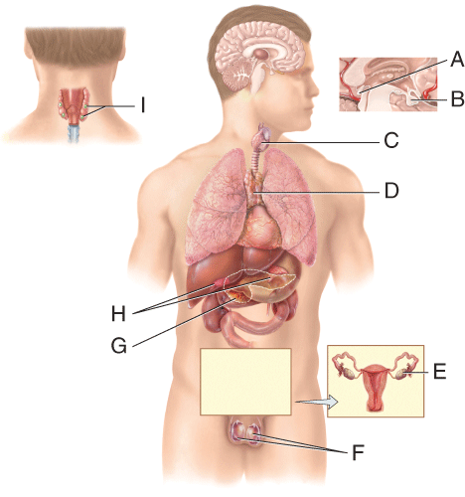

a) A
b) B
c) C
d) I
e) D

Answer: b

Difficulty: Medium
Bloomcode: Application
Learning Objective 1: LO 18.6 Describe the properties of the hypothalamus and pituitary gland and the relationships between them.
Section Reference 1: Sec 18.6 Hypothalamus and Pituitary Gland

Question type: Multiple Choice

36) Which of the labeled endocrine glands secretes hormones that regulate the basal metabolic rate (BMR)?

a) C
b) D
c) A
d) G
e) I

Answer: a

Difficulty: Medium
Bloomcode: Application
Learning Objective 1: LO 18.7 Describe the location, histology, hormones, and functions of the thyroid gland.
Section Reference 1: Sec 18.7 Thyroid Gland

Question type: Multiple Choice

37) Which of the following labeled endocrine glands secretes hormones that regulate blood calcium ion levels?

a) B
b) A
c) H
d) D
e) I

Answer: e

Difficulty: Medium
Bloomcode: Application
Learning Objective 1: LO 18.8 Describe the location, histology, hormone, and functions of the parathyroid glands.
Section Reference 1: Sec 18.8 Parathyroid Glands

Question type: Multiple Choice

38) Which of the labeled endocrine glands secretes steroid hormones in response to long-term stress?

a) D
b) G
c) H
d) I
e) F

Answer: c

Difficulty: Medium
Bloomcode: Application
Learning Objective 1: LO 18.9 Describe the location, histology, hormones, and functions of the adrenal glands.
Section Reference 1: Sec 18.9 Adrenal Glands

Question type: Multiple Choice

39) Which of the following is NOT an endocrine gland aging effect?

a) Rise in the blood levels of PTH
b) Less cortisol and aldosterone production
c) Decreased levels of gonadotropins
d) Decreased levels of calcitriol and calcitonin
e) Increase in thymus size

Answer: e

Difficulty: Medium
Bloomcode: Analysis
Learning Objective 1: LO 18.16 Describe the effects of aging on the endocrine system.
Section Reference 1: Sec 18.16 Aging and the Endocrine System

Question type: Multiple Choice

40) Which zone of the adrenal gland secretes aldosterone?
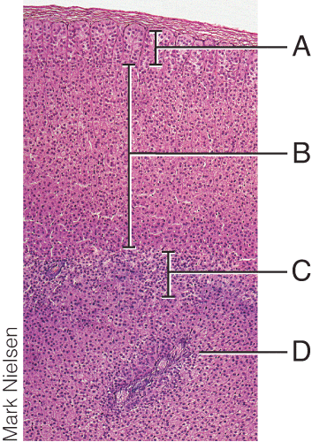

a) A
b) B
c) C
d) D
e) None of the zones

Answer: a

Difficulty: Medium
Bloomcode: Application
Learning Objective 1: LO 18.9 Describe the location, histology, hormones, and functions of the adrenal glands.
Section Reference 1: Sec 18.9 Adrenal Glands

Question type: Multiple Choice

41) Which zone of the adrenal gland secretes androgens?

a) A
b) B
c) C
d) D
e) None of the zones

Answer: c

Difficulty: Medium
Bloomcode: Application
Learning Objective 1: LO 18.9 Describe the location, histology, hormones, and functions of the adrenal glands.
Section Reference 1: Sec 18.9 Adrenal Glands

Question type: Multiple Choice

42) Which labeled structure in the diagram secretes glucagon?
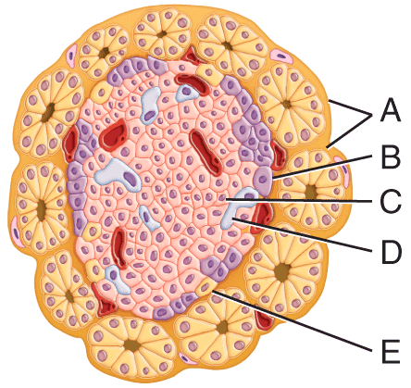

a) A
b) B
c) C
d) D
e) E

Answer: b

Difficulty: Medium
Bloomcode: Application
Learning Objective 1: LO 18.10 Describe the location, histology, hormones, and functions of the pancreatic islets.
Section Reference 1: Sec 18.10 Pancreatic Islets

Question type: Multiple Choice

43) Which labeled structure in the diagram secretes a hormone that stimulates events that lower blood glucose concentration?

a) A
b) B
c) C
d) D
e) E

Answer: c

Difficulty: Medium
Bloomcode: Application
Learning Objective 1: LO 18.10 Describe the location, histology, hormones, and functions of the pancreatic islets.
Section Reference 1: Sec 18.10 Pancreatic Islets

Question type: Multiple Choice

44) Which of the following is an incorrect pairing of a body system and an endocrine contribution to that system?

a) Thyroid hormones promote normal development and growth of the skeleton.
b) Erythropoietin regulates the amount of oxygen carried in blood by adjusting the number of red blood cells.
c) Leptin enhances appetite.
d) Glucocorticoids depress inflammation and immune responses.
e) Epinephrine depresses the activity of the digestive system.

Answer: c

Difficulty: Medium
Bloomcode: Analysis
Learning Objective 1: LO 18:17 Describe how the endocrine system contributes to homeostasis.
Section Reference 1: Ch 18: Focus on Homeostasis

Question type: Essay

45) Compare and contrast the mechanisms of action of lipid-soluble versus water-soluble hormones.

Answer:

Difficulty: Medium
Bloomcode: Application
Learning Objective 1: LO 18.4 Describe the two general mechanisms of hormone action.
Section Reference 1: Sec 18.4 Mechanisms of Hormone Action
Solution: Upon reaching their target cells, lipid-soluble hormones diffuse across the phospholipid bilayer of the target cell membrane and bind to receptors in the cytosol or nucleus. The activated receptor usually acts by turning transcription of genes either on or off, thus regulating synthesis of a protein. Water-soluble hormones bind to receptors that protrude from the target cell surface, which activate intracellular signaling pathways that lead to changes in the cell's metabolic activity.

Question type: Essay

46) Describe the role of the hypothalamus in the regulation of hormone release from the pituitary gland.

Answer:

Difficulty: Hard
Bloomcode: Synthesis
Learning Objective 1: LO 18.6 Describe the properties of the hypothalamus and pituitary gland and the relationships between them.
Section Reference 1: Sec 18.6 Hypothalamus and Pituitary Gland
Solution: The hypothalamus is the integrating center for much sensory input. It secretes releasing and inhibiting hormones which diffuse into the hypophyseal portal system to regulate secretion of all hormones from the anterior pituitary gland. The hypothalamus also contains receptors that monitor blood osmotic pressure and neural input from reproductive structures. Integration of this input leads to production of ADH and OT by neurosecretory cells of the hypothalamus. These hormones are then transported through the hypothalamic- hypophyseal tract to be released by exocytosis from the posterior pituitary gland in response to nerve impulses.

Question type: Essay

47) Enuresis, or bedwetting, may be caused by psychological, anatomical or physiological factors. In the latter case, vasopressin is often prescribed and is a very effective treatment. What is vasopressin? How can it prevent enuresis?

Answer:

Difficulty: Medium
Bloomcode: Application
Learning Objective 1: LO 18.6 Describe the properties of the hypothalamus and pituitary gland and the relationships between them.
Section Reference 1: Sec 18.6 Hypothalamus and Pituitary Gland
Solution: Vasopressin is also called antidiuretic hormone or ADH. In addition to its vasoconstrictive effects, ADH causes the kidneys to reabsorb more water. Someone who does not make enough ADH may not be able to contain all of the urine produced while they are sleeping. If they are not awakened by the pressure in their urinary bladder, they may wet the bed instead of getting up and going to the toilet. Since vasopressin helps the body reabsorb more water, a person's bladder should not get so full that they end up wetting the bed while sleeping.

Question type: Essay

48) What is a goiter? Explain how goiters can develop in both hyposecretion and hypersecretion disorders. In these hyposecretion and hypersecretion disorders, would you expect the levels of other regulatory hormones involved in control of thyroid hormone secretion to be high or low? Why?

Answer:

Difficulty: Medium
Bloomcode: Application
Learning Objective 1: LO 18.18 Describe the disorders that affect the endocrine system.
Section Reference 1: Disorders: Homeostatic Imbalances
Solution: A goiter is an enlarged thyroid gland. Hyposecretion goiters are usually due to insufficient iodide in the diet. Resulting low levels of thyroid hormones cause increased TRH and TSH until adequate thyroid activity is restored. Graves' disease causes hyperthyroidism by producing an antibody that mimics TSH. Thyroid enlargement occurs, and production of thyroid hormones increases. TRH and natural TSH remain low due to negative feedback, but TSH-mimicking antibody stimulates increased thyroid hormone production and secretion.

Question type: Essay

49) Compare the metabolic changes that occur during starvation with those that occur in diabetes mellitus.

Answer:

Difficulty: Hard
Bloomcode: Evaluation
Learning Objective 1: LO 18.18 Describe the disorders that affect the endocrine system.
Section Reference 1: Disorders: Homeostatic Imbalances
Solution: A starving person is lacking energy-providing nutrient sources, and so, must use structural components of the body as energy sources. The diabetic consumes adequate nutrients, but due to the lack of insulin, is unable to move glucose into cells, and so, cannot use the glucose as an energy source. In both cases, energy generation becomes dependent on non-glucose sources, such as fatty acids and amino acids. Mobilization and metabolism of fats and proteins for energy production purposes leads to ketoacidosis, weight loss, and hunger.

Question type: Text Drop Down

50) Benign tumors of chromaffin cells of the adrenal medulla cause [dropdown 1]. The only treatment for this is [dropdown 2].

Dropdown1 choices
acromegaly
goiter
myxedema
pheochromocytoma

Dropdown 2 choices
growth hormone supplementation
radiation
surgery
thyroid hormone supplementation

Answer 1: pheochromocytoma
Answer 2: surgery

Difficulty: Medium
Bloomcode: Application
Learning Objective 1: LO 18.18 Describe the disorders that affect the endocrine system.
Section Reference 1: Disorders: Homeostatic Imbalances

51) Which of the following hormones is produced in the zone of the adrenal gland labeled B?

a) Cortisol
b) Epinephrine
c) Norepinephrine
d) Glucagon
e) Androgens

Answer: a

Difficulty: Medium
Bloomcode: Application
Learning Objective 1: LO 18.9 Describe the location, histology, hormones, and functions of the adrenal glands.
Section Reference 1: Sec 18.9 Adrenal Glands

52) Which of the following describes a function of a hormone produced in the zone of the adrenal gland labeled B?

a) Enables body to resist stressors and also increases blood glucose
b) Intensifies sympathetic responses in other parts of the body
c) Accelerates formation of glucose from glycogen (glycogenolysis)
d) Stimulates growth of axillary and pubic hair
e) Stimulates breast development and milk secretion

Answer: a

Difficulty: Hard
Bloomcode: Evaluation
Learning Objective 1: LO 18.9 Describe the location, histology, hormones, and functions of the adrenal glands.
Section Reference 1: Sec 18.9 Adrenal Glands

53) Which of the following conditions could potentially result from hyposecretion of a hormone released by the portion of the marked gland in the diagram?
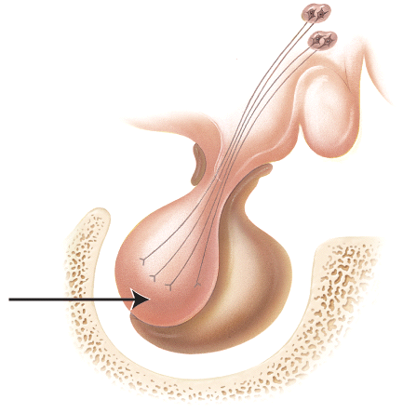

a) Tetany
b) Acromegaly
c) Diabetes insipidus
d) Goiter
e) cushing's syndrome

Answer: c

Difficulty: Hard
Bloomcode: Evaluation
Learning Objective 1: LO 18.18 Describe the disorders that affect the endocrine system.
Section Reference 1: Disorders: Homeostatic Imbalances

54) Identify the stalk-like structure labeled A in the diagram.
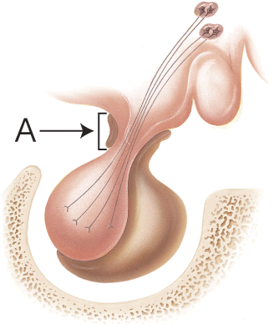
a) Hypothalamus
b) Anterior pituitary
c) Posterior pituitary
d) Infundibular
e) Hypophysial fossa

Answer: d

Difficulty: Medium
Bloomcode: Application
Learning Objective 1: LO 18.6 Describe the properties of the hypothalamus and pituitary gland and the relationships between them.
Section Reference 1: Sec 18.6 Hypothalamus and Pituitary Gland

55) The endocrine gland shown in the diagram is found in a depression in the sphenoid bone (marked in the diagram) called the
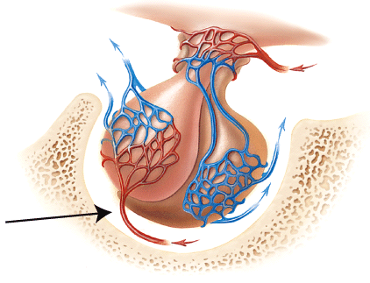

a) Maxilla.
b) Infundibulum.
c) Primary plexus.
d) Cribiform plate.
e) Hypophyseal fossa

Answer: e

Difficulty: Medium
Bloomcode: Application
Learning Objective 1: LO 18.6 Describe the properties of the hypothalamus and pituitary gland and the relationships between them.
Section Reference 1: Sec 18.6 Hypothalamus and Pituitary Gland

56) Which of the following bones (marked in the diagram) contains a depression which houses the endocrine gland shown in the diagram?
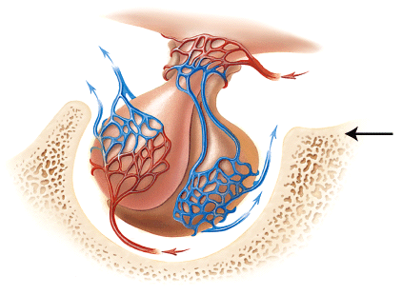

a) Maxilla
b) Sphenoid bone
c) Mandible
d) Ethmoid bone
e) Temporal bone

Answer: b

Difficulty: Medium
Bloomcode: Application
Learning Objective 1: LO 18.6 Describe the properties of the hypothalamus and pituitary gland and the relationships between them.
Section Reference 1: Sec 18.6 Hypothalamus and Pituitary Gland

57) Which of the following hormones is produced by the cells marked in the thyroid follicle shown in the histology picture?
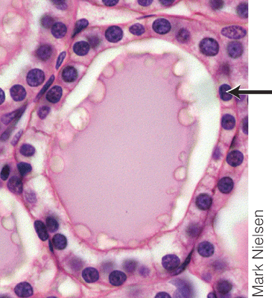

a) Calcitonin
b) Vasopressin
c) Triiodothyronine (T₃)
d) Antidiuretic hormone (ADH)
e) Calcitriol

Answer: c

Difficulty: Medium
Bloomcode: Analysis
Learning Objective 1: LO 18.7 Describe the location, histology, hormones, and functions of the thyroid gland.
Section Reference 1: Sec 18.7 Thyroid Gland

58) Which of the following hormones is produced by the cells marked in the thyroid follicle shown in the histology picture?
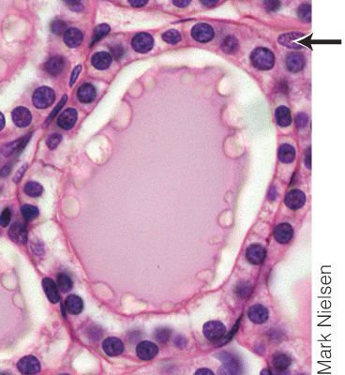

a) Calcitonin
b) Vasopressin
c) Triiodothyronine (T₃)
d) Antidiuretic hormone (ADH)
e) Calcitriol

Answer: a

Difficulty: Medium
Bloomcode: Analysis
Learning Objective 1: LO 18.7 Describe the location, histology, hormones, and functions of the thyroid gland.
Section Reference 1: Sec 18.7 Thyroid Gland

59) What is the major function of the hormone produced by the cells marked in the thyroid follicle shown in the histology picture?

a) Involved in regulation of calcium homeostasis.
b) Enhances contraction of smooth muscle cells in the uterus during delivery.
c) In females, initiates development of oocytes. In males, stimulates sperm production.
d) Stimulates the action of osteoclasts.
e) Increases blood levels of Na⁺ and water.

Answer: a

Difficulty: Hard
Bloomcode: Evaluation
Learning Objective 1: LO 18.7 Describe the location, histology, hormones, and functions of the thyroid gland.
Section Reference 1: Sec 18.7 Thyroid Gland

60) Which of the following diseases results when the cells marked in the histology image are destroyed by the immune system?
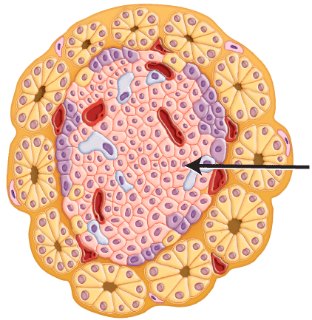

a) Cushing's disease
b) Addison's disease
c) Acromegaly
d) Type 1 diabetes
e) Diabetes insipidus

Answer: d

Difficulty: Medium
Bloomcode: Analysis
Learning Objective 1: LO 18.10 Describe the location, histology, hormones, and functions of the pancreatic islets.
Learning Objective 2: LO 18.18 Describe the disorders that affect the endocrine system.
Section Reference 1: Sec 18.10 Pancreatic Islets
Section Reference 2: Disorders: Homeostatic Imbalances

61) What endocrine abnormality does the male on the left standing next to a female of average height have?
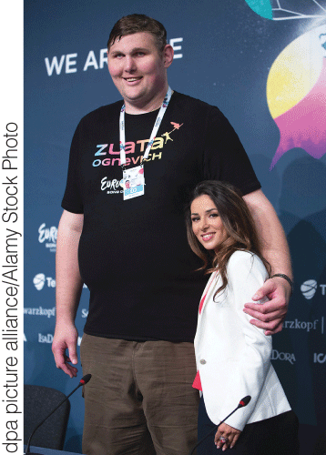

a) Goiter
b) Graves' disease
c) Type 2 diabetes
d) Cushing's syndrome
e) Pituitary gigantism

Answer: e

Difficulty: Medium
Bloomcode: Application
Learning Objective 1: LO 18.16 Describe the effects of aging on the endocrine system.
Section Reference 1: Disorders: Homeostatic Imbalances

62) The disorder shown in the male on the left of this figure is due to a hypersecretion of hormones by which endocrine gland?

a) Thyroid gland
b) Pineal gland
c) Parathyroid gland
d) Pituitary gland
e) Pancreas

Answer: d

Difficulty: Medium
Bloomcode: Analysis
Learning Objective 1: LO 18.18 Describe the disorders that affect the endocrine system.
Section Reference 1: Disorders: Homeostatic Imbalances

63) The patient shown is suffering from a disease called ________, caused by a pituitary hypersecretion of hGH during adulthood.
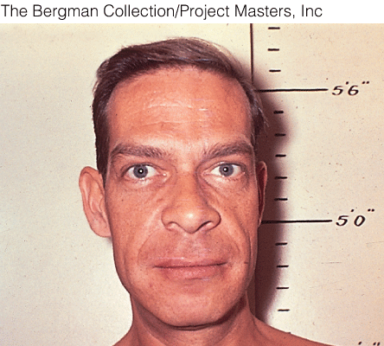

a) Goiter
b) Graves' Disease
c) Acromegaly
d) Cushing's syndrome
e) Gigantism

Answer: c

Difficulty: Medium
Bloomcode: Analysis
Learning Objective 1: LO 18.18 Describe the disorders that affect the endocrine system.
Section Reference 1: Disorders: Homeostatic Imbalances

64) Which of the following endocrine disorders is the individual shown in this picture suffering from?
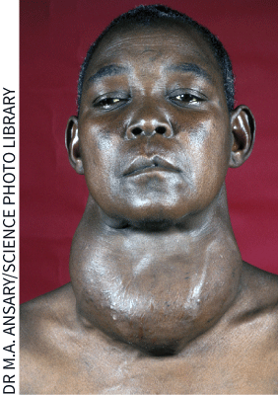

a) Acromegaly
b) Graves' Disease
c) Goiter
d) Cushing's syndrome
e) Gigantism

Answer: c

Difficulty: Medium
Bloomcode: Analysis
Learning Objective 1: LO 18.18 Describe the disorders that affect the endocrine system.
Section Reference 1: Disorders: Homeostatic Imbalances

65) Hypothyroidism during adulthood can produce which of the following disorders?

a) Acromegaly
b) Graves' Disease
c) Hypoglycemia
d) Cushing's syndrome
e) Myxedema

Answer: e

Difficulty: Medium
Bloomcode: Analysis
Learning Objective 1: LO 18.18 Describe the disorders that affect the endocrine system.
Section Reference 1: Disorders: Homeostatic Imbalances

Question type: Multiple Choice

66) The following is a possible progression of which of the following disorders: Inadequate dietary iodine intake ‡ low level of thyroid hormone in blood ‡ increased TSH secretion ‡ thyroid gland enlargement.

a) Acromegaly
b) Tetany
c) Goiter
d) Cushing's syndrome
e) Addison's disease

Answer: c

Difficulty: Medium
Bloomcode: Application
Learning Objective 1: 18.18 Describe the disorders that affect the endocrine system.
Section Reference 1: Disorders: Homeostatic Imbalance

67) Which of the following is an abnormal condition of excess androgen secretion, observed primarily in women, that is characterized by the presence of excessive body and facial hair in a male pattern?

a) Acromegaly
b) Tetany
c) Hirsutism
d) Gynecomastia
e) Myxedema

Answer: c

Difficulty: Medium
Bloomcode: Application
Learning Objective 1: LO 18.18 Describe the disorders that affect the endocrine system.
Section Reference 1: Disorders: Homeostatic Imbalances

68) A condition characterized by excessive development of mammary glands in a male is called

a) acromegaly.
b) pheochromocytoma.
c) hirsutism.
d) gynecomastia.
e) myxedema.

Answer: d

Difficulty: Medium
Bloomcode: Application
Learning Objective 1: LO 18.18 Describe the disorders that affect the endocrine system.
Section Reference 1: Disorders: Homeostatic Imbalances

Question Type: Text Drop Down

69) Two of the hallmarks of hyperparathyroidism are [dropdown 1] and [dropdown 2].

Dropdown 1 choices:
broken bones
excessive thirst
increased hair growth
myxedema

Dropdown 2 choices:
bronze skin
buffalo hump
kidney stones
rapid heart rate

Answer 1: broken bones
Answer 2: kidney stones

Difficulty: Medium
Bloomcode: Application
Learning Objective 1: LO 18.16 Describe the effects of aging on the endocrine system.
Section Reference 1: Disorders: Homeostatic Imbalances\

Question type: Multiple Choice

70) Hypersecretion of a hormone by the endocrine gland marked in the diagram results in a type of depression that affects some people during the winter months, when the day length is short. This condition is known as
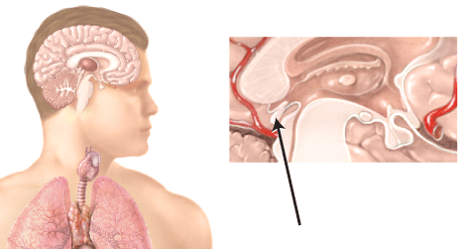

a) thyroid crisis (storm).
b) general adaptation syndrome (GAS).
c) seasonal affective disorder (SAD).
d) Addisonian crisis.
e) posttraumatic stress disorder (PTSD).

Answer: c

Difficulty: Medium
Bloomcode: Analysis
Learning Objective 1: LO 18.12 Describe the properties of the pineal gland and thymus.
Section Reference 1: Sec 18.12 Pineal Gland and Thymus

71) Seasonal affective disorder is due to hypersecretion of which of the following hormones by the endocrine gland marked in the diagram?

a) Testosterone
b) Glucagon
c) Melatonin
d) Aldosterone
e) Vasopressin

Answer: c

Difficulty: Medium
Bloomcode: Application
Learning Objective 1: LO 18.12 Describe the properties of the pineal gland and thymus.
Section Reference 1: Sec 18.12 Pineal Gland and Thymus

72) Which of the following hormones is produced by the endocrine gland marked in the diagram?
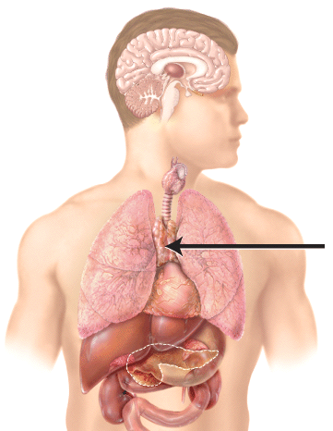

a) Testosterone
b) Glucagon
c) Melatonin
d) Thymopoietin
e) Vasopressin

Answer: d

Difficulty: Medium
Bloomcode: Application
Learning Objective 1: LO 18.12 Describe the properties of the pineal gland and thymus.
Section Reference 1: Sec 18.12 Pineal Gland and Thymus

73) All prostaglandins are derived from a 20-carbon precursor molecule called

a) thromboxane.
b) intrinsic factor.
c) thymopoietin.
d) arachidonic acid.
e) cholesterol.

Answer: d

Difficulty: Medium
Bloomcode: Application
Learning Objective 1: LO 18.13 Describe the hormonal properties of cells in tissues and organs that are not classified as endocrine glands.
Section Reference 1: Sec 18.13 Other Endocrine Tissues and Organs, Eicosanoids, and Growth Factors

74) Human chorionic gonadotropin (hCG) is produced by the

a) placenta.
b) ovaries.
c) testes.
d) pituitary gland.
e) hypothalamus.

Answer: a

Difficulty: Medium
Bloomcode: Application
Learning Objective 1: LO 18.13 Describe the hormonal properties of cells in tissues and organs that are not classified as endocrine glands.
Section Reference 1: Sec 18.13 Other Endocrine Tissues and Organs, Eicosanoids, and Growth Factors

75) Leptin is a hormone produced by the

a) placenta.
b) ovaries.
c) testes.
d) pituitary gland.
e) adipose tissue.

Answer: e

Difficulty: Medium
Bloomcode: Application
Learning Objective 1: LO 18.13 Describe the hormonal properties of cells in tissues and organs that are not classified as endocrine glands.
Section Reference 1: Sec 18.13 Other Endocrine Tissues and Organs, Eicosanoids, and Growth Factors

76) The anterior pituitary develops from which of the following germ layers during embryonic development?

a) Mesoderm
b) Endoderm
c) Ectoderm
d) A combination of two of the layers
e) None of the answer selections are correct

Answer: c

Difficulty: Medium
Bloomcode: Analysis
Learning Objective 1: LO 18.15 Describe the development of endocrine glands.
Section Reference 1: Sec 18.15 Development of the Endocrine System

77) The thyroid gland develops from which of the following germ layers during embryonic development?

a) Mesoderm
b) Endoderm
c) Ectoderm
d) A combination of two of the layers
e) None of the answer selections are correct

Answer: b

Difficulty: Medium
Bloomcode: Analysis
Learning Objective 1: LO 18.15 Describe the development of endocrine glands.
Section Reference 1: Sec 18.15 Development of the Endocrine Systems

78) The adrenal medulla develops from which of the following germ layers during embryonic development?

a) Mesoderm
b) Endoderm
c) Ectoderm
d) A combination of two of the layers
e) None of the answer selections are correct

Answer: c

Difficulty: Medium
Bloomcode: Analysis
Learning Objective 1: LO 18.15 Describe the development of endocrine glands.
Section Reference 1: Sec 18.15 Development of the Endocrine System

79) Endocrine tissues that secrete steroid hormones are derived from

a) mesoderm.
b) endoderm.
c) ectoderm.
d) a combination of two or more layers.
e) none of the layers that are listed.

Answer: a

Difficulty: Medium
Bloomcode: Analysis
Learning Objective 1: LO 18.15 Describe the development of endocrine glands.
Section Reference 1: Sec 18.15 Development of the Endocrine System

80) Which of the following glands is NOT an endocrine gland?

a) Pituitary gland
b) Thyroid gland
c) Adrenal gland
d) Sebaceous gland
e) Pineal gland

Answer: d

Difficulty: Easy
Bloomcode: Knowledge
Learning Objective 1: LO 18.2 Distinguish between exocrine and endocrine glands.
Section Reference 1: Sec 18.2 Endocrine Glands

81) Which of the following is NOT a common characteristic of an exocrine gland?

a) Initially secretes its products into a duct.
b) Secretes materials onto outer surface of the body.
c) Secretes materials into the lumen of hollow organs.
d) Its secretory products are carried in body fluids to distant target cells.
e) All the answer selections describe characteristics of exocrine glands.

Answer: d

Difficulty: Medium
Bloomcode: Application
Learning Objective 1: LO 18.2 Distinguish between exocrine and endocrine glands.
Section Reference 1: Sec 18.2 Endocrine Glands

82) Since insulin released from the pancreas is carried in the bloodstream to distant target cells, like muscle cells, it is considered to be a(n)

a) local hormone.
b) circulating hormone.
c) paracrine.
d) autocrine.
e) neurotransmitter.

Answer: b

Difficulty: Medium
Bloomcode: Application
Learning Objective 1: LO 18.3 Describe how the various classes of hormones interact with target-cell receptors.
Section Reference 1: Sec 18.3 Hormone Activity

83) Which of the following is an example of a hormone that is secreted from an endocrine gland in response to a chemical change in the blood?

a) Parathyroid hormone release from the parathyroid gland.
b) Insulin release from the pancreas.
c) Glucagon release from the pancreas.
d) ADH release from the posterior pituitary gland.
e) All the answer selections are correct.

Answer: e

Difficulty: Medium
Bloomcode: Analysis
Learning Objective 1: LO 18.5 Describe the mechanisms of control of hormone secretion.
Section Reference 1: Sec 18.5 Control of Hormone Secretion

84) All the following hormones are produced and secreted by the ovaries EXCEPT

a) estradiol.
b) estrone.
c) progesterone.
d) inhibin.
e) follicle-stimulating hormone.

Answer: e

Difficulty: Medium
Bloomcode: Analysis
Learning Objective 1: LO 18.11 Describe the location, hormones, and functions of the male and female gonads.
Section Reference 1: Sec 18.11 Ovaries and Testes

85) Which of the following is a protein hormone produced by the testes that suppresses secretion of follicle-stimulating hormone by the anterior pituitary gland?

a) Chorionic gonadotropin
b) Testosterone
c) Estradiol
d) Inhibin
e) Relaxin

Answer: d

Difficulty: Medium
Bloomcode: Analysis
Learning Objective 1: LO 18.11 Describe the location, hormones, and functions of the male and female gonads.
Section Reference 1: Sec 18.11 Ovaries and Testes

