- AT command on Xnode:
In function < reportMQTT >, the value of variable <isinitialized> = 0, so it goes to <setTime()>
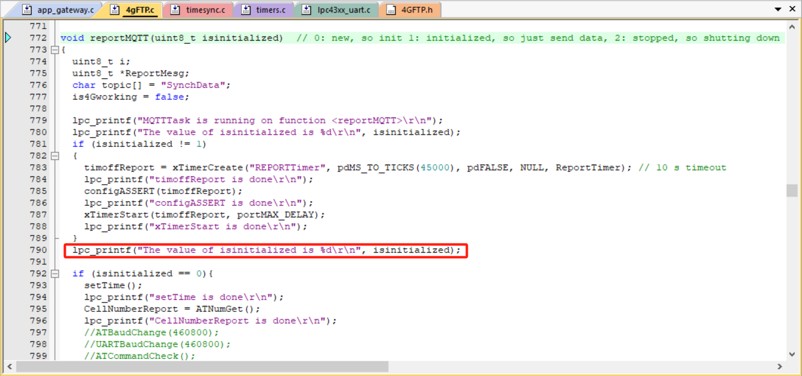
In function <setTime()>, it includes the implementation of <ATCommandCheck()>
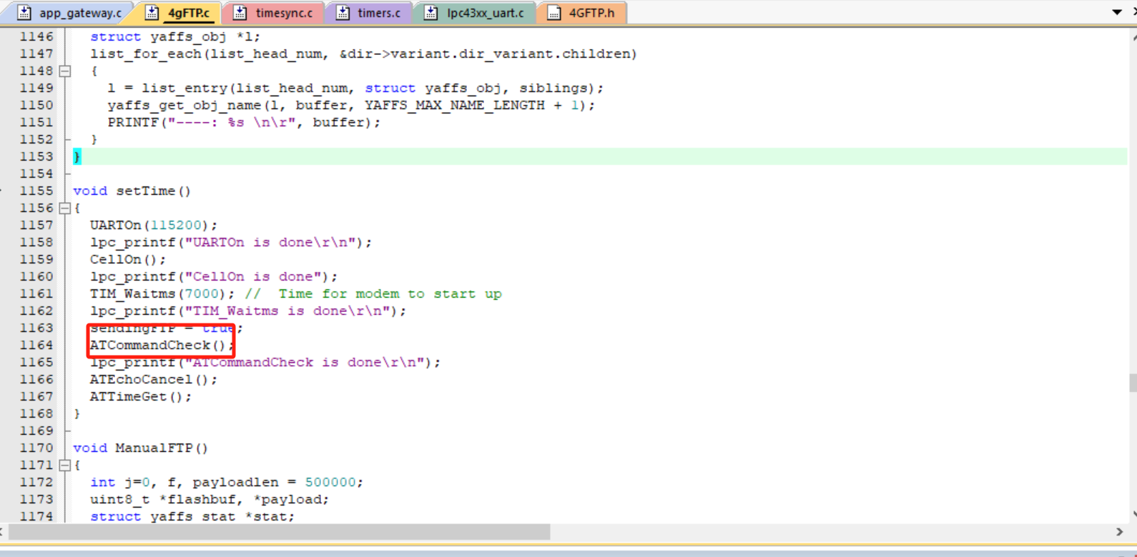
In implementation <ATCommandCheck()>, it judges the value of return of function <checkATmessageReply>, which send the command <AT> by UART as follows.
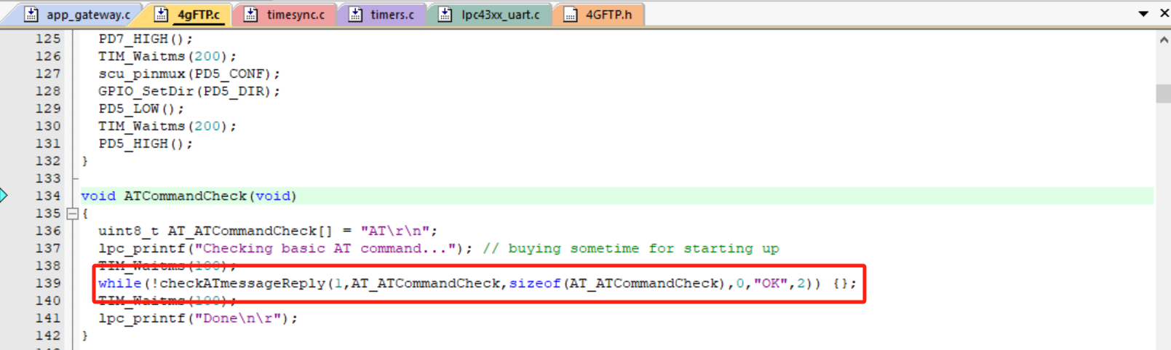
Here, the values of variables are: message = ‘AT/n/r’; synching4G = 0; size = 5;
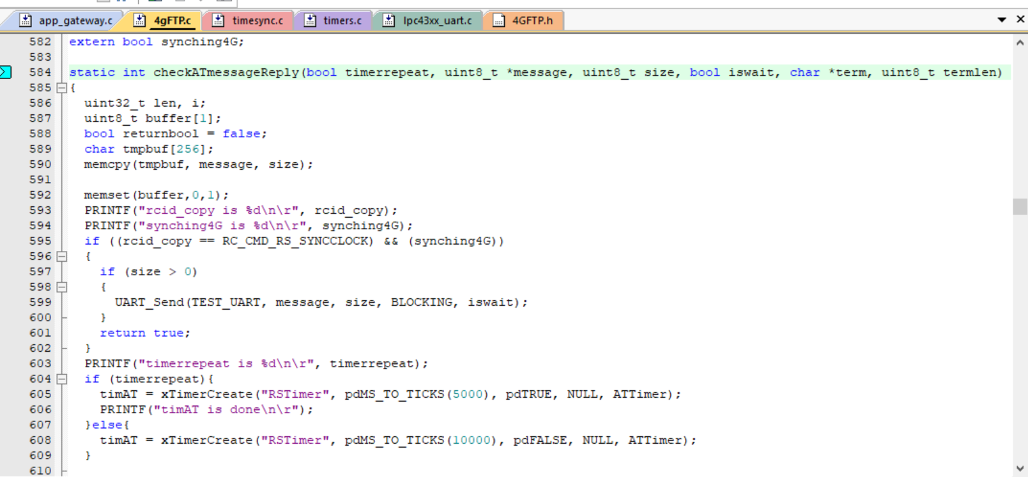

And the messge = ‘AT/n/r’ is sent by function <UART_Send> in line 620, and it should receive the message ‘OK’ by function <UART_Receive> in line 627 to the condition <len > 0>. However, no message is received by function <UART_Receive> and <len = 0>, and it is stuck in here. Besides, the 4G module in Xnode doesn’t light up the green bulb when it is powered.
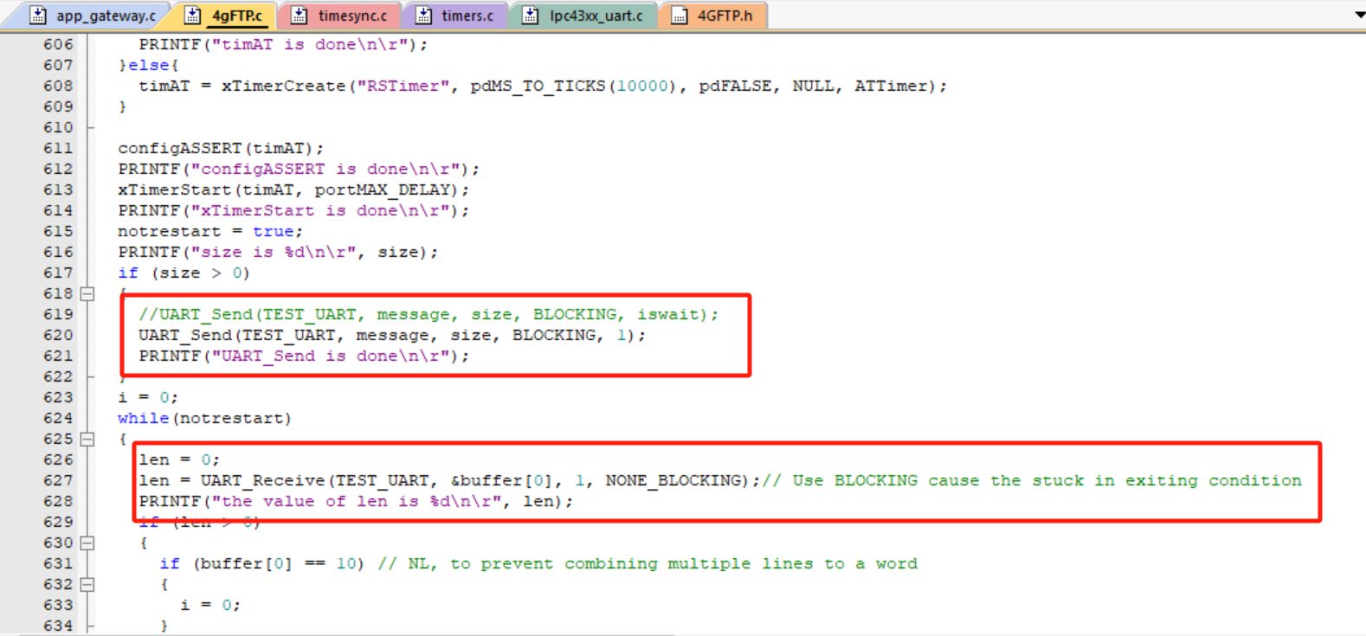

- Checking the 4G module of Xnode
Send the <AT> on TERA TERM, and it reflects <OK>, works fine.
