Consumer Preferences for Fresh Produce
Survey Questionnaire
TUM School of Management, Technical University of Munich
Master’s Thesis Research — Academic Use Only

Section 1: Informed Consent
Dear Participant,
This questionnaire is administered as part of a master’s thesis research project at the TUM School of Management, Technical University of Munich. The study investigates purchasing preferences of Chinese consumers regarding fresh agricultural produce.
All responses are collected anonymously. The data will be used exclusively for academic research and statistical analysis. No personally identifiable information will be collected or disclosed.
Completing this questionnaire takes approximately 2 minutes. Participation is entirely voluntary, and you may withdraw at any time without consequence.

Please indicate your consent below:
(1) I have read the above information and agree to participate in this study.
(2) I do not agree to participate.

Section 2: Demographic Information
A1. What is your gender?
(1) Female
(2) Male
(3) Other
(4) Prefer not to say

A2. What is your age group?
(1) 18–25 years
(2) 26–35 years
(3) 36–45 years
(4) 46–55 years
(5) 55 years or above

A3. What is your average monthly disposable income?
(1) Below 6,000 RMB
(2) 6,000–14,000 RMB
(3) Above 14,000 RMB

A4. On average, how often do you purchase fresh fruits and vegetables per week?
(1) Rarely / Almost never
(2) 1–2 times
(3) 3–4 times
(4) 5 times or more

Section 3: Scenario Description
Please read the following scenario carefully: Imagine you are shopping for fruit in the fresh produce section of a supermarket near your home. The apples on the left are currently on promotion. Please answer the subsequent questions based on the product information provided.
Note: The apples on the left and right were harvested at the same time and are of the same variety. They are identical in all respects except for their appearance.

Stimulus Materials (Experimental Conditions)

Condition A — Standard Promotional Framing
“Special Promotion — Discounted Price! Sweet in flavour, freshly arrived. Sold at a reduced price due to cosmetic imperfections. (Harvested simultaneously with the apples on the right, identical in every respect except appearance.)”

Condition B — Anthropomorphic Framing
“Special Promotion — Discounted Price! We are just as sweet and delicious as our siblings on the right — a little rough around the edges, but equally fresh and tasty. We have worked hard to grow, and we hope you will take us home. (Harvested simultaneously with the apples on the right, identical in every respect except appearance.)”
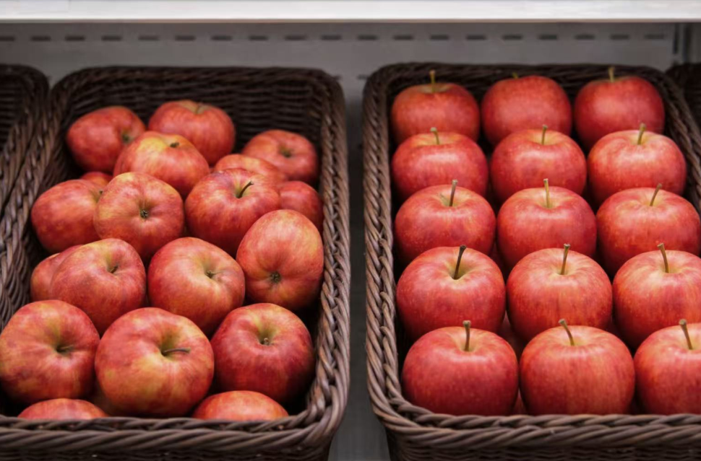

Section 4: Manipulation Check — Perceived Anthropomorphism
Based on the product information above, please rate your agreement with the following statements.
Scale: 1 = Strongly Disagree 2 = Disagree 3 = Neutral 4 = Agree 5 = Strongly Agree
Statement | Strongly Disagree (1) | Disagree (2) | Neutral (3) | Agree (4) | Strongly Agree (5)
C1. This product description made me feel as though the apples were “speaking”. | ○ | ○ | ○ | ○ | ○
C2. This product description made me feel that the apples had human-like characteristics or emotions. | ○ | ○ | ○ | ○ | ○
C3. This product description made me feel that the apples were trying to communicate with me. | ○ | ○ | ○ | ○ | ○

Section 5: Perceived Quality
Based on your intuitive judgment, please rate your agreement with the following statements about the quality of the apples on the left.
Scale: 1 = Strongly Disagree 2 = Disagree 3 = Neutral 4 = Agree 5 = Strongly Agree
Statement | Strongly Disagree (1) | Disagree (2) | Neutral (3) | Agree (4) | Strongly Agree (5)
D1. I believe these apples taste good. | ○ | ○ | ○ | ○ | ○
D2. I believe these apples are safe to consume. | ○ | ○ | ○ | ○ | ○
D3. I believe these apples are as nutritious as regular apples. | ○ | ○ | ○ | ○ | ○
D4. Overall, I consider the quality of these apples to be acceptable. | ○ | ○ | ○ | ○ | ○

Section 6: Sympathy Toward the Product
Please respond based on your genuine emotional reaction upon seeing the apples on the left.
Scale: 1 = Strongly Disagree 2 = Disagree 3 = Neutral 4 = Agree 5 = Strongly Agree
Statement | Strongly Disagree (1) | Disagree (2) | Neutral (3) | Agree (4) | Strongly Agree (5)
E1. Seeing these apples, I feel a sense of compassion toward them. | ○ | ○ | ○ | ○ | ○
E2. Seeing these apples, I feel they are rather pitiable. | ○ | ○ | ○ | ○ | ○
E3. Seeing these apples, I feel an urge to help them. | ○ | ○ | ○ | ○ | ○
E4. Seeing these apples, I experience a feeling of sympathy. | ○ | ○ | ○ | ○ | ○

Section 7: Purchase Intention
Assuming you currently need to purchase apples, please rate your agreement with the following statements.
Scale: 1 = Strongly Disagree 2 = Disagree 3 = Neutral 4 = Agree 5 = Strongly Agree
Statement | Strongly Disagree (1) | Disagree (2) | Neutral (3) | Agree (4) | Strongly Agree (5)
F1. I would be willing to purchase apples with non-standard appearances. | ○ | ○ | ○ | ○ | ○
F2. If I encountered this type of promotion in a supermarket, I would likely purchase them. | ○ | ○ | ○ | ○ | ○
F3. On my next shopping trip, I would actively consider choosing cosmetically imperfect produce. | ○ | ○ | ○ | ○ | ○

Section 8: Attitude Toward Food Waste
Based on your daily experiences and perceptions, please rate your agreement with the following statements.
Scale: 1 = Strongly Disagree 2 = Disagree 3 = Neutral 4 = Agree 5 = Strongly Agree
Statement | Strongly Disagree (1) | Disagree (2) | Neutral (3) | Agree (4) | Strongly Agree (5)
G1. I consider food waste to be a serious social problem. | ○ | ○ | ○ | ○ | ○
G2. Reducing food waste is an important consideration in my daily life. | ○ | ○ | ○ | ○ | ○
G3. I feel uncomfortable or guilty when I think about how much food is discarded. | ○ | ○ | ○ | ○ | ○
G4. I believe every individual has a responsibility to reduce food waste. | ○ | ○ | ○ | ○ | ○
G5. I am aware of the negative environmental consequences of food waste (e.g., carbon emissions, resource depletion). | ○ | ○ | ○ | ○ | ○

Section 9: Attention Check
H1. Which type of fruit was featured in this questionnaire?
(1) Banana
(2) Peach
(3) Apple

H2. Attention check: Please select option C.
(1) A
(2) B
(3) C
(4) D

Thank You
Thank you for your time and participation. Your responses are invaluable to this research.
This study investigates consumer preferences toward produce of varying appearances. All data will be used solely for academic analysis. If you have any questions, please contact: go52riw@tum.com.
We wish you a pleasant day.

